content table
content table 1
Documents provided by PSL 2
aPPLICATION DEPLOYMENT 2
BUILD FILE CONFIGURATIONS......…………………………………………………………………………………….6

Documents provided by PSL
- /SDKGenerator-<Version>.zip
- /NetSDK.zip
- /SDKGenerator_GettingStarted.pdf

aPPLICATION DEPLOYMENT
Unzip the SDKGenerator-<Version>.zip file which is provided with the installation folder in any location of your pc.
To run the application just double-Click on the RunSDKGenerator.jar file which is inside the unzipped folder.

Notice that you can also create a direct access to this file so you won’t need to come to this folder again.

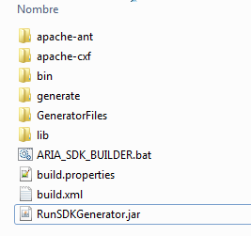

If you feel comfortable with that, you can access to the GeneratorFiles folder and put some default settings on the GenerationParms.xml. Although this file is updated by the application so this is only done in extreme cases.
The application has micro helps on each of the text fields so please remember to look at them.
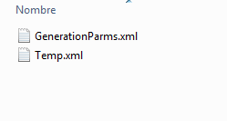
If there is no problem then the user interface will look like the image below.
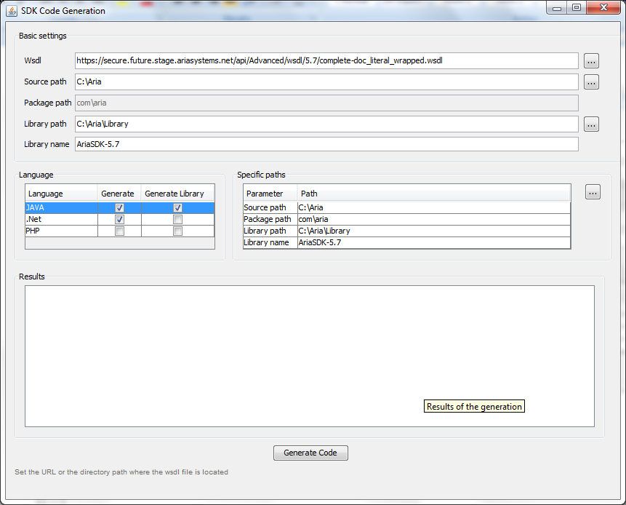

Please notice
- The Package path text field is disabled so it can’t be edited by the user but is enabled on the specific paths table. You can modify it here but please take in account that this change will affect the package distribution on the generated jar. So this will hurts any existing application that already uses an Aria sdk jar file. The default value [com/aria] is the one which is already being used by the Free Reg Sample application. But this could be changed in case you want to customize the package distribution to a different way for future applications.
- In the Languages table you will see the JAVA, .Net and PHP languages to select. For this version will the generation will only work for the JAVA and .Net language. And the PHP code was added just in case you want to create a PHP generation library. In case you don’t want to see the unused languages you can just delete those nodes from the GenerationParms.xml file. Remember that this could be done only by somebody who is familiar with xml files.
For example, if you want to avoid the php language from the screen then you will have to delete the selected node on the image below.
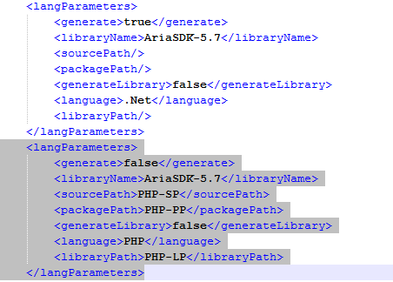
- The generated file for the .Net language will have to be unzipped. Move the unzipped “AriaBillingComplete.cs” and “RestUtilities.cs” to the AriaRestClient and the “AriaCompleteTest.cs” to the AriaRestClientTest projects in order to update the existing classes of previous wsdl version.
- The library generation has to be done following the instructions on the [Readme.txt] file included on the NetSDK folder. This happens because is unnecessary to generate the libraries when the user has also to update the service reference on his own project inside the visual studio solution.
- The generated library files (AriaWebService.DLL and AriaRestClient.DLL) are available inside the “build” folder.
- To test FullReg and FreeReg, copy the library files in build folder and put them in library/AriaSDK in FreeReg or FullReg solution directory.
- Open the solution file in Visual Studio 2010 Build it and run.

Note: For .NetSDK we must use “*doc-literal_wrapped.wsdl” in both Java SDK generator (step1) and build file (refer step4). If we used some other WSDL file it will show runtime issues due to missing namespace declaration.
E.g.: Wrapped WSDL - https://secure.future.stage.ariasystems.net/api/Advanced/wsdl/6.10/complete-doc_literal_wrapped.wsdl

Build file
- In build file (resides in NetSDK folder as AriaSDK.build) we need to mention the Application path; Visual studio 2010 installed path and wrapped WSDL path (either the local path or web URL).
- In build file, the “regenerate-from-wsdl” block contains commands to generate the Reference.cs file using given WSDL URL using SvcUtil.exe (visual studio utility function).
- Reference.cs file gets copied to both AriaRestClient and AriaWebService service reference path.
Reference.cs files contains definition of each API call’s parameter and return types. It also has the service contract definitions.
- “clean” block contains commands to delete build folder finally.
- "compile" block contain commands to get the configuration elements from app.config file and build the solution using Nant tool.
Nant Tool resides in tools folder inside of NetSDK folder.

