NULL V.S. Empty String

(name == null) says that no assignment has been made yet.  
(name == “”) says that an assignment has been made; its value is “”.

Determine if a string s is empty:

s==null || s.length()==0

Suffix Tree

The suffix tree for a string S is a [tree](http://en.wikipedia.org/wiki/Tree_(data_structure)) whose edges are labeled with strings, such that each suffix of S corresponds to exactly one path from the tree's root to a leaf.

Build Suffix Tree:

Naïve method: O(n2) (n is length of String S)

Ukkonen’s Algorithm: Time O(n) Space O(n)

Longest Common Subsequence Time O(mn), Space O(mn)

Longest Common Substring Time O(mn), Space O(mn)

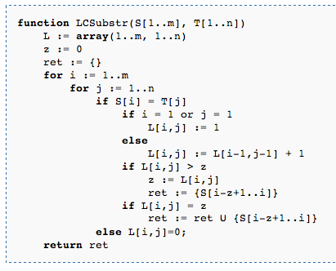

Keep only the last and current row of the DP table to save memory (O(min(m,n)) instead of O(mn))

Longest palindromic subsequence O(n^2)

Longest(i, j)= j-i+1 (if j-i<=1);

2+longest(i+1, j-1) if x[i]==x[j]

max(longest(i+1, j), longest(I, j-1)) otherwise

Longest palindromic substring O(n^2) O(n)

