As many modern cities Astana offer to their visitors the great opportunities for cultural recreation. The new theatre “Astana Opera” attract many people from different regions

Do <https://wiki.helsinki.fi/plugins/servlet/mobile#content/view/113252841>

If you

themThe fast pace of life in cities sometimes leaves no time for cultural recreation. Capitals like Astana offer the great opportunities for this like museums, historical parks, theatres and so forth, but citizens often don’t appreciate it. Do you agree that it is a bit paradoxical situation? Dear readers, I want to persuade you to escape from the daily routine and Is

Is it your first time in Astana and you don’t know where to go? Do you love culture recreation? Have you ever heard about Astana Opera? So this blog is for you. Here I am going to tell you, my dear readers, what does it look like to visit the Opera and Ballet Theatre “Astana Opera”.





**Experiment 2: Constructing a zinc/cooper cell**

|  |  |  |  |  |
| --- | --- | --- | --- | --- |
| **Polarity** | | **E0half-cell** | | **E0cell** |
| **Anode** | **Cathode** | **Anode** | **Cathode** | 1.076 V |
| Zn | Cu |  |  |

**Experiment 3: Constructing a zinc/iron cell**

|  |  |  |  |  |
| --- | --- | --- | --- | --- |
| **Polarity** | | **E0half-cell** | | **E0cell** |
| **Anode** | **Cathode** | **Anode** | **Cathode** | 0.433 V |
| Zn | Fe |  |  |

**Experiment 4: Constructing an iron/copper cell**

|  |  |  |  |  |
| --- | --- | --- | --- | --- |
| **Polarity** | | **E0half-cell** | | **E0cell** |
| **Anode** | **Cathode** | **Anode** | **Cathode** | 0.624 V |
| Fe | Cu |  |  |

|  |  |
| --- | --- |
| **Equipment** | **Changes** |
| solid | instead of white powder black precipitate formed |
| solution | stained from blue to black |
| test tube | warmed up |

Anions (negative ions) move to the anode, where the excess of positive ions emerges. Similarly (but reversed) cations (positive ions) balance the charge of the cathode.

Zn0(s) + Cu2++ SO2-4(aq) → Zn2++ SO2-4(aq) + Cu0(s)

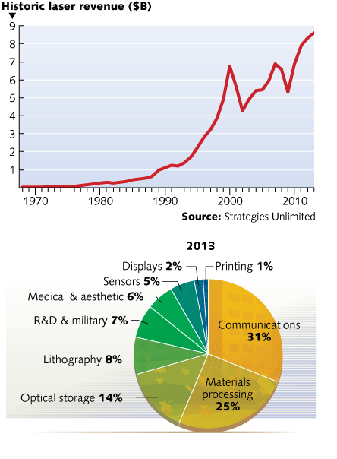

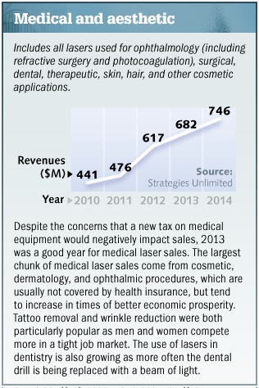 

Images for Math Presentation:

<http://goodnewsfl.org/carbon-dating/>

<http://www.biology.arizona.edu/biomath/tutorials/applications/carbon.html>

<http://www.brisbanetimes.com.au/entertainment/art-and-design/brisbane-hosts-egyptian-mummy-exhibition-20111003-1l4lm.html>

1. Compare the ratio of 12C to 14C.

- In living organisms:

12C : 14C – constant expected ratio

- After the death:

Amount of isotope 14C begins to decay exponentially.

2.Use the general formula for exponential decay:

m(t) = m0e-rt

r – the relative decay rate

Radiocarbon-14 dating is the primary method to date fossil remains.

Gave examples of how to determine the age of materials.

25,000 years old archeological artifacts prove that the first humans in America came from Siberia crossing the Bering Straits on foot.

Exponential growth and decay functions y = abx determine how the quantity of things increase or decrease over the time.

Many natural processes such as the growth of a population, studies of electricity and temperature, radioactive decay can be modeled by the exponential function.

This presentation is about Carbon dating. Uses the exponential function to calculate the age of organic remains.

Unfortunately, the main drawback of our university is the language of communication between the students. The majority prefer Kazakh or Russian and of them speak on English only in class.

Unfortunately, the main drawback of our university is the language of communication between the students. The majority prefer Kazakh or Russian and of them speak on English only in class.

he Scuola Normale Superiore in Pisa

he Scuola Normale Superiore in Pisa

"Enrico Fermi - Biographical". Nobelprize.org. Nobel Media AB 2014. Web. 14 Nov 2015. <http://www.nobelprize.org/nobel_prizes/physics/laureates/1938/fermi-bio.html>

<http://hyperphysics.phy-astr.gsu.edu/hbase/nucene/u235chn.html>

The Biography.com website

Professor of theoretical physics at the University of Rome in 1927.

J. Nutr. March 1, 2005

vol. 135 no. 3 437-443

<http://www.sci.utah.edu/~dfwang/BE6000/BE6000_TermPaper_Dafang.pdf>

<http://www.sci.utah.edu/~dfwang/BE6000/BE6000_TermPaper_Dafang>

<http://www.sci.utah.edu/~dfwang/BE6000/BE6000_TermPaper_Dafang.pdf>

<https://www.yumpu.com/en/document/view/22807922/effects-of-microgravity-cardiovascular-baroreflex-adaptation-in->

**Effects of microgravity on cardiovascular system**

Microgravity cause significant changes in circulatory system of organism. In space blood doesn’t expose the force of gravity and accumulates in upper regions of body, which creates a higher blood pressure in the brain and chest. It causes the syndromes of “puffy head” and “bird legs”, when the volume of face increase and, oppositely, legs become smaller. In the environment of microgravity the heart doesn’t perform at a normal level as in the Earth, which leads to dysfunctional changes and decreasing of sizes. (Mark, 2003)

The baroreceptors or pressoreceptors, controlling the change of the arterial blood pressure, associate the redistribution of fluid with a true increase of the total amount of blood. They transmit electrical signals to the brain and as a result astronauts start to feel dizzy and faint, when standing upright because the body cannot maintain normal pressure (orthostatic intolerance). (Aurora and Tabaresh, 1995)

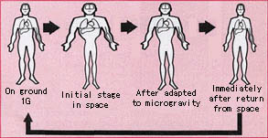

*Fluid shift in the human body*

Aurora, T. S. and C. Tabaresh. 1995. “Microgravity and the human body”. Physics Education Journal 30 (3): 143-150. Accessed November 29, 2015. <http://iopscience.iop.org/article/10.1088/0031-9120/30/3/004/meta>

Mark, Hans. 2003. “Cardiovascular System in Space”. In *Encyclopaedia of space science and technology,* 263-276. Hoboken: John Wiley & Sons.

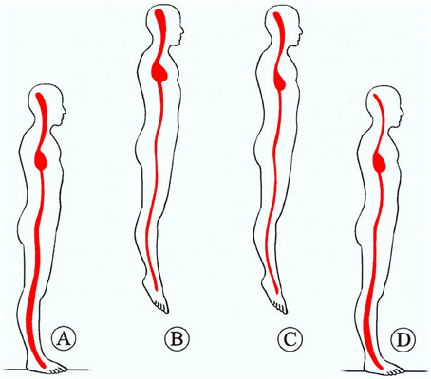

<http://journal.frontiersin.org/article/10.3389/fphys.2014.00054/full>

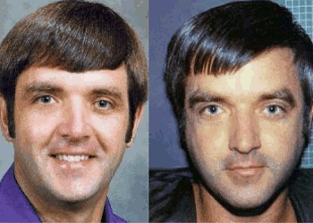

*Syndrome of “puffy head”*

[*http://www.wonderwhizkids.com/index.php/gravity*](http://www.wonderwhizkids.com/index.php/gravity)

*Spelke, Elizabeth S. 2005. “Sex Differences in Intrinsic Aptitude for Mathematics and Science?”American Psychological Association 60 (9): 950 –958. DOI: 10.1037/0003-066X.60.9.950*

Hartmann P., A. Ramseier , F. Gudat, MJ. Mihatsch, W. Polasek. 1994. Abstract. In “Normal weight of the brain in adults in relation to age, sex, body height and weight.” Pathologe. 15(3):165-70. <http://www.ncbi.nlm.nih.gov/pubmed/8072950>

Corinne A. Moss-Racusina, John F. Dovidiob , Victoria L. Brescollc , Mark J. Grahama,, and Jo Handelsmana. 2012. “Science faculty’s subtle gender biases favor male students.” Proceedings of the National Academy of Sciences of the United States of America 109 (41): 16474–16479. Accessed December 3, 2015. <http://www.pnas.org/content/109/41/16474.full.pdf>

Cummins, Denise. 2015. “Why the STEM gender gap is overblown?” Accessed December 1, 2015. <http://www.pbs.org/newshour/making-sense/truth-women-stem-careers/>

Hampshire, Adam, Roger R. Highfield, Beth L. Parkin, Adrian M. Owen. 2012. “Fractionating Human Intelligence”. Neuron 76 (6): 1225-1237. DOI:10.1016/j.neuron.2012.06.022

Jantz, Gregory.2014. "Brain Differences Between Genders." Psychology Today. February 27, 2014. Accessed December 6, 2015. <https://www.psychologytoday.com/blog/hope-relationships/201402/brain-differences-between-genders>.

Hartmann P., A. Ramseier , F. Gudat, MJ. Mihatsch, W. Polasek. 1994. Abstract. In “Normal weight of the brain in adults in relation to age, sex, body height and weight.” Pathologe. 15(3):165-70. <http://www.ncbi.nlm.nih.gov/pubmed/8072950>

Jensen, Lorenzo.2015. "13 Real Differences Between Male And Female Brains." Thought Catalog. June 24, 2015. Accessed December 6, 2015. <http://thoughtcatalog.com/lorenzo-jensen-iii/2015/06/13-real-differences-between-male-and-female-brains/>

NobelPrize.org. Accessed December 6, 2015. <http://www.nobelprize.org/>

Spencer, S.J., Steele, C.M., & Quinn, D.M. 1999. “Stereotype threat and women's math performance”. Journal of Experimental Social Psychology 35 (1) : 4-28. doi:10.1006/jesp.1998.1373

Thompson, James. 2013. “Are girls too normal? Sex differences in intelligence.” Accessed December 6, 2015. <http://drjamesthompson.blogspot.com/2013/09/are-girls-too-normal-sex-differences-in.html>

Zayed, Ahmed. 2014. “Does IQ Test Measure Intelligence?” Last Modified: November 26, 2014. <https://www.consumerhealthdigest.com/brain-health/does-iq-test-measure-intelligence.html>

Our tutor said that the ordinary PPT presentation would be boring and it is better to think about something more creative.

In contrast with other forms of transport, maglev trains emit no harmful substances during the operation and the noise level is significantly low. Because maglev trains are powered by electrical energy, they do not produce carbon dioxide and other chemicals as vehicles, which burn fossil fuels, do (Yaghoubi et al. 2011). Furthermore, taking into account the non-direct protection of the atmospheric quality as energy consumption for maglev is lower, which will be discussed in the next sections, pollutants generated by power plants are decreased noticeably (Wang and Wang 2010). Due to the absence of mechanical contact between the parts of maglev train, it does not produce engine noise or rolling noise and vibration, as in high-speed wheel-rail trains. The only source of noise can be from the friction between body of vehicle and air, known as aerodynamic noise, which can rise at high speeds. Nevertheless, maglev system operating at the speed of 300 km/h not louder in comparison with light rail vehicle, and at the higher speeds the level of noise is the same as in conventional trains moving at the much lower speeds (Yaghoubi et al. 2011). Maglev trains as clean and quite type of high-speed trains can significantly ease the burden on the environment.

**3. Maglev trains: how do they work?**

Before discussing the benefits and drawbacks of maglev technology it is necessary to understand how this system does work and the differences between conventional and maglev trains. Firstly, this part will describe three main parts of maglev trains, which provides its functionality, which are levitation, propulsion and guidance. Then it will be explained how the transfer of energy to vehicle occurs.

**Levitation**

Levitation is an ability of train to stay above the track not touching the guideway. In accordance to which type of magnets are used for maintaining the suspension there are generally two main types of levitation technology: electromagnetic suspension (EMS) and electrodynanic suspension (EDS). While the former uses the attraction force between electromagnets and a guideway, the latter maintains the levitation by the repulsive force (Lee et al. 2006). (Figure 1)

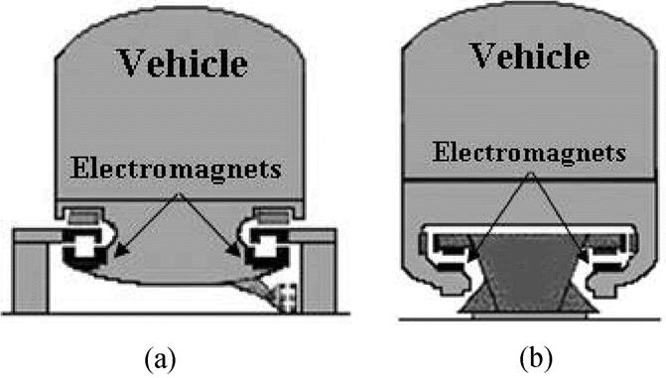 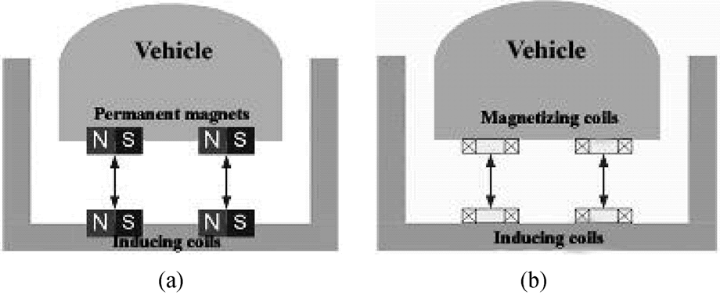

(a) (b)

Figure 1. Levitation. a) Electromagnetic suspension. (b) Electrodynamic suspension. Source: Lee et al. 2006.

Although EMS is technically easier to implement than EDS and can levitate in low or zero speeds, it is unstable, especially at high speeds, which requires a sophisticated control-feedback system in order to maintain small air gap approximately equal to 10mm. By contrast, in EDS system it is not necessary to precisely control air gap (about 100mm), which allows such trains to achieve high speeds. However, EDS needs sufficient speed to operate and it is also expensive to construct (Lee et al. 2006).

**Propulsion**

Propulsion is considered as creating the force, which moves the train forward along a track in a straight line. In maglev trains instead of conventional rotary motors linear motors are utilized, which can be represented as an unrolled version of rotary motor with stator, or primary (stationary part), rotor, or secondary (rotating part) and windings flattened and laid on the guideway (Figure 2). There are two types of linear motors used for maglev trains: Linear Induction Motor (LIM) and Linear Synchronous Motor (LSM). (Lee et al. 2006)

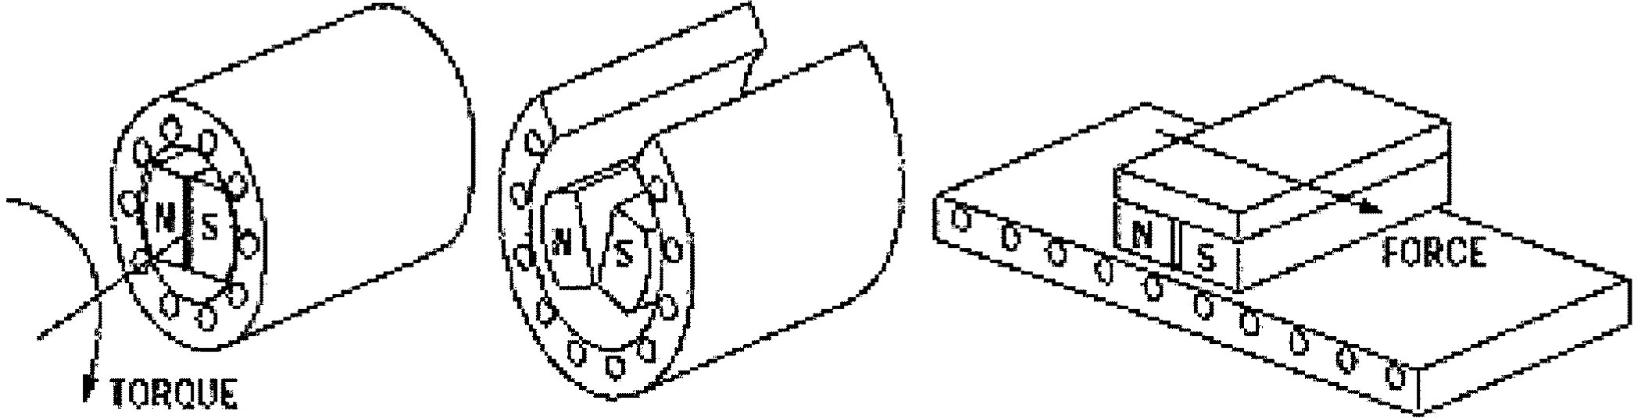

Figure 2. Linear motor derived from rotary motor. Source: Lee et al. 2006.

In normal rotary motor magnetic field generated by stator induce the electromotive force (EMF) in rotor, which cause spinning of axle. In LIM instead of inducing rotating force the EMF produced by primary piece create a linear force (Figure 3). However, in this type of motor moving magnetic field of secondary is slower than in stator, unlike in LSM, where the presence of permanent magnets in secondary part allows to turn in steps with the primary field. As a result, LSM is more efficient and powerful, though the reliability and controllability of two types of motor are similar. (Lee et al. 2006)

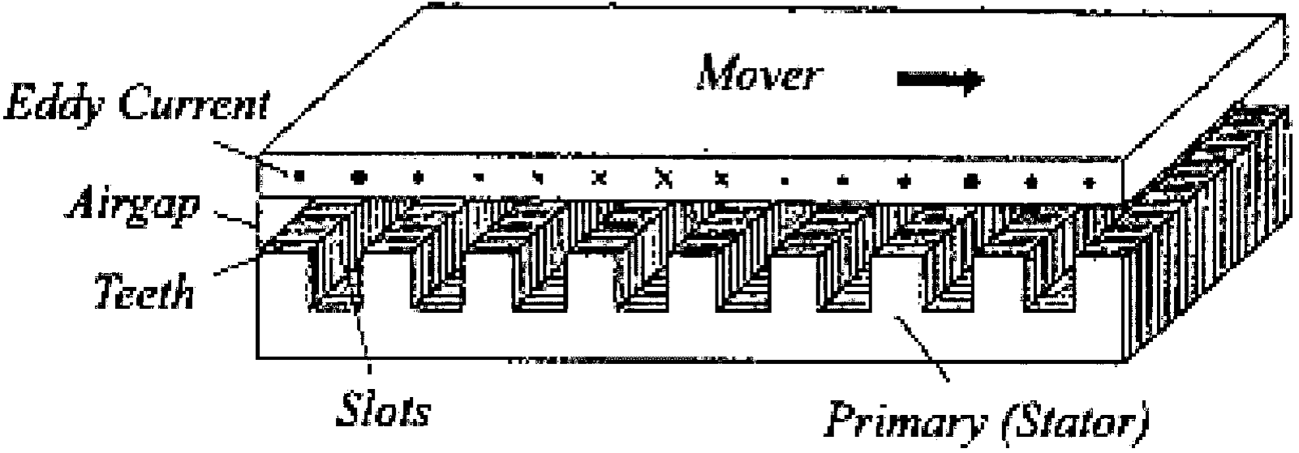 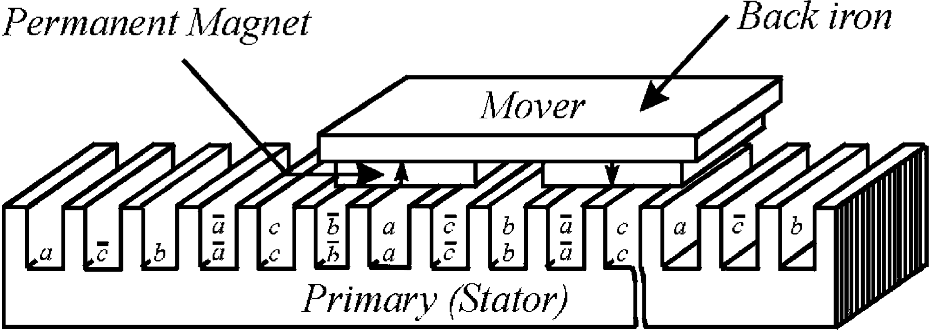

Figure 3. Linear induction motor. Figure 4. Linear synchronous motor.

Source: Lee et al. 2006. Source: Lee et al. 2006.

**Guidance**

Guidance is an essential part of maglev trains the main purpose of which is to locate the vehicle exactly at the centre of the guideway. For high-speed trains repulsive magnetic force is used as for example in Transrapid system (Figure 5) where the interaction between electromagnets fixed in both sides of vehicle and guideway prevents lateral displacement of the train.

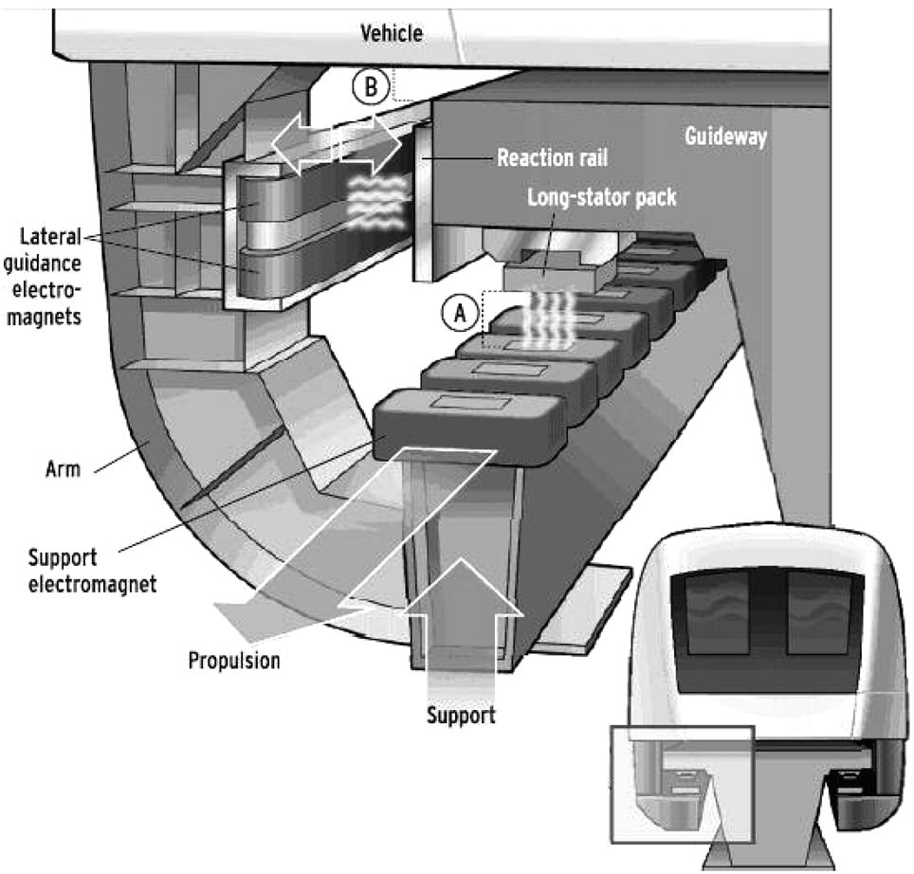

Fig. 5. Guidance in Transrapid.

**Transfer of energy to Vehicle**

Before discussing the benefits and drawbacks of maglev technology, it is necessary to understand how this system does work and the differences between conventional and maglev trains.

<https://afisha.mail.ru/cinema/selection/676_ot_temnogo_ritsarya_do_leviafana_100_luchshih_filmov_xxi_veka/?from=mr_news>

<https://jsfiddle.net/pke614ab/5/>

<http://informatics.mccme.ru/>

<https://ideone.com/kSwq5H>

<https://www.wes.org/wes-tools/>

<http://larrr.com/category/google/>

<http://larrr.com/pora-nachinat-gotovitsya-k-podache-na-letnyuyu-stazhirovku/>

<http://www.cc.chu.edu.tw/~changc/course/share/database/company-oracle/ch8-queries.sql>

<http://osxh.ru/content/webserver_os_x>

<https://codewithawa.com/posts/complete-user-registration-system-using-php-and-mysql-database>

<https://codewithawa.com/posts/to-do-list-application-using-php-and-mysql-database>

<https://www.youtube.com/watch?v=C--mu07uhQw&t=25s>

<http://www.leapsummit.com/>

<http://codeforces.com/gym/100092/my>

<http://www.intern.supply/>

Probably this sounds silly, but several years ago I red one manga about a hacker who use his abilities to help people. Then I had a strong desire to become like him.

Apart from this I think our generation was a witness of the rapid development of computer technologies. I remember the times when the first cell phones appear and when the Internet was something exotic. Thinking about this I want to understand how our devices work and how human invented a computer. Cybersecurity is also what I want to study in order to prevent bad hackers for wrong purposes.

<https://www.simplyhired.com/search?q=computer+science+internship&l=new+york%2C+ny&job=mmQJ272Nou8erL10Lj7vzFTDcvCKfc3q5CCFV04uyPDdd1nGHq4HsA>

http://slideplayer.com/slide/3313017/