# Personal profile

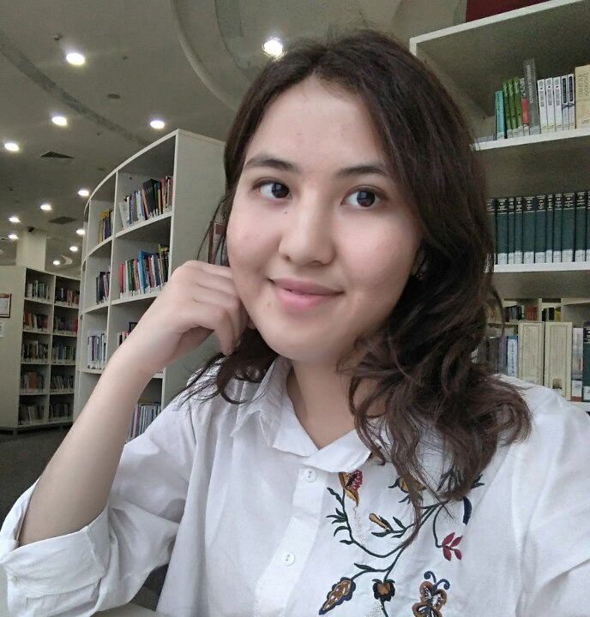

## Nickname:

Jenny

## Born:

March 8th, 1997

## Hometown:

Pavlodar, Kazakhstan

## University/Faculty:

Nazarbayev University in Astana, Economics

## Hobbies and interests:

Dancing, playing volleyball and debating, especially I would be glad to see performances such as dance competitions and concerts. I really love nature and discovering new places. I am also keen on reading diverse books.

My part-time job in Kazakhstan is tutoring high school students to take IELTS and SAT exams because I want to share my knowledge with the growing generation.

I am particularly enthusiastic about working with educational tools because I find them very useful. It is one way of sharing with knowledge.

I want to become a role model for my younger sister by overcoming this huge challenge. Moreover, I truly need to assist my parents financially and become financially independent.

## Favorite thing you like about SW:

I am sure that I will experience personal growth, develop problem-solving skills, and attain a long-lasting positive attitude. These are the qualities I need in order to have my own business and other assets. Moreover, I will have a chance to change the world into a better place through education.

## Biggest achievement in life:

I won a gold medal in the Republic English Language Olympiad and received 8.0 overall for IELTS. Then, for me winning the international debate tournament in Astana was one of the greatest achievements in my life.

## Favorite quote:

“If not us, then who?

If not now, then when?”

## Favorite bands/musicians:

## One Republic, Shakira, Kazakh musicians, Nicole Sherzinger, Dua Lipa and Aikyn.

## Favorite movies:

Three Idiots, Wonder Woman, Titanic, Kazakh comedy films such “Wedding for three”, Harry Potter.

## Favorite series/sitcoms:

Sherlock.

## Favorite TV shows:

Leader of XXI century, “The most intelligent”, “What?, Where? And When?”

## Favorite actors and actresses:

Leonardo DiCaprio, Anne Hathaway.

## Favorite sportsmen:

Yevgenia Medvedeva

## Favorite books:

Martin Iden by Jack London, Harry Potter by J.K. Rowling, Sherlock Holmes by Arthur Conan Doyle, The Master and Margarita by Mikhail Bulgakov.

## Countries travelled:

Kazakhstan