Explanation by differing use of the answer scale across countries

In the previous sections we investigated different explanations for differences in the estimated quality of questions across countries. It was found that in three countries the low quality was an artifact of a difference in the time between the repetitions necessary for the estimation of the question's reliabilities. [complexity didn't matter but translation might].

Differences in understanding: the translation of the questionnaire

[talk about translation and Portugal: if the translation is substantially different, a different question is asked and it can't be said whether the differences are due to the question or the country. In the case of Portugal, the same method is not properly varied and the high quality coefficients are artifacts.]

Differences in the way of answering: use of the scale

experiment women: scale was varied. this provides an opportunity to study the use of the answer scale and agree-disagree versus direct categories.

We selected three countries for which the quality coefficients differed a lot in this experiment: in the Czech Republic and Estonia they were low, while in Greece the highest coefficients were found. In order to test whether these differences were statistically significant a test was done using the unstandardized coefficients. (now trying it with 6 countries and unequal covariances).

So far we assumed that all the observed variables were continuous. In this experiment, however, it is more realistic to assume that they are ordered categories. A continuous scale underlies these categories, and each category is chosen by the respondent with a probability that depends on this scale. If these probabilities are very close to each other for different values of the latent trait, the categories are not distinguished well from one another. On the contrary, certain ranges of the traits might relate strongly with one category and not the others. Then the answers falling in this category are a good measurement of the corresponding range of the trait. An answer scale provides a good measurement of a continuous trait as a whole if such a category exists for all often occurring ranges of the trait.

If the questions mean the same thing – that is, if the translations are comparable – then differences can still occur. Not because of a different understanding of the question, but due to differences in the way of choosing a category given the score on the latent trait. For example, people from the Czech Republic might be more polite than others and therefore more inclined to answer “agree” to a question in spite of a negative opinion. In that case the observed answers on the agree-disagree scale will be of lower quality than in other countries because the categories do not distinguish as well between different opinions. We will later show that something like this seems to have occurred.

The ordered categorical MTMM model can be estimated by specifying that the categories' underlying scales are related to latent traits and methods in the same way as continuous observed variables are in a continuous MTMM model. The probabilities of falling in a certain category of one of the nine observed variables can be estimated by specifying thresholds which must be exceeded on the underlying scale before the next category is chosen. The probabilities are then modeled as the log of odds and (arbitrarily) logistically or normally distributed errors (Scott Long 1997: 114-147). We specified normally distributed errors which yield an ordered probit model for each underlying scale. Each scale is then modeled as part of a multitrait-multimethod experiment in the fashion described earlier for continuous variables.
The different parameters were estimated using the EM algorithm for full-information maximum likelihood. Both the planned missing data of the split ballot design and unplanned item-missing data were included as part of the model under the assumption that the unplanned missing data were missing at random given the nine observed variables in the experiment and country. The standard errors were obtained using a sandwich estimator which yields asymptotically correct variances using the ESS design weights even for non-normal and non-independent data (Asparouhov 2005; Satorra ....).

Figure 3: Stem and leaf plot of the power of the chi-square test based on the modification index to detect a misspecified threshold of at least 0.10. Plotting the first two digits after the decimal point reveals that the power is relatively low in most cases.

0.
0 | 99999
1 | 0001122223457789
2 | 00000111222224444466778
3 | 356666789999
4 | 001234568
5 | 111233445689
6 | 14
7 | 7

Value 642.929*
Degrees of Freedom 47**
P-Value 0.0000

Value 306.130*
Degrees of Freedom 13**
P-Value 0.0000

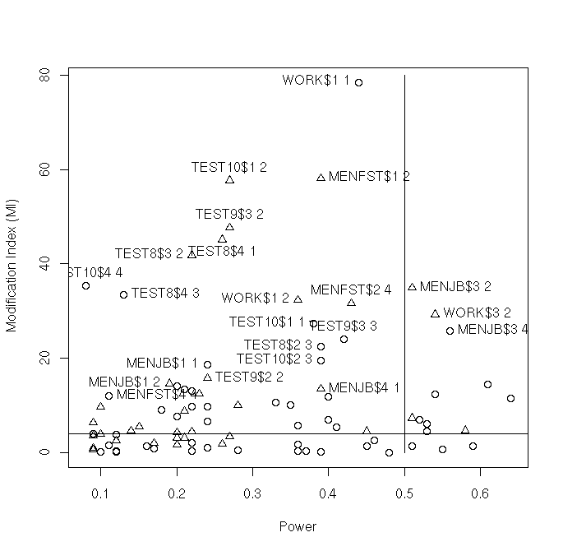
M1 Agree – Disagree: Czech Republic and Estonia answer “agree” until 1 standard deviation above the mean while even disagree is rare. In Greece the division across the range of the scale is more distinguished, and a higher quality can be expected. However, the extremes still do not come into play and quite a few errors are made. If this model holds, the observed scores for Czech Republic and Estonia can not be compared with those of Greece, since a different answering strategy is used.

CZ | 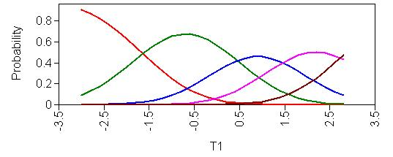
EE | 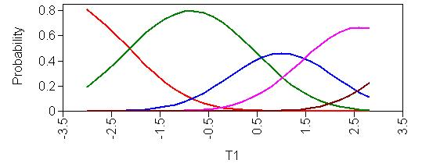
GR | 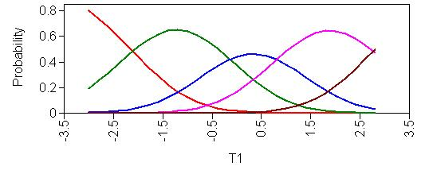

M3: Same item, direct question. All three countries show a similar answer pattern. The middle three categories are more clearly distinguished from one another.

CZ | 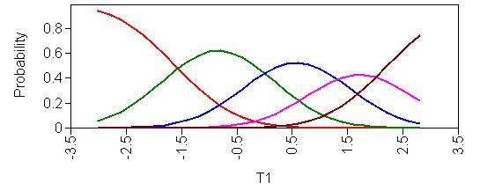
EE | 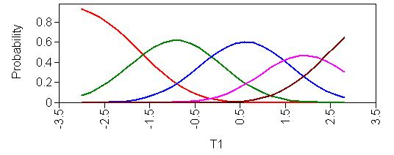
GR | 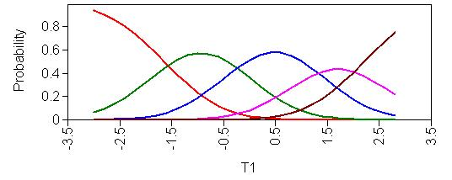
References

Asparouhov, T. (2005). Sampling weights in latent variable modeling. Structural Equation Modeling, 12, 411-434.

