HW9: Individual Effort Report
Server Design
I. Overview of Major Components and Packages
1. Server.java (Servlet)
- Handles HTTP requests (GET/POST).
- Interacts with the MySQL database.
- Publishes review events to RabbitMQ for asynchronous processing.
2. AlbumInfo.java
- Model class representing album metadata.
- Used as a data transfer object (DTO) for serializing/deserializing album data (via Gson).
3. ReviewConsumer.java
- Consumes messages from RabbitMQ (likeQueue).
- Parses and stores user reviews into the MySQL album_reviews table.
II. Data Flow and Relationships
1. Album Upload
- Stores the album into the albums table in MySQL.
- Returns AlbumInfo as a JSON response.
2. Review Upload
- Publishes it to RabbitMQ queue likeQueue.
3. Review Consumption (RabbitMQ Consumer)
- On message receive, inserts or updates the review in the MySQL album_reviews table.
4. Review Get
- Get random album review stats in JSON

III. Server on AWS
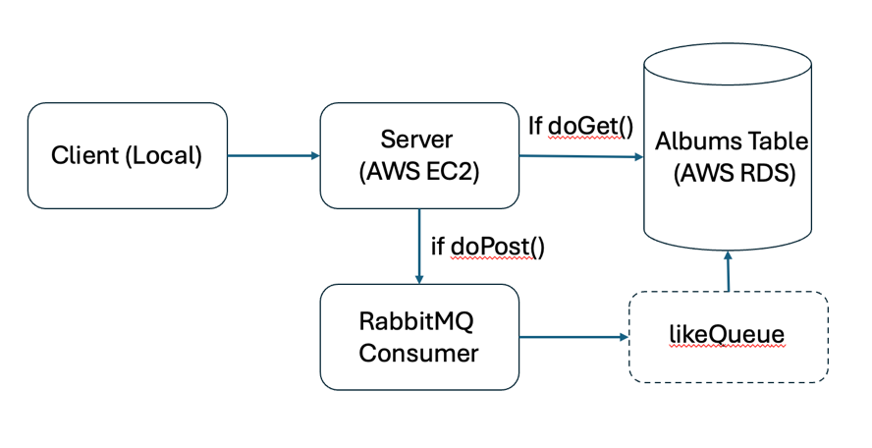
(Note: RabbitMQ runs locally via an SSH channel directing messages)

Results (locally)
The throughput has been steadily kept at around 2000 in each experiment, except it jumped to around 3000 in 10 10 2, meaning that the system may have some room to grow, it could be due to queued tasks can be fed more consistently or more parallelism fills in idle CPU/network gaps, or simple the network behaves better at that time. The sure thing right now is that the system may still have room for handling more threads.
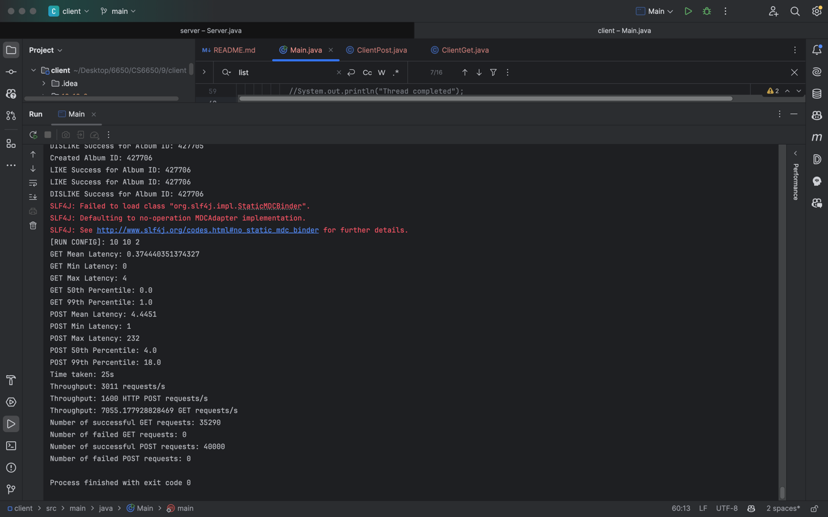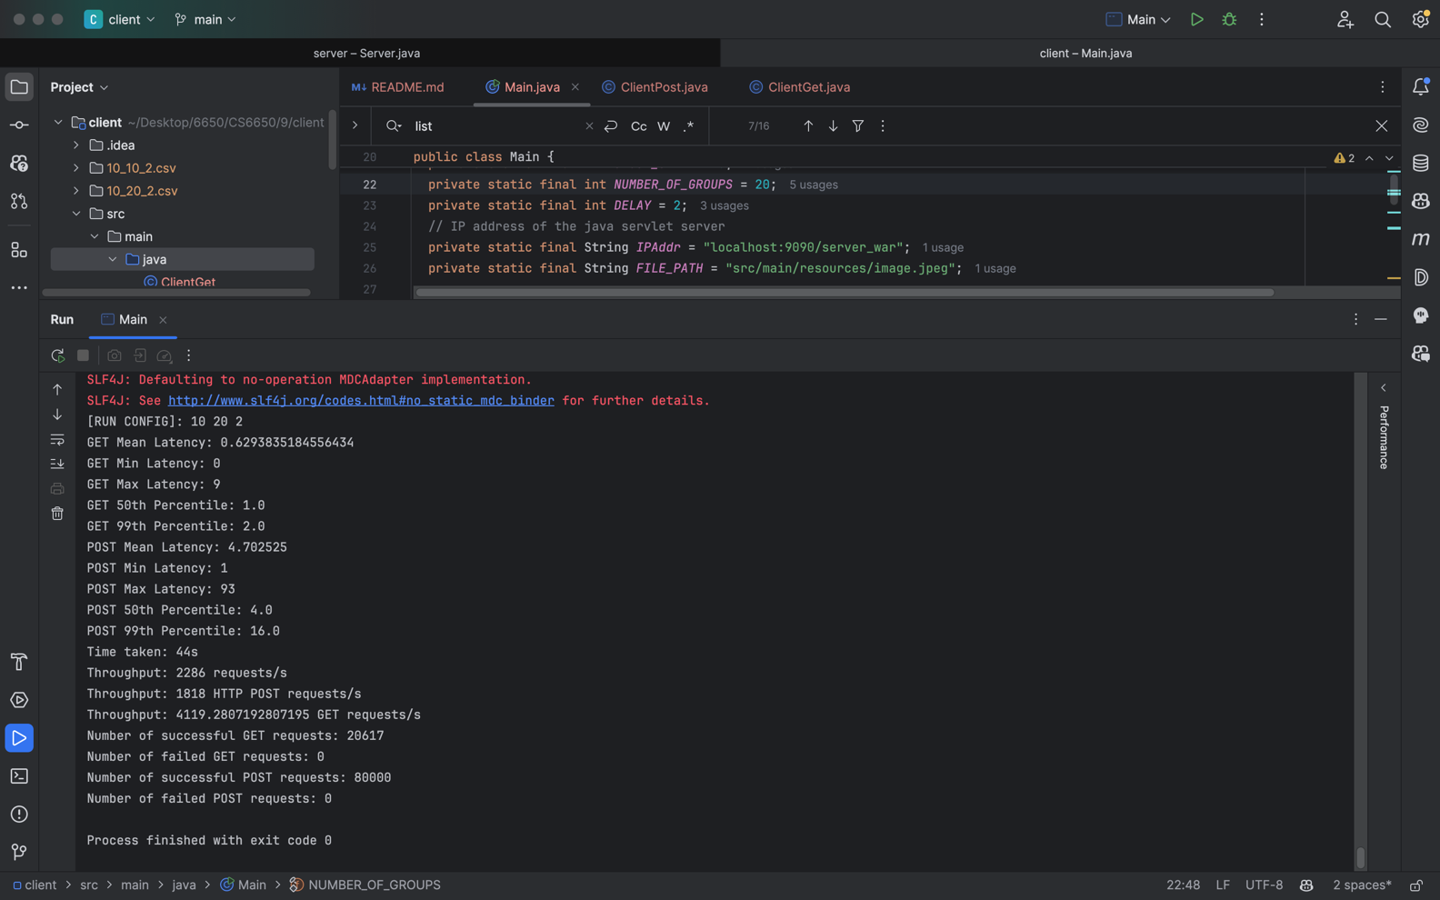

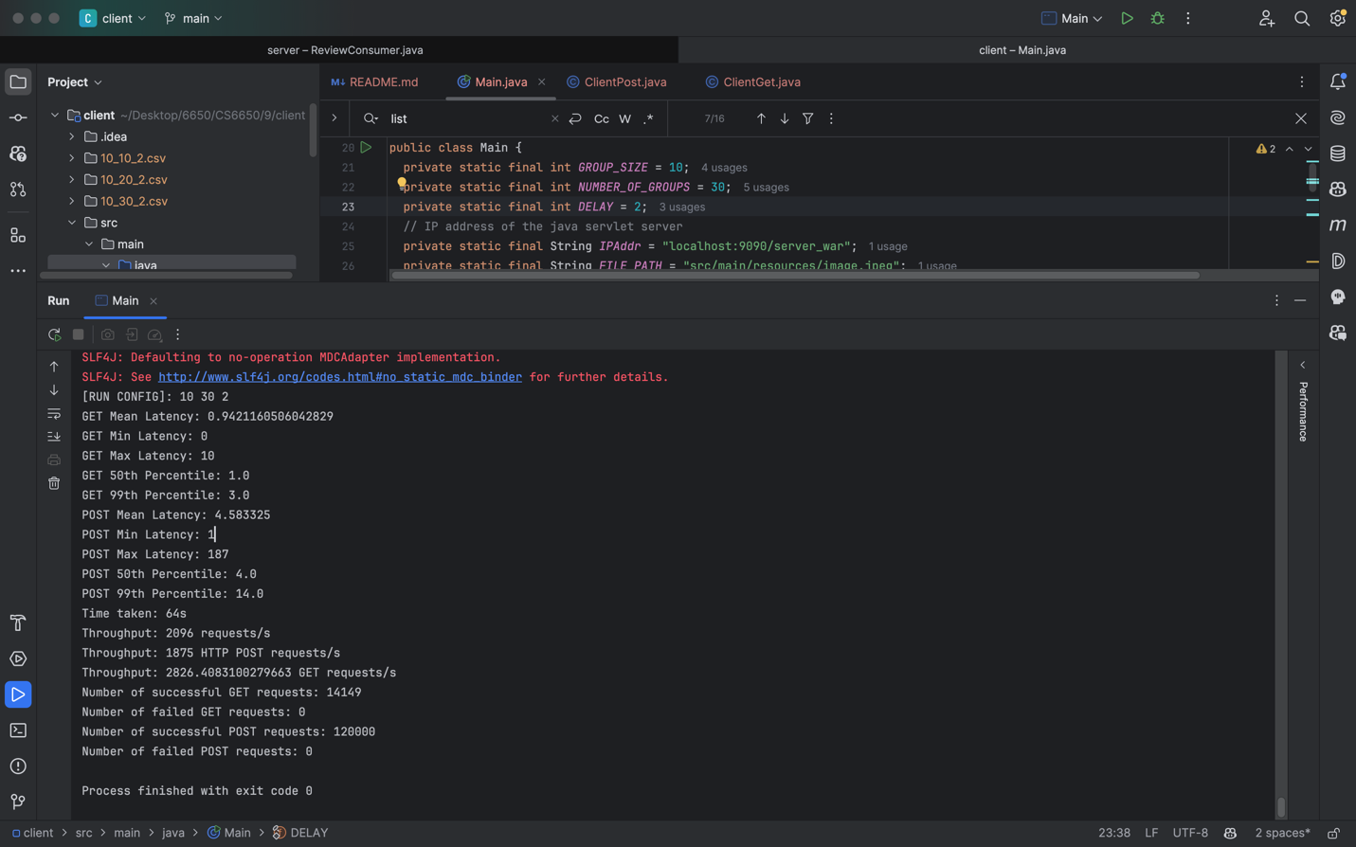

However, RabbitMQ queue sizes increased significantly. Before implementing the 3 getReview threads, the max size was 75. Right now the queue size easily reached 2000, and max at around 7500 in 10302.
Possible reasons maybe that before adding the threads, we had only POST threads creating albums and immediately queuing album IDs so that each post thread finished fast and the album ID queue (albumIds) grew slowly and stopped growing once POST threads finished. After adding the threads, all albums created during POST are already queued by then. And the get review threads Continuously read album IDs without removing them from the queue and do not consume(resume) IDs, and allow the queue to grow indefinitely.

RabbitMQ statistics for 10 10 2:
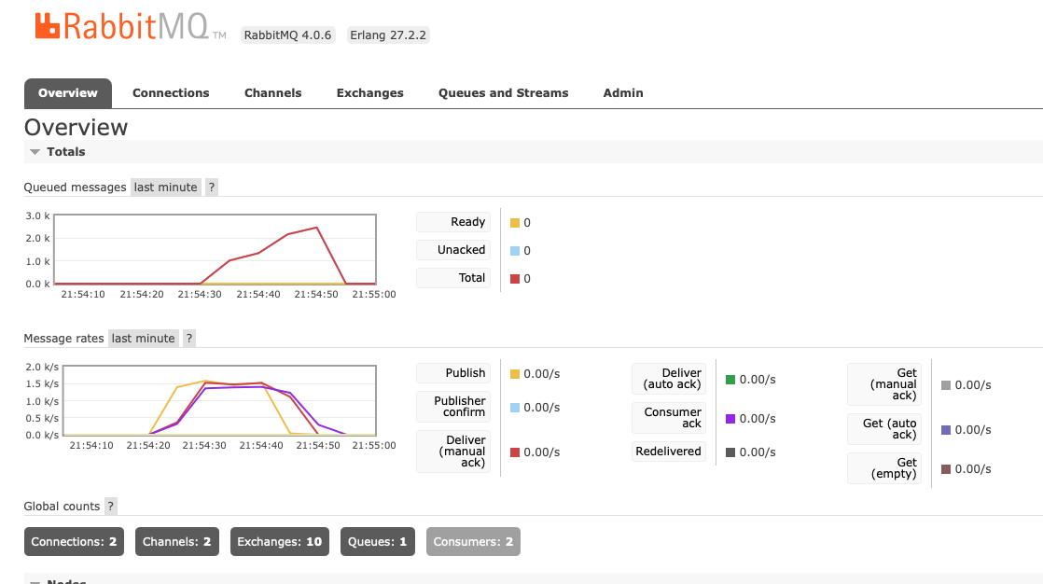
RabbitMQ statistics for 10 20 2:
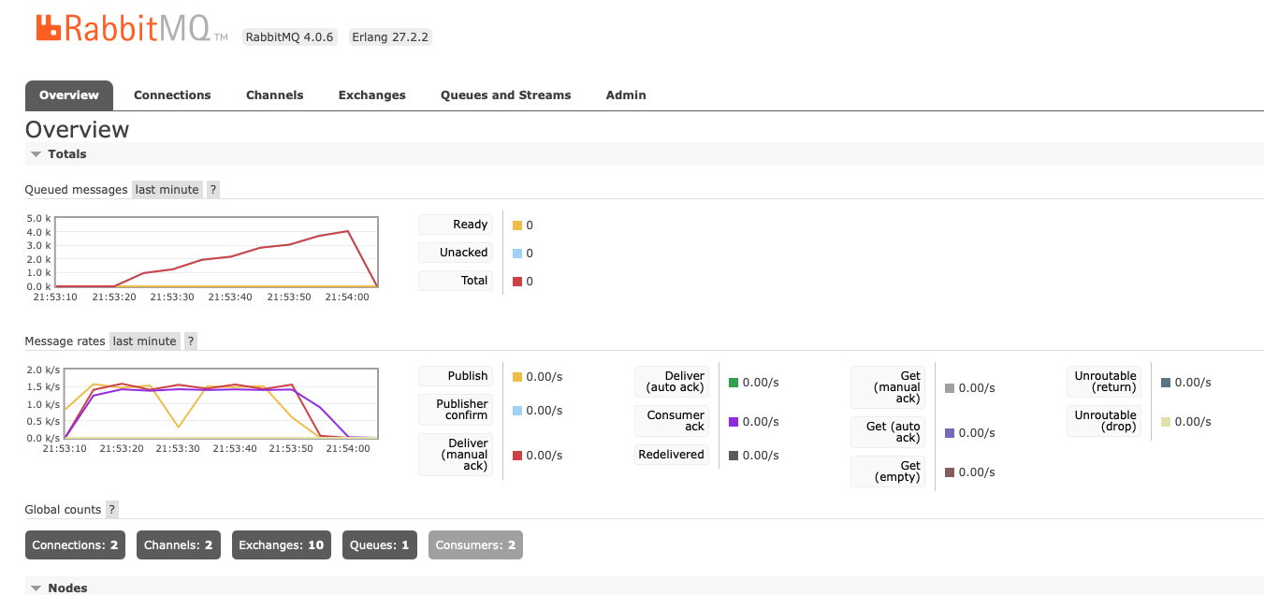
RabbitMQ statistics for 10 30 2:
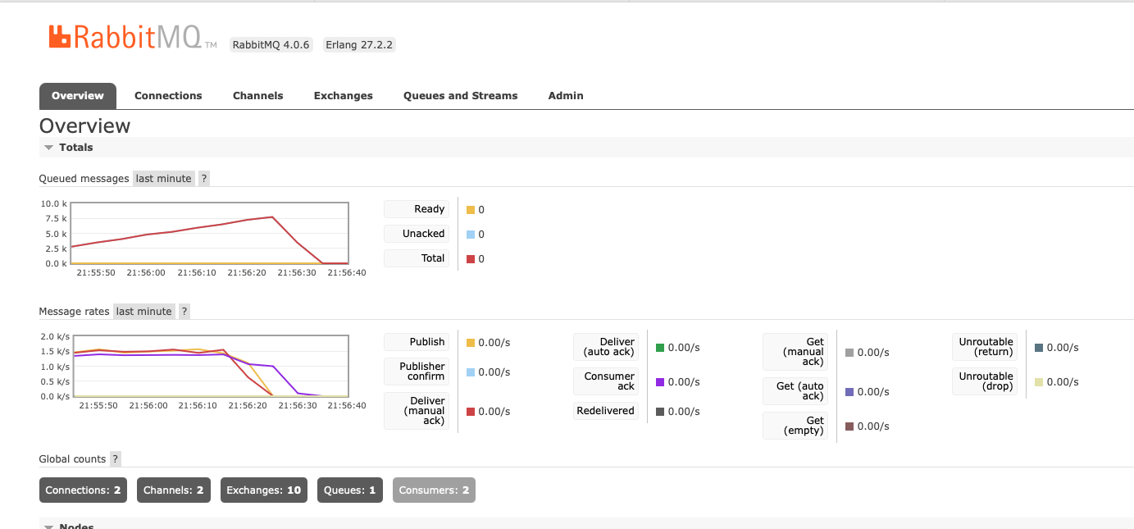

Results (AWS EC2)
The throughput has been steadily kept at around 2000 in each experiment, except it jumped to around 3000 in 10 10 2, meaning that the system may have some room to grow, it could be due to queued tasks can be fed more consistently or more parallelism fills in idle CPU/network gaps, or simple the network behaves better at that time. The sure thing right now is that the system may still have room for handling more threads.
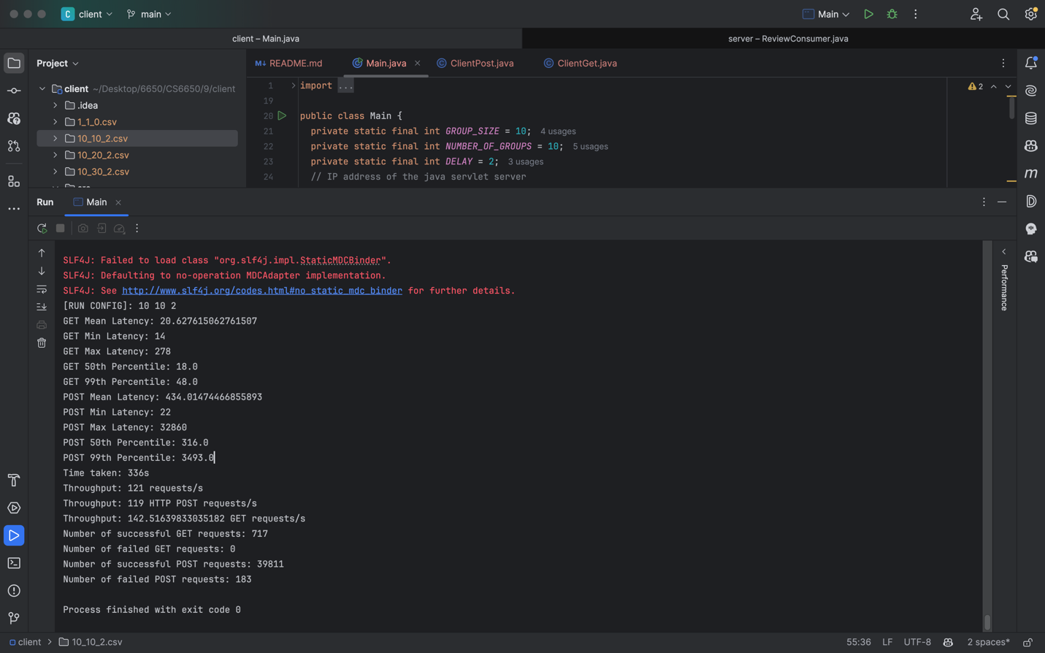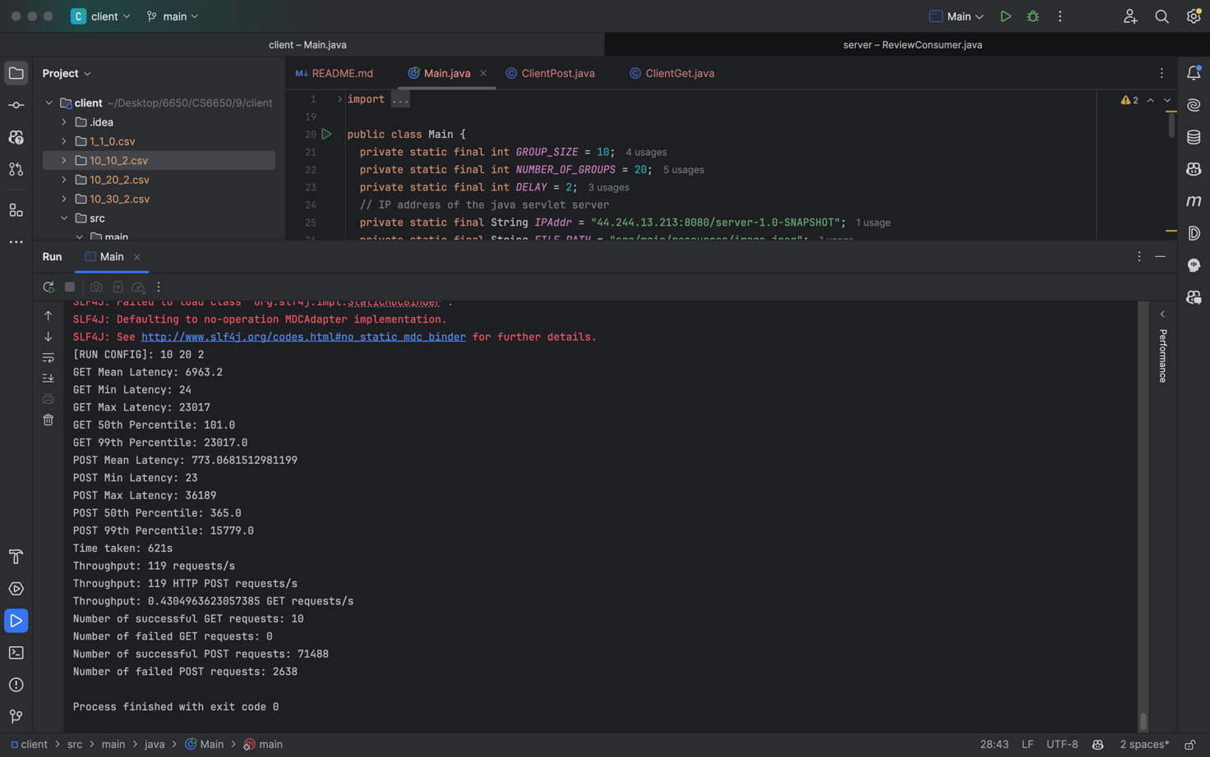

However, RabbitMQ queue sizes increased significantly. Before implementing the 3 getReview threads, the max size was 75. Right now the queue size easily reached 2000, and max at around 7500 in 10302.
Possible reasons maybe that before adding the threads, we had only POST threads creating albums and immediately queuing album IDs so that each post thread finished fast and the album ID queue (albumIds) grew slowly and stopped growing once POST threads finished. After adding the threads, all albums created during POST are already queued by then. And the get review threads Continuously read album IDs without removing them from the queue and do not consume(resume) IDs, and allow the queue to grow indefinitely.

RabbitMQ statistics for 10 10 2:
RabbitMQ statistics for 10 20 2:
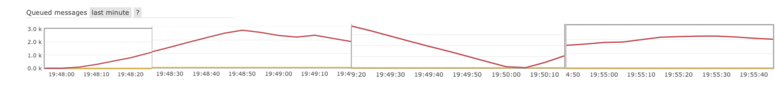
RabbitMQ statistics for 10 30 2:

