HW8: Individual Effort Report
Server Design
I. Overview of Major Components and Packages
1. Server.java (Servlet)
- Handles HTTP requests (GET/POST).
- Interacts with the MySQL database.
- Publishes review events to RabbitMQ for asynchronous processing.
2. AlbumInfo.java
- Model class representing album metadata.
- Used as a data transfer object (DTO) for serializing/deserializing album data (via Gson).
3. ReviewConsumer.java
- Consumes messages from RabbitMQ (likeQueue).
- Parses and stores user reviews into the MySQL album_reviews table.
II. Data Flow and Relationships
1. Album Upload
- Stores the album into the albums table in MySQL.
- Returns AlbumInfo as a JSON response.
2. Review Upload
- Publishes it to RabbitMQ queue likeQueue.
3. Review Consumption (RabbitMQ Consumer)
- On message receive, inserts or updates the review in the MySQL album_reviews table.

Results
The throughput has been steadily kept at around 2000 in each experiment, except it jumped to around 2500 in 30 30 2, meaning that the system may have some room to grow, it could be due to queued tasks can be fed more consistently or more parallelism fills in idle CPU/network gaps, or simple the network behaves better at that time. The sure thing right now is that the system may still have room for handling more threads.
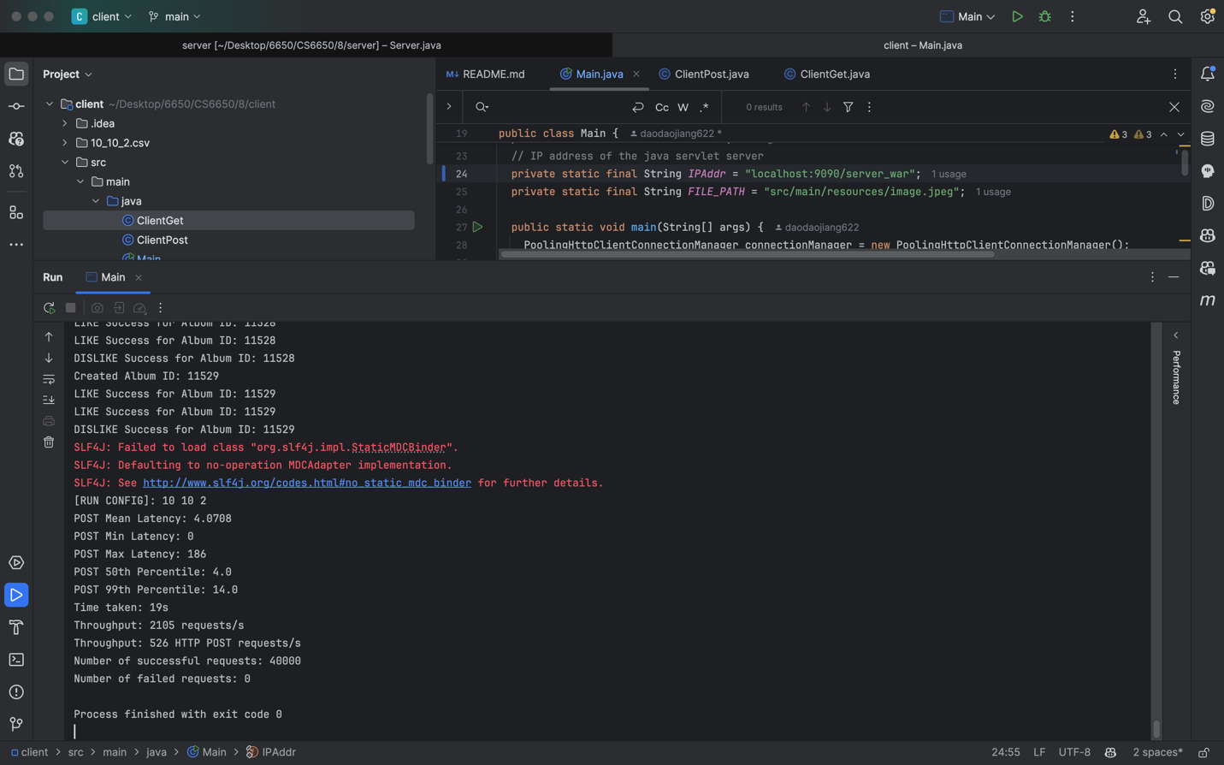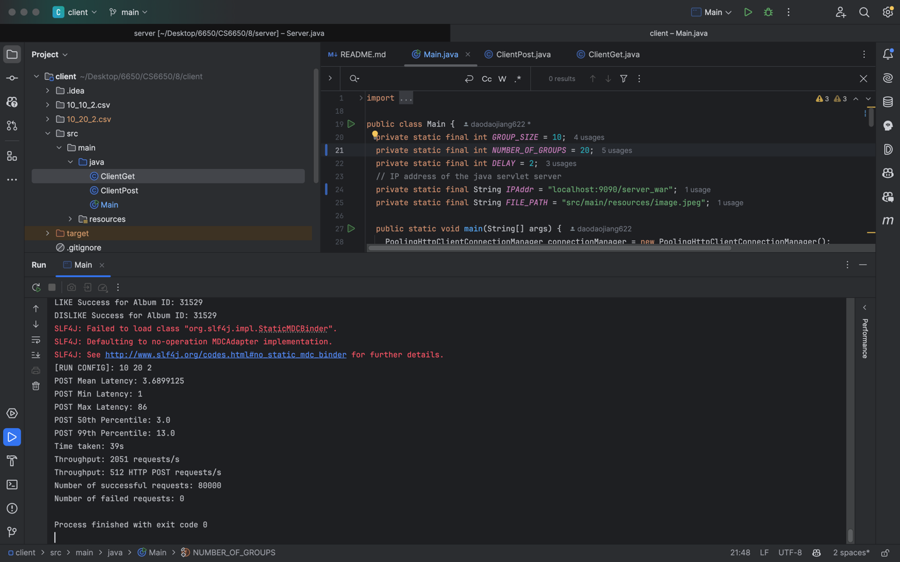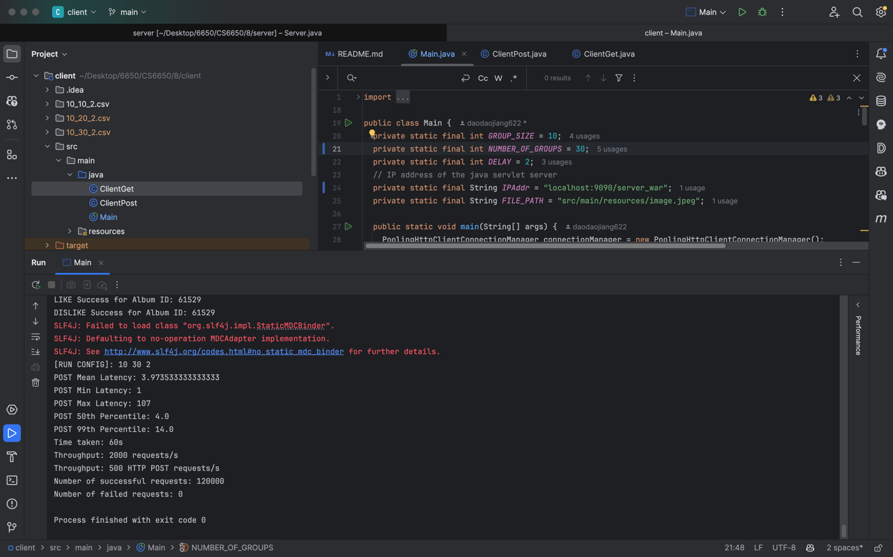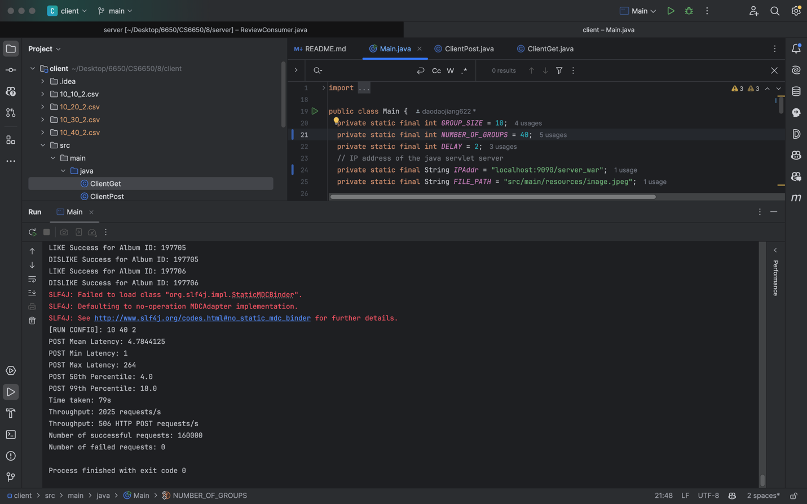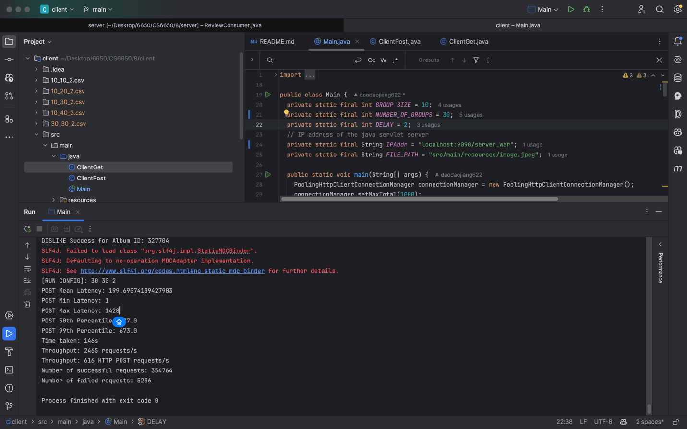
Queue sizes for 10 10 2, 10 20 2, and 10 30 2 never near 1000, indicating the current implementation of consumer is efficient enough to handle the threads. However, we can see it reaches 10k for 30 30 2, suggesting a need to a need to scale the consumer horizontally. The shapes of queue size have some plateau but are more closely resembles to pointy shape, also suggesting a need to scale horizontally.
RabbitMQ statistics for 10 10 2:
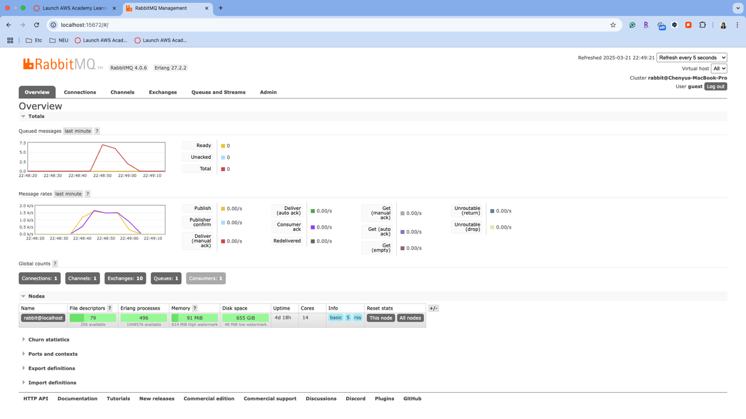
RabbitMQ statistics for 10 20 2: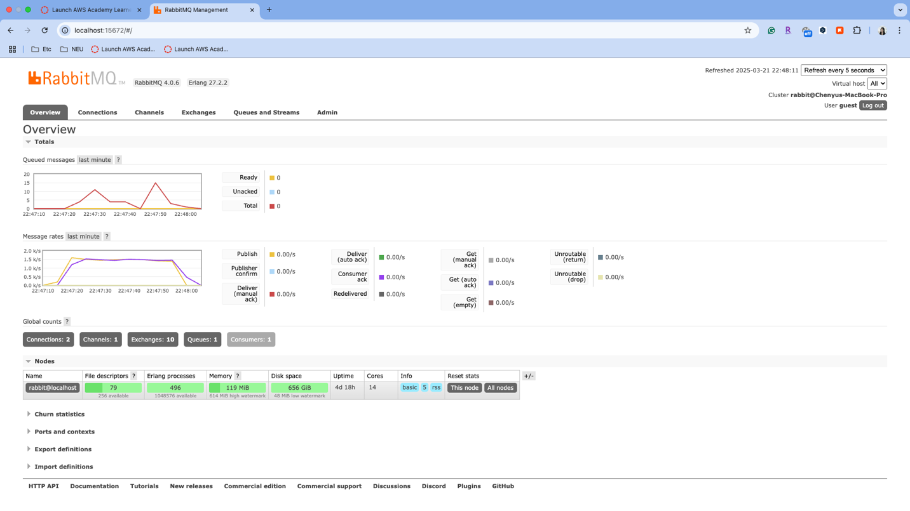 RabbitMQ statistics for 10 30 2: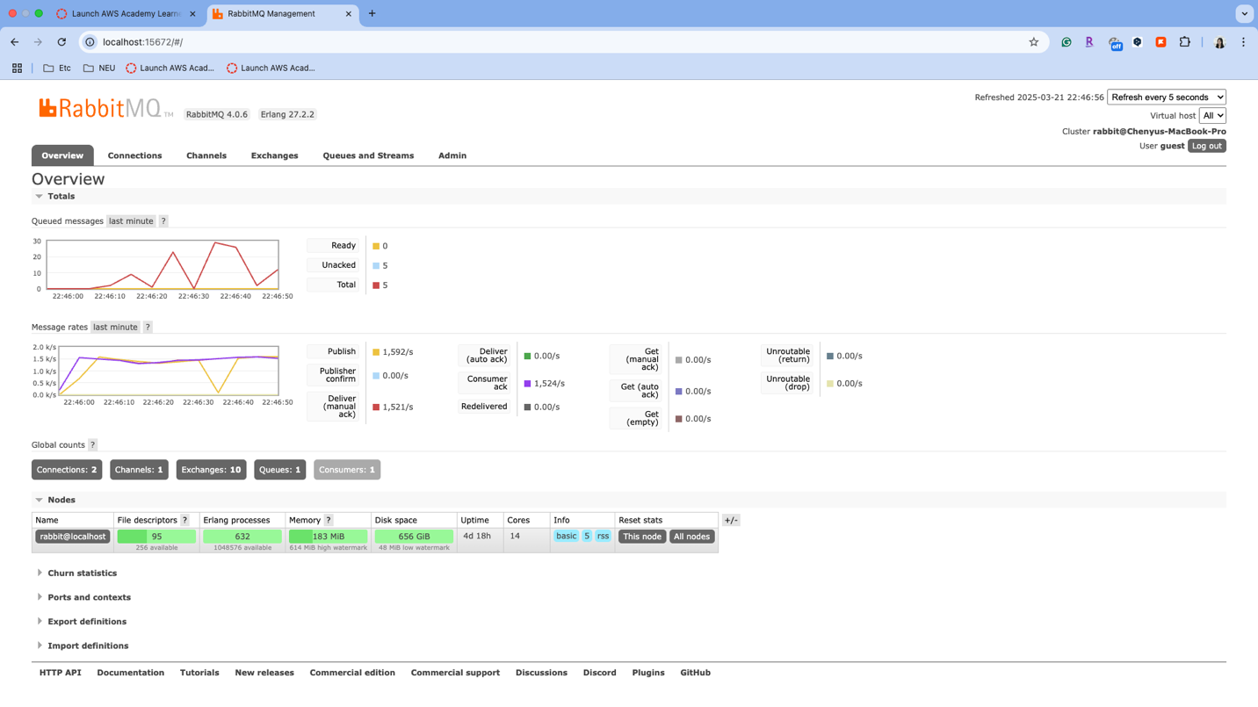
RabbitMQ statistics for 30 30 2: