Screen Specification
AIMS Software |  | Date of creation | Approved by | Reviewed by | Person in charge
Screen specification | Delivery form screen | 26/10/2021 |  |  | Dao Duc Manh
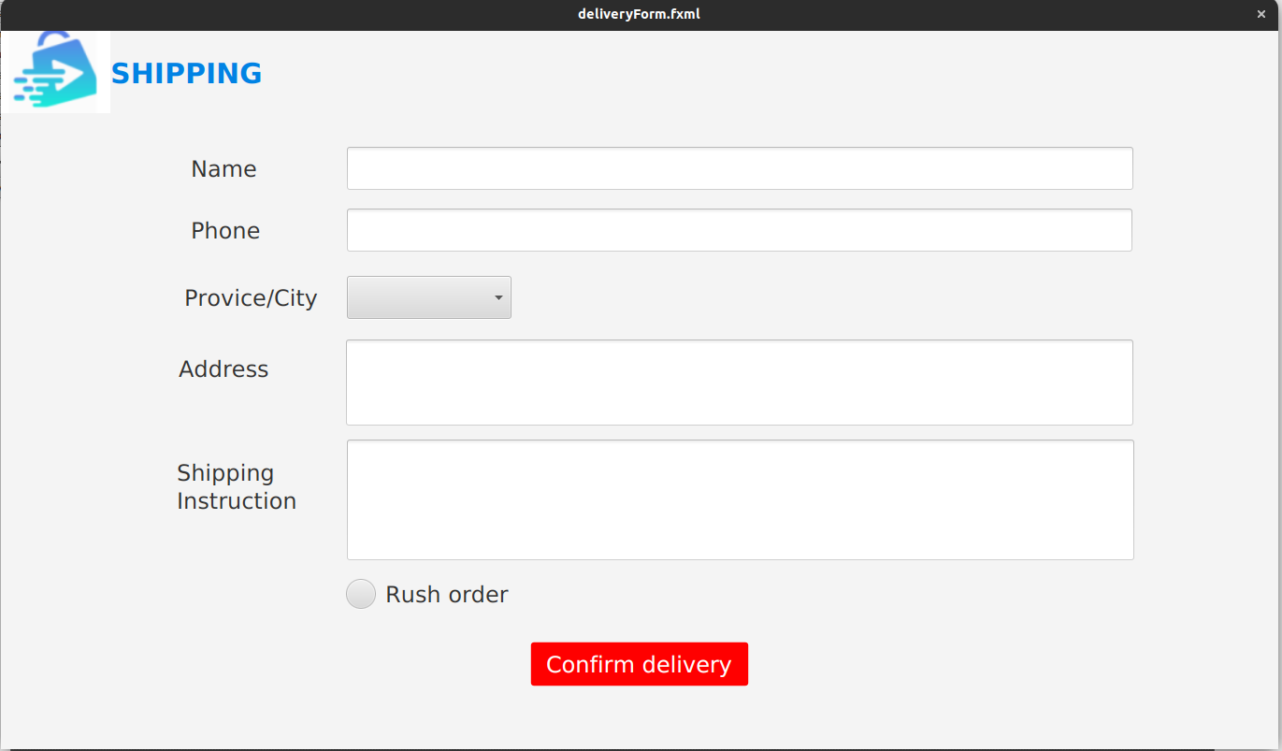 |  | Control | Operation | Function
 |  | Area for gathering delivery information | Initial | Getting customer’s information for delivery
 |  | Rush order radio button | Click for select | Selection for placing rush order or not
 |  | Confirm delivery button | Click | Confirm to place order
Defining the field attributes
Screen name | View cart
Item name | Number if digits(bytes) | Type | Field attribute | Remarks
Name | 50 | Text | Black | Left-justified
Phone | 30 | Text | Black | Left-justified
Province/City | 50 | Text | Black | Left-justified
Address | 100 | Text | Black | Left-justified
Shipping Instruction | 150 | Text | Black | Left-justified

