Screen Specification
AIMS Software |  | Date of creation | Approved by | Reviewed by | Person in charge
Screen specification | Rush order screen | 26/10/2021 |  |  | Dao Duc Manh
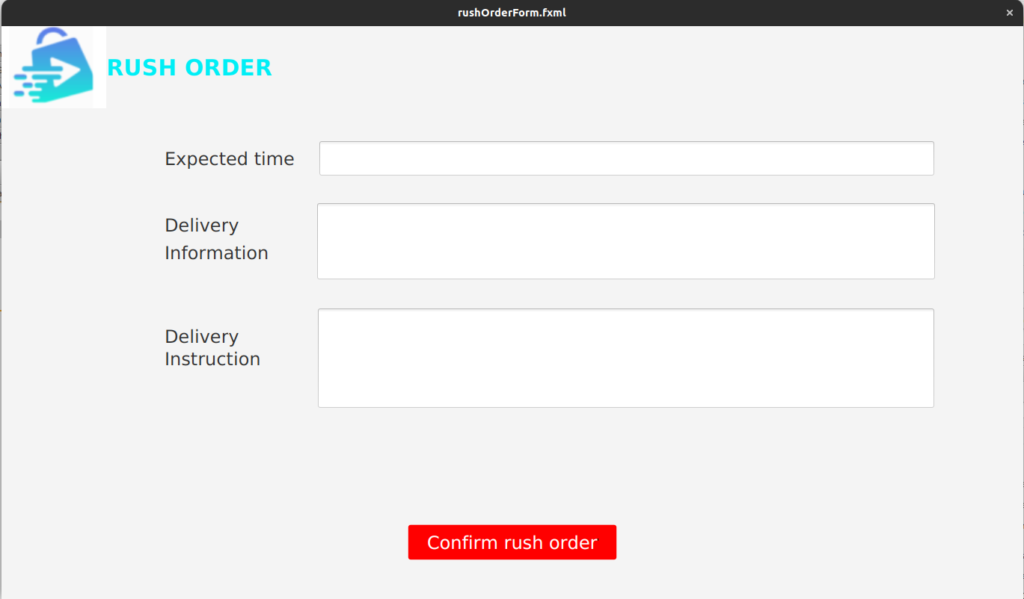 |  | Control | Operation | Function
 |  | Area for gathering delivery information of rush order | Initial | Getting customer’s information for rush order
 |  | Confirm rush order button | Click | Confirm to place rush order

Defining the field of attributes
Screen name | Rush order
Item name | Number of digits(bytes) | Type | Field attribute | Remarks
Expected time | 50 | Numeral | Black | Left-justified
Price | 100 | Text | Black | Left-justified
Subtotal | 150 | Text | Black | Left-justified

