Screen specification
AIMS Software |  | Date of creation | Approved by | Reviewed by | Person in charge
Screen specification | View cart screen | 26/10/2021 |  |  | Dao Duc Manh
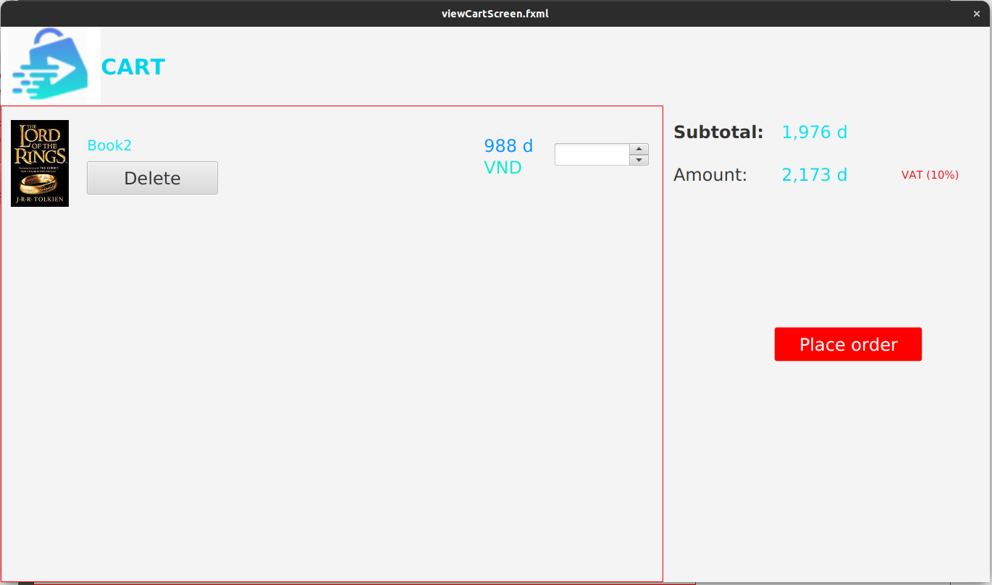 |  | Control | Operation | Function
 |  | Area for displaying the subtotal | Initial | Display the subtotal
 |  | Area for display items in the cart | Initial | Display the media with the corresponding information
 |  | Place order button | Click | Display the Delivery form
 |  | Delete button | Click | Remove the item from the cart

Defining the field of attributes
Screen name | View cart
Item name | Number of digits(bytes) | Type | Field attribute | Remarks
Media title | 50 | Numeral | Blue | Left-justified
Price | 20 | Numeral | Blue | Right-justified
Subtotal | 20 | Numeral | Blue | Left-justified

