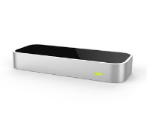

A .Change background sound

D.Musical Notes

B.Movements coordinates

D.Musical Notes

C.MultiPlay requests/responses

**Sound**

**Play**

**Agent**

**User**

**Agent** <GuiAgent>

**Move**

**ToSound**

**Agent**

**Multi**

**Play**

**Agent**

**User**

**Agent** <GuiAgent>