Air Quality Project
My solution for air quality project consists of 5 phases:

Loading and cleaning data
For loading data I am using a read.csv function which loads the data from csv and creates a data frame. Next, I'm removing a NA records and replacing not available data on analogue data from few days before, or if it isn't set, on few days after. For this purposes I am created the function get.FillValueForTimeSeries(PM10), which available in helper.R file.
Also I perform a feature scale because range of values NO, NO2.. is in about [0; 700] and for values of WSPD in about [0;10]

Clusterisation
Next step in my work is clusterization. I am using a k-means algorithm, which divide the data into 4 groups that means a “Very High”, “High”, “Medium” or “Low” air quality.

Forecasting a future data based on regression model.
For prediction a continous values I am used a ARIMA model, which decomposes the data into season, trend and white noise and fits a model.

My weekly-period data looks as:
1) NO:
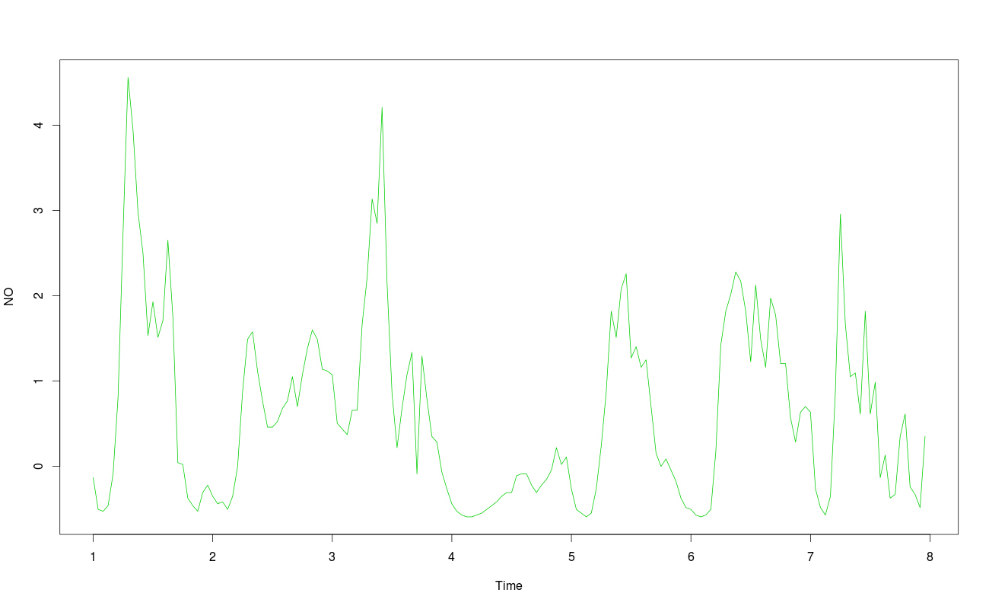
2) NO2:
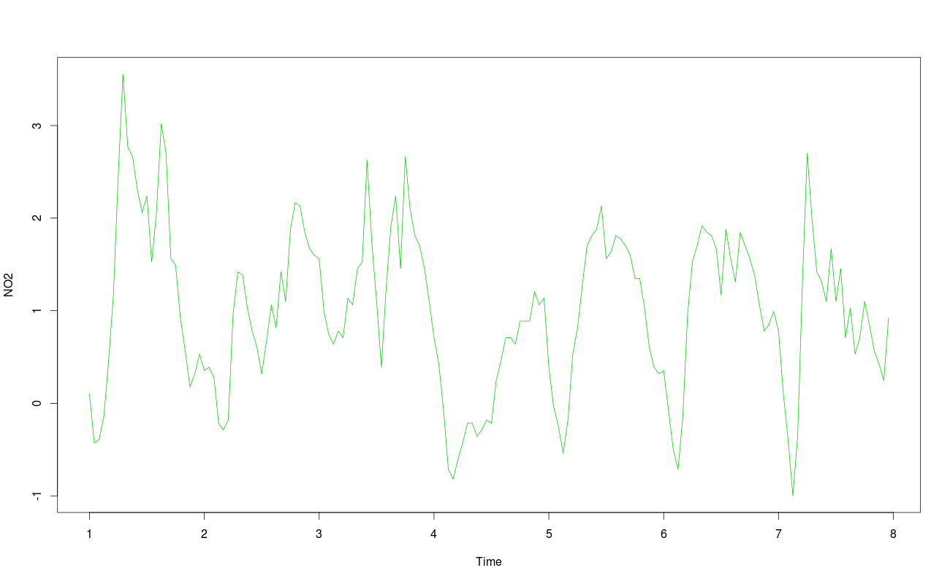
3) NOX:
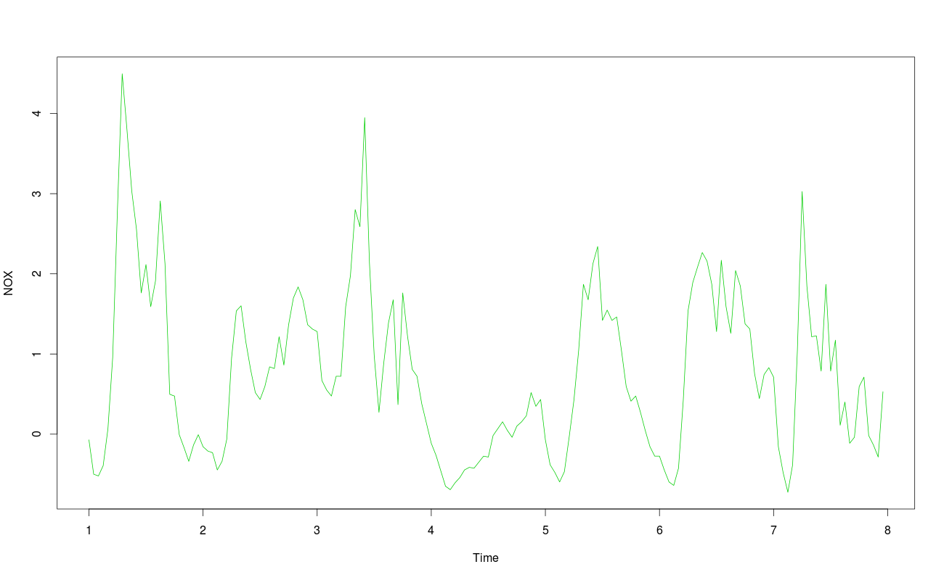

4) PM10:
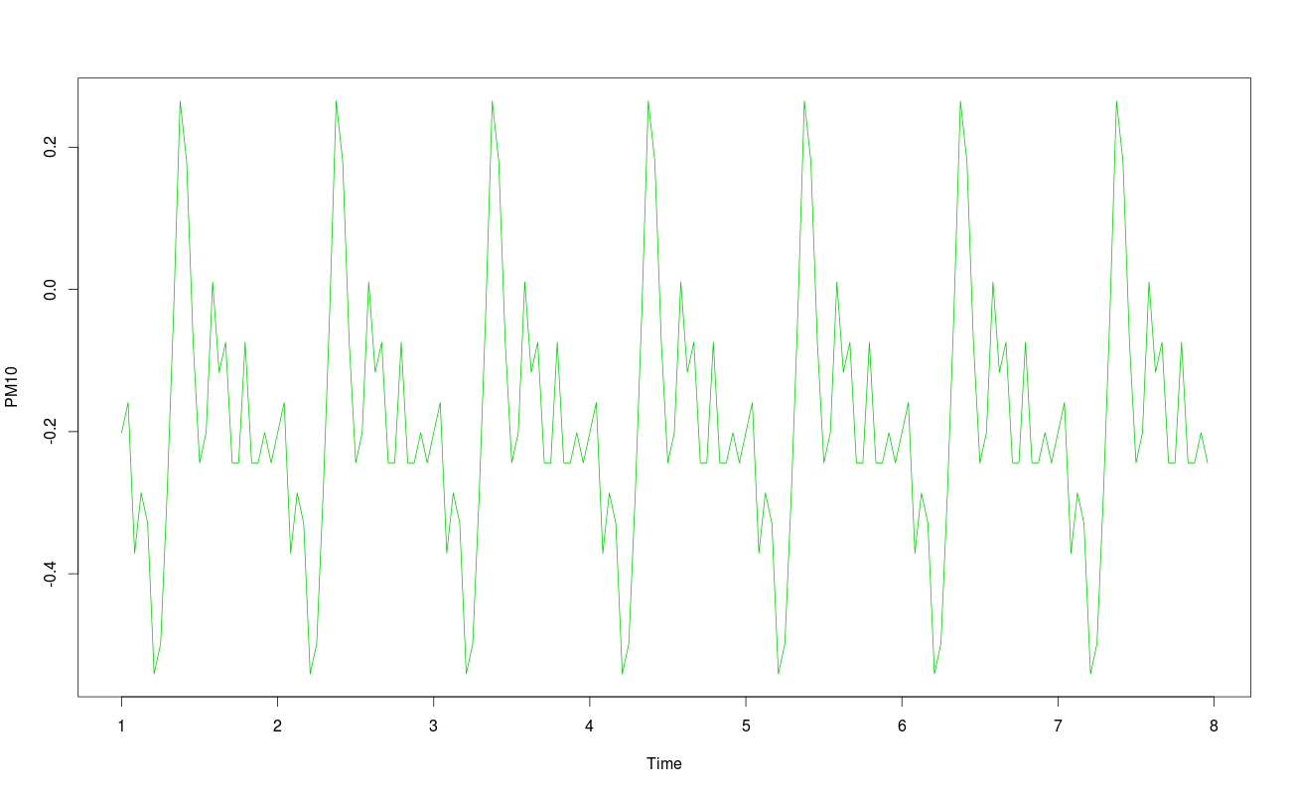
5) PM2.5:
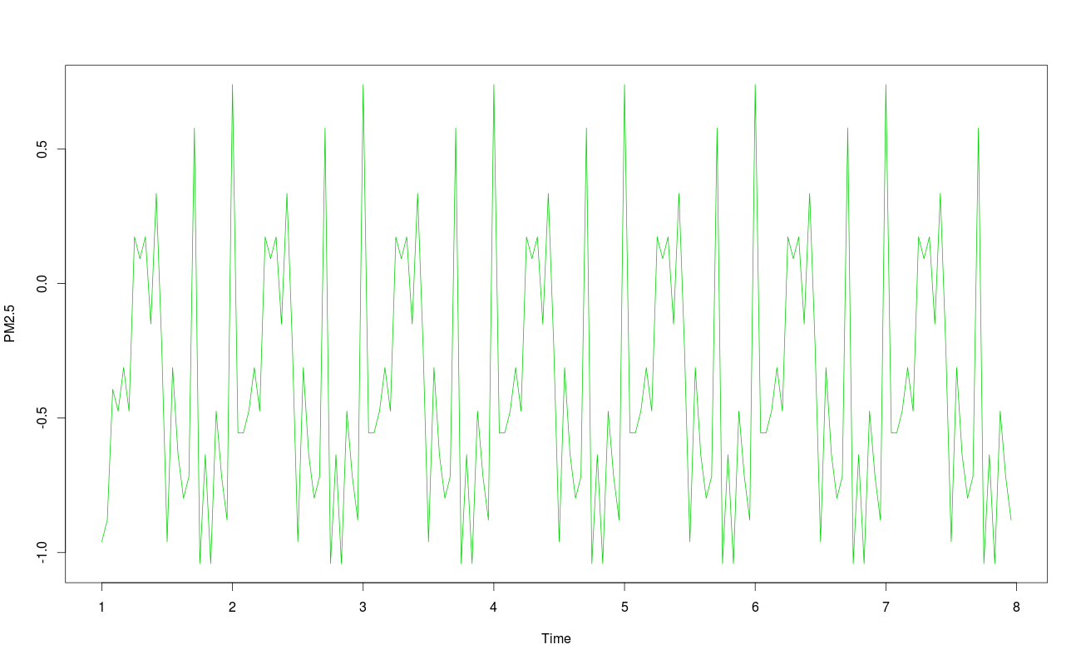

6) WDIR:
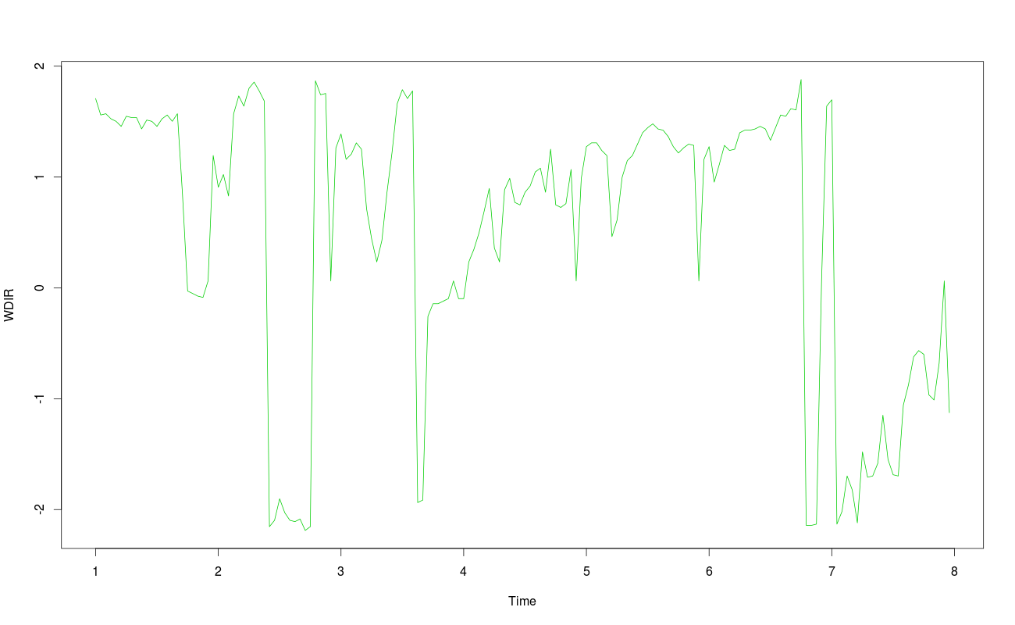
7) WSPD:
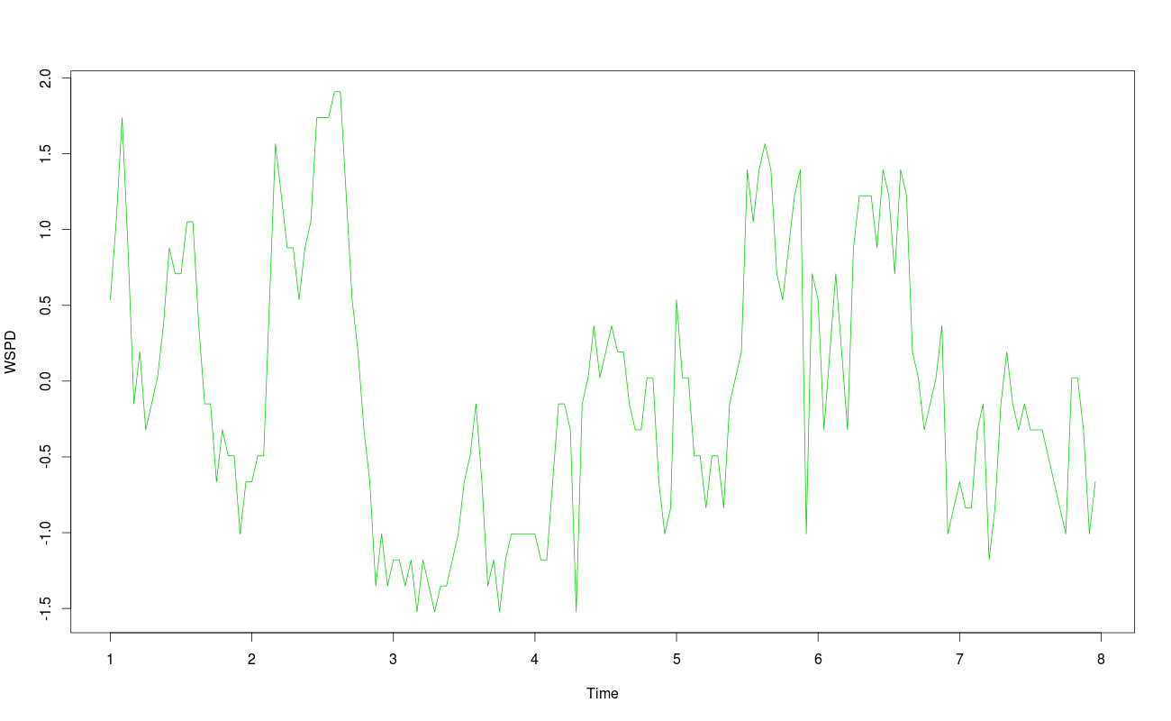

Decomposition of data into seasonal, trend and white noise for all period in my case looks as illustrated below (first is all data, later is week data):

1) For NO values:
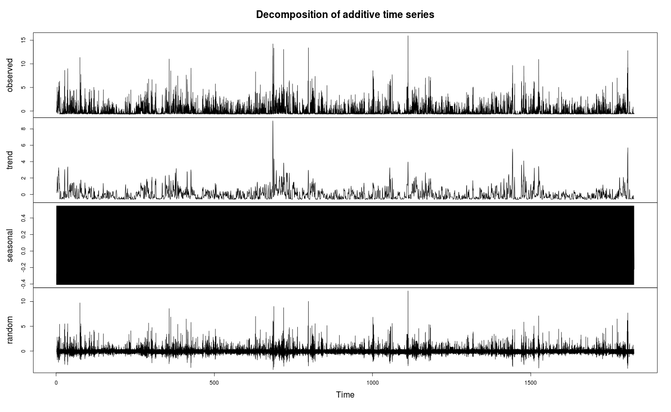
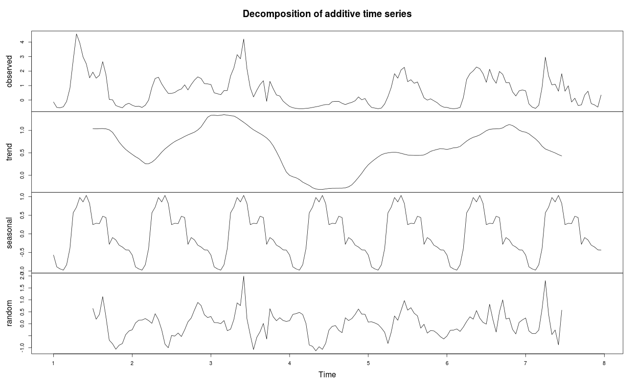

2) For NO2 values:
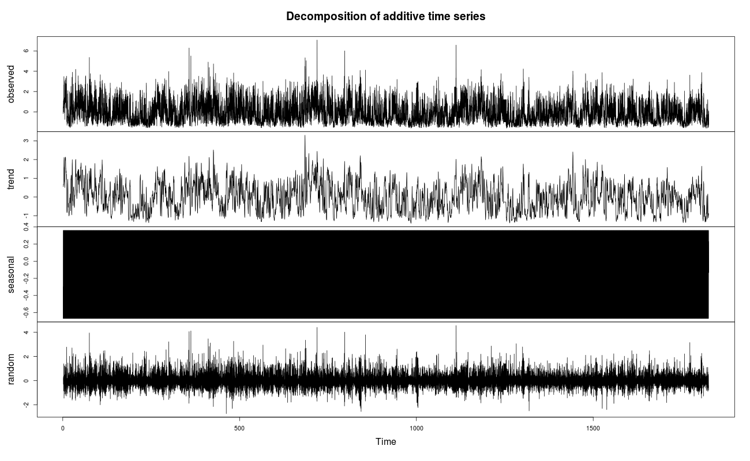
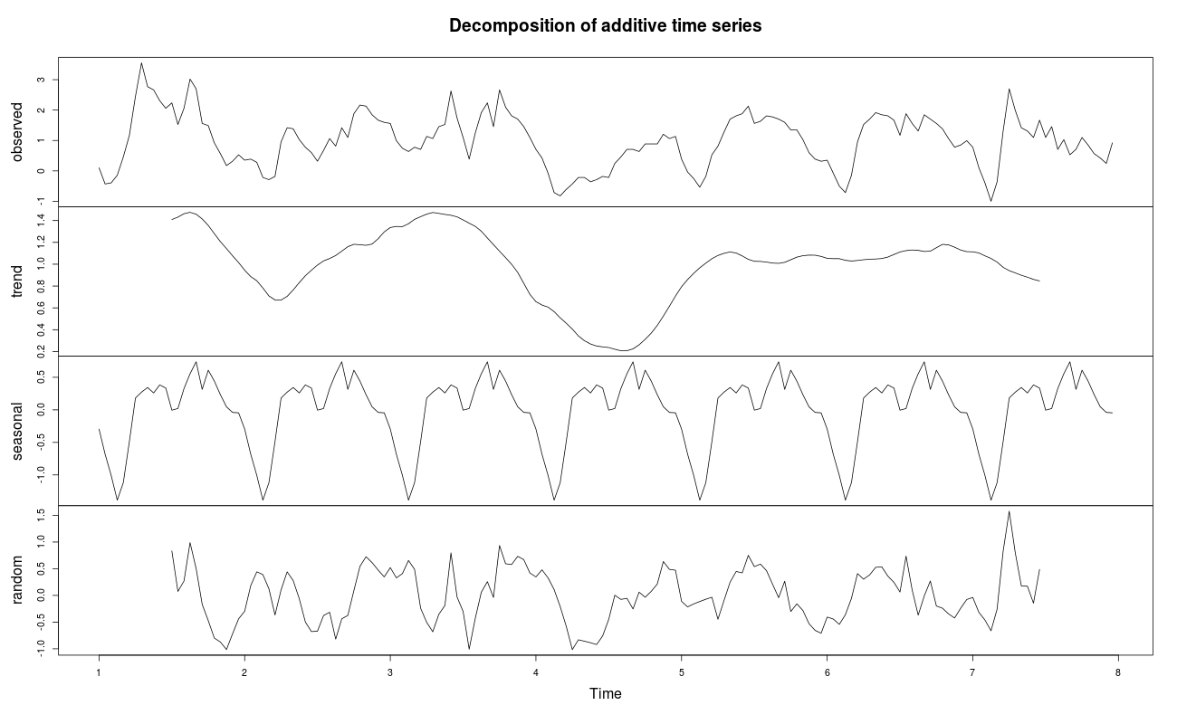

3) For NOX values:
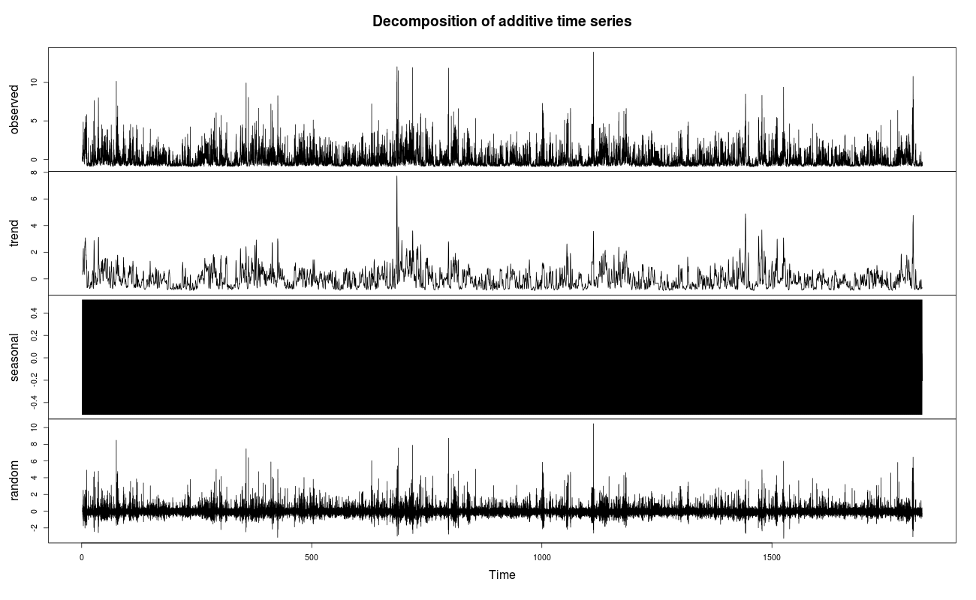
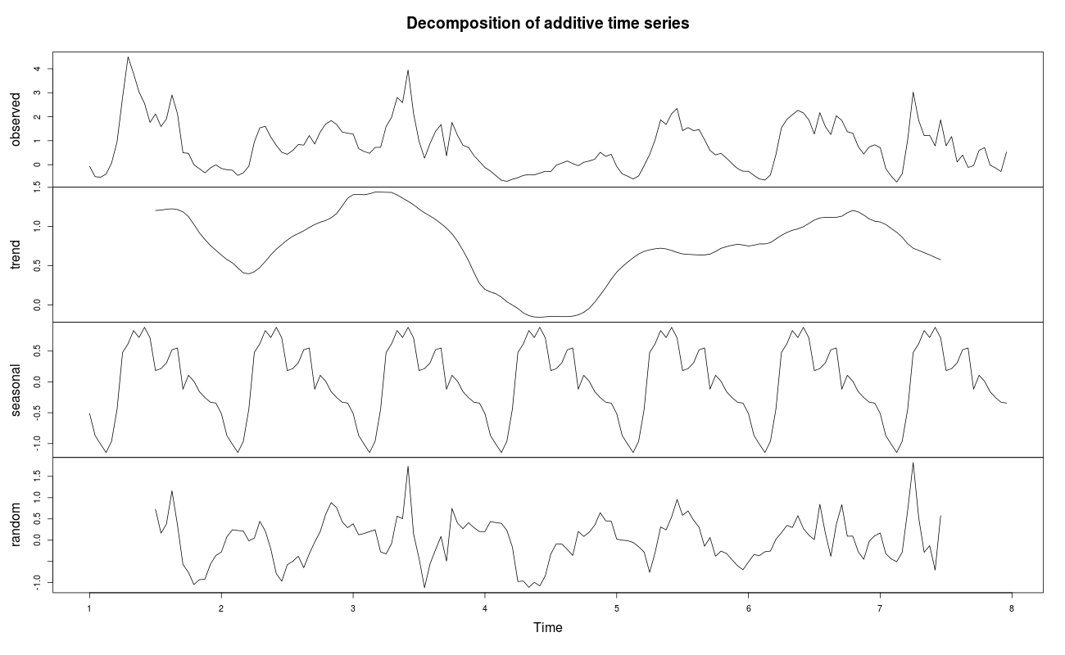

4) For PM10 values:
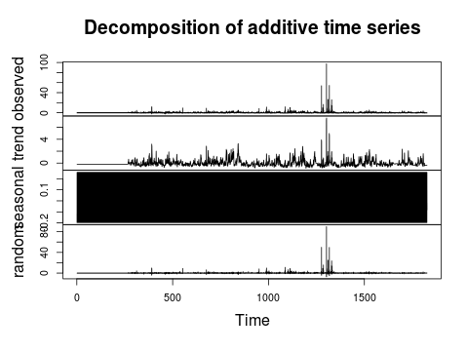

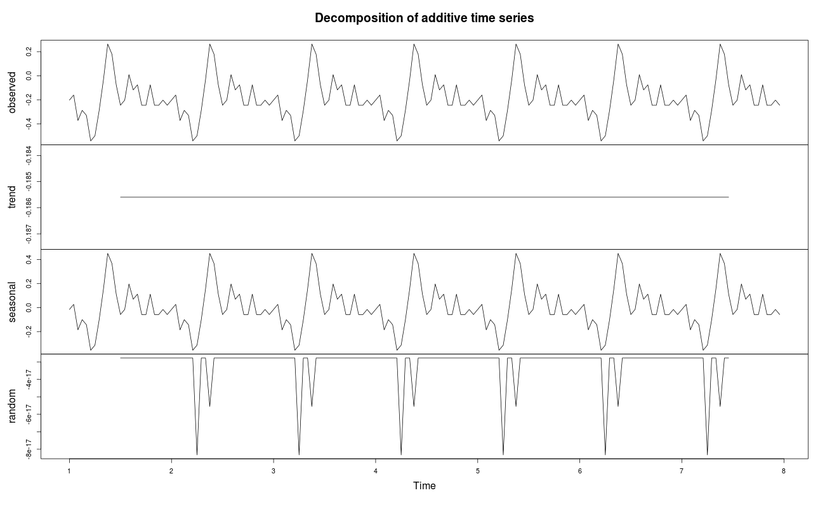

5) For PM2.5 values:
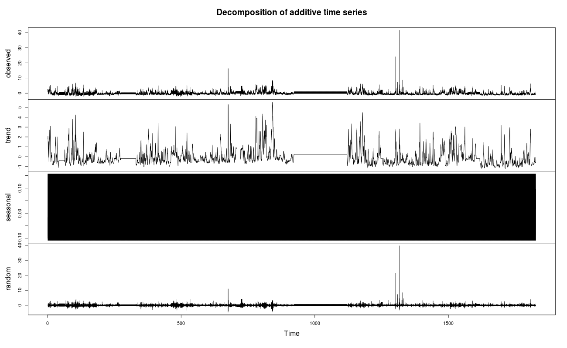
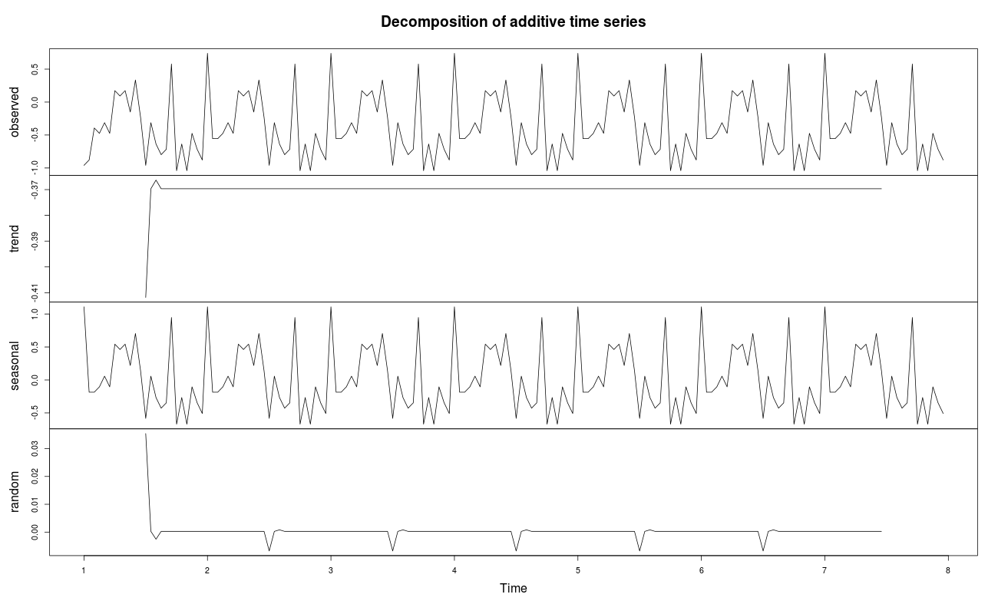

6) For WDIR values:
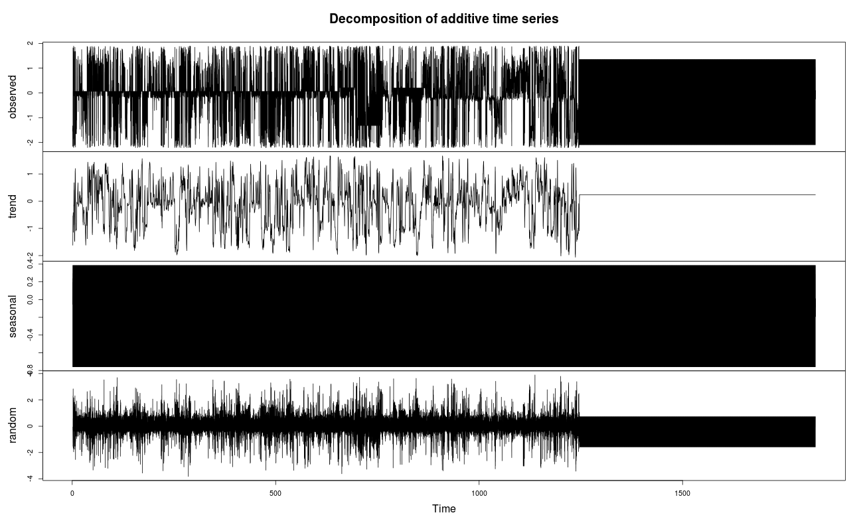
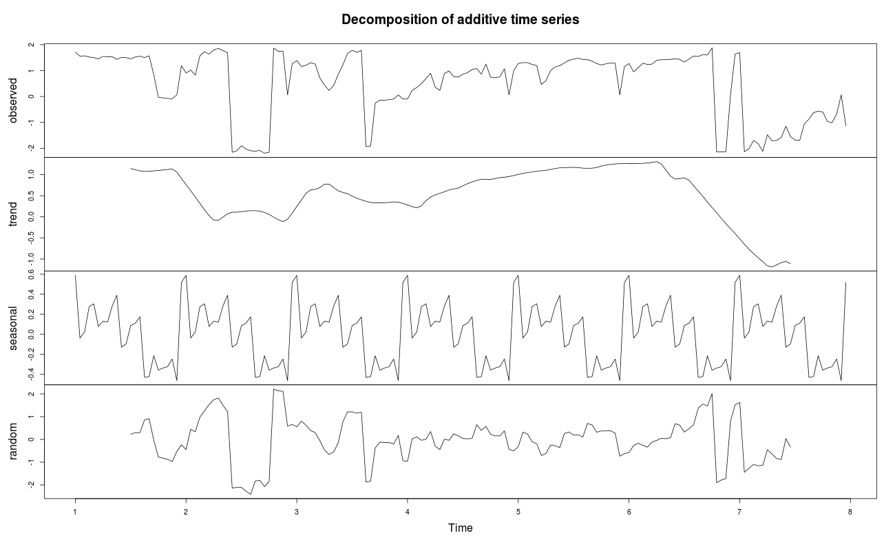

7) For WSPD values:
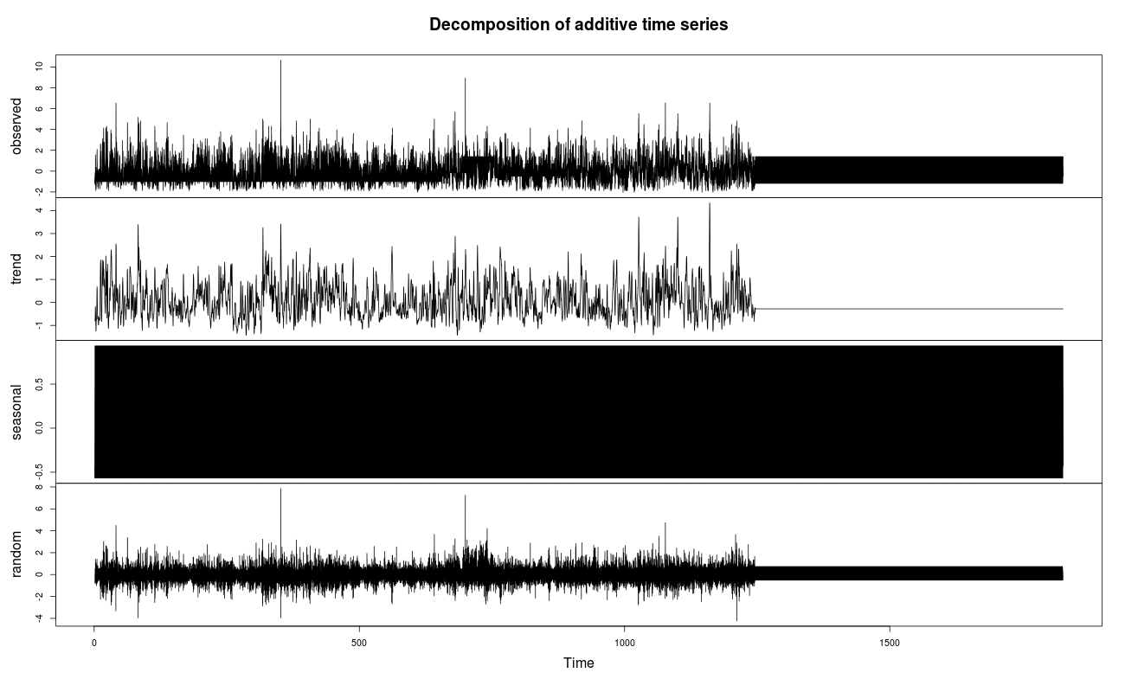
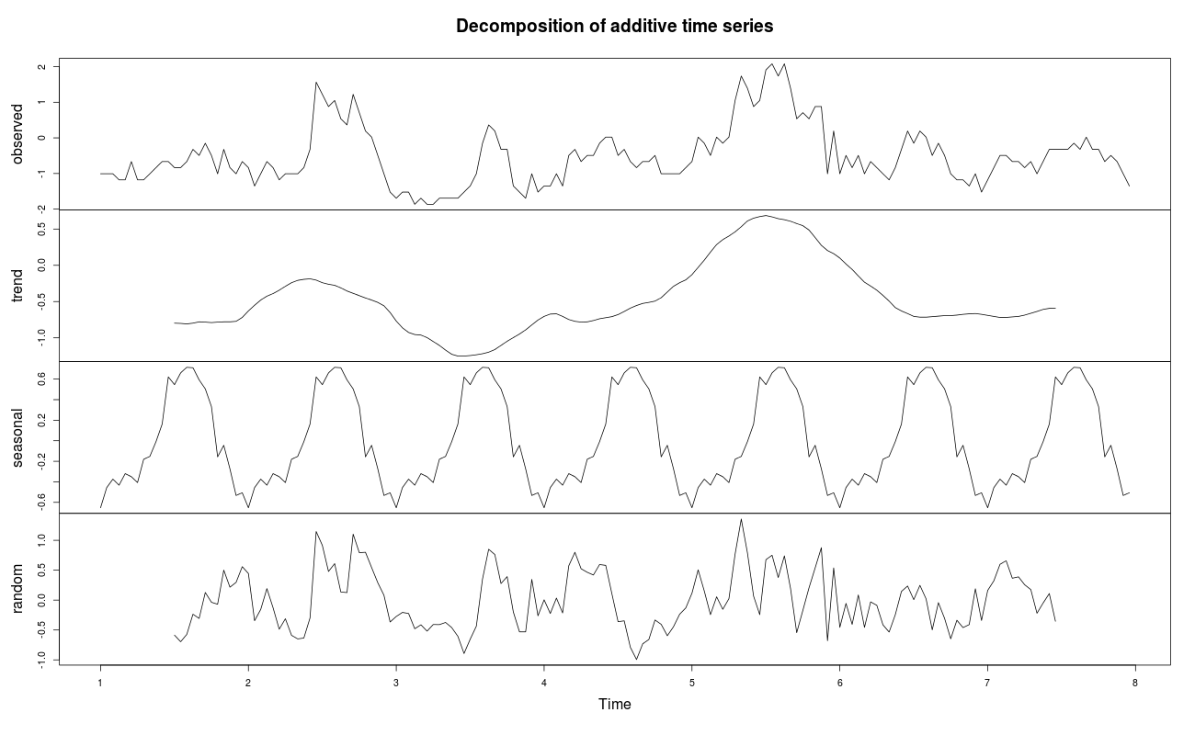
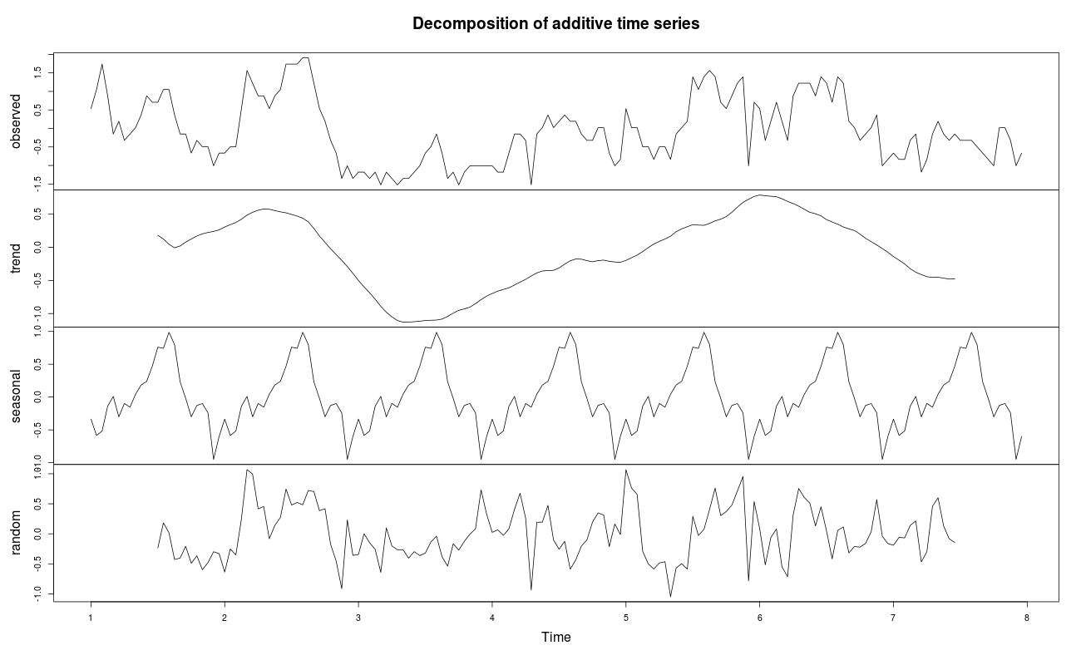

Next I used a sarima.for function for forecast the next 2-days period for all of NO, NO2, NOX, PM10, PM2.5, WDIR, WSPD parameters.
As a result I got follows (where red lines is predicted values and blue lines is real values):
1) For NO:
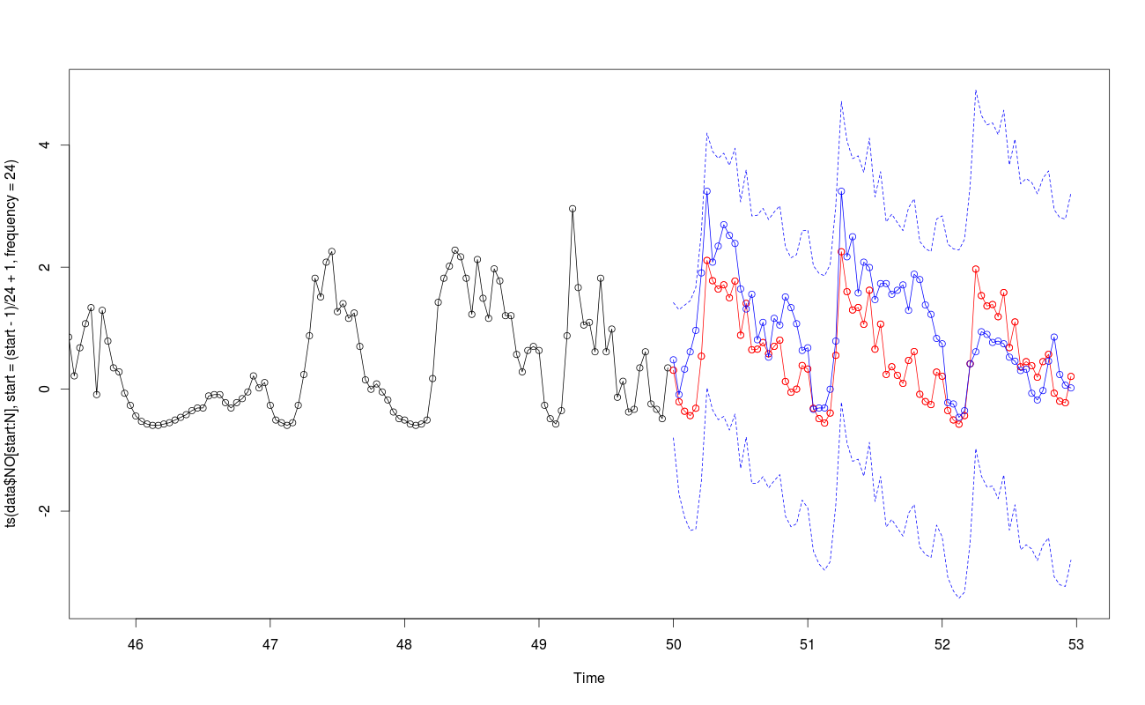

2) For NO2:
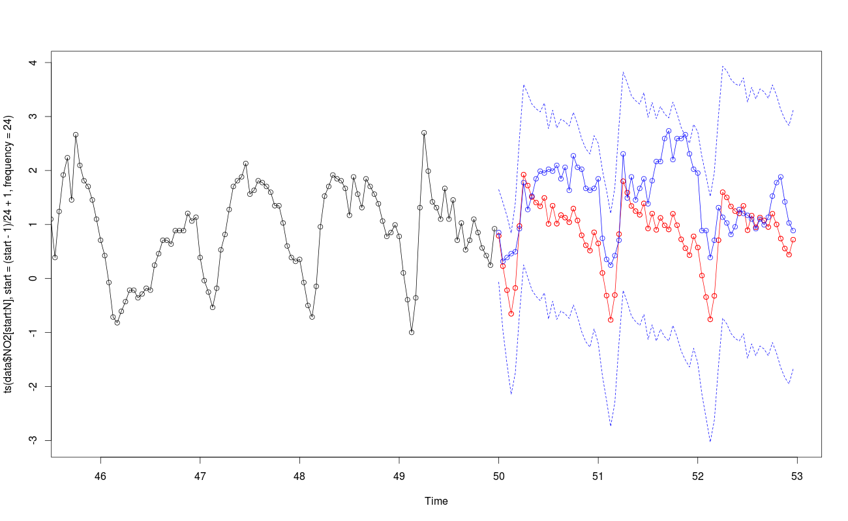

3) For NOX:
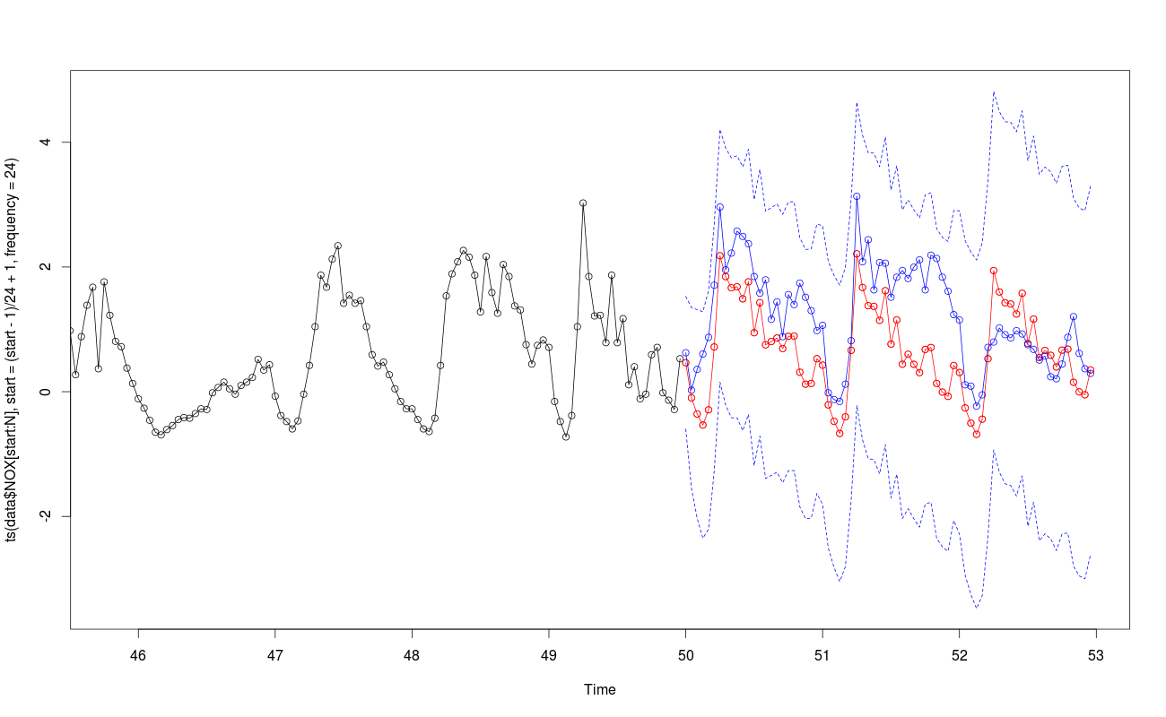

4) For PM10:
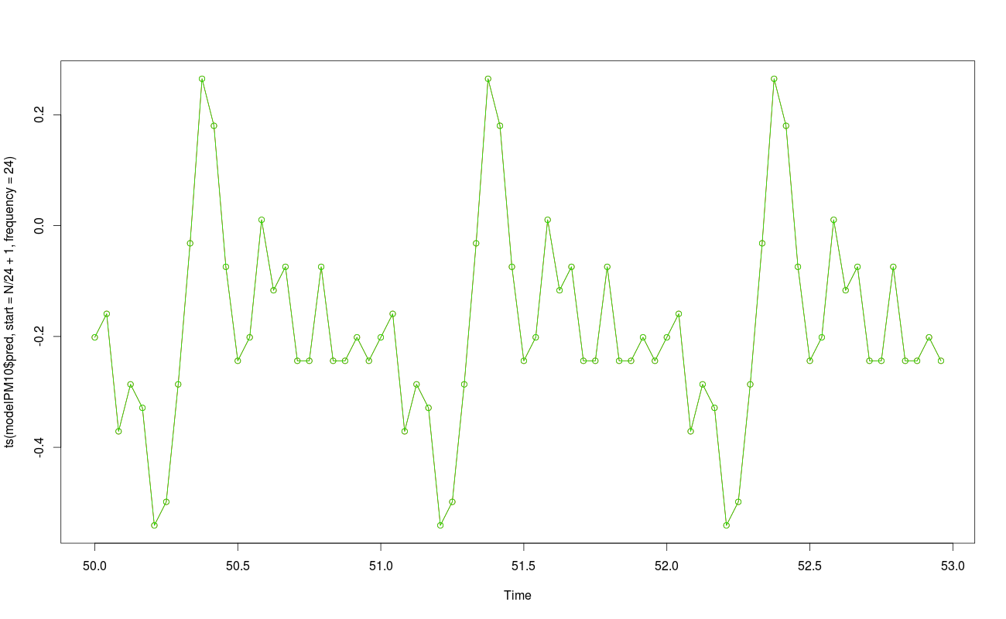

5) For PM2.5:
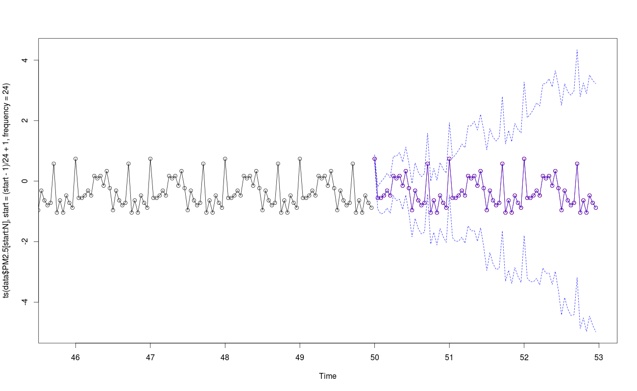

6) For WSPD:
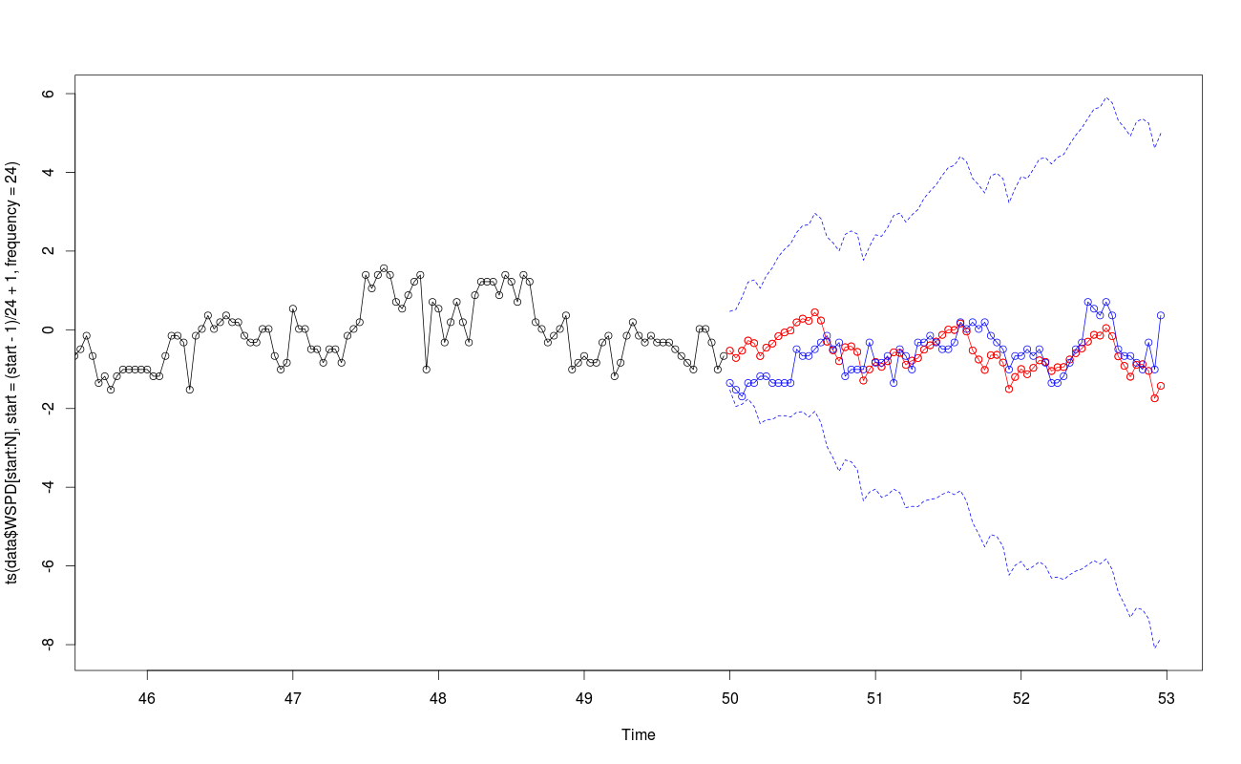

7) For WDIR:
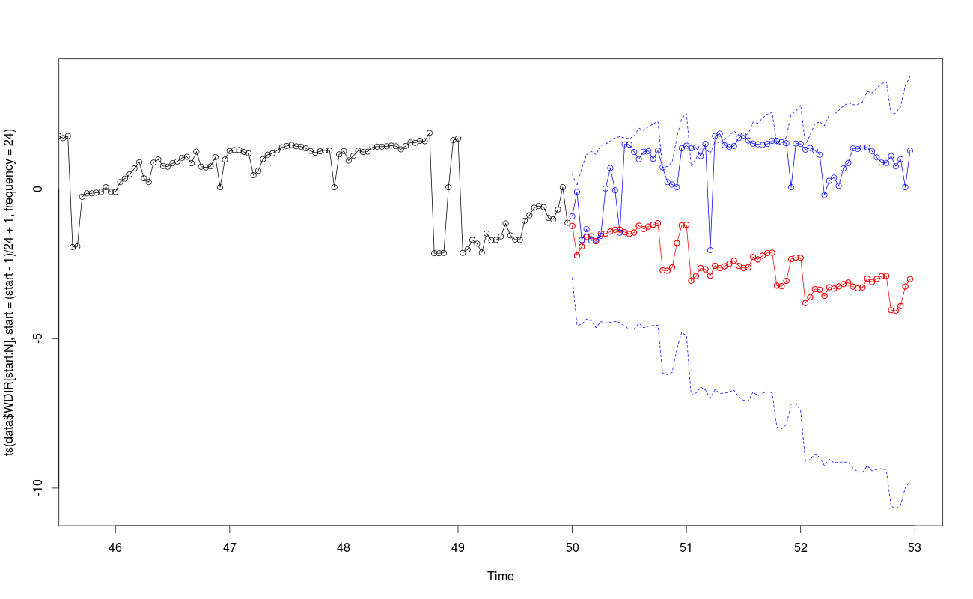

Classification
Next, I am used a neural network classification for separating predicted values into 4 groups (Very High, High, Medium, Low).
As a result I got a following image FOR PREDICTED values on the next 72 hours (where green is real data and red is predicted class):
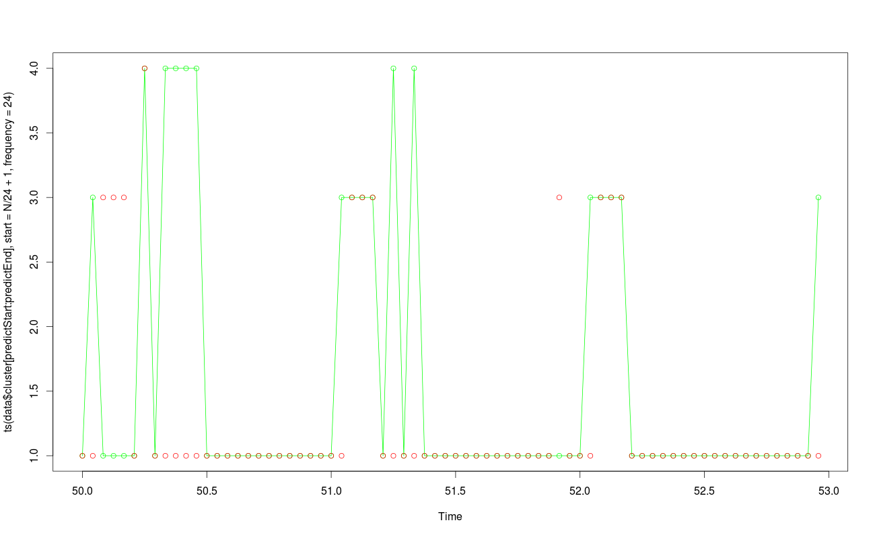

Accuracy
After that I calculated an accuracy based on first week data by following R code:
round(length(classes[data$cluster[predictStart:predictEnd] == classes]) / length(classes) * 100, 2)

As a result I got an accuracy about 80.56% (in one of the best cases)

About:
This solution was prepared by Alex Kozlov. Some parts of R-code may be used by Sergey Semenkevich because in the beginning we are worked together with him.
Code for this solution is available on github repository: https://github.com/daoleen/RAir/blob/master/TimeSeries15.R

Thanks and Best regards,
Alexander Kozlov

