represent excessive delays in page loading.

The dominant type of interface for electronic commerce ap-

plications, the web browser, provides many of these features

through its use of multimedia and hyperlinking.

System benefits from the user perspective are substantially

different from the retailer perspective. Ideally, systems should

be enjoyable to use and invoke confidence in the consumer

regarding their purchasing decisions.

A successful web site design should balance tradeoffs associ-

ated with factors such as: 1) page loading, 2) business con-

tent, 3) navigation efficiency, 4) security and 5) marketing /

consumer focus (Gehrke and Turban, 1999). Page loading

refers to the time it takes to load a web page. Business content

refers to the quality of presentation and the usefulness of the

content to the user. Navigation efficiency refers to the effort

required to retrieve information; this can be reflected in over-

all site design (number of links required to retrieve the correct

information) or the effectiveness of a search engine. Market-

ing / consumer focus refers to how well the site markets its

products and services. For example, increasing business con-

tent may mean employing forms of multimedia such as video,

***Measures of System Success***

The success or effectiveness of information systems is typi-

cally measured in many different ways, such as user satisfac-

tion, system usage, and utility of information systems in deci-

sion making (Klenke, 1992)(Park, 2000). User satisfaction is

oe of the most important and frequently researched con-

structs in information systems research. For our purposes, the

proposed framework identifies two distinct but possibly inter-

related measures of system success. From the organization’s

point of view, system success is defined in terms of the reve-

72

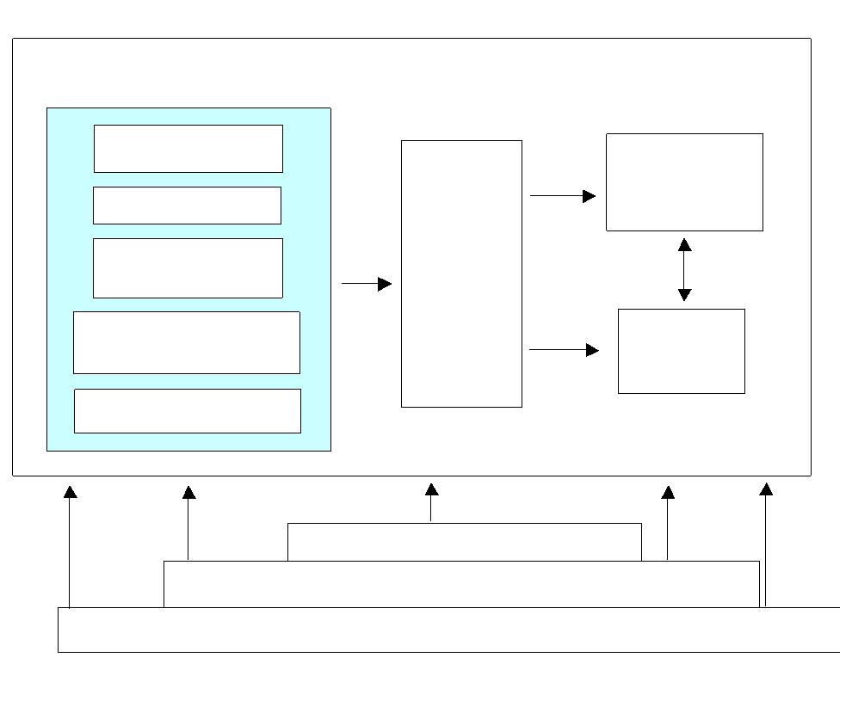

**用户因素**

人口统计

心理

用户情景

寻求信息策略

购买意向

用户

界面

设计

系统

成功

（组织）

系统

成功

（用户）

任务环境

组织环境

外部环境