# To support both python 2 and python 3

from __future__ import division, print_function, unicode_literals

import numpy as np

import matplotlib.pyplot as plt

import math

y=1

Y = np.array([[

448.524 + y,

509.248 + y,

535.104 + y,

551.432 + y,

623.418 + y,

625.992 + y,

655.248 + y,

701.377 + y,

748.918 + y,

757.881 + y,

831.004 + y,

855.409 + y,

866.707 + y,

902.545 + y,

952.261 + y,

995.531 + y,

1069.78 + y,

1074.42 + y,

1103.88 + y,

1138.69 + y,

1153.13 + y,

1240.27 + y,

1251.9 + y,

1287.97 + y,

1320.47 + y,

1374.92 + y,

1410.16 + y,

1469.69 + y,

1478.54 + y,

1515.28 + y,

]]).T

# Visualize data

x=15

X=np.array([[30 + x,

32.4138 + x,

34.8276 + x ,

37.2414 + x ,

39.6552 + x ,

42.069 + x,

44.4828 + x,

46.8966 + x ,

49.3103 + x ,

51.7241 + x ,

54.1379 + x,

56.5517 + x ,

58.9655 + x ,

61.3793 + x ,

63.7931 + x,

66.2069 + x ,

68.6207 + x ,

71.0345 + x ,

73.4483 + x ,

75.8621 + x,

78.2759 + x ,

80.6897 + x ,

83.1034 + x ,

85.5172 + x ,

87.931 + x ,

90.3448 + x ,

92.7586 + x ,

95.1724 + x ,

97.5862 + x ,

100 + x ,

]]).T

plt.plot(X, Y, 'ro')

plt.axis([ 60, 130,460, 1527])

plt.xlabel('Diện tích ')

plt.ylabel('Giá Đất')

plt.show()

# Building Xbar

one = np.ones((X.shape[0], 1))

Xbar = np.concatenate((one, X), axis = 1)

# Calculating weights of the fitting line

A = np.dot(Xbar.T, Xbar)

b = np.dot(Xbar.T, Y)

w = np.dot(np.linalg.pinv(A), b)

print('w = ', w)

# Preparing the fitting line

w_0 = w[0][0]

w_1 = w[1][0]

print(w_0,w_1)

x0 = np.linspace(60,130, 2)

y0 = w_0 + w_1*x0

# Drawing the fitting line

plt.plot(X.T, Y.T, 'ro') # data

plt.plot(x0, y0) # the fitting line

plt.axis([ 60, 130,460, 1527])

plt.xlabel('Diện tích')

plt.ylabel('Giá đất')

plt.show()

#tinh toan du lieu

x_0=430

w_x=math.sqrt(math.pow(w_0,2)+math.pow(w_1,2))

y_0 = w_0 + w_1*x_0+w_x

print("Giá đất của mảnh đất có diện tích %s là:"%(x_0),y_0)

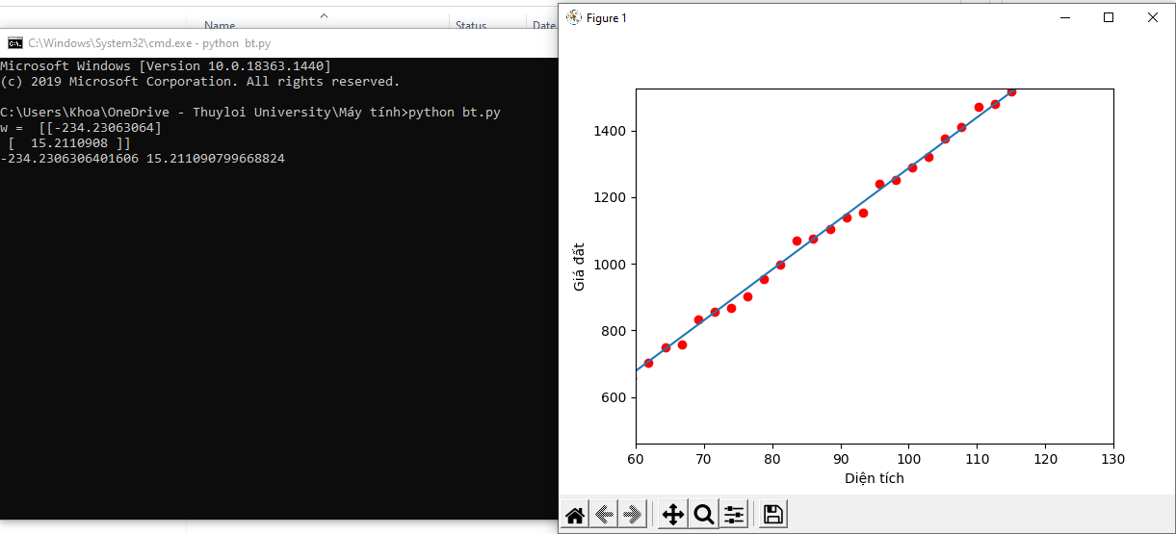

Dự đoán

