**Run code at localhost**

I downloaded starter code

[image-filter-starter-code](https://github.com/udacity/cloud-developer/tree/master/course-02/project/image-filter-starter-code)

I installed packages

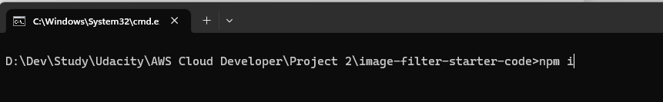

Run the development

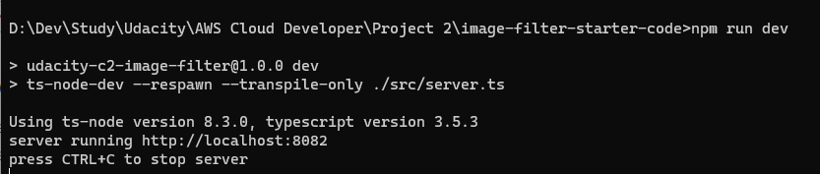

The server was running

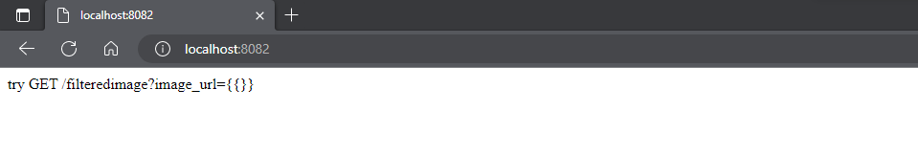

I edited file server.ts to complete an endpoint which uses query parameter to download an image from a public URL, filter the image, and return the result.

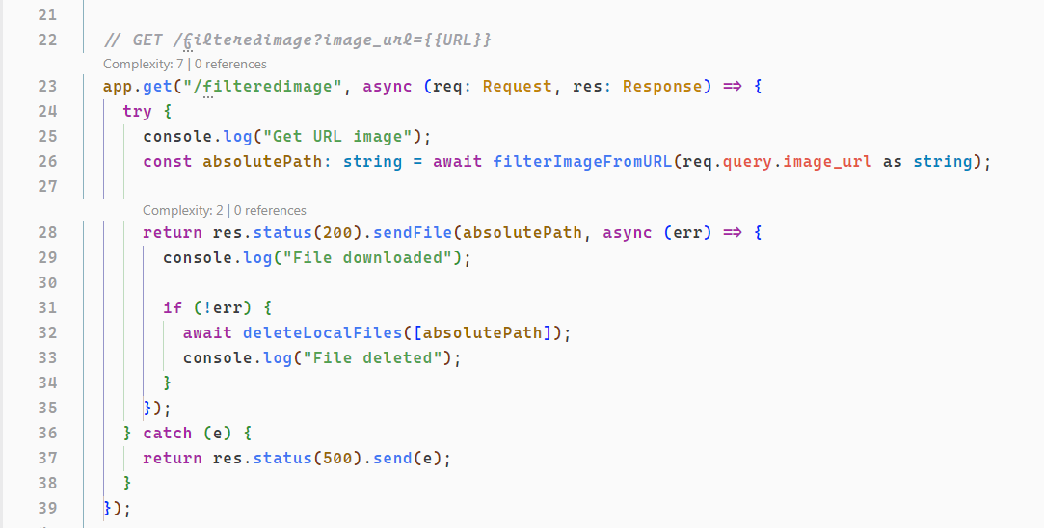

I had this error when testing with image “https://upload.wikimedia.org/wikipedia/commons/b/bd/Golden_tabby_and_white_kitten_n01.jpg”

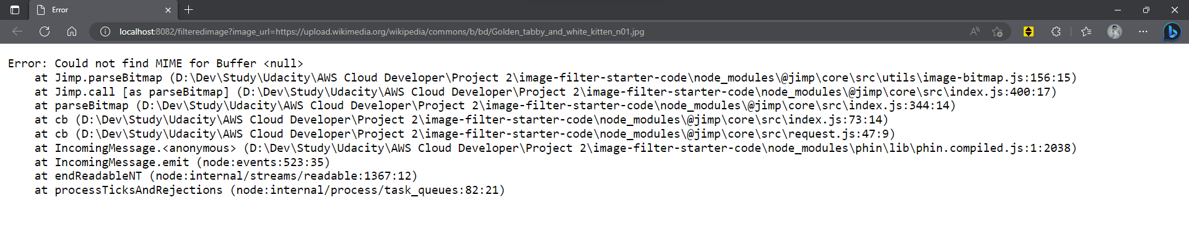

I dected this issue, I found reason comes from Jimp library if downloading image with redirect url.

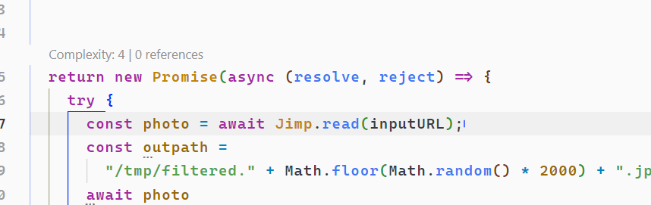

So, I try to edit some logic here. I use node-fetch to read buffer from url, then read that read by Jimp.

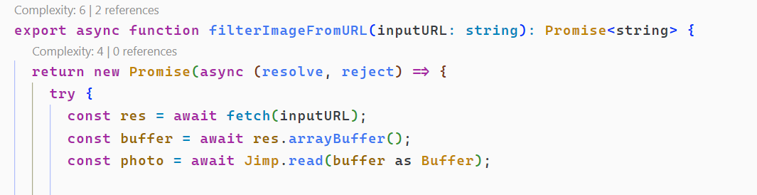

And now, I can download image

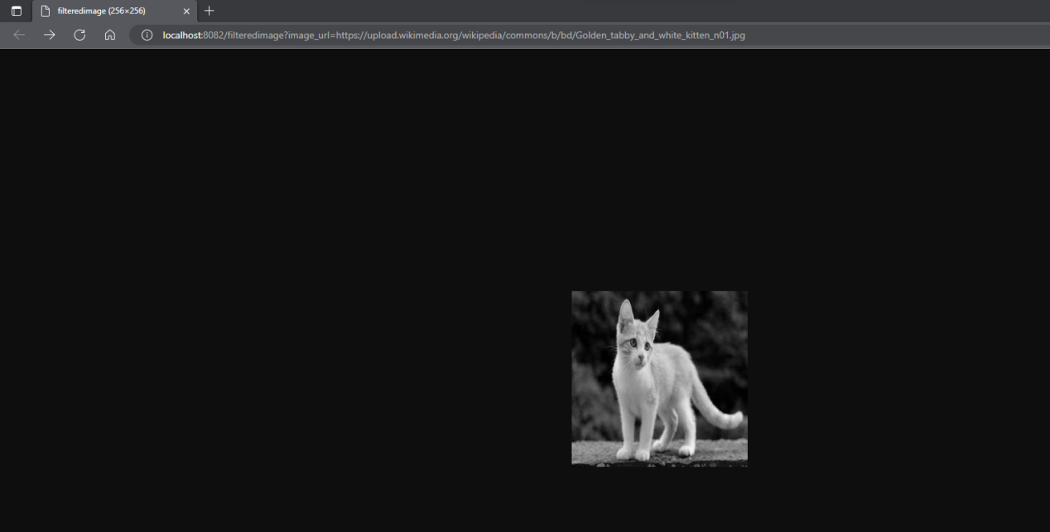

**Deploy web**

Install EB cli through

[Manually install the EB CLI - AWS Elastic Beanstalk (amazon.com)](https://docs.aws.amazon.com/elasticbeanstalk/latest/dg/eb-cli3-install-advanced.html)

Check version EB

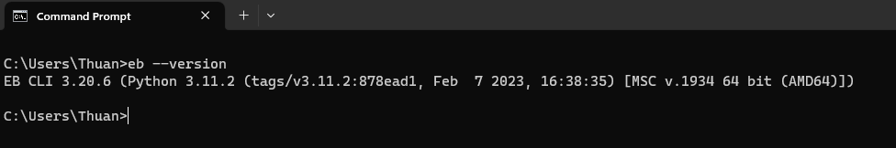

Create User in IAM

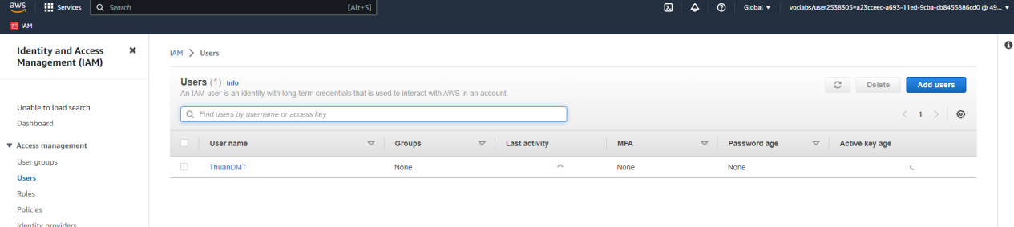

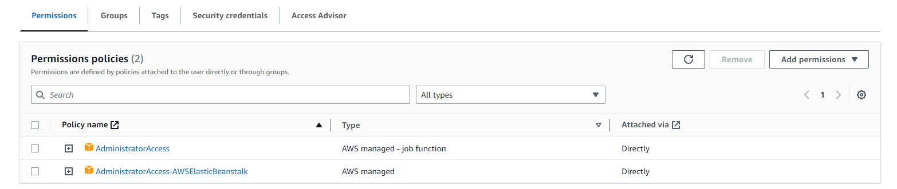

Create access key

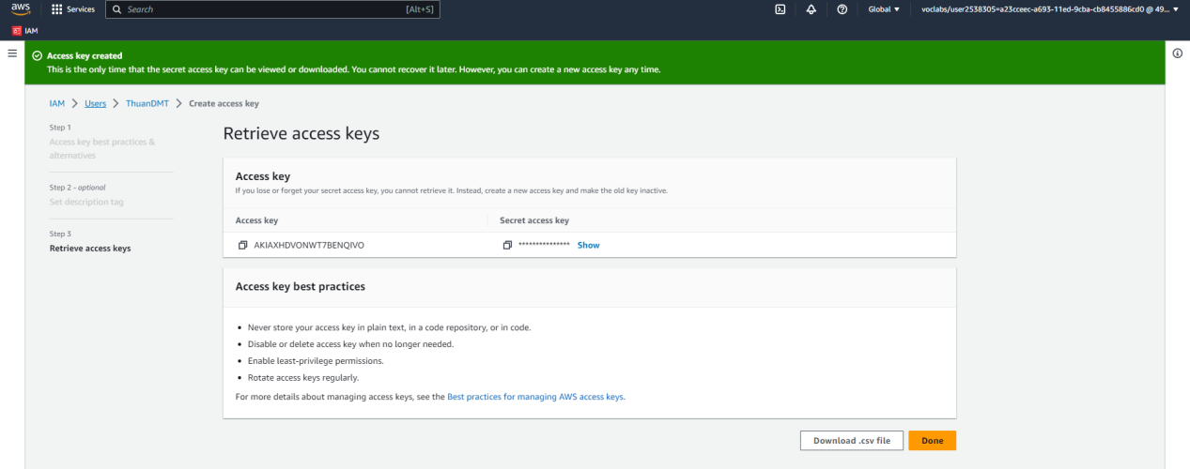

Init EB

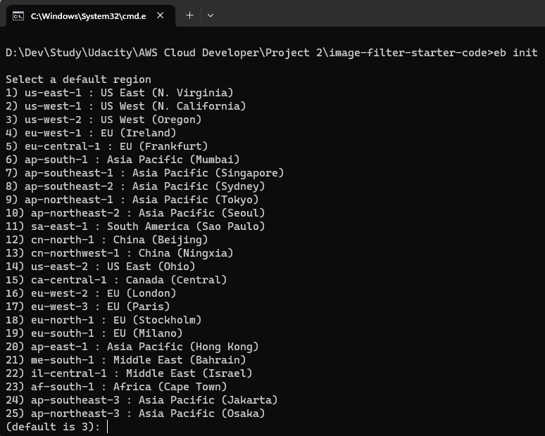

Select region [us-east-1](https://us-east-1.console.aws.amazon.com/console/home?region=us-east-1" \t "https://us-east-1.console.aws.amazon.com/console/_top) and init application

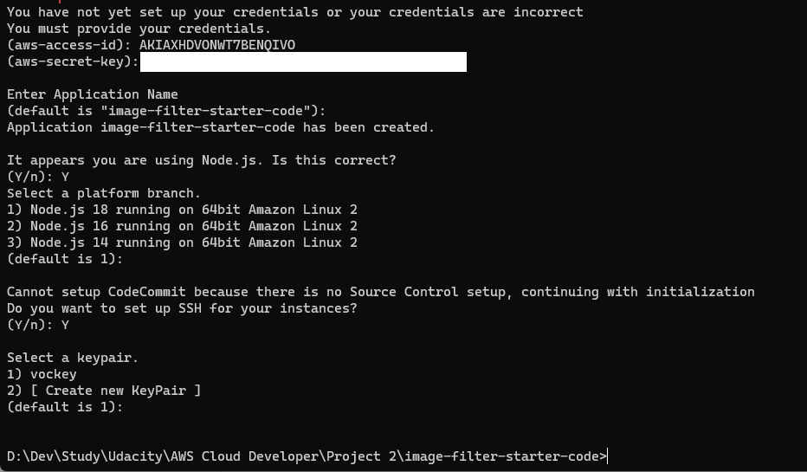

Edit config.yml

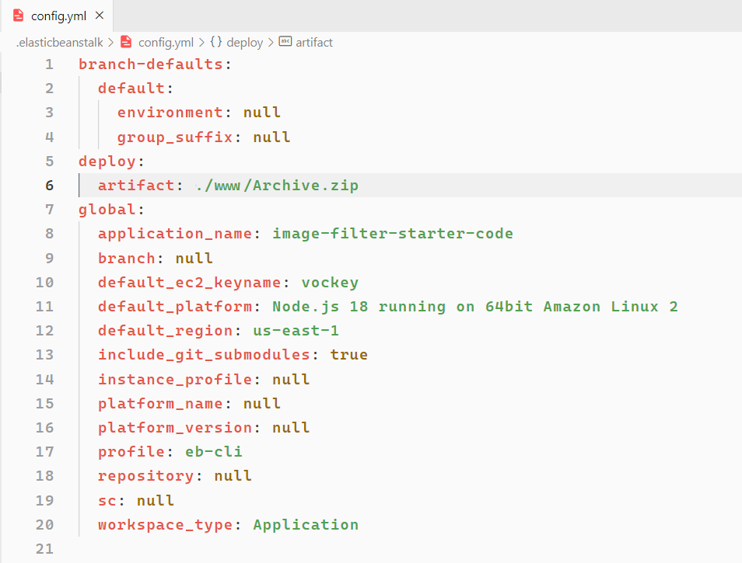

Because I’m using Windows OS, so I use tar to zip code. I edit build script

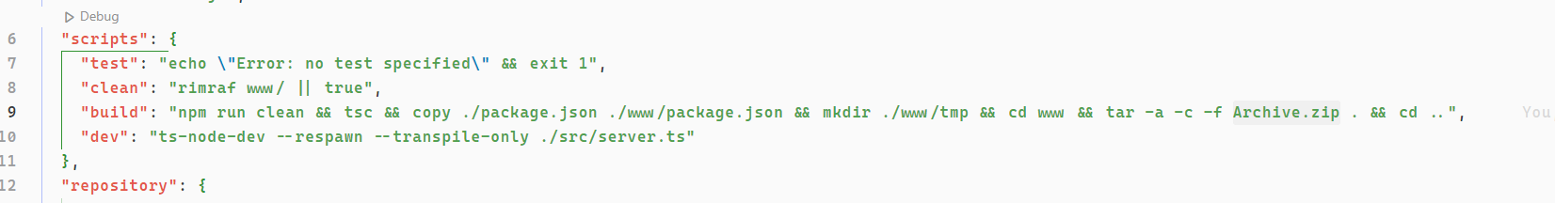

Create EB

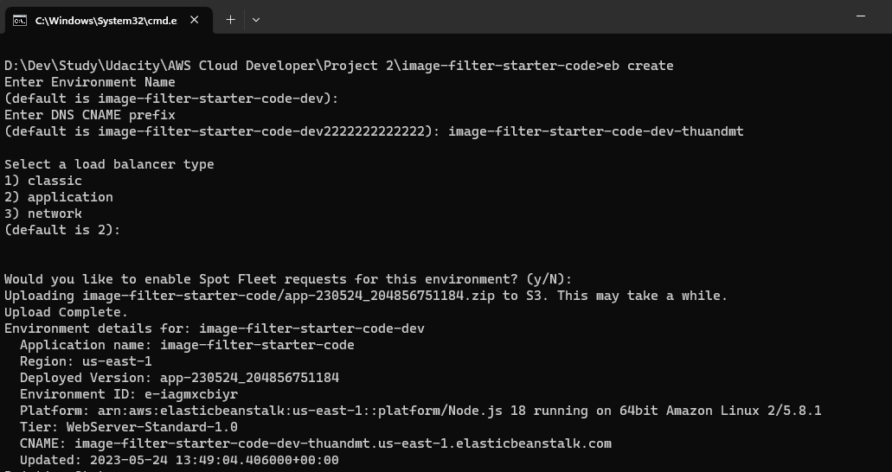

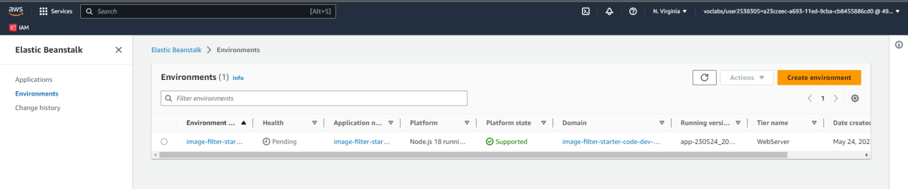

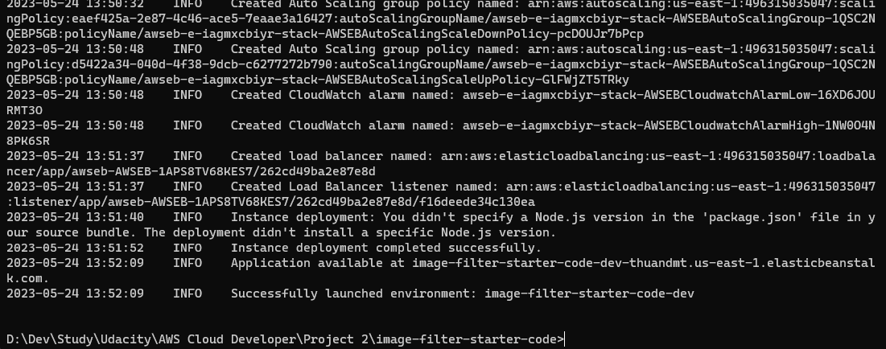

Deploy EB

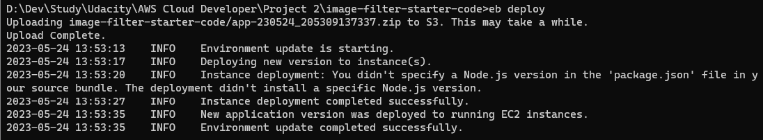

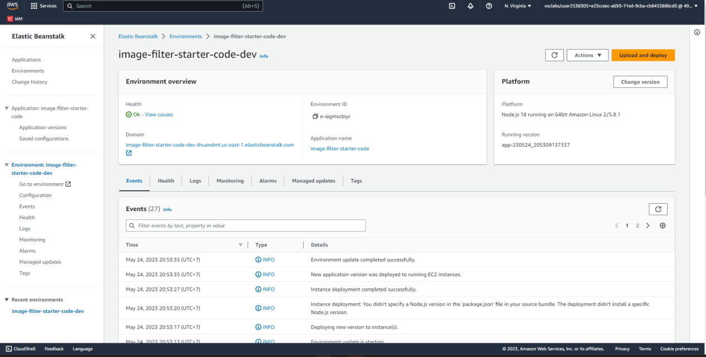

Deploy done

Domain: [image-filter-starter-code-dev-thuandmt.us-east-1.elasticbeanstalk.com](http://image-filter-starter-code-dev-thuandmt.us-east-1.elasticbeanstalk.com/)

Test: [filteredimage (256×256) (image-filter-starter-code-dev-thuandmt.us-east-1.elasticbeanstalk.com)](http://image-filter-starter-code-dev-thuandmt.us-east-1.elasticbeanstalk.com/filteredimage?image_url=https://upload.wikimedia.org/wikipedia/commons/b/bd/Golden_tabby_and_white_kitten_n01.jpg)

