CANTHO UNIVERSITY SOFTWARE CENTER
CAMPUS 3 – CTU
- - - - -  - - - - -



LOANS PROCESSING SYSTEM

Supervisor Authors:
LUONG HOANG HUONG NGUYEN HAI VIET
NGUYEN PHAM BICH PHUONG PHAM HUY
Can Tho, 13/06/2017

In the journey together with the growth and development of the national economy, agriculture and rural areas. Our company is in charge of the lending market. Senior managers have decided to computerize the entire process (LPS - Loan Processing System) and now have a separate department loans like for handling vehicle loans ,vehicle Finance Department, housing Loans ,home Finance, personal loans personal Finance and for educational, loan, educational Finance
When someone comes for a mandatory loan the person must fill out the form that person must complete information on the form refers to the personal information and details of the loan request.LPS must accept the details of customers such as address, The organization, payroll ... and then loan proceeds. The borrower can choose the type of loan, the loan amount, the repayment term and the loan itself. The system will then process the monthly payments. Based on interest rates. Interest rates vary by type of loan and term and are processed monthly or yearly interest-rate loans.
The system is combined with the following functions:
1. The function of registration of customer information (customer information table)
2. admin information board
3. The function automatically generates the account number
4. Handle the loan
5. Fine penalties if customers do not pay on time
6. The system needs to pay attention to the approval needed to avoid data differences.
7.Support function
8. Calculate loan interest rates based on the table

1. Client:QuickLoan Company
2. Inputs provided by the Client.
2.2.1. Inputs for the application:
No | Functions | Details
1 | Login | Input | User name and password
1 | Login | Process | Find username and password in System
1 | Login | Output | User Account
2 | Change Password | Input | Old Password, New Password  And Confirm New Password
2 | Change Password | Process | Change Old Password to New Password
2 | Change Password | Output | New Password
3 | Change Information | Input | New Information
3 | Change Information | Process | Change Information in System
3 | Change Information | Output | New Information
4 | Create New Customer | Input | New Information of Customer
4 | Create New Customer | Process | Insert Information of Customer
4 | Create New Customer | Output | Information of New Customer
5 | Edit Customer | Input | New Information
5 | Edit Customer | Process | Change Information of Customer Into System
5 | Edit Customer | Output | New Information of Customer
6 | Delete Account Customer | Input | AccountNo.
6 | Delete Account Customer | Process | Delete Account in System
6 | Delete Account Customer | Output | Delete Account
7 | Upload New Loans | Input | Detail of New Loan
7 | Upload New Loans | Process | Insert New Loan in System
7 | Upload New Loans | Output | New Loan
8 | Search Loan | Input | Account No. amount of loanand duration time of loan
8 | Search Loan | Process | Find Account No. amount of loanand duration of loan in System
8 | Search Loan | Output | Loan Information
9 | Edit Loan’s information | Input | New Loan
9 | Edit Loan’s information | Process | Change Information of New Loan in System
9 | Edit Loan’s information | Output | New Information of Loan
10 | Delete a Loan | Input | LoanID
10 | Delete a Loan | Process | Delete Loan in System
10 | Delete a Loan | Output | Delete Loan
11 | Delete a Contact | Input | Contact ID
11 | Delete a Contact | Process | Delete Contact in System
11 | Delete a Contact | Output | Delete Contact
12 | Upload new Contacts | Input | Detail of new contact
12 | Upload new Contacts | Process | Insert new contact in System
12 | Upload new Contacts | Output | New contact
13 | Edit Contact | Input | Contact ID
13 | Edit Contact | Process | Change Contact in System
13 | Edit Contact | Output | New Contact
14 | Search Contact | Input | ContactID,EmployeeID ,LoanID
14 | Search Contact | Process | Find ContactNO in System
14 | Search Contact | Output | Contact
15 | Search Information of Installment | Input | Loan ID, Customer ID
15 | Search Information of Installment | Process | Find Installment In System
15 | Search Information of Installment | Output | Display Installment
16 | Upload new Promotions | Input | Detail of New Promotions
16 | Upload new Promotions | Process | Insert new Promotions in System
16 | Upload new Promotions | Output | New Promotions
3. Hardware & Software Requirements.
3.1 Server:
+Hardware:
- CPU: Pentium IV 2.8Ghz(or better).
- Memory: 2GB of RAM (or better).
-HDD: 40GB (or higher).
+Software:
- Operating system: Windows XP SP2(or higher).
- Web Browser: Internet Explorer 8.0, FireFox 2.0, Chrome.
- Java SE 8.0(or higher).
- MS SQL Server 2012 (or higher).
3.2Client:
+ Hardware:
-CPU: Pentium IV 2.8Ghz(or better).
-Memory: 1GB of RAM (or better).
-HDD: 40GB (or higher).
-Display Screen: 1024x768 (or higher).
+Software:
-Operating system: Windows XP SP2(or higher).
- Web Browser: Internet Explorer 8.0, FireFox 2.0, Chrome...
-Java SE 8.0(or higher).
5. Customer’s Acceptance Criteria.
S.No | Customer’s Acceptance Criteria
1 | Application must have interfaces, photographs, eye-catching colors, attracted users access.
3 | Application must have high interactively, functions of software must be easy to use.
4 | Easy tomanage, easy to update
5 | Accept the customer details.
6 | Generate unique loan account no. for each customer
7 | System stored the details like loan type, amount, duration and the documents into database
8 | Process the loan.
9 | Calculate amount of interest rate must to pay
10 | Keep track installments of customers.
11 | Customer will be charged if they don't pay an installment by the pre-decided date.
12 | User could generate various reports:  a. All customers’ report.  b. Payment due report.  c. Fine report.
13 | The user should be able to perform search based on the loan account no, amount of loan and duration of loan.
14 | Validation needed to avoid data discrepancies.
15 | Display user-friendly information over time.
16 | Include help options.
17 | There is a warranty

Project Plan
- Project Details :
- Name of the client : QuickLoan Company
- Date of Project Plan : 05-July-2017
Project Vision/Objectives:: In order to meet the growing demands of society, everyone wants to quickly become rich for themselves and society. To make the first first have to have a first amount of investment. Or do you require a car without money. Do you worry about that, look for our company for financial support without much worry
Backing up the strategy is a corporate culture that is built and built on five core values:
- Customers are a center of gravity
- Effective
- Ambitious
- Trust
- Make differences
Quick Loan Company believes that with the vision and strategy, the company will fulfill its mission of bringing the highest benefit to customers, pay attention to the interests of employees and shareholders. The community.
Project Initiation/Requirement Document:
- Services information of QuickLoan
- Input data provided by the customer.
- Standards provided by the customer.
- Sample Contracts.
- Reports template.
- Sample profile.
- Deliverables:
- Application:
- Deploy the application
- Application source code
- Document:
- Help document: User manual, installation guide.
- Project Document : Report , Project status report.

- Project Denpendencies:
Methods of working group not effective | Methods of working group effective:
The team was not on time | Always on time
Wrong assignment | Properly assign work
Do not listen to the opinions of members | Always listen to other members
Do not respect the opinions of members | Respect the opinion of the team members
There is no sense of responsibility in the team. | Each member must have a sense of responsibility
- Major Project Milestones
Definition of the problem: 10-May-2017
Requirement analysis: 12-May-2017
Design: 20-May-2017
Development: 17-May-2017
Evaluation/Testing: 27-May-2017
Implementation: 05-June-2017
Maintenance: 07-June-2017
- Quality Plan:
- Review Activities:
- One week periodic review project progress and quality features of application
- Testing Activities:
All functions must be tested before releasing.
- Backup and recovery strategies:
- Need to synchronize the data on all computer’s member.
- Regularly update and scan for viruses.
- Backup data into Cloud, USB or hard drive.

Design Plan | Document name:  GUI Standards Document | SWD/Form No.4
Effective Date:15/05/2017 | Version: 2 | Page No:1
Property | Value
Document theme and color scheme | White, Grey
Form- Background color | White,blue,Grey
Title-Font Size | 18
Title-Font color | Black
Title-Font style | Times New Roman
Title-Alignment | Left
Background color of Controls on the form | White
Foreground color of Controls on the form | Black
Control Caption-Font size | 13
Control Caption-Font color | Red
Control Caption-Font style | Times New Roman
Control caption and controls-Aligment | Center
Command button-Alignment | Left

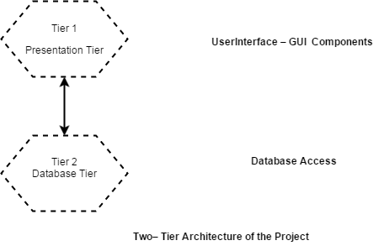
Two – Tier Architecture of the project
Context Diagram
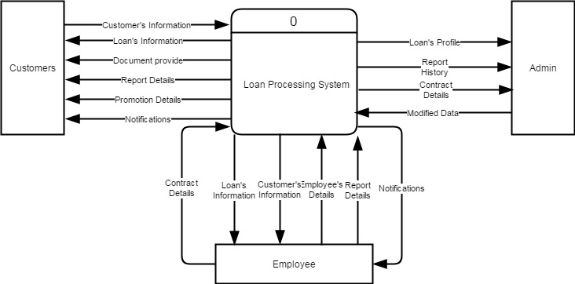
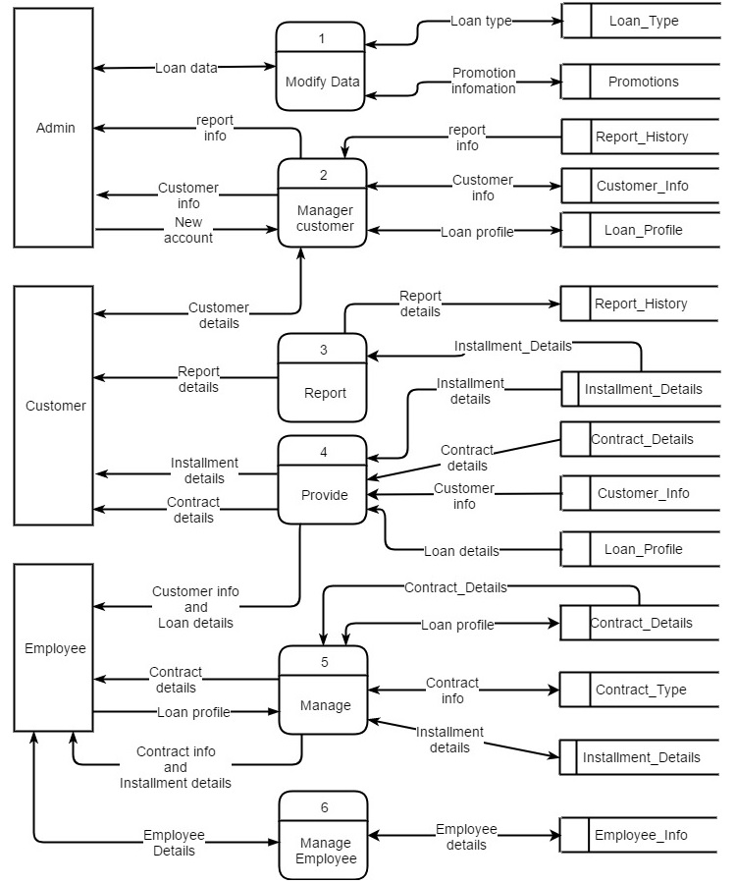

DFD Level 0
DFD lever 1 (ADMIN)
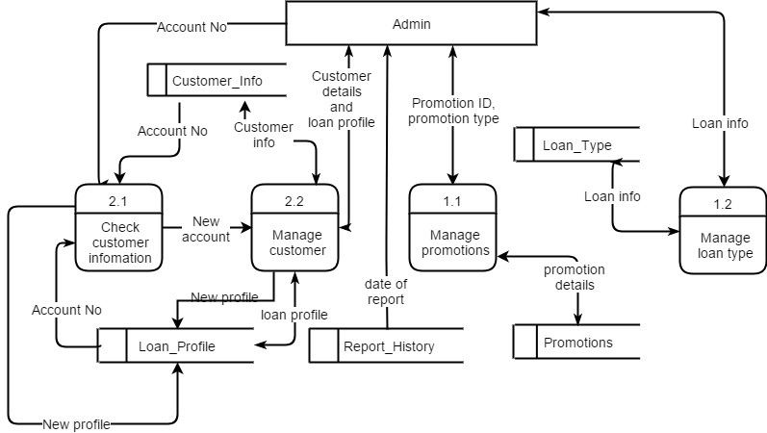

DFD lever 1 (Customer)
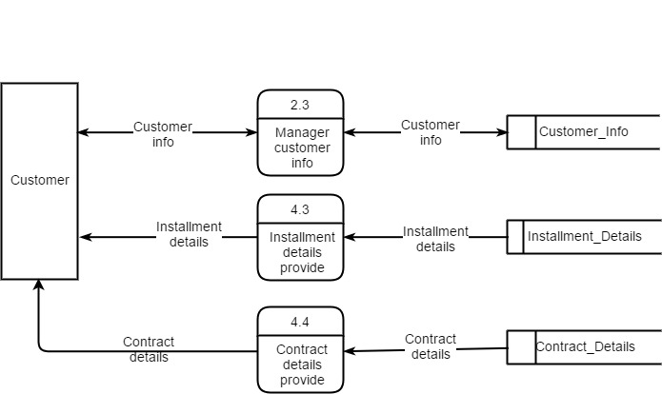

DFD lever 1 (Employee)
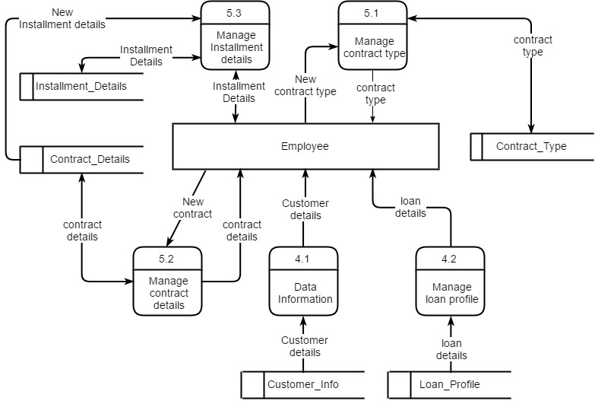

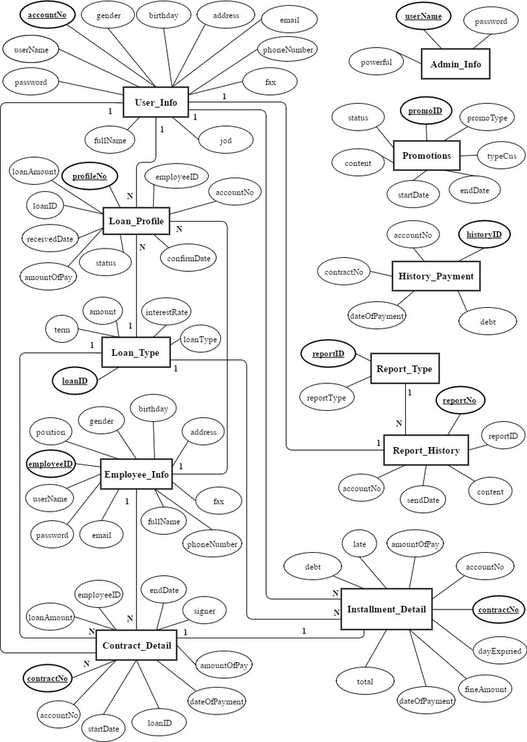

Login

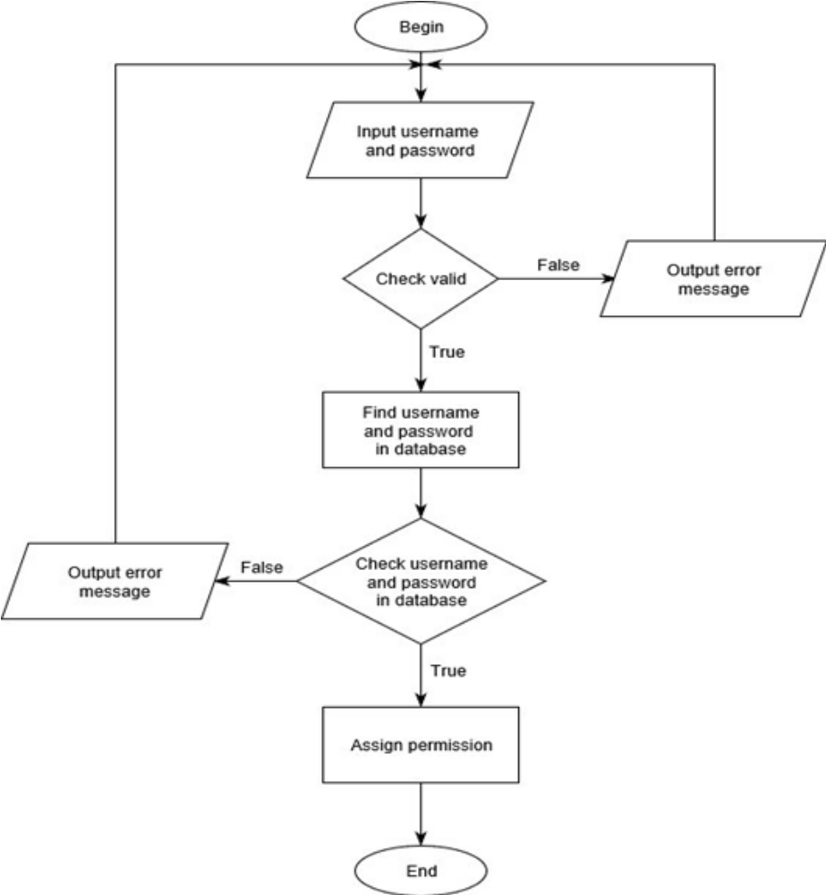

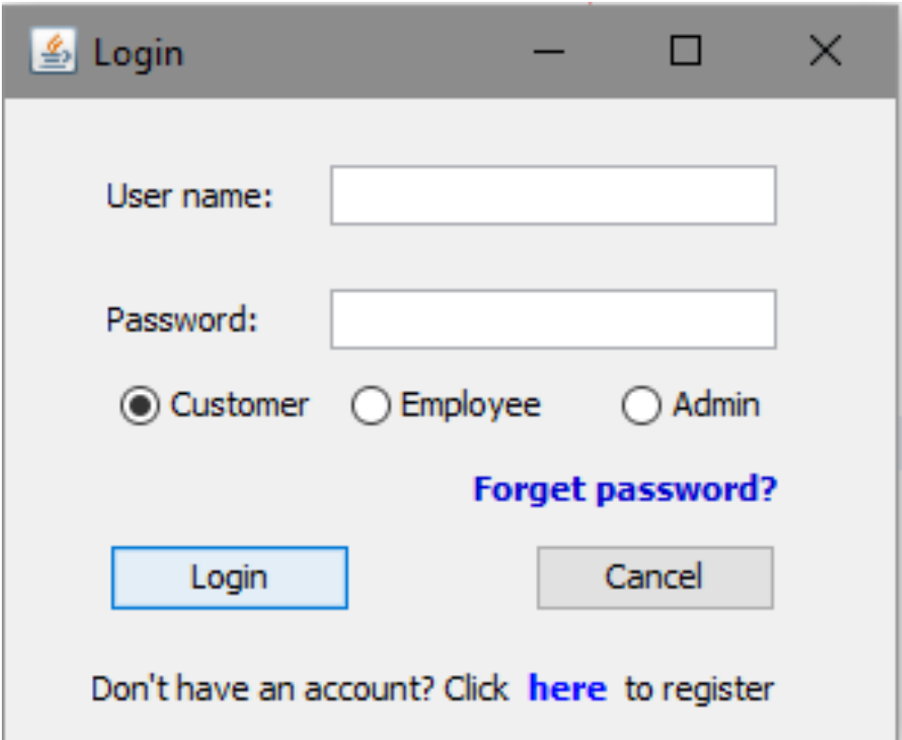

Register
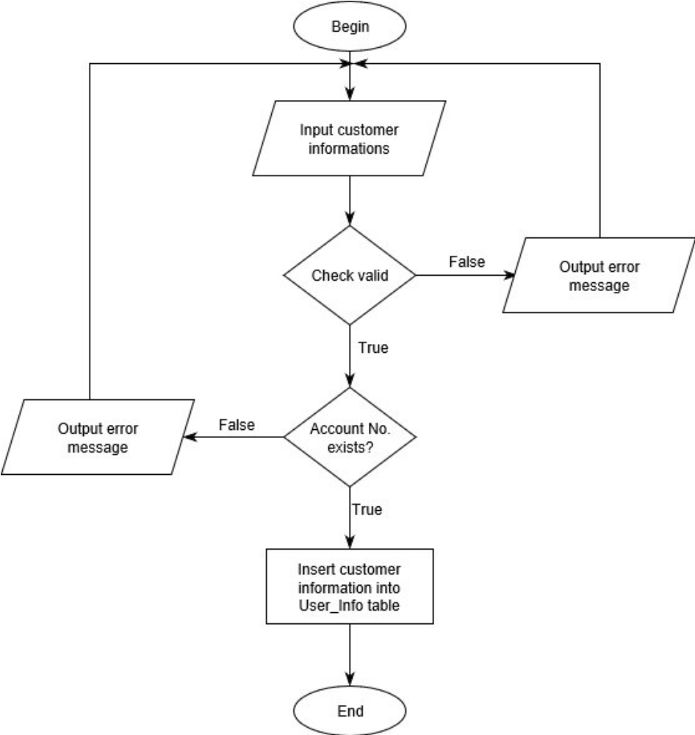
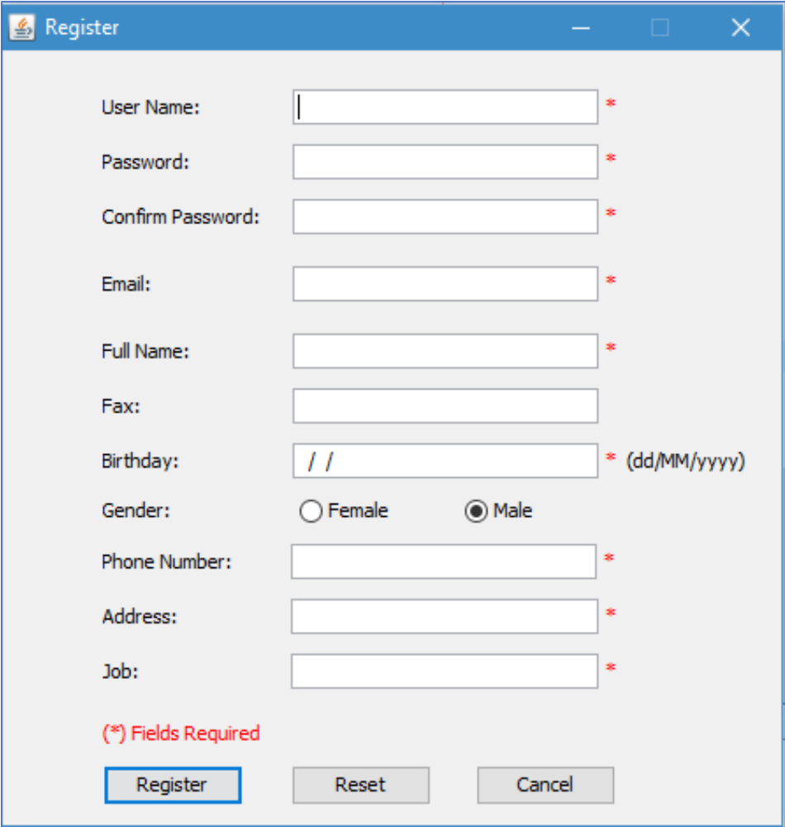

Reset password
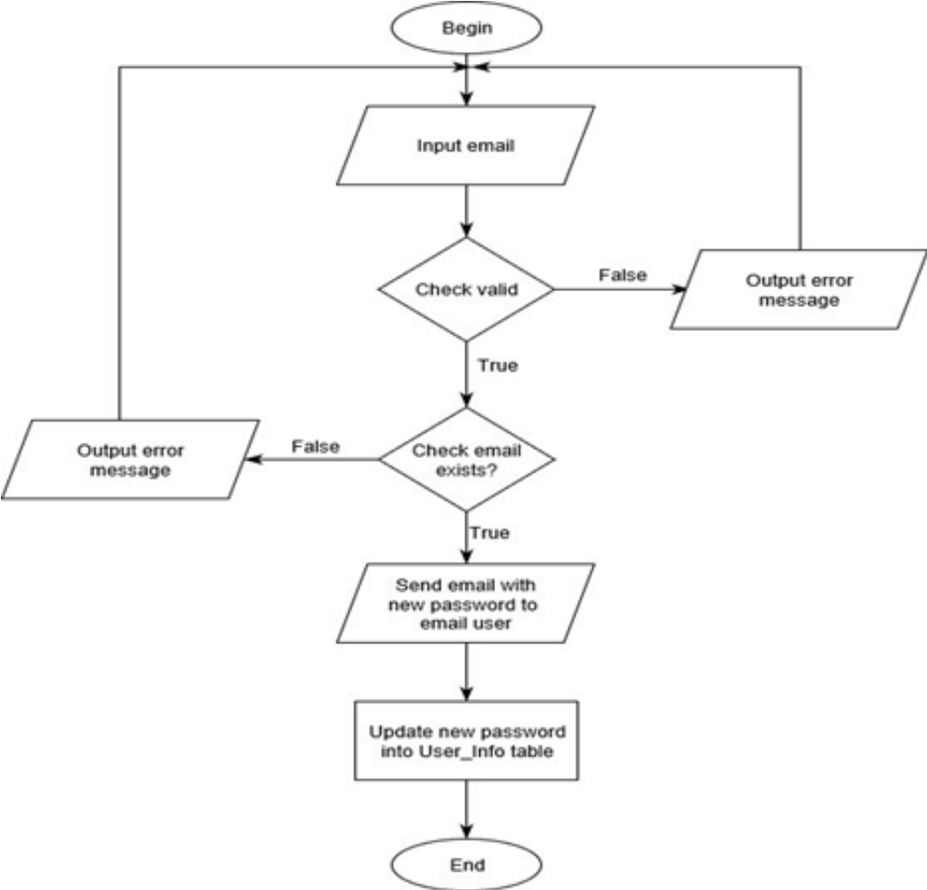
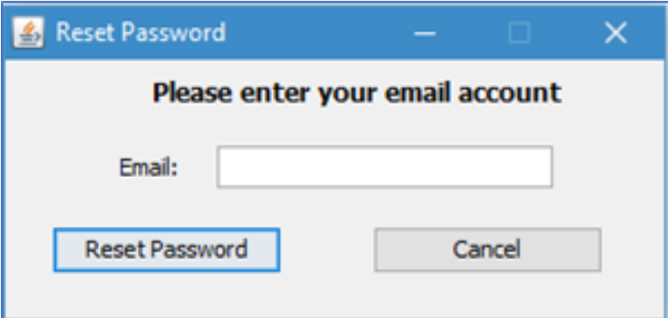
Change password
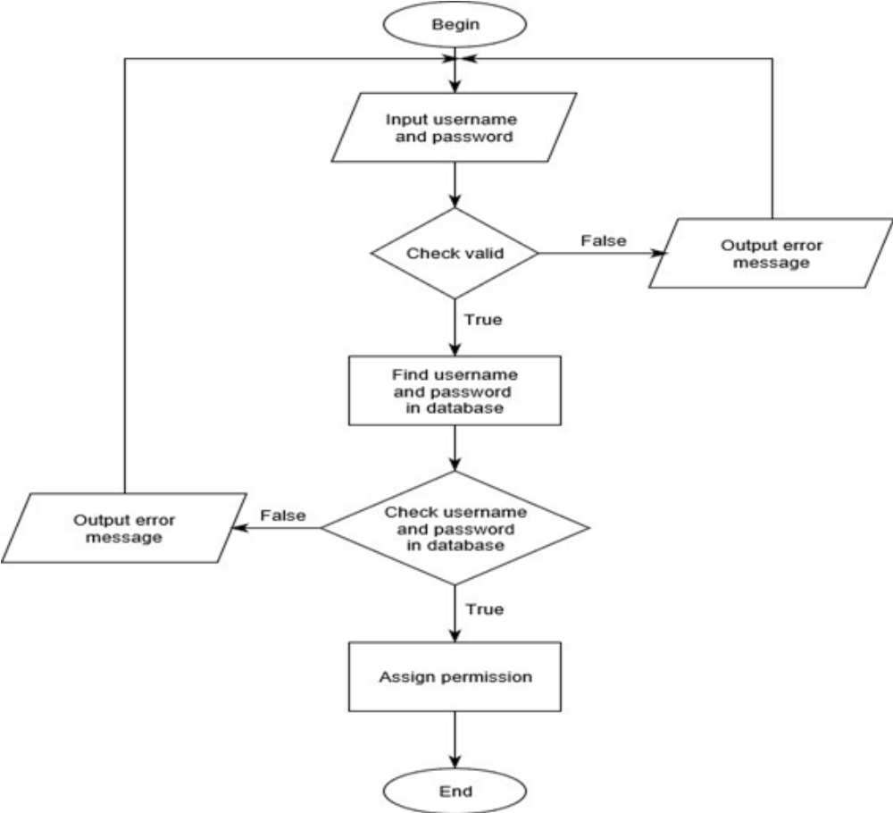
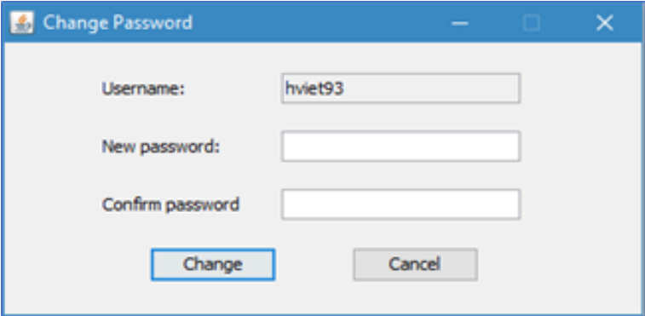
Edit information
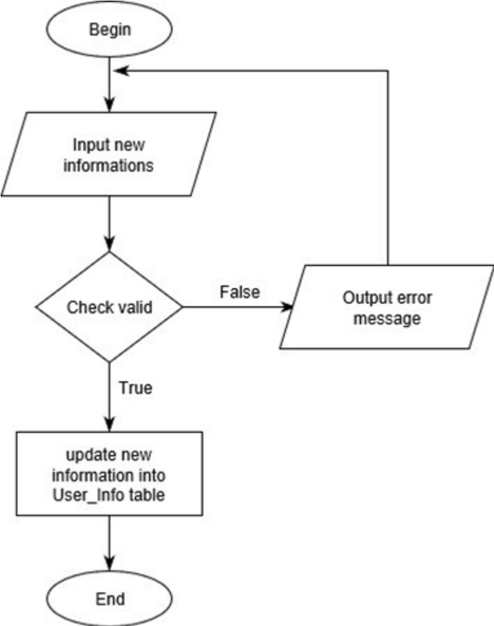
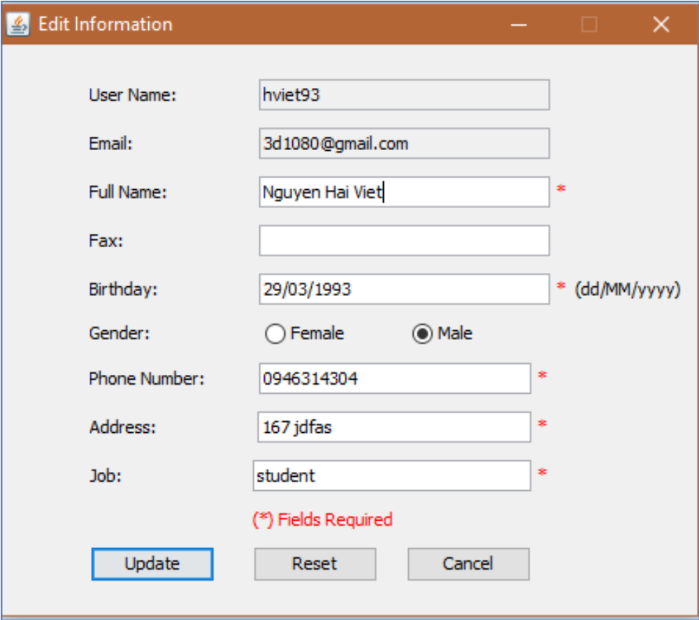

Create a new loan profile
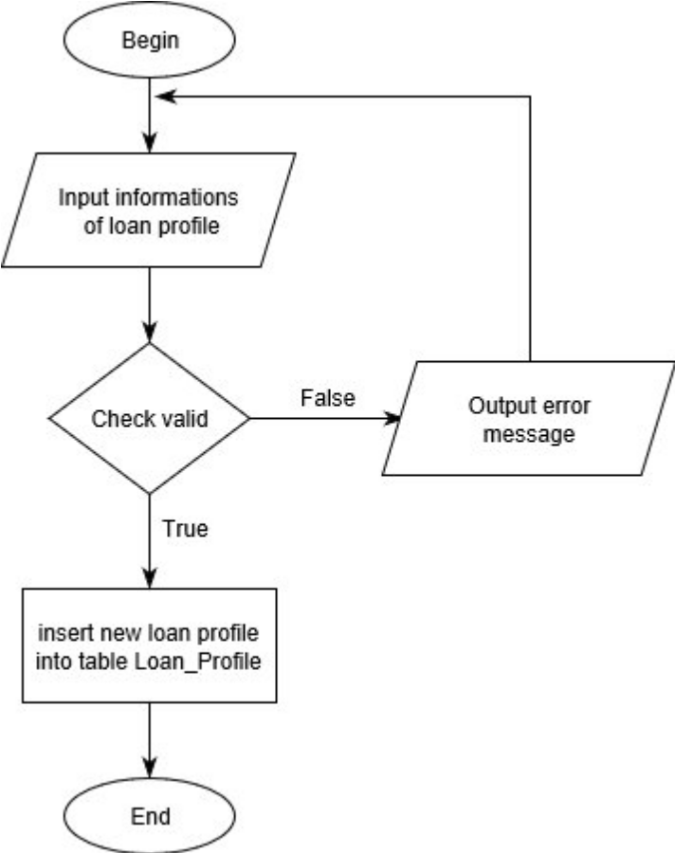

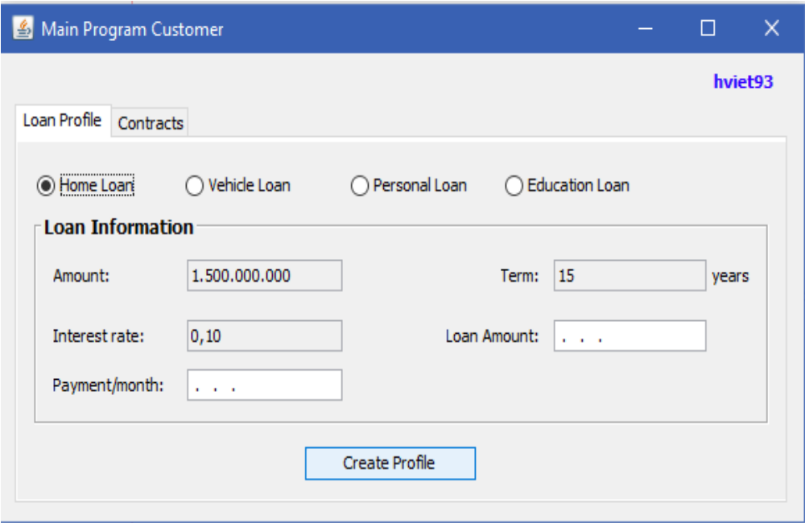

Create contract docx file
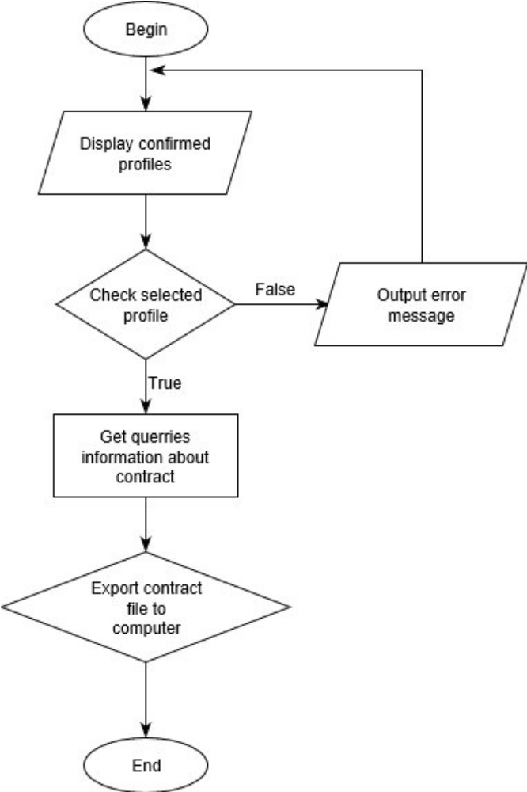
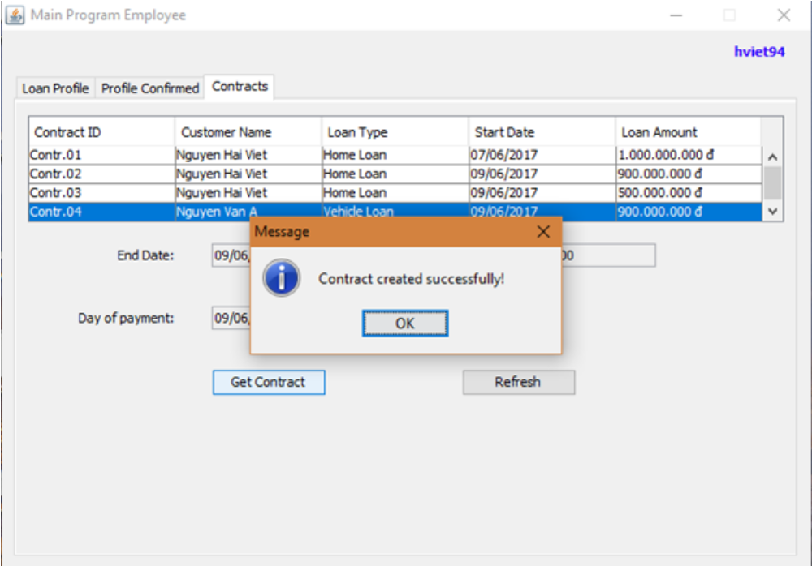

Create new contract
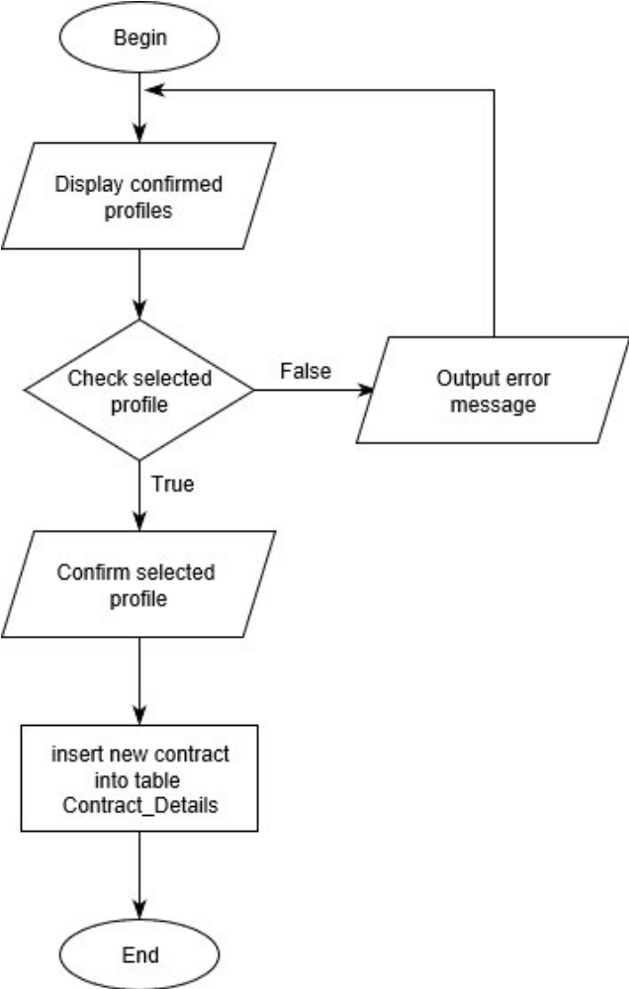

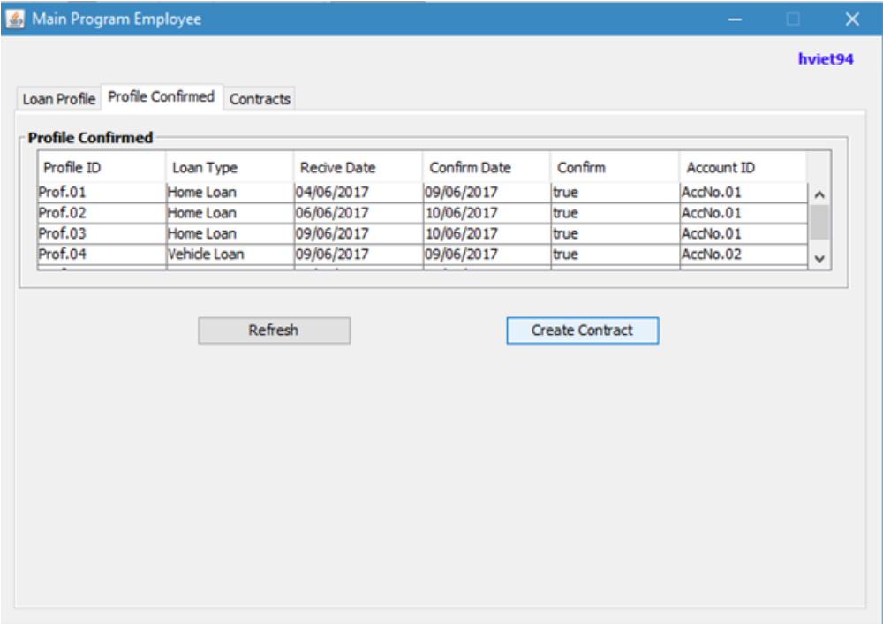

Insert promotion
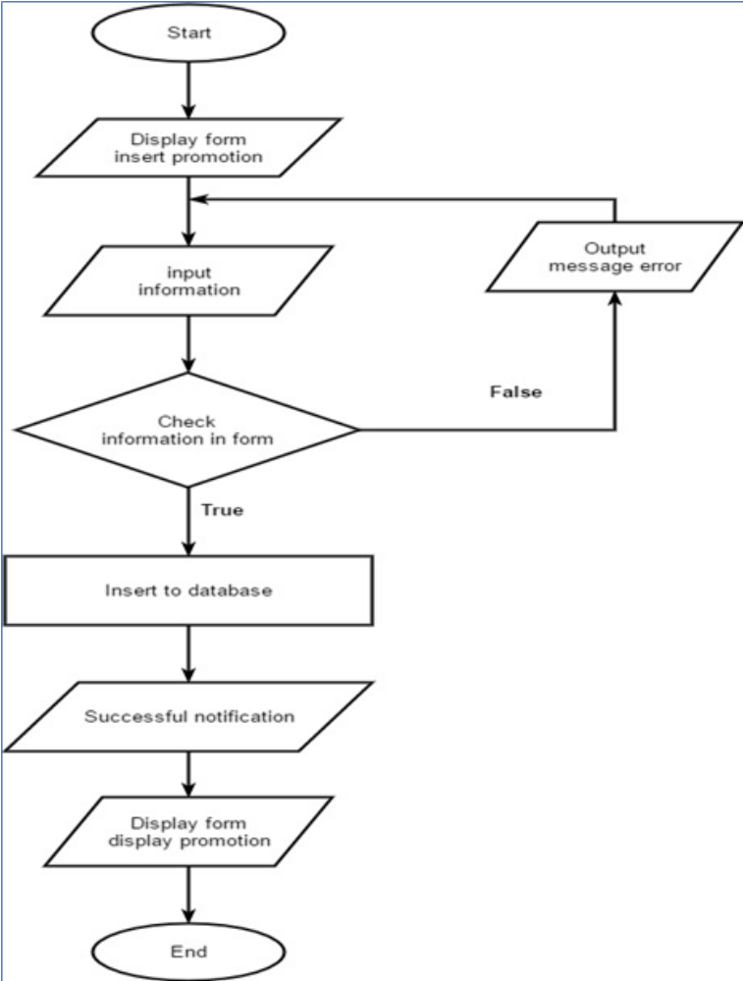

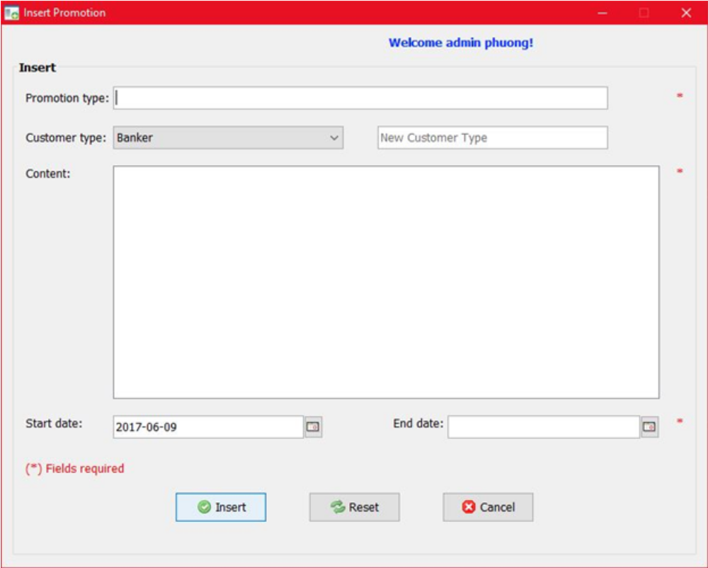

Insert loan type
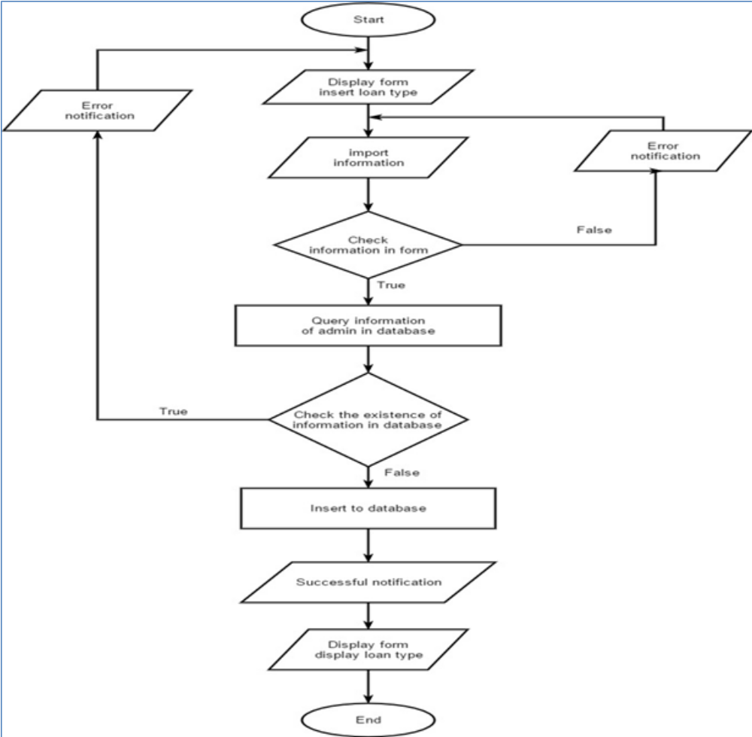

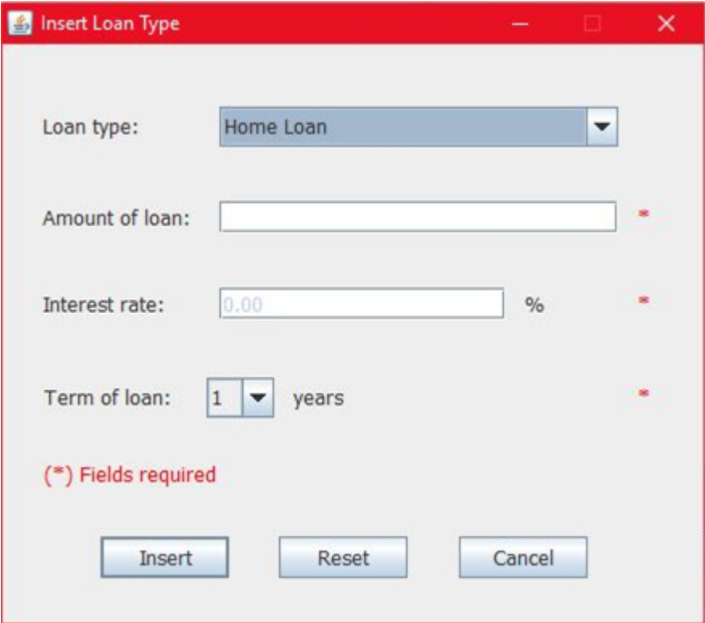
Form display promotion

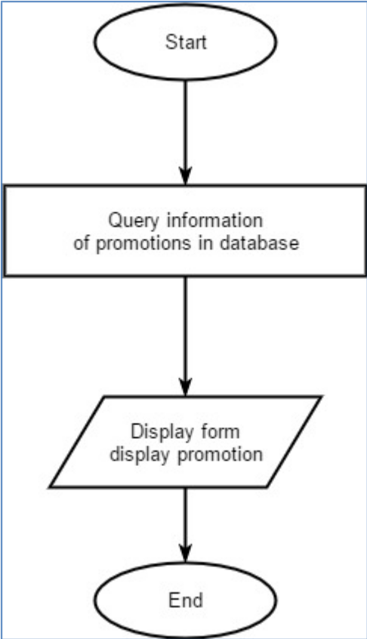

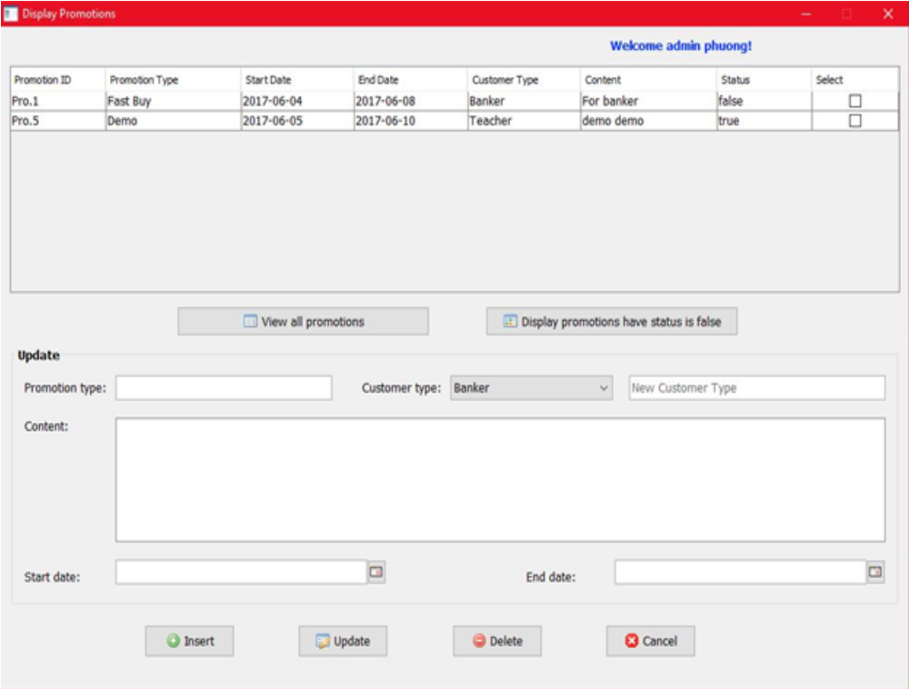

Delete Promotion
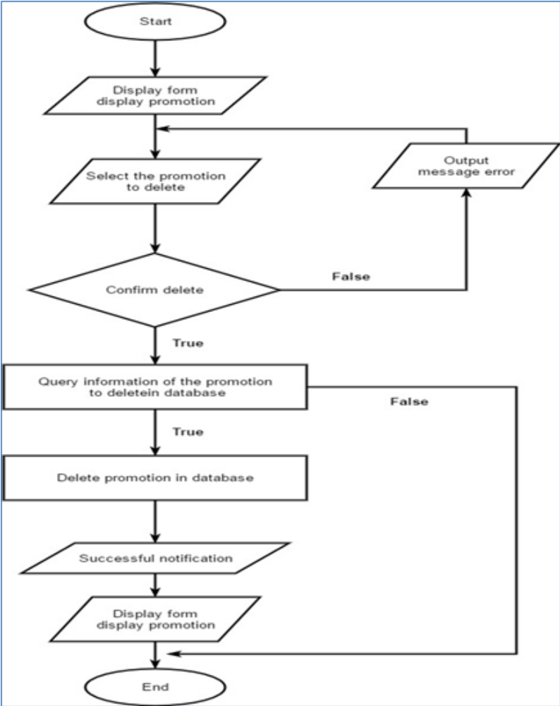

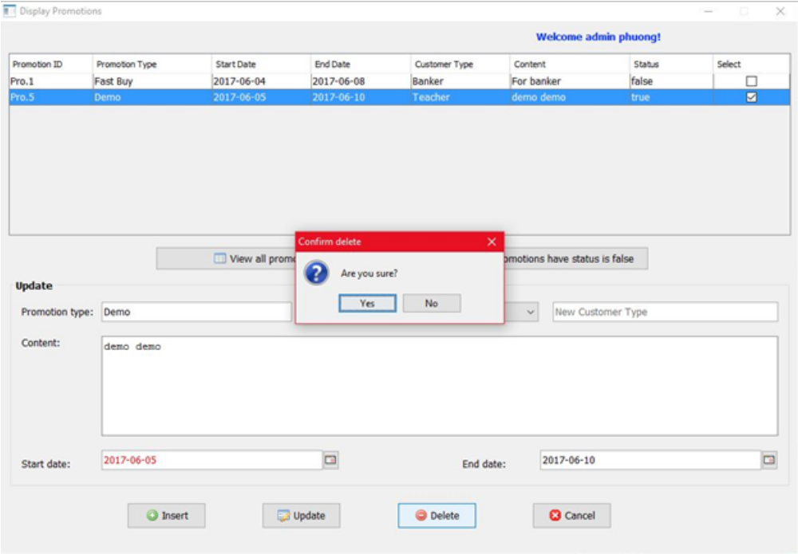

Update Promotion
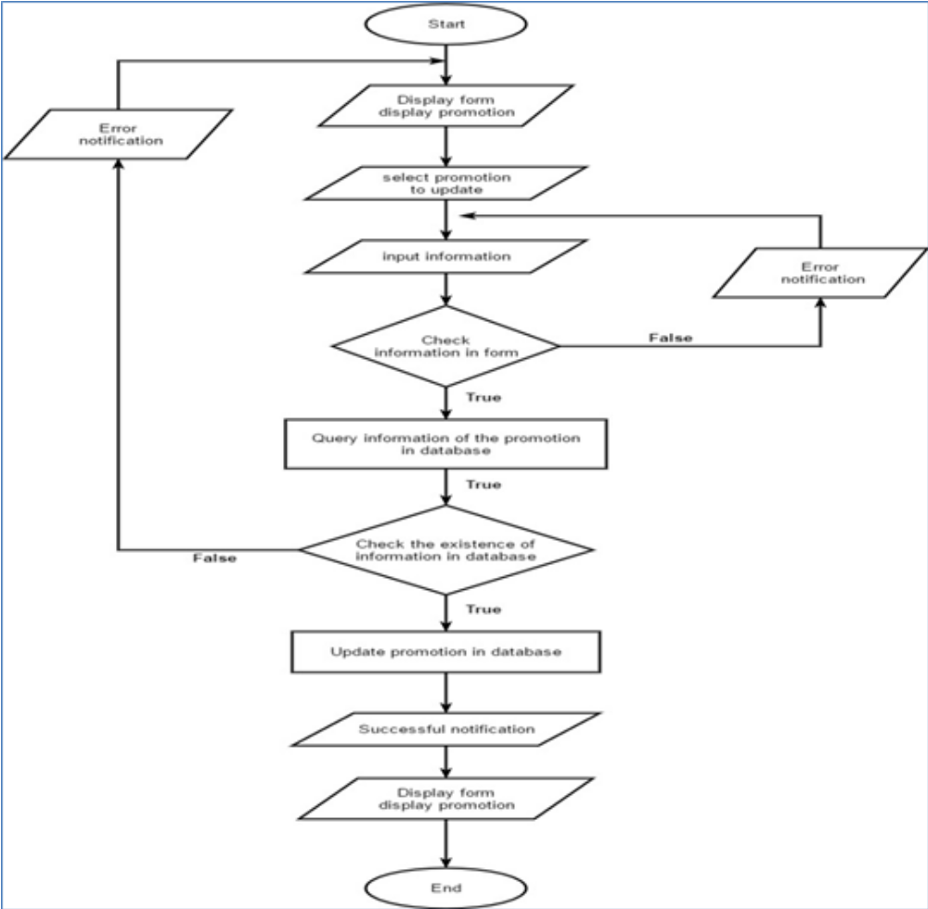

Remove Admin
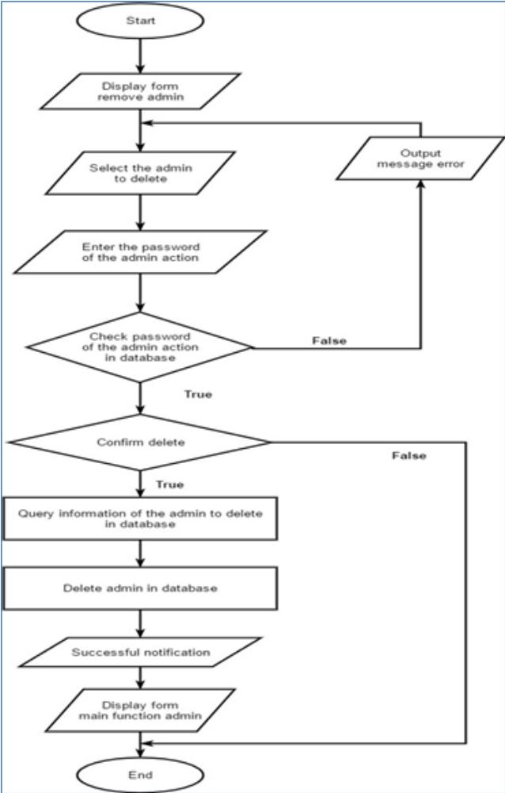

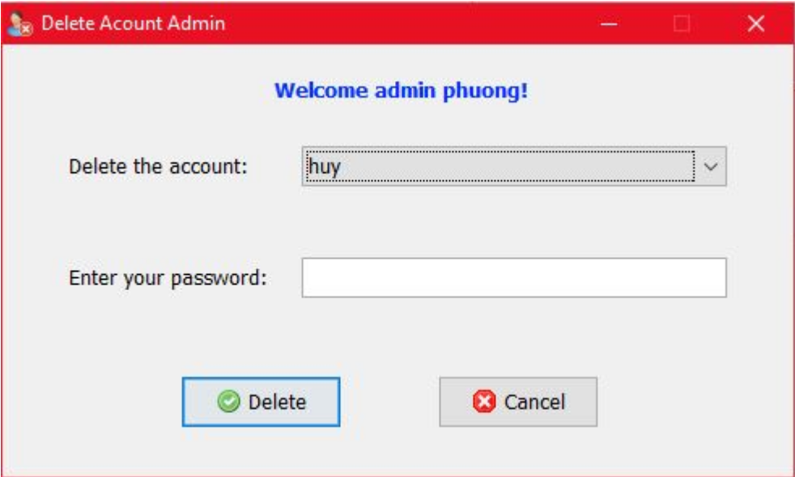

Check Payment
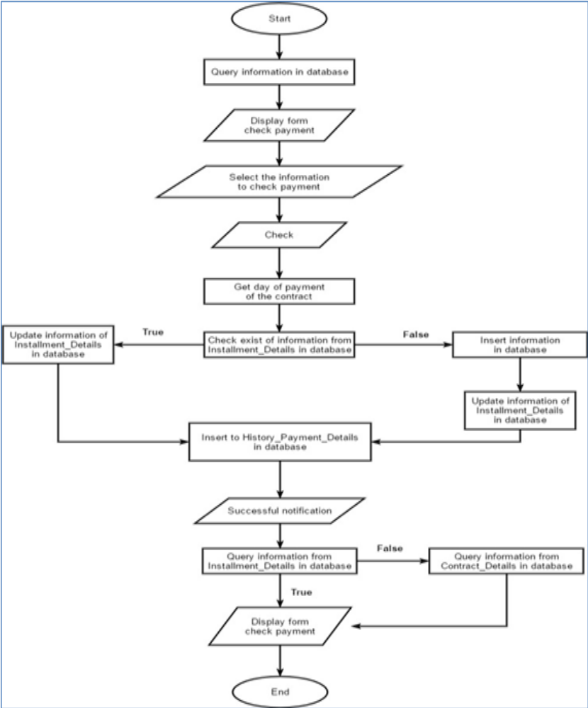

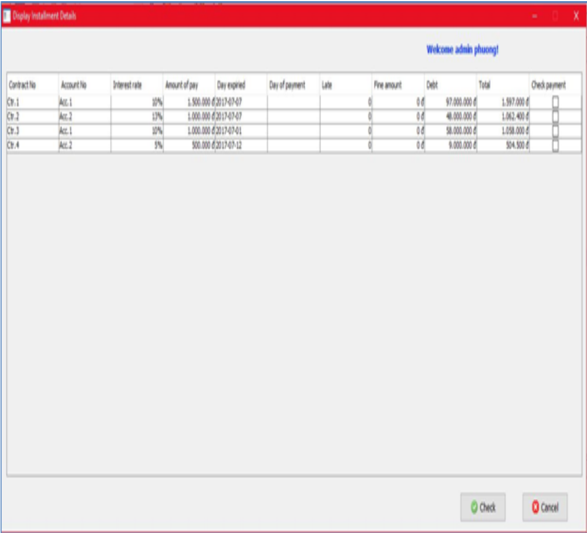

Admin View Customer List
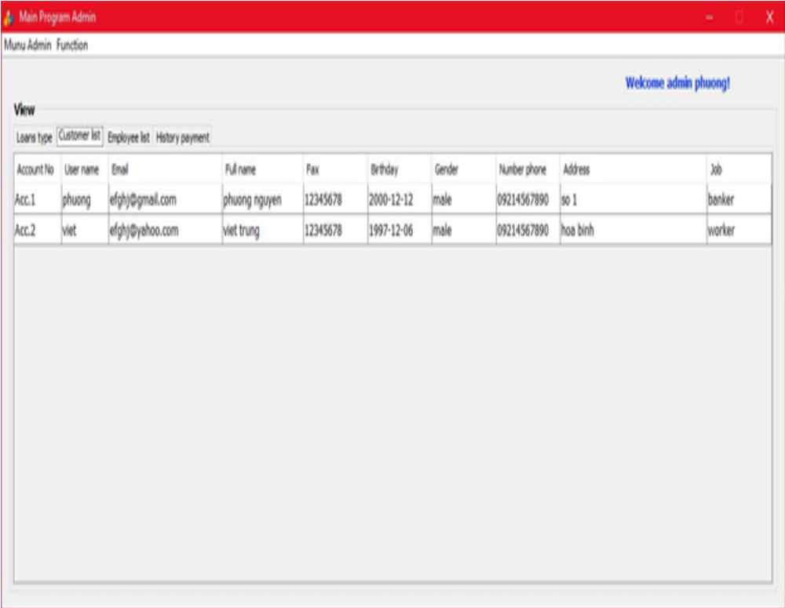
Admin View Employee List
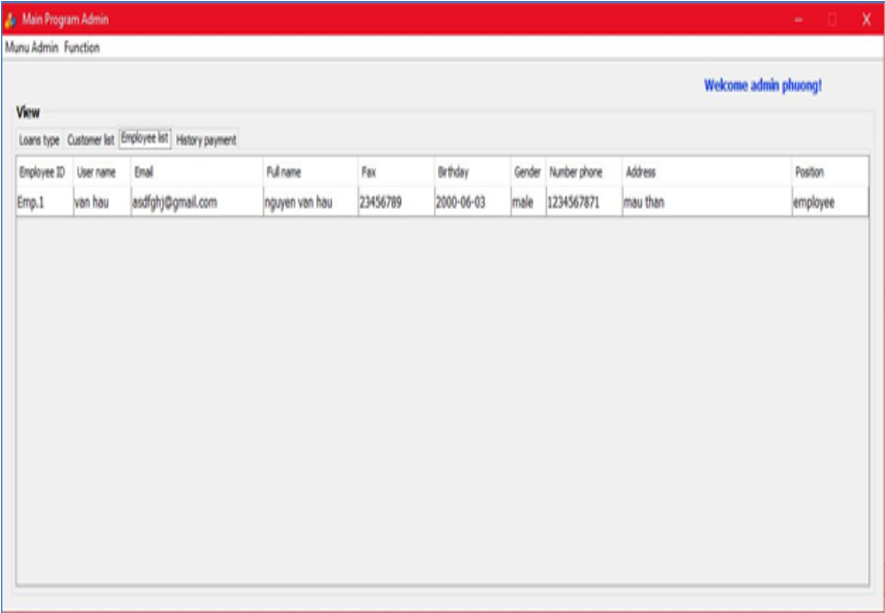

Form display admin list
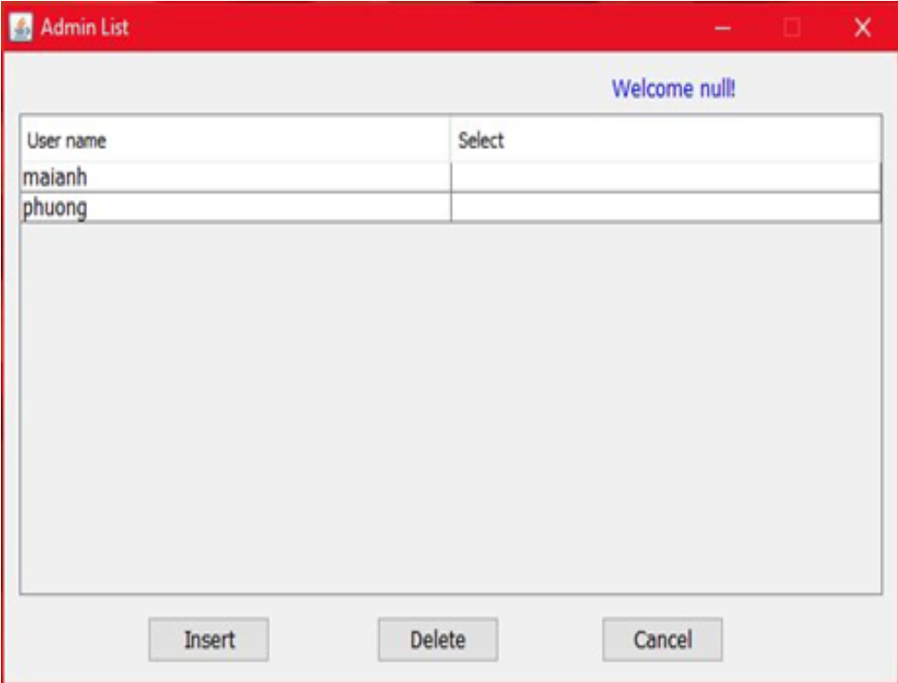

Admin View History Payment
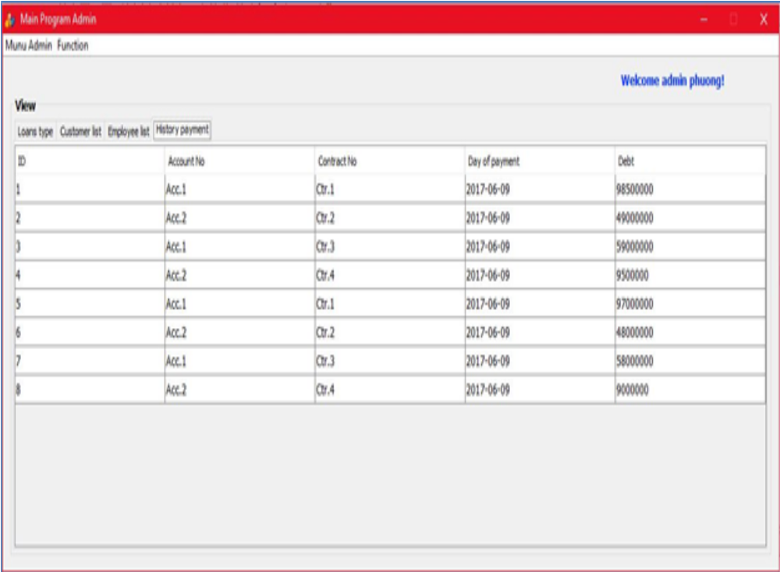

Admin View Loans Type
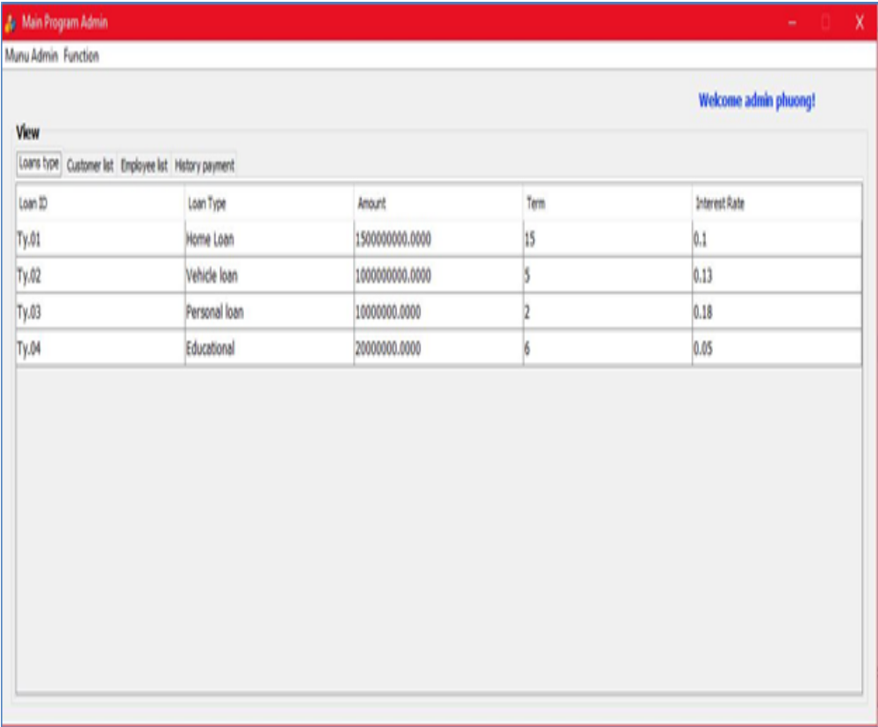

User_info
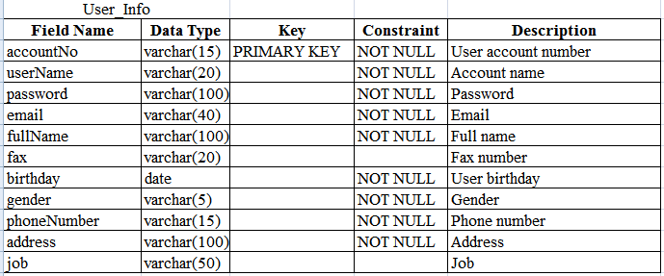
Admin_info
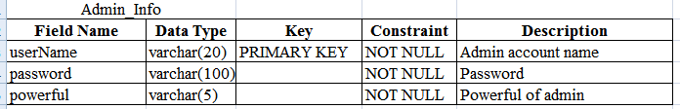

Employee_info
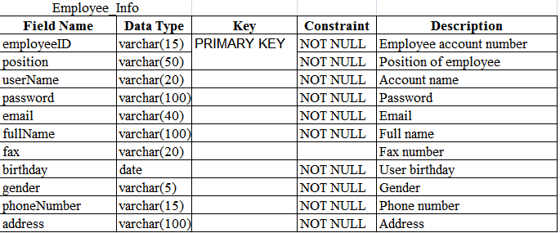
Loans_type
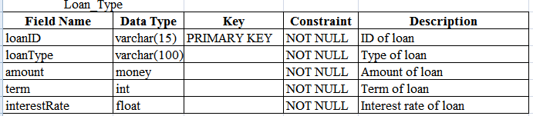

Loans_Profile
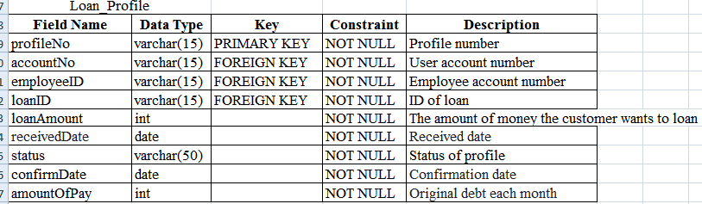
Contract_details
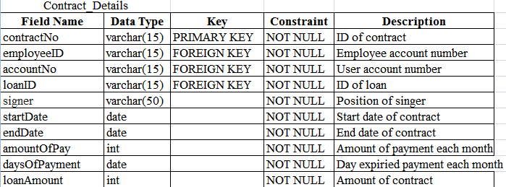

Installment_details
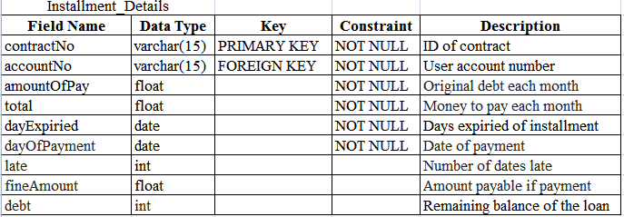
Promotions
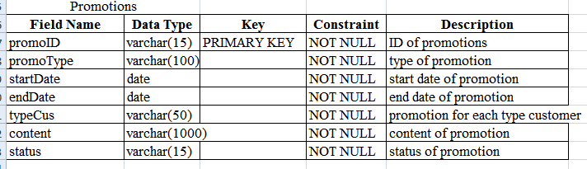
Report_history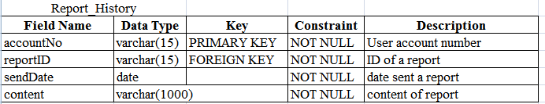
Report_type
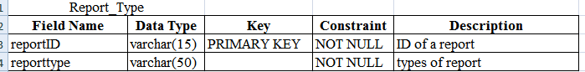
History_payment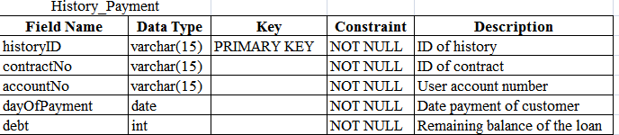

Group activities of the plan:
Form.No | Description | Start Day | NemberName
Form 1 | Problem Definition Document | 10/05/2017 | Nguyen Hai Viet
Form 2.a | CRS | 12/05/2017 | Nguyen Pham Bich Phuong
Form 2.b | CRS | 14/05/2017 | Pham Huy
Form 3 | CRS/Customer  Acceptance Criteria | 16/05/2017 | Nguyen Hai Viet
Form 4 | GUI | 16/05/2017 | Pham Huy
Form 5 | DFD | 10/05/2017 | Nguyen Hai Viet
Form 6 | E-R Diagram | 10/05/2017 | Nguyen Pham Bich Phuong
Form 7 | GUI and FlowChart | 20/05/2017 | Pham Huy
Form 8 | Database table | 10/05/2017 | Nguyen Pham Bich Phuong
Form 9 | Group assignment | 28/05/2017 | Nguyen Hai Viet
Form 10 | Check Function | 30/052017 | Pham Huy
Form 11 | Project Denpendencies | 20/05/2017 | Nguyen Pham Bich Phuong
Form 12 | Recommendations | 09/06/2014 | Pham Huy

No | Check Function | Status
1 | Design | Finish(15/05/2017)
2 | Design admin | Finish(15/05/2017)
3 | Design update , delete , add(customer,employee),display information, change information, reset password | Finish(15/05/2017)
4 | Design employee | Finish(15/05/2017)
5 | Design update , change , reset ,display (password , information) | Finish(15/05/2017)
6 | Design Customer | Finish(15/05/2017)
7 | Design update , change , reset ,display (password , information) | Finish(15/05/2017)
8 | Insert Loan type | Finish(25/05/2017)
9 | Insert promotion | Finish(25/05/2017)
10 | Edit promotion | Finish(25/05/2017)
11 | Amount of loan | Finish(25/05/2017)
12 | Term of loan | Finish(25/05/2017)
13 | Interest rate | Finish(25/05/2017)
14 | Display admin list | Finish(25/05/2017)
15 | Display promotion | Finish(25/05/2017)
16 | Delete promotion | Finish(25/05/2017)
17 | Update promotion | Finish(25/05/2017)
18 | Remove admin | Finish(25/05/2017)
19 | Remove employee | Finish(25/05/2017)
20 | Remove customer | Finish(25/05/2017)
21 | Check payment | Finish(25/05/2017)
22 | View customer list | Finish(25/05/2017)
23 | View employee list | Finish(25/05/2017)
24 | View history payment | Finish(25/05/2017)

Project Denpendencies:
Methods of working group not effective | Methods of working group effective:
Not willing to give opinion, passive | Assign work a very reasonable way
Many ideas, difficult | Multiple implementation of the method
Working groups are not punctual | Always on time
Assinging tasking do not rational | Assign work a very reasonable way
Do not listen to the opinions of members | Always listen to others speak
Do not respect the opinions of members | Respect the opinions of the group members
No self- conscious of their responsibilities in the group | The self- consciousness of each member of the group

No. | Responsibilities | Date of implementation of the plan | Recommendations
No. | Responsibilities | From | To
Form 1 | Problem Definition Document | 10/05/2017 | May 12,2017
Form 2.a | CRS | 12/05/2017 | May 14,2017
Form 2.b | CRS | 14/05/2017 | May 14,2017
Form 3 | CRS/Customer  Acceptance Criteria | 16/05/2017 | May 18,2017
Form 4 | GUI | 16/05/2017 | May 18,2017
Form 5 | DFD | 10/05/2017 | May 15,2017
Form 6 | E-R Diagram | 10/05/2017 | May 15,2017
Form 7 | GUI and FlowChart | 20/05/2017 | May 25,2017
Form 8 | Database table | 10/05/2017 | May 12,2017
Form 9 | Group assignment | 28/05/2017 | May 31,2017
Form 10 | Check Function | 30/052017 | Jun 02,2017
Form 11 | Project Denpendencies | 20/05/2017 | May 22,2017
Form 12 | Recommendations | 09/06/2014 | Jun 08,2017

