|  |  |  |
| --- | --- | --- |
| **Design plan** | **Document Name: Problem Definition Document** | **SWD/Form No.1** |
| **Effective Date: 3/10/2017** | **Version: 1** | **Page No.1** |

**Introduction:**

LMN medical store is a medical store which buys and sells medicines for the requirement of the customer. The store will buy medicines from companies or other medical stores and then sell them for customer as wholesale retail shops and selling prescription drugs. For the past few months they are facing difficulties in maintaining the records of payment, ordering, delivering, and storing information, because they don't have an effective system to manage information about customer, dealer, distributors also as orders, payments. And then, slipups appear.

Now they want to have an automated system application that holds the complete information about the drugs, dealers, and wholesale retails in a modular form to make convenient approach to track all the records and avoid slipups in all system.

The application will provide functions:

Entering all information about drugs, customers, dealers.

Inventory management.

Update the quantity of drugs automatically regularly.

Payment details and the details of the purchased done information will be kept in the database and can be retrieve easily.

|  |  |  |
| --- | --- | --- |
|  | **Prepared By (Student)** | **Approved By (Teacher)** |
| **Date: 3/10/2017** | **Nguyen Phuoc Nguyen**  **Truong Phuoc Loi**  **Luu Truong Moc** | **Le Thi Minh Loan** |

|  |  |  |
| --- | --- | --- |
| **Design plan:** | **Document Name: CRS** | **SWD/Form No.2A** |
| **Effective Date: 3/12/2017** | **Version: 1** | **Page No.1/2** |

1. **List of inputs to the system**

Producer

* Name
* Address
* Phone
* Email

Category

* Name

Product

* Product name
* Producer
* Category
* Selling Price
* Detail

Supplier

* Name
* Address
* Phone
* Email

Supplying

* Supplier
* Supplying date
* Discount

Product

* Supplying
* Product
* Quantity
* Price
* Making date
* Deadline

|  |  |  |  |  |
| --- | --- | --- | --- | --- |
|  | **Prepared By (Student)** | | **Approved By (Teacher)** | |
| **Date: 3/12/2017** | **Nguyen Phuoc Nguyen**  **Truong Phuoc Loi**  **Luu Truong Moc** | | **Le Thi Minh Loan** | |
| **Design plan:** | | **Document Name: CRS** | | **SWD/Form No.2A** |
| **Effective Date: 3/15/2017** | | **Version: 1** | | **Page No.2/2** |

Customer

* Name
* Address
* Phone
* Email

User

* Username
* Password
* User type
* Name

1. **List of outputs expected from the system**

* Statistic Calculation.
* Easy searching for selling.
* Supplying details, Order details.

1. **Overview of processes involved in the system**

* User login
* Customer, Supplier, Producer management
* Selling, Order product

1. Hardware and software required for implementing the project

|  |  |  |
| --- | --- | --- |
|  | Hardware | Software |
| Client | * Java SE .0 * SQL Server 2012 * NetBeans 7.1 | * HDD window XP above |

|  |  |  |  |  |
| --- | --- | --- | --- | --- |
|  | **Prepared By (Student)** | | **Approved By (Teacher)** | |
| **Date: 3/15/2017** | **Nguyen Phuoc Nguyen**  **Truong Phuoc Loi**  **Luu Truong Moc** | | **Le Thi Minh Loan** | |
| **Design plan:** | | **Document Name: CRS/Customer Acceptance Criteria** | | **SWD/Form No.2B** |
| **Effective Date: 3/15/2017** | | **Version: 1** | | **Page No.1** |

|  |  |
| --- | --- |
| **S.No** | **Customer’s Acceptance Criteria** |
| 1. | Display information detail of products |
| 2. | Client can watch, add, update and delete information about customer |
| 3. | Client can watch, add, update and delete information of products |
| 4. | Client can watch, add, update and delete information of supplier and category |
| 5. | Login, update information, forget/ change password of administrator |
| 6. | Display information of orders |
| 7. | Look for information of products, customers |

|  |  |  |  |
| --- | --- | --- | --- |
|  | **Prepared By (Student)** | | **Approved By (Teacher)** |
| **Date: 3/15/2017** | **Nguyen Phuoc Nguyen**  **Truong Phuoc Loi**  **Luu Truong Moc** | | **Le Thi Minh Loan** |
| **Design plan** | | **Document Name: Project Plan** | **SWD/Form No.3** |
| **Effective Date: 3/17/2017** | | **Version: 1** | **Page No.1/2** |

**Project plan:**

1. **Project Details:**

* **Name of the Client:**

LMN General Medical Store

* **Date of Project Plan:** 28/02/2017
* **Project Vision/Objectives:**

Develop a management system application which store information about drugs, customers, retailers, distributors and manage them, also have enough necessary functions for the store’s owner to work effectively, such as statistic bill, calculate revenue, import, export inventory. Automatically processers like updating quantity, alert out of stock, discount depend on type of customer.

* **Scope:**

Medical store, retails shop, surgery, distributors.

* **Our understanding about the Client organization:**

LMN is a small medical store which buys drugs from many distributors and sells them to customer (Retail buyers or another store) with two type: Selling prescription drugs and wholesale – retail.

* **Project with Organization with Responsibilities and Authorities:**
* Nguyen Nguyen Phuoc: Team leader – Talk client’s information, division works, design standards and interface, coding.
* Moc Luu Truong: Team member – Talk client’s information, coding.
* Loi Truong Phuoc: team member – Talk client’s information, coding.

|  |  |  |
| --- | --- | --- |
|  | **Prepared By (Student)** | **Approved By (Teacher)** |
| **Date: 3/17/2017** | **Nguyen Phuoc Nguyen**  **Luu Truong Moc**  **Truong Phuoc Loi** | **Le Thi Minh Loan** |
| **Design plan:** | **Document Name: Project Plan** | **SWD/Form No.3** |
| **Effective Date: 3/19/2017** | **Version: 1** | **Page No.2/2** |

1. **Project initiation/Requirement Documents**

Client’s requirement document.

Project standards requirement document.

1. **Deliverable**

Using guide book, setting guide book, Project document.

1. **Project dependencies**

* Members slow process or out of the project – Solution: Leave the lacking for later updating.

1. **Major project prototype**

LMN Medical Store App.

1. **Quality plan**

* **Review Activities**

At least 3 times a week, each meeting there is a check for each member in group to review processing, help to solve hard troubles: Members usually come late or

* **Testing Activities**

Check database.

Check functions.

Check results.

Check exception.

* **Backup and recovery strategies**

Each member store a copy of project in their own computer and one in their mail drive.

|  |  |  |
| --- | --- | --- |
|  | **Prepared By (Student)** | **Approved By (Teacher)** |
| **Date: 3/19/2017** | **Nguyen Phuoc Nguyen**  **Luu Truong Moc**  **Truong Phuoc Loi** | **Le Thi Minh Loan** |

|  |  |  |
| --- | --- | --- |
| **Design plan** | **Document Name: GUI Standards Document** | **SWD/Form No.4** |
| **Effective Date: 3/20/2017** | **Version: 1** | **Page No.1** |

**Document Design**

|  |  |
| --- | --- |
| **Property** | **Value** |
| Document theme and color scheme | Times new Roman – Color black |
| From-Background color | White |
| Title-Font Size | 15 |
| Title-Font Color | Black |
| Title-Font Style | Times new roman |
| Title-Alignment | Left |
| Background color of Controls on the form | White |
| Foreground color of Controls on the form | Black |
| Control Caption – Font Size | 13 |
| Control Caption – Font Color | Black |
| Control Caption – Font Style | Times new roman |
| Control caption and controls-Alignment | Left |
| Command button-Alignment | Center |

|  |  |  |  |  |
| --- | --- | --- | --- | --- |
|  | **Prepared By (Student)** | | **Approved By (Teacher)** | |
| **Date: 3/20/2017** | **Nguyen Phuoc Nguyen** | | **Le Thi Minh Loan** | |
| **Design plan:** | | **Document Name: Interface Design Document** | | **SWD/Form No.5** |
| **Effective Date: 3/20/2017** | | **Version: 1** | | **Page No.1/4** |

|  |  |  |
| --- | --- | --- |
| **Document Name** | **Description** | **Controls on the Document** |
| User login |  | - Textfield Username  - Passwordfield Password  - Button Login |
| Main Form |  | - Menubar  - Quick Button  - TabbedPane |

|  |  |  |
| --- | --- | --- |
|  | **Prepared By (Student)** | **Approved By (Teacher)** |
| **Date: 3/22/2017** | **Nguyen Phuoc Nguyen** | **Le Thi Minh Loan** |
| **Design plan:** | **Document Name: Interface Design Document** | **SWD/Form No.5** |
| **Effective Date: 3/20/2017** | **Version: 1** | **Page No.2/4** |

|  |  |  |
| --- | --- | --- |
| **Document Name** | **Description** | **Controls on the Document** |
| Add Product |  | - ComboBox Category, Producer  - Textfield Product Name, Selling Price  - TextArea Detail  - Button Add, Cancel  - Lable Message |
| Selling |  | - Textfield Customer  - Button Choose Customer, Confirm Sell, Reset Form, Cancel  - Button Add, Remove Product, Update Quantity, Selling Price |

|  |  |  |
| --- | --- | --- |
|  | **Prepared By (Student)** | **Approved By (Teacher)** |
| **Date: 3/22/2017** | **Nguyen Phuoc Nguyen** | **Le Thi Minh Loan** |
| **Design plan** | **Document Name: Interface Design Document** | **SWD/Form No.5** |
| **Effective Date: 3/20/2017** | **Version: 1** | **Page No.3/4** |

|  |  |  |
| --- | --- | --- |
| **Document Name** | **Description** | **Controls on the Document** |
| Choose Customer |  | - Textfield Search Customer |
| Choose Product |  | - Textfield SearchProduct, Quantity, Selling Price  - Lable Current Quantity, Suggestion Price  - Button Add Product for Selling, Cancel |

|  |  |  |
| --- | --- | --- |
|  | **Prepared By (Student)** | **Approved By (Teacher)** |
| **Date: 3/22/2017** | **Nguyen Phuoc Nguyen** | **Le Thi Minh Loan** |
| **Design plan** | **Document Name: Interface Design Document** | **SWD/Form No.5** |
| **Effective Date: 3/20/2017** | **Version: 1** | **Page No.4/4** |

|  |  |  |
| --- | --- | --- |
| **Document Name** | **Description** | **Controls on the Document** |
| Statistic Finance |  | - Button Today, This month, this year, Ever, Statistic with particular time  - Textfield from year, month, day, textfield to year, month, day  - Lable Selling, Order, Total’s value and their supplied product’s value, Total finance  - Lable Total Product, total Quantity and Total value in inventory |

|  |  |  |  |
| --- | --- | --- | --- |
|  | **Prepared By (Student)** | | **Approved By (Teacher)** |
| **Date: 3/22/2017** | **Nguyen Phuoc Nguyen** | | **Le Thi Minh Loan** |
| **Design plan** | | **Document Name: Table Design Document** | **SWD/Form No.6** |
| **Effective Date: 3/22/2017** | | **Version: 1** | **Page No.1/2** |

|  |  |  |  |  |  |
| --- | --- | --- | --- | --- | --- |
| **Name of the Table** | **Table Description** | **Number of Fields** | **Primary Key** | **Related Tables** | **Foreign Key** |
| Supplier | Suppliers’ information | 5 | SupplierID | 1. Supplying |  |
| Supplying | Supplying times | 4 | SupplyingID | 1. Supplier  2. SuppliedProduct | Supplier (SupplierID) |
| SuppliedProduct | Supplying’ Products as Product for sell | 8 | SuppliedProductID | 1. Supplying  2. Product  3. Selling  4. Order | Supplying (SupplyingID), Product (ProductID) |
| Category | Category | 2 | CategoryID | 1. Product |  |
| Producer | Producers’ information | 5 | ProducerID | 1. Product |  |
| Product | Product’ information | 6 | ProductID | 1. Category  2. Producer  3. SuppliedProduct | Category (CategoryID), Producer (ProducerID) |
| Customer | Customer’ information | 5 | CustomerID | 1. Selling  2. Order |  |
| Selling | Selling (Retail) | 6 | SellingID | 1. Customer  2. SuppliedProduct | Customer (CustomerID), SuppliedProduct (SuppliedProductID) |
| Order | Order (Wholesale) | 7 | OrderID | 1. Customer  2. OrderDetail | Customer (CustomerID) |
| OrderDetail | Order Detail | 4 | OrderID, SuppliedProductID | 1. OrderDetail  2. SuppliedProduct |  |
| User | User’ information | 5 | UserID |  |  |

|  |  |  |
| --- | --- | --- |
|  | **Prepared By (Student)** | **Approved By (Teacher)** |
| **Date: 3/22/2017** | **Nguyen Phuoc Nguyen** | **Le Thi Minh Loan** |
| **Design plan** | **Document Name: Document Design** | **SWD/Form No.6** |
| **Effective Date: 3/22/2017** | **Version: 1** | **Page No.2/2** |

ER

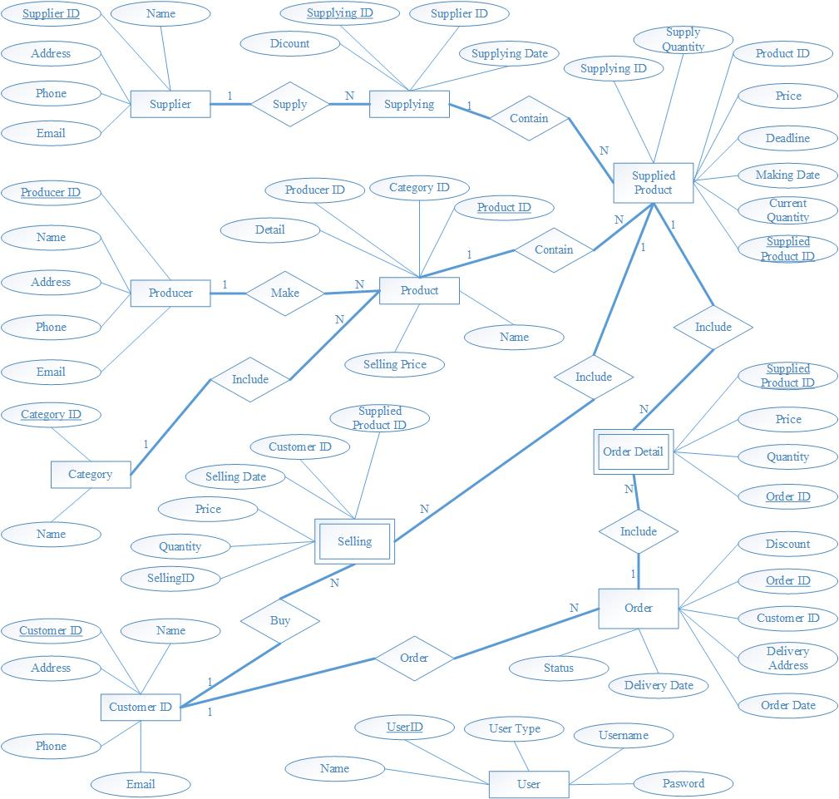

|  |  |  |  |
| --- | --- | --- | --- |
|  | **Prepared By (Student)** | | **Approved By (Teacher)** |
| **Date: 3/22/2017** | **Nguyen Phuoc Nguyen** | | **Le Thi Minh Loan** |
| **Design plan** | | **Document Name: Process Design Document** | **SWD/Form No.7** |
| **Effective Date: 4/10/2017** | | **Version: 1** | **Page No.1/13** |

**DFD Context Diagram**

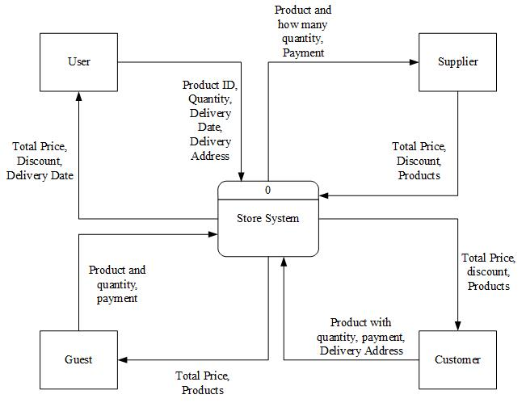

|  |  |  |
| --- | --- | --- |
|  | **Prepared By (Student)** | **Approved By (Teacher)** |
| **Date: 4/10/2017** | **Nguyen Phuoc Nguyen** | **Le Thi Minh Loan** |

|  |  |  |
| --- | --- | --- |
| **Design plan** | **Document Name: Process Design Document** | **SWD/Form No.7** |
| **Effective Date: 4/10/2017** | **Version: 1** | **Page No.2/13** |

**Selling (Retail) – Part 1**

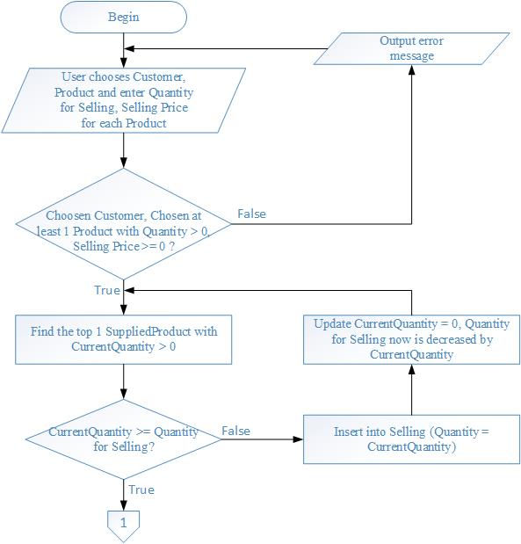

|  |  |  |
| --- | --- | --- |
|  | **Prepared By (Student)** | **Approved By (Teacher)** |
| **Date: 4/10/2017** | **Nguyen Phuoc Nguyen** | **Le Thi Minh Loan** |

|  |  |  |
| --- | --- | --- |
| **Design plan** | **Document Name: Process Design Document** | **SWD/Form No.7** |
| **Effective Date: 4/10/2017** | **Version: 1** | **Page No.3/13** |

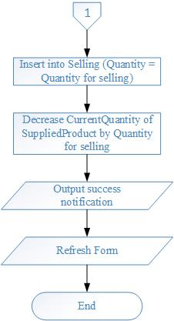**Selling (Retail) – Part 2**

|  |  |  |
| --- | --- | --- |
|  | **Prepared By (Student)** | **Approved By (Teacher)** |
| **Date: 4/10/2017** | **Nguyen Phuoc Nguyen** | **Le Thi Minh Loan** |

|  |  |  |
| --- | --- | --- |
| **Design plan** | **Document Name: Process Design Document** | **SWD/Form No.7** |
| **Effective Date: 4/10/2017** | **Version: 1** | **Page No.4/13** |

**New Product**

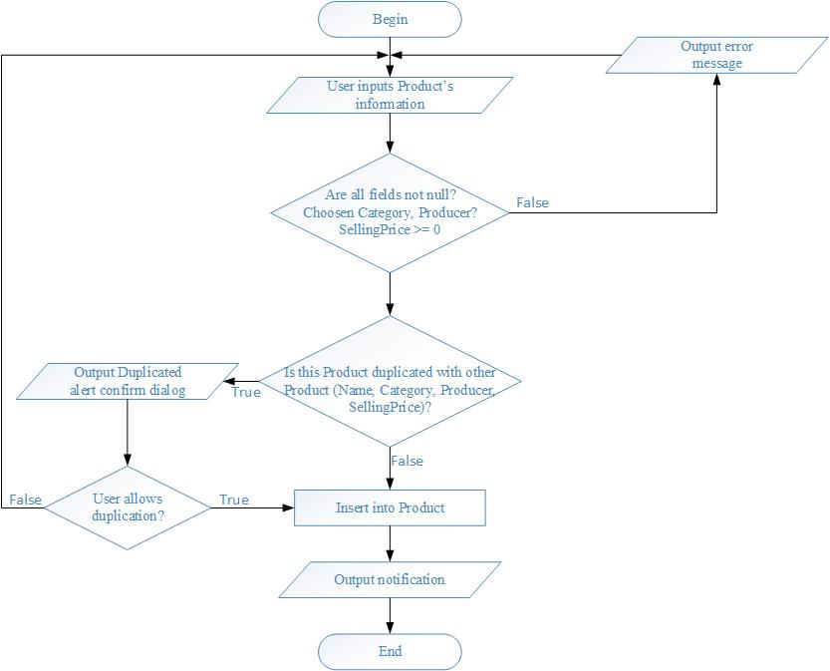

|  |  |  |
| --- | --- | --- |
|  | **Prepared By (Student)** | **Approved By (Teacher)** |
| **Date: 4/10/2017** | **Nguyen Phuoc Nguyen** | **Le Thi Minh Loan** |

|  |  |  |
| --- | --- | --- |
| **Design plan** | **Document Name: Process Design Document** | **SWD/Form No.7** |
| **Effective Date: 4/10/2017** | **Version: 1** | **Page No.5/13** |

**Update Product**

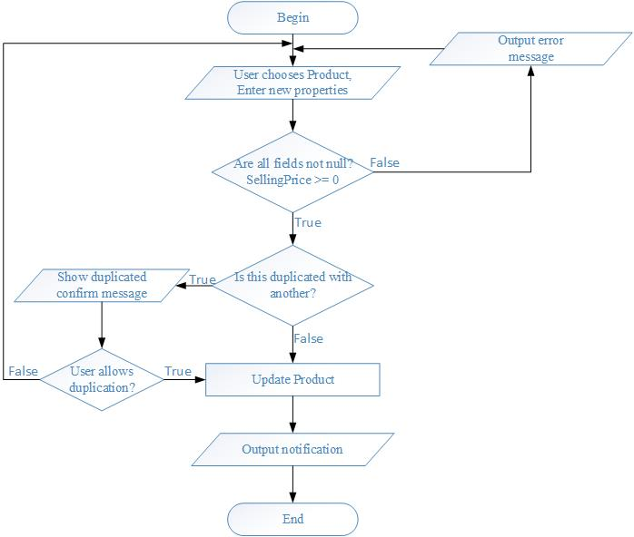

|  |  |  |
| --- | --- | --- |
|  | **Prepared By (Student)** | **Approved By (Teacher)** |
| **Date: 4/10/2017** | **Nguyen Phuoc Nguyen** | **Le Thi Minh Loan** |

|  |  |  |
| --- | --- | --- |
| **Design plan** | **Document Name: Process Design Document** | **SWD/Form No.7** |
| **Effective Date: 4/10/2017** | **Version: 1** | **Page No.6/13** |

**Delete Product**

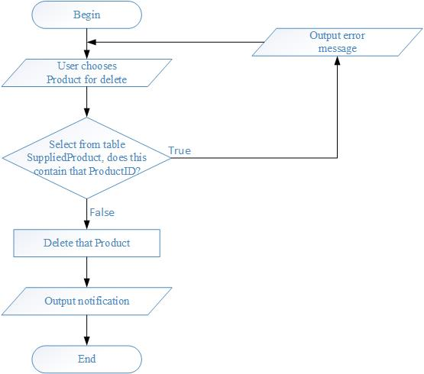

|  |  |  |
| --- | --- | --- |
|  | **Prepared By (Student)** | **Approved By (Teacher)** |
| **Date: 4/10/2017** | **Nguyen Phuoc Nguyen** | **Le Thi Minh Loan** |

|  |  |  |
| --- | --- | --- |
| **Design plan** | **Document Name: Process Design Document** | **SWD/Form No.7** |
| **Effective Date: 4/10/2017** | **Version: 1** | **Page No.7/13** |

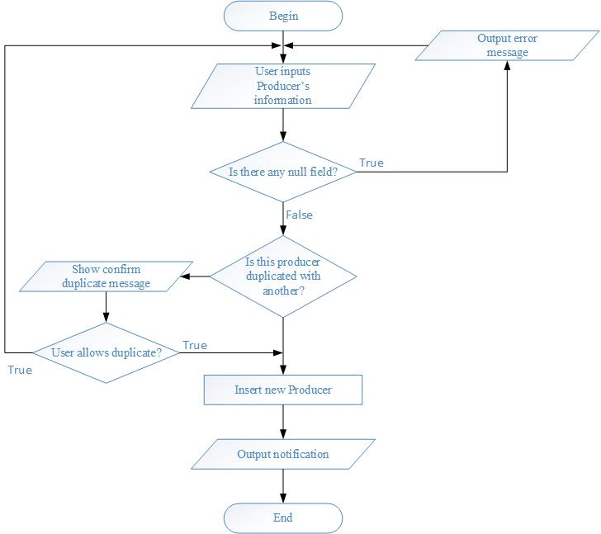**New Producer**

|  |  |  |
| --- | --- | --- |
|  | **Prepared By (Student)** | **Approved By (Teacher)** |
| **Date: 4/10/2017** | **Nguyen Phuoc Nguyen** | **Le Thi Minh Loan** |

|  |  |  |
| --- | --- | --- |
| **Design plan** | **Document Name: Process Design Document** | **SWD/Form No.7** |
| **Effective Date: 4/10/2017** | **Version: 1** | **Page No.8/13** |

**Update Producer**

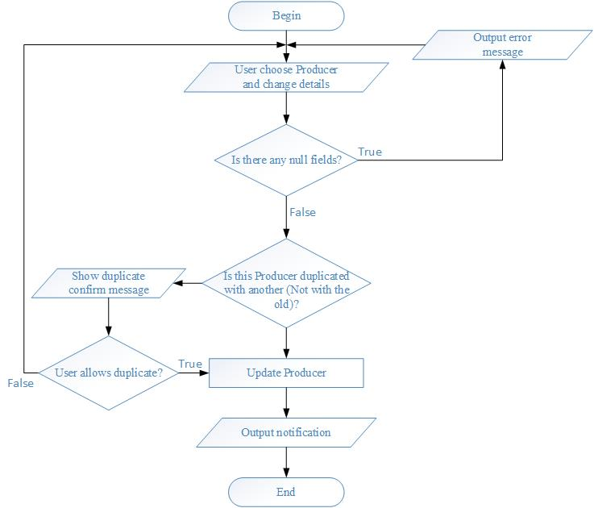

|  |  |  |
| --- | --- | --- |
|  | **Prepared By (Student)** | **Approved By (Teacher)** |
| **Date: 4/10/2017** | **Nguyen Phuoc Nguyen** | **Le Thi Minh Loan** |

|  |  |  |
| --- | --- | --- |
| **Design plan** | **Document Name: Process Design Document** | **SWD/Form No.7** |
| **Effective Date: 4/10/2017** | **Version: 1** | **Page No.9/13** |

**Delete Producer**

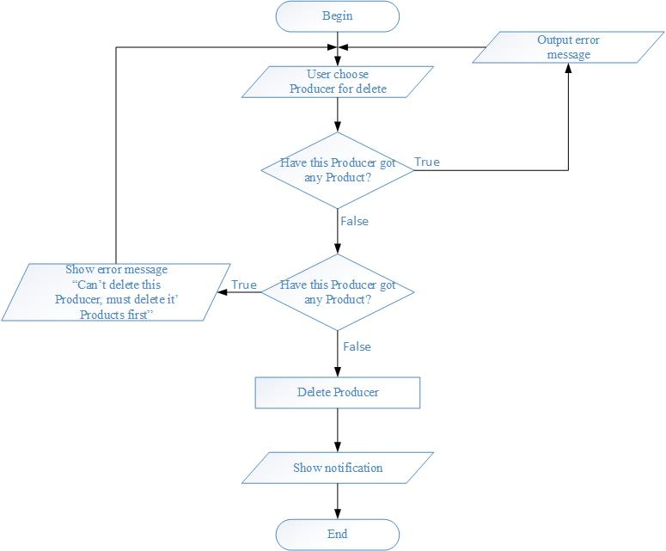

|  |  |  |
| --- | --- | --- |
|  | **Prepared By (Student)** | **Approved By (Teacher)** |
| **Date: 4/10/2017** | **Nguyen Phuoc Nguyen** | **Le Thi Minh Loan** |

|  |  |  |
| --- | --- | --- |
| **Design plan** | **Document Name: Process Design Document** | **SWD/Form No.7** |
| **Effective Date: 4/10/2017** | **Version: 1** | **Page No.10/13** |

**New Category**

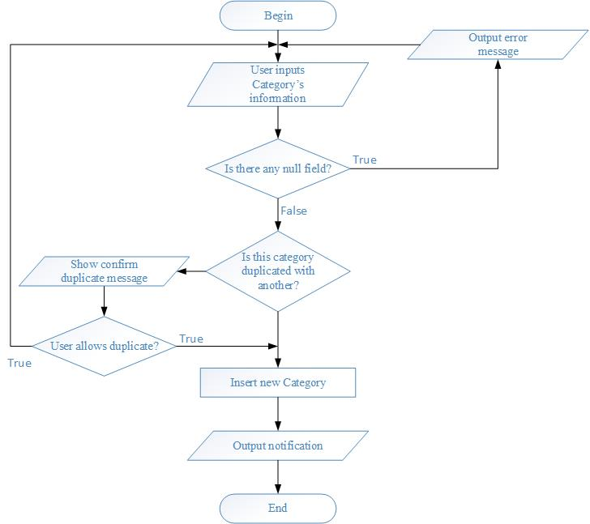

|  |  |  |
| --- | --- | --- |
|  | **Prepared By (Student)** | **Approved By (Teacher)** |
| **Date: 4/10/2017** | **Nguyen Phuoc Nguyen** | **Le Thi Minh Loan** |

|  |  |  |
| --- | --- | --- |
| **Design plan** | **Document Name: Process Design Document** | **SWD/Form No.7** |
| **Effective Date: 4/10/2017** | **Version: 1** | **Page No.11/13** |

**Update Category**

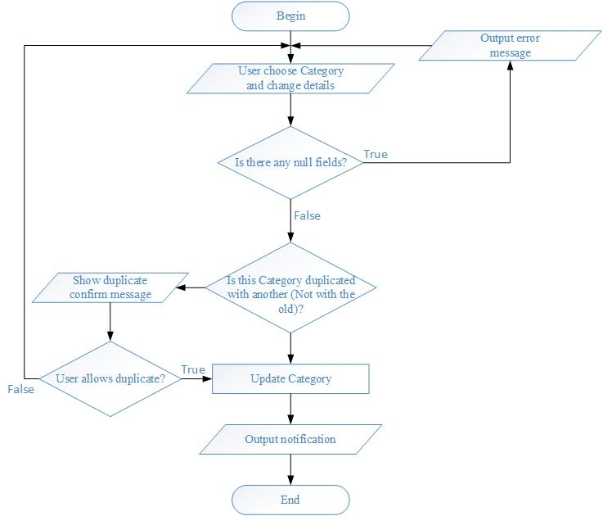

|  |  |  |
| --- | --- | --- |
|  | **Prepared By (Student)** | **Approved By (Teacher)** |
| **Date: 4/10/2017** | **Nguyen Phuoc Nguyen** | **Le Thi Minh Loan** |

|  |  |  |
| --- | --- | --- |
| **Design plan** | **Document Name: Process Design Document** | **SWD/Form No.7** |
| **Effective Date: 4/10/2017** | **Version: 1** | **Page No.12/13** |

**Delete Category**

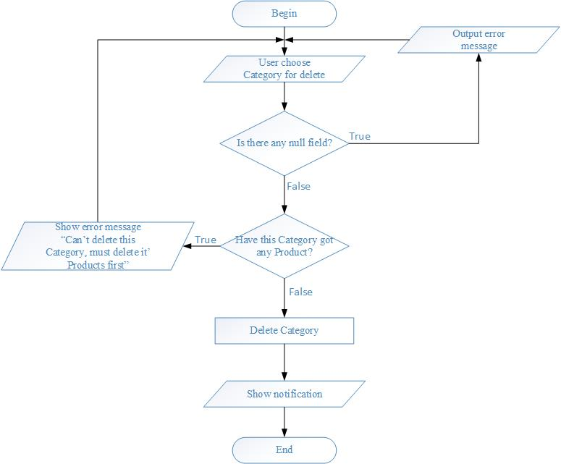

|  |  |  |
| --- | --- | --- |
|  | **Prepared By (Student)** | **Approved By (Teacher)** |
| **Date: 4/10/2017** | **Nguyen Phuoc Nguyen** | **Le Thi Minh Loan** |

|  |  |  |
| --- | --- | --- |
| **Design plan** | **Document Name: Process Design Document** | **SWD/Form No.7** |
| **Effective Date: 4/10/2017** | **Version: 1** | **Page No.13/13** |

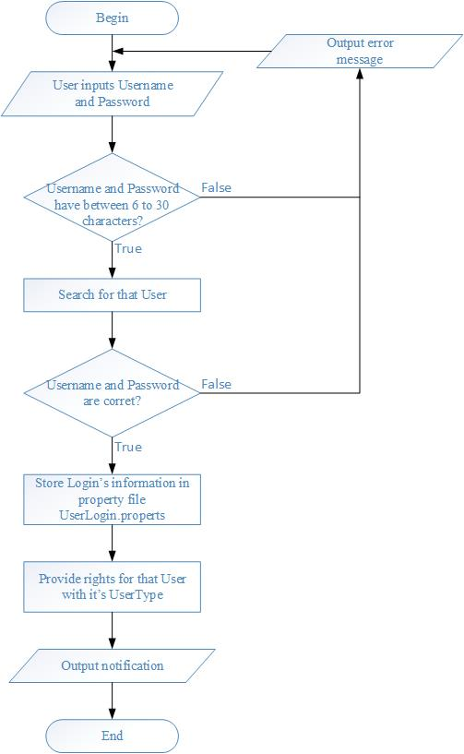

|  |  |  |
| --- | --- | --- |
|  | **Prepared By (Student)** | **Approved By (Teacher)** |
| **Date: 4/10/2017** | **Nguyen Phuoc Nguyen** | **Le Thi Minh Loan** |

|  |  |  |
| --- | --- | --- |
| **Design plan** | **Document Name: Coding Standards Document** | **SWD/Form No.8** |
| **Effective Date: 3/20/2017** | **Version: 1** | **Page No.1/2** |

**Coding Standard Document**

1. **Programming Standards**

* Every button should have an Icon for expressing, image icons have to store in the folder Icons in source “[Project_Name]/src/Icons” and They are imported using “Image chooser, Image within Project, Image using for project have extension **.png**.
* Must have declaration part for classes and interfaces using for the project.

1. **Standards for code writing style**

* Statement of each group must indented a **Tab**.
* Using “{}” to block a group of statements or only one statement even and the “{“ is right after the declaration. For example:

If (today == 5){

Statement;

}

* Each group of a work should have a line gap. For example:

Work 1: Variable declaration;

Work 2: Access database;

Receive data;

Process data;

Work 3: Close data;

|  |  |  |
| --- | --- | --- |
|  | **Prepared By (Student)** | **Approved By (Teacher)** |
| **Date: 3/20/2017** | **Nguyen Phuoc Nguyen** | **Le Thi Minh Loan** |
| **Design plan** | **Document Name: Coding Standards Document** | **SWD/Form No.8** |
| **Effective Date: 3/20/2017** | **Version: 1** | **Page No.2/2** |

**Coding Standard Document**

1. **Standards for declaring Variables**

* Every Variable are meaningful, the first word is lowercase and each meaning word later have the first letter is uppercase.
* Variables are using for loop can be “I” (Index) and loops inner can use “j” and then “k”, “m”, “n”. For example:

For (int I = 0; I < n; i++){

For (int j = 0; … //Allowed

For (int n = 0;… //Now allowed, next of “j” is “k”

}

1. **Standards for function declaring Variables**

* Must have declaration for any functions and it declares return value, parameters if necessary. For example:

//Reload the interface

Public void load(){

}

* Any lines have to fix in 80 character, if not, detach it.

|  |  |  |
| --- | --- | --- |
|  | **Prepared By (Student)** | **Approved By (Teacher)** |
| **Date: 3/20/2017** | **Nguyen Phuoc Nguyen** | **Le Thi Minh Loan** |

|  |  |  |
| --- | --- | --- |
| **Design plan** | **Document Name: Task Sheet** | **SWD/Form No.9** |
| **Effective Date: 3/23/2017** | **Version: 1** | **Page No.1** |

|  |  |  |  |  |  |  |
| --- | --- | --- | --- | --- | --- | --- |
| **Project Ref. No.:** | **Project Title:** | **Plan Prepared By: Nguyen Phuoc Nguyen** | | **Date of Preparation of Activity Plan:** | | |
| **Task Sub division** | **Description** | **Planned Start Date** | **Actual Start Date** | **Actual Days** | **Team Member Names** | **Status** |
| Form No:1 | Problem Definition Document | 3/02/2017 | 3/02/2017 | 1 | Nguyen Phuoc Nguyen | 100% |
| Form No:2A | CRS | 3/05/2017 | 3/05/2017 | 1 | Luu Truong Moc | 100% |
| Form No:2B | CRS/Customer Acceptance Criteria | 3/05/2017 | 3/05/2017 | 1 | Luu Truong Moc | 100% |
| Form No:3 | Project Plan | 3/07/2017 | 3/08/2017 | 5 | Nguyen Phuoc Nguyen  Luu Truong Moc  Truong Phuoc Loi | 100% |
| Form No:4 | GUI Standards Document | 3/12/2017 | 3/12/2017 | 3 | Nguyen Phuoc Nguyen | 100% |
| Form No:5 | Interface  Design Document | 3/20/2017 | 3/22/2017 | 1 | Nguyen Phuoc Nguyen | 100% |
| Form No:6 | Table Design  Document | 3/32017 | 5/3/2017 | 1 | Nguyen Phuoc Nguyen | 100% |
| Form No:7 | Process  Design Document | 3/32017 | 7/32017 | 10 | Nguyen Phuoc Nguyen | 100% |
| Form No:8 | Coding Standards Document | 3/20/2017 |  | 15 | Nguyen Phuoc Nguyen | 100% |
| Form No:9 | Task Sheet | 3/23/2017 | 3/23/2017 | 5 | Truong Phuoc Loi  Nguyen Phuoc Nguyen | 100%  100% |
| Form No:10 | Testing Document | 3/23/2017 | 3/23/2017 | 3 | Nguyen Phuoc Nguyen | 100% |
| Form No:11 | Project Review | 3/27/2017 | 3/27/2017 | 1 | Nguyen Phuoc Nguyen | 100% |
| Form No:12 | Final Check List | 3/27/2017 | 3/27/2017 | 1 | Nguyen Phuoc Nguyen | 100% |

|  |  |  |
| --- | --- | --- |
|  | **Prepared By (Student)** | **Approved By (Teacher)** |
| **Date: 3/23/2017** | **Nguyen Phuoc Nguyen**  **Truong Phuoc Loi** | **Le Thi Minh Loan** |

|  |  |  |
| --- | --- | --- |
| **Design plan** | **Document Name: Testing Document** | **SWD/Form No.10** |
| **Effective Date: 4/18/2017** | **Version: 1** | **Page No.1** |

|  |  |  |  |  |  |  |
| --- | --- | --- | --- | --- | --- | --- |
| **Project Ref. No.:** | **Project Title:** | **Plan Prepared By: Nguyen Phuoc Nguyen** | | **Date of Preparation of Activity Plan:** | | |
| **Task Sub division** | **Description** | **Planned Start Date** | **Actual Start Date** | **Actual Days** | **Team Member Names** | **Status** |
| Form No:1 | Problem Definition Document | 3/02/2017 | 3/02/2017 | 1 | Nguyen Phuoc Nguyen | 100% |
| Form No:2A | CRS | 3/05/2017 | 3/05/2017 | 1 | Luu Truong Moc | 100% |
| Form No:2B | CRS/Customer Acceptance Criteria | 3/05/2017 | 3/05/2017 | 1 | Luu Truong Moc | 100% |
| Form No:3 | Project Plan | 3/07/2017 | 3/08/2017 | 5 | Nguyen Phuoc Nguyen  Luu Truong Moc  Truong Phuoc Loi | 100% |
| Form No:4 | GUI Standards Document | 3/12/2017 | 3/12/2017 | 3 | Nguyen Phuoc Nguyen | 100% |
| Form No:5 | Interface  Design Document | 3/20/2017 | 3/22/2017 | 1 | Nguyen Phuoc Nguyen | 100% |
| Form No:6 | Table Design  Document | 3/32017 | 5/3/2017 | 1 | Nguyen Phuoc Nguyen | 100% |
| Form No:7 | Process  Design Document |  |  |  | Nguyen Phuoc Nguyen  Luu Truong Moc  Truong Phuoc Loi | 100%  0%  0% |
| Form No:8 | Coding Standards Document | 3/20/2017 |  |  | Nguyen Phuoc Nguyen | 100% |
| Form No:9 | Task Sheet | 3/23/2017 | 3/23/2017 | 5 | Truong Phuoc Loi  Nguyen Phuoc Nguyen | 100%  100% |
| Form No:10 | Testing Document |  |  |  | Nguyen Phuoc Nguyen | 100% |
| Form No:11 | Project Review |  |  |  | Nguyen Phuoc Nguyen | 100% |
| Form No:12 | Final Check List |  |  |  |  |  |

|  |  |  |
| --- | --- | --- |
|  | **Prepared By (Student)** | **Approved By (Teacher)** |
| **Date: 4/18/2017** | **Nguyen Phuoc Nguyen** | **Le Thi Minh Loan** |

|  |  |  |
| --- | --- | --- |
| **Design plan: Store Desktop Application** | **Document Name: Project Review** | **SWD/Form No.11** |
| **Effective Date: 4/18/2017** | **Version: 1** | **Page No.1** |

|  |  |  |  |  |  |
| --- | --- | --- | --- | --- | --- |
| **Date:** | **Project Plan Activity/ Milestone** | **Work Specification** | **Status of the Activity** | **Remarks** | **Responsibility** |
| 3/02/2017 | 3/05/2017 | Take Customer’s information | Finished |  | - Nguyen Phuoc Nguyen  - Truong Phuoc Loi  - Luu Truong Moc |
| 3/05/2017 | 3/10/2017 | Design | Finished |  | - Nguyen Phuoc Nguyen |
| 3/12/2017 | 3/24/2017 | Coding | Nguyen Phuoc Nguyen (Finished) |  | - Nguyen Phuoc Nguyen  - Truong Phuoc Loi  - Luu Truong Moc |
| 3/22/2017 | 3/25/2017 | Testing | Finished |  | Nguyen Phuoc Nguyen |

|  |  |  |  |
| --- | --- | --- | --- |
|  | **Prepared By (Student)** | | **Approved By (Teacher)** |
| **Date: 4/18/2017** | **Nguyen Phuoc Nguyen** | | **Le Thi Minh Loan** |
| **Design plan: Store Desktop Application** | | **Document Name: Final Check List** | **SWD/Form No.12** |
| **Effective Date: 3/27/2017** | | **Version: 1** | **Page No.1** |

|  |  |  |
| --- | --- | --- |
| **S.No.** | **Aspect tested** | **Suggestion / Remarks** |
| 1. | Have all the modules been properly integrated and are they completely functional? | All base Process have been finished but because there are members out of the Project so It lacks Supplying and Order function |
| 2. | Does each unit meet its objective and purpose?  Are all the validations happening as specified in Process Design | Finish |
| 3. | Have all Design and Coding standards been followed and implemented? | Finish |
| 4. | Is the GUI design consistent all over? | Finish |
| 5. | Are the code work as per the specification? | Finish |
| 6. | Does the application’s functionality resolve the client problem, and satisfy his needs completely? | Finish |
| 7. | Have the hardware and software been correctly chosen? | Finish |
| 8. | Additional features and utilities that give value addition to the entire project. | Finish |

|  |  |  |
| --- | --- | --- |
|  | **Prepared By (Student)** | **Approved By (Teacher)** |
| **Date: 3/27/2017** | **Nguyen Phuoc Nguyen** | **Le Thi Minh Loan** |

|  |  |  |
| --- | --- | --- |
| **Design plan: Store Desktop Application** | **Document Name: Implement and Using Guidance Document** | **SWD/Form No.** |
| **Effective Date: 3/28/2017** | **Version: 1** | **Page No.1/6** |

**Using Guide Document**

Open file LMNMedicalStore and Press Username “Administrator”, Password “123456”

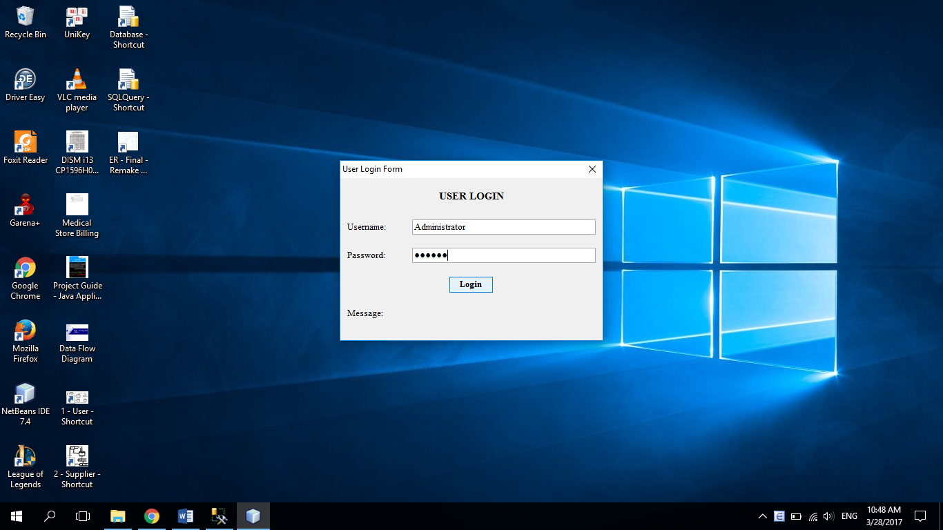

|  |  |  |  |  |
| --- | --- | --- | --- | --- |
|  | | **Prepared By (Student)** | **Approved By (Teacher)** | |
| **Date: 3/28/2017** | | **Nguyen Phuoc Nguyen** | **Le Thi Minh Loan** | |
| **Design plan: Store Desktop Application** | **Document Name: Implement and Using Guidance Document** | | | **SWD/Form No.** |
| **Effective Date: 3/28/2017** | **Version: 1** | | | **Page No.2/6** |

**Selling**

* Click menu Order -> Selling (Retail) or button Sell

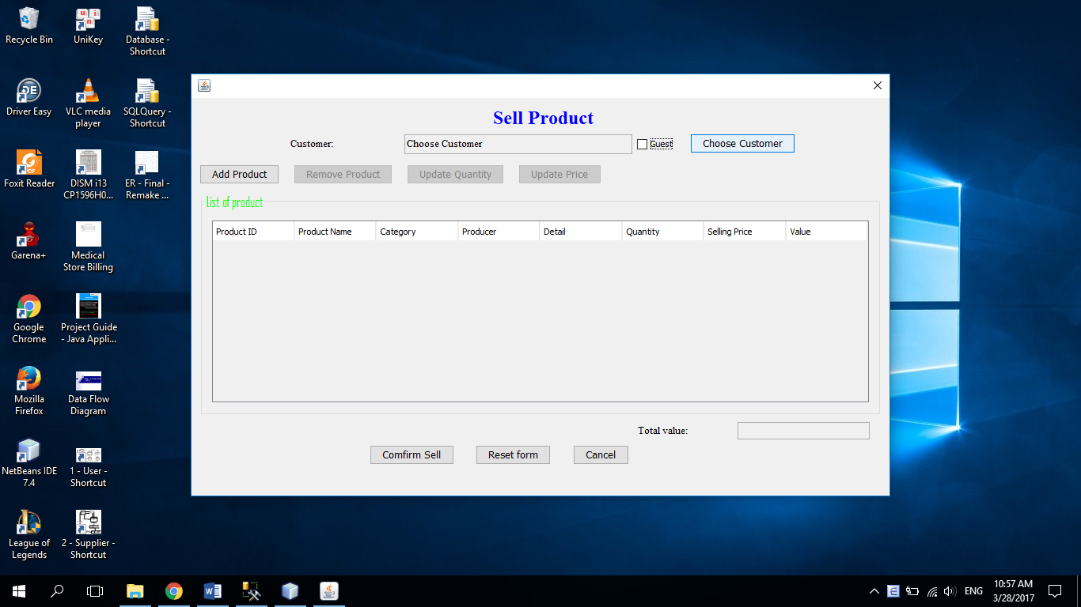

|  |  |  |  |  |
| --- | --- | --- | --- | --- |
|  | | **Prepared By (Student)** | **Approved By (Teacher)** | |
| **Date: 3/28/2017** | | **Nguyen Phuoc Nguyen** | **Le Thi Minh Loan** | |
| **Design plan: Store Desktop Application** | **Document Name: Implement and Using Guidance Document** | | | **SWD/Form No.** |
| **Effective Date: 3/28/2017** | **Version: 1** | | | **Page No.3/6** |

* In Customer, you can choose customer for sell by click button Choose Customer after deselected checkbox Guest
  + Choose Customer: click to choose customer, you also can type key to search for customer at Search Customer

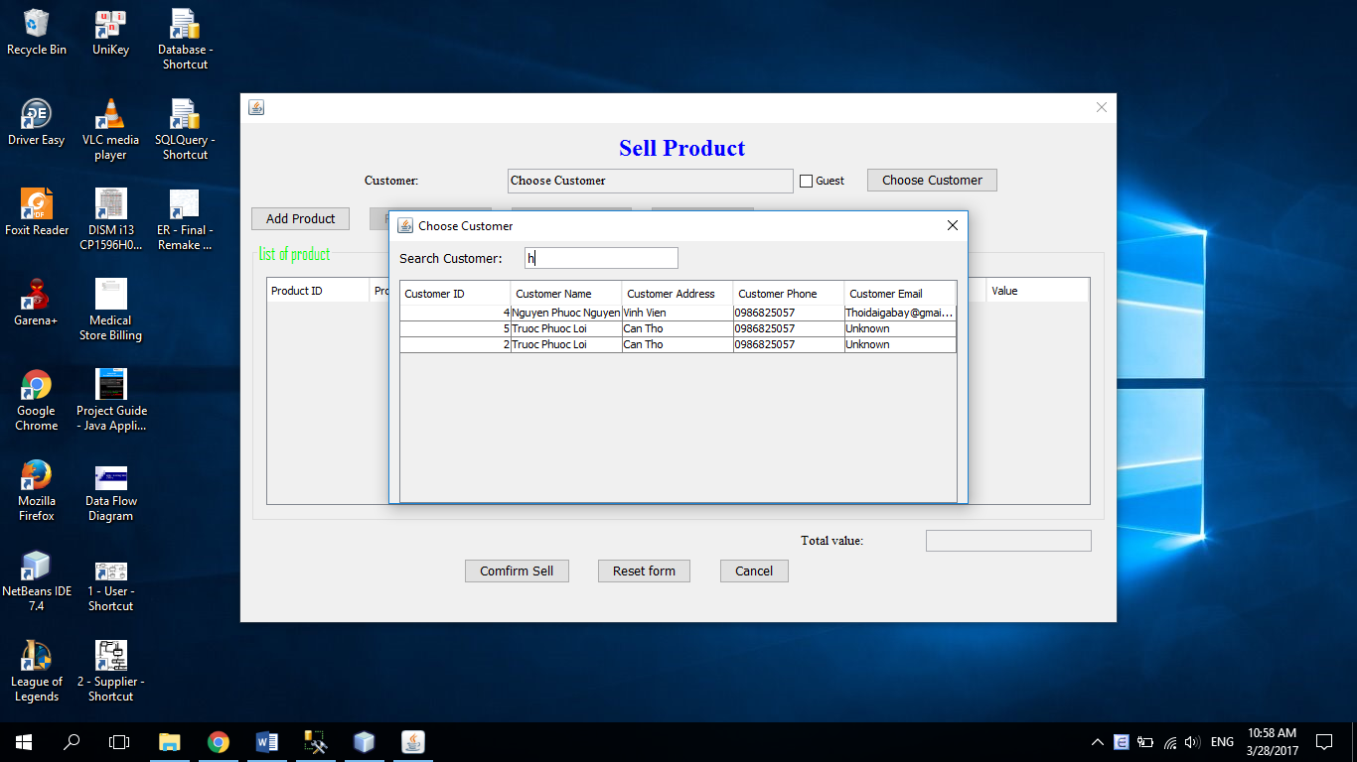

|  |  |  |  |  |
| --- | --- | --- | --- | --- |
|  | | **Prepared By (Student)** | **Approved By (Teacher)** | |
| **Date: 3/28/2017** | | **Nguyen Phuoc Nguyen** | **Le Thi Minh Loan** | |
| **Design plan: Store Desktop Application** | **Document Name: Implement and Using Guidance Document** | | | **SWD/Form No.** |
| **Effective Date: 3/28/2017** | **Version: 1** | | | **Page No.4/6** |

* Now you click button Add product to add product for sell, the same with Choose Customer, you must type Quantity and price be for add to temp table product:

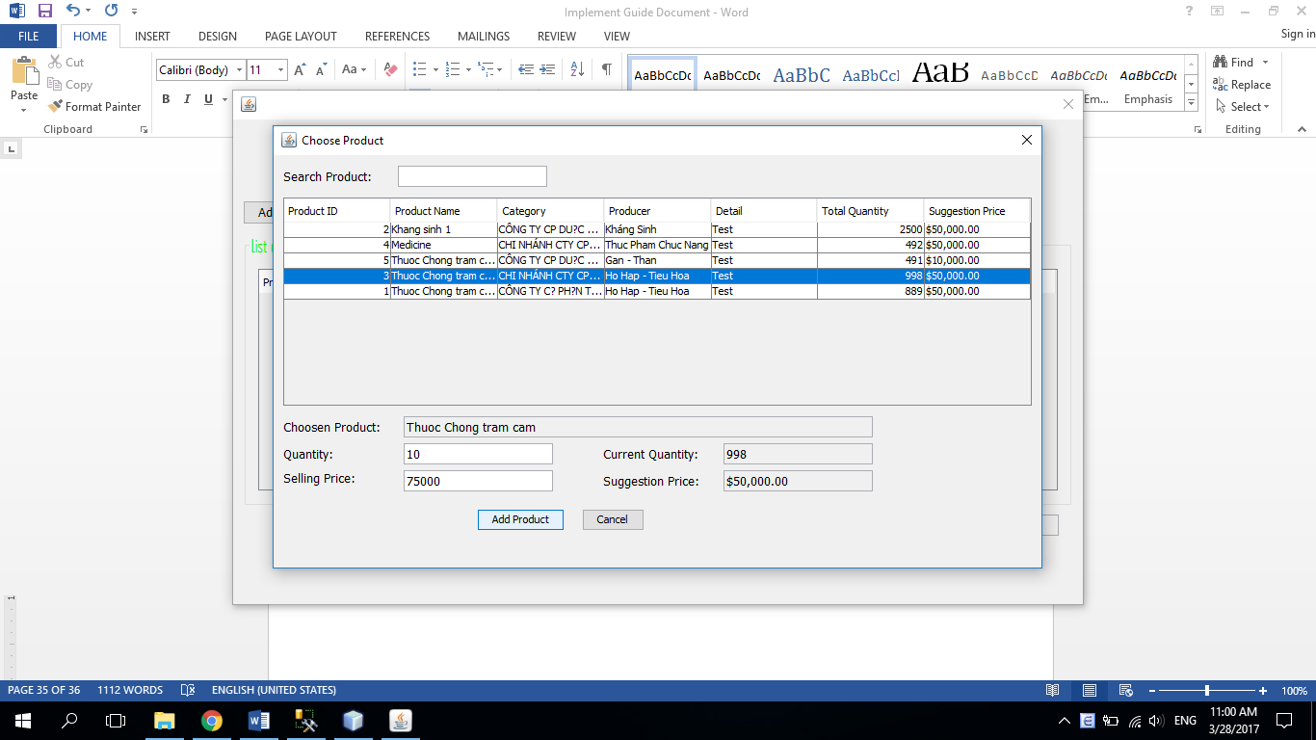

|  |  |  |
| --- | --- | --- |
|  | **Prepared By (Student)** | **Approved By (Teacher)** |
| **Date: 3/28/2017** | **Nguyen Phuoc Nguyen** | **Le Thi Minh Loan** |

|  |  |  |
| --- | --- | --- |
| **Design plan: Store Desktop Application** | **Document Name: Implement and Using Guidance Document** | **SWD/Form No.** |
| **Effective Date: 3/28/2017** | **Version: 1** | **Page No.5/6** |

* Now you can change quantity, selling price or remove product after selected them, finally press Confirm sell:

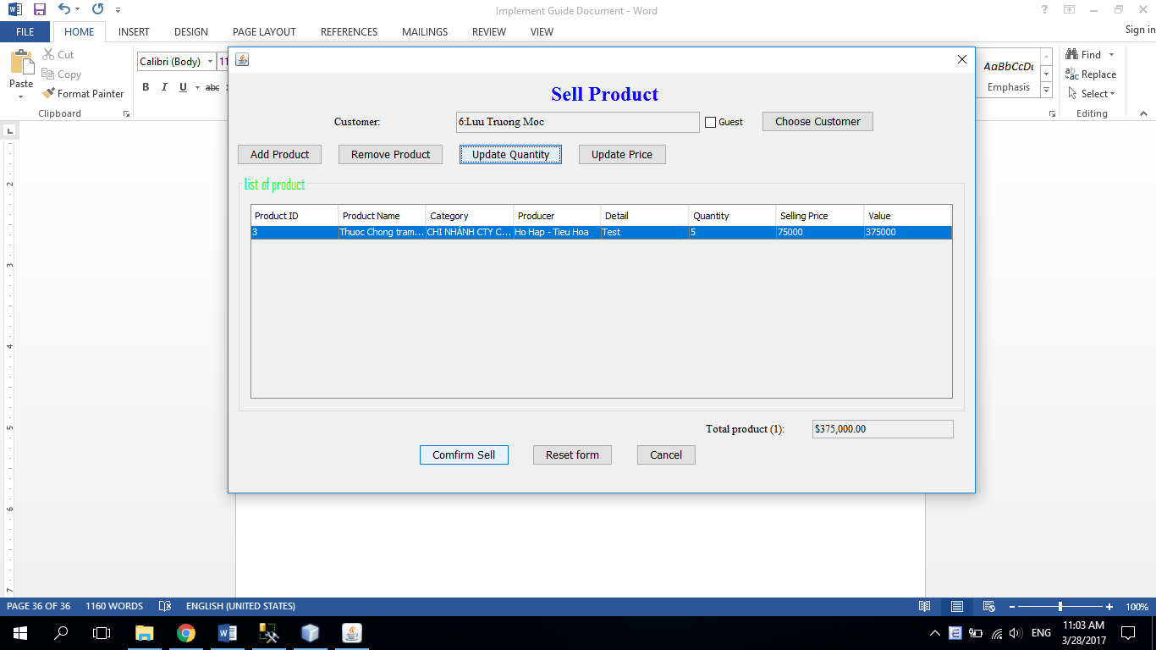

|  |  |  |
| --- | --- | --- |
|  | **Prepared By (Student)** | **Approved By (Teacher)** |
| **Date: 3/28/2017** | **Nguyen Phuoc Nguyen** | **Le Thi Minh Loan** |

|  |  |  |
| --- | --- | --- |
| **Design plan: Store Desktop Application** | **Document Name: Implement and Using Guidance Document** | **SWD/Form No.** |
| **Effective Date: 3/28/2017** | **Version: 1** | **Page No.6/6** |

A notification will appear, that you completely Sale:

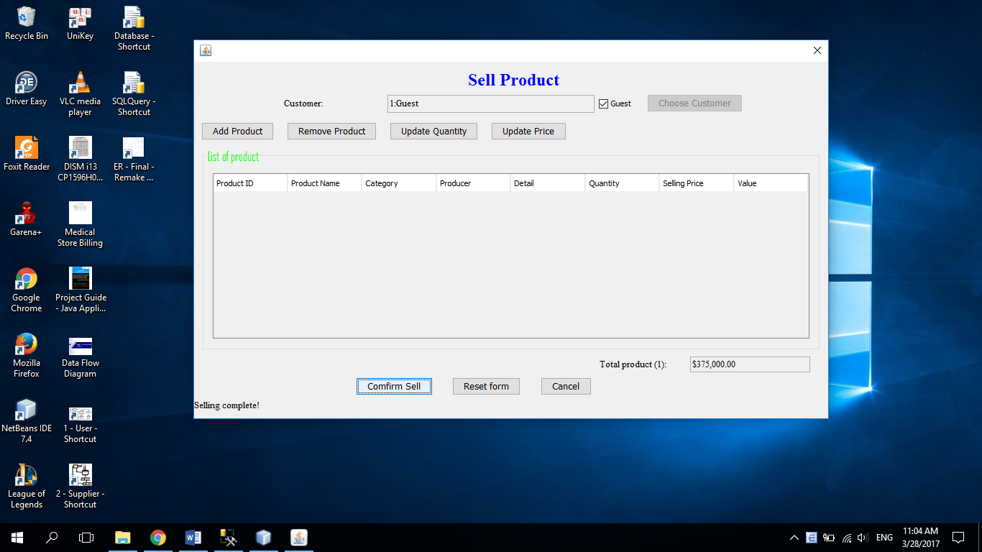

|  |  |  |
| --- | --- | --- |
|  | **Prepared By (Student)** | **Approved By (Teacher)** |
| **Date: 3/28/2017** | **Nguyen Phuoc Nguyen** | **Le Thi Minh Loan** |