|  |  |
| --- | --- |
| **ZNA Collaboration Services Best Practices for Power Apps** |  |

**Authors:**

Linda Frazier; Swati Singh

**Contributors:**

**Andrew Groninger; Andy Kunz; Michael Wolff**

Table of Contents

**1.** **Introduction to Power Apps** 3

**2.** **Types of Power Apps** 3

**3.** **Power App Environments** 4

**5.** **Software Development Lifecycle Management – using Production, Test and Dev Power App environments** 6

**6.** **P1 and P2 licenses** 12

**7.** **Zurich PowerApps Style Guidelines** 12

**8.** **Best Practices Miscellaneous** 12

a. Create an Application list and track the details related to each 12

**b.** **Service Acct Ids** 12

**Summary:**

Microsoft provides application development solutions that speeds up application development and empowers non-developers to create applications and automated workflows.

According to a Forrester report on the Total Economic Impact™ (TEI) and potential return on investment (ROI), enterprises that may realize by deploying PowerApps and Microsoft Flow (Flow).1

Interviewees noted that by reducing application development time and empowering non-developers to create custom applications and workflows, they were able to greatly reduce development costs and streamline business processes. These process improvements delivered business benefits such as reduced time-to-market, better customer service, and increased revenues.

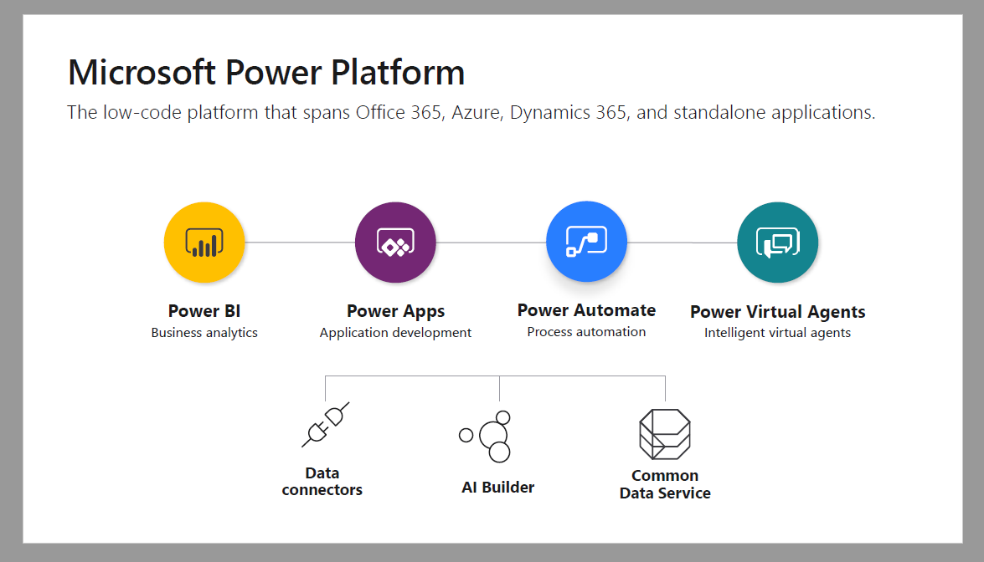

*Quantified Benefits*

**The average cost to develop an application is 70% less with PowerApps and Flow**. For applications that can be developed using these new tools and included connectors, the internal development effort, professional services fees, and/or vendor applications purchase costs are much lower. Additionally, the effort to maintain code and manage applications is less.

* **Developing additional applications in-house eliminated vendor license costs**. Interviewees provided examples of external applications that were replaced with in-house developed applications using PowerApps and Flow.
* **PowerApps and Flow increases process automation and efficiencies.** The applications and workflows that were created digitized existing, manual, and often paper-based processes. The efficiency gains can vary widely by role, and mobile workers especially benefited from these process improvements.

*Unquantified Benefits*

* **PowerApps and Flow empowers users which increase employee satisfaction.** Both IT and business users can now more efficiently and effectively create applications that deliver business value. In many cases, these applications would never have been built without these tools. This gives users more control over their work and enables them to eliminate repetitive and annoying manual activities.
* **Streamlining and automating processes delivers business transformation and improved business outcomes**. Interviewees described many ways that their businesses have improved. This includes happier customers, reduced time-to-market, and revenue protection
* **Employees can make better and faster decisions from better access to information**. Much of the development work completed with PowerApps and Flow enables faster collection of information from first line workers and transferal, to decision makers in a more usable format. This, in turn, means that better decisions are made based on data sets that are larger and closer to real-time
* **Additional value is realized with other Microsoft solutions, such as Dynamics CRM and SharePoint, because PowerApps and Flow extend those solutions’ capabilities**. Interviewees described how these solutions, being part of the Microsoft stack, enable them to build on prior investments to create more value. Additionally, tying into the Microsoft Common Data Store (CDS) allows them to easily integrate data across solutions and workflows.
* **Mobile applications developed with PowerApps and Flow are more secure than would likely otherwise have been developed**. Because these applications and workflows tie into Active Directory (AD) and other Microsoft security solutions, IT can control permissions at the data and application levels. Additionally, users building in these tools helps to reduce shadow IT. All PowerApps that are built on the Common Data Service for Apps are automatically GDPR compliant.

1. **Introduction to Power Apps** 
   1. **Power Apps:** Build high productivity apps you need for your business with a rich set of tools. Building apps with Power Apps helps everyone from business analysts to professional developers work more efficiently together. Solve business problems with intuitive visual tools tt don’t require code, work faster with a platform that enables data integration and distribution, and extend the platform with building blocks for professional developers. Easily build and share apps on any device.

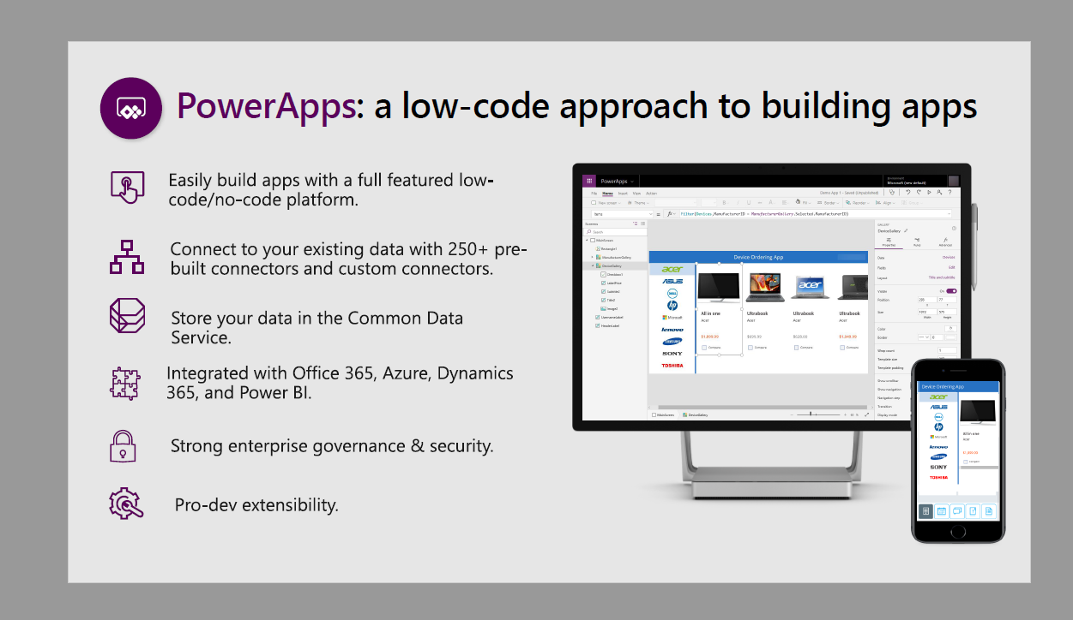

1. **Types of Power Apps**

|  |  |  |
| --- | --- | --- |
| **Power App Type** | **Description** | **When to Use?** |
| Canvas | Canvas apps can be built with or without a Common Data Service database. They use connectors to access data and services. Canvas apps start with a blank screen like an artist’s canvas and the creator manually lays out each screen. This allows the creator to have complete control of placements of controls on the canvas.  Click [here](https://docs.microsoft.com/en-us/powerapps/maker/canvas-apps/getting-started) for instructions on how to create a Canvas Power App.  Click [here](https://docs.microsoft.com/en-us/powerapps/maker/canvas-apps/app-from-sharepoint) for instructions on how to create a Canvas Power App using data in a SharePoint List. | **BEST PRACTICE: Canvas Apps are the recommended best option for low-medium complex enhancement requests related to customizations in SharePoint lists.** |
| Model Driven | Model-driven apps require a Common Data Service database and are built on top of the data modeled in that database environment. Model-driven apps materialize views and detail screens based on the data structure. Because of this, they offer users a more consistent look and feel from one screen to the next without much effort by the creator | Model Driven Apps will be used for high complex requests and may require P1 licenses depending on the connectors needed. |
| Customized List Forms | Customized list forms – Easy to use to add branding and very light weight customizations (font color, etc). Best practice is to NOT use this type for anything more than branding. These types of Power apps can only be used in the Default environment.  Click [here](https://docs.microsoft.com/en-us/powerapps/maker/canvas-apps/customize-list-form) for instructions on how to create a Customized List Form | Use for simple branding and font size and style changes in SharePoint lists.  Not recommended unless it is strictly used for minor cosmetic changes |

1. **Power App Environments**

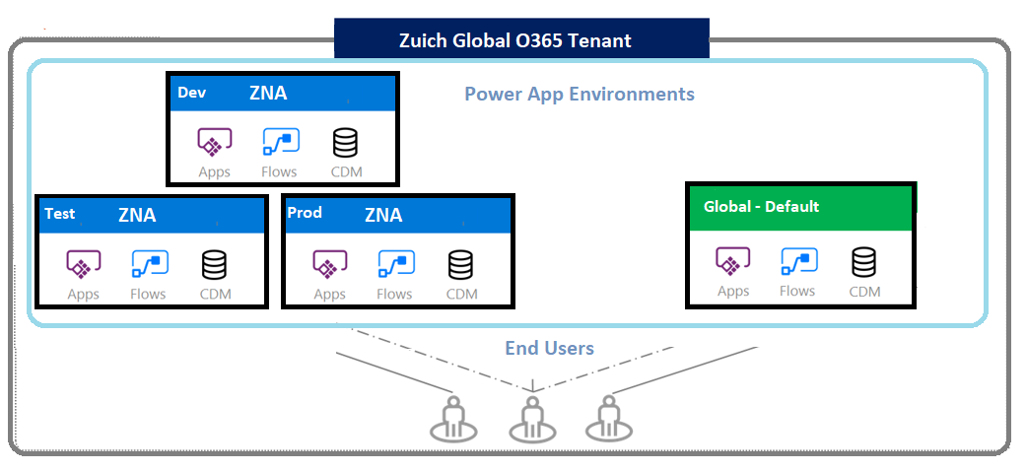

|  |  |  |  |  |
| --- | --- | --- | --- | --- |
|  | **Environment** | **All User Access Level** | **Access Level** | **Administrator Access Level** |
|  | Default | Maker- Create/Edit | Maker/Create/Edit | Admin /Maker -Create/Edit |
| **1** | POPL-US-001003-PROD | Consumption/Use | Consumption/Use | Admin /Maker -Create/Edit |
| **2** | POPL-US-001003-UAT | Consumption | Maker – Create/Edit | Admin /Maker -Create/Edit |
| **3** | POPL-US-001003-DEV | Consumption | Maker – Create/Edit | Admin /Maker -Create/Edit |

**Here are the groups and proposed members for each environment:**

|  |  |  |  |
| --- | --- | --- | --- |
| **Environment** | **Admins Role** | **Maker/Creator Role** | **Read/Consumer (groups if available)** |
| ZNA Production | Andy Kunz  Patrick Reed  Swati Singh  Andrew Groninger  Linda Frazier | Govardana Redi  Subhrajit Bordoloi |  |
| ZNA DEV | Andy Kunz  Patrick Reed  Swati Singh  Andrew Groninger  Jay Mueller  Linda Frazier  Govardana Redi  Subhrajit Bordoloi | SPAAS Team members  Mario Ramos  Brandon Calabrese  Michael Wolff  Noah Luther  Todd Vanderwater  Super users – TBD |  |
| ZNA UAT | Same as above  Use same group as above. | Same as above  Use same group as above. |  |

1. **Best Practices for Default Environment:**

* App should be used for lightweight collaboration.
* App shouldn’t contain confidential/highly confidential information
* App shouldn’t be a business-critical application and used by more than 50 people
* App shouldn’t be interfacing with any other applications
* App doesn’t require dedicated support from developers or platform team
* Customized list form is not recommended except for minor cosmetic changes. Canvas app is preferred solution because it provides the out of the box capabilities.
* If you need a standard template to develop PowerApps please use this **link**
* **App is not allowed to share data externally (outside Zurich environment)**

*If your app doesn’t meet the above criteria, please contact USZ_sharepointcustomsolutions@zurichna.com to move your PowerApps to our ZNA controlled environment that meets compliance and governance requirements.*

1. **Software Development Lifecycle Management – using Production, Test and Dev Power App environments**

**Use cases PowerApps:**

* + 1. **New Power App and a New SharePoint site**- Follow SDLC for Power apps but end user creates new SP site in production
    2. **Existing SharePoint site and New Power App-** Follow SDLC for Power apps + SP site
    3. **Existing SharePoint site and Existing Power App (Superuser)-** 1. Up to 2 hours change can be done in production exclude power automate (Approvals required) 2. Others follow SDLC for Power apps + SP site
    4. **Enhancements to SP site(View changes/New page for SP site)-** Up to 2 hours change can be done in production exclude power automate (Approvals required)

**SOFTWARE DEVELOPMENT LIFE CYCLE STEP DESCRIPTION**

**Use Case 1 (New Power App and a New SharePoint site)**

**Step 1: Create a separate SharePoint site for both Test and Production in the production O365 tenant**.

1. Create the Test site using the same name/title as the Production site, with “Test” added a suffix to the title
   * Example URL Production - <https://zurichinsurancenam.sharepoint.com/sites/SPaaSTeam>
   * Example URL Test - https://zurichinsurancenam.sharepoint.com/sites/SPaaSTeamTEST
2. Each site will have a different URL to easily distinguish between the two sites
3. Test site collection can have different security settings limited to the users who will need access and test

**Step 2: Sharegate migration tool to migrate SharePoint design elements between the two sites**

a) Efficiently migrates design elements between the two environments to ensure unique IDs remain the same

b) Data should NOT be copied from Production to Test sites for compliance reasons. Use “Copy only Schema” to only copy the design

c) Test data should be created on the test site to mitigate risk of sending workflows inadvertently based on production data

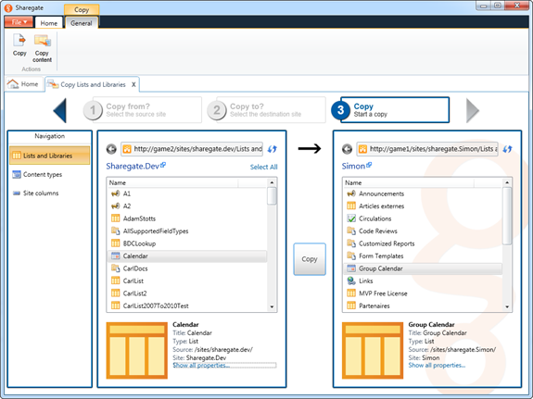

If you have Power Automate (Flows) that are associated to the change, you can attach those to the Power App. Therefore, the export to the package can be done in one step and includes all flows.

**Step 3: When a Developer is asked to make changes to an existing PowerApps or create a new Power App, follow the below steps:**

1. Go to the Test Power App environment
2. Create a new Power App/Edit existing in the **Test Power Environment**
3. Confirm the connector is pointing to Test Data Source(s). It should already be pointing to Test data source/connector.
4. Make development changes in the Test Power Apps in the **Test Power Environment**
5. Conduct System and User Acceptance Testing in the Test SharePoint Site
6. Get approval from UAT testers and create a Change Control
7. Export the PowerApp to a package file and name the file: “Name of the PowerApps-env- date exported. .zip file
8. Store the zip file in the code source location
9. Source Code location: SPAAS TeamSite, new private channel called **Source Code Vault.**

|  |  |
| --- | --- |
| * Select **Apps** from the left navigation bar   [image](https://pwrappscdn.azureedge.net/mediahandler/blog/media/PowerApps/blog/636355bc-7d6f-4648-bded-f3dacb548b88.png) | * Select **Export (preview)** for the app you want to export   [image](https://pwrappscdn.azureedge.net/mediahandler/blog/media/PowerApps/blog/c194e1ea-7fe5-4b8e-984e-8f5b390b80a4.png) |

|  |  |
| --- | --- |
| Enter a Name and Description for the package   * [image](https://pwrappscdn.azureedge.net/mediahandler/blog/media/PowerApps/blog/5365c54a-27b7-4104-8263-92322f920401.png) | Within the ‘Review Package Content’ section you can optionally add comments or notes or change the setting for how each individual resource will be imported into the target environment during package import  [image](https://pwrappscdn.azureedge.net/mediahandler/blog/media/PowerApps/blog/5464b330-bdc4-4974-a446-a810252890c3.png)   * When you are done select **Export** and the package file will begin downloading within a few seconds |

**Best Practices for naming Power Apps source code (UAT and Production)**

1. Production Copy (example: App ABC) **(Located in Power App Production)**
   * Connector Points to Production Connection (Production SharePoint site)
2. UAT Copy – Name the Power App with the same name as Production Copy but append “UAT” (example App ABC Test) **(Located in Power App UAT )**
   * Connector points to UAT Connection (UAT SharePoint Site)

* Developers should NEVER make changes to an existing Power App/Flow when the connector is pointing to the Production site

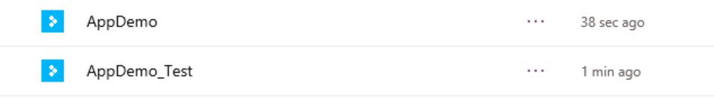

**Step 4: Migrate changes to Power App to Production Environment (New or existing)**

1. During the approved Change Control window, the designated Administrator will use approved service account to take the Exported package file from above and Import it into the Production Power Environment.
   1. **Open Power Apps in Production Environment**
   2. Select Apps
   3. Select Import and then Upload and select the app package file from the Source Code Vault Teams Private Channel
   4. Select upload and rename
   5. If its NEW – Select New.
2. A dialog box will display asking you if you want to replace the existing Power App with the same name. Click **Update.** This will then update the Production copy of the Power app with the changes you made to the Test Copy.
3. You will then need to open the Production version of the Power app and change the connection to point to the Production SharePoint site.
4. Publish the Production Power App to save the changes.
5. Export the PowerApps code to a zip file and store in code source mgmt. (Powerappname_PROD_DDMMYYYY)

|  |  |  |  |  |
| --- | --- | --- | --- | --- |
| |  |  | | --- | --- | | You can import an app package via the following steps:  Go to [web.powerapps.com](https://web.powerapps.com/)   * Select **Apps** from the left navigation bar * [image](https://pwrappscdn.azureedge.net/mediahandler/blog/media/PowerApps/blog/fff78883-7cc0-444e-8afc-a968383539fb.png) | * Select **Import package (preview)**   [image](https://pwrappscdn.azureedge.net/mediahandler/blog/media/PowerApps/blog/f26f0386-891f-462e-b2f4-603669375969.png)   * Select **Upload** and select the app package file that you want to import   [image](https://pwrappscdn.azureedge.net/mediahandler/blog/media/PowerApps/blog/4321faef-4dae-496a-b21e-e39c7cc7c661.png) |  |  |  | | --- | --- | |  |  |   (similar to the one below) that outlines whether or not the import operation was successful  NOTE: If you are importing an app and chose to ***Update*** an existing app, the new changes will be saved as a draft of the applications.  You will need to [publish](https://powerapps.microsoft.com/tutorials/save-publish-app/#publish-an-app) those changes in order for them to be available all other users of the applications.  [image](https://pwrappscdn.azureedge.net/mediahandler/blog/media/PowerApps/blog/92c3739f-a1ba-4e9d-a01b-5df650f912a1.png)  **Step 5: In the event of a rollback**   1. For a Power App rollback, the developer can open the Production Power App and revert it back to the last version which was overwritten during the last CR migration window |
|  |

1. **P1 and P2 licenses**
   1. Need further discussion around this topic and what licenses we need.
   2. We only need a P1/P2 license when we need to make an external data source connection
   3. Whenever possible, make connections to external data sources using a Flow/Power Automate which only requires the service acct id that is running the Flow to have the P1/P2 license.
      1. Example: For external data lookups – write a flow to pull in new data daily from the external datasource into a SharePoint List. Then your SharePoint site/Power App can perform the lookup to the list. The user id of the user is used behind Power Apps to do lookups.
      2. Only if the requirement is to have a “real-time” lookup would you need the user id to have the P1/P2 license to make the connection to the external datasource.

# **Zurich PowerApps Style Guidelines**

https://teams.microsoft.com/l/file/44770335-047D-4451-8059-342F1DF1732A?tenantId=473672ba-cd07-4371-a2ae-788b4c61840e&fileType=docx&objectUrl=https%3A%2F%2Fzurichinsurancenam.sharepoint.com%2Fsites%2FSPaaSTeam%2FShared%20Documents%2FDeveloper%20Guidelines%2FZNAPowerApp_TemplateGuidelines.docx&baseUrl=https%3A%2F%2Fzurichinsurancenam.sharepoint.com%2Fsites%2FSPaaSTeam&serviceName=teams&threadId=19:82cd0f0204e64d9a9eb802cd959c5f14@thread.skype&groupId=9ebdd2a8-4d95-45fe-9a0f-876f5a1e2982

1. **Best Practices Miscellaneous**
   1. Create an Application list and track the details related to each
      1. Application name, Site Owner, testers
      2. Overview of the application
      3. Details related Power App/Automate
      4. Developers/Service Acct Ids
   2. **Service Acct Ids**
      1. Use Service Acct Ids to run PowerAutomate/Flows
      2. Share PowerApps with Service Acct IDs
      3. The below is a table of the Service Acct IDs to be used.

The following three service acct ids are available for the Collaboration support development team to use.

All these service accts have E3 licenses and Mailboxes

|  |  |  |
| --- | --- | --- |
|  | **Service account ID Name** | **How/when to use.** |
|  |  |  |
| 2 | svc-O365-Powerapp |  |
| 3 | Svc-Office365-O365 |  |