# Hardware Requirements

The purpose of this section is to describe processor, storage, and network requirements to deploy a DAOS system.

## Deployment Options

As illustrated in the figure below, a DAOS storage system can be deployed in two different ways:

* **Pooled Storage Model**: The DAOS servers can run on dedicated storage nodes in separate racks. This is a traditional pool model where storage is uniformly accessed by all compute nodes. In order to minimize the number of I/O racks and to optimize floor space, this approach usually requires high-density storage servers.
* **Hyper-converged Storage Model**: In this model, the storage nodes are integrated into compute racks and can be either dedicated or shared nodes. The DAOS servers are thus massively distributed, and storage access is non-uniform and must take locality into account. This model is common in hyper-converged infrastructure.

While DAOS is mostly deployed following the pooled model, active research is conducted to efficiently support the hyper-converged model as well.

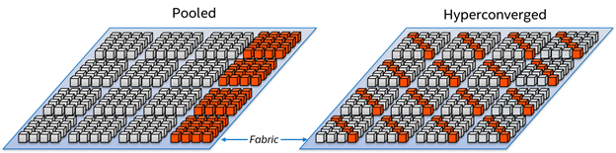

## Processor Requirements

DAOS requires a 64-bit processor architecture and is primarily developed on Intel x86_64 architecture. The DAOS software and the libraries it depends on (e.g., ISA-L, SPDK, PMDK, and DPDK) can take advantage of Intel SSE and AVX extensions.

DAOS is also regularly tested on 64-bit ARM processors configured in Little Endian mode. The same build instructions that are used for x86_64 are applicable for ARM builds as well. DAOS and its dependencies will make the necessary adjustments automatically in their respective build systems for ARM platforms.

## Network Requirements

The DAOS network layer relies on libfabrics and supports OFI providers for Ethernet/sockets, InfiniBand/verbs, RoCE, and Intel Omni-Path Architecture (OPA). An RDMA-capable fabric is preferred for better performance. DAOS can support multiple rails by binding different instances of the DAOS server to individual network cards.

The DAOS control plane provides methods for administering and managing the DAOS servers using a secure socket layer interface. An additional out-of-band network connecting the nodes in the DAOS service cluster is required for DAOS administration. Management traffic between clients and servers uses IP over Fabric.

## Storage Requirements

DAOS requires each storage node to have direct access to storage-class memory (SCM). While DAOS is primarily tested and tuned for Optane DC Persistent Memory, the DAOS software stack is built over the Persistent Memory Development Kit (PMDK) and the DAX feature of the Linux and Windows operating systems as described in the SNIA NVM Programming Model[1]. As a result, the open-source DAOS software stack should be able to run transparently over any storage-class memory supported by the PMDK.

The storage node can optionally be equipped with NVMe (non-volatile memory express) SSDs to provide capacity. HDDs, as well as SATA and SAS SSDs, are not supported by DAOS. Both NVMe 3D-NAND and Optane SSDs are supported. Optane SSDs are preferred for DAOS installation that targets a very high IOPS rate. NVMe-oF devices are also supported by the userspace storage stack but have never been tested.

A minimum 6% ratio of SCM to SSD capacity will guarantee that DAOS has enough space in SCM to store its internal metadata (e.g., pool metadata, SSD block allocation tracking).

For testing purposes, SCM can be emulated with DRAM by mounting a tmpfs filesystem, and NVMe SSDs can be also emulated with DRAM or a loopback file.

## Storage Server Design

The hardware design of a DAOS storage server balances the network bandwidth of the fabric with the aggregate storage bandwidth of the NVMe storage devices. This relationship sets the number of NVMe drives. For example, 8 PCIe gen4 x4 NVMe SSDs balance two 200Gbps PCIe gen4 x16 network adapters. The capacity of the SSDs will determine the minimum capacity of the Optane PMem DIMMs needed to provide the 6% ratio for DAOS metadata.

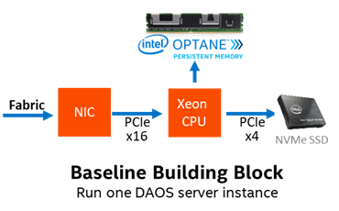

## CPU Affinity

Recent Intel Xeon data center platforms use two processor CPUs connected together with the Ultra Path Interconnect (UPI). PCIe lanes in these servers have a natural affinity to one CPU. Although globally accessible from any of the system cores, NVMe SSDs and network interface cards connected through the PCIe bus may provide different performance characteristics (e.g., higher latency, lower bandwidth) to each CPU. Accessing non-local PCIe devices may involve traffic over the UPI link that might become a point of congestion. Similarly, persistent memory is non-uniformly accessible (NUMA), and CPU affinity must be respected for maximal performance.

Therefore, when running in a multi-socket and multi-rail environment, the DAOS service must be able to detect the CPU to PCIe device and persistent memory affinity and minimize as much as possible non-local access. This can be achieved by spawning one instance of the I/O Engine per CPU, then accessing only the persistent memory and PCI devices local to that CPU from that server instance. The DAOS control plane is responsible for detecting the storage and network affinity and starting the I/O Engines accordingly.

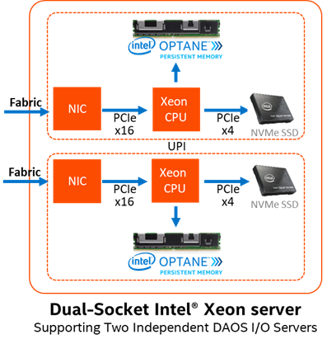

## Fault Domains

DAOS relies on single-ported storage massively distributed across different storage nodes. Each storage node is thus a single point of failure. DAOS achieves fault tolerance by providing data redundancy across storage nodes in different fault domains.

DAOS assumes that fault domains are hierarchical and do not overlap. For instance, the first level of a fault domain could be the racks and the second one, the storage nodes.

For efficient placement and optimal data resilience, more fault domains are better. As a result, it is preferable to distribute storage nodes across as many racks as possible.

1. <https://www.snia.org/sites/default/files/ technical_work/final/NVMProgrammingModel_v1.2.pdf>