# Architecture

DAOS is an open-source software-defined scale-out object store that provides high bandwidth and high IOPS storage containers to applications and enables next-generation data-centric workflows combining simulation, data analytics, and machine learning.

Unlike the traditional storage stacks that were primarily designed for rotating media, DAOS is architected from the ground up to exploit new NVM technologies and is extremely lightweight since it operates End-to-End (E2E) in user space with full OS bypass. DAOS offers a shift away from an I/O model designed for block-based and high-latency storage to one that inherently supports fine-grained data access and unlocks the performance of the next-generation storage technologies.

Unlike traditional Burst Buffers, DAOS is a high-performant independent and fault-tolerant storage tier that does not rely on a third-party tier to manage metadata and data resilience.

## DAOS Features

DAOS relies on OFI for low-latency communications and stores data on both storage-class memory and NVMe storage. DAOS presents a native key-array-value storage interface that offers a unified storage model over which domain-specific data models are ported, such as HDF5, MPI-IO, and Apache Arrow. A POSIX I/O emulation layer implementing files and directories over the native DAOS API is also available.

DAOS I/O operations are logged and then inserted into a persistent index maintained in SCM. Each I/O is tagged with a particular timestamp called epoch and is associated with a particular version of the dataset. No read-modify-write operations are performed internally. Write operations are non-destructive and not sensitive to alignment. Upon read request, the DAOS service walks through the persistent index and creates a complex scatter-gather Remote Direct Memory Access (RDMA) descriptor to reconstruct the data at the requested version directly in the buffer provided by the application.

The SCM storage is memory-mapped directly into the address space of the DAOS service that manages the persistent index via direct load/store. Depending on the I/O characteristics, the DAOS service can decide to store the I/O in either SCM or NVMe storage. As represented in Figure 2-1, latency-sensitive I/Os, like application metadata and byte-granular data, will typically be stored in the former, whereas checkpoints and bulk data will be stored in the latter. This approach allows DAOS to deliver the raw NVMe bandwidth for bulk data by streaming the data to NVMe storage and maintaining internal metadata index in SCM. The Persistent Memory Development Kit (PMDK)[^1] allows managing transactional access to SCM and the Storage Performance Development Kit (SPDK)[^2] enables user-space I/O to NVMe devices.

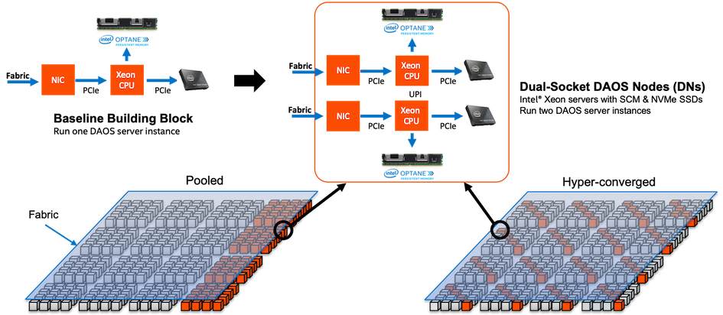 Figure 2-1. DAOS Storage

DAOS aims at delivering:

* High throughput and IOPS at arbitrary alignment and size
* Fine-grained I/O operations with true zero-copy I/O to SCM
* Support for massively distributed NVM storage via scalable collective communications across the storage servers
* Non-blocking data and metadata operations to allow I/O and computation to overlap
* Advanced data placement taking into account fault domains
* Software-managed redundancy supporting both replication and erasure code with an online rebuild
* End-to-end data integrity
* Scalable distributed transactions with guaranteed data consistency and automated recovery
* Dataset snapshot
* Security framework to manage access control to storage pools
* Software-defined storage management to provision, configure, modify and monitor storage pools over COTS hardware
* Native support for Hierarchical Data Format (HDF)5, MPI-IO and POSIX namespace over the DAOS data model
* Tools for disaster recovery
* Seamless integration with the Lustre parallel filesystem
* Mover agent to migrate datasets among DAOS pools and from parallel filesystems to DAOS and vice versa

## DAOS Components

A data center may have hundreds of thousands of compute nodes interconnected via a scalable high-performance fabric, where all, or a subset of the nodes called storage nodes, have direct access to NVM storage. A DAOS installation involves several components that can be either collocated or distributed.

### DAOS System, Storage Node, Server, I/O Engine, and Target

A DAOS *system* is identified by a system name, and consists of a set of DAOS *storage nodes* connected to the same fabric. The DAOS storage nodes run one DAOS *server* instance per node, which in turn starts one DAOS *I/O Engine* process per physical socket. Membership of the DAOS servers is recorded into the system map, that assigns a unique integer *rank* to each *I/O Engine* process. Two different DAOS systems comprise two disjoint sets of DAOS servers, and do not coordinate with each other.

The DAOS *server* is a multi-tenant daemon running on a Linux instance (either natively on the physical node or in a VM or container) of each *storage node*. Its *I/O Engine* sub-processes export the locally-attached SCM and NVM storage through the network. It listens to a management port (addressed by an IP address and a TCP port number), plus one or more fabric endpoints (addressed by network URIs). The DAOS server is configured through a YAML file in /etc/daos, including the configuration of its I/O Engine sub-processes. The DAOS server startup can be integrated with different daemon management or orchestration frameworks (for example a systemd script, a Kubernetes service, or even via a parallel launcher like pdsh or srun).

Inside a DAOS I/O Engine, the storage is statically partitioned across multiple *targets* to optimize concurrency. To avoid contention, each target has its private storage, its own pool of service threads, and its dedicated network context that can be directly addressed over the fabric independently of the other targets hosted on the same storage node. The SCM modules are typically configured in *AppDirect interleaved* mode. They are thus presented to the operating system as a single PMEM namespace per socket (in fsdax mode). When *N* targets per I/O Engine are configured, each target is using *1/N* of the capacity of the fsdax SCM capacity of that socket, independently of the other targets. Each target is also using a fraction of the NVMe capacity of the NVMe drives that are attached to this socket.

A target does not implement any internal data protection mechanism against storage media failure. As a result, a target is a single point of failure and the unit of fault. A dynamic state is associated with each target: Its state can be either “up and running”, or “down and not available”.

A target is the unit of performance. Hardware components associated with the target, such as the backend storage medium, the CPU core(s), and the network, have limited capability and capacity.

The number of targets exported by a DAOS I/O Engine instance is configurable, and depends on the underlying hardware (in particular, the number of SCM modules and the number of NVMe SSDs that are served by this I/O Engine instance). As a best practice, the number of targets of an I/O Engine should be an integer multiple of the number of NVMe drives that are served by this I/O Engines.

### Storage API, Application Interface and Tools

Applications, users, and administrators can interact with a DAOS system through two different client APIs. The management API offers the ability to administrate a DAOS system. It is intended to be integrated with different vendor-specific storage management or open-source orchestration frameworks. The dmg CLI tool is built over the DAOS management API. On the other hand, the DAOS library (libdaos) implements the DAOS storage model. It is primarily targeted at application and I/O middleware developers who want to store datasets in a DAOS system. User utilities like the daos command are also built over the API to allow users to manage datasets from a CLI.

Applications can access datasets stored in DAOS either directly through the native DAOS API, through an I/O middleware library (e.g. POSIX emulation, MPI-IO, HDF5) or through frameworks like Spark or TensorFlow that have already been integrated with the native DAOS storage model.

### Agent

The DAOS agent is a daemon residing on the client nodes that interacts with the DAOS library to authenticate the application processes. It is a trusted entity that can sign the DAOS Client credentials using certificates. The agent can support different authentication frameworks, and uses a Unix Domain Socket to communicate with the client library.