# Data Integrity

Arguably, one of the worst things a data storage system can do is to return incorrect data without the requester knowing. While each component in the system (network layer, storage devices) may offer protection against silent data corruption, DAOS provides end-to-end data integrity using checksums to better ensure that user data is not corrupted silently.

For DAOS, end-to-end means that the client will calculate and verify checksums, providing protection for data through the entire I/O stack. During a write or update, the DAOS Client library (libdaos.so) calculates a checksum and appends it to the RPC message before transferred over the network. Depending on the configuration, the DAOS Server may or may not calculate checksums to verify the data on receipt. On a fetch, the DAOS Server will send a known good checksum with the requested data to the DAOS Client, which will calculate checksums on the data received and verify.

## Requirements

### Key Requirements

There are two key requirements that DAOS will support.

1. Detect silent data corruption - Corruption will be detected on the distribution and attribute keys and records within a DAOS object. At a minimum, when corruption is detected, an error will be reported.
2. Correct data corruption - When data corruption is detected, an attempt will be made to recover the data using data redundancy mechanisms.

### Supportive/Additional Requirements

Additionally, DAOS will support:

1. End to End Data Integrity as a Quality of Service Attribute - Container properties are used to enable/disable the use of checksums for data integrity as well as define specific attributes of data integrity feature. Refer to [Data Integrity Readme](https://daos-stack.github.io/user/container/#data-integrity) for details on configuring a container with checksums enabled.
2. Minimize Performance Impact - When there is no data corruption, the End to End Data Integrity feature should have minimal performance impacted. If data corruption is detected, performance can be impacted to correct the data. Work is ongoing to minimize performance impact.
3. Inject Errors - The ability to corrupt data within a specific record, key, or checksum will be necessary for testing purposes. Fault injection is used to simulate corruption over the network and on disk. The DAOS_CSUM_CORRUPT_* flags used for data corruption are defined in src/include/daos/common.h.
4. Logging - When data corruption is detected, error logs are captured in the client and server logs.

Features not yet supported:

1. Event Logging - When silent data corruption is discovered, an event should be logged in such a way that it can be retrieved with other system health and diagnostic information.
2. Proactive background service task - A background task on the server which scans for and detects (audits checksums) silent data corruption and corrects.

# Keys and Value Objects

Because DAOS is a key/value store, the data for both keys and values is protected, however, the approach for both is slightly different. For the two different value types, single and array, the approach is also slightly different.

## Keys

On an update and fetch, the client calculates a checksum for the data used as the distribution and attribute keys and will send it to the server within the RPC. The server verifies the keys with the checksum. While enumerating keys, the server will calculate checksums for the keys and pack within the RPC message to the client. The client will verify the keys received.

!!! note Checksums for keys are not stored on the server. A hash of the key is calculated and used to index the key in the server tree of the keys (see [VOS Key Array Stores](https://github.com/daos-stack/daos/blob/master/src/vos/README.md#key-array-stores)). It is also expected that keys are stored only in Storage Class Memory which has reliable data integrity protection.

## Values

On an update, the client will calculate a checksum for the data of the value and will send it to the server within the RPC. If “server verify” is enabled, the server will calculate a new checksum for the value and compare with the checksum received from the client to verify the integrity of the value. If the checksums don’t match, then data corruption has occurred and an error is returned to the client indicating that the client should try the update again. Whether “server verify” is enabled or not, the server will store the checksum. See [VOS](https://github.com/daos-stack/daos/blob/master/src/vos/README.md) for more info about checksum management and storage in VOS.

On a fetch, the server will return the stored checksum to the client with the values fetched so the client can verify the values received. If the checksums don’t match, then the client will fetch from another replica if available in an attempt to get uncorrupted data.

There are some slight variations to this approach for the two different types of values. The following diagram illustrates a basic example. (See [Storage Model](storage.md) for more details about the single value and array value types)

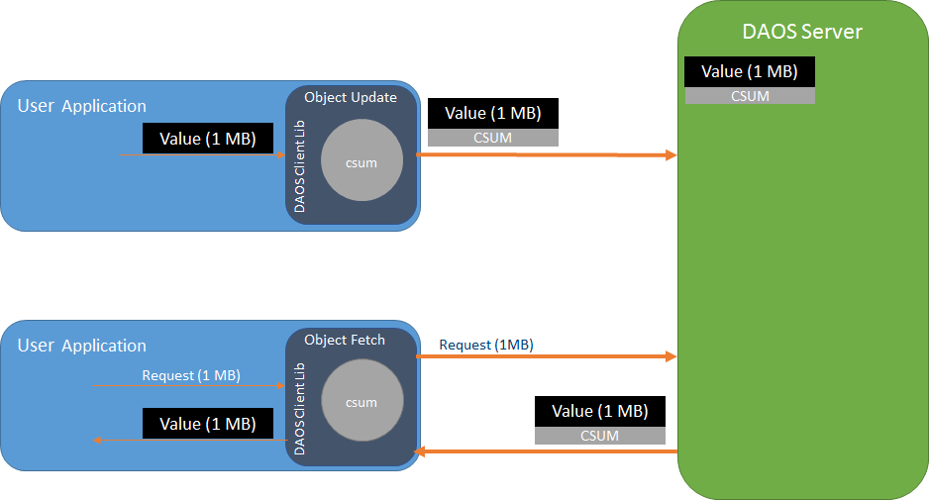

Basic Checksum Flow

### Single Value

A Single Value is an atomic value, meaning that writes to a single value will update the entire value and reads retrieve the entire value. Other DAOS features such as Erasure Codes might split a Single Value into multiple shards to be distributed among multiple storage nodes. Either the whole Single Value (if going to a single node) or each shard (if distributed) will have a checksum calculated, sent to the server, and stored on the server.

Note that it is possible for a single value, or shard of a single value, to be smaller than the checksum derived from it. It is advised that if an application needs many small single values to use an Array Type instead.

### Array Values

Unlike Single Values, Array Values can be updated and fetched at any part of an array. In addition, updates to an array are versioned, so a fetch can include parts from multiple versions of the array. Each of these versioned parts of an array are called extents. The following diagrams illustrate a couple examples (also see [VOS Key Array Stores](https://github.com/daos-stack/daos/blob/master/src/vos/README.md#key-array-stores) for more information):

A single extent update (blue line) from index 2-13. A fetched extent (orange line) from index 2-6. The fetch is only part of the original extent written.

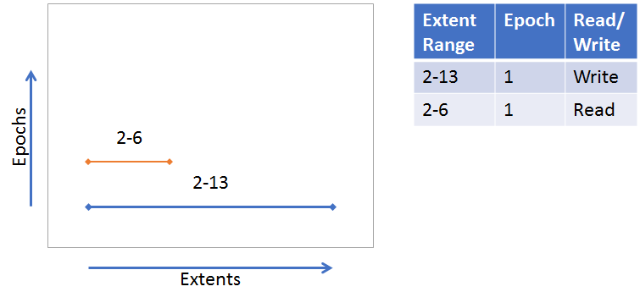

Many extent updates and different epochs. A fetch from index 2-13 requires parts from each extent.

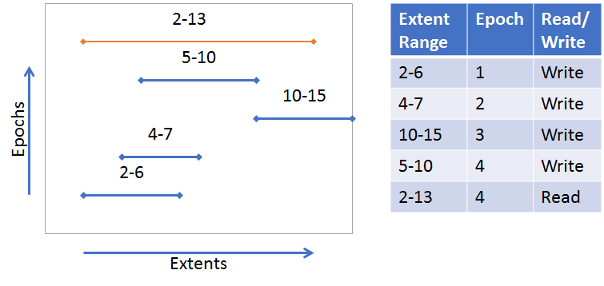

Array Example 2

The nature of the array type requires that a more sophisticated approach to creating checksums is used. DAOS uses a “chunking” approach where each extent will be broken up into “chunks” with a predetermined “chunk size.” Checksums will be derived from these chunks. Chunks are aligned with an absolute offset (starting at 0), not an I/O offset. The following diagram illustrates a chunk size configured to be 4 (units is arbitrary in this example). Though not all chunks have a full size of 4, an absolute offset alignment is maintained. The gray boxes around the extents represent the chunks.

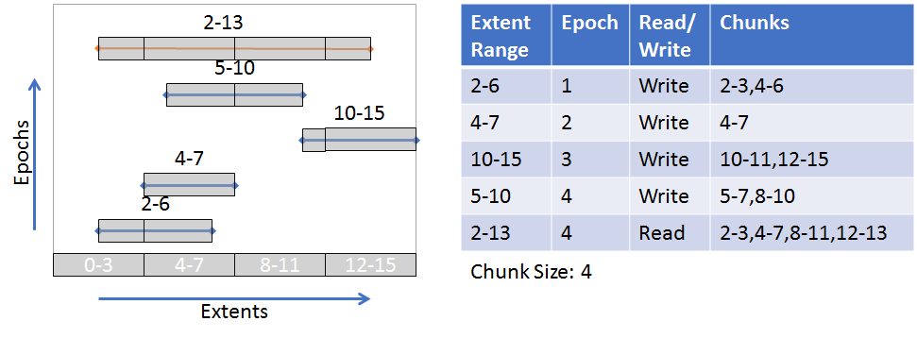

(See [Object Layer](https://github.com/daos-stack/daos/blob/master/src/object/README.md) for more details about the checksum process on object update and fetch)

# Checksum calculations

The actual checksum calculations are done by the [isa-l](https://github.com/intel/isa-l) and [isa-l_crypto](https://github.com/intel/isa-l_crypto) libraries. However, these libraries are abstracted away from much of DAOS and a common checksum library is used with appropriate adapters to the actual isa-l implementations. [common checksum library](../../src/common/README.md#checksum)

# Performance Impact

Calculating checksums can be CPU intensive and will impact performance. To mitigate performance impact, checksum types with hardware acceleration should be chosen. For example, CRC32C is supported by recent Intel CPUs, and many are accelerated via SIMD.

# Quality

Unit and functional testing is performed at many layers.

|  |  |  |
| --- | --- | --- |
| Test executable | What’s tested | Key test files |
| common_test | daos_csummer, utility functions to help with chunk alignment | src/common/tests/checksum_tests.c |
| vos_test | vos_obj_update/fetch apis with checksum params to ensure updating and fetching checksums | src/vos/tests/vts_checksum.c |
| srv_checksum_tests | Server side logic for adding fetched checksums to an array request. Checksums are appropriately copied or created depending on extent layout. | src/object/tests/srv_checksum_tests.c |
| daos_test | daos_obj_update/fetch with checksums enabled. The -z flag can be used for specific checksum tests. Also –csum_type flag can be used to enable checksums with any of the other daos_tests | src/tests/suite/daos_checksum.c |

## Running Tests

**With daos_server not running**

./commont_test  
./vos_test -z  
./srv_checksum_tests

**With daos_server running**

export DAOS_CSUM_TEST_ALL_TYPE=1  
./daos_server -z  
./daos_server -i --csum_type crc64

# Life of a checksum (WIP)

## Rebuild

In order for rebuild/migrate process to get checksums so it doesn’t have to recalculate them, the object list and object fetch task api’s provide a checksum iov parameter. If memory is allocated for the iov, then the daos client will pack the checksums into the it. If insufficient memory is allocated in the buffer, the iov_len will be set to the required capacity and the checksums packed into the buffer is truncated.

### Client Task API Touch Points

* **dc_obj_fetch_task_create**: sets csum iov to daos_obj_fetch_t args. These args are set to the rw_cb_args.shard_args.api_args and accessed through an accessor function (rw_args2csum_iov) in cli_shard.c so that rw_args_store_csum can easily access it. This function, called from dc_rw_cb_csum_verify, will pack the data checksums received from the server into the iov.
* **dc_obj_list_obj_task_create**: sets csum iov to daos_obj_list_obj_t args. args.csum is then copied to obj_enum_args.csum in dc_obj_shard_list(). On enum callback (dc_enumerate_cb()) the packed csum buffer is copied from the rpc args to obj_enum_args.csum (which points to the same buffer as the caller’s)

### Rebuild Touch Points

* migrate_fetch_update_(inline|single|bulk) - the rebuild/migrate functions that write to vos locally must ensure that the checksum is also written. These must use the csum iov param for fetch to get the checksum, then unpack the csums into iod_csum.
* obj_enum.c is relied on for enumerating the objects to be rebuilt. Because the fetch_update functions will unpack the csums from fetch, it will also unpack the csums for enum, so the unpacking process in obj_enum.c will simply copy the csum_iov to the io (dss_enum_unpack_io) structure in **enum_unpack_recxs()** and then deep copy to the mrone (migrate_one) structure in **migrate_one_insert()**.

### Packing/unpacking checksums

When checksums are packed (either for fetch or object list) only the data checksums are included. For object list, only checksums for data that is inlined is included. During a rebuild, if the data is not inlined, then the rebuild process will fetch the rest of the data and also get the checksums.

* ci_serialize() - “packs” checksums by appending the struct to an iov and then appending the checksum info buffer to the iov. This puts the actual checksum just after the checksum structure that describes the checksum.
* ci_cast() - “unpacks” the checksum and describing structure. It does this by casting an iov’s buffer to a dcs_csum_info struct and setting the csum_info’s checksum pointer to point to the memory just after the structure. It does not copy anything, but really just “casts”. To get all dcs_csum_infos, a caller would cast the iov, copy the csum_info to a destination, then move to the next csum_info(ci_move_next_iov) in the iov. Because this process modifies the iov structure it is best to use a copy of the iov as a temp structure.

## VOS

* akey_update_begin - determines how much extra space needs to be allocated in SCM to account for the checksum ### Arrays
* evt_root_activate - evtree root is activated. If has a csum them the root csum properties are set (csum_len, csum_type, csum_chunk_size)
* *evt_desc_csum_fill* - if root was activated with a punched record then it won’t have had the csum fields set correctly so set them here. Main purpose is to copy the csum to the end of persistent evt record (evt_desc). Enough SCM should have been reserved in akey_update_begin.
* *evt_entry_csum_fill* - Copy the csum from the persistent memory to the evt_entry returned. Also copy the csum fields from the evtree root to complete the csum_info structure in the evt_entry.
* akey_fetch_recx - checksums are saved to the ioc for each found extent. Will be used to be added to to the result later.

### Update/Fetch (copied from vos/README.md)

* SV Update: vos_update_end -> akey_update_single -> svt_rec_store
* Sv Fetch: vos_fetch_begin -> akey_fetch_single -> svt_rec_load
* EV Update: vos_update_end -> akey_update_recx -> evt_insert
* EV Fetch: vos_fetch_begin -> akey_fetch_recx -> evt_fill_entry

## Enumeration

For enumeration the csums for the keys and values are packed into an iov dedicated to csums. - fill_key_csum - Checksum is calcuated for the key and packed into the iov - fill_data_csum - pack/serialize the csum_info structure into the iov.

## Aggregation

* srv_csum_recalc.c - the checksum verification and calculations occur here

# Checksum Scrubbing (In Development)

A background task will scan (when the storage server is idle to limit performance impact) the Version Object Store (VOS) trees to verify the data integrity with the checksums. Corrective actions can be taken when corruption is detected. See Corrective Actions

## Scanner

### Goals/Requirements

* **Detect Silent Data Corruption Proactively** - The whole point of the scrubber is to detect silent data corruption before it is fetched.
* **Minimize CPU and I/O Bandwidth** - Checksum scrubbing scanner will impact CPU and the I/O bandwidth because it must iterate the VOS tree (I/O to SCM) fetch data (I/O to SSD) and calculate checksums (CPU intensive). To minimize both of these impacts, the server scheduler must be able to throttled the scrubber’s I/O and CPU usage.
* **Minimize Media Wear** - The background task will minimize media wear by preventing objects from being scrubbed too frequently. A container config/tunable will be used by an operator to define the minimum number of days that should pass before an object is scanned again.
* **Continuous** - The background task will be a continuous processes instead of running on a schedule. Once complete immediately start over. Throttling approaches should prevent from scrubbing same objects too frequently.

### High Level Design

* Per Pool ULT (I/O xstream) that will iterate containers. If checksums and scrubber is enabled then iterate the object tree. If a record value (SV or array) is not marked corrupted then scan.
  + Fetch the data.
  + Create new ULTs (helper xstream) to calculate checksum for data
  + Compare calculated checksum with stored checksum.
  + After every checksum is calculated, determine if need to sleep or yield.
  + If checksums don’t match confirm record is still there (not deleted by aggregation) then update record as corrupted
* After each object scanned yield to allow the server scheduler to reschedule the next appropriate I/O.

#### Sleep or Yield

Sleep for sufficient amount of time to ensure that scanning completes no sooner than configured interval (i.e. once a week or month). For example, if the interval is 1 week and there are 70 checksums that need to be calculated, then at a maximum 10 checksums are calculated a day, spaced roughly every 2.4 hours. If it doesn’t need to sleep, then it will yield to allow the server scheduler to prioritize other jobs.

## Corrective Actions

There are two main options for corrective actions when data corruption is discovered, in place data repair and SSD eviction.

### In Place Data Repair

If enabled, when corruption is detected, the value identifier (dkey, akey, recx) will be placed in a queue. When there are available cycles, the value identifier will be used to request the data from a replica if exists and rewrite the data locally. This will continue until the SSD Eviction threshold is reached, in which case, the SSD is assumed to be bad enough that it isn’t worth fixing locally and it will be requested to be evicted.

### SSD Eviction

If enabled, when the SSD Eviction Threshold is reached the SSD will be evicted. Current eviction methods are pool and target based so there will need to be a mapping and mechanism in place to evict an SSD. When an SSD is evicted, the rebuild protocol will be invoked.

Also, once the SSD Eviction Threshold is reached, the scanner should quit scanning anything on that SSD.

## Additional Checksum Properties > doc/user/container.md / doc/user/pool.md?

These properties are provided when a container or pool is created, but should also be able to update them. When updated, they should be active right away.

* Scanner Interval - Minimum number of days scanning will take. Could take longer, but if only a few records will pad so takes longer. (Pool property)
* Disable scrubbing - at container level & pool level
* Threshold for when to evict SSD (number of corruption events)
* In Place Correction - If the number checksum errors is below the Eviction Threshold, DAOS will attempt to repair the corrupted data using replicas if they exist.

## Design Details & Implementation

### Pool ULT

The code for the pool ULT is found in srv_pool_scrub.c. It can be a bit difficult to follow because there are several layers of callback functions due to the nature of how ULTs and the vos_iterator work, but the file is organized such that functions typically call the function above it (either directly or indirectly as a callback). For example (~> is an indirect call, -> is a direct call):

ds_start_scrubbing_ult ~> scrubbing_ult -> scrub_pool ~> cont_iter_scrub_cb ->  
 scrub_cont ~> obj_iter_scrub_cb ...

#### Silent Data Corruption Detection (TODO)

::Still todo::

obj_iter_scrub(coh, epr, csummer, pool_uuid, event_handlers, entry, type)  
{  
 build_iod  
 vos_obj_fetch(coh, oid, epoch, dkey, iod, sgl);  
 // for single value  
 csum = calc_checksum(type, csummer, iod, sgl)  
 compare(csum, entry.csum)  
 // for recx  
 for each chunk calc csum and compare  
}

### VOS Layer

* In order to mark data as corrupted a flag field is added to bio_addr_t which includes a CORRUPTED bit.
* The vos update api already accepts a flag, so a CORRUPTED flag is added and handled during an update so that, if set, the bio address will be updated to be corrupted.
* On fetch, if a value is already marked corrupted, return -DER_CSUM

### Object Layer

* When corruption is detected on the server during a fetch, aggregation, or rebuild the server calls VOS to update value as corrupted.
* (TBD) Add Server Side Verifying on fetch so can know if media or network corruption (note: need something so extents aren’t double verified?)

## Debugging

* In the server.yml configuration file set the following env_vars

- D_LOG_MASK=DEBUG  
- DD_SUBSYS=pool  
- DD_MASK=csum