**INSTRUCTIONS**

**Please read the instructions carefully before doing the questions.**

1. You can use materials in your computer, notebook and text book.
2. You are **NOT allowed** to use any device to share data with others.

Beside the above conditions, students must follow the following requirements**:**

1. **The work must complete by using Visual Studio 2022++**
2. **The Framework must be .NET 6.0**
3. **THIS PART IS VERY IMPORTANT, PLEASE READ IT CAREFULLY AND FOLLOW THE INSTRUCTIONS.**

* You are given a database script (.sql file) in Zip file. Execute the script before doing questions.
* **You must use the given solution.**
* **You are not allowed to add any more libraries via NuGet Package Manager into given solution.**
* **Just one of above requirements is violated, your work will be considered as invalid.**

On completion, submit the **whole solution folder.**

**Before submitting, you can delete the folder [bin] in each project to reduce the size of the solution, to fit the requirements of PEA_Client.**

**Question 1. (7 points)**

In this question, you are asked to write an application that provide some API to manage products.

**Note:** 0 will be given to the work that

* not using database connection string in the file **appsettings.json**
* do not config for testing by **Swagger** using the root path **http://localhost:5100**

You are asked to build three APIs, as following:

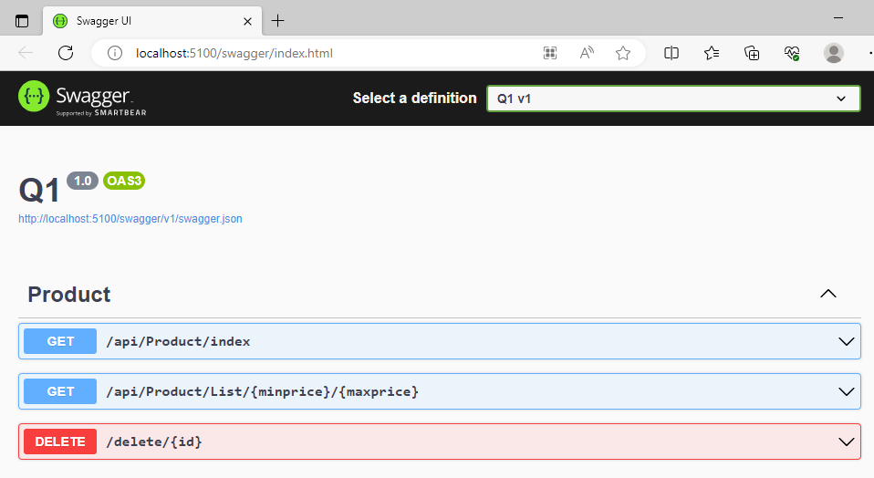

**1.1 (2 points)**

The API at url **/api/Product/index**:

* Using GET method.
* Returns all products in database. The result is like figure bellows:

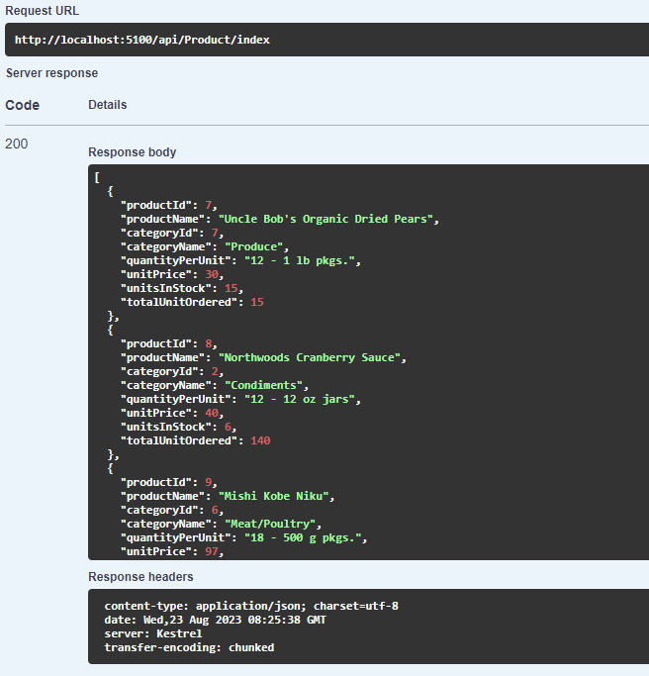

**1.2 (2 points)**

The API at url **/api/Product/List/{minprice}/{maxprice}**:

* Using GET method.
* Returns all products with price of each product is between **minprice** and **maxprice**.

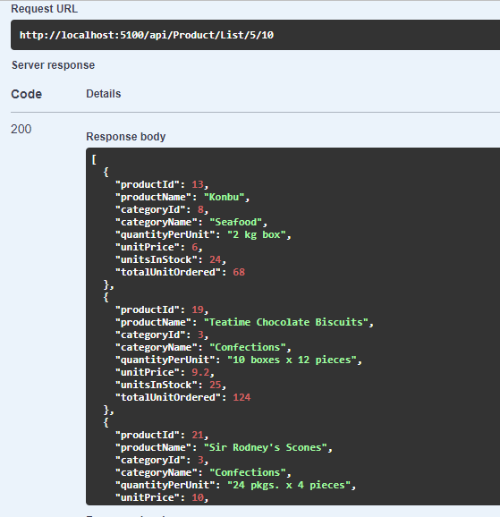

**1.3 (2 point)**

The API at url **/api/delete/{id}** that allows delete a product by id:

* Using DELETE method.
* Allows delete a product by id.

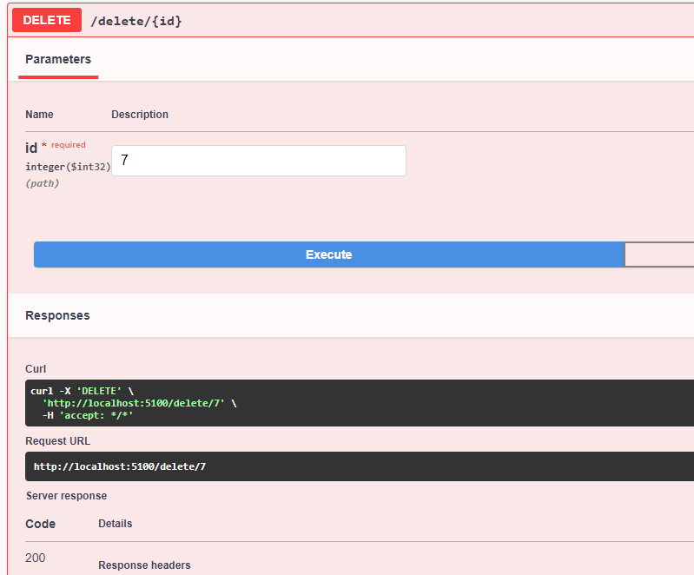

Configuring the api with url api/product/index using Odata with select, filer, orderby and count methods. (0.5 points)

Configuring the api with url api/product/index to return text/csv data (0.5 points):

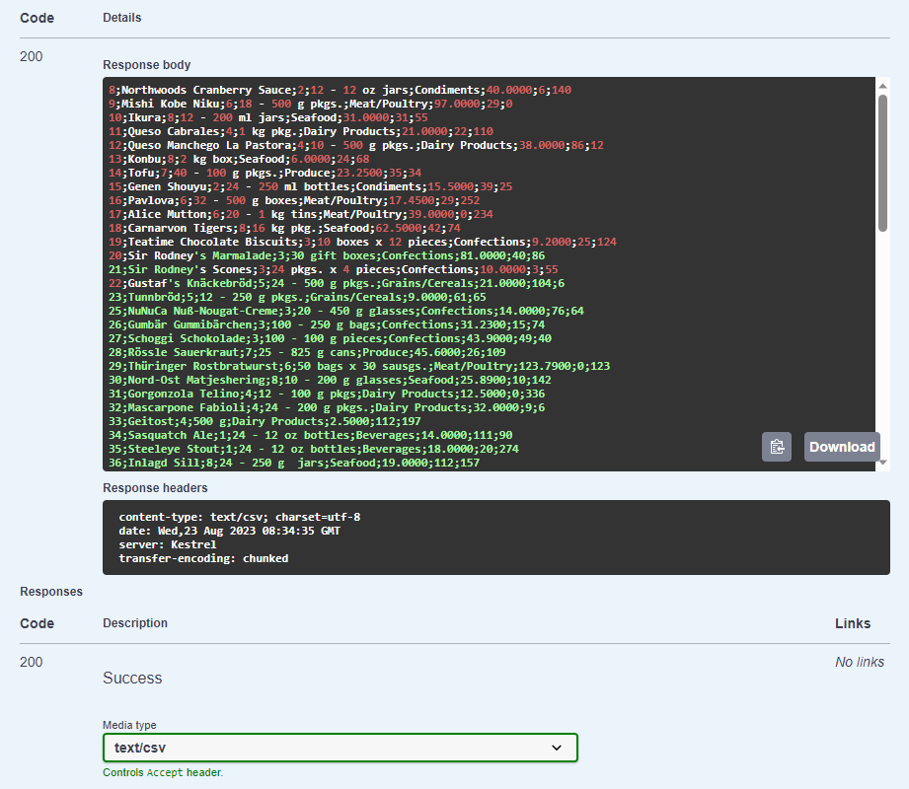

**Question 2.** (**3 points**)

In this question, you are asked to write a web site using MVC or Razor Pages that using api **GivenAPIs**.

Note that: using the root path[**http://localhost:5100**](http://localhost:5100)to call APIs.

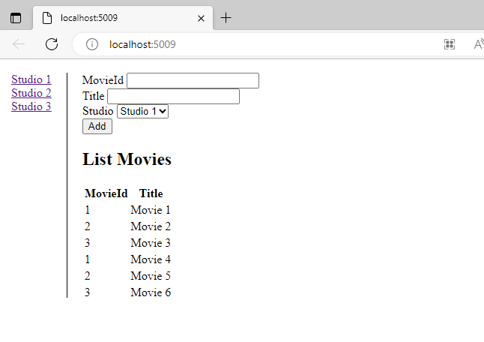

When filling information into the textboxes and clicking the **Add** button, you can add information. After adding, the newly added movie information will be displayed in List Movies.

Display all studios as links (see left column). After clicking on any studio, the **List Movies** will change for each studio (find list movies of each Studio).