**PROJECT DEMO**

1. **Project Functions:**

* Design UI for pages
* List products
* Search products
* Crud operations with products
* Login
* Register

1. **Technologies:**

**+ Web Api Server:**

* ASP Net Core 3.1
* Entity Framework Core 3.1 (Code First)
* ASP NET Identity (For login and register user)

**+ Web Page:**

* Angular 14

**+ Database:**

* Sql Server 2019

1. **Database Design:**

|  |  |
| --- | --- |
| **Tables Design** | |
| **Product** | **User (Identity)** |
| Id(int) | UserName(string) |
| ProductName(string) | Password(string) |
| Description(string) | Email(string) |
| ImageUrl(string) | PhoneNumber(string) |
| Price(decimal) |  |

1. **Design of the Application:**

The application will be made of a Web-based distributed to support multiple user transaction at the same time.

Backend API with ASP.Net Core 3.1

SQL Server 2019

User interface with Angular 14

1. **Use case:**

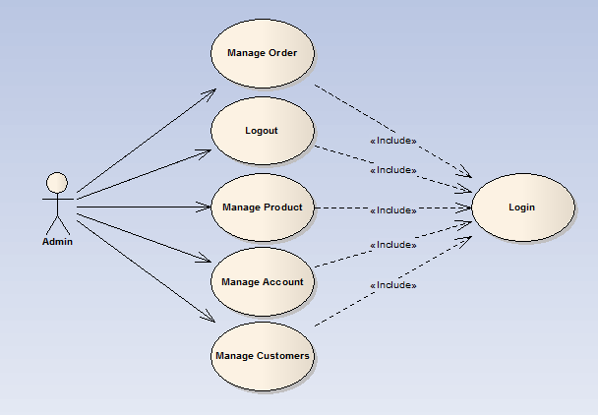

1. **Use Case Details:**

**1.Register:**

|  |  |
| --- | --- |
| **Name** | **Register** |
| Description | Guest registers for an account to perform further tasks |
| Users | Guest |
| Pre-conditions | User has not had an account yet |
| Basic Course of Events | 1. User provides some personal information (username, password, name, address…). 2. System validates all details provided by users. 3. User has a new account so that he/she can user further tasks. |
| Alternative Path | In step 2, if one or some details are invalid, system will display an error message |
| Post-conditions | User has a new account so that he/she can user further tasks |
|  | |

**2.Login:**

|  |  |
| --- | --- |
| **Name** | **Login** |
| Description | User or Admin login to perform corresponding tasks |
| Users | All users |
| Pre-conditions | User or Admin has not login yet |
| Basic Course of Events | 1. User enters username and password, then press login button. 2. System checks whether both username and password are valid or not. 3. If valid, the user will be logged into the site. |
| Alternative Path | In step 2, if username or password is invalid, system will display an error message |
| Post-conditions | User or Admin has logged in so that can do his/her further functions. |
|  | |

**3.Logout:**

|  |  |
| --- | --- |
| **Name** | **Logout** |
| Description | User or Admin logout to terminate their accessibility |
| User | All user |
| Pre-condition | User or Admin has logged in |
| Basic Courses of Events | 1. The user clicks the logout button 2. The session is terminated. 3. The system turns back to the site for guess. |
| Alternative Path | None |
| Post-conditions | User has logout that terminate their session. The system redirect to the guest site |
|  | |

**4.Products:**

|  |  |
| --- | --- |
| **Name** | **View Product** |
| Description | User views all products or products in one category |
| Users | User |
| Pre-conditions | None |
| Basic Course of Events | User choose to do with product(edit,update,delete) |
| Alternative Path | None |
| Post-conditions | All products are displayed |
|  | |

|  |  |
| --- | --- |
| **Name** | **Search Products** |
| Description | User searchs products that she/he need |
| Users | User |
| Pre-conditions | None |
| Basic Course of Events | 1. User enter search string and press search button. 2. System check whether a product matching search string exists. 3. Products are displayed. |
| Alternative Path | In step 2, if no product is found, system will notify to user |
| Post-conditions | The matched products are displayed |
|  | |