**Lesson 41**

**Part 1**

**We connect the accelerometer LIS3DSH**

The theme of our today's lesson is to connect a newer accelerometer than the one we used to study in[**lesson 39**](http://narodstream.ru/stm-urok-39-podklyuchaem-akselerometr-lsm303dlhc-chast-1/) . This accelerometer is also an accelerometer made using MEMS technology - **LIS3DSH**.

        First, this accelerometer, along with the I2C interface, can also be connected using the SPI interface, which makes the data transfer and use more reliable. Secondly, this accelerometer is installed on the STM32F4 Discovery board, which we have been working with for a very long time, and it has already become like a native. And this I consider to be an important motivation. And thirdly, it has better technical characteristics:

        The reading range is ± 2g / ± 4g / ± 6g / ± 8g / ± 16g;

The sensitivity is 0.06-0.73 mg / digit;

Deviation from zero ± 60 mg.

Well, we will get acquainted with other characteristics, subtleties, registers and other pitfalls of the accelerometer during its programming.

We will create a project for the Cube MX from one of the past projects USB_OTG_CDC, because instead of USART to transfer the accelerometer readings to the PC, we will try to use the USB CDC Device, since it is more convenient to work with it because of the need for some intermediate adapters. Call the project ACCEL407.

        Run the project in Cube MX, disable I2C, enable SPI1 in Full-Duplex Master mode

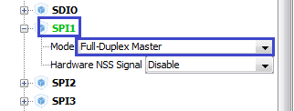

        SPI leaves the default and does not redirect anywhere

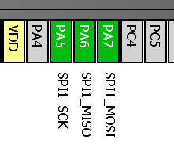

We will include 3 more legs. One for chip selection (CS), the other two for interrupt detection. Perhaps the latter we do not need, but for the sake of inclusion, so that by mistake they do not subsequently be involved in something else.

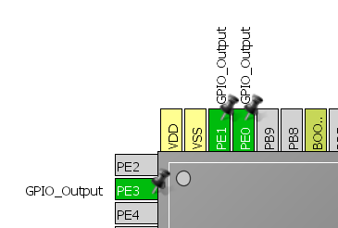

Also, we'll turn on the output of the ports of the ports to control the multi-colored LEDs on the board

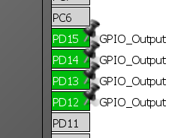

In the SPI settings, only the transfer rate will be changed

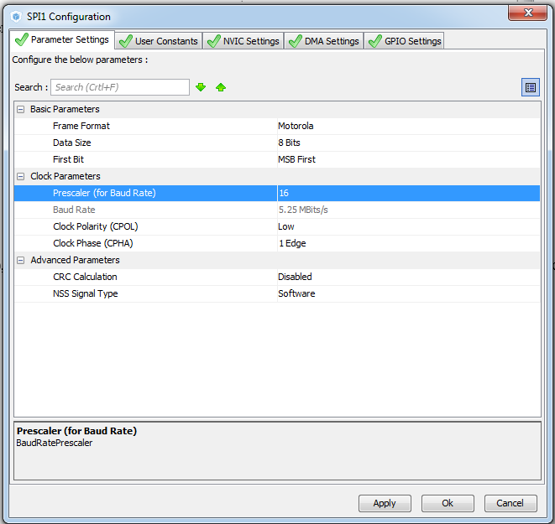

Also, change the settings in the GPIO at the foot of the PE3 port, setting it to Medium.

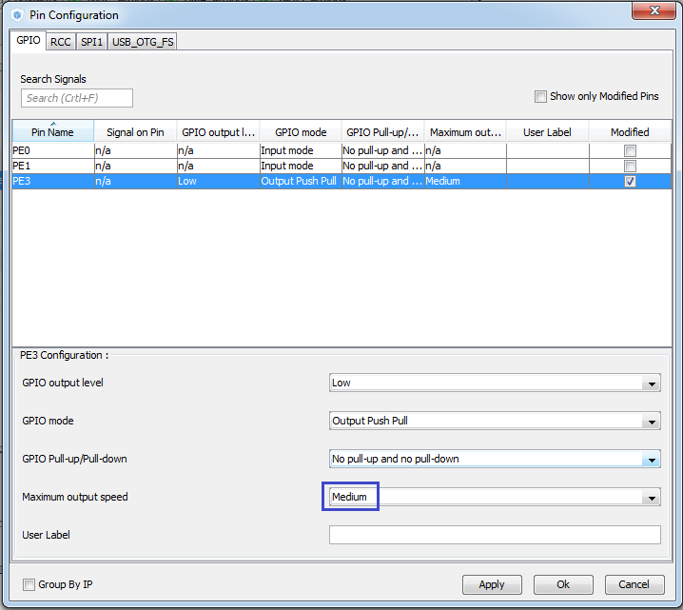

We go into Project -> Settings and change the stack and heap values ​​there so that the USB device does not give us an error after installing the driver (Code 10).

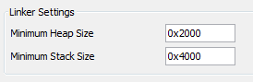

Generate the project and open it in Keil 5. Also, by tradition, configure the programmer for auto-cutting.We will collect the project.

We remove everything that concerns the character display, since we probably will not need it. Remove the library connection from main.h:

#include "stm32f4xx_hal.h"

~~#include "lcd.h"~~

Here we leave only the transfer to USB to check if it works.

  / * USER CODE BEGIN 2 * /

        sprintf (str_tx, "USB Transmitrn");

  / * USER CODE END 2 * /

In the endless loop, we also leave only what concerns the transfer to USB

  while (1)

  {

        CDC_Transmit_FS ((uint8_t *) str_tx, strlen (str_tx));

        HAL_Delay (500);

  / * USER CODE END WHILE * /

Let's run the controller to make sure the USB port is working and delete the whole transfer, the line array and the line preparation:

/ * Private variables ------------------- * /

~~char str_rx [21];~~

/ * USER CODE END PV * /

-

  / * USER CODE BEGIN 2 * /

~~sprintf (str_tx, "USB Transmitrn");~~

  / * USER CODE END 2 * /

-

  while (1)

  {

~~CDC_Transmit_FS ((uint8_t *) str_tx, strlen (str_tx));~~

~~HAL_Delay (500);~~

  / * USER CODE END WHILE * /

-

~~char str_tx [21];~~

  / * USER CODE END 1 * /

Also delete the following lines from the file usbd_cdc_if.c, and uncomment it one line:

/ * USER CODE BEGIN PRIVATE_VARIABLES * /

~~extern char str_rx [21];~~

/ * USER CODE END PRIVATE_VARIABLES * /

-

static int8_t CDC_Receive_FS (uint8_t * Buf, uint32_t * Len)

{

  / * USER CODE BEGIN 6 * /

**USBD_CDC_SetRxBuffer (& hUsbDeviceFS, & Buf [0]);**

~~strncpy (str_rx, (char *) Buf, * Len);~~

~~str_rx [* Len] = 0;~~

  USBD_CDC_ReceivePacket (& hUsbDeviceFS);

  return (USBD_OK);

  / * USER CODE END 6 * /

We rewrite the project just in case, to make sure that we do not have any errors.

Two files to work with the accelerometer can be used from the last lesson, renaming them properly, connecting to the project and making some changes.

The names, respectively, will change to lis3dsh.h and lis3dsh.c. At the same time, we will remove the files lcd.h and lcd.c. from Inc and Src. We connect these files by adding lis3dsh.c in the project to the Application / User group, and connecting lis3dsh.h to main.h. Also we'll add macros, like those we made in the project under 3 discovery for convenient control of the LEDs.

#include "stm32f4xx_hal.h"

**#include "lis3dsh.h"**

// ----------------

**#define LD_PORT GPIOD**

**#define LD3 GPIO_PIN_13 // ORANGE**

**#define LD4 GPIO_PIN_12 // GREEN**

**#define LD5 GPIO_PIN_14 // RED**

**#define LD6 GPIO_PIN_15 // BLUE**

**#define LD3_ON HAL_GPIO_WritePin (LD_PORT, LD3, GPIO_PIN_SET) // ORANGE**

**#define LD4_ON HAL_GPIO_WritePin (LD_PORT, LD4, GPIO_PIN_SET) // GREEN**

**#define LD5_ON HAL_GPIO_WritePin (LD_PORT, LD5, GPIO_PIN_SET) // RED**

**#define LD6_ON HAL_GPIO_WritePin (LD_PORT, LD6, GPIO_PIN_SET) // BLUE**

**#define LD3_OFF HAL_GPIO_WritePin (LD_PORT, LD3, GPIO_PIN_RESET) // ORANGE**

**#define LD4_OFF HAL_GPIO_WritePin (LD_PORT, LD4, GPIO_PIN_RESET) // GREEN**

**#define LD5_OFF HAL_GPIO_WritePin (LD_PORT, LD5, GPIO_PIN_RESET) // RED**

**#define LD6_OFF HAL_GPIO_WritePin (LD_PORT, LD6, GPIO_PIN_RESET) // BLUE**

// ----------------

Composition of these files after making changes.

The contents of lis3dsh.h:

**#ifndef LIS3DSH_H_**

**#define LIS3DSH_H_**

**#include "stm32f4xx_hal.h"**

**#include <string.h>**

**// ----------------**

**#define ABS (x) (x <0)? (-x): x**

**// ----------------**

**#define LD_PORT GPIOD**

**#define LD3 GPIO_PIN_13 // ORANGE**

**#define LD4 GPIO_PIN_12 // GREEN**

**#define LD5 GPIO_PIN_14 // RED**

**#define LD6 GPIO_PIN_15 // BLUE**

**#define LD3_ON HAL_GPIO_WritePin (LD_PORT, LD3, GPIO_PIN_SET) // ORANGE**

**#define LD4_ON HAL_GPIO_WritePin (LD_PORT, LD4, GPIO_PIN_SET) // GREEN**

**#define LD5_ON HAL_GPIO_WritePin (LD_PORT, LD5, GPIO_PIN_SET) // RED**

**#define LD6_ON HAL_GPIO_WritePin (LD_PORT, LD6, GPIO_PIN_SET) // BLUE**

**#define LD3_OFF HAL_GPIO_WritePin (LD_PORT, LD3, GPIO_PIN_RESET) // ORANGE**

**#define LD4_OFF HAL_GPIO_WritePin (LD_PORT, LD4, GPIO_PIN_RESET) // GREEN**

**#define LD5_OFF HAL_GPIO_WritePin (LD_PORT, LD5, GPIO_PIN_RESET) // RED**

**#define LD6_OFF HAL_GPIO_WritePin (LD_PORT, LD6, GPIO_PIN_RESET) // BLUE**

**// ----------------**

**void Accel_Ini (void);**

**void Accel_ReadAcc (void);**

**// ----------------**

**#endif / * LIS3DSH_H_ * /**

The contents of the file lis3dsh.c:

**#include "lis3dsh.h"**

**// ------------**

**static void Error (void)**

**{**

**}**

**// -------------**

**uint8_t Accel_IO_Read (uint16_t DeviceAddr, uint8_t RegisterAddr)**

**{**

**return 0;**

**}**

**// -------------**

**void Accel_IO_Write (uint16_t DeviceAddr, uint8_t RegisterAddr, uint8_t Value)**

**{**

**}**

**// -------------**

**uint8_t Accel_ReadID (void)**

**{**

**uint8_t ctrl = 0x00;**

**return ctrl;**

**}**

**// -------------**

**void Accel_AccFilterConfig (uint8_t FilterStruct)**

**{**

**}**

**// -------------**

**void AccInit (uint16_t InitStruct)**

**{**

**}**

**// -------------**

**void Accel_GetXYZ (int16_t * pData)**

**{**

**}**

**// -------------**

**void Accel_ReadAcc (void)**

**{**

**}**

**// -------------**

**void Accel_Ini (void)**

**{**

**}**

**// -------------**

Call the sensor initialization in main ();

  / * USER CODE BEGIN 2 * /

**Accel_Ini ();**

  / * USER CODE END 2 * /

In the function-error handler, turn on the red LED

static void Error (void)

{

**LD5_ON;**

}

Add the handle of our SPI:

#include "lis3dsh.h"

// ------------

**extern SPI_HandleTypeDef hspi1;**

In the [**next part of the**](http://narodstream.ru/stm-urok-41-podklyuchaem-akselerometr-lis3dsh-chast-2/) lesson, we will attempt to read the data identifier, thereby making sure that the correct tire settings are set and that we are working with this sensor.   
Also write the function of writing data to the accelerometer registers.

**Lesson 41**

**Part 2**

# ****We connect the accelerometer LIS3DSH****

In the [**previous part of**](http://narodstream.ru/stm-urok-41-podklyuchaem-akselerometr-lis3dsh-chast-1/) our lesson, we briefly studied the documentation for the sensor, created a project for it, added some macros and set up library files.

Let's now write a function for receiving and transmitting over SPI:

// -------------

**static uint8_t SPIx_WriteRead (uint8_t Byte)**

**{**

**uint8_t receivedbyte = 0;**

**if (HAL_SPI_TransmitReceive (& hspi1, (uint8_t *) & Byte, (uint8_t *) & receivedbyte, 1, 0x1000)! = HAL_OK)**

**{**

**Error ();**

**}**

**return receivedbyte;**

**}**

// -------------

Add some more macros to the header file lis3dsh.h:

#define LD6_OFF HAL_GPIO_WritePin (LD_PORT, LD6, GPIO_PIN_RESET) // BLUE

// ----------------

**#define CS_GPIO_PORT GPIOE**

**#define CS_PIN GPIO_PIN_3**

**#define CS_ON HAL_GPIO_WritePin (CS_GPIO_PORT, CS_PIN, GPIO_PIN_RESET)**

**#define CS_OFF HAL_GPIO_WritePin (CS_GPIO_PORT, CS_PIN, GPIO_PIN_SET)**

**#define DUMMY_BYTE ((uint8_t) 0x00)**

**// ----------------**

**#define LIS3DSH_WHO_AM_I_ADDR 0x0F**

**// ----------------**

**#define READWRITE_CMD ((uint8_t) 0x80)**

**#define MULTIPLEBYTE_CMD ((uint8_t) 0x40)**

// ----------------

Add the code to the **Accel_IO_Read**function , changing also the arguments and the input and return values:

**void** Accel_IO_Read ( **uint8_t * pBuffer, uint8_t ReadAddr, uint16_t NumByteToRead**)

{

**if (NumByteToRead> 0x01)**

**{**

**ReadAddr | = (uint8_t) (READWRITE_CMD | MULTIPLEBYTE_CMD);**

**}**

**else**

**{**

**ReadAddr | = (uint8_t) READWRITE_CMD;**

**}**

**CS_ON;**

**SPIx_WriteRead (ReadAddr);**

**while (NumByteToRead> 0x00)**

**{**

**/ * Send dummy byte (0x00) to generate the SPI clock to ACCELEROMETER (Slave device) * /**

**\* pBuffer = SPIx_WriteRead (DUMMY_BYTE);**

**NumByteToRead-;**

**pBuffer ++;**

**}**

**CS_OFF;**

}

Add a line to the **Accel_ReadID**function :

uint8_t Accel_ReadID (void)

{

  uint8_t ctrl = **0**;

**Accel_IO_Read (& ctrl, LIS3DSH_WHO_AM_I_ADDR, 1);**

  return ctrl;

}

Well, also add the code to the initialization function **Accel_Ini**:

void Accel_Ini (void)

{

**uint16_t ctrl = 0x0000;**

**HAL_Delay (1000);**

**if (Accel_ReadID () == 0x3F) LD4_ON;**

**else Error ();**

}

We will collect the code and tell the controller and see if we have a green LED

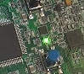

At us the light-emitting diode shines, means we on a correct way.

Now, to further initialize the accelerometer, we need a function to write data to the registers of our sensor

// -------------

**void Accel_IO_Write (uint8_t * pBuffer, uint8_t WriteAddr, uint16_t NumByteToWrite)**

**{**

**CS_OFF;**

**if (NumByteToWrite> 0x01)**

**{**

**WriteAddr | = (uint8_t) MULTIPLEBYTE_CMD;**

**}**

**CS_ON;**

**SPIx_WriteRead (WriteAddr);**

**while (NumByteToWrite> = 0x01)**

**{**

**SPIx_WriteRead (* pBuffer);**

**NumByteToWrite-;**

**pBuffer ++;**

**}**

**CS_OFF;**

**}**

// -------------

In the [**next part of the**](http://narodstream.ru/stm-urok-41-podklyuchaem-akselerometr-lis3dsh-chast-3/) lesson, we finish writing the initialization of the accelerometer, and also write a function to read the data from the sensor.

**Lesson 41**

**Part 3**

# ****We connect the accelerometer LIS3DSH****

In the [**previous part of**](http://narodstream.ru/stm-urok-41-podklyuchaem-akselerometr-lis3dsh-chast-2/) our lesson, we considered the data identifier, thus making sure the correct settings of the bus and the fact that we are working with this sensor, and also wrote the function of writing data to the accelerometer registers.

Now write write the code in the function of initializing the settings

**void AccInit (uint16_t InitStruct)**

**{**

**uint8_t ctrl = 0x00;**

**ctrl = (uint8_t) (InitStruct);**

**Accel_IO_Write (& ctrl, LIS3DSH_CTRL_REG4_ADDR, 1);**

**ctrl = (uint8_t) (InitStruct >> 8);**

**Accel_IO_Write (& ctrl, LIS3DSH_CTRL_REG5_ADDR, 1);**

**}**

The purpose of the registers 4 and 5 of the sensor will be discussed below when we enter the settings data there.

Now we will continue to write the code in the main initialization function of our accelerometer

        else Error ();

**/ * Configure MEMS: power mode (ODR) and axes enable * /**

**ctrl = (uint16_t) (LIS3DSH_DATARATE_100 | LIS3DSH_XYZ_ENABLE);**

**/ * Configure MEMS: full scale and self test * /**

**ctrl | = (uint16_t) ((LIS3DSH_SERIALINTERFACE_4WIRE |**

**LIS3DSH_SELFTEST_NORMAL |**

**LIS3DSH_FULLSCALE_2 |**

**LIS3DSH_FILTER_BW_800) << 8);**

**AccInit (ctrl);**

**LD6_ON;**

}

And now we'll try to figure out what and where we're putting it.

First, **let's look at the LIS3DSH_CTRL_REG4_ADDR**register **(address 0x20)**

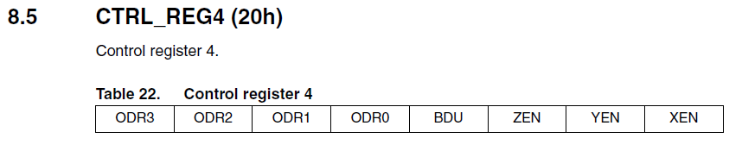

In it we will configure the following bits:

**LIS3DSH_DATARATE_100**: value **0x60**: with this value we will include the bits ODR1 and ODR2, thereby adjust the data rate of 100 hertz.

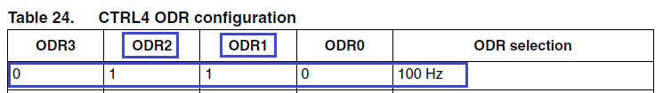

**LIS3DSH_XYZ_ENABLE**: value **0x07: enable the**bits of all axes, thus let the sensor know that it reads the data of all three axes (x, y and z)

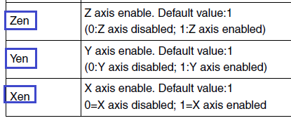

We do not include anything else in this register. Now let's **look**at the following case:**LIS3DSH_CTRL_REG5_ADDR (address 0x24).**

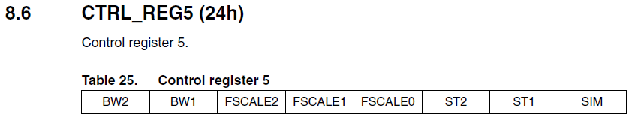

Here are the settings:

**LIS3DSH_SERIALINTERFACE_4WIRE:**value **0x00:**this bit is responsible for enabling the interface bus mode. Leave 0, so we turn on the 4-wire SPI.

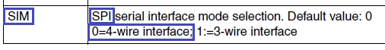

**LIS3DSH_SELFTEST_NORMAL:**value **0x00:**here we will denote that we will not include bits 1 and 2 (ST1 and ST2), thereby enabling the initial self-test mode (normal mode).

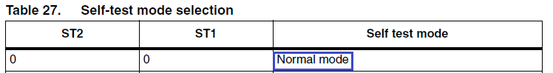

**LIS3DSH_FULLSCALE_2:**value **0x00:**we also do not turn on the FSCALE bits, let's say the accelerometer so that it measures the readings on all axes ranging from -2G to + 2G.

image14

**LIS3DSH_FILTER_BW_800:**value **0x00:**bits of the bandwidth of the anti-aliasing filter. We do not install them, so we will have a bandwidth of 800 hertz.

image15

Well, in order to get information that we have nothing moved, we'll turn on the blue LED at the end of the function.

Now let's move on to the more interesting part of our lesson - getting the measured readings from the sensor. We will enter a certain code into the function **Accel_GetXYZ.**

void Accel_GetXYZ (int16_t * pData)

{

**int8_t buffer [6];**

**uint8_t crtl, i = 0x00;**

**float sensitivity = LIS3DSH_SENSITIVITY_0_06G;**

**float valueinfloat = 0;**

}

In this code, adding to the variable function, we are interested in the sensitivity value**LIS3DSH_SENSITIVITY_0_06G.**Here we set up that in a certain register we will insert later such data that will allow us to adjust the sensitivity of the sensor to 0.06 mg.

We **count the**data from the register **LIS3DSH_CTRL_REG5_ADDR (address 0x24)**, the assignment of bits of which we analyzed above, to the variable ctrl.

float valueinfloat = 0;

**Accel_IO_Read (& crtl, LIS3DSH_CTRL_REG5_ADDR, 1);**

}

Further from the corresponding sensor registers we consider the lower and higher bytes of the 16-bit readings measured for each of the three axes

  Accel_IO_Read (& crtl, LIS3DSH_CTRL_REG5_ADDR, 1);

**Accel_IO_Read ((uint8_t *) & buffer [0], LIS3DSH_OUT_X_L_ADDR, 1);**

**Accel_IO_Read ((uint8_t *) & buffer [1], LIS3DSH_OUT_X_H_ADDR, 1);**

**Accel_IO_Read ((uint8_t *) & buffer [2], LIS3DSH_OUT_Y_L_ADDR, 1);**

**Accel_IO_Read ((uint8_t *) & buffer [3], LIS3DSH_OUT_Y_H_ADDR, 1);**

**Accel_IO_Read ((uint8_t *) & buffer [4], LIS3DSH_OUT_Z_L_ADDR, 1);**

**Accel_IO_Read ((uint8_t *) & buffer [5], LIS3DSH_OUT_Z_H_ADDR, 1);**

Next, we check the few bits from the 5 register. Since we are only interested in 1,2 and 5 bits, the rest will be reset by the mask (LIS3DSH__FULLSCALE_SELECTION = 0x38)

  Accel_IO_Read ((uint8_t *) & buffer [5], LIS3DSH_OUT_Z_H_ADDR, 1);

**switch (crtl & LIS3DSH__FULLSCALE_SELECTION)**

**{**

**}**

Depending on the values ​​of these bits, we make a value in the sensitivity variable, that is, we will thereby adjust the sensitivity of the sensor depending on the measurement limits.

  switch (crtl & LIS3DSH__FULLSCALE_SELECTION)

  {

**case LIS3DSH_FULLSCALE_2:**

**sensitivity = LIS3DSH_SENSITIVITY_0_06G;**

**break;**

**case LIS3DSH_FULLSCALE_4:**

**sensitivity = LIS3DSH_SENSITIVITY_0_12G;**

**break;**

**case LIS3DSH_FULLSCALE_6:**

**sensitivity = LIS3DSH_SENSITIVITY_0_18G;**

**break;**

**case LIS3DSH_FULLSCALE_8:**

**sensitivity = LIS3DSH_SENSITIVITY_0_24G;**

**break;**

**case LIS3DSH_FULLSCALE_16:**

**sensitivity = LIS3DSH_SENSITIVITY_0_73G;**

**break;**

**default:**

**break;**

}

Well, in accordance with the sensitivity, we transform the measured readings a little and insert them into the buffer for further use in the work of our program.

   break;

  }

**for (i = 0; i <3; i ++)**

**{**

**valueinfloat = ((buffer [2 * i + 1] << 8) + buffer [2 * i]) * sensitivity;**

**pData [i] = (int16_t) valueinfloat;**

**}**

}

Next, we'll write the code in the Accel_ReadAcc function.

void Accel_ReadAcc (void)

{

**int16_t buffer [3] = {0};**

**int16_t xval, yval , zval = 0x00;**

**Accel_GetXYZ (buffer);**

**HAL_Delay (20);**

}

Readings from the sensor are read in an infinite loop in the main () function.

  / * USER CODE BEGIN 3 * /

**Accel_ReadAcc ();**

  }

  / * USER CODE END 3 * /

In the [**next part of the**](http://narodstream.ru/stm-urok-41-podklyuchaem-akselerometr-lis3dsh-chast-4/) lesson, we will complete the work with the accelerometer-accelerometer LIS3DSH, finish writing the function of collecting values ​​from the axes of the accelerometer and monitoring these values ​​using LEDs, a terminal and a visualization program that I wrote myself.

# ****We connect the accelerometer LIS3DSH****

In the [**previous part of**](http://narodstream.ru/stm-urok-41-podklyuchaem-akselerometr-lis3dsh-chast-3/) our lesson, we finished writing the initialization of the accelerometer, and also wrote a function to read the data from the sensor.

We continue the function Accel_ReadAcc. Enter the sensor readings into the buffer:

  Accel_GetXYZ (buffer);

**xval = buffer [0];**

**yval = buffer [1];**

**zval = buffer [2];**

  HAL_Delay (20);

Now we process these indications and, depending on their values, light certain LEDs on the board.

  zval = buffer [2];

**if ((ABS (xval))> (ABS (yval)))**

**{**

**if (xval> 200)**

**{**

**LD5_ON;**

**}**

**else if (xval <-200)**

**{**

**LD4_ON;**

**}**

**}**

**else**

**{**

**if (yval> 200)**

**{**

**LD3_ON;**

**}**

**else if (yval <-200)**

**{**

**LD6_ON;**

**}**

**}**

  HAL_Delay (20);

And, accordingly, at the end of the function, we all extinguish the LEDs.

        HAL_Delay (20);

**LD3_OFF;**

**LD4_OFF;**

**LD5_OFF;**

**LD6_OFF;**

}

We will sew the controller and see the result.

If everything is fine, we will try to transfer these results to a PC via USB CDC. Let's take some code from the last lesson.

Connect file for USB CDC

#include "lis3dsh.h"

**#include "usbd_cdc_if.h"**

// ------------

Add a global variable to the file lis3dsh.c

extern SPI_HandleTypeDef hspi1;

**uint8_t buf2 [8] = {0};**

**char str1 [30] = {0};**

// ------------

Insert the code into the Accel_ReadAcc function

  zval = buffer [2];

**sprintf (str1, "X:% 06d Y:% 06d Z ::% 06drn", xval, yval, zval);**

**CDC_Transmit_FS ((uint8_t *) str1, strlen (str1));**

  if ((ABS (xval))> (ABS (yval)))

We'll collect the code, we'll sew the controller and see the result with the help of, for example, the monitor of the port built into the software for Arduino, as it slows down less than some similar utilities.

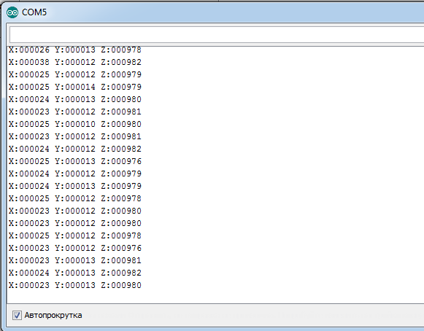

Excellent!

        Now let's try to see the indications with the help of some visualization utility. But since I did not find any utility to work correctly with USB, I had to write it myself. To use this utility, fill the buffer appropriately by commenting out the character transfer code in USB, and call the transfer function:

  zval = buffer [2];

// sprintf (str1, "X:% 06d Y:% 06d Z:% 06drn", xval, yval, zval);

// CDC_Transmit_FS ((uint8_t *) str1, strlen (str1));

**buf2 [0] = 0x11;**

**buf2 [1] = 0x55;**

**buf2 [2] = (uint8_t) (xval >> 8);**

**buf2 [3] = (uint8_t) xval;**

**buf2 [4] = (uint8_t) (yval >> 8);**

**buf2 [5] = (uint8_t) yval;**

**buf2 [6] = (uint8_t) (zval >> 8);**

**buf2 [7] = (uint8_t) zval;**

**CDC_Transmit_FS (buf2, 8);**

        if ((ABS (xval))> (ABS (yval)))

Also we will remove while the multiplier in function of information gathering

  for (i = 0; i <3; i ++)

  {

    valueinfloat = ((buffer [2 * i + 1] << 8) + buffer [2 * i]) ~~* sensitivity~~;

    pData [i] = (int16_t) valueinfloat;

And instead of 200 in the LED control code, we put 2000, adding zero to 200, so that the LEDs are less sensitive to acceleration

        if ((ABS (xval))> (ABS (yval)))

  {

                if (xval> 200 **0**)

                {

                        LD5_ON;

                }

                else if (xval <-200 **0**)

                {

                        LD4_ON;

                }

        }

        else

        {

                if (yval> 200 **0**)

                {

                        LD3_ON;

                }

                else if (yval <-200 **0**)

                {

                        LD6_ON;

                }

        }

Run the utility and see the change in the axis chart in time, depending on the position of the debug board, and hence the sensor accelerometer (click on the image to enlarge the image)

[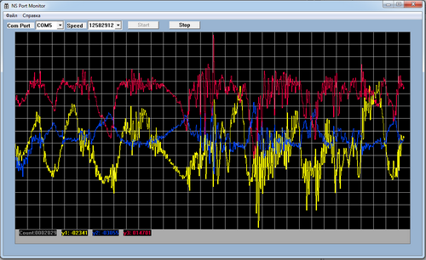](http://narodstream.ru/wp-content/uploads/2016/11/image00_1103.png)