**DAC. Noise**

We create the project from the project **DAC_ TRIANGLE** . Let's call it **DAC_NOISE** . Run the project in the Cube, in the *DAC* settings, select the next generation mode and amplitude

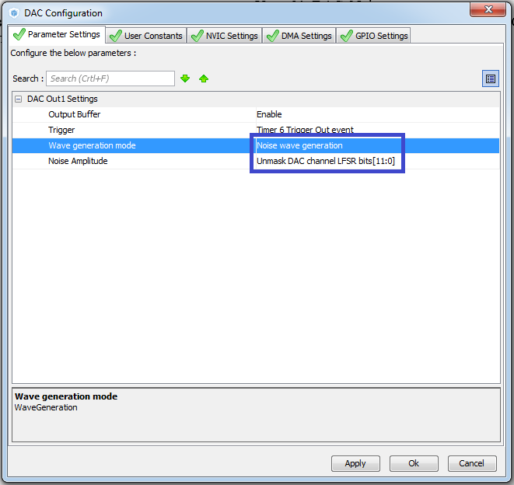

We do not touch the timer settings yet.

Generate and run the project, compile it, configure the programmer

Let's sew the controller

This frequency is too high.

Let's adjust another frequency. Since we have a timer running at 84 MHz, in the Cube MX we expose the divider 83 and the period 10. Thus we set the interrupt triggering from the timer with a frequency of 100 kilohertz.

Again, generate, open, run the project. Let's sew the controller

We see that at this frequency our home-made oscilloscope perfectly copes, since it is not the frequency of some complicated period, but the frequency of the appearance of the random shelves of our random number generator.

Let's now increase the frequency by 10 times, it's possible in the project itself, making instead of 83 in divider 41, and the period instead of 10 will be put 2. The frequency will be 1 MHz.

We'll compile the project and run the controller.

Now everything is beautiful.

Next time, we will try to use the RNG thermal generator as the raw data for the noise generator.