**Lesson 30**

**DAC. Sinus. DMA**

Today, we will also try, using DMA technology, to create oscillations of the sinusoidal form also from data prepared in advance in the array in view of the fact that sinusoidal oscillations are not provided for in hardware at all in the MC. Also, according to numerous requests in different lessons, we will try to measure the oscillation frequency and period in cycles of a full sinusoidal oscillation. To display the data on the screen, we also use the LCD 20x4, which we will connect via the I2C adapter.

We create the project from the project DAC_TRIANGLE2. Let's call it DAC_SIN. Run the project in the Cube and turn it on I2C1

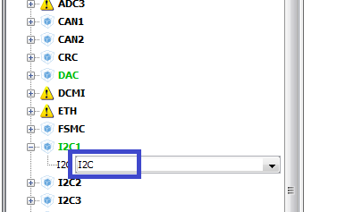

In Configuration, let's leave it as it was.

Generate, run and compile the project. Let's set up the programmer. We copy the files lcd.c and lcd.h from the project I2CLCD80. We connect the file lcd.c to the project, and also connect the lcd.h file to the main.h file

#include "stm32f4xx.h"

**#include "lcd.h"**

We replace the array uint16_t buf_tr [64] with this

**uint16_t buf_sin [60] = {**

**11,45,100,177,274,391,526,678,**

**844,1024,1215,1415,1622,1834,2048,2262,**

**2474,2681,2881,3072,3252,3418,3570,3705,**

**3822,3919,3996,4051,4085,4095,4085,4051,**

**3996,3919,3822,3705,3570,3418,3252,3072,**

**2881,2681,2474,2262,2048,1834,1622,1415,**

**1215.1024.844.678.526,391.274,177,**

**100,45,11,0**

**};};**

Accordingly, here we also make some changes

        HAL_TIM_Base_Start (& htim6);

        HAL_DAC_Start_DMA (& hdac, DAC_CHANNEL_1, (uint32_t *) **buf_sin**, **60**, DAC_ALIGN_12B_R);

  / * USER CODE END 2 * /

Also we need a counter and a string variable

/ * Private variables ------------------- * /

**uint32_t clk_counter = 0;**

**char str [20];**

uint16_t buf_sin [60] = {

Also for the organization of the MC clock count, we need a certain code in main.c here

#include "main.h"

**#define DWT_CYCCNT * (volatile unsigned long *) 0xE0001004**

**#define DWT_CONTROL * (volatile unsigned long *) 0xE0001000**

**#define SCB_DEMCR * (volatile unsigned long *) 0xE000EDFC**

/ * USER CODE END Includes * /

and here

  / * USER CODE BEGIN 2 * /

**uint32_t frq = HAL_RCC_GetHCLKFreq ();**

**SCB_DEMCR | = 0x01000000;**

**DWT_CONTROL | = 1;**

**DWT_CYCCNT = 0;**

  HAL_TIM_Base_Start (& htim6);

Also, we make certain changes to the file stm32f4xx_it.c, practically repeating everything from the main.c file with some exceptions (extern)

/ * USER CODE BEGIN 0 * /

**#define DWT_CYCCNT * (volatile unsigned long *) 0xE0001004**

**#define DWT_CONTROL * (volatile unsigned long *) 0xE0001000**

**#define SCB_DEMCR * (volatile unsigned long *) 0xE000EDFC**

**extern uint32_t clk_counter;**

/ * USER CODE END 0 * /

In the interrupt handler from DMA in the same file, we will count the measures

void DMA1_Stream5_IRQHandler (void)

{

  / * USER CODE BEGIN DMA1_Stream5_IRQn 0 * /

**clk_counter = DWT_CYCCNT;**

**DWT_CYCCNT = 0;**

  / * USER CODE END DMA1_Stream5_IRQn 0 * /

Initialize the display in the main.c file

        HAL_DAC_Start_DMA (& hdac, DAC_CHANNEL_1, (uint32_t *) buf_sin, 60, DAC_ALIGN_12B_R);

**LCD_ini ();**

**LCD_Clear ();**

And in an infinite loop, we will display what we have counted

  while (1)

  {

**sprintf ((char *) str, "% u", clk_counter); // the number of cycles for the period**

**LCD_SetPos (0, 0);**

**LCD_String (str);**

**sprintf ((char *) str, "% u", (clk_counter * 1000) / (frq / 1000)) // the period time in microseconds**

**LCD_SetPos (0, 1);**

**LCD_String (str);**

**sprintf ((char *) str, "% u", frq / clk_counter); // frequency in hertz**

**LCD_SetPos (0, 2);**

**LCD_String (str);**

**HAL_Delay (1000);**

                / * USER CODE END WHILE * /

We will collect the code, we will sew the controller and see the result.

Let's try to play with the timer

First we put such data

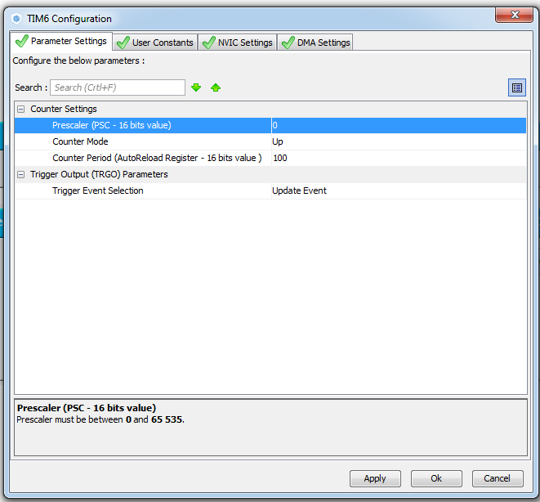

Decrease the period by half to 50

While you can do all this in Keil.

We will collect, we will sew and look.

Let's try to reduce it by half to 25

We will collect, we will sew and look.

Reduce to 12

We will collect, we will sew and look.