**Lesson 24**

**HAL. SPI. LED Static indication**

In the [**last lesson,**](http://narodstream.ru/stm-urok-23-hal-spi-sdvigovyj-registr-74hc595/) we connected via the **SPI** bus the **74HC595** chip , which is a shift register.

Today, with the help of this chip, we will try to adjust the seven-segment LED indicator with a common anode.

Here is the pinout of this indicator

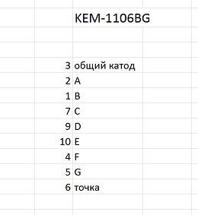

And here it is the connection scheme (click on the image to enlarge the image)

[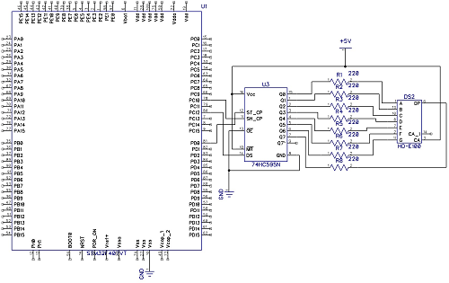](http://narodstream.ru/wp-content/uploads/2017/01/Image01.jpg)

Similarly, everything is connected, just like the LEDs, Only the segments are already connected not to the common wire, but to the power wire, and to the controller they are already reversed by cathodes.

But here we have everything connected in practice

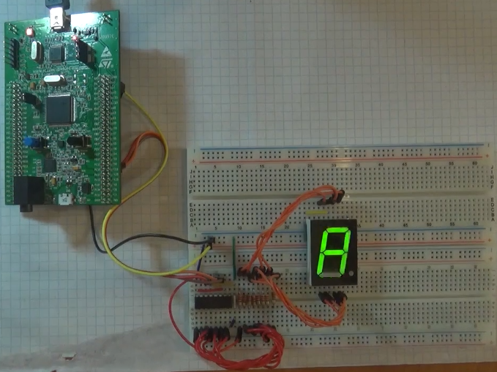

Also note that we already with the same shift register have already connected the indicator to the controller AVR in the [**appropriate lesson**](http://narodstream.ru/avr-urok-26-spi-podklyuchaem-led-indikator/) . So those interested can look.

We create the project from the previous project SPI595, we call it SPI_595_LED.

From the project LED_STAT we copy the files led.c and led.h to the corresponding directory.

Start the Cube. Generally nothing is done there, we generate and open the project in Keil.

We move on to the project. We connect the file led.c and configure the programmer.

We will collect the project.

Connect led.h to main.h

#include "stm32f4xx_hal.h"

**#include "led.h"**

In the main () function, we correct the lines as follows, since everything is upside down, and in order to extinguish the LEDs, we need to reverse all the outputs of the unit

        cs_set ();

~~aTxBuffer [0] = 0x01;~~

~~HAL_SPI_Transmit (& hspi3, (uint8_t *) aTxBuffer, 1, 5000);~~

~~cs_strob ();~~

~~HAL_Delay (1000);~~

        aTxBuffer [0] = 0xFF;

        HAL_SPI_Transmit (& hspi3, (uint8_t *) aTxBuffer, 1, 5000);

        cs_strob ();

        HAL_Delay ( **200**);

In the infinite loop, we correct the cycle as follows

  / * USER CODE BEGIN WHILE * /

  while (1)

  {

                for (i = 0; i <= **9**; i ++)

                {

**segchar (i);**

                        HAL_Delay ( **1000**);

                }

  / * USER CODE END WHILE * /

The main patches will affect the led library. Therefore, go to the file led.h

Here we clean it completely

#include "main.h"

~~#define SA GPIO_PIN_7~~

~~#define SB GPIO_PIN_8~~

~~#define SC GPIO_PIN_9~~

~~#define SD GPIO_PIN_10~~

~~#define SE GPIO_PIN_11~~

~~#define SF GPIO_PIN_12~~

~~#define SG GPIO_PIN_13~~

~~#define SH GPIO_PIN_14~~

#define SA_SET HAL_GPIO_WritePin (GPIOE, SA, GPIO_PIN_RESET);

From the next 16 lines, we delete first the semicolon, we'll put it in the calls.

In the file led.c we add the following variables (the first two can be copied from the file main.c)

#include "led.h"

**extern uint8_t aTxBuffer [1];**

**extern SPI_HandleTypeDef hspi3;**

**uint8_t portseg = 0;**

We need a variable portseg to store the state of the output port of our chip, which we do not track, but we will just remember.

Also copy from the main.c file here these lines and insert them into led.c

uint8_t portseg = 0;

**#define cs_set () HAL_GPIO_WritePin (GPIOD, GPIO_PIN_0, GPIO_PIN_RESET)**

**#define cs_reset () HAL_GPIO_WritePin (GPIOD, GPIO_PIN_0, GPIO_PIN_SET)**

**#define cs_strob () cs_reset (); cs_set ()**

void segchar (uint8_t seg)

Let's return to led.h.

First we fix the first line, part of the code can be taken from main.c

#define SA_SET **aTxBuffer [0] = portseg & = ~ 0x01; HAL_SPI_Transmit (& hspi3, (uint8_t *) aTxBuffer, 1,5000); cs_strob ()**

#define SA_RESET HAL_GPIO_WritePin (GPIOE, SA, GPIO_PIN_SET);

Now we make the second line, copying the code from the first, slightly converting it

**#define SA_RESET aTxBuffer [0] = portseg | = 0x01; HAL_SPI_Transmit (& hspi3, (uint8_t *) aTxBuffer, 1,5000); cs_strob ()**

Now the code from these lines will be transferred to the remaining 14 lines, changing only the bit in portseg

#define SB_SET aTxBuffer [0] = portseg & = ~ **0x02**; HAL_SPI_Transmit (& hspi3, (uint8_t *) aTxBuffer, 1,5000); cs_strob ()

#define SB_RESET aTxBuffer [0] = portseg | = **0x02**; HAL_SPI_Transmit (& hspi3, (uint8_t *) aTxBuffer, 1,5000); cs_strob ()

#define SC_SET aTxBuffer [0] = portseg & = ~ **0x04**; HAL_SPI_Transmit (& hspi3, (uint8_t *) aTxBuffer, 1,5000); cs_strob ()

#define SC_RESET aTxBuffer [0] = portseg | = **0x04**; HAL_SPI_Transmit (& hspi3, (uint8_t *) aTxBuffer, 1,5000); cs_strob ()

#define SD_SET aTxBuffer [0] = portseg & = ~ **0x08**; HAL_SPI_Transmit (& hspi3, (uint8_t *) aTxBuffer, 1,5000); cs_strob ()

#define SD_RESET aTxBuffer [0] = portseg | = **0x08**; HAL_SPI_Transmit (& hspi3, (uint8_t *) aTxBuffer, 1,5000); cs_strob ()

#define SE_SET aTxBuffer [0] = portseg & = ~ **0x10**; HAL_SPI_Transmit (& hspi3, (uint8_t *) aTxBuffer, 1,5000); cs_strob ()

#define SE_RESET aTxBuffer [0] = portseg | = **0x10**; HAL_SPI_Transmit (& hspi3, (uint8_t *) aTxBuffer, 1,5000); cs_strob ()

#define SF_SET aTxBuffer [0] = portseg & = ~ **0x20**; HAL_SPI_Transmit (& hspi3, (uint8_t *) aTxBuffer, 1,5000); cs_strob ()

#define SF_RESET aTxBuffer [0] = portseg | = **0x20**; HAL_SPI_Transmit (& hspi3, (uint8_t *) aTxBuffer, 1,5000); cs_strob ()

#define SG_SET aTxBuffer [0] = portseg & = ~ **0x40**; HAL_SPI_Transmit (& hspi3, (uint8_t *) aTxBuffer, 1,5000); cs_strob ()

#define SG_RESET aTxBuffer [0] = portseg | = **0x40**; HAL_SPI_Transmit (& hspi3, (uint8_t *) aTxBuffer, 1,5000); cs_strob ()

#define SH_SET aTxBuffer [0] = portseg & = ~ **0x80**; HAL_SPI_Transmit (& hspi3, (uint8_t *) aTxBuffer, 1,5000); cs_strob ()

#define SH_RESET aTxBuffer [0] = portseg | = **0x80**; HAL_SPI_Transmit (& hspi3, (uint8_t *) aTxBuffer, 1,5000); cs_strob ()

We collect, sew, look

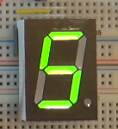

In the [**next lesson**](http://narodstream.ru/stm-urok-25-hal-spi-led-dinamicheskaya-indikaciya/) we will try to work with dynamic indication by connecting two shift registers at once.