**Lesson 48**

**Part 1**

**USB DEVICE AUDIO**

[*Previous lesson*](http://narodstream.ru/stm-urok-47-podklyuchaem-giroskop-lsm6ds3-chast-1/) [*Programming STM32 STM32*](http://narodstream.ru/programmirovanie-mk-stm32/) [*Next part*](http://narodstream.ru/stm-urok-48-usb-device-audio-chast-2/)

Today we will continue to study the new interface - the I2S bus. And we will work as well as in the last lesson on I2S - with the chip CS43L22 installed on the STM32F4-DISCOVERY board. Only in this lesson we will try to take the digital audio stream not from a WAV file, but from a PC via the USB bus, that is, we will try to create a sound card from our board. The sound card will, of course, not be complete, since it will only work on playback (only in DAC mode), but nevertheless, I think we will fix the work with the I2S bus thoroughly, and also we will study another class of USB - DEVICE Audio.

We will create our project from an old project, in which nothing extra is connected - TEST002, and we will name the new project USB_DEVICE_AUDIO.

Open our project in Cube MX and make the necessary settings.

First turn off unnecessary LEDs, leaving only red and green.

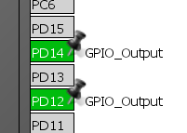

Turn on the bus itself I2S

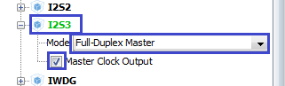

No legs are redefined. Let's leave it as it is. It is on these legs that the Audio DAC chip is connected.

Disable the 6th timer

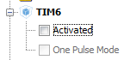

Turn on USB_OTG_FS in Device_Only mode

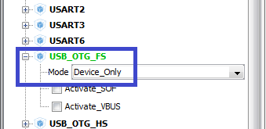

In USB_DEVICE in the Class For FS IP section, select Audio Device Class

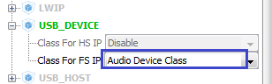

For the work of the RESET foot of the microcircuit, we will still need to turn on the output and adjust this port foot (PD4)

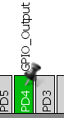

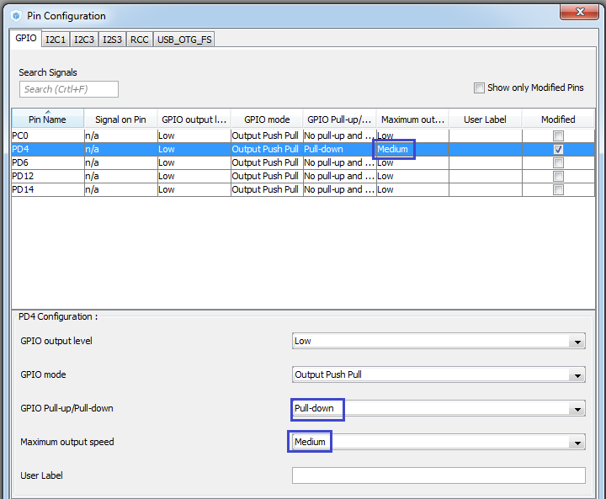

In the "Clock Configuration" section, turn everything on to the maximum

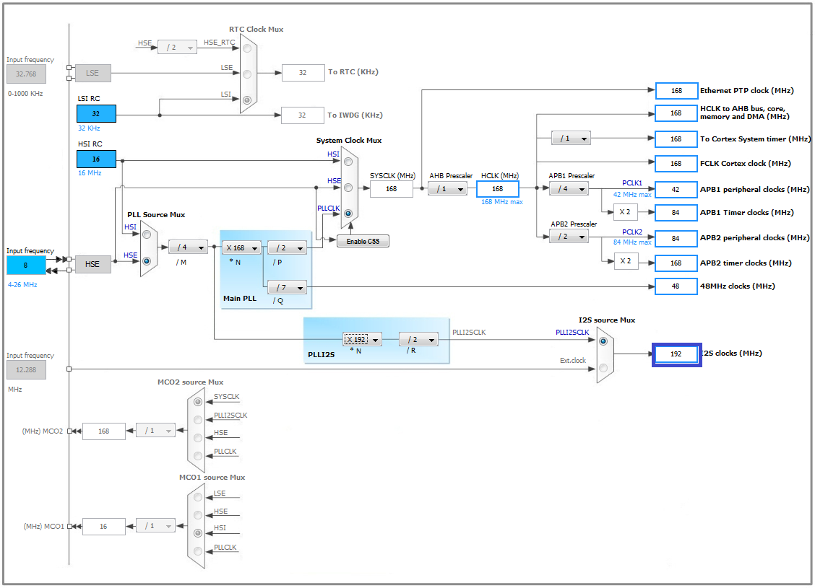

We will also make some adjustments to the I2S settings

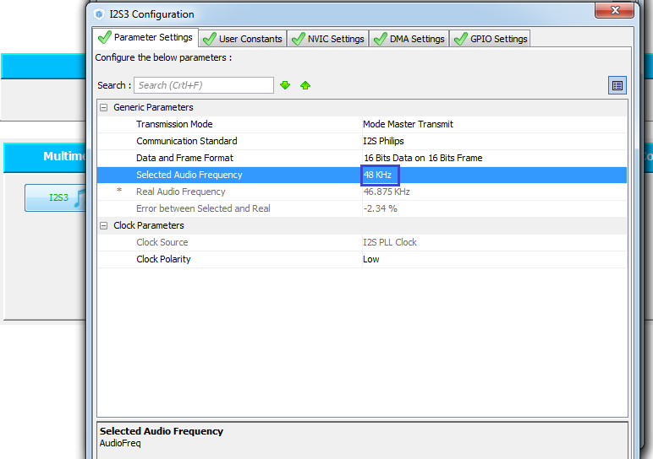

Also add and configure DMA on the I2S bus

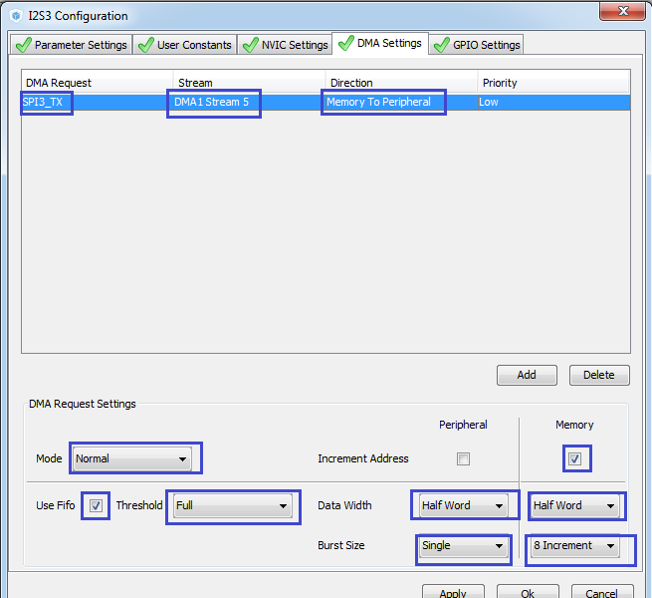

In USB Device we will increase the sampling rate

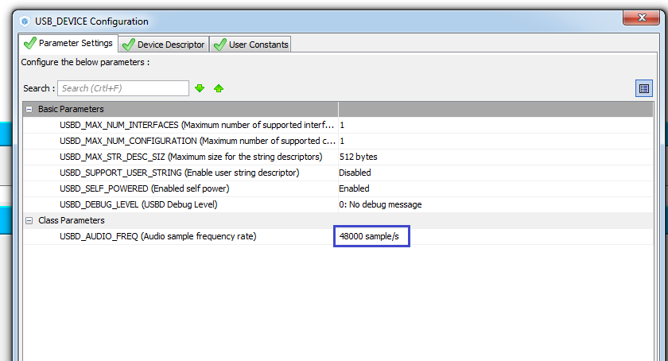

It is also desirable to change the device descriptor, otherwise if you have already used a virtual port, there may be problems

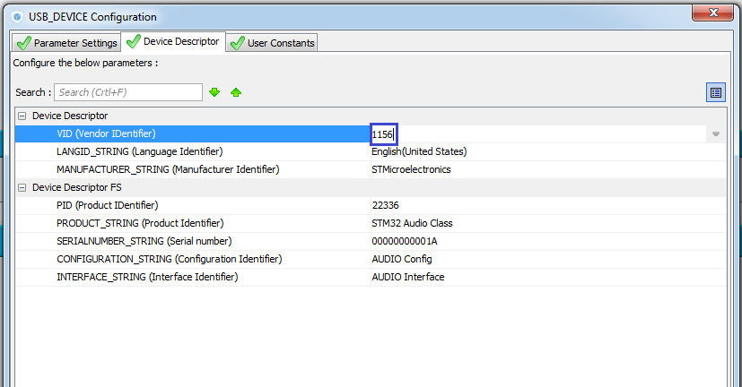

And since the chip management occurs in contrast to the main audio stream already on the I2C bus, it is necessary to include also this bus. Turn on the bus I2C1

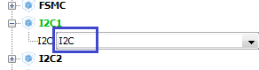

The PB7 foot will need to be redefined on PB9. I think everyone already knows how to do this. First, reset it, and then redefine it

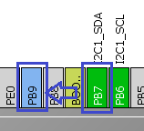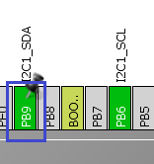

In Project -> Setting, set the following stack and heap settings

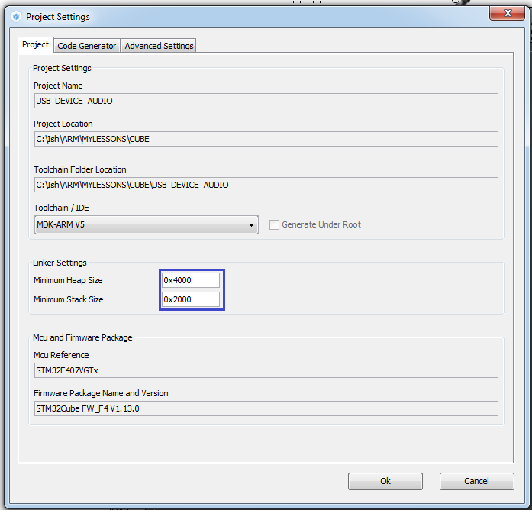

Generate the project for the Keil environment, configure the programmer for autocutting and compile the project.

Add to the project files designed to work with audio, audioplay.c and audioplay.h from the project I2S_AUDIO.

Connect the file audioplay.c in the Application / User tree

Also add the connection of this library to the main module main.h

#include "stm32f4xx.h"

**#include "audioplay.h"**

Delete the following line here:

~~uint8_t tim6_counter;~~

Remove all the code from an infinite loop

  / * USER CODE BEGIN 3 * /

~~if (HAL_GPIO_ReadPin (GPIOA, GPIO_PIN_0) == GPIO_PIN_SET)~~

~~{~~

~~HAL_TIM_Base_Start (& htim6);~~

~~HAL_TIM_Base_Start_IT (& htim6);~~

~~}~~

~~else~~

~~{~~

~~tim6_counter = 0;~~

~~HAL_TIM_Base_Stop (& htim6);~~

~~HAL_TIM_Base_Stop_IT (& htim6);~~

~~HAL_GPIO_WritePin (GPIOD, GPIO_PIN_12 | GPIO_PIN_13 | GPIO_PIN_14 | GPIO_PIN_15, GPIO_PIN_RESET);~~

~~}~~

In the file audioplay.c remove the connection of unnecessary libraries

#include "audioplay.h"

~~#include "fatfs.h"~~

~~#include "usb_host.h"~~

~~#include "lcd.h"~~

Also delete some more lines related to the use of remote libraries

~~static uint32_t WaveDataLength = 0;~~

-

~~extern FIL WavFile;~~

-

~~extern ApplicationTypeDef Appli_state;~~

~~char str2 [20];~~

~~char str3 [20];~~

-

~~UINT bytesread = 0;~~

-

~~extern WAVE_FormatTypeDef * waveformat;~~

-

~~AudioTotalSize = waveformat-> FileSize;~~

~~/ * Get Data from USB Flash Disk * /~~

~~WaveDataLength = waveformat-> FileSize;~~

-

~~LCD_SetPos (0,3);~~

~~LCD_String (str2);~~

~~LCD_String (str3);~~

Remove some unnecessary ads from the file audioplay.c

~~/ * Position in the audio play buffer * /~~

~~__IO BUFFER_StateTypeDef buffer_offset = BUFFER_OFFSET_NONE;~~

-

~~/ * Defines for the Audio playing process * /~~

~~#define PAUSE_STATUS ((uint32_t) 0x00) / * Audio Player in Pause Status * /~~

~~#define RESUME_STATUS ((uint32_t) 0x01) / * Audio Player in Resume Status * /~~

~~#define IDLE_STATUS ((uint32_t) 0x02) / * Audio Player in Idle Status * /~~

-

~~#define AUDIO_RESET_GPIO_CLK_ENABLE () __GPIOD_CLK_ENABLE ()~~

-

~~/ * Variables used in normal mode to manage audio file during DMA transfer * /~~

~~uint32_t AudioTotalSize = 0xFFFF; / * This variable holds the total size of the audio file * /~~

~~int32_t AudioRemSize = 0xFFFF; / * This variable holds the remaining data in the audio file * /~~

~~uint16_t * CurrentPos; / * This variable holds the current position of the audio pointer * /~~

-

~~__IO uint32_t PauseResumeStatus = IDLE_STATUS;~~

-

~~static uint32_t WaveDataLength = 0;~~

-

~~#define AUDIO_BUFFER_SIZE 0X8000~~

-

~~uint8_t Audio_Buffer [AUDIO_BUFFER_SIZE];~~

~~AUDIO_StateMachine Audio;~~

~~uint32_t samplerate;~~

~~uint32_t offsetpos;~~

~~uint32_t cnt;~~

~~uint32_t dur; // variable for the remaining time of playing the file~~

AudioPlay_Init and AudioPlay_Start functions will be deleted with all content

~~void AudioPlay_Init (uint32_t AudioFreq)~~

~~{~~

~~samplerate = AudioFreq;~~

~~__IO uint8_t volume = 70;~~

~~if (AudioOut_Init (OUTPUT_DEVICE_AUTO, volume, samplerate)! = 0)~~

~~{~~

~~Error ();~~

~~}~~

~~}~~

// ------------------

~~void AudioPlay_Start (uint32_t AudioFreq)~~

~~{~~

-

~~}~~

Also delete the contents of the event handler functions and slightly rename them

// ------------------

void AudioPlay_HalfTransfer_Call **B**ack (void)

{

}

// ------------------

void AudioPlay_Transfer **Complete**_Call **B**ack (void)

{

}

Rename the function also in the file audioplay.h in the declaration of its prototype

void AudioPlay_HalfTransfer_Call **B**ack (void);

void AudioPlay_Transfer **Complete**_Call **B**ack (void);

Also, connect the file usbd_audio_if.h in this file

#include "stm32f4xx_hal.h"

**#include "usbd_audio_if.h"**

Remove the function declaration from this file

~~void AudioPlay_Start (uint32_t AudioFreq);~~

And the announcement of the function AudioPlay_Init will be corrected in the declaration of another function

uint8_t AudioOut_Init (uint16_t OutputDevice, uint8_t Volume, uint32_t AudioFreq);

Also remove all declarations of variables and structures except SPI3, and instead of them we add others, taking them from the si-file

#include "usbd_audio_if.h"

// ----------------

#define I2S3 SPI3

**/ * Codec output DEVICE * /**

**#define OUTPUT_DEVICE_SPEAKER 1**

**#define OUTPUT_DEVICE_HEADPHONE 2**

**#define OUTPUT_DEVICE_BOTH 3**

**#define OUTPUT_DEVICE_AUTO 4**

**/ * Audio status definition * /**

**#define AUDIO_OK ((uint8_t) 0)**

**#define AUDIO_ERROR ((uint8_t) 1)**

**#define AUDIO_TIMEOUT ((uint8_t) 2)**

// ----------------

uint8_t AudioOut_Init (uint16_t OutputDevice, uint8_t Volume, uint32_t AudioFreq);

Add a couple more macros

**/ * Codec POWER DOWN modes * /**

**#define CODEC_PDWN_HW 1**

**#define CODEC_PDWN_SW 2**

Paste the interrupt handlers in main.c

/ * USER CODE BEGIN 4 * /

**void HAL_I2S_TxCpltCallback (I2S_HandleTypeDef * hi2s3)**

**{**

**if (hi2s3-> Instance == I2S3)**

**{**

**AudioPlay_TransferComplete_CallBack ();**

**}**

**}**

**// -------------------------**

**void HAL_I2S_TxHalfCpltCallback (I2S_HandleTypeDef * hi2s)**

**{**

**if (hi2s-> Instance == I2S3)**

**{**

**AudioPlay_HalfTransfer_CallBack ();**

**}**

**}**

/ * USER CODE END 4 * /

Connect our board to the PC, and ST-Link, and USB OTG

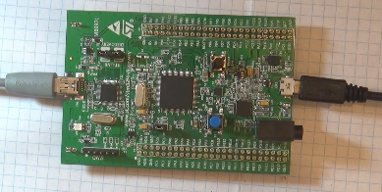

We will collect the project, we will impose the controller and make sure that the driver of our future sound card is normally installed

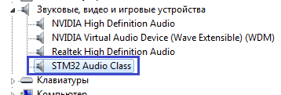

In the file usbd_audio_if.c we connect our library

/ * USER CODE BEGIN INCLUDE * /

**#include "audioplay.h"**

/ * USER CODE END INCLUDE * /

In the same file in the AUDIO_Init_FS function, we call the initialization of the microcircuit

static int8_t AUDIO_Init_FS (uint32_t AudioFreq, uint32_t Volume, uint32_t options)

{

  / * USER CODE BEGIN 0 * /

**AudioOut_Init (OUTPUT_DEVICE_AUTO, Volume, AudioFreq);**

  return (USBD_OK);

  / * USER CODE END 0 * /

}

In the [**next part of the**](http://narodstream.ru/stm-urok-48-usb-device-audio-chast-2/) lesson, we will write a few more functions and connect them to the drivers of the sound card driver.

**Lesson 48**

**Part 2**

# USB DEVICE AUDIO

In the [**last part of**](http://narodstream.ru/stm-urok-48-usb-device-audio-chast-1/) this lesson, we created and configured a project in Cube MX, created the application framework, added all the macros and global variables that we will need in the process of writing the code. Also we started to write some functions of the audio library.

In the file audioplay.c write delay functions in microseconds. We use this function often

// ---------------------

**__STATIC_INLINE void DelayMicro (__ IO uint32_t micros)**

**{**

**micros * = (SystemCoreClock / 1000000) / 5;**

**while (micros-);**

**}**

// ---------------------

void Error (void)

In the functions **AudioOut_Init** and **cs43l22_Init,** we replace the delay functions HAL_Delay with the DelayMicro functions, since with HAL latency functions I had hangs and debugging did not work

**DelayMicro (5000);**

  HAL_GPIO_WritePin (AUDIO_RESET_GPIO, AUDIO_RESET_PIN, GPIO_PIN_SET);

**DelayMicro (5000);**

Disable optimization for better debugging

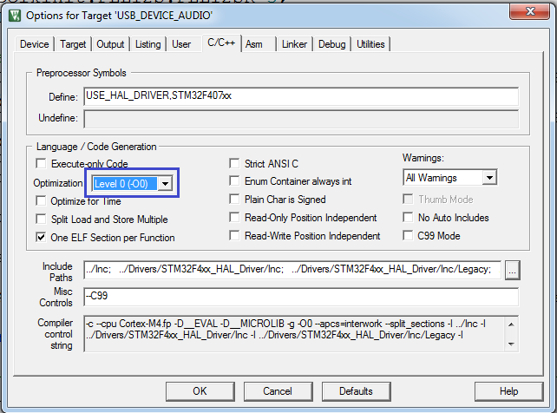

We compile the code and check to see if we have an audio DAC ID and whether it's actually been read.We will check this with debugging. Set the breakpoint, start debugging, get to the breakpoint, and then go in steps. If everything is properly read, we will get to the place marked in the figure

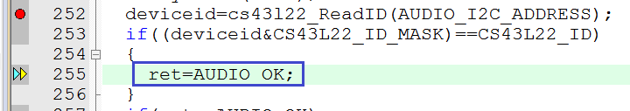

Next, insert another line in the initialization

  counter + = CODEC_IO_Write (DeviceAddr, 0x04, OutputDev);

**/ * Clock configuration: Auto detection * /**

**counter + = CODEC_IO_Write (DeviceAddr, 0x05, 0x81);**

  / * Set the Slave Mode and the audio Standard * /

  counter + = CODEC_IO_Write (DeviceAddr, 0x06, CODEC_STANDARD);

Thus we in the DAC include auto-detection of the speed, also a divisor by 2

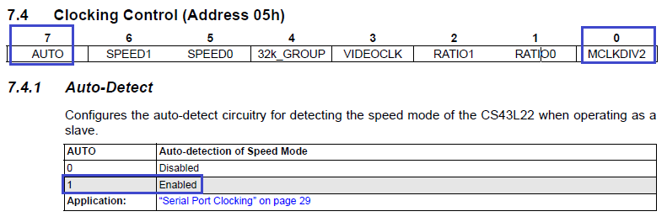

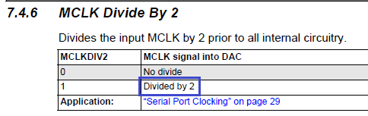

Add one more input argument to the function cs43l22_Stop in the file audioplay.c

// ------------------

uint32_t cs43l22_Stop (uint16_t DeviceAddr **, uint32_t CodecPdwnMode**)

{

Let's fix the AudioPlay_Stop function

**uint8_t** AudioPlay_Stop ( **uint32_t** Option)

{

**uint8_t ret = AUDIO_OK;**

**/ * Call Audio Codec Stop function * /**

**if (**cs43l22_Stop (AUDIO_I2C_ADDRESS **, Option)! = 0)**

**{**

**ret = AUDIO_ERROR;**

**}**

**if (ret == AUDIO_OK)**

**{**

**if (Option == CODEC_PDWN_HW)**

**{**

**/ * Wait at least 100us * /**

**DelayMicro (2000);**

**}**

**/ * Stop DMA transfer of PCM samples to the serial audio interface * /**

**if (HAL_I2S_DMAStop (& hi2s3)! = HAL_OK)**

**{**

**ret = AUDIO_ERROR;**

**}**

**}**

**/ * Return AUDIO_OK when all operations are correctly done * /**

**return ret;**

}

// ------------------

In the file audioplay.h add a prototype of this function

uint8_t AudioOut_Init (uint16_t OutputDevice, uint8_t Volume, uint32_t AudioFreq);

**uint8_t AudioPlay_Stop (uint32_t Option);**

Call this function in the file usbd_audio_if.c in a specific handler

static int8_t AUDIO_DeInit_FS (uint32_t options)

{

  / * USER CODE BEGIN 1 * /

**AudioPlay_Stop (CODEC_PDWN_SW);**

  return (USBD_OK);

  / * USER CODE END 1 * /

}

Now in the file audioplay.c change the call to the function cs43l22_Play

uint32_t cs43l22_Play (uint16_t DeviceAddr **, uint16_t * pBuffer, uint16_t Size**)

{

We insert two functions of the following content

// ------------------

**uint8_t AudioPlay_Play (uint16_t * pBuffer, uint32_t Size)**

**{**

**uint8_t ret = AUDIO_OK;**

**if (cs43l22_Play (AUDIO_I2C_ADDRESS, pBuffer, Size)! = 0)**

**{**

**Error ();**

**ret = AUDIO_ERROR;**

**}**

**if (ret == AUDIO_OK)**

**{**

**if (HAL_I2S_Transmit_DMA (& hi2s3, (uint16_t *) pBuffer, DMA_MAX (Size / AUDIODATA_SIZE))! = HAL_OK)**

**{**

**Error ();**

**ret = AUDIO_ERROR;**

**}**

**}**

**return ret;**

**}**

**// ------------------**

**void AudioPlay_ChangeBuffer (uint16_t * pData, uint16_t Size)**

**{**

**HAL_I2S_Transmit_DMA (& hi2s3, (uint16_t *) pData, Size);**

**}**

// ------------------

Well, everything is standard here, I think there's nothing to explain.

We paste the prototypes into the file audioplay.h

uint8_t AudioPlay_Stop (uint32_t Option);

**uint8_t AudioPlay_Play (uint16_t * pBuffer, uint32_t Size);**

**void AudioPlay_ChangeBuffer (uint16_t * pData, uint16_t Size);**

In the file usbd_audio_if.c in the handler we insert function calls

static int8_t AUDIO_AudioCmd_FS (uint8_t * pbuf, uint32_t size, uint8_t cmd)

{

  / * USER CODE BEGIN 2 * /

  switch (cmd)

  {

    case AUDIO_CMD_START:

**AudioPlay_Play ((uint16_t *) pbuf, size);**

    break;

    case AUDIO_CMD_PLAY:

**AudioPlay_ChangeBuffer ((uint16_t *) pbuf, size);**

    break;

  }

  return (USBD_OK);

  / * USER CODE END 2 * /

}

In the [**next part of**](http://narodstream.ru/stm-urok-48-usb-device-audio-chast-3/) this lesson we will finish the study of this topic and hear the work of the sound card written by our hands.

**Lesson 48**

**Part 3**

# USB DEVICE AUDIO

[*Previous part*](http://narodstream.ru/stm-urok-48-usb-device-audio-chast-2/) [*Programming STM32 MK*](http://narodstream.ru/programmirovanie-mk-stm32/) [*Next lesson*](http://narodstream.ru/stm-urok-49-hal-magnitometr-lsm303dlhc-chast-1/)

In the [**last part of**](http://narodstream.ru/stm-urok-48-usb-device-audio-chast-2/) this lesson, we wrote a few more functions and connected them to the drivers of the sound card driver.

Insert another function into the file audioplay.c

**// ------------------**

**uint8_t AudioPlay_SetVolume (uint8_t Volume)**

**{**

**uint8_t ret = AUDIO_OK;**

**/ * Call the codec volume control function with converted volume value * /**

**if (cs43l22_SetVolume (AUDIO_I2C_ADDRESS, Volume)! = 0)**

**{**

**ret = AUDIO_ERROR;**

**}**

**/ * Return AUDIO_OK when all operations are correctly done * /**

**return ret;**

**}**

**// ------------------**

We paste the prototype of this function into the file audioplay.h

void AudioPlay_ChangeBuffer (uint16_t * pData, uint16_t Size);

**uint8_t AudioPlay_SetVolume (uint8_t Volume);**

In the file usbd_audio_if.c in the AUDIO_VolumeCtl_FS handler, we call this function

static int8_t AUDIO_VolumeCtl_FS (uint8_t vol)

{

  / * USER CODE BEGIN 3 * /

**AudioPlay_SetVolume (vol);**

  return (USBD_OK);

  / * USER CODE END 3 * /

}

Insert another function into the file audioplay.c

// ------------------

**uint8_t AudioPlay_SetMute (uint32_t Cmd)**

**{**

**uint8_t ret = AUDIO_OK;**

**/ * Call the Codec Mute function * /**

**if (cs43l22_SetMute (AUDIO_I2C_ADDRESS, Cmd)! = 0)**

**{**

**ret = AUDIO_ERROR;**

**}**

**/ * Return AUDIO_OK when all operations are correctly done * /**

**return ret;**

**}**

// ------------------

Let's write a prototype for it

uint8_t AudioPlay_SetVolume (uint8_t Volume);

**uint8_t AudioPlay_SetMute (uint32_t Cmd);**

Insert the function call in the file usbd_audio_if.c in the same name handler

static int8_t AUDIO_MuteCtl_FS (uint8_t cmd)

{

  / * USER CODE BEGIN 4 * /

**AudioPlay_SetMute (cmd);**

  return (USBD_OK);

  / * USER CODE END 4 * /

}

In the file audioplay.c in the handlers we will add calls to these handlers in the USB library

// ------------------

void AudioPlay_HalfTransfer_Callback (void)

{

**HalfTransfer_CallBack_FS ();**

**}**

// ------------------

void AudioPlay_TransferComplete_CallBack (void)

{

**TransferComplete_CallBack_FS ();**

}

We will collect the project and we will sew the controller.

Also after the firmware it is desirable to enter the parameters of the playback devices and set this device as the default

