<https://www.youtube.com/watch?v=8vmKtS8W7IQ>

Step -1::: C:\Users\daoud\My_Work\DockerProject\Hello World>docker build -t welcome-app .



Check the all docker images

Step -2 : C:\Users\daoud\My_Work\DockerProject\Hello World>docker images

Step-3 : docker run -p 5000:5000 welcome-app

Step -4 : check the how many container is running

PS C:\Users\daoud\My_Work\DockerProject\Hello World> docker ps



Step -5 : stop the container command

docker stop 68d372506dc8 ( container id)

**deploy the docker images on docker Hub :** [**https://hub.docker.com/**](https://hub.docker.com/)

**docker hub : I have login from my gmail account:**

**step -1 : credentials :**

**username: daoudimca**

**Pwd: ilove???? (fill the ?)**

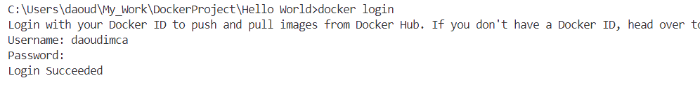

Rename the docker image:

* remove the image and build again . when we buils the new images we have give first our user name then use the dockerimage name
* example : in docker hub my user name is : daoudimca
* example : daoudimca/docker image name

List of docker images command : docker images

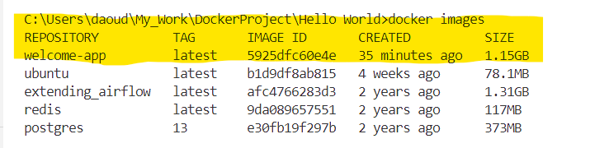

**Remove docker command : C:\Users\daoud\My_Work\DockerProject\Hello World>**docker image rm -f welcome-app

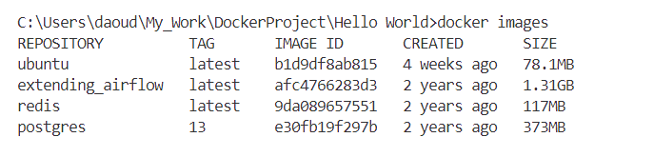

**Build the docker image: User Name /image Name**

**Follow above pattern**

**docker build -t daoudimca/welcome-app .**

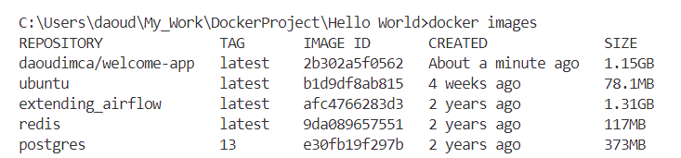

**Push docker image on Docker Hub:**

docker push daoudimca/welcome-app:latest

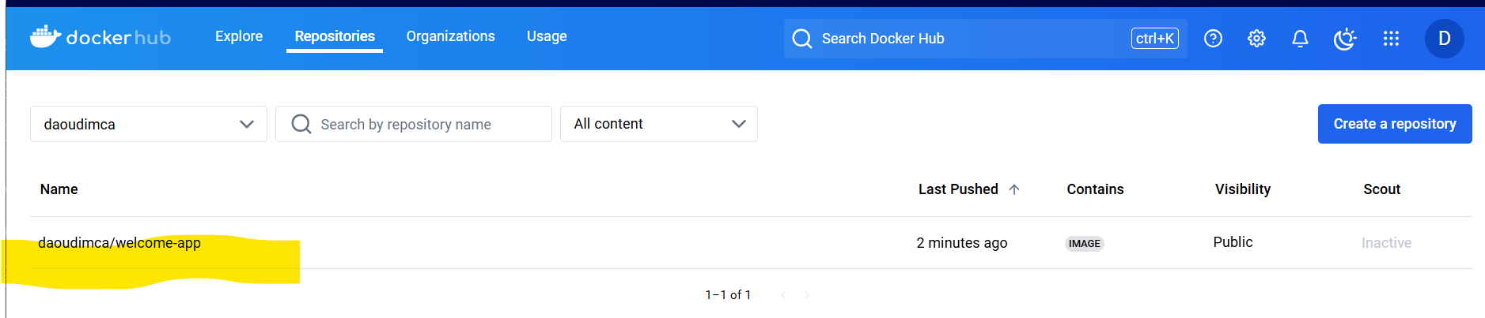

Pulled from docker hub run on local machine:

docker pull daoudimca/welcome-app:latest

* first we have to rename the our existing docker image in local machine bcz when we pulled the docker image so it have the same name so to test it we will rename our local docker image

**Rename command for docker image in local :**

* **docker tag daoudimca/welcome-app daoudimca/welcome-app1**
* 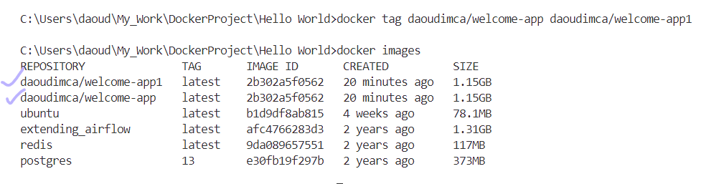
* **Remove the docker image**
* C:\Users\daoud\My_Work\DockerProject\Hello World>docker image rm -f daoudimca/welcome-app:latest

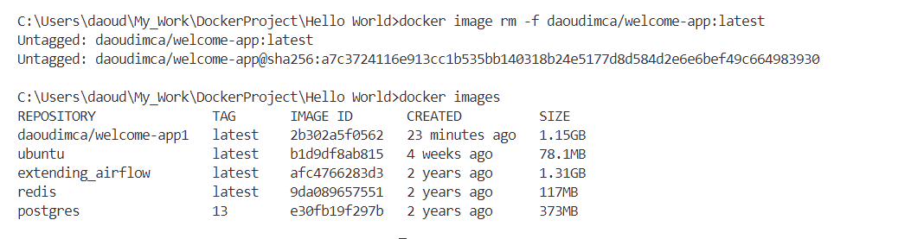

* Puller docker images from docker hub
* docker pull daoudimca/welcome-app:latest

* Run the image again
* A screenshot of a computer

  Description automatically generated