Danielle Panfili

HW5

SER316

April 13th 2018

**Task 1 Step 7:**

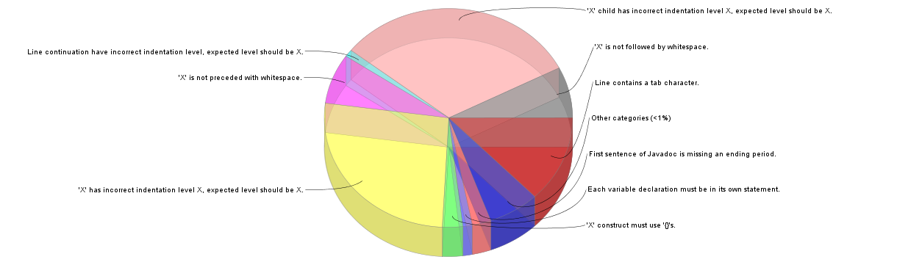

Check style found 678 check style violations. These are due to the 29 categories it found and the violations within it.

After changing spacing and indentation, I now have 228 markers.