1.组件的使用

为了方便复用代码,四五六套页面相同的部分抽离成了组件,每个页面分为3个部分,
以组织机构页面为例子
org.html:页面入口,里面包含了引用的js css 和每套主题对应的外层框架 frame.com.html
frame.com.html:页面框架组件,每套主题对应一个frame
使用时复制<template>...</template>内的html代码和<script>...</script>内的js代码,
替换org.html中的<com-frame></com-frame>标签
每个frame组件中有一个<slot>...</slot>标签,用来替换其他组件
例如替换后的机构管理页面构成

- 这里是原来的org.html
- <!DOCTYPE html>
- <html lang="en">

- <head>
- <meta charset="UTF-8">
- <meta name="viewport" content="width=device-width, initial-scale=1.0,maximum-scale=1.0, minimum-scale=1.0, user-scalable=no">
- <title>机构管理</title>
- <link rel="stylesheet" href="../images/font/iconfont.css">
- <link rel="stylesheet" href="../css/default.css">
- <link rel="stylesheet" href="../js/lib/layui/css/layui.css">
- <link rel="stylesheet" href="../js/lib/zTree/css/zTreeStyle/zTreeStyle.css" type="text/css">
- <script type="text/javascript" src="../js/lib/common.js"></script>
- <script src="../js/lib/layui/layui.js"></script>
- <script src="../js/lib/load.js"></script>
- </head>

- <body class="six">
- <div id="app" class="appDiv" active="机构管理">
- <!-- frame.com.html开始 -->
- <div class="homePage">
- <div class="headerDiv">
- <div class="contentArea">
- <div class="topLogo centerFlex isPc">
- <a href="../views/six/home.html" class="texta centerFlex">
- <img class="logo" src="../images/six/home_logo_icon.png" alt="">
- <span class="logoText">CASC</span>
- </a>
- </div>
- <div class="menuIcon">
- <i class="iconfont iconhome_list_icon"></i>
- </div>
- <div class="secondMenuDiv blockDiv" style="display: none;">
- <div class="secondMenuContent">
- <div class="menuItem userBtn"><a href="javascript:;">用户列表</a></div>
- <div class="menuItem"><a href="../views/six/org.html">机构管理</a></div>
- <div class="menuItem"><a href="../views/six/dictionary.html">字典管理</a></div>
- <div class="menuItem"><a href="../views/six/plan.html">策划目录</a></div>
- <div class="menuItem"><a href="../views/six/quality.html">质卡填报</a></div>
- <div class="menuItem"><a href="../views/six/plan.html">承担的任务</a></div>
- <div class="menuItem"><a href="../views/six/charts.html">图表</a></div>
- </div>
- </div>
- <div class="rightDiv">
- <div class="searchDiv">
- <div class="inputItem">
- <div class="inputBox">
- <input type="text" placeholder="输入关键词搜索…">
- <img src="../images/six/home_sousuo_icon@2x.png" alt="">
- </div>
- </div>
- </div>
- <div class="fucList centerFlex">
- <div class="fucItem">
- <a href="../views/six/nav.html" class="texta centerFlex">
- <i class="iconfont iconhome_icon1" style="color:var(--color-text-primary);font-size:20px;"></i>
- </a>
- </div>
- <div class="fucItem centerFlex">
- <div class="dropDownMenu">
- <div class="avatarDiv">
- <i class="iconfont icontheme_icon1" style="color:var(--color-text-primary);font-size:20px;"></i>
- </div>
- <div>
- <div><a href="../views/four/home.html">第四套</a></div>
- <div><a href="../views/five/home.html">第五套</a></div>
- <div><a href="../views/six/home.html">第六套</a></div>
- </div>
- </div>
- </div>
- </div>

- <div class="userInfo cursor">
- <div class="dropDownMenu">
- <div class="avatarDiv">
- <img class="headPic" src="../images/six/home_headpic_icon.png" alt="">
- <span class="userName">admin</span>
- <i class="iconfont iconarrow-down" style="color:var(--color-text-regular)"></i>
- </div>
- <div>
- <div><a href="javascript:;">个人信息</a></div>
- <div><a href="javascript:;">修改密码</a></div>
- <div><a href="javascript:;">我的通知</a></div>
- <div><a href="../views/six/login.html">退出</a></div>
- </div>
- </div>
- </div>
- </div>
- </div>
- </div>
- <div class="contentDiv">
- <div class="mobileShadow"></div>
- <div class="menuDiv" style="display: none;">
- <div class="topLogo topLogo1 centerFlex isMobile">
- <a href="../views/six/home.html" class="texta centerFlex">
- <img class="logo" src="../images/six/home_logo_icon.png" alt="">
- <span class="logoText">CASC</span>
- </a>
- </div>

- <ul class="menuContent">
- <li class="menuItem">
- <a href="../views/six/nav.html">
- <i class="iconfont iconhome_home_icon1"></i>
- 首页
- </a>
- </li>
- <li class="menuItem">
- <a href="../views/six/home.html">
- <i class="iconfont iconhome_working_icon1"></i>
- 我的工作台
- </a>
- </li>
- <li class="menuItem setBtn">
- <a href="javascript:;">
- <i class="iconfont iconhome_organ_icon"></i>
- 机构用户
- </a>
- </li>
- <li class="menuItem setBtn">
- <a href="javascript:;" >
- <i class="iconfont iconhome_set_icon1"></i>
- 系统设置
- </a>
- </li>
- </ul>
- </div>
- <div class="thirdMenuDiv blockDiv" style="display: none;">
- <div class="thirdMenuContent">
- <div class="menuItem"><a href="../views/six/userInfo.html">用户列表</a></div>
- <div class="menuItem"><a href="../views/six/userInfo.html">用户添加</a></div>
- <div class="menuItem"><a href="../views/six/userInfo.html">用户列表</a></div>
- <div class="menuItem"><a href="../views/six/userInfo.html">用户列表</a></div>
- </div>
- </div>
- <div class="mainDiv">
- <!-- <slot></slot> -->
- <!-- 这里替换成org.com.html的内容 -->
- <!-- org.com.html开始 -->
- <div class="orgDiv blockDiv">
- <div class="treeDiv">
- <ul id="orgTree" class="ztree"></ul>
- </div>
- <div class="tableDiv">
- <div class="mb20 breadDiv">
- <span class="mr10 isPc">当前位置 : </span>
- <span class="layui-breadcrumb isPc" lay-separator=">">
- <a href="" class="activebread">机构用户</a>
- <a href="javascript:;">机构用户</a>
- </span>
- <span class="layui-breadcrumb isMobile" lay-separator="/">
- <a href="" class="activebread">机构用户</a>
- <a href="javascript:;">机构用户</a>
- </span>
- </div>
- <div class="mb10">
- <form class="layui-form" action="">
- <div class="layui-form-item">
- <label class="layui-form-label">归属公司</label>
- <div class="layui-input-block">
- <input type="text" placeholder="请选择" id="companySelect" class="layui-input" readonly="readonly" />
- </div>
- </div>
- <div class="layui-form-item">
- <label class="layui-form-label">归属部门</label>
- <div class="layui-input-block">
- <select name="dept">
- <option value=""></option>
- <option value="0">公司领导</option>
- <option value="1">综合部</option>
- <option value="2">市场部</option>
- <option value="3">技术部</option>
- </select>
- </div>
- </div>
- <div class="layui-form-item">
- <label class="layui-form-label">登录名</label>
- <div class="layui-input-block">
- <input type="text" name="loginName" placeholder="请输入登录名" autocomplete="off"
- class="layui-input">
- </div>
- </div>
- <div class="layui-form-item">
- <label class="layui-form-label">姓名</label>
- <div class="layui-input-block">
- <input type="text" name="name" placeholder="请输入姓名" autocomplete="off" class="layui-input">
- </div>
- </div>
- <div class="layui-form-item">
- <div class="isPc" style="margin-left:20px;">
- <button class="layui-btn plain">编辑</button>
- <button class="layui-btn plain">导出</button>
- <button class="layui-btn plain">导入</button>
- <button class="layui-btn">添加用户</button>
- </div >
- <div class="isMobile" style="white-space: nowrap;">
- <button class="layui-btn plain layui-btn-sm">编辑</button>
- <button class="layui-btn plain layui-btn-sm">导出</button>
- <button class="layui-btn plain layui-btn-sm">导入</button>
- <button class="layui-btn layui-btn-sm">添加用户</button>
- </div >
- </div>
- </form>
- </div>
- <div class="table mb25 verticle-line-table">
- <table class="layui-table " lay-data="{data:tableData, page:true, id:'idTest'}" lay-filter="demo">
- <thead>
- <tr>
- <th lay-data="{field:'company',width:130}">归属公司</th>
- <th lay-data="{field:'dept', width:140}">归属部门</th>
- <th lay-data="{field:'loginName', width:130,templet: '#tempOrg1'}">登录名</th>
- <th lay-data="{field:'name', width:120}">姓名</th>
- <th lay-data="{field:'phone', width:150}">电话</th>
- <th lay-data="{field:'mobile'}">手机</th>
- <th lay-data="{width:170, align:'center', toolbar: '#tempOrg2'}">操作</th>
- </tr>
- </thead>
- </table>
- <script type="text/html" id="tempOrg1">
- <a class="primary cursor button" lay-event="del">{{d.loginName}}</a>
- </script>
- <script type="text/html" id="tempOrg2">
- <a class="primary cursor button" lay-event="edit" style="margin-right:22px;">编辑</a>
- <a class="primary danger cursor button" lay-event="del">删除</a>
- </script>
- </div>
- </div>
- </div>
- <script>
- var tableData = [
- { company: "山东省总公司", dept: "公司领导", loginName: "admin", name: "管理员", phone: "36655556", mobile: "18888888888", },
- { company: "山东省总公司", dept: "公司领导", loginName: "admin", name: "管理员", phone: "36655556", mobile: "18888888888", },
- { company: "山东省总公司", dept: "公司领导", loginName: "admin", name: "管理员", phone: "36655556", mobile: "18888888888", },
- { company: "山东省总公司", dept: "公司领导", loginName: "admin", name: "管理员", phone: "36655556", mobile: "18888888888", },
- { company: "山东省总公司", dept: "公司领导", loginName: "admin", name: "管理员", phone: "36655556", mobile: "18888888888", },
- { company: "山东省总公司", dept: "公司领导", loginName: "admin", name: "管理员", phone: "36655556", mobile: "18888888888", },
- { company: "山东省总公司", dept: "公司领导", loginName: "admin", name: "管理员", phone: "36655556", mobile: "18888888888", },
- { company: "山东省总公司", dept: "公司领导", loginName: "admin", name: "管理员", phone: "36655556", mobile: "18888888888", },
- { company: "山东省总公司", dept: "公司领导", loginName: "admin", name: "管理员", phone: "36655556", mobile: "18888888888", },
- { company: "山东省总公司", dept: "公司领导", loginName: "admin", name: "管理员", phone: "36655556", mobile: "18888888888", },
- { company: "山东省总公司", dept: "公司领导", loginName: "admin", name: "管理员", phone: "36655556", mobile: "18888888888", },
- { company: "山东省总公司", dept: "公司领导", loginName: "admin", name: "管理员", phone: "36655556", mobile: "18888888888", },
- { company: "山东省总公司", dept: "公司领导", loginName: "admin", name: "管理员", phone: "36655556", mobile: "18888888888", },
- { company: "山东省总公司", dept: "公司领导", loginName: "admin", name: "管理员", phone: "36655556", mobile: "18888888888", },
- { company: "山东省总公司", dept: "公司领导", loginName: "admin", name: "管理员", phone: "36655556", mobile: "18888888888", },
- { company: "山东省总公司", dept: "公司领导", loginName: "admin", name: "管理员", phone: "36655556", mobile: "18888888888", },
- { company: "山东省总公司", dept: "公司领导", loginName: "admin", name: "管理员", phone: "36655556", mobile: "18888888888", },
- { company: "山东省总公司", dept: "公司领导", loginName: "admin", name: "管理员", phone: "36655556", mobile: "18888888888", },
- { company: "山东省总公司", dept: "公司领导", loginName: "admin", name: "管理员", phone: "36655556", mobile: "18888888888", },
- { company: "山东省总公司", dept: "公司领导", loginName: "admin", name: "管理员", phone: "36655556", mobile: "18888888888", },
- ];
- (function () {
- var treeData = [
- {
- name: '山东省总公司',
- value: '山东省总公司',
- label: '山东省总公司',
- type: 'company',
- icon: `../images/${window.skinName||'four'}/file_icon@2x.png`,
- children: [
- { label: '公司领导', name: '公司领导', value: '公司领导', type: 'dept', icon: "../images/five/file2_icon@2x.png" },
- { label: '综合部', name: '综合部', value: '综合部', type: 'dept', icon: "../images/five/file2_icon@2x.png" },
- { label: '市场部', name: '市场部', value: '市场部', type: 'dept', icon: "../images/five/file2_icon@2x.png" },
- { label: '技术部', name: '技术部', value: '技术部', type: 'dept', icon: "../images/five/file2_icon@2x.png" },
- { label: '研发部', name: '研发部', value: '研发部', type: 'dept', icon: "../images/five/file2_icon@2x.png" },
- {
- label: '济南市分公司',
- name: '济南市分公司',
- value: '济南市分公司',
- type: 'company',
- icon: `../images/${window.skinName||'four'}/file_icon@2x.png`,
- children: [
- { label: '公司领导', name: '公司领导', value: '公司领导', type: 'dept', icon: "../images/five/file2_icon@2x.png" },
- { label: '综合部', name: '综合部', value: '综合部', type: 'dept', icon: "../images/five/file2_icon@2x.png" },
- { label: '市场部', name: '市场部', value: '市场部', type: 'dept', icon: "../images/five/file2_icon@2x.png" },
- { label: '技术部', name: '技术部', value: '技术部', type: 'dept', icon: "../images/five/file2_icon@2x.png" },
- { label: '研发部', name: '研发部', value: '研发部', type: 'dept', icon: "../images/five/file2_icon@2x.png" },
- {
- label: '历城区分公司',
- name: '历城区分公司',
- value: '历城区分公司',
- type: 'company',
- icon: `../images/${window.skinName||'four'}/file_icon@2x.png`,
- children: [
- { label: '公司领导', name: '公司领导', value: '公司领导', type: 'dept', icon: "../images/five/file2_icon@2x.png" },
- { label: '综合部', name: '综合部', value: '综合部', type: 'dept', icon: "../images/five/file2_icon@2x.png" },
- { label: '市场部', name: '市场部', value: '市场部', type: 'dept', icon: "../images/five/file2_icon@2x.png" },
- { label: '技术部', name: '技术部', value: '技术部', type: 'dept', icon: "../images/five/file2_icon@2x.png" },
- { label: '研发部', name: '研发部', value: '研发部', type: 'dept', icon: "../images/five/file2_icon@2x.png" },
- ],
- },
- {
- name: '市中区分公司',
- label: '市中区分公司',
- value: '市中区分公司',
- type: 'company',
- icon: `../images/${window.skinName||'four'}/file_icon@2x.png`,
- children: [
- { label: '公司领导', name: '公司领导', value: '公司领导', type: 'dept', icon: "../images/five/file2_icon@2x.png" },
- { label: '综合部', name: '综合部', value: '综合部', type: 'dept', icon: "../images/five/file2_icon@2x.png" },
- { label: '市场部', name: '市场部', value: '市场部', type: 'dept', icon: "../images/five/file2_icon@2x.png" },
- { label: '技术部', name: '技术部', value: '技术部', type: 'dept', icon: "../images/five/file2_icon@2x.png" },
- { label: '研发部', name: '研发部', value: '研发部', type: 'dept', icon: "../images/five/file2_icon@2x.png" },
- ],
- },
- {
- name: '历下区分公司',
- label: '历下区分公司',
- value: '历下区分公司',
- type: 'company',
- icon: `../images/${window.skinName||'four'}/file_icon@2x.png`,
- children: [
- { label: '公司领导', name: '公司领导', value: '公司领导', type: 'dept', icon: "../images/five/file2_icon@2x.png" },
- { label: '综合部', name: '综合部', value: '综合部', type: 'dept', icon: "../images/five/file2_icon@2x.png" },
- { label: '市场部', name: '市场部', value: '市场部', type: 'dept', icon: "../images/five/file2_icon@2x.png" },
- { label: '技术部', name: '技术部', value: '技术部', type: 'dept', icon: "../images/five/file2_icon@2x.png" },
- { label: '研发部', name: '研发部', value: '研发部', type: 'dept', icon: "../images/five/file2_icon@2x.png" },
- ],
- },
- ],
- },
- ]
- }];
- var setting = {
- data: {
- key: {
- title: "t"
- },
- },
- callback: {
- beforeClick: function () {
- alert(1);
- },
- onClick: function () {
- alert(2);
- }
- }
- };
- $(document).ready(function () {
- var treeObj = $.fn.zTree.init($("#orgTree"), setting, treeData);
- treeObj.expandAll(true);
- });
- //归属公司
- layui.config({
- base: "../js/lib/layui/lay/mymodules/"
- }).use(['form', "jquery", "cascader", "form"], function () {
- var $ = layui.jquery;
- var cascader = layui.cascader;

- var cas = cascader({
- elem: "#companySelect",
- data: treeData,
- value: [],
- success: function (valData, labelData) {
- console.log(valData, labelData);
- }
- });
- });
- layui.use('table', function () {
- var table = layui.table;
- });
- layui.use('element', function(){
- var element = layui.element;
- });
- })()
- </script>
- <!-- org.com.html结束 -->
- </div>
- </div>
- </div>
- <script>
- window.skinName = "six";
- $(function(){
- if(window.innerWidth<1000){
- $(".thirdMenuDiv").before($(".secondMenuDiv"));
- }else{
- $(".rightDiv").before($(".secondMenuDiv"));
- }
- window.addEventListener("resize",function(){
- if(window.innerWidth<1000){
- $(".thirdMenuDiv").before($(".secondMenuDiv"));
- }else{
- $(".rightDiv").before($(".secondMenuDiv"));
- }
- });
- $(".setBtn").bind("click",function(){
- $(".secondMenuDiv").show();
- });
- $(".userBtn").bind("click",function(){
- $(".thirdMenuDiv").show();
- });
- $(".menuItem").bind("click",function(){
- hideMenu();
- event.stopPropagation();
- });

- document.querySelector(".menuIcon").addEventListener("click",function(){
- showMenu();
- event.stopPropagation();
- });
- document.querySelector(".mobileShadow").addEventListener("click",function(){
- hideMenu();
- event.stopPropagation();
- });
- function showMenu(){
- document.querySelector(".mobileShadow").style.display = "";
- document.querySelector(".menuDiv").classList.remove("hideMenu");
- }
- function hideMenu(){
- document.querySelector(".mobileShadow").style.display = "none";
- document.querySelector(".menuDiv").classList.add("hideMenu");
- }
- if(window.innerWidth<1000){
- hideMenu();
- }
- document.querySelector(".menuDiv").style.display = "";
- window.addEventListener("resize",function(){
- if(window.innerWidth<1000){
- hideMenu();
- }
- document.querySelector(".menuDiv").style.display = "";
- })
- var menuName = $("#app").attr("active");
- if(menuName){
- $(".menuDiv a").each(function(index,item){
- if($(item).text().indexOf(menuName)!=-1){
- $(".menuDiv li.active").removeClass("active");
- $($(item).parents("li")[0]).addClass("active");
- }
- })
- }
- });
- </script>
- <!-- frame.com.html结束 -->
- </div>
- <script type="text/javascript" src="../js/lib/zTree/js/jquery.ztree.all.js"></script>
- </body>
- </html>

2.样式的使用
4,5,6套主题对应的样式名子为 four five six
使用时在body上添加class
<body class="six">...
或者在页面的某一块引用,用class将某个组件包住
- <html>
- <head></head>
- <body>
- <div class="five">..第五套样式的组件</div>
- <div class="six">..第六套样式的组件</div>
- </body>
- </html>
效果如下图,
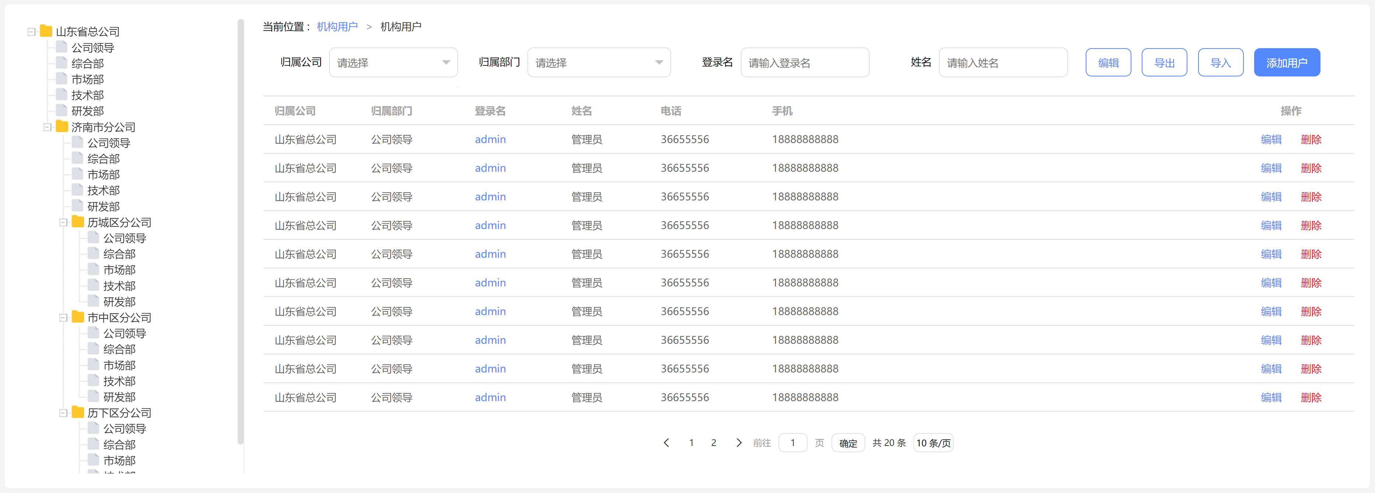
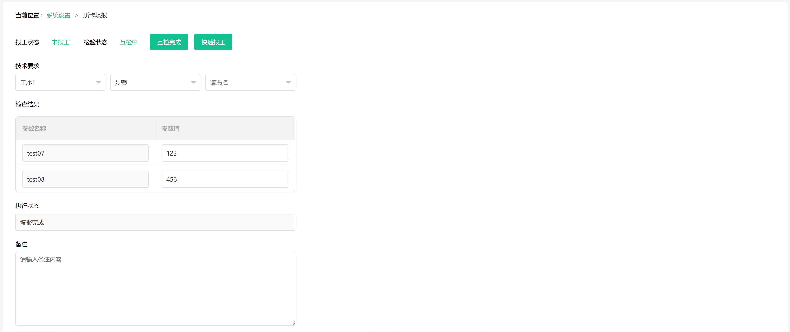

3.注意事项
3.1请不要将四五六套引入的js,css和其他静态文件替换成其他版本,因为这三套工程引用的文件有过修改
- <link rel="stylesheet" href="../images/font/iconfont.css">
- <link rel="stylesheet" href="../css/default.css">
- <link rel="stylesheet" href="../js/lib/layui/css/layui.css">
- <link rel="stylesheet" href="../js/lib/zTree/css/zTreeStyle/zTreeStyle.css" type="text/css">
- <script type="text/javascript" src="../js/lib/common.js"></script>
- <script src="../js/lib/layui/layui.js"></script>
- <script src="../js/lib/load.js"></script>//这个只在前台开发时有用,相应功能没有完善
- <script type="text/javascript" src="../js/lib/zTree/js/jquery.ztree.all.js"></script>

3.2每个组件中最外层的div样式请不要修改
dictionary.com.html中dictionaryDiv样式名请不要修改,它定义了字典的总样式
- <template>
- <div class="dictionaryDiv blockDiv">

- ...
- </template>

3.3 load.js是前台页面开发时候偷懒用的,正式工程请不要使用
这些代码请都替换掉
- <com-frame>
- <!-- 正文内容 -->
- <com-org class="blockDiv"></com-org>
- </com-frame>
- <script>
- load("./coms/frame.com.html","com-frame");
- load("../coms/org/org.com.html","com-org");
- </script>
- <script src="../js/lib/load.js"></script>

3.4 pc版和移动版是一套页面

