This is a simple Front End project. You can open it directly with your browser. Or you can deploy it on your server and access it by URL.

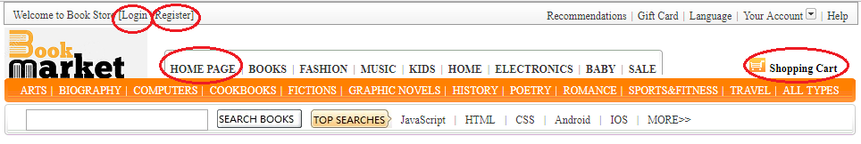

For this project, I just 4 pages, that are Home Page, Shopping Cart, Login and Register. You can jump between these pages by click on the red cycle shown above.

