|  |  |  |
| --- | --- | --- |
|  | **Rochester Institute of Technology**  **Golisano College of Computing and Information Sciences**  **School of Interactive Games and Media**  **2145 Golisano Hall – (585) 475-7680** |  |

**Data Structures & Algorithms for Games & Simulation II**

**IGME 309**

**First exam – Practical (version D)**

I’ve included a solution under the _Binary folder. **Please take a look at that before continuing reading this document.** You are not allowed to open past projects.

Right out of the box you will begin with this:

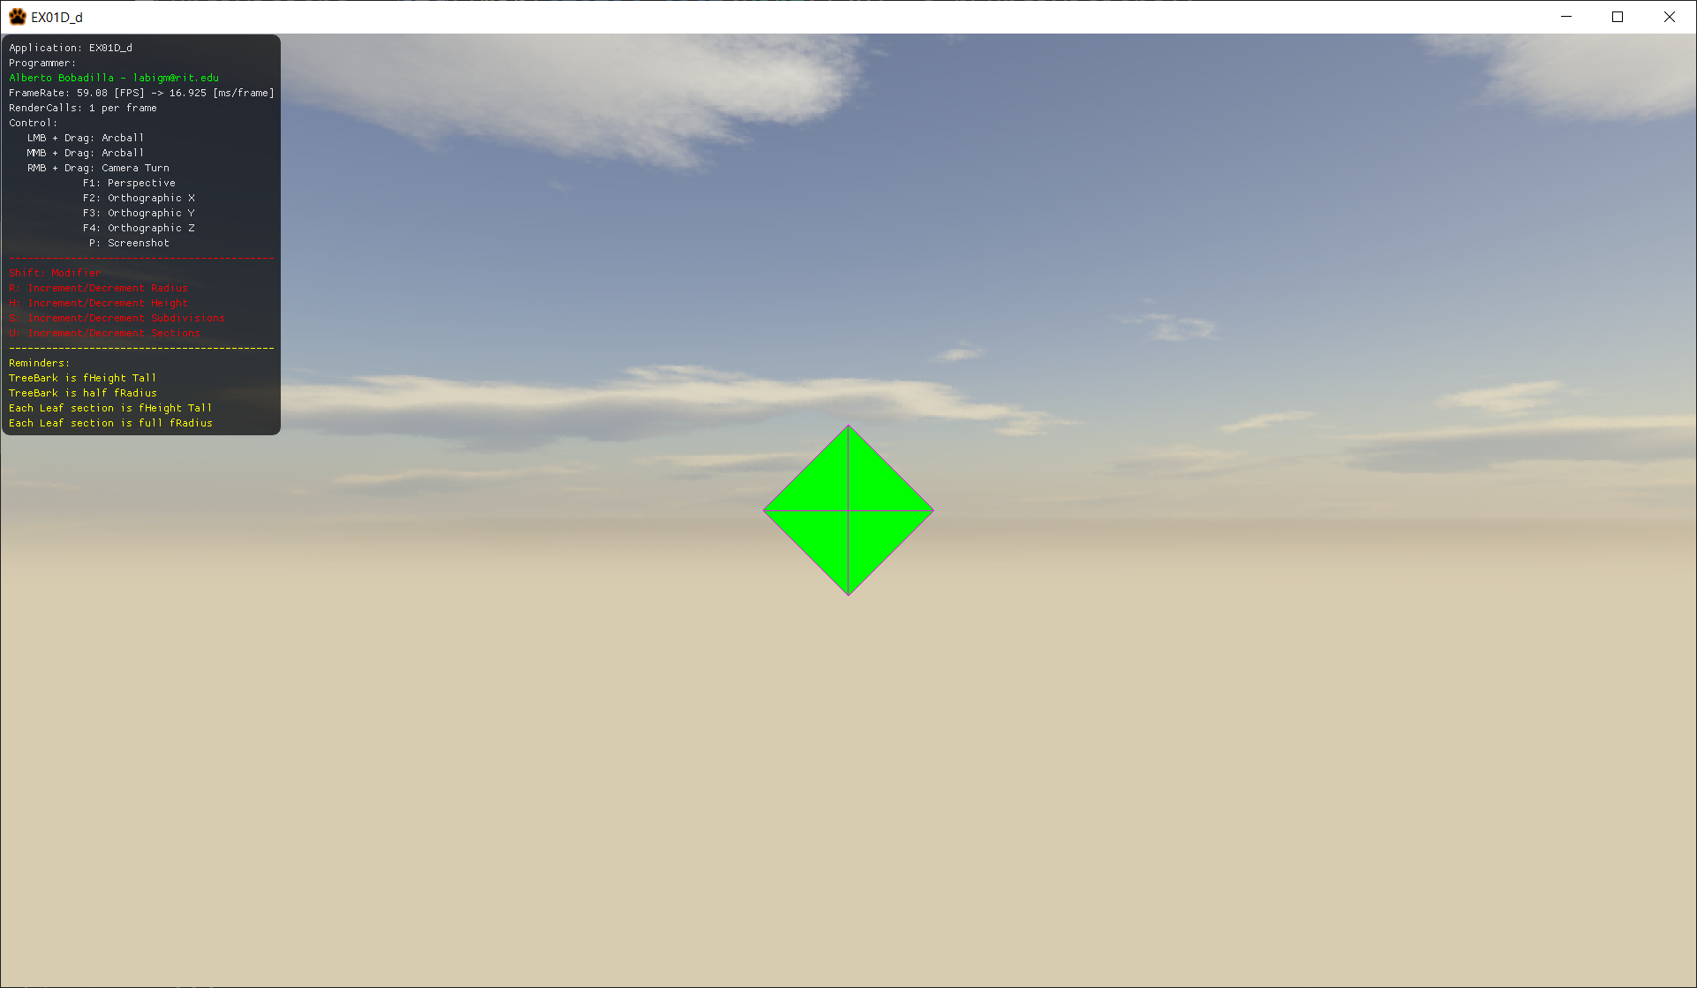

You are working on a drawing app that will display a pine tree model that can be dynamically generated and modified into different forms. The end result using the default values provided in the executable should look like this:

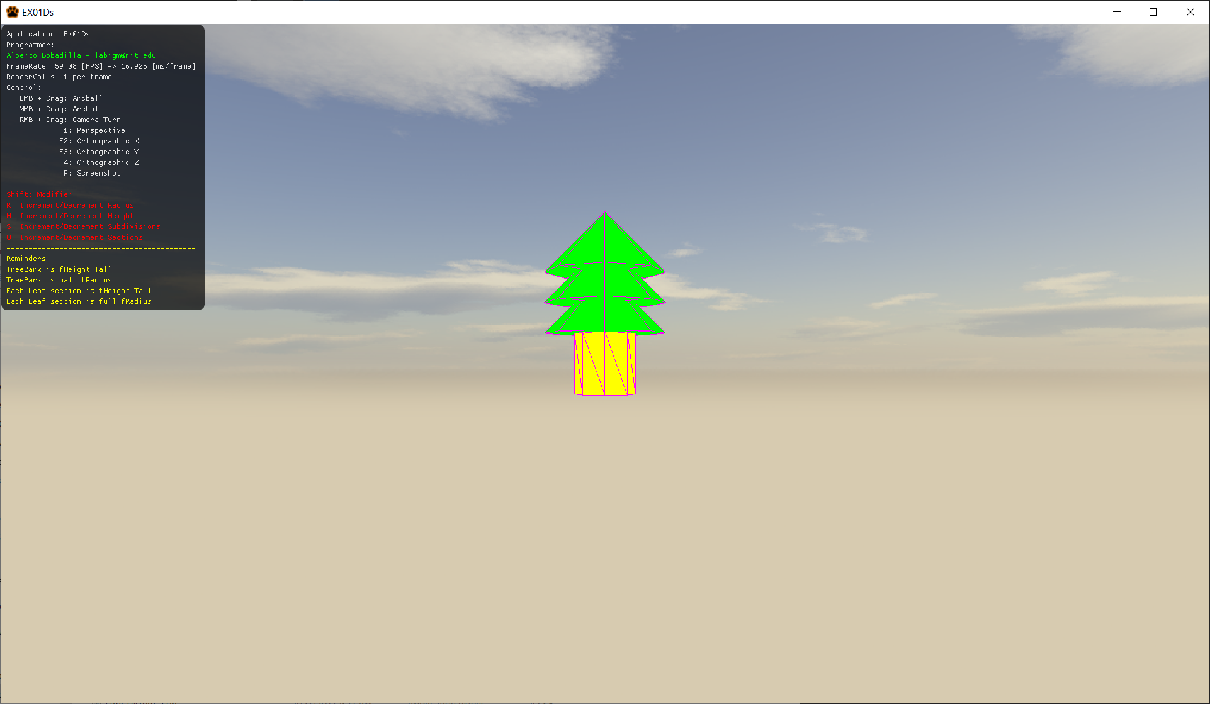

From the starter code there are some things you need to do:

1. Modify the MyMesh.cpp GeneratePine method to generate the shape
   1. All shape-components will have the same subdivision level
   2. Each Tip cone part will have always a height equal to the fHeight argument and each new part will have the origin at the geometrical center of the previous cone. The first one will align with the top of the cylinder on its base. There will be equal number of sections as the a_uSections argument.
   3. The bark cylinder part will always have a height equal to the a_fHeight argument but its radius is equals to half the a_fRadius argument.

Tips

1. There are pragma regions for your convenience, anything inside a DOES NOT NEED CHANGES region is bug-free ready to use
2. For your convenience an arcball has been added to the tree shape.
3. You can use whatever colors you want for the parts but they need to be distinct from each other. I recommend Green for the leaves and yellow for the tree bark but feel free to be creative.
4. Your files need to compile, if the code does not compile it gets an automatic 0, its better for you to comment the faulty lines and receive partial credit than no credit at all.
5. Memory is handled for you unless you make new variables.
6. The only file you need to modify is:
   1. MyMesh.cpp
      * GeneratePine(…)
7. You are allowed to add more variables and methods as needed. But you will **only submit the file MyMesh.cpp,** in the odd case that you are adding more variables on other files make sure you are giving me all the files I need to grade.
8. Your shape needs to be dynamically generated, this means that you can’t hardcode the subdivisions or any other argument, you can try the different arguments with the keys shown in the GUI, shift + the key will subtract, the key alone will add.

Grade:

20 points – Cylinder tree bark

20 points – Cone leaves tip(s)

15 points – Your Cone parts are dynamic

15 points – Your Cone is pointing up, not into the screen or any other orientation.

10 points – Pieces align on the appropriate place.

10 points – Shape parts have different colors.

10 points - You submit only the MyMesh.cpp file unzipped (unless you really needed to include more files for a reason, you need to tell us why in the comments)

***Submit to the dropbox labeled Exam 1 –Practical***

The required submission asks only for a single unzipped file containing MyMesh.cpp, not the whole solution, it should be no larger than 10kb, if you are using extra files for creating variables and such, please include those files as well in a zipped file. The content of your submission should look like this (routes might be different):

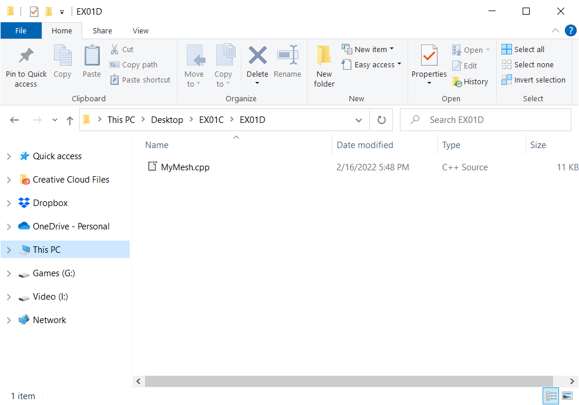

After you submit your file, it is your responsibility to download your submission and make it is what you worked on and not the starter code, **it has happened to other students before, do not let it happen to you.**