**The Function of Stock Selection Tool**

The Stock Selection Tool was developed using Python to enable the user in viewing the closing prices of equities in the Malaysian market in the past. Built with pandas for data processing and the yfinance library to pull out data, this application will provide users with an efficient way to make informed decisions based on key indicators of stock performance.

The application enables the registered users to have safe and tailored access by registering themselves securely using Email and Password authentication. Further, after login, retrieving historical closing prices for several equities in a timescale specified by the user allows users to focus their attention on the stock or time period of interest. The tool performs basic analyses of the retrieved closing prices: it finds the highest and lowest closing prices in the period chosen by the user, calculates the average closing price, and computes the percentage change between the first and last days of the period chosen by the user. The application also saves user interactions-including analysis results-in a CSV file for later use. Moreover, the user can just view and review past stock picks by retrieving and showing previously recorded data.

**Objective**

The main objective of the Stock Selection Tool is to provide customers with a trustworthy platform to analyze past closing prices of stocks in the Malaysian market. It is an amazing too that regardless of one’s technical or financial level of knowledge, one may now simply gather, evaluate, and retain critical stock performance data. Using the YFinance library, this application can retrieve previous closing prices for any stock ticker over a specified time period. Moreover, the program pulls reliable data, ensuring relevance and dependability, and users may set the required timeframe.

It will, by itself, carry out some extensive analysis of the returned data to identify the high and the low of the closing prices within the selected time period, the average of the closing prices for the period, and the percentage change in the closing price from the beginning to the end of the chosen time interval. With such measures, the overall performance and tendencies of the stock can be better understood by the users.

The program also has the ability to track and save data, apart from real-time insights. All user interactions, such as selected stock tickers and analytical findings, are kept in a structured CSV file. This feature allows users to keep a record of their stock assessments for future use and go back to analyze their previous analysis. This enables the user to review patterns and compare performance over time, making the application a helpful tool for learning and decision-making.

Finally, through providing consumers with fundamental insight into the movement of stock, the Stock Selection Tool aims to empower the user in making an educated decision. The app supports improved insight into the movement of stock for a more effective analysis and thus confident decision-making either for novices trying to test waters or for veterans to gauge past performance.

**Methodology and workflow**

The Stock Selection Tool employs a structured approach in simplifying how users engage in stock market data. The process involves the authentication and registration of users: returning users log in safely while new users create an account using an email address and password created for that purpose. Credentials are securely stored to maintain security but also to allow access to the capabilities of the tool in times to come. Thereafter, the customer selects the stock to work with by providing a stock ticker symbol, such as 1155.KL for Maybank Malaysia, and a date period, like the last month or year. The application then uses the YFinance library to get the historical stock data of the selected time, particularly closing prices.

The program will, in detail, analyze the closing prices after retrieving the data. It finds the highest and lowest closing prices inside the date range, computes the average closing price during the given time frame, and calculates the % change between the first and final closing prices. These important measures are presented to the user in understandable terms, which will allow easy judgment of the performance of the stock.

Additionally, the program saves user interactions, including email, chosen stock ticker, and analysis results in a CSV file to ensure that data is saved for later use. Now, it is very easy for users to fetch and look at their past analyses. This makes it simple for users to review their past stock picks and better understand market trends over time, as the program will have the capability to access and display saved data. Besides furnishing customers with useful information for well-informed decision-making, this organized process ensures that everything is effective and user-friendly.

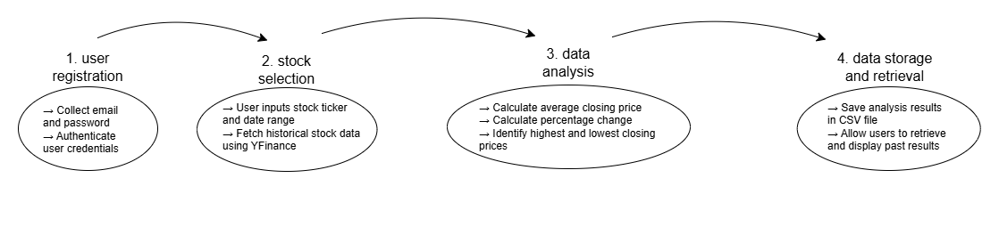

**Configuration and Setup**

First and foremost, all of the required software and libraries were installed to the computer so that it is convenient while using the Stock Selection Tool. Besides, the action as below is done to set up the environment.

#### **1. Python Installation**

* The Stock Selection Tool requires Python to be installed on the system.
* Recommended Python version is **3.6 or higher**.
* Python can be downloaded, and the installation instructions can be followed according to the operating system.

#### **2. Required Libraries**

The program relies on the following Python libraries:

* **pandas**: pandas is used for data manipulation and analysis.
* **yfinance**: yfinance is used for fetching historical stock data.

#### It is also should be noted that these libraries must be installed in the Python environment, so that the installation is valid and from a trusted source.

#### **Installation Instructions**

To install the required libraries, pip (Python's package manager) should be installed ahead. Thus, a terminal or command prompt should be opened to execute the following commands:

Code 1: pip install pandas

Code 2: pip install yfinance

#### **3. Verify Library Installation**

To verify that the libraries are correctly installed, the following commands in a Python shell shall be run:

import pandas

import yfinance

print("Pandas version:", pandas.__version__)

print("YFinance is installed successfully.")

#### **4. Clone or Download the Source Code**

* The GitHub repository containing the Stock Selection Tool should be cloned, or the source code files (main.py and functions.py) to be downloaded.

git clone <link of repository>

#### **5. Run the Program**

* Open a terminal or command prompt.
* Approach to the folder containing the main.py file.
* Execute the program using the following command: main.py

#### **6. Sample CSV File**

A sample CSV file containing previously stored user interactions shall be provided in the repository. Besides, one must also ensure that the program has access to this file for testing or demonstration purposes

#### **7. Any Problem that is Encountered**

If any issues are encountered, it should be ensured that the Python installation is correctly configured, and all dependencies are properly installed. Besides, if the pip, yfinance and pandas are not installed directly from the python, then it shall be download separately from the official website. For instance, the file name for pip installation is get-pip.py file and the file can be retrieved from <https://pypi.org/project/pip/>.