| **Team Number** | 07 | **Section** | 61 |
| --- | --- | --- | --- |
| **Team Members** | 1. Daphne Dao 2. Samantha Yip 3. Richie Nguyen 4. Hayk Meghavoryan | | |
| **Software Name** | Journaly McJournalFace | | |

# Introduction

## Objective

This document is going to propose an open-source software that allows users to write in their personal journal. This software will allow users to create journal entries and also personalize it to their own taste. Through this document, it’ll give precise descriptions of the tasks and functions which the program will perform and provide to the user. It’ll show samples of the program design and its functions. The audiences for this document are the clients and designers.

## References

Moqups.com

Professor Yazdankah’s Lecture Notes

## Acronyms, and Abbreviations

| N/A | Not Applicable |
| --- | --- |

# Software Overview

## Problem Statement

Many people love to write in journals for their own personal reasons. Typically, they would have their own journals to write their own thoughts down. However, there are a myriad of problems with having a physical journal. For one, it can easily get lost or forgotten by the writer. A physical journal can also be damaged by water, light, and eventually, time. One way of solving this problem is by creating a software system for personal journals. It’ll stay in the user’s safe space and stay in the database (or files) for an unlimited period of time. With an online journal, it won’t get damaged by the elements or be forgotten by the user. As of now, there are no personal applications that are both free and open-sourced. Many of the good online applications will either make you pay, have numerous ads, or steal your data. This software aims to be free, open-sourced, and be user friendly.

## Scope

This product would target those that write in journals and its for all users who have basic computer knowledge.

## Functional Requirements

1. Users will be able to create new journal entries.
2. Users will be able to title it, set date-time, and write inside the journal entries
3. The user can save the entries or delete it
4. The user will be able to search for the journal entry by using the search box
5. The user will be able to edit the journal (change Journal name, date-time, and content) and save/cancel the changes
6. The user can cancel a journal draft when they start creating it
7. The software will allow user to change their password when they launch the program for the first time
8. The software will allow user to choose a security question and answer the question
9. The software will allow user to reset password (in case they forget)
10. User will be able to provide their password to enter the application

# Use Cases

| **Use Case Name** | | UC-01: Login | |
| --- | --- | --- | --- |
| Goal | | | |
| The user logs into the system using a password | | | |
| Participating Actors | | | |
| * The user * The system | | | |
| Glossary | | | |
| N/A | | | |
| Primary Flow of Events | | | |
| Trigger | | | |
| User launches application | | | |
| **Steps** | **Action** | | **System Response** |
| 1 | User launches application | | System shows login page |
| 2 | User enters password | | System verifies password  System shows home page |
| Alternative Flow of Events | | | |
| **Alternative Trigger** | | | |
| User enters wrong password | | | |
| **Steps** | **Action** | | **System Response** |
| 1 | User inputs incorrect password | | System shows message telling the user about the incorrect password  System stays on login page |

| **Use Case Name** | | UC-02: First Time Login | |
| --- | --- | --- | --- |
| Goal | | | |
| The user logs into the system for the first time and creates a new account | | | |
| Participating Actors | | | |
| * The user * The system | | | |
| Glossary | | | |
| N/A | | | |
| Primary Flow of Events | | | |
| Trigger | | | |
| User launches application for the first time | | | |
| **Steps** | **Action** | | **System Response** |
| 1 | User runs application for the first time | | System redirects to the password change page. System asks for password change (UC-05) |
| 2 | User changes password and creates security question and answer (UC-05) | | System writes new password and security question and answer to JMJAccount.txt  System shows confirmation pop-up window with “OK” button |
| 3 | User clicks on “OK” button | | System shows home page |
| Alternative Flow of Events | | | |
| **Alternative Trigger** | | | |
| User clicks cancel | | | |
| **Steps** | **Action** | | **System Response** |
| 1 | User clicks cancel | | System will go back to the login page.  JMJAccount.txt will keep the default, “p”, password |

| **Use Case Name** | | UC-03: New Journal Entry | |
| --- | --- | --- | --- |
| Goal | | | |
| Create a new journal entry with an optional name, date-time, journal text. | | | |
| Participating Actors | | | |
| User, system | | | |
| Glossary | | | |
| N/A | | | |
| Primary Flow of Events | | | |
| Trigger | | | |
| User clicks on the new (journal) entry button. | | | |
| **Steps** | **Action** | | **System Response** |
| 1 | Clicks the new journal entry button | | System redirects to the Journal Entry Page containing the fields to type the title, date, time, and content. |
| 2 | User enters the title (optional), date, time, and content of the journal entry. | |  |
| 3 | User presses the save button | | Creates a new file for the entry and has the entry title stored in another file. The user will be able to continue writing their journal entry. |
| Alternative Flow of Events | | | |
| **Alternative Trigger** | | | |
| Step 2. User doesn’t enter time, date or content | | | |
| **Steps** | **Action** | | **System Response** |
| 1 | User clicks on the save button | | System will open a pop-up that prompts the user to fill out the required fields. |
| 2 | User fills in the required fields. | | System will save the entry and the user will be able to continue writing their journal entry. |
| **Alternative Trigger** | | | |
| User cancels the process to make a new journal entry | | | |
| **Steps** | **Action** | | **System Response** |
| 1 | Step 2. Clicks the exit button | | System returns to the homepage. |

| **Use Case Name** | | UC-04: Searching | |
| --- | --- | --- | --- |
| Goal | | | |
| Users will be able to find a specific journal entry based on the journal’s title | | | |
| Participating Actors | | | |
| User, System | | | |
| Glossary | | | |
| N/A | | | |
| Primary Flow of Events | | | |
| Trigger | | | |
| User clicks on the search box at the top of the homepage. | | | |
| **Steps** | **Action** | | **System Response** |
| 1 | User clicks on the search button | | System will redirect to the search page. If they already have journal entries, it will be shown on the page. If not, it will be empty. |
| 2 | User will type their keyword(s) | |  |
| 3 | User will click on the search button. | | The page will show journal entries with that title. It’ll show the documents that best fit the keywords at the top first. |
| 4 | User clicks on a Journal Entry. | | System will go to the Journal Entry Page with the selected journal entry saved data shown. |
| Alternative Flow of Events | | | |
| **Alternative Trigger** | | | |
| User clicks cancel | | | |
| **Steps** | **Action** | | **System Response** |
| 1 | User clicks on the cancel button | | System will go back to the homepage. |
| **Alternative Trigger** | | | |
| User clicks on an empty cell | | | |
| **Steps** | **Action** | | **System Response** |
| 1 | User clicks on an empty cell | | System will prompt a text that tells the User that no Journal Entry is detected. |

| **Use Case Name** | | UC-05: Change Password | |
| --- | --- | --- | --- |
| Goal | | | |
| The user changes the password and creates the security question and answer. | | | |
| Participating Actors | | | |
| * The user * The system | | | |
| Glossary | | | |
| N/A | | | |
| Primary Flow of Events | | | |
| Trigger | | | |
| User clicks on “change password” button | | | |
| **Steps** | **Action** | | **System Response** |
| 1 | User clicks on “change password” button | | System opens change password window |
| 2 | User enters old password, new password, verifies new password, and creates a security question and answer | |  |
| 3 | User clicks the submit button | | System writes new password and security question and answer to JMJAccount.txt  System shows window completing password change with “OK” button |
| 3 | User clicks on “OK” button | | System shows home page |
| Alternative Flow of Events | | | |
| **Alternative Trigger** | | | |
| User enters wrong password for the old password | | | |
| **Steps** | **Action** | | **System Response** |
| 1 | User inputs incorrect old password | | System shows message telling the user about the incorrect old password  System stays on change password page |
| **Alternative Trigger** | | | |
| User enters wrong password for verifying the new password | | | |
| **Steps** | **Action** | | **System Response** |
| 1 | User inputs incorrect verification password | | System shows message telling the user about the incorrect verification password  System stays on change password page |

| **Alternative Trigger** | | |
| --- | --- | --- |
| User clicks “Cancel” button | | |
| **Steps** | **Action** | **System Response** |
| 1 | User clicks on “Cancel” button | System exits to login page |

| **Alternative Trigger** | | |
| --- | --- | --- |
| User leave security question/answer security question blank | | |
| **Steps** | **Action** | **System Response** |
| 1 | User leave security question/answer security question blank |  |
| 2 | Submit button is pressed | System shows a message telling the user that security question/answer security question cannot be left blank.  System stays on change password page |

| **Use Case Name** | | UC-06: Reset Password | |
| --- | --- | --- | --- |
| Goal | | | |
| User will be able to change their password | | | |
| Participating Actors | | | |
| User, system | | | |
| Glossary | | | |
| N/A | | | |
| Primary Flow of Events | | | |
| Trigger | | | |
| User clicks on the forgot password button. | | | |
| **Steps** | **Action** | | **System Response** |
| 1 | User clicks on the forgot password button. | | System opens the forgot password pop-up |
| 2 | User enters their new password, new password confirmation, security question, and their answer to their security question. | |  |
| 3 | Presses the submit button | | System changes the old password to the new one in JMJAccount.txt. Pop-up closes and is still on the login page. |
| Alternative Flow of Events | | | |
| **Alternative Trigger** | | | |
| User enters wrong answer to security question | | | |
| **Steps** | **Action** | | **System Response** |
| 1 | User enters wrong answer to security question | |  |
| 2 | Submit button is pressed | | System will keep the pop-up open and tell the user that the security answer is wrong |
| **Alternative Trigger** | | | |
| User enters password that doesn’t match the confirmation password | | | |
| **Steps** | **Action** | | **System Response** |
| 1 | User enters different passwords for the password and confirm password field | |  |
| 2 | Submit button is pressed | | System will keep the pop-up open and tell the user that the passwords don’t match |

| **Use Case Name** | | UC-07: Logout | |
| --- | --- | --- | --- |
| Goal | | | |
| User will be able to logout of the application | | | |
| Participating Actors | | | |
| User, system | | | |
| Glossary | | | |
| N/A | | | |
| Primary Flow of Events | | | |
| Trigger | | | |
| User clicks on the logout button | | | |
| **Steps** | **Action** | | **System Response** |
| 1 | User clicks on the logout button | | System returns to the login page. |
| Alternative Flow of Events | | | |
| **Alternative Trigger** | | | |
| N/A | | | |

| **Use Case Name** | | UC-08: Editing Journal Entry | |
| --- | --- | --- | --- |
| Goal | | | |
| User will be able to edit an existing entry | | | |
| Participating Actors | | | |
| User, system | | | |
| Glossary | | | |
| N/A | | | |
| Primary Flow of Events | | | |
| Trigger | | | |
| User clicks on the edit button in an entry | | | |
| **Steps** | **Action** | | **System Response** |
| 1 | User clicks on the journal entry of their choice from the search engine | | System will redirect to the journal page with the title, date-time and contents. |
| 2 | User edits the journal entry | |  |
| 3 | User clicks the edit button | | System shows a popup to confirm that new edits to the journal entry were saved. System will update the old journal with the new edits on the file. |
| Alternative Flow of Events | | | |
| **Alternative Trigger** | | | |
| User clicks cancel | | | |
| **Steps** | **Action** | | **System Response** |
| 1 | User edits journal entry and clicks cancel | | System will disregard any changes and keep the old journal entry. System will redirect to the homepage |

| **Alternative Trigger** | | |
| --- | --- | --- |
| User leaves date-time blank | | |
| **Steps** | **Action** | **System Response** |
| 1 | User leaves date-time blank |  |
| 2 | User presses submit | System will open a pop-up saying that the date-time cannot be left blank. |

| **Use Case Name** | | UC-09: Deleting Journal Entry | |
| --- | --- | --- | --- |
| Goal | | | |
| User will be able to delete an existing entry | | | |
| Participating Actors | | | |
| User, system | | | |
| Glossary | | | |
| N/A | | | |
| Primary Flow of Events | | | |
| Trigger | | | |
| User clicks on the delete button in an entry | | | |
| **Steps** | **Action** | | **System Response** |
| 1 | User clicks on the specific journal entry from the search engine. | | System will redirect to the journal page with the title, date-time and contents. |
| 1 | User clicks the delete button | | System returns to the homepage and shows a popup to confirm that the journal entry was deleted. System will delete the file and delete the entry title in the list of journal entry names. |
| Alternative Flow of Events | | | |
| **Alternative Trigger** | | | |
| User clicks cancel | | | |
| **Steps** | **Action** | | **System Response** |
| 1 | User clicks cancel | | System will redirect to the homepage |

# Mockups

**Login Page:**

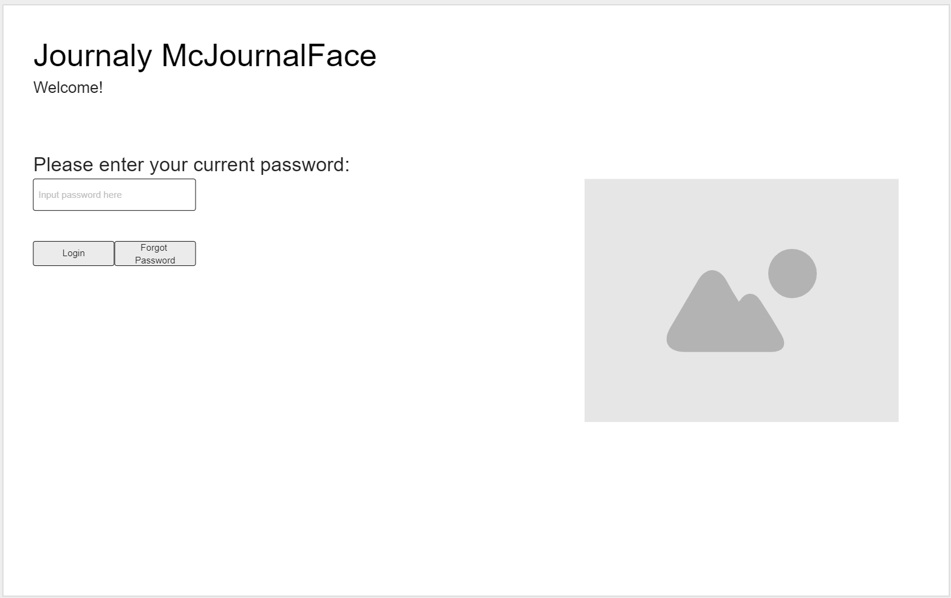

**Home Page:** 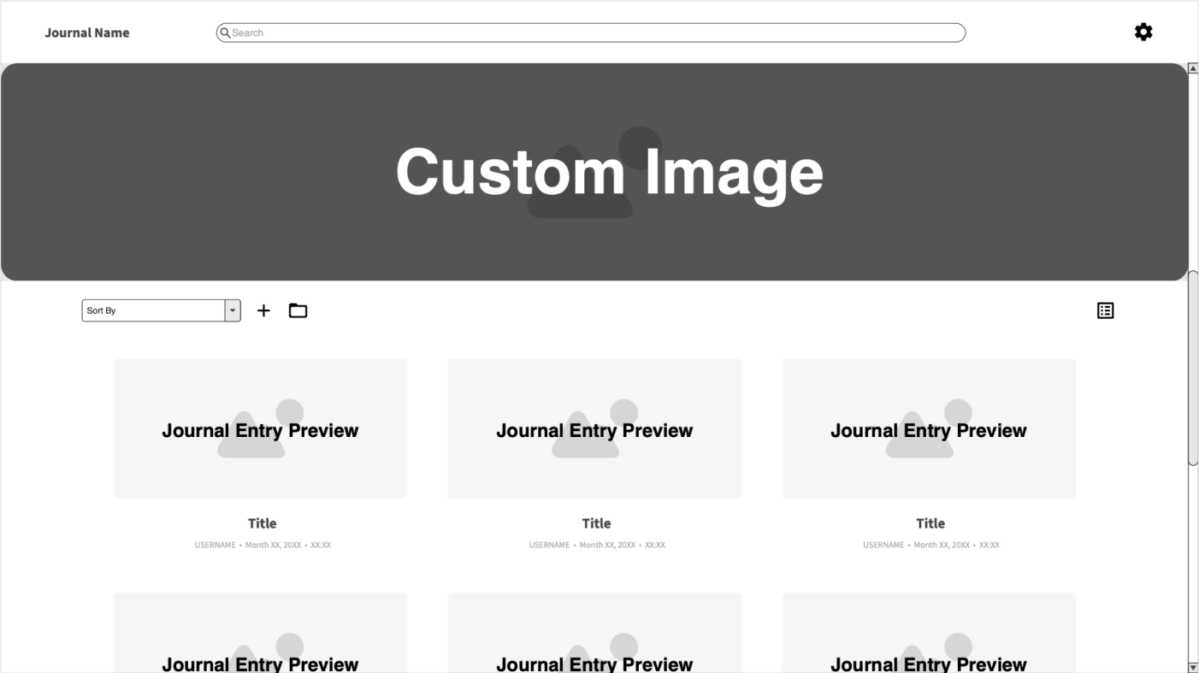

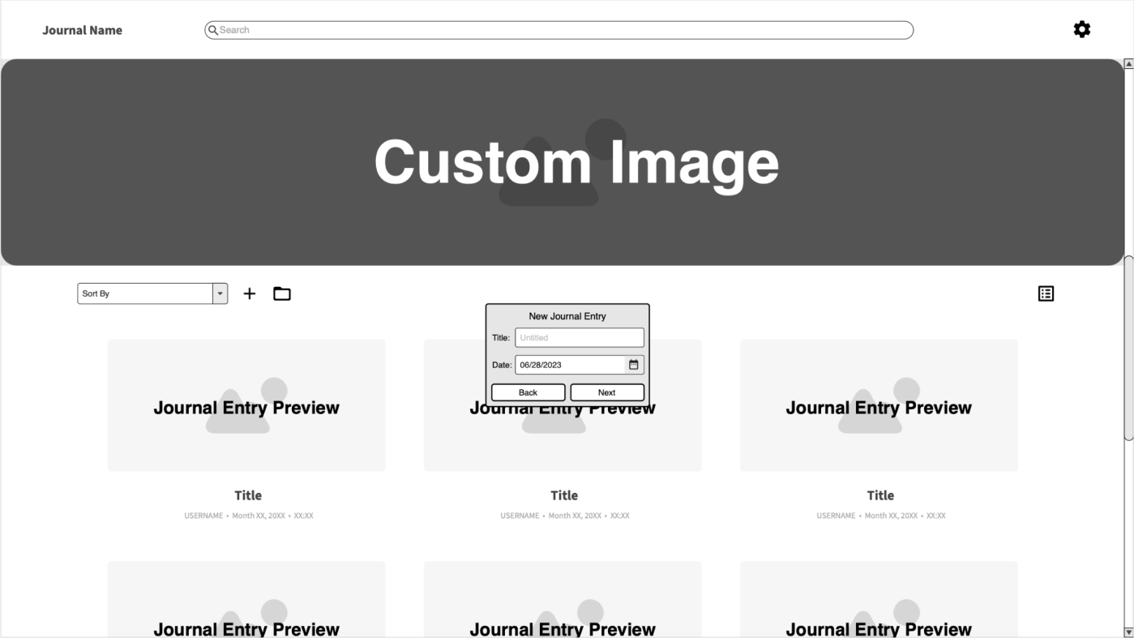

**Journal Entry Page:**

