| **Team Number** | 07 | **Section** | 61 |
| --- | --- | --- | --- |
| **Team Members** | 1. Daphne Dao 2. Samantha Yip 3. Richie Nguyen 4. Hayk Meghavoryan | | |
| **Software Name** | Journaly McJournalFace | | |

# Introduction

## Objective

The objective of this document is to show the individual components of the software (classes, methods, interfaces) and how they work together. It’ll also show how the software components will function with each other and their relationships. The document will also have sample designs of the software and what the user will see. The audiences for this document are developers.

## References

Professor Yazdankah’s Lecture Notes

Violet UML Editor

StarUML

## Acronyms and Abbreviations

| IDE | Integrated Development Environment |
| --- | --- |
| N/A | Not Applicable |

# Software Overview

## Functional Requirements

1. Users will be able to create new journal entries.
2. Users will be able to title it, set date-time, and write inside the journal entries
3. The user can save the entries or delete it
4. The user will be able to search for the journal entry by using the search box
5. The user will be able to edit the journal (change Journal name and date) and save/cancel the changes
6. The user can cancel a journal draft when they start creating it
7. The software will allow user to change their password when they launch the program for the first time
8. The software will allow user to choose a security question and answer the question
9. The software will allow user to reset password (in case they forget)
10. User will be able to provide their password to enter the application

# Detailed Design

## UML Class Diagrams

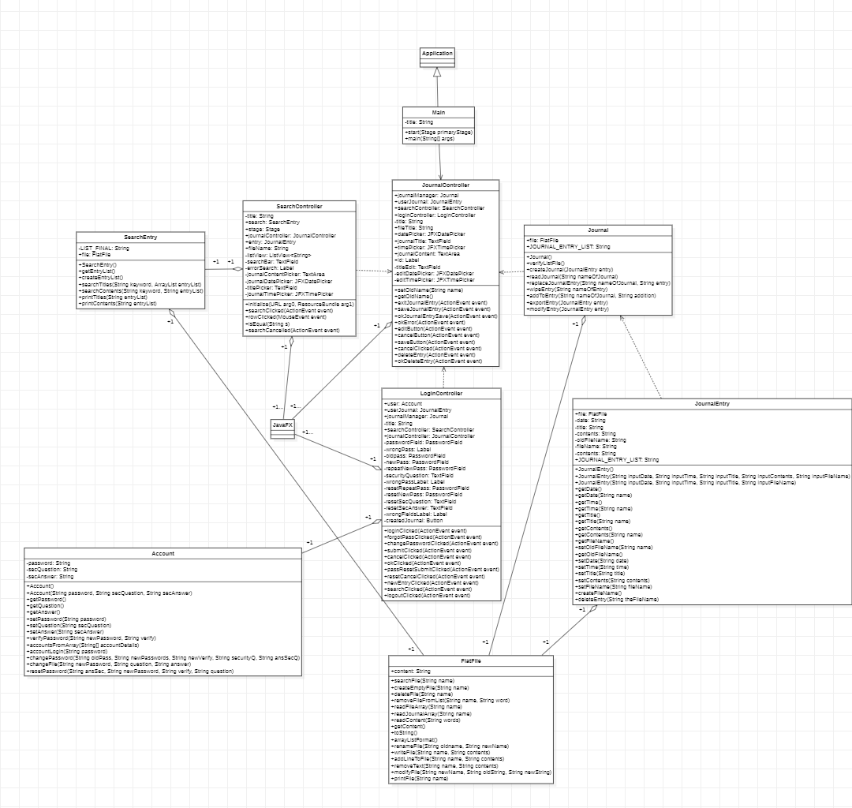

## UML Sequence and/or State Diagrams

**UML Sequence Diagram:   
Logging in (not first time user)**  
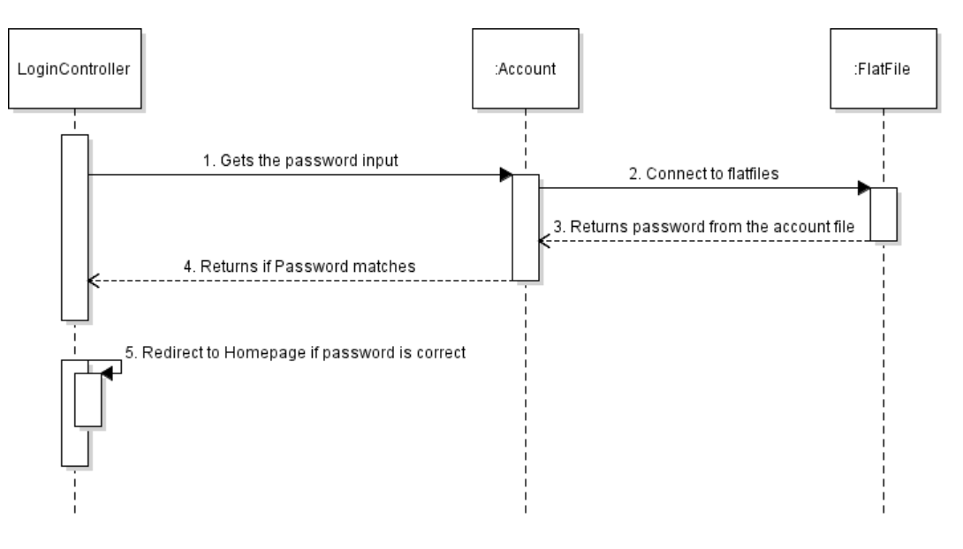

**UML State Diagram**  
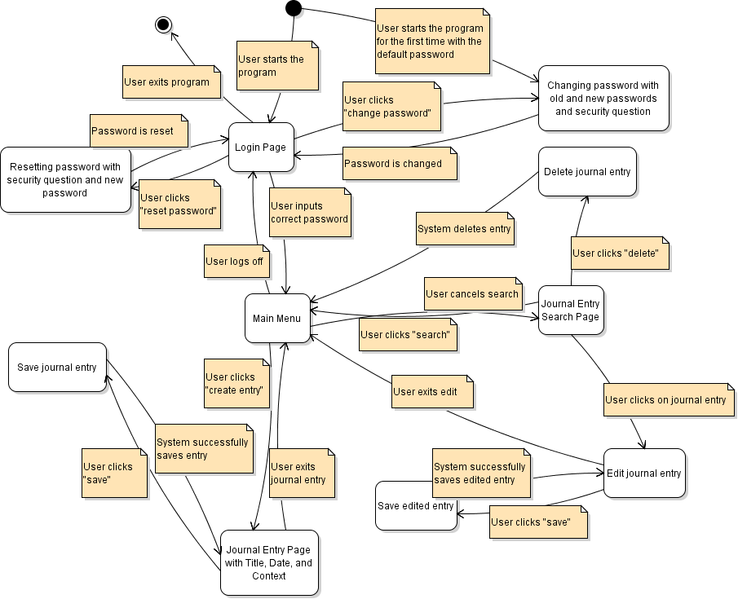

## Mockups

**Login Screen:**

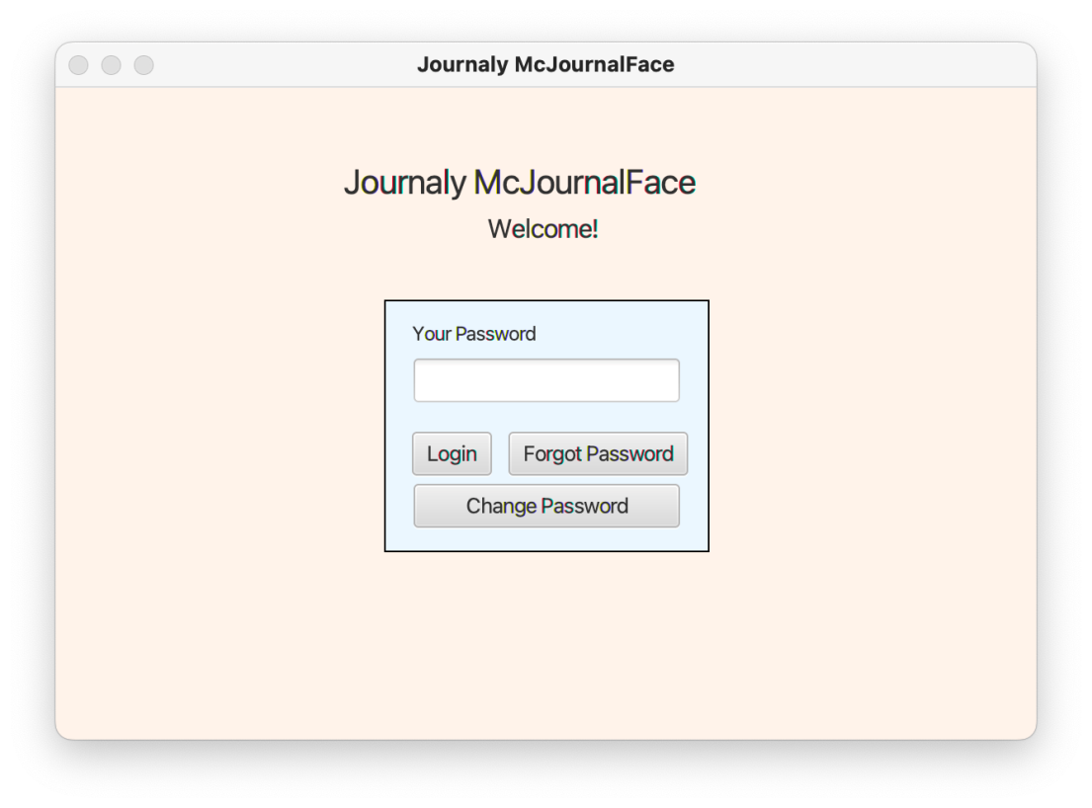

**Login Screen Wrong/No Password Entered:**

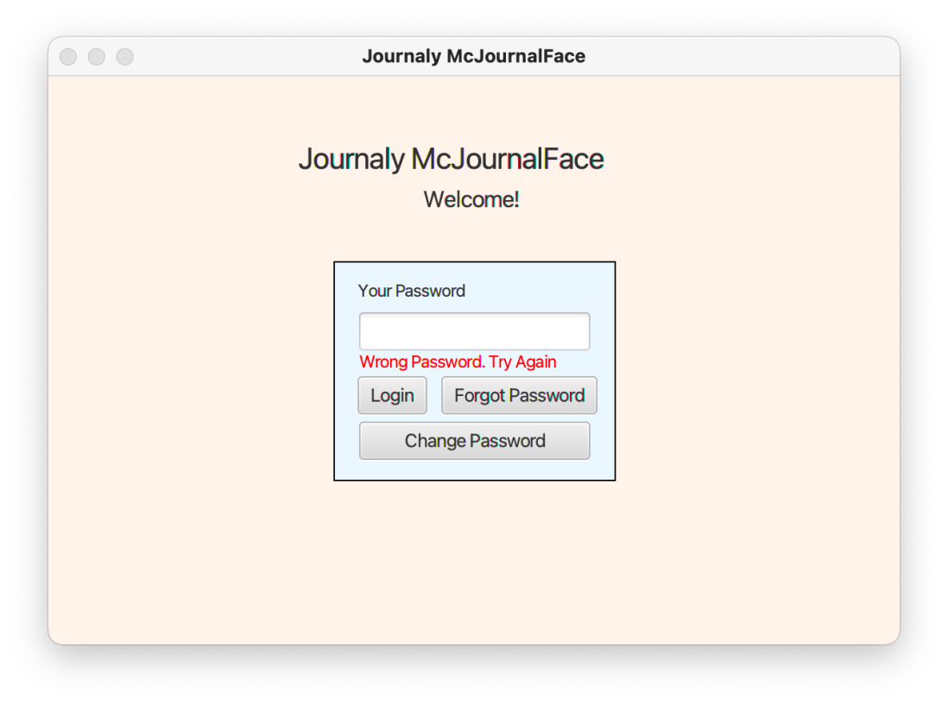

**Password Change Page**

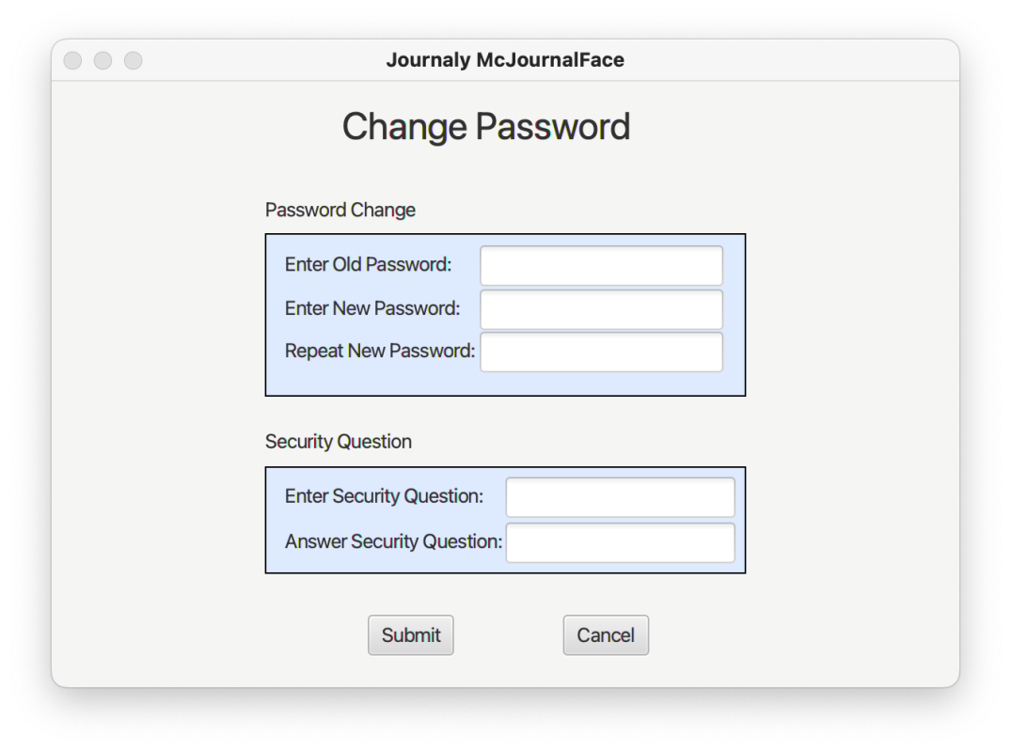

**Forgot Password:**

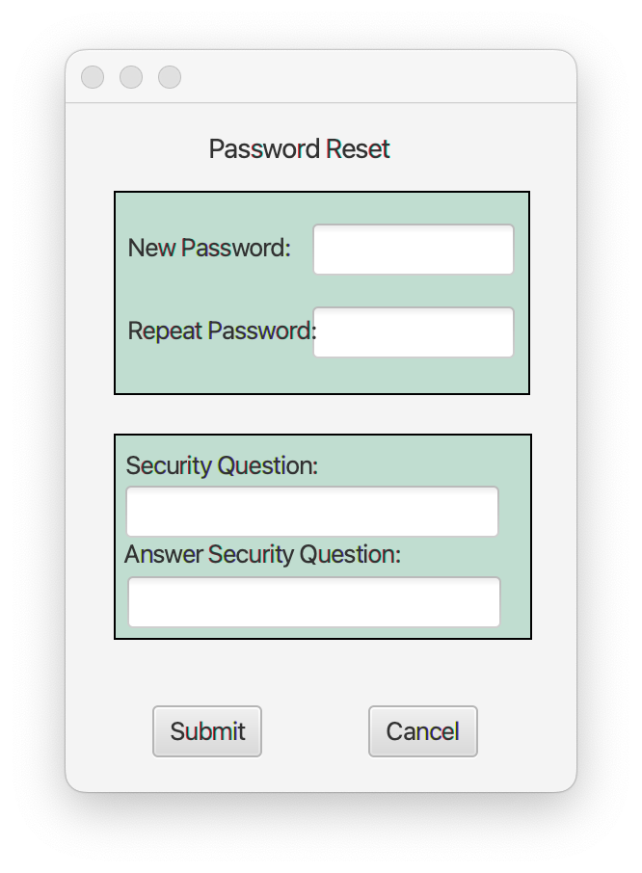

**Home Page:**

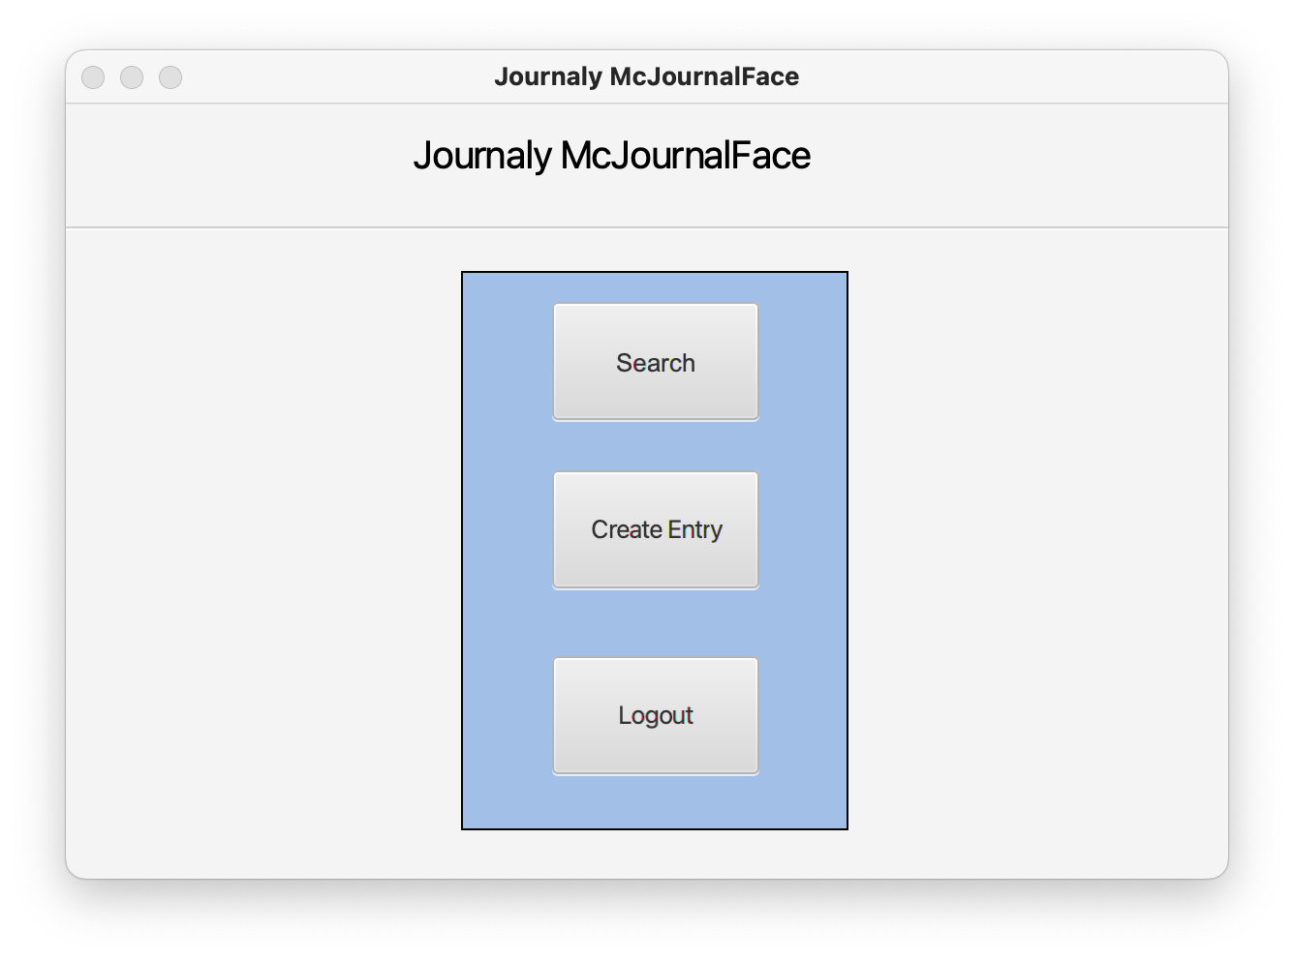

**Empty Journal Entry:**

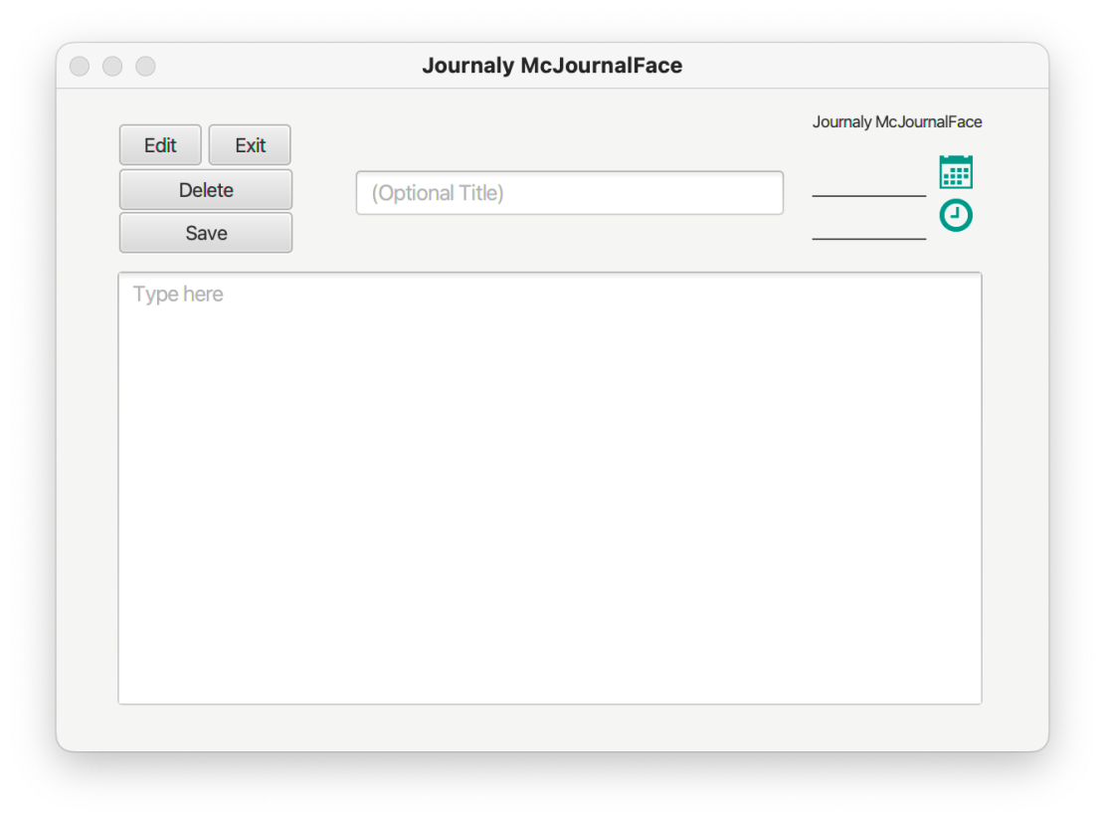

**Enter Time and Date:**

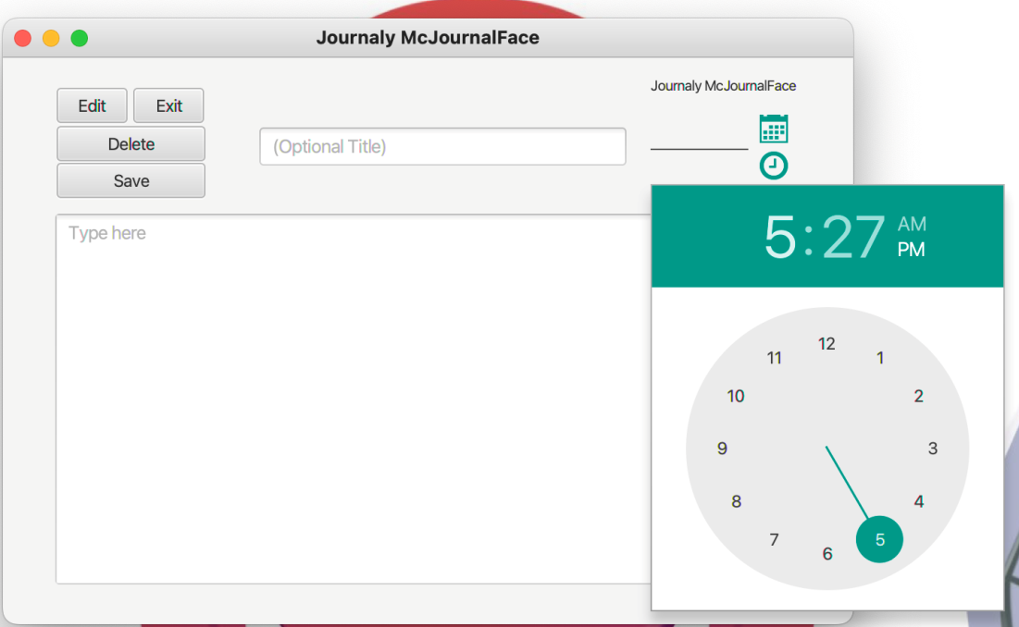

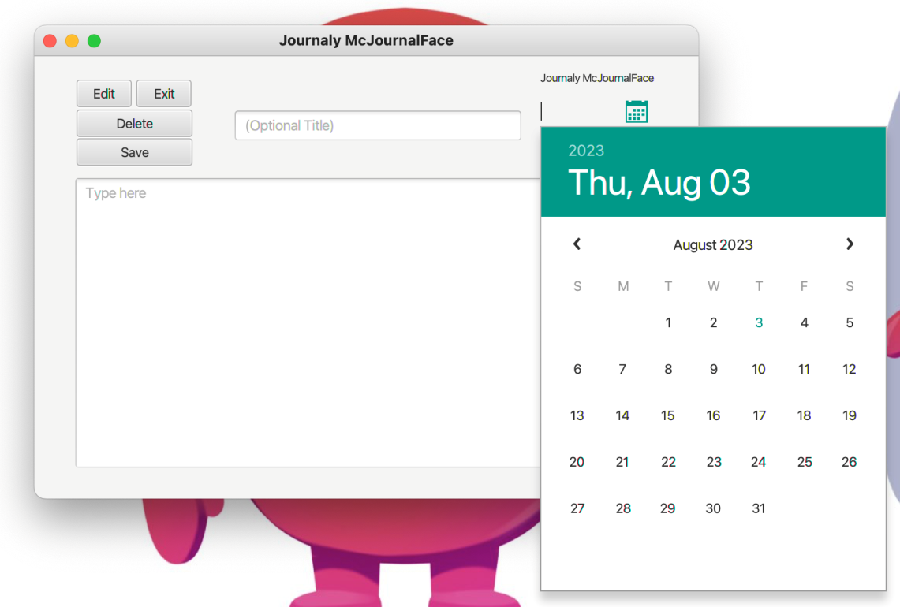

**No Title Journal Entry:**

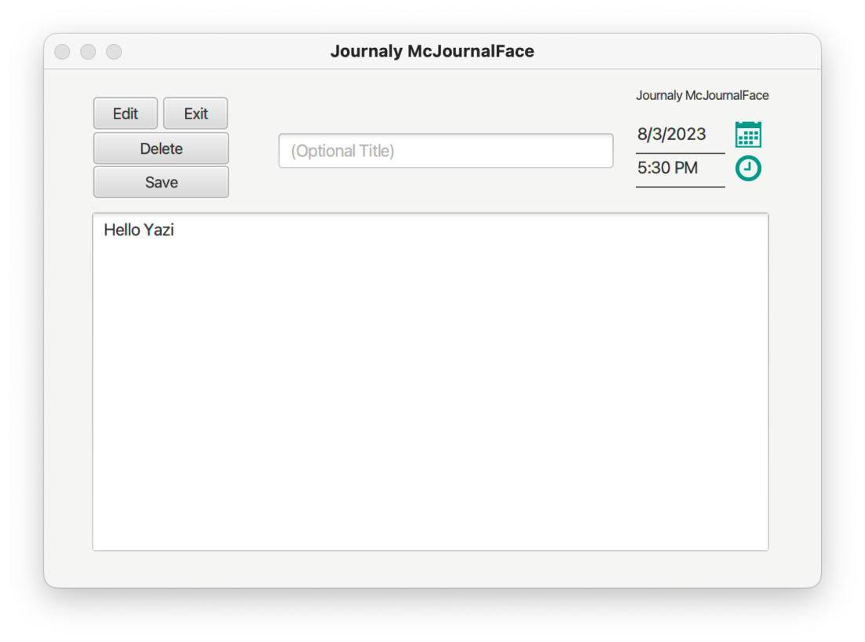

**Filled Journal Entry:**

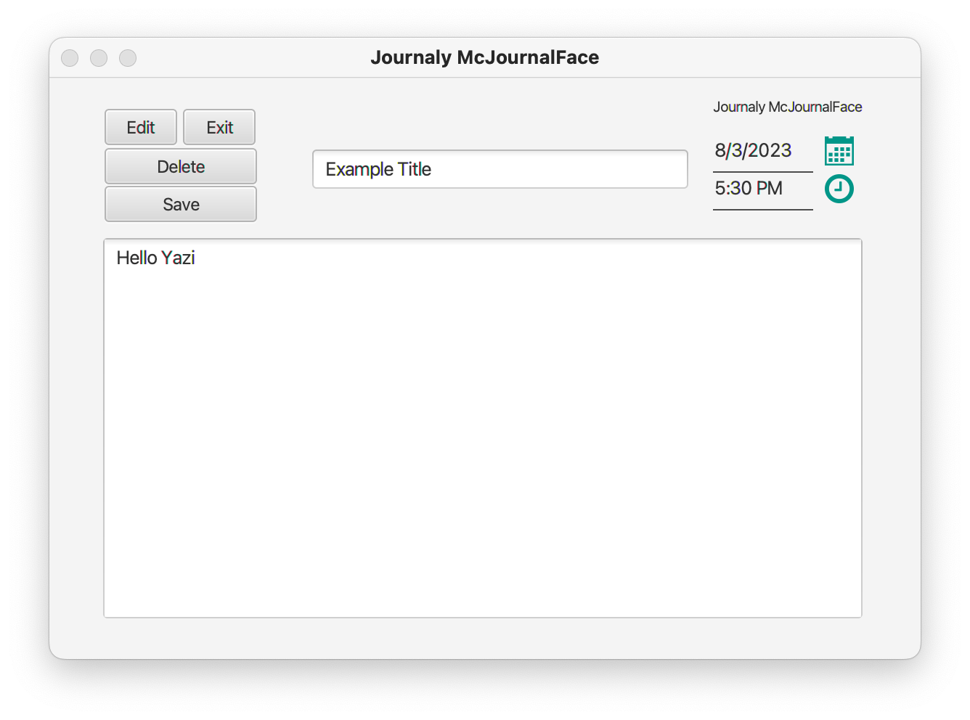

**No Date/Time Pop Up:**

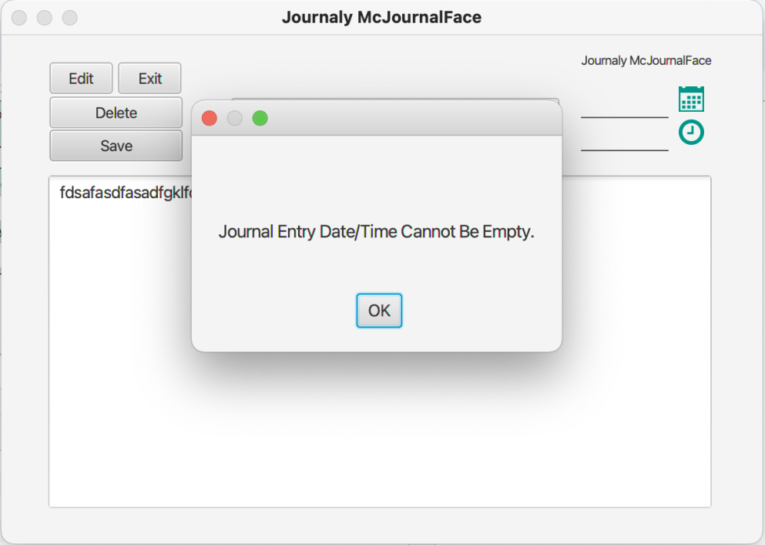

**Save Journal Entry Pop Up:**

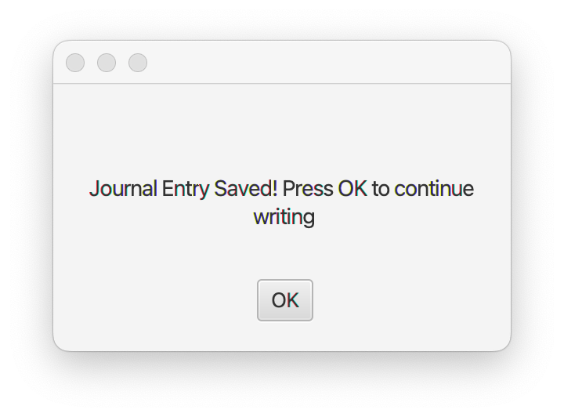

**Edit Journal Entry:**

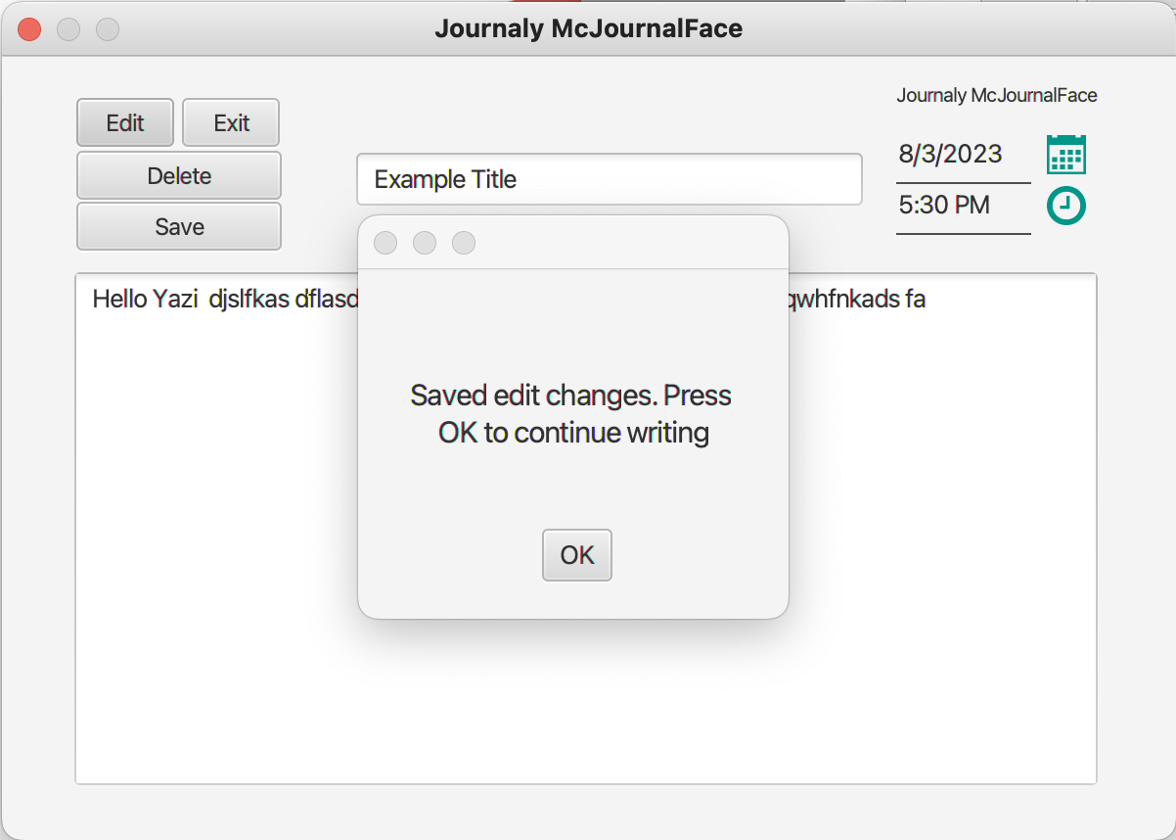

**Delete Journal Entry Pop Up:**

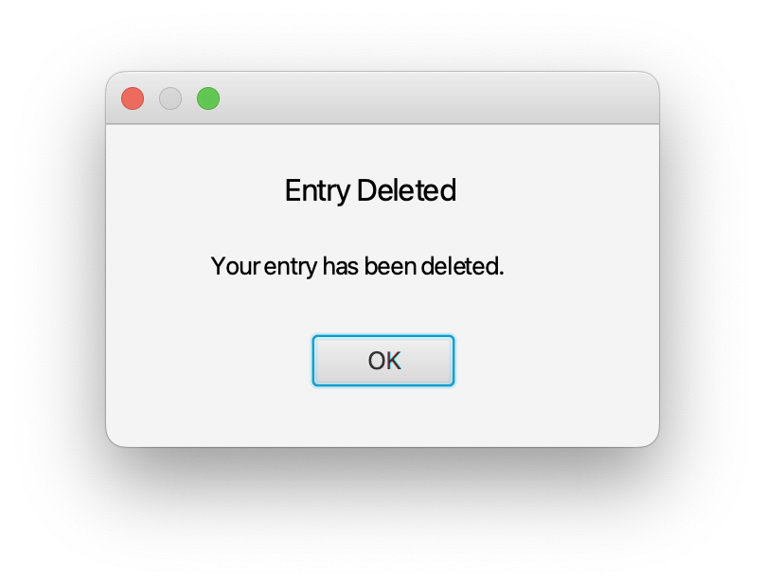

**Search Page Empty and Filled:**

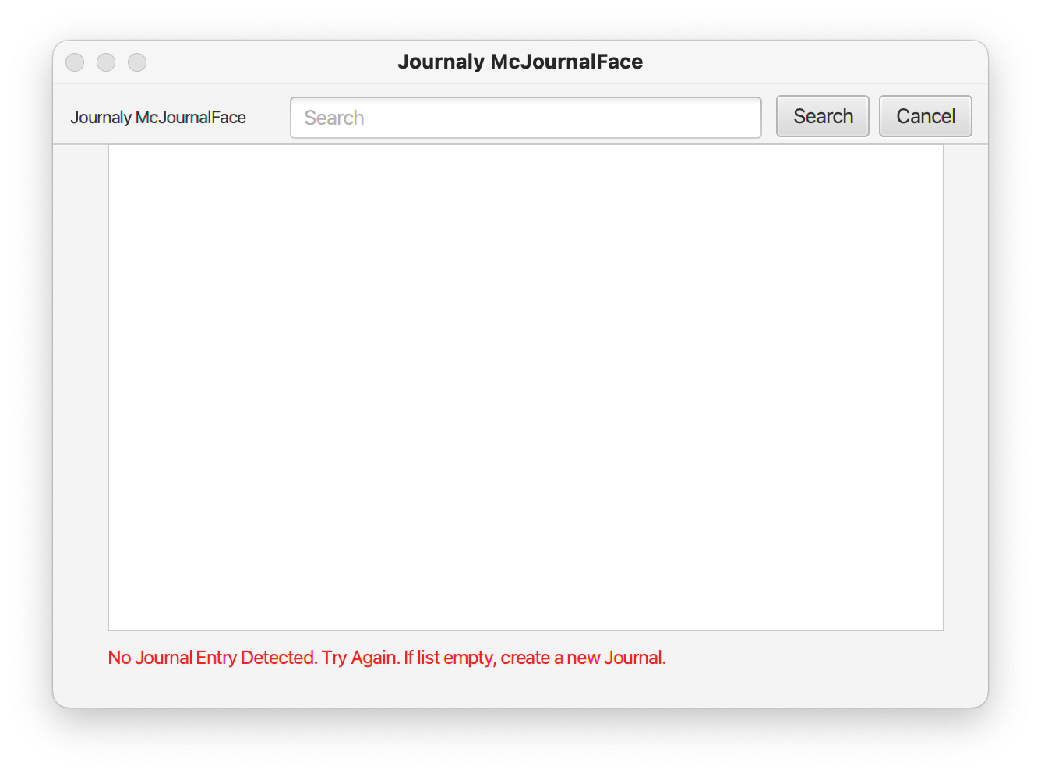

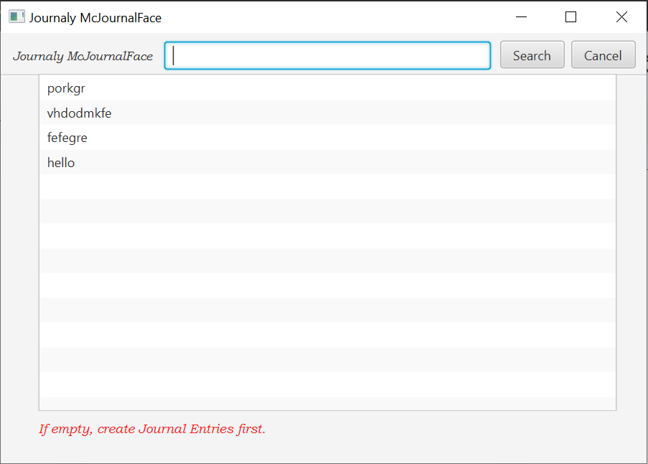

**Search Page after clicking on specific title:**

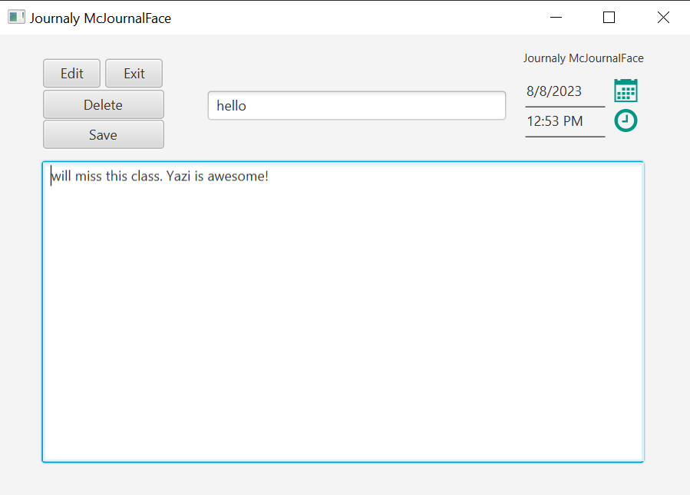

**Search page after clicking search:**

