# BACKWARDS FRAM (bkFRAM; FRAMVS2.18)

## **Introduction**

Backwards FRAM is a utility that finds FRAM starting cohorts if estimates of escapements (Coho) or (extreme-)terminal run sizes (Chinook) and fishery catches (landed and non-retention) are provided. Starting cohorts are initial FRAM run sizes before natural mortality, fishing mortality, and maturation. The program iteratively adjusts stock recruit scalars (a surrogate for starting cohorts, see Equation 1) and runs FRAM forward until the resulting escapements or terminal run sizes match the targets. For Chinook, bkFRAM calculates age 3 to 5 starting cohorts, for Coho, starting cohorts are in units of January Age 3 fish. For Chinook, target abundances are generally closely aligned with historical definitions of terminal or extreme terminal run sizes (TRS, ETRS) used for pre-season forecasts or post-season accounting (see Table 1) and exclude age 2s.

Post-season bkFRAM runs are generally conducted to create the starting cohorts that result in observed escapements (or ETRS, TRS) given known fishery impacts. These cohorts are needed to calculate post-season exploitation rates. Pre-season bkFRAM runs are generally conducted to create starting cohorts that result in forecasted (extreme-)terminal run sizes. These pre-season runs will likely be populated with recent year average fishery impacts to obtain ‘best’ estimates of pre-fishing abundances.

## **Methods**

BkFRAM can be run for an individual stock or a combination of stocks (including all stocks).

It requires a “seed” run that contains desired fishery impacts (observed values for post-season runs or recent year average values for pre-season runs). The seed run will also contain starting cohorts for stocks where this parameter is known; i.e. the forecast is already in starting cohort units rather than terminal run size units.

BkFRAM can run in three modes. The mode is selected using a flag in the input process. Flags are stock-specific, allowing all three flags (values = 0,1,2) to be used in a single bkFRAM model run.

* Mode 0 (flag 0): This mode does not use bkFRAM to find starting stock scalars. Instead, FRAM uses the starting cohort values from the existing “StockRecruit” table.
* Mode 1 (flag 1): This mode uses an algorithm to iteratively adjust stock recruit scalars until the target abundance is achieved. Target abundances are adipose mark specific. This method is used when the mark rate of a stock is known.
* Mode 2 (flag 2): This mode is selected when target mark rates are unavailable. Algorithms from mode 1 are used to find the starting stock recruit scalars that result in the combined target abundance (marked and unmarked components). The program will then apply mark rates derived from the existing “StockRecruit” table to split starting cohorts into marked and unmarked components.

**Core Algorithms**

In FRAM, run specific starting cohorts are related to base period starting cohort. This is done by multiplying the base period cohort times a stock recruit scalar resulting in the desired starting cohort.

For more information about FRAM algorithms and the base period please see “Fishery Regulation and Assessment Model (FRAM) – Technical Documentation for Chinook and Coho – October 2008”.

***Computing Starting Cohorts***

*Equation 1:*

or

***Iteratively Adjusting Stock Recruit Scalars (Mode 1 and 2)***

For Chinook

The Chinook algorithm uses forward (regular) FRAM calculations to solve for the stock recruit scalar needed to obtain a target terminal run size, given known time step fishery catches, natural mortality rates, and maturation rates.

The only parameter changing between iterations are stock-specific catches, resulting in new recruit scalars, resulting in new stock catches, etc.

To back-calculate starting cohorts given a known terminal run size, the catch summaries (PTCatch, TermCatch) entering the main equation have to strictly follow FRAM terminal run size definitions and handling (i.e. terminal versus pre-terminal treatment, inclusion or exclusion of incidental mortality from TRS definitions, etc.).

*Equation 2:*

StockScalar(s, a, t1) = ((BkTarget(s,a) + (PTCatch(s,a,t1) * MatRate(s,a,t1) + (PTCatch(s,a,t1) * (1 - MatRate(s,a,t1)) * (1 - M(a,t2)) + PTCatch(s,a,t2)) * MatRate(s,a,t2) + ((PTCatch(s,a,t1) *(1 - MatRate(s,a,t1)) * (1 - M(a,t2))+ PTCatch(s,a,t2)) * (1 - MatRate(s,a,t2)) * (1 - M(a,t3)) + PTCatch(s,a,t3)) * MatRate(s,a,t3))) + TermCatch(s,a,t1) + TermCatch(s,a,t2) + TermCatch(s,a,t3))/((1 - M(a,t1)) * MatRate(s,a,t1) + (1 - M(a,t1)) * (1 - MatRate(s,a,t1)) * (1 - M(a,t2)) * MatRate(s,a,t2) + (1 - M(a,t1)) * (1 - MatRate(s,a,t1)) * (1 - M(a,t2)) *

(1 - MatRate(s,a,t2)) * (1 - M(a,t3)) * MatRate(s,a,t3))/BPCohort(s,a)

For Coho

The Coho algorithm is simpler than that utilized for Chinook, as maturation only occurs in the final time step (October-December) and is always 100%. Similar to Chinook the calculation is based on adding time step mortalities of a stock to the escapement target, expanding for natural mortality occurring in each time step, and working backwards from time 5 to time 1. The mortalities are calculated by summing landed, drop-off, and non-retention mortalities over all fisheries for a stock and time step.

Mark-selective fishery bias correction calculations used for Coho produce an error when the exploitation rate exceeds 100%. This frequently occurs during early iterations, because the abundances from the seed run (usually the pre-season run) are not related to the post-season catches; i.e. low pre-season forecast but high post-season terminal catches. To avoid errors, the first iteration initiates starting cohorts at 1000 times base period abundance. Additionally, the first 7 iterations are run without bias correction to get sufficiently close to the target escapement, before adding mark selective fishing bias calculations for all remaining iterations. Thus in coho, the seed abundances are only used for stocks that are not adjusted during bkFRAM (Flag = 0) or for calculating mark rates (Flag = 2).

*Equation 3 & 4:*

*StockMort(s,t) =* LandedCatch(s, a, f, t) + MSFLandedCatch(s,a,f,t) + NonRetention(s,a,f,t) + MSFNonRetention(s,a,f,t) + DropOff(s,a,f,t) + MSFDropOff(s,a,f,t)

StockScalar(s, a) = ((((((BkTarget(s) + StockMort(s, t5)) / (1 - M(a, t5)) +

StockMort(s, t4)) / (1 - M(a, t4)) + StockMort(s, t3)) /

(1 - M(a, t3)) + StockMort(s, t2)) / (1 - M(a, t2)) +

StockMort(s, t1)) / (1 - M(a, t1))) / BaseCohortSize(s,a)

*Where,*

*a = Age*

*BkTarget = Backwards FRAM run size target; escapement or (extreme)terminal run size*

*BPCohort = Base period starting cohort*

*Cohort = Starting Cohort*

*FRAM_Escapement = Escapement or (extreme)terminal run size resulting from a forward FRAM run*

*f = Fisheries*

*M = Natural Mortality*

*MatRate = Maturation Rate*

*PTCatch = Mortality summed over all preterminal fisheries*

*s = Stock*

*StockMort = Mortality summed over all fisheries for a stock and time step*

*StockScalar = Stock Recruit Scalar*

*t = Time step; t1 = Oct-April, t2 = May-June, t3 = July-Sep*

*TermCatch = Terminal catch summed over all terminal fisheries*

***Calculations for Unknown Mark Rates (Mode 2)***

When mark rates are unknown, and thus the marked and unmarked components of a stock are unknown, FRAM uses mark rates from the starting cohorts of the “seed run” (usually the final pre-season model run), found in the “StockRecruit” table of the MS Access database. It applies these to the combined stock (marked plus unmarked) starting cohort to iteratively compute new stock recruit scalars. Rather than targeting a marked or unmarked escapement value, the algorithm adds marked and unmarked FRAM escapements of a stock and compares these to the target value.

Unlike Coho (Figure 2), the Chinook bkInput screen (Figure 5) has a row for total stock abundance (marked plus unmarked). A flag of 2 in the total stock row signals the use of mark rates from the “seed run”. For Coho, a flag of 2 in either the marked or unmarked row will treat the input value as a total combined (marked plus unmarked) stock abundance and split it into marked and unmarked components using mark rates from the initial "seed" model run. If there are conflicting flags for the same stock, the program will produce an error message. If using flag 2 for a stock, the corresponding marked or unmarked component should be flagged as “0”.

**BkFRAM and Age-2: Chinook**

For Chinook, the user can select whether to use age-3 recruit scalars for age-2 starting cohorts.

A checkbox is located on the ‘Backwards FRAM Run Menu’. A check mark will result in using the same recruit scalar for age-2s that was calculated in the final iteration for age-3s.

## **X Age 2 from 3**

**Convergence Criteria**

The program iterates until the FRAM escapement or terminal run size is within one fish of the target stock abundance and then terminates the iteration process, unless the user specifies a number of iterations on the ‘Backwards FRAM Run Menu’ that is smaller than the number of iterations needed to achieve convergence.

*Equation 5:*

|FRAM_Escapement(s,a) - BkTarget(s,a)|<= 1

**Testing and Supplemental Iteration Information**

When bkFRAM iterations are complete, a text file called ‘BackFRAMCheck.txt’ is created in the same directory as the FRAM database in use. This file contains information about the number of iterations performed to reach convergence and a comparison of FRAM calculated run sizes to run size targets for each stock and each iteration.

Example of the BackFRAMCheck file:

*Iteration #1*

*Stk# Age FRAM-TRS Target-TRS ScaleFactor New-Scalar Old-Scalar Cohort StockName*

*1 3 2951 2950 0.9997 0.1534 0.1534 8879 U-NkSm FF*

*1 4 1403 1403 0.9999 0.1262 0.1262 2107 U-NkSm FF*

## **Running BkFRAM**

1. Open the FRAM program, select the FRAM MS Access database file that contains the desired seed run, then open the FRAM model run you will use as your seed run from the database.

## On the ‘Main Menu’ select ‘Post Season Run’

## **Post Season Run**

1. This will bring up the ‘Backwards FRAM Run Menu’

From here one can either select to set the Backwards Abundance Targets, by clicking

## **Target Escapements**

or if the target values are already set, select the number of desired iterations and press ‘Start Iterations’. The default number of iterations is 99. This number will rarely be reached, as iterations automatically terminate when the convergence criteria is met.

**Start Iterations**

For Chinook, upon selection of the ‘Start Iterations’ buttons a message box pops-up requiring the user to select whether to use TAMI catches for the run. If the FRAM run already has the correct TAMI catches stored, either because the catches were entered directly into FRAM or because FRAM has already been run forward with the correct TAMM (TAMI catches are then automatically saved into the FRAM database), then the answer would be “No”.

1. Setting Target Escapements (Figure 2 and 5).

Selecting the ‘Target Escapements’ button brings up the ‘Target Escapements for Backwards FRAM’ menu.

For Chinook

To enter target terminal run sizes manually: Enter terminal run sizes by stock, age, and mark status and flag as “1” in the correspondingly labeled cells. If the mark rate is unknown, enter the combined (marked plus unmarked) abundance in the “Total” row and flag as “2” (i.e. will use mark rates from “seed run”). If you do not wish to overwrite exisiting cohort sizes for a stock, flag relevant row(s) (Total, Marked, Unmarked) as “0”.

To enter target terminal run sizes using an Excel file: Target run sizes can also be loaded from a MS Excel template file designed for model inputs (“BkFRAM_ChinookTemplate...xls”) by selecting the ‘Import Escapements’ button and then locating and selecting the file with the desired values.

**Import Escapements**

Escapement values can also be exported by selecting the top left corner of the table grid in the software interface and pressing ‘Ctrl C’ to copy and ‘Ctrl V’ to paste.

Note: The button “Load Back-FRAM Catch” is currently not functional for Chinook in the bkFRAM menu. This functionality is not needed as catches can be loaded through the forward FRAM Main Menu, Edit Model Run, Input Menu-Fishery, Quota/Scalers or Non-Retention sections from a template file.

For Coho

To enter target escapements manually: Enter escapements by stock and mark status and flag as “1” in the correspondingly labeled cells. Coho escapement values should exclude jacks (age 2), as coho are assumed to be age 3 in the FRAM model framework. If the mark rate is unknown, enter the combined (marked plus unmarked) escapement in either the marked or unmarked stock row and flag as “2” (will use mark rates from “seed run”). If you do not wish to overwrite exisiting cohort sizes for a stock, flag relevant row(s) (Marked, Unmarked) as “0”.

To enter target escapements using an Excel file: Escapement values can also be loaded from a MS Excel template file designed for model inputs (“Coho Escape….xls”) by selecting the ‘Import Escapements’ button and then locating and selecting the file with the desired values.

**Import Escapements**

The template file workbook needs to contain a worksheet tab called “FRAMEscape2”. The escapement values within the worksheet should be entered and organized as shown below:

|  |  |  |  |
| --- | --- | --- | --- |
| **FRAM Unit coho escapement summary** |  |  |  |
| **FRAM Stock** |  | **1999** | **2000** |
| Age 3 nkskrw unmarked |  | 953 | 3,530 |
| Age 3 nkskrw marked |  |  |  |
| Age 3 kendlh unmarked |  |  |  |
| Age 3 kendlh marked |  | 2,561 | 3,100 |
| Age 3 skokmh unmarked |  |  |  |
| Age 3 skokmh marked |  | 29,179 | 31,591 |

A column exists for every year desired for updating model inputs. The program will request a single “Year” to load from the Excel worksheet.

Escapement values can be also be exported by selecting the ‘Export to Spreadsheet’ button on the ‘Target Escapements for Backwards FRAM’ menu using the same workbook template file needed for importing. The program will also request the “Year” of data to export.

**Export to Spreadsheet**

The ‘Load Back-FRAM Catch’ button is working for Coho in bkFRAM, although catches are usually loaded into the model run through the forward FRAM Main Menu, Edit Model Run, Input Menu-Fishery, Quota/Scalers or Non-Retention sections from a template file. The necessary file for using the ‘Load Back-FRAM Catch’ button will likely be titled “BackFRAM_Catch…xls”, with each individual year on a separate worksheet titled “Year”FRAM (i.e. 2017FRAM).

**Load Back-FRAM Catch**

Once the file is selected, the program requests a run year to load.

The catch values within the worksheet should be entered and organized as shown below:

|  |  |  |  |  |  |  |  |  |  |  |  |  |
| --- | --- | --- | --- | --- | --- | --- | --- | --- | --- | --- | --- | --- |
| **Return Year 2001** |  |  |  |  |  |  |  |  |  |  |  |  |
| FRAM | FW comm | TP1 |  | TP2 |  | TP3 |  | TP4 |  | TP5 |  |  |
| Catch Unit | unit | Jan-June |  | July |  | Aug |  | Sept |  | Oct-Dec |  | **Total** |
| No Cal Trm |  | #N/A |  | #N/A |  | #N/A |  | #N/A |  | #N/A |  | **#N/A** |
| Cn Cal Trm |  | #N/A |  | #N/A |  | #N/A |  | #N/A |  | #N/A |  | **#N/A** |
| Ft Brg Spt |  | 325 |  | 110 |  | 2 |  | 0 |  | 0 |  | **437** |

Once the input values are updated, select ‘Exit’ to return to the ‘Backwards FRAM Run Menu’ to ‘Start Iterations’.

1. After iterations are complete, the programs returns a result screen (Figures 3 and 6) which lists target escapements, resulting BkFRAM escapements, and new stock recruit scalars side by side in order to assess whether values have sufficiently converged.
2. Saving targets and resulting stock recruit scalars.

After running BkFRAM, backwards targets, flags, and new stock recruit scalars can be saved by selecting ‘**Save BkFRAM Targets and new Recruit Scalars’** from the ‘Backwards FRAM Run Menu’. This brings up the following message box: “*This action saves BkFRAMTargets as well as Recruit Scalars. To save, please follow instructions of next menu.”* Then the ‘Save-Menu’ pops-up, where the user can select to replace the existing run, save as a new run, or cancel save. If the user selects the ‘Save BkFRAM Targets and New Recruit Scalars’ button after the targets are entered or importet, but before iterations are run, the save action will only save the new targets.

## Appendix:

Noteworthy changes to historical bkFRAM

* The previous version of bkFRAM had 4 flags (instead of 3) for computing starting cohorts. There were two methods (flag 1 and flag 3) to compute starting cohorts. Flag 3 was added after a weakness with the flag 1 method was discovered. The flag 1 method was flawed for stocks that matured in more than one time step. The flag 3 method also had shortcoming, because it relied on a linear algorithm to approximate non-linear processes, occasionally leading to non-convergence. Modelers would usually choose method 1 for all stocks with maturation in one time steps and method 3 for the remaining stocks. For compatibility with old FRAM model runs, a flag 3 will still process in new bkFRAM, but the calculation used for adjusting the stock recruit scalars follows those outline for flag 1 in this document.
* Prior to this version of bkFRAM, for method 2 (bkFRAM targets are for the combined marked and unmarked stock), the mark rates from the existing "StockRecruit" table would have been applied to the escapement target, thus turning a pre-fishing mark rate into a post-fishing mark rate. This likely resulted in overestimating mark rates when pre-terminal mark-selective fisheries were modeled. The new method 2 uses pre-fishing mark rates on pre-fishing abundances and is generally more compatible with the origin of mark-rate forecasts, which are usually derived from mark-rate at release information.
* Prior to FRAMVS version 2.19, for method 2, running bkFRAM would have resulted in the computation of marked and unmarked targets for stocks missing a mark rate. These targets would have been saved at the end of a bkFRAM run as the new targets, thus overwriting the original targets and the flag would have been changed to 1. This is no longer the case. The original escapement target is saved and never overwritten. This preserves the original escapement input and prevents saving a new target that may not have fully converged on the desired value.

|  |  |  |  |  |  |  |
| --- | --- | --- | --- | --- | --- | --- |
|  |  | **Input** | | **BkFRAM Result** | **Program Saves** | |
| **Method** | **Stock** | **BkTarget** | **BkFlag** | **Escapement** | **BkTarget** | **BkFlag** |
| Old | Tulalip UM | 0 | 0 | 198 | 198 | 1 |
| Old | Tulalip M | 2000 | 2 | 1800 | 1800 | 1 |
| New | Tulalip UM | 0 | 0 | 198 | 0 | 0 |
| New | Tulalip M | 2000 | 2 | 1800 | 2000 | 2 |

## Visual Basic Code in FRAM program for BkFRAM: PSEUDO CODE

## CHINOOK

‘when pressing “START ITERATIONS” button

**BackChinFRAM (main subroutine)**

* **Call** BackChinArrays (define BkRuns = **BackwardsChinook)**

For BackFRAMIteration = 1 To NumBackFRAMIterations

* **Call** Check_CHINOOK_TerminalRun
  + **Call** RunCalcs()’forward calcualtions
  + **Call** SumChinTermRun (calculates **TermChinRun**)’add catches
  + **Compare BackwardsChinook to TermChinRun and compute Recruit Scalars**

Next Iter

**End BackChinFRAM**

Class FVS_BackwardsTarget

‘Read in Backwards Targets

BackwardsChinook(Stk, Age) = BFTargetGrid.Item(Age - 1, Stk - 1).Value

**Call** BackChinookFram(BackFRAMIteration, NumBackFRAMIterations)

**Call** BackChinArrays()

* Set Backwards Chinook Terminal Run Names

ReDim TermRunName(37)

TermRunName(1) = "Nook/Samish Fall"

* Set TermStock Array for holding bkTargets for either total, marked, or unmarked stock components (3 values per 39 FRAM stocks)

ReDim TermStockNum(NumStk + NumStk / 2 - 1)

TermStockNum(1) = -1 ‘NookSam Total

TermStockNum(2) = 1 ‘NookSam UM

TermStockNum(3) = 2 ‘NookSam M

TermStockNum(4) = -2 ‘NookSpring Total

TermStockNum(5) = 3 ‘NF NookSpring UM

TermStockNum(6) = 4 ‘NF NookSpring M

TermStockNum(7) = 5 ‘SF NookSpring UM

TermStockNum(8) = 6 ‘SF NookSpring M

* Set TFish Arrays defining fisheries to include in terminal run size definition

ReDim TFish(NumStk / 2, 10)

TFish(1, 1) = 3 : TFish(1, 2) = 39 : TFish(1, 3) = 40 : TFish(1, 4) = 73

* Set TTime Array defining time steps to include in terminal run definition

ReDim TTime(NumStk / 2, 2)

TTime(1, 1) = 3

‘Compute mark rates of the original mode run

For TRun = 1 To NumStk + NumChinTermRun

For Age = 3 To 5

StartRate(Stk, Age) = StockRecruit(Stk, Age, 1) / (StockRecruit(Stk, Age, 1) + StockRecruit(Stk + 1, Age, 1)) ' UM

StartRate(Stk + 1, Age) = StockRecruit(Stk + 1, Age, 1) (StockRecruit(Stk, Age, 1) + StockRecruit(Stk + 1, Age, 1)) ' M

Next Age

Next TRun

‘Start iterations

For BackFRAMIteration = 1 To NumBackFRAMIterations

**Call** Check_CHINOOK_TerminalRun ‘this is where all the magic happens

**Call** RunCalcs() ‘run forward to re-calculate catches by stock

For TRun = 1 To NumStk + NumChinTermRuns

If BackwardsFlag(TRun) = 2 Then 'combined M and UM

**Call** SumChinTermRun ‘sums catches

For J = StartNum To EndNum

Stk = TermStockNum(J)

TSum = TermRunStock(Stk)

For Age As Integer = 3 To 5

'- Sum Escapement

For TStep As Integer = 1 To 3

TermChinRun(J, Age) = TermChinRun(J, Age) + Escape(Stk, Age, TStep)

Next TStep

'- Sum Terminal Fishery Catches

For I = 2 To TFish(TSum, 1) + 1

'Loop through stock specific fisheries and calculate the FRAM terminal run size which uses bkFRAM definitions and is directly compared to the bkFRAM target

Fish = TFish(TSum, I)

For TStep = TTime(TSum, 1)To TTime(TSum, 2)

TermChinRun(J,Age)= TermChinRun(J, Age) + LandedCatch(Stk, Age, Fish, TStep) + MSFLandedCatch(Stk, Age, Fish, TStep)

Next TStep

Next I

'sum separately over terminal and preterminal fisheries not part of TRS definition. These catches are needed to expand TRS to Starting Cohort

For TStep = 1 To NumSteps - 1

For Fish = 1 To NumFish - 2

‘exclude esc, fw net & sport

Select Case Fish ‘for fisheries part of TRS definition

Case TFish(TSum,2),TFish(TSum,3),TFish(TSum,4),TFish(TSum,5), TFish(TSum,6),TFish(TSum,7),TFish(TSum,8),TFish(TSum,9),TFish(TSum,10)

Select Case TStep

Case TTime(TSum, 1), TTime(TSum, 2)

‘add incidental mortality from terminal fisheries, because they are not part of the bkFRAM TRS definition

AgeTSCatchTerm+= Shakers(Stk,Age,Fish,TStep) + NonRetention + DropOff + MSFShakers + MSFNonRetention + MSFDropOff(

Else ‘add moratlity from non terminal time steps

AgeTSCatchTerm += LandedCatch + Shakers + NonRetention + DropOff + MSFLandedCatch + MSFShakers + MSFNonRetention + MSFDropOff

End If

End Select

Case Else ‘fisheries not part of TRS definition

If TerminalFisheryFlag(Fish, TStep) = 0 Then

AgeTSCatch += LandedCatch + Shakers + NonRetention + DropOff + MSFLandedCatch + MSFShakers + MSFNonRetention + MSFDropOff

Else

AgeTSCatchTerm += LandedCatch + Shakers + NonRetention + DropOff + MSFLandedCatch + MSFShakers + MSFNonRetention + MSFDroOff

End If

End Select

Next Fish

Next TStep

Next Age

Next J

**End** SumChinTermRun

For Age = 3 To 5

‘sum marked and unmarked catches

AgeTSCatch(Stk, Age, TStep) = AgeTSCatch(Stk) + AgeTSCatch (Stk + 1)

AgeTSCatchTerm(Stk, Age, TStep) = AgeTSCatchTerm(Stk) + AgeTSCatchTerm(Stk + 1)

‘main bkFRAM algorithm

StockRecruit(Stk, Age,1) = ((BackwardsChinook(TRun,Age)+((AgeTSCatch(Stk,Age,1)) * MaturationRate(Stk,Age,1)+((AgeTSCatch(Stk,Age,1))* (1- MaturationRate(Stk,Age,1)) * (1-NaturalMortality(Age,2))+(AgeTSCatch(Stk,Age,2)))* MaturationRate(Stk,Age,2) +(((AgeTSCatch(Stk,Age,1))*(1-MaturationRate(Stk,Age,1))*(1-NaturalMortality(Age, 2))+(AgeTSCatch(Stk,Age,2)))*(1-MaturationRate(Stk,Age,2))*(1-NaturalMortality(Age, 3))+(AgeTSCatch(Stk,Age,3)))*MaturationRate(Stk,Age,3)))+AgeTSCatchTerm(Stk,Age,1) + AgeTSCatchTerm(Stk,Age,2)+AgeTSCatchTerm(Stk,Age,3))/

((1-NaturalMortality(Age,1)) * MaturationRate(Stk,Age,1)+(1-NaturalMortality (Age,1))*(1-MaturationRate(Stk,Age, 1))*(1-NaturalMortality (Age,2))*MaturationRate(Stk,Age,2)+(1-NaturalMortality(Age, 1))*(1-MaturationRate (Stk,Age,1))*(1-NaturalMortality(Age,2))*(1-MaturationRate (Stk,Age,2))*(1-NaturalMortality(Age,3))*MaturationRate(Stk,Age,3))/

BaseCohortSize(Stk, Age)

‘split into marked and unmarked

StockRecruit(Stk+1,Age,1) = StockRecruit(Stk, Age, 1) * StartRate(Stk + 1, Age)

StockRecruit(Stk, Age, 1) = StockRecruit(Stk, Age, 1) * StartRate(Stk, Age)

‘sum marked and unmarked terminal runs

TermChinRun(TRun, Age) = TermChinRun(TRun + 1, Age) + TermChinRun(TRun + 2, Age)

ElseIf BackwardsFlag(TRun) = 1 Then

‘same as Flag 2 above but catches and TRS not added for marked and unmarked. StockRecruit is not split.

EndIf

Next TRun

‘Iterate until bkTarget is within one Chinook of FRAM Terminal Chinook Run

For TRun = 1 To NumStk + NumChinTermRun

For Age = 3 To 5

If BackwardsChinook(TRun, Age) > 0 And BackwardsFlag(TRun) <> 0 Then

If Math.Abs(BackwardsChinook(TRun, Age) - TermChinRun(TRun, Age)) > 1 Then

DoneIterating = DoneIterating + 1

End If

End If

Next Age

Next TRun

If DoneIterating = 0 Then

Exit For

End If

Next BackFRAMIteration

## COHO

Public Class FVS_BackwardsFram

Private Sub StartIterationsButton_Click

‘Setting flags and targets for stock aggregates with “Flag 2”

For BackFRAMIteration = 1 To NumBackFRAMIterations

**Call** RunBackFRAM() ‘(in Sub RunCalcs)

**Call** ScaleCohort()’Initialize StartingCohort as 1000 * BPCohort

For TStep = 1 to NumSteps

Call NatMort()

Call CompCatch(PTerm)

Call IncMort(PTerm)

Call Mature()

Call CompCatch(Term)

Call IncMort(Term)

Call CompEscape()

**Call** Check_BackwardsTarget

**Compare BackwardsTarget to Escape and iteratively compute Recruit Scalars**

Next BackFRAMIteration

Public Class FVS_BackwardsFram

Private Sub StartIterationsButton_Click(ByVal sender As Object, ByVal e As System.EventArgs

For Stk As Integer = 1 To NumStk

If BackwardsFlag(Stk) = 2 Then ' use starting mark rate on starting cohorts rather than escape targets

If (Stk Mod 2) = 0 Then

'- Marked Target ... process combined target in unmarked stock spot

If BackwardsFlag(Stk - 1) = 0 Then

SumScalers = StockRecruit(Stk, 3, 1) + StockRecruit(Stk - 1, 3, 1)

If SumScalers = 0 Then

MsgBox("Error - Backwards Stock FLAG = 2 points to Stock Scalers = ZERO" & vbCrLf &

Exit Sub

End If

RunBackwardsTarget(Stk - 1) = BackwardsTarget(Stk) / 2

RunBackwardsTarget(Stk) = RunBackwardsTarget(Stk - 1)

RunBackwardsFlag(Stk - 1) = 2

RunBackwardsFlag(Stk) = 2

Else ' creates error message when both the marked and unmarked stock component have a flag of 2

MsgBox("FLAG = 2 - Error for Backwards FRAM Target Esc" & vbCrLf & "Stock# " & Stk.ToString & "

Exit Sub

End If

Else

'- UnMarked Target ...

SumScalers = StockRecruit(Stk, 3, 1) + StockRecruit(Stk + 1, 3, 1)

If BackwardsFlag(Stk + 1) = 0 Then

If SumScalers = 0 Then

MsgBox("Error - Backwards Stock FLAG = 2 points to Stock Scalers = ZERO" & vbCrLf & "Stock

Exit Sub

End If

RunBackwardsTarget(Stk + 1) = BackwardsTarget(Stk) / 2

RunBackwardsTarget(Stk) = RunBackwardsTarget(Stk + 1)

RunBackwardsFlag(Stk + 1) = 2

RunBackwardsFlag(Stk) = 2

Stk = Stk + 1

Else

MsgBox("FLAG = 2 - Error for Backwards FRAM Target Esc" & vbCrLf & "Stock# " & Stk -

Exit Sub

End If

End If

End If

For BackFRAMIteration = 1 To NumBackFRAMIterations

Call RunBackFRAM()

Call ScaleCohort()

' prevent ER from exceeding 100% otherwise MSF bias corrected equation produce error

If BackFRAMIteration < 8 Then 'don't start bias calculations until target escapemetns are close

MSFBiasFlag = False

Else

MSFBiasFlag = SaveInitialFlag

End If

If BackFRAMIteration < 2 Then

For Stk = 1 To NumStk

If BackwardsFlag(Stk) > 0 Or RunBackwardsFlag(Stk) > 0 Then

Cohort(Stk, Age, PTerm, 1) = 1000 * BaseCohortSize(Stk, Age)

End If

Next Stk

For TStep = 1 To NumSteps

Call NatMort()

Call CompCatch(PTerm)

Call IncMort(PTerm)

Call Mature()

Call CompCatch(Term)

Call IncMort(Term)

Call CompEscape()

Call Check_BackwardsTarget(BackFRAMIteration, NumBackFRAMIterations)

For Stk = 1 To NumStk

For Fish = 1 To NumFish

For timestep = 1 To NumSteps

StockMort(Stk, timestep) += LandedCatch(Stk, 3, Fish, timestep) + MSFLandedCatch(Stk, 3, Fish, timestep) + NonRetention(Stk, 3, Fish, timestep) + MSFNonRetention(Stk, 3, Fish, timestep) + DropOff(Stk, 3, Fish, timestep) + MSFDropOff(Stk, 3, Fish, timestep)

Next

Next

Next Stk

For Stk As Integer = 1 To NumStk

If StockRecruit(Stk, Age, 1) <> 0 And BackwardsTarget(Stk) <> 0 And BackwardsFlag(Stk) = 1 Then

StockRecruit(Stk, Age, 1) = ((((((BackwardsTarget(Stk) + StockMort(Stk, 5)) / (1 - NaturalMortality(3, 5)) + StockMort(Stk, 4)) / (1 - NaturalMortality(3, 4)) + StockMort(Stk, 3)) /

(1 - NaturalMortality(3, 3)) + StockMort(Stk, 2)) / (1 - NaturalMortality(3, 2)) + StockMort(Stk, 1)) / (1 - NaturalMortality(3, 1))) / BaseCohortSize(Stk, Age)

If BackwardsTarget(Stk) > 0 Then

If Math.Abs(BackwardsTarget(Stk) - Escape(Stk, Age, TStep)) > 1 Then

DoneIterating = DoneIterating + 1

End If

End If

Else

If RunBackwardsFlag(Stk) = 2 Then 'combined marked and unmarked target

StockRecruit(Stk, Age, 1) = ((((((RunBackwardsTarget(Stk) * 2 + StockMort(Stk, 5) + StockMort(Stk + 1, 5)) / (1 - NaturalMortality(3, 5)) + StockMort(Stk, 4) + StockMort(Stk + 1, 4)) / (1 - NaturalMortality(3, 4)) + StockMort(Stk, 3) + StockMort(Stk + 1, 3)) / (1 - NaturalMortality(3, 3)) + StockMort(Stk, 2) + StockMort(Stk + 1, 2)) /

(1 - NaturalMortality(3, 2)) + StockMort(Stk, 1) + StockMort(Stk + 1, 1)) / (1 - NaturalMortality(3, 1)) * InitialCohort(Stk) / (InitialCohort(Stk) + InitialCohort(Stk + 1))) / BaseCohortSize(Stk, Age)

Next BackFRAMIteration

**Table 1.** Backwards FRAM Target Run Size Definitions: Chinook

This table represents which Chinook FRAM fisheries (by FisheryID numeric values and generic titles) and time steps (horizontal) are included in the run size definition of each stock (by StockID numeric values and StockName) (vertical). A “yes” denotes that the landed catch of ages 3-5 Chinook in fishery and time steps are added to the age 3-5 run to the river (escapement + freshwater catch). T1 equals October-April time step, T2 equals May-June time step, and T3 equals July-September time step.

|  |  | **25** | **39,40** | **46,47** | **48** | **49,50** | **51,52** | **58,59** | **60** | **61** | | **62** | **63** | **65,66** | **68,69** | **70,71** |  |  |  |
| --- | --- | --- | --- | --- | --- | --- | --- | --- | --- | --- | --- | --- | --- | --- | --- | --- | --- | --- | --- |
| **Stock Name** | **Stk #** | **Willapa Net** | **NT/T B'ham Bay Net** | **NT/T Skagit Net** | **8D Sport** | **NT/T 8A Net** | **NT/T 8D Net** | **NT/T 10,11 Net** | **10A Sport** | | **10A Net** | **10E Sport** | **10E Net** | **NT/T HC Net** | **NT/T 13 Net** | **NT/T 13A Net** | **T1** | **T2** | **T3** |
| Nooksack/Samish Fall | 1, 2 |  | yes |  |  |  |  |  |  | |  |  |  |  |  |  |  |  | yes |
| NF Nooksack Spr | 3,4,5,6 |  | yes |  |  |  |  |  |  | |  |  |  |  |  |  |  |  | yes |
| Skagit Summer/Fall Fing | 7,8 |  |  | yes |  |  |  |  |  | |  |  |  |  |  |  |  | yes | yes |
| Skagit Summer/Fall Year | 9,10 |  |  | yes |  |  |  |  |  | |  |  |  |  |  |  |  | yes | yes |
| Skagit Spring Year | 11,12 |  |  | yes |  |  |  |  |  | |  |  |  |  |  |  |  | yes | yes |
| Snohomish Fall Fing | 13,14 |  |  |  |  |  |  |  |  | |  |  |  |  |  |  |  |  | yes |
| Snohomish Fall Year | 15,16 |  |  |  |  |  |  |  |  | |  |  |  |  |  |  |  |  | yes |
| Stillaguamish Fall Fing | 17,18 |  |  |  |  |  |  |  |  | |  |  |  |  |  |  |  |  | yes |
| Tulalip Fall Fing | 19,20 |  |  |  | yes |  | yes |  |  | |  |  |  |  |  |  |  |  | yes |
| Mid PS Fall Fing | 21,22 |  |  |  |  |  |  |  | yes | | yes | yes | yes |  |  |  |  |  | yes |
| UW Accelerated | 23,24 |  |  |  |  |  |  |  |  | |  |  |  |  |  |  |  |  | yes |
| South Puget Sound Fall Fing | 25,26 |  |  |  |  |  |  |  |  | |  |  |  |  | yes | yes |  |  | yes |
| South Puget Sound Fall Year | 27,28 |  |  |  |  |  |  |  | yes | | yes | yes | yes |  | yes | yes |  |  | yes |
| White River Spring Fing | 29,30 |  |  |  |  |  |  |  |  | |  |  |  |  |  |  |  | yes | yes |
| Hood Canal Fall Fing | 31,32 |  |  |  |  |  |  |  |  | |  |  |  | yes |  |  |  |  | yes |
| Hood Canal Fall Year | 33,34 |  |  |  |  |  |  |  |  | |  |  |  | yes |  |  |  |  | yes |
| JDF Tribs. Fall | 35,36 |  |  |  |  |  |  |  |  | |  |  |  |  |  |  |  |  | yes |
| CR Oregon Hatchery Tule | 37,38 |  |  |  |  |  |  |  |  | |  |  |  |  |  |  |  |  | yes |
| CR Washington Hatchery Tule | 39,40 |  |  |  |  |  |  |  |  | |  |  |  |  |  |  |  |  | yes |
| Lower Columbia River Wild | 41,42 |  |  |  |  |  |  |  |  | |  |  |  |  |  |  |  |  | yes |
| CR Bonneville Pool Hatchery | 43,44 |  |  |  |  |  |  |  |  | |  |  |  |  |  |  |  |  | yes |
| Columbia R Upriver Summer | 45,46 |  |  |  |  |  |  |  |  | |  |  |  |  |  |  |  | yes | yes |
| Columbia R Upriver Bright | 47,48 |  |  |  |  |  |  |  |  | |  |  |  |  |  |  |  |  | yes |
| Cowlitz River Spring | 49,50 |  |  |  |  |  |  |  |  | |  |  |  |  |  |  | yes |  |  |
| Willamette River Spring | 51,52 |  |  |  |  |  |  |  |  | |  |  |  |  |  |  | yes |  |  |
| Snake River Fall | 53,54 |  |  |  |  |  |  |  |  | |  |  |  |  |  |  |  |  | yes |
| Oregon North Coast Fall | 55,56 |  |  |  |  |  |  |  |  | |  |  |  |  |  |  |  |  | yes |
| WCVI Total Fall | 57,58 |  |  |  |  |  |  |  |  | |  |  |  |  |  |  |  |  | yes |
| Fraser River Late | 59,60 |  |  |  |  |  |  |  |  | |  |  |  |  |  |  |  |  | yes |
| Fraser River Early | 61,62 |  |  |  |  |  |  |  |  | |  |  |  |  |  |  |  |  | yes |
| Lower Georgia Strait | 63,64 |  |  |  |  |  |  |  |  | |  |  |  |  |  |  |  |  | yes |
| White River Spring Year | 65,66 |  |  |  |  |  |  |  |  | |  |  |  |  |  |  |  | yes | yes |
| Lower Columbia Naturals | 67,68 |  |  |  |  |  |  |  |  | |  |  |  |  |  |  |  |  | yes |
| Central Valley Fall | 69,70 |  |  |  |  |  |  |  |  | |  |  |  |  |  |  |  |  | yes |
| WA North Coast Fall | 71,72 |  |  |  |  |  |  |  |  | |  |  |  |  |  |  |  |  | yes |
| Willapa Bay | 73,74 | yes |  |  |  |  |  |  |  | |  |  |  |  |  |  |  |  | yes |
| Hoko River | 75,76 |  |  |  |  |  |  |  |  | |  |  |  |  |  |  |  |  | yes |
| Mid OR Cst | 77,78 |  |  |  |  |  |  |  |  | |  |  |  |  |  |  |  |  | yes |

**Figure 1.** Main Coho Backwards FRAM Run Menu

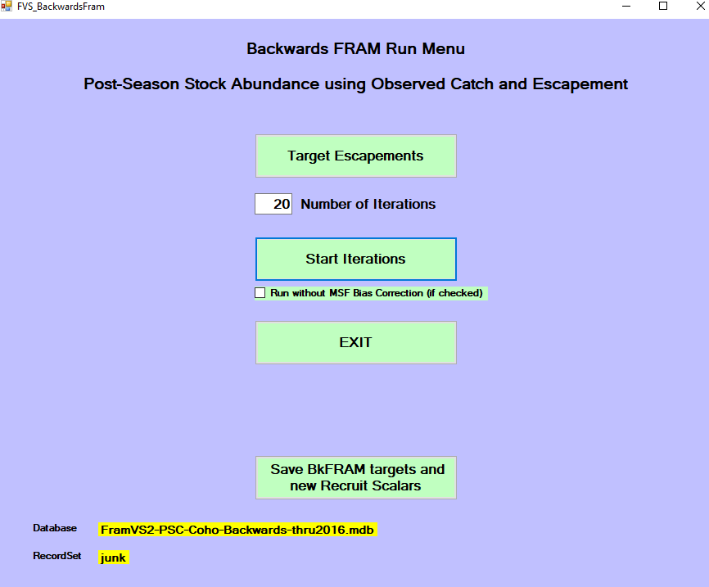

**Figure 2.** Coho Backwards FRAM Target Escapements Input Screen. 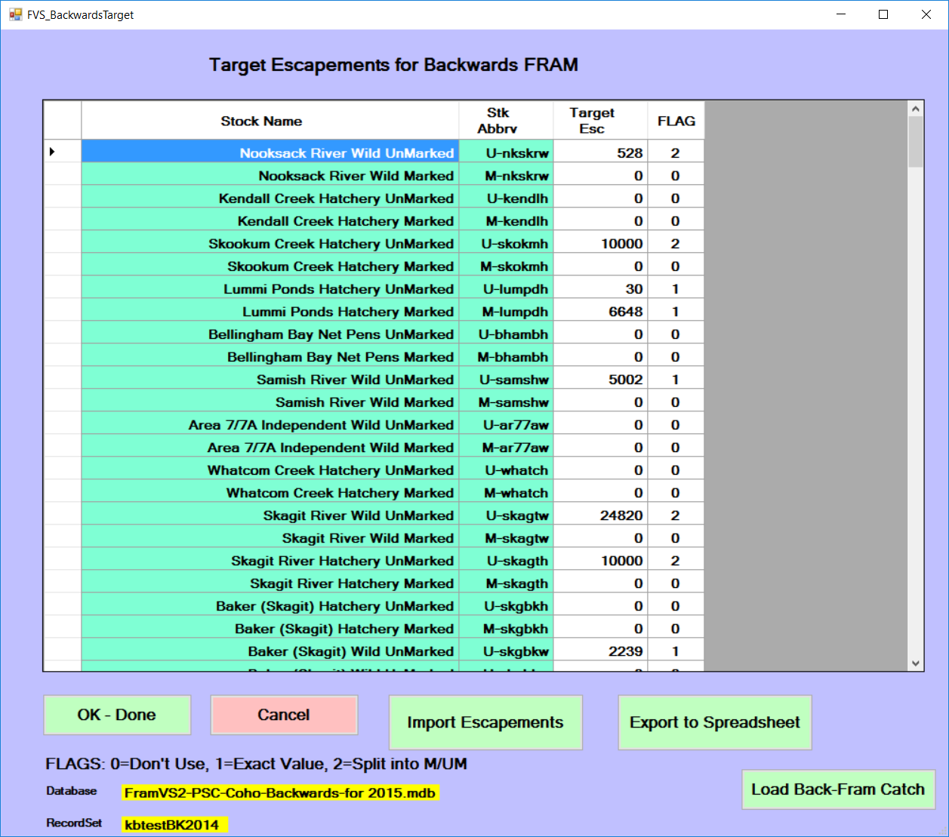

**Figure 3.** Coho Backwards FRAM Results Screen.

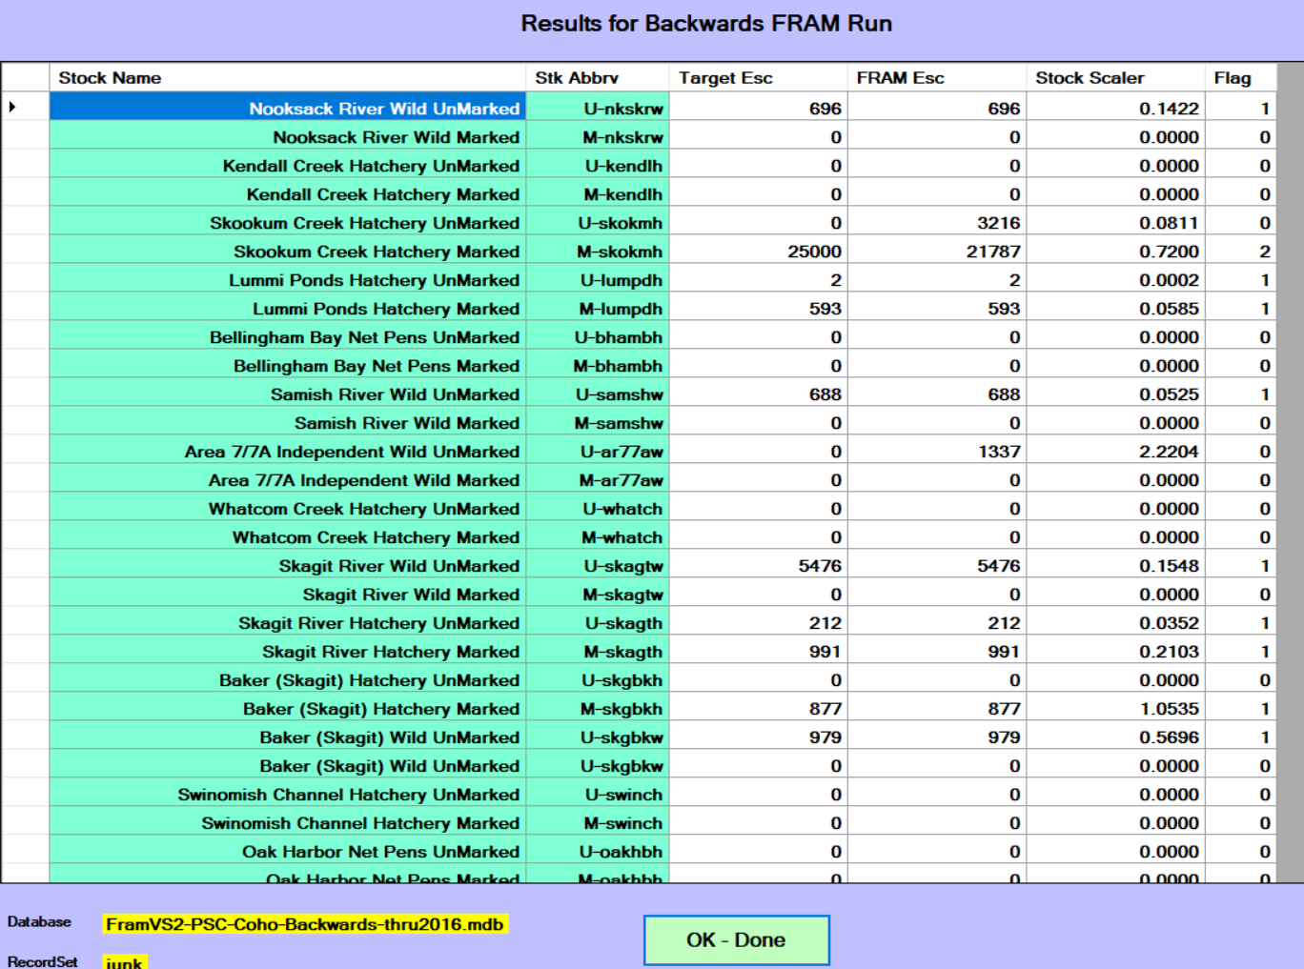**Figure 4.** Chinook Backwards FRAM Run Menu.

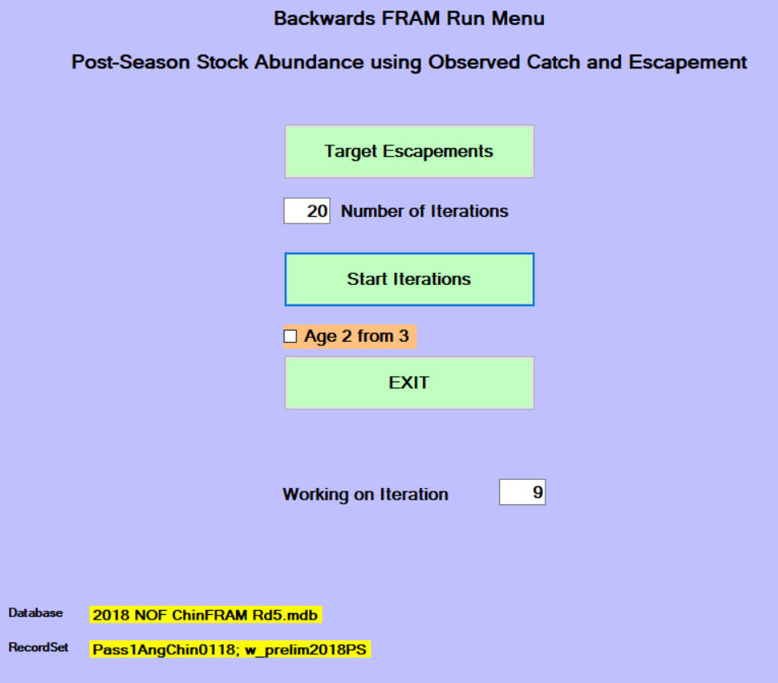

**Figure 5.** Chinook Backwards FRAM Target Escapements Input Screen.

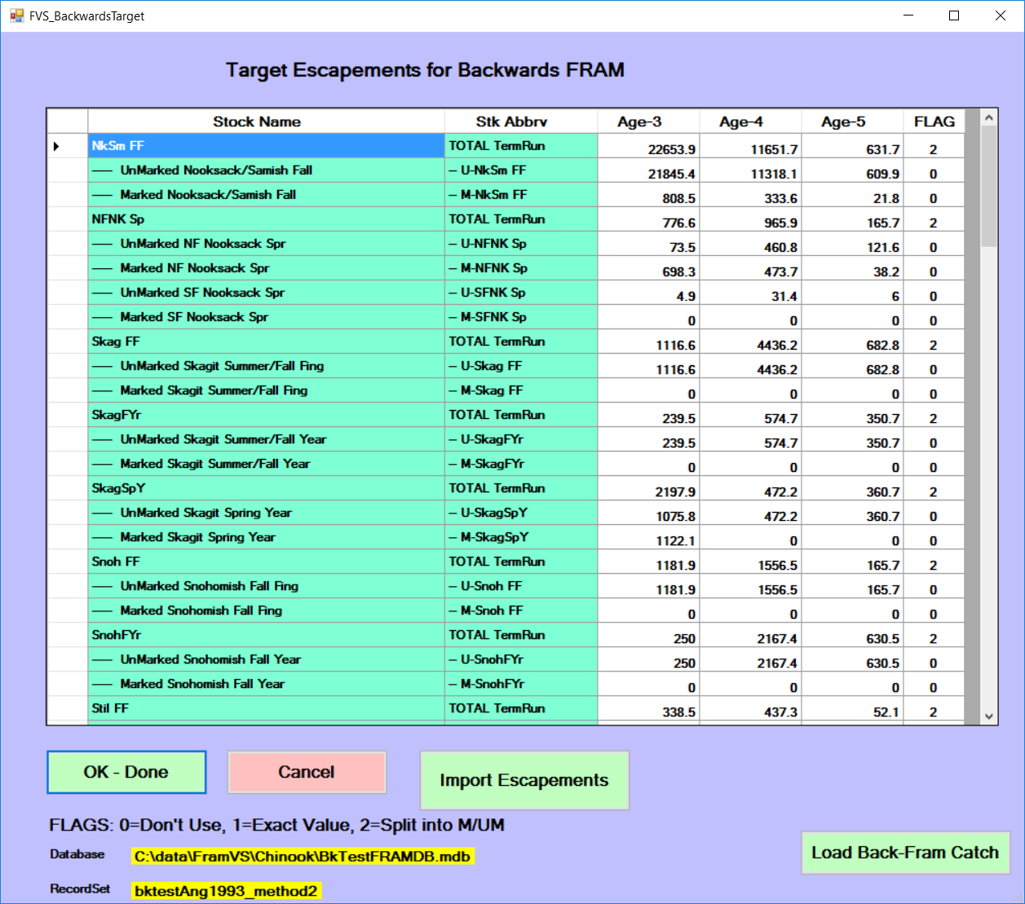

**Figure 6.** Chinook Backwards FRAM Results Screen.

