Manager Performance & Risk Report
Period: 2021-02-11 to 2026-02-10
Observations: 1,304
Risk-free rate: daily series loaded from data/risk_free_daily.csv (Sharpe/alpha computed on excess returns).

Executive Summary

Key takeaways
- Cumulative return: -32.03% | Annualized return: -7.19%
- Annualized vol: 9.27% | Sharpe (excess): -0.76
- Max drawdown: -37.04% (peak 2021-04-22 → trough 2024-08-07)
- Beta vs benchmark (latest 252d): 0.41 | Full-period beta: 0.42
- Worst month: 2021-06-30 (-6.52%) | Current drawdown: -20.29%

Monitoring Notes
- Current drawdown: -20.29%
- Latest rolling vol (63d): 9.54% (annualized)
- Latest rolling Sharpe (252d, excess): -0.59
- Latest rolling beta (252d): 0.41
Worst 5 days (daily returns):
- 2024-01-18: -2.16%
- 2025-10-07: -1.68%
- 2022-05-05: -1.66%
- 2023-09-05: -1.66%
- 2022-10-10: -1.61%

Monitoring Flags
- Drawdown breach: current drawdown -36.28% <= -20% threshold.
- Max drawdown breach: max drawdown -37.04% <= -20% threshold.
- Sharpe deterioration: 99% of last 126 days had rolling Sharpe < 0.00 (latest -0.59).

Performance & Risk Summary
Metric | Value
Annual return | -7.19%
Cumulative returns | -32.03%
Annual volatility | 9.27%
Sharpe ratio | -0.76
Calmar ratio | -0.19
Stability | 0.94
Max drawdown | -37.04%
Omega ratio | 0.88
Sortino ratio | -1.02
Skew | -0.06
Kurtosis | 0.29
Tail ratio | 0.89
Daily value at risk | -1.20%
Alpha | -5.70%
Beta | 0.42

Charts

Equity Curve
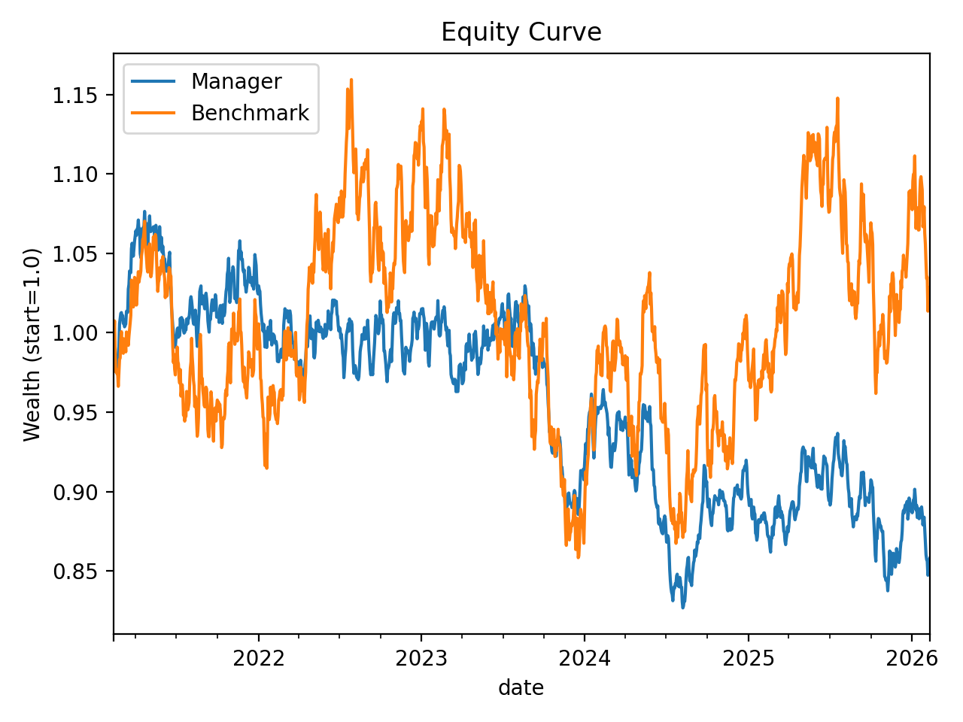
Wealth index (start=1.0) aligned to common trading days. Benchmark shown as provided in benchmark_prices.csv.

Drawdown
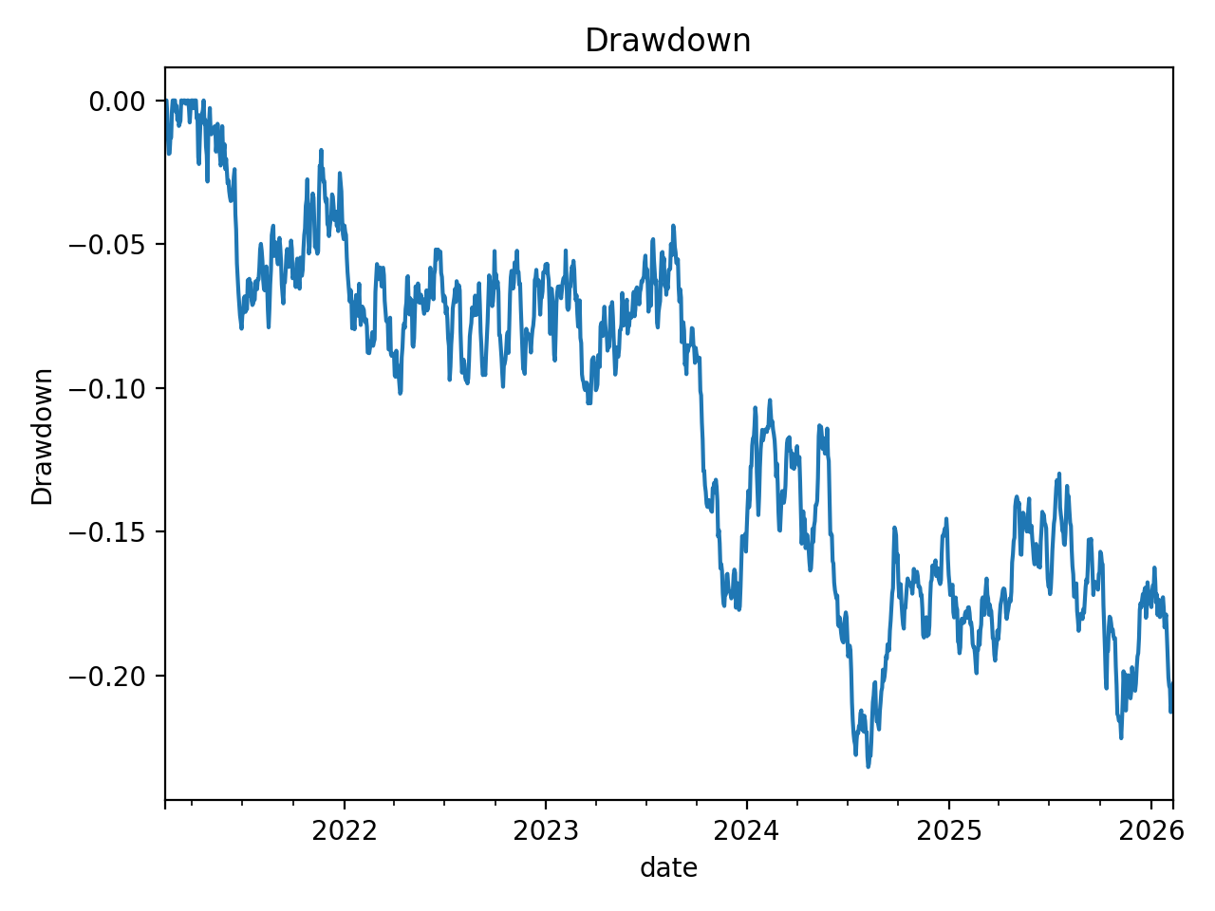

Rolling Volatility
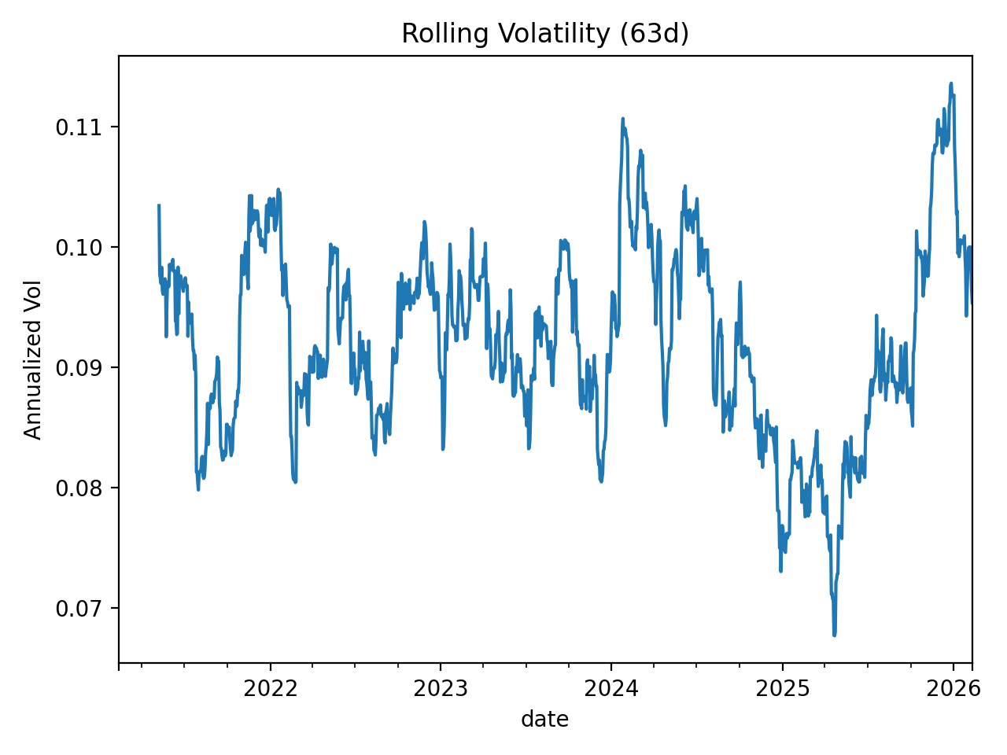

Rolling Sharpe
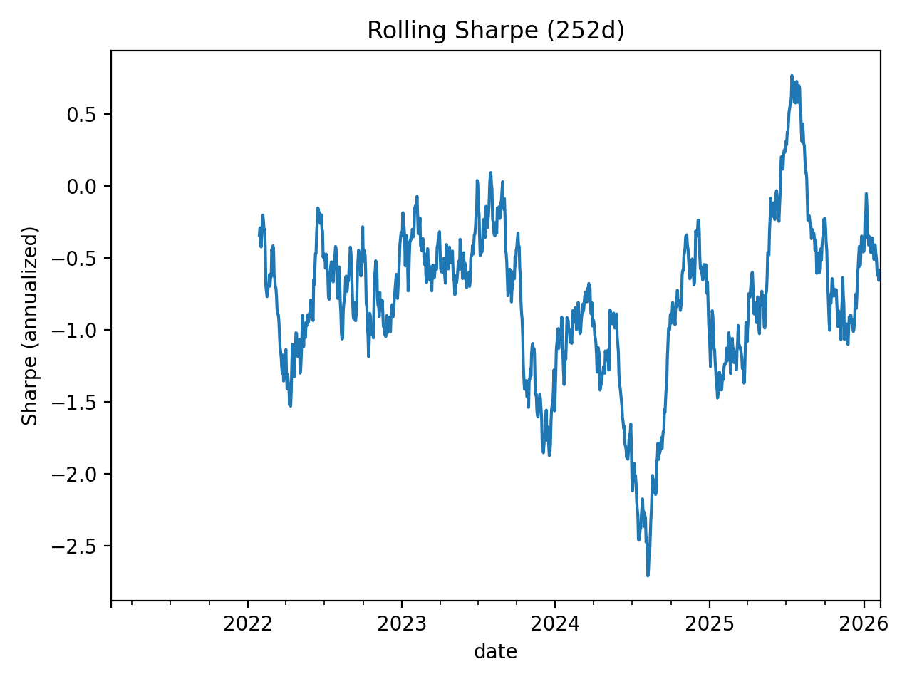

Rolling Beta
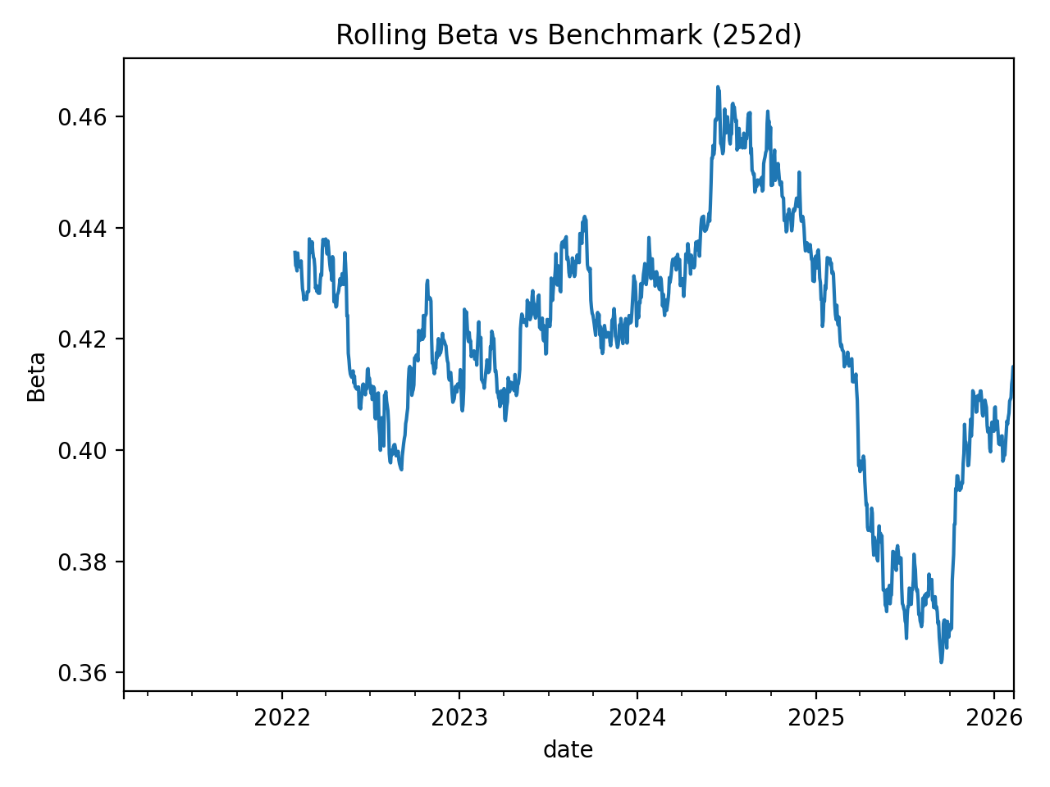

Return Distribution
