Performance Evaluation
AWS-EC2 Cloud Benchmark

This document contain the performance evaluation of CPU Benchmark, Disk Benchmark and Memory Benchmark on AWS EC-2 Cloud. My experiments cover all the original specification for all benchmarks of AWS-EC2 cloud. There are so many experiments done for all benchmarks and every experiments have done 3-times for calculating average and standard deviation of all figures.

First of all, I describe the Environment of AWS-EC2 Cloud which is shown in below figure. Then the specification of each benchmark is presented followed by experiment analysis and result in form of table and graph.

1. AWS-EC2 Environment

write this command on AWS-EC2 instance after launching. It gives you following output of all specification

[ec2-user@ip-172-31-49-170 ~]$ lscpu

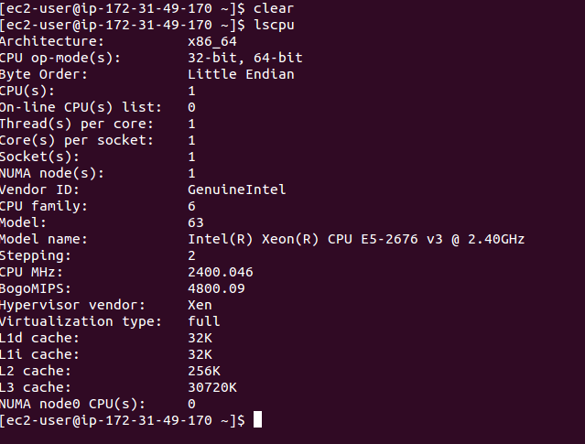

2. Benchmark Experiment and Result Analysis

I represent all experimental result analysis of three benchmark of CPU, Disk and Memory and explanations of each and every outcomes with comparison of theoretical performance.

2.1 CPU Benchmark

a. For CPU Benchmark, calculating results in terms of FLOPS(FLoating point Operations per
Second) and IOPS (Interger Operations per Second) and then find GFLOPS and GIOPS . (G
– Giga 10⁹).
b. Results of FLOPS and IOPS according to no. of threads(1, 2 and 4 threads) shown in figure Fig 1. below in form of graph.
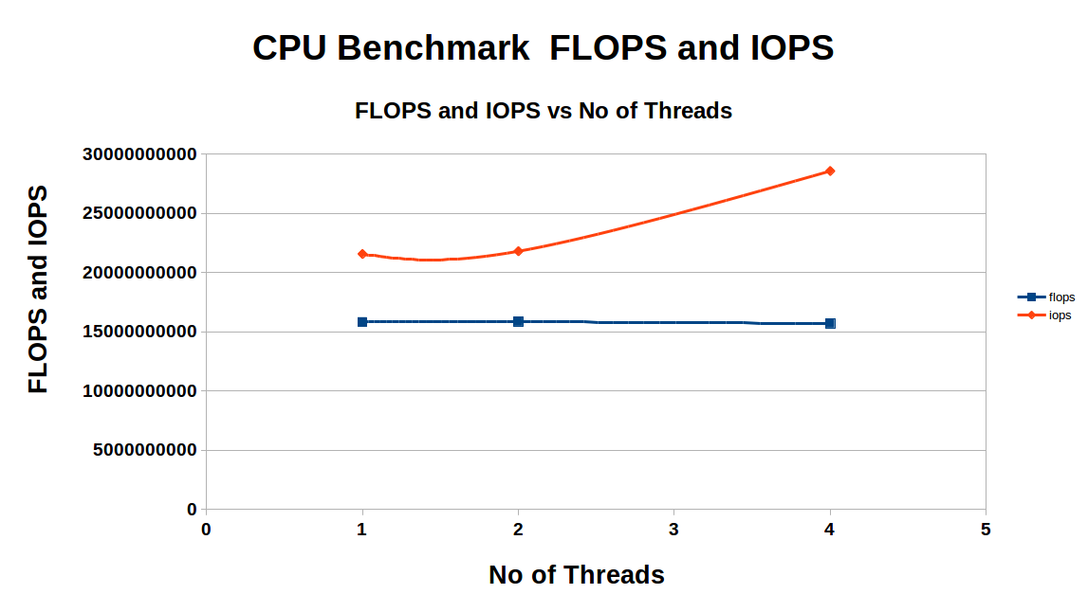
Fig 1.

c. According to practical result no. of optimal threads is “4” for best performance

No. of Threads | Average(GFLOPS) | SD(GFLOPS) | Average(GIOPS) | SD(GIOPS)
1 | 15.794472300 | 0.00934 | 21.573456800 | 0.17122
2 | 15.810272300 | 0.01747 | 21.642424300 | 0.11734
4 | 15.871454500 | 0.00794 | 28.533168500 | 0.12344

d. Practicle performance

FLOPS = 15810272300 and GFLOPS = 15.81
IOPS = 21563328500 and GIOPS = 21.63

e. Theoritical peak performance of AWS-EC2 cloud is given below:

performance = (CPU Speed in GHz) * (CPU IPC)* (no.of cores in CPU) * (number of CPU per node)

performance = 2.4*16*1*1 = 38.4 GFLOPS

f. Efficiency of CPU Speed (GFLOPS) (49.65 %)

Efficiency = (15.81)/(38.4)
= 49.65 %

g. I run this program for 10 min and took 600 samples of 1 second each. I took samples of FLOPS and
IOPS. It gives me a better idea of CPU performance while performing this much of exsperiments.

Given below graph gives better idea of FLOPS and IOPS
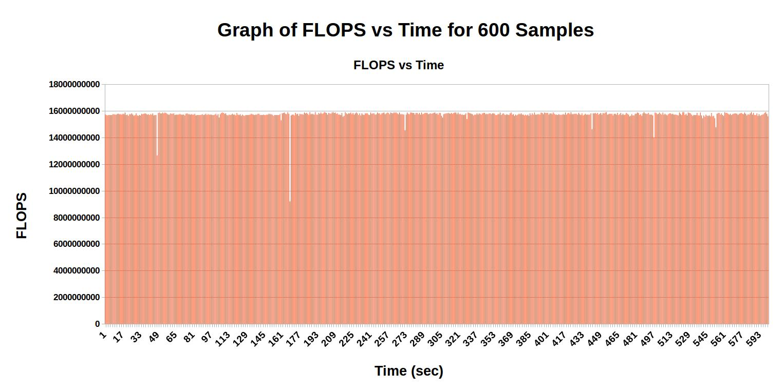
Fig 2.

h. 10 mins samples of IOPS and measured CPU Performance.
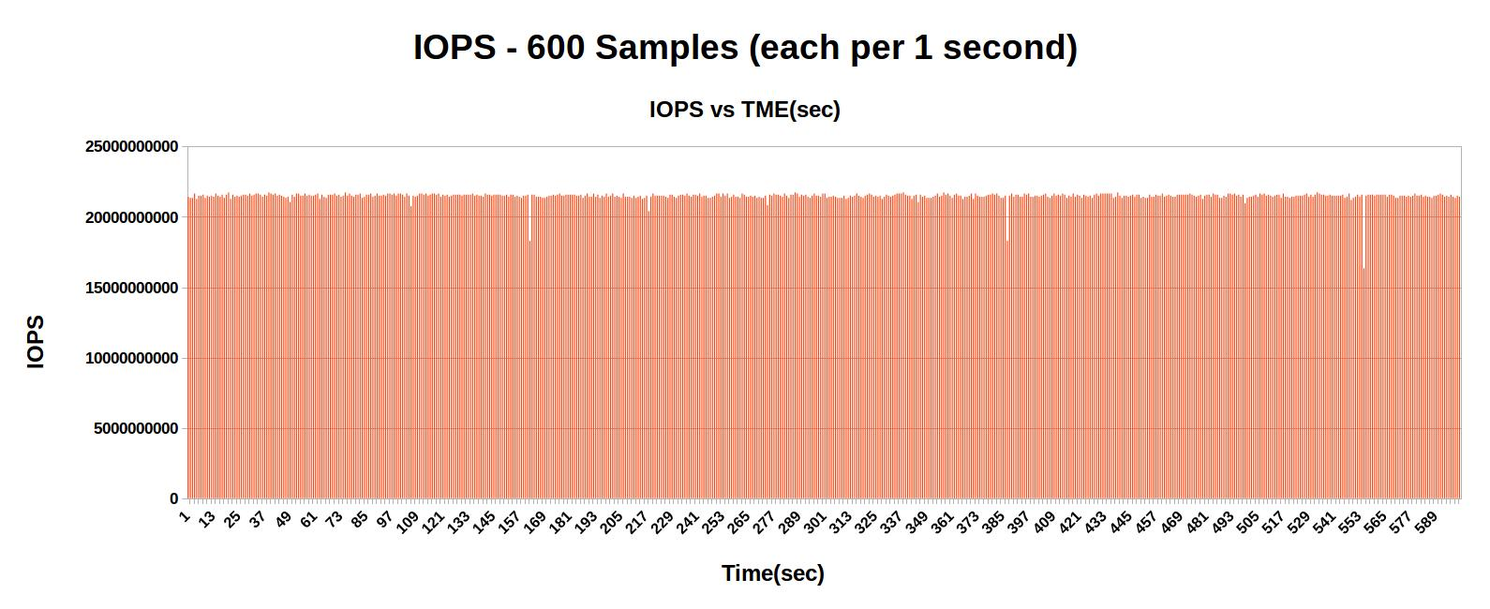
Fig.2

I. Practical Performance by running “linpack” on the AWS-EC2 Cloud. Below is the figure to see the performance of CPU benchmark.

Efficiency of linpack result to theoretical result = (33.69/38.4)
= 87.73%
Efficiency = 87.73%.

Figure is for “linpack” CPU Benchmark.
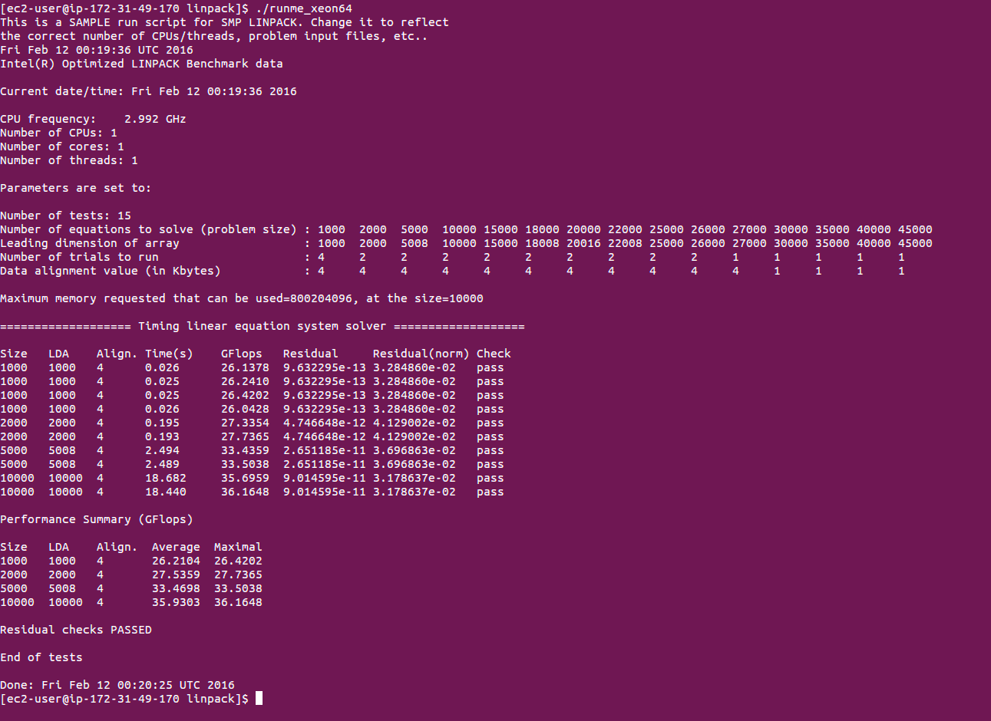
Fig 3.

Explanations

CPU performance in terms of GFLOPS and GIOPS is gradually increase initially when doing millions of operations. Then after it is stable. So in the graph is shows stable value for billions of operations. We need to do billions of operations for CPU performance for better and consistent result. It gives accurate answer for 100000000 iterations for 1s and I took 600 samples by 10 mins so that I got consistent result.

Issued Faced

While measuring the CPU benchmark first thing I m confused with the IPC of processor so that I could not evaluate the theoretical peak performance. While I was doing program than faced problem with some JAVA time related functions and how to calculate cpu time and wall clock time.

2.2 Disk Benchmark

a. AWS-EC2 Cloud had disk to measure a performance of it in terms of disk throughput(MB/s) and latency(ms). For Disk Benchmark I did Read and Write operation on file of 1B, 1KB, 1MB sequential and Random. Find result for multiple experiment like Sequential Read for 1B with 1- Thread, Random Write for 1KB with 2-thread and so on.

No of experiments = 2*2*3*2 = 24
(Read/Write) * (Sequential/Random) * (1B/1KB/1MB) * (1-thread/2-thread)

Disk performance in terms of throughput(MB/s) and latency (ms) calculated for all the experiments mentioned below in table.

Practical throughput = 3745.318 MB/s Practical Latency = 0.267 ms
Theoretical Disk performance = 6.00 GB/s = 6000 MB/s (SATA V-3)
efficiency = (3754.318/6000) *100 = 62.42 %

- Below graph is give the better idea about the comparison with the different experiments
- Sequential throughput always higher than Random throughput in both the case Read and Write.
- Write throughput is always less than the Read throughput and latency is reverse.
- Random access is costlier than Sequential access in terms of speed and accuracy.
- No of threads is increase than throughput is decrease in all cases because thread handling overhead.
- The lesser the latency, The Higher the performance.
- So, In terms of throughput(MB/s) and latency.
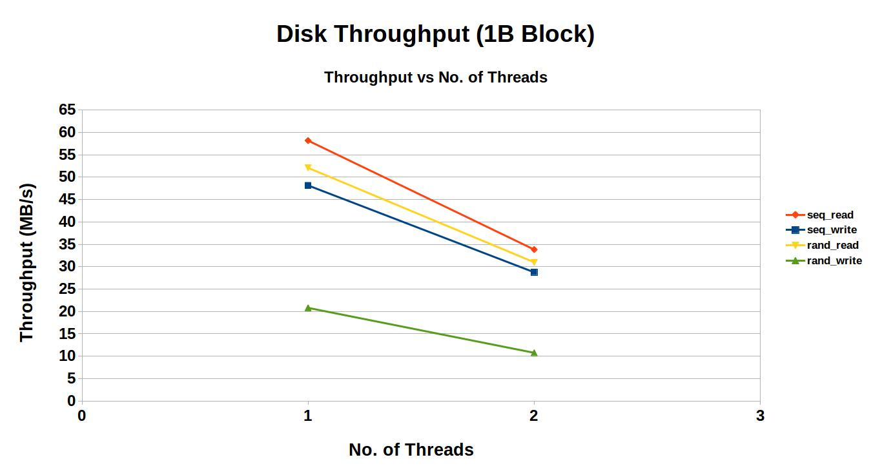
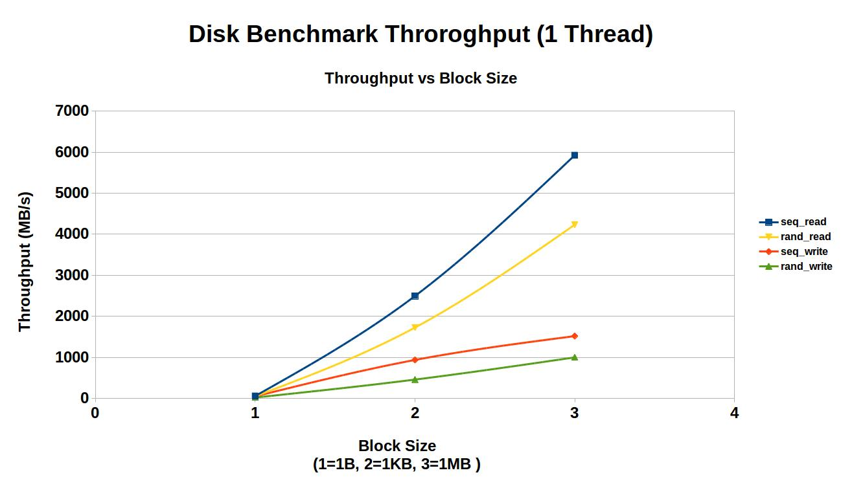
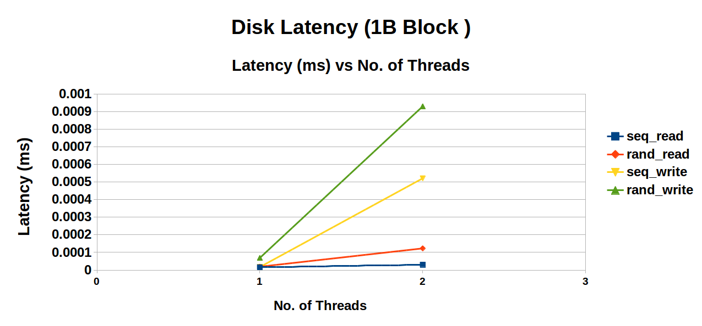
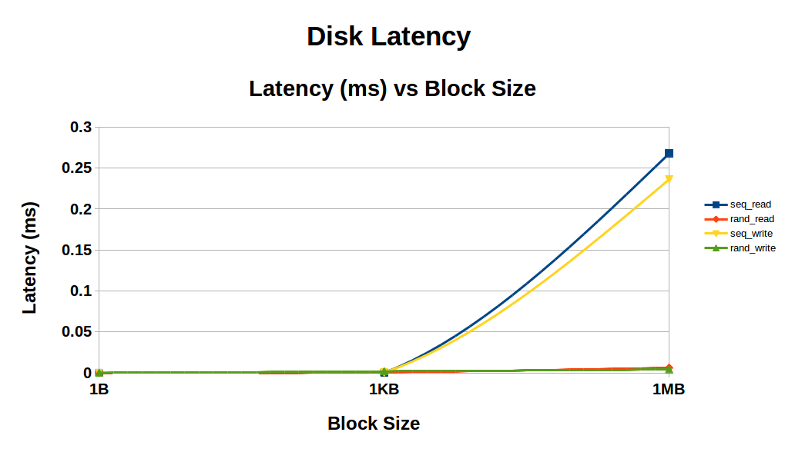

Sequential Read

Block Size | No. of Threads | Average(Throughput (MB/s)) | SD(Throughput (MB/s)) | Average (Latency (ms)) | SD(Latency(ms))
1B | 1 | 56.5849 | 1.01223 | 0.000016 | 0.000004
1B | 2 | 32.4231 | 0.96992 | 0.000030 | 0.000003
1KB | 1 | 2484.4534 | 1.09461 | 0.000183 | 0.000040
1KB | 2 | 2137.2445 | 0.94674 | 0.000190 | 0.000010
1MB | 1 | 5880.31311 | 0.95105 | 0.267799 | 0.003500
1MB | 2 | 5180.6477 | 1.0991 | 0.274545 | 0.002300

Random Read

Block Size | No. of Threads | Average(Throughput (MB/s)) | SD(Throughput (MB/s)) | Average (Latency (ms)) | SD(Latency(ms))
1B | 1 | 52.071 | 0.64532 | 0.000019 | 0.000005
1B | 2 | 30.9692 | 1.0403 | 0.000521 | 0.000032
1KB | 1 | 1725.0571 | 0.67554 | 0.000798 | 0.000052
1KB | 2 | 1566.4123 | 0.64284 | 0.000623 | 0.000076
1MB | 1 | 4231.9685 | 0.51678 | 0.063230 | 0.000504
1MB | 2 | 4023.3211 | 0.43572 | 0.167394 | 0.002034

Sequential Write

Block Size | No. of Threads | Average(Throughput (MB/s)) | SD(Throughput (MB/s)) | Average (Latency (ms)) | SD(Latency(ms))
1B | 1 | 49.0506 | 0.6180 | 0.000020 | 0.000008
1B | 2 | 30.8317 | 0.88293 | 0.000123 | 0.000042
1KB | 1 | 935.9977 | 0.9232 | 0.000566 | 0.000048
1KB | 2 | 690.2321 | 1.0022 | 0.000587 | 0.000072
1MB | 1 | 1224.2568 | 1.2133 | 0.063200 | 0.004030
1MB | 2 | 1023.3121 | 0.8992 | 0.083211 | 0.000342

Random Write

Block Size | No. of Threads | Average(Throughput (MB/s)) | SD(Throughput (MB/s)) | Average (Latency (ms)) | SD(Latency(ms))
1B | 1 | 20.7958 | 0.9012 | 0.000069 | 0.000008
1B | 2 | 10.7612 | 0.7812 | 0.000930 | 0.000078
1KB | 1 | 508.9865 | 0.8233 | 0.001919 | 0.000204
1KB | 2 | 412.3123 | 1.2110 | 0.001318 | 0.000123
1MB | 1 | 998.5963 | 0.91212 | 0.042300 | 0.003279
1MB | 2 | 732.1232 | 1.01311 | 0.303231 | 0.004321

Note

- Average and Standard Deviation of throughput and latency gives the better and accurate performance of disk.

- Average and Standard Deviation are calculated for each and every experiments thrice.

- For Disk Performance in every experiments File Size is 100 MB.

Practical Performance of Disk Speed on IOZONE Benchmark Tool:

- I used iozone3_434 for benchmarking of disk of AWS_EC2 Cloud.
- Comparison Between Iozone result and My program Practical result for 1MB block size.

Access Type | Iozone | My Practical Results
Sequential Read | 9485.232 | 5880.31311
Random Read | 10230.845 | 4231.9685
Sequential Write | 2192.645 | 1224.2568
Random Write | 4282.950 | 998.5963

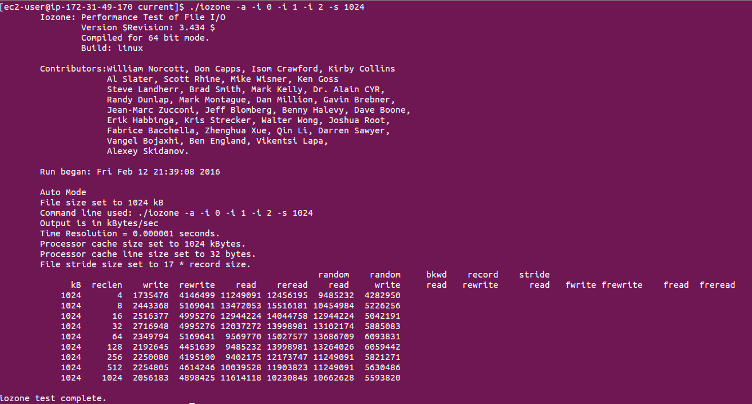
Fig : Iozone – 1MB multiple experiment

Theoritical Performance of Disk
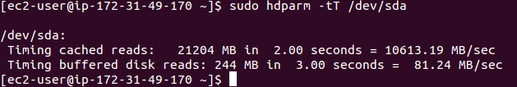
EFFICIENCY:

Efficiency of Iozone to Theoritical = (9485.232/10613.19) * 100
= 89.38 %

2.3 Memory Benchmark

- Memory benchmark is for Sequential and random Access for different data size of 1B/1KB/1MB.

- All different experiment is done thrice and took Average and Standard Deviation for better accuracy and consistency.

- Thread Effect on Memory Throughput

a.) As we increase the no of block size Sequential and Random throughput is increase
b) As we increase the no of threads then Sequential and random throughput is decrease because thread overhead.
c.) For all experiment Sequential throughput is always higher than Random Throughput.

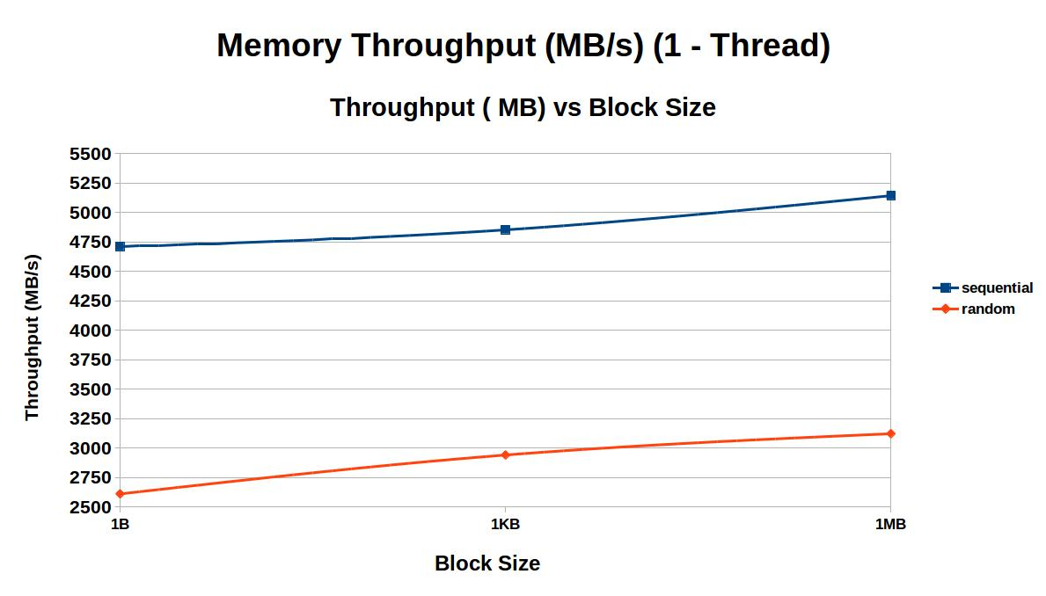

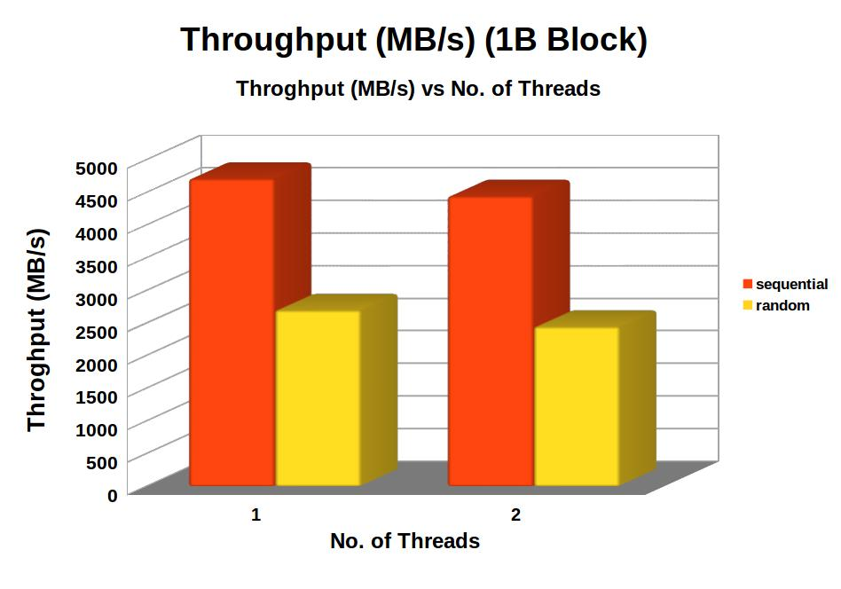

- Thread Effect on Memory Latency

a.) As we increase the no of block size Sequential and Random Latency is decrease

b) As we increase the no of threads then Sequential and Random latency is increase because thread overhead.

c.) For all experiment Random Latency is always higher than Sequential Latency.

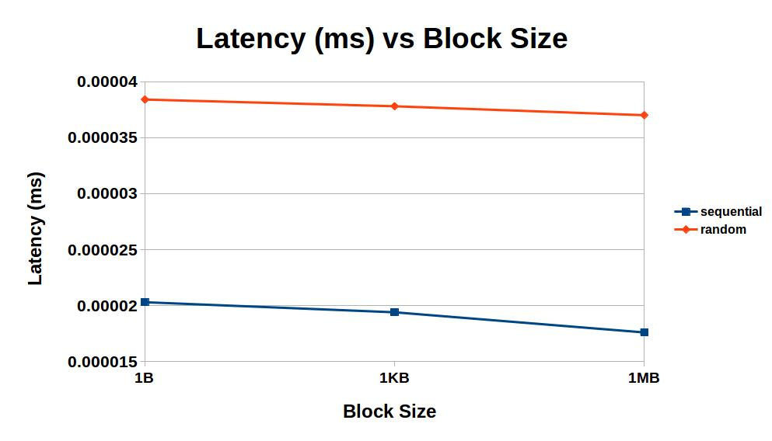

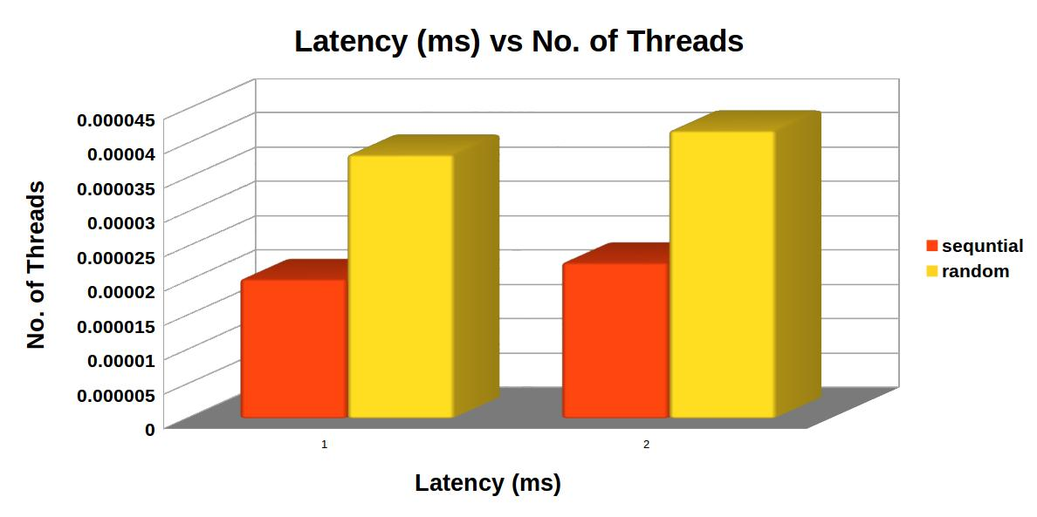

Calculation

- Theoretical Throughput = 10600 MB/s , Latency = 0.320 ms

- The Optimal no of threads is 1, 1B Block size.

- Practical Throughput = 4710.211 MB/s and Latency = 0.0000203 ms

- Efficiency = 44.45 %

Sequential Access

Block Size | No. of Threads | Average(Throughput (MB/s)) | SD(Throughput (MB/s)) | Average (Latency (ms)) | SD(Latency(ms))
1B | 1 | 4710.211 | 1.01223 | 0.0000203 | 0.000004
1B | 2 | 4444.312 | 0.96992 | 0.0000227 | 0.000003
1KB | 1 | 4853.131 | 1.09461 | 0.0000194 | 0.000040
1KB | 2 | 4564.502 | 0.94674 | 0.0000224 | 0.000010
1MB | 1 | 5143.322 | 0.95105 | 0.0000176 | 0.003500
1MB | 2 | 4670.34 | 1.0991 | 0.0000215 | 0.002300

Random Access

Block Size | No. of Threads | Average(Throughput (MB/s)) | SD(Throughput (MB/s)) | Average (Latency (ms)) | SD(Latency(ms))
1B | 1 | 2698.231 | 0.64532 | 0.0000384 | 0.000005
1B | 2 | 2444.98 | 1.0403 | 0.0000419 | 0.000032
1KB | 1 | 2745.131 | 0.67554 | 0.0000378 | 0.000052
1KB | 2 | 2493.05 | 0.64284 | 0.0000410 | 0.000076
1MB | 1 | 2796.321 | 0.51678 | 0.0000370 | 0.000504
1MB | 2 | 2570.56 | 0.43572 | 0.0000402 | 0.002034

STREAM Benchmark Result Analysis

- I run Stream Benchmark and result is given in the below screen shot.

- Theoretical Throughput = 10600 MB/s , Latency = 0.320 ms

- While practical Throughput = 6714.45 MB/sec and Latency = 0.03023 ms

- Efficiency for Throughput = 63.35 %

- Efficiency for Latency = 0.95 %
