The RCALIBFRAC Rotating Dipole — A Figure Companion
Status: supporting figures for distribution. Companion to MEASURED_VS_EXPECTED_FLUX.md (the variable-design note) and DAR_FIBER_LOSS_REPORT.md (the full DAR investigation, Parts IV–V, where the text, numbers, and caveats live). K. Honscheid (OSU) with Claude (Anthropic) · 2026-08-13.
What these figures show. RCALIBFRAC carries a rotating, zenith-tied dipole that looks like differential atmospheric refraction (DAR) but is a flux-processing bias injected at the subtract_sky step of the spectroscopic pipeline — and it is general to point-source spectrophotometry, not specific to RCALIBFRAC. This document is the pictures; the two companion reports carry the argument in full.
The decomposition used throughout. The per-fiber standard-star loss map is rotated into a common zenith-aligned (derotated) frame and fit to a radial monopole + a rotating dipole (D_rot) + a rotating quadrupole (Q_rot). Q_rot is the real DAR (it matches the independent Weiner and Kirkby estimates); D_rot is the artifact these figures are about.

1. The pattern — a zenith-tied dipole on top of the DAR quadrupole
The loss, stacked in the zenith-aligned frame, is systematically lower toward the zenith and higher away from it: a coherent dipole, sitting on top of the real field-differential quadrupole. This is the feature the investigation set out to explain.
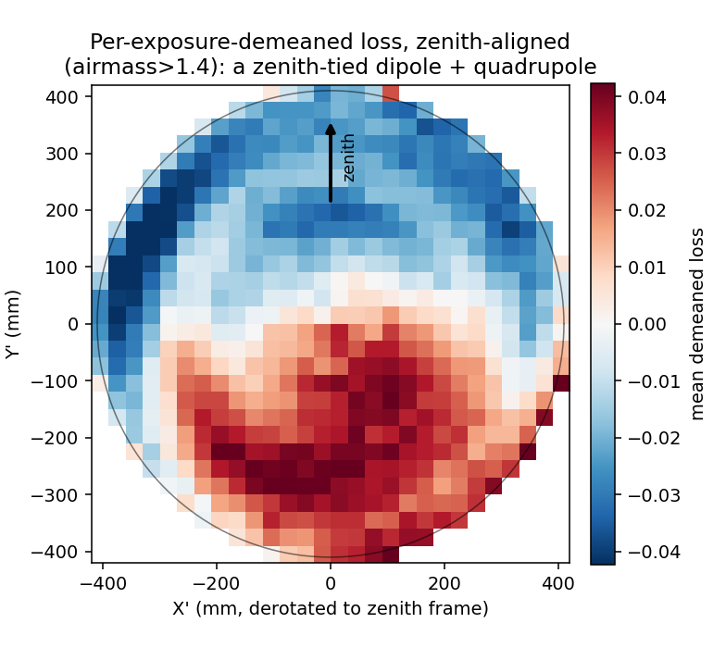
Per-exposure-demeaned standard-star loss in the derotated, zenith-aligned focal plane (airmass > 1.4). Loss is systematically lower toward the zenith and higher away from it — a coherent, zenith-tied dipole — on top of the field-differential quadrupole.

2. It is real, grows with airmass — and has no counterpart in the DAR studies
Both multipoles grow with airmass, but the dipole is consistently ~2× the quadrupole. The quadrupole matches the independent DAR estimates (Weiner, Kirkby) to 10–20%; the dipole, at twice that amplitude, matches nothing — the anomaly that drove the investigation.
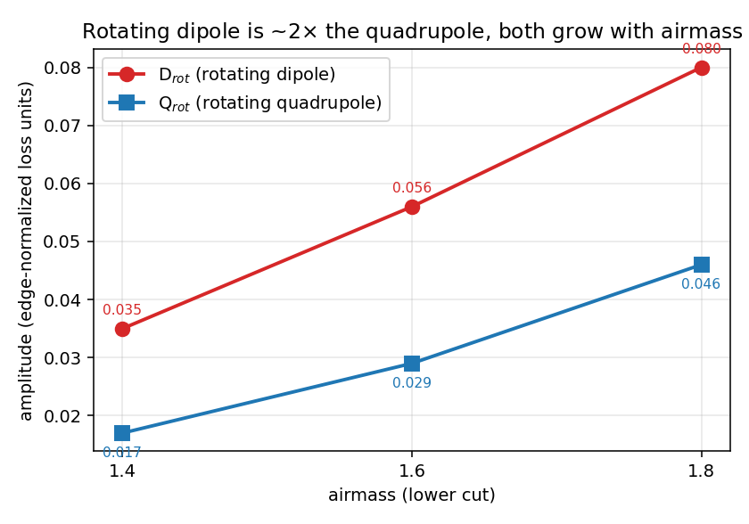
The rotating dipole (D_rot) and quadrupole (Q_rot) vs airmass. Both grow, and the dipole is consistently ~2x the quadrupole — the feature with no counterpart in the model/telemetry DAR studies.

3. It is not a geometric fiber-to-light offset — the dither test
DESI’s dither sequences measure the actual fiber-to-light offset field by a completely different technique (a geometric centroid fit, not a flux ratio). That real geometry shows no rotating dipole — while its quadrupole grows and tracks Q_rot on the same data (a built-in positive control). So there is no coherent geometric offset; the loss dipole is not a real pointing/DAR effect.
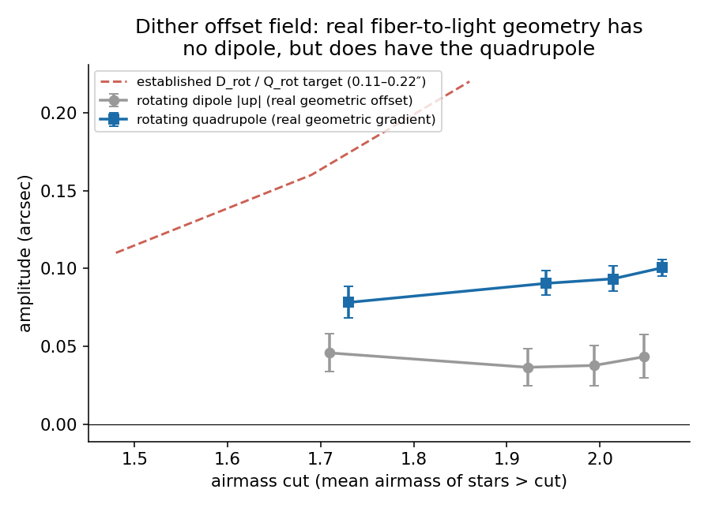
The real, independently-measured fiber-to-light offset field (dither) shows no rotating dipole (flat at ~0.04 arcsec, well below the target band) while its rotating quadrupole grows with airmass and tracks Q_rot. Same stars, same exposures, same measurement — the quadrupole resolves cleanly, and there is no dipole to resolve.

4. It is injected at the sky-subtraction step
Snapshotting the standard-star flux at each construction stage and refitting the dipole: it is small and airmass-flat through fiberflat, then jumps ~2× specifically at sky subtraction — where its airmass growth also switches on — and is unchanged by the aperture correction after. This localizes the effect to subtract_sky.
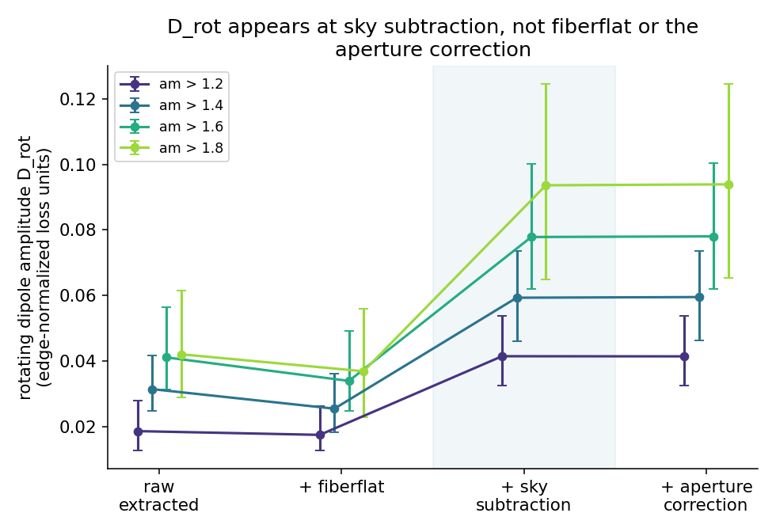
D_rot fit to the standard-star flux at each construction stage (raw -> +fiberflat -> +sky subtraction -> +aperture correction). The rotating dipole is small and airmass-flat through fiberflat, then jumps ~2x specifically at sky subtraction — where its airmass growth switches on — and is unchanged by the aperture correction after.

5. Its character (I) — it grows with star brightness
D_rot increases with standard-star brightness — the opposite of the ∝1/flux scaling a simple additive sky-background residual would produce, ruling that naive mechanism out.
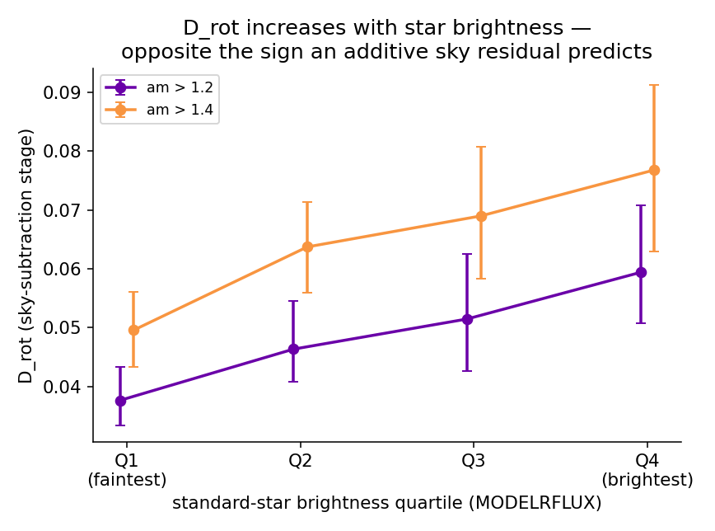
D_rot fit in quartiles of standard-star brightness. It increases with star brightness — the opposite of the 1/flux scaling a simple additive sky-background residual would predict — ruling that mechanism out.

6. Its character (II) — it needs a real sky to act on
D_rot scales strongly with the pipeline’s per-exposure sky brightness: dark sky gives a dipole consistent with zero; bright sky gives one at or above full amplitude. The effect requires a real sky background — and it is why the dipole vanishes at dark sky while the real DAR quadrupole does not.
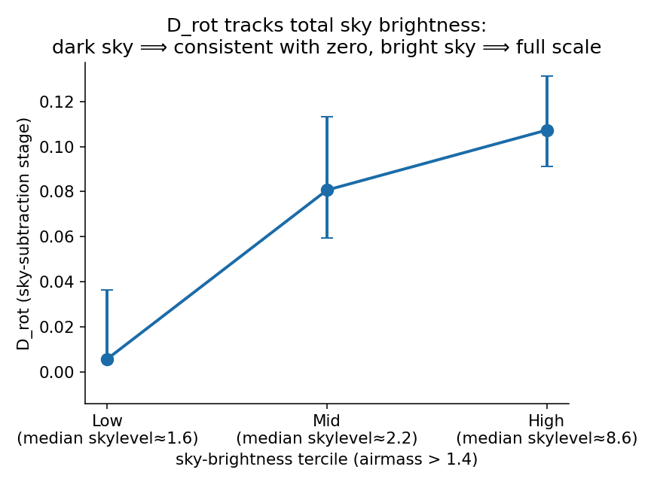
D_rot fit in terciles of the pipeline’s per-exposure sky brightness. Dark sky gives a dipole consistent with zero; bright sky gives one at or above the full amplitude — the mechanism needs a real sky background to act on.

7. It is general to point-source spectrophotometry, not just RCALIBFRAC
The strongest generality check uses spectrograph counts/s vs external Legacy photometry, over all point sources — a metric that shares nothing with RCALIBFRAC except the sky-subtracted flux (no stellar model, no flux calibration, no standard-star selection; ~470k stars). The same dipole (and quadrupole) survive and grow with airmass. So the bias is in the sky-subtracted counts themselves, inherited by any counts-based metric — there is no clean counts-based DAR metric until the coupling is understood.
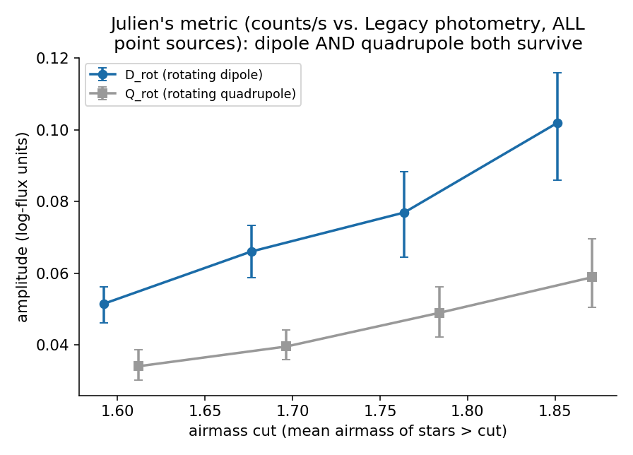
Spectrograph counts/s vs Legacy photometry, all point sources. Both the dipole and the quadrupole survive and grow with airmass, on a metric that shares nothing with RCALIBFRAC except the sky-subtracted flux (no stellar model, no flux calibration, no standard-star selection). The coherent signals are robust (tight bootstrap CIs off ~470k stars).

8. The artifact-free alternative — the geometric L_field / L_see
Because the bias is in the flux, the clean route is geometric: metrics built from guide-camera (GFA) imaging, which never touch sky-subtracted flux. Side by side, the derotated RCALIBFRAC map shows the rotating dipole, while L_field (the GFA field-distortion metric) shows a clean quadrupole with no dipole — D_rot = 0 by construction. (L_see is the companion whole-array level metric; see FIBER_LOSS_METRICS.md.)
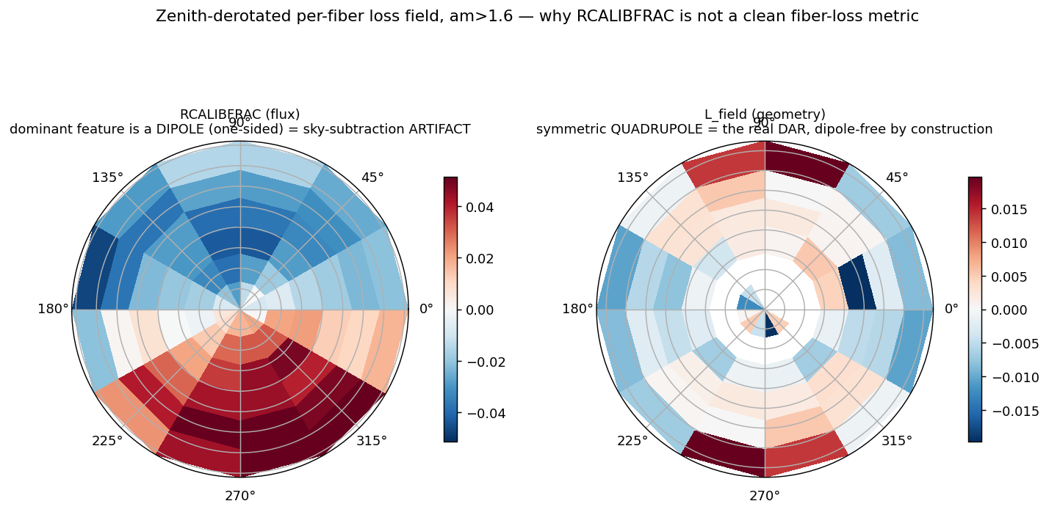
Left: the derotated, stacked per-fiber loss map from RCALIBFRAC — a clear rotating dipole (plus quadrupole). Right: the same decomposition of L_field, the GFA-based field-distortion metric — a clean quadrupole with no rotating dipole (D_rot = 0 by construction). The artifact and its artifact-free replacement, side by side.

Bottom line
- RCALIBFRAC’s rotating dipole is a sky-subtraction artifact, not DAR: it is not geometric (dither), it is injected at subtract_sky, it needs a real sky and the star’s own flux, and it reproduces on all point sources with external photometry.
- No flux-ratio variable escapes it — it is upstream of the ratio, the normalization, and the aperture correction (and RATIO_RAW would inherit it too, for spatial use).
- For DAR / spatial loss, use the geometric GFA metrics — L_field (field-distortion) and L_see (level), which are dipole-free by construction.
- The real DAR quadrupole is unaffected (~11 μm at high airmass, dark-sky, matching Weiner/Kirkby).
- The exact algorithmic step inside subtract_sky is not yet pinned — that piece is handed to desispec.

