Differential Atmospheric Refraction and Fiber Flux Loss at High Airmass

Detection, Mechanism, and Observing-Strategy Implications
K. Honscheid (OSU) with Claude (Anthropic) · consolidated 2026-07-23
Consolidated report combining the DAR fiber-loss investigation (started 2026-07-20/21, NERSC access-window constrained) with the pointing/timing follow-up performed off-site during the NERSC outage. From the pooled calibstars standard-star dataset plus a per-exposure pointing/timing table joined from the KPNO exposure database. Figures reproduce from notebooks/dar_fiber_loss_reproduction.ipynb and notebooks/dar_pointing_tests.ipynb. Companion to FIELD_ROTATION_REPORT.md. The earlier standalone drafts are archived under archive/.

Executive summary — two findings
Much of the remaining DESI schedule targets southern fields (Dec −10° to −30°) at sustained high airmass. Investigating what limits standard-star fiber flux there turned up two distinct results:
Finding 1 — a flux-loss calibration shift turned on around mid-2025, and nobody had flagged it. Standard-star loss (loss = 1 − RCALIBFRAC) stepped up around mid-2025 across all airmass — including low airmass, where DAR is negligible — so it reflects a change in the flux-loss calibration / measurement itself, not in positioning or the atmosphere. A three-epoch split shows it is not the March-2026 PlateMaker change (loss is unchanged across that date at every airmass). We flag the shift to the Data Systems team and do not diagnose its origin here — it need not be an offline-pipeline change; a genuine instrument or software effect would look the same. This was detected in the course of the DAR work; it had not been noticed before.
Finding 2 — the steep growth of loss with airmass is residual DAR acting during the exposure. DESI has a working, airmass-driven ADC that removes the bulk atmospheric dispersion; what remains is a residual DAR effect that accumulates over the exposure and grows with airmass. Using new per-exposure pointing we show the residual loss forms a focal-plane dipole that rotates with the parallactic angle — a direct geometric confirmation of DAR — driven near the meridian by the rotation of the refraction offset (not the change in its magnitude). It scales with the rotation drift tan z·dq/dt·T, is largely irreducible by positioning, and is invisible to the short dither sequences used to validate positioning. It sets a physical limit on high-airmass fiber throughput with concrete observing-strategy consequences — most importantly that proximity to transit, not Dec or airmass alone, is the dominant lever, and that the ADC’s hard ZD = 60° (airmass 2.0) limit means Dec ≤ −28° fields run their entire observation in an under-corrected regime.
The two findings are independent: Finding 1 is why the loss level moved (a calibration question we hand off); Finding 2 is why loss climbs with airmass in every epoch (a physics result with scheduling implications). The report is organized as Part I — the detection, Part II — the DAR mechanism, Part III — observing-strategy implications, with the detailed investigation history in the appendices.
Data. The pooled calibstars dataset: one row per VALID standard-star measurement across every DESI DARK/BRIGHT/DARK1B/BRIGHT1B science exposure (corrected complete population n = 15,206 exposures, 1,614,728 star-measurements; the earlier population was n = 12,043 / 1.27 M — see Appendix A), with focal-plane X/Y, RCALIBFRAC, loss, airmass, seeing, night. Joined to a per-exposure pointing/timing table from the exposure database (RA/Dec, hour angle, parallactic angle, zenith distance, exposure time, ADC prism angles, hexapod rotator rate), validated internally to sub-degree. Convention throughout: red = flux loss, blue = excess; focal plane +Y = North, fixed to the sky by the equatorial mount.

Part I — The detection: a mid-2025 flux-loss calibration shift

1. When did the loss change?
The question that started the pointing follow-up was a two-epoch before/after split at the PlateMaker date, which showed higher “after” loss. Before reading anything physical into that, we asked simply when the loss changed. Mean loss vs time, split by airmass:
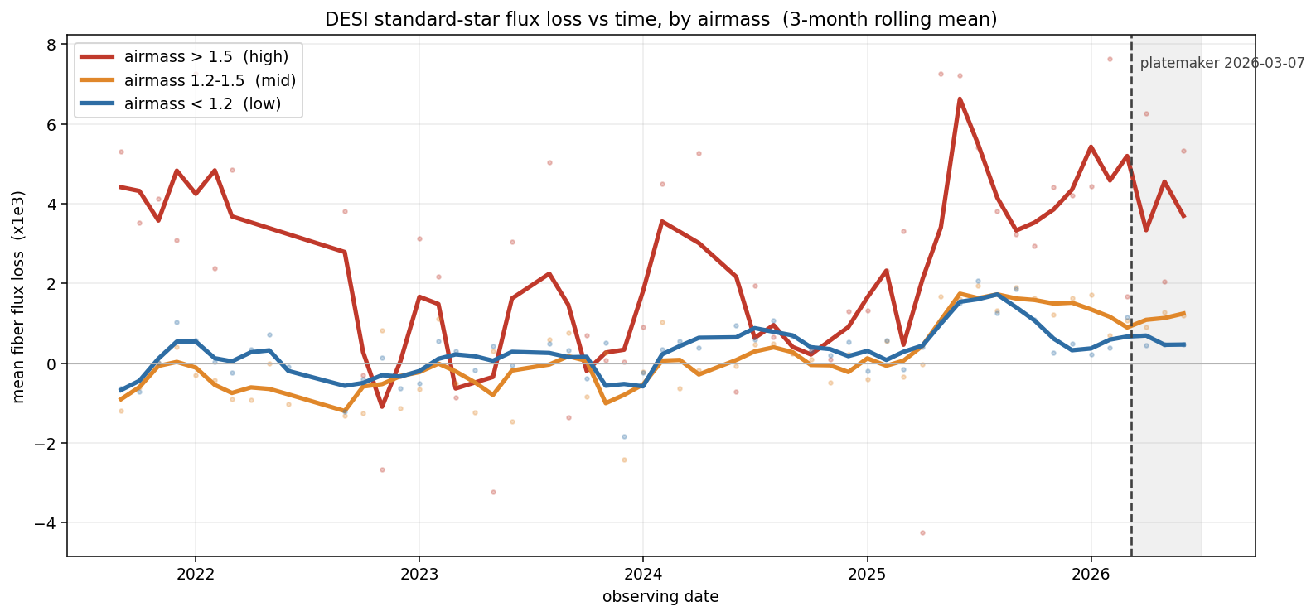
Standard-star flux loss vs time, by airmass
Three things read off it directly:
- The rise is airmass-graded — high (>1.5) ≫ mid (1.2–1.5) > low (<1.2) — not confined to one bin.
- Even low airmass lifts off its flat pre-2025 baseline. A pure DAR / observing effect would leave the low-airmass curve flat; instead it rises too, so there is a genuine systematic component underneath, present where DAR is negligible.
- There is no step at the PlateMaker line (dashed, 2026-03-07). The climb is well underway before that date.
To sharpen it, split into three epochs and compare mean loss vs airmass directly. Epoch A is before 2025-03 (the flat baseline); B runs 2025-03 to the 2026-03-07 PlateMaker change; C is after (July 2026 excluded — that month’s on-sky time was weather-limited and non-representative).
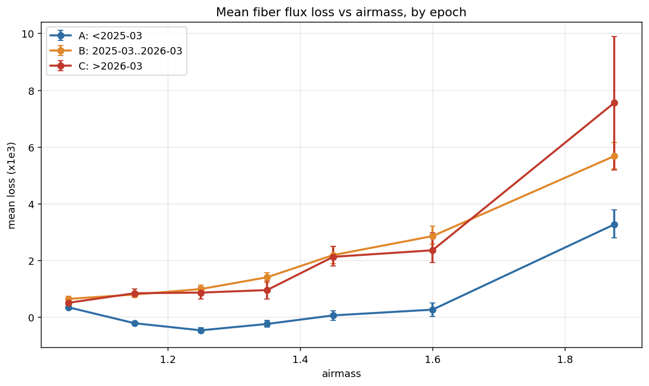
Mean loss vs airmass for the three epochs
airmass | A (<2025-03) | B (2025-03→2026-03) | C (>2026-03)
1.0–1.2 (low, DAR-free → isolates the systematic) | 0.12 [0.08, 0.15] | 0.70 [0.64, 0.76] | 0.67 [0.57, 0.76]
1.5–2.05 (high, where a PlateMaker effect would live) | 0.97 [0.74, 1.16] | 4.11 [3.83, 4.39] | 3.89 [3.12, 4.59]
(mean loss ×10⁻³, with bootstrap-over-exposures 16–84% intervals.)

2. It is calibration-level — not the PlateMaker, not purely DAR
- A → B is a large, significant jump at both airmasses (low 0.12 → 0.70, ~6×; high 0.97 → 4.11, ~4×; the intervals are nowhere near overlapping). This is the mid-2025 systematic.
- B → C is null. Low airmass 0.70 vs 0.67, high airmass 4.11 vs 3.89 — statistically identical, intervals fully overlapping. In the figure, the B and C curves lie essentially on top of each other across the whole airmass range. The PlateMaker change added nothing at any airmass.
- The low-airmass jump is the key. Where DAR is negligible, positioning and atmosphere cannot produce a loss; yet the loss still rose A → B. That isolates a calibration- / measurement-level change — something in how RCALIBFRAC is produced changed around mid-2025.
What we conclude, and what we deliberately do not. Something in the flux-loss calibration changed around mid-2025. We flag this to the Data Systems team and do not attempt to diagnose its origin: it need not be a change in the offline pipeline — a genuine instrument or software effect would produce the same signature. What the three-epoch split does establish is negative and positive at once: the increase is not the PlateMaker (B ≈ C), and is not purely DAR (it appears even at low airmass). The original before/after “excess” was an artifact of a two-epoch split straddling this mid-2025 transition — the “before” bin blended the flat A period with the risen B period, so “after” (= C) looked elevated relative to that blend. Split at the actual transition and the PlateMaker step vanishes. (The March-2026 change did add a second-order refraction term to positioning; it is dither-validated to improve instantaneous accuracy and is discussed only where relevant in Part III.)
That settles when and whether-the-code. The rest of the report addresses the second, independent question — why the loss grows with airmass in every epoch — which is residual DAR.

Part II — The mechanism: residual DAR during the exposure

3. The setup: DESI’s ADC removes the bulk, so we are measuring the residual
Before interpreting any high-airmass loss as “DAR,” note that DESI actively corrects DAR. The exposure record carries adc_angle1/adc_angle2 (deg) and adc_status1/adc_status2 for the two-element atmospheric dispersion corrector, and the data show it is real, active, and airmass-driven (n = 12,043 sample):
- Prism separation angle |adc_angle1 − adc_angle2| (circular-wrapped) correlates with airmass at ρ = 0.996 — rising smoothly from ~12.5° near zenith to ~116° at the highest airmasses. This is the textbook signature of a counter-rotating dual-prism ADC: separation sets the amount of achromatic dispersion correction, which must grow with airmass.
- The prisms are STOPPED (fixed) for the whole exposure — both adc_status = STOPPED for 100% of exposures, and there is no adc_rate field anywhere in the schema (unlike the corrector rotator, which is continuously driven via hexapod['rot_rate']). The ADC is set once and held.
Two consequences frame everything below. (i) Because the ADC is fixed with no tracking, once set it cannot adapt to airmass continuing to change during the exposure — giving a specific physical mechanism for the intra-exposure, time-accumulating residual we characterize. (ii) The bulk, achromatic, zenith-aligned DAR shift is already removed, so the residual we see is smaller and need not reproduce the naive “uncorrected DAR” shape — an important caution for reading the spatial patterns in §6.
Caveat: the working assumption “ADC angle is set near exposure start and held fixed” is a strong circumstantial case (100% STOPPED, no rate field, tight airmass correlation) but not independently validated for when the angle is set, the way the airmass snapshot was (Appendix A). Treat it as the leading hypothesis.

4. The residual loss pattern is DAR
Binned by airmass, the focal-plane loss shows a coherent North–South dipole — blue North, red South — strengthening steeply with airmass (before top, after bottom):
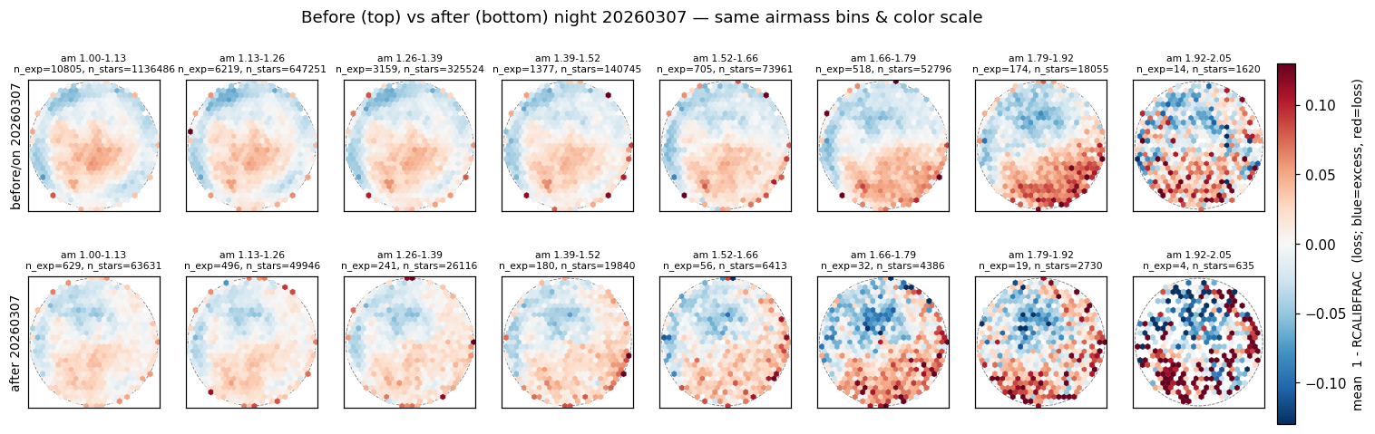
Focal-plane loss by airmass bin
(a) It matches the equatorial-mount prediction. Because the focal plane is fixed to the sky, DAR lies along the parallactic angle in a fixed focal-plane frame. The geometry predicts a dipole (a tilt across the field) with amplitude scaling as tan z·sec²z along the N–S axis (southern fields have their zenith toward +Y near transit). Fitting the loss tilt per airmass bin confirms both:
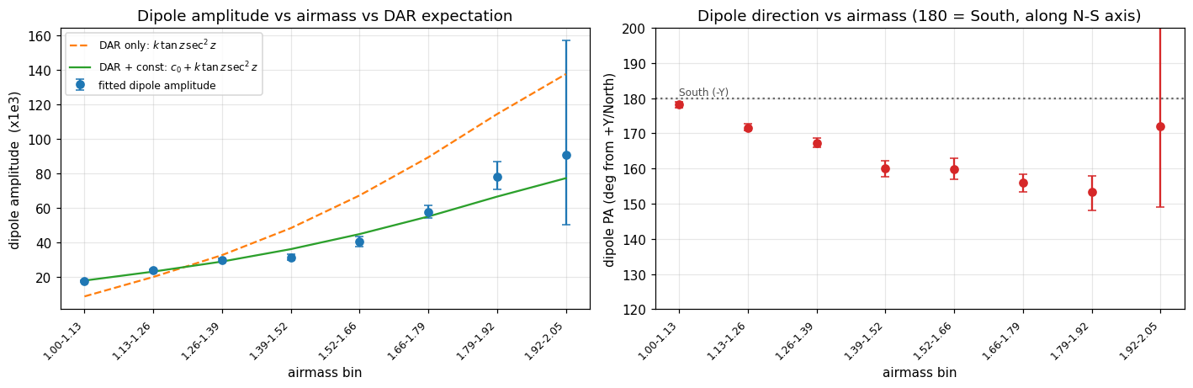
DAR dipole: direction along N-S, amplitude following tan z sec^2 z
A smooth dipole+quadrupole template captures most of the spatial structure, leaving the discrete per-petal calibration pattern as the residual:
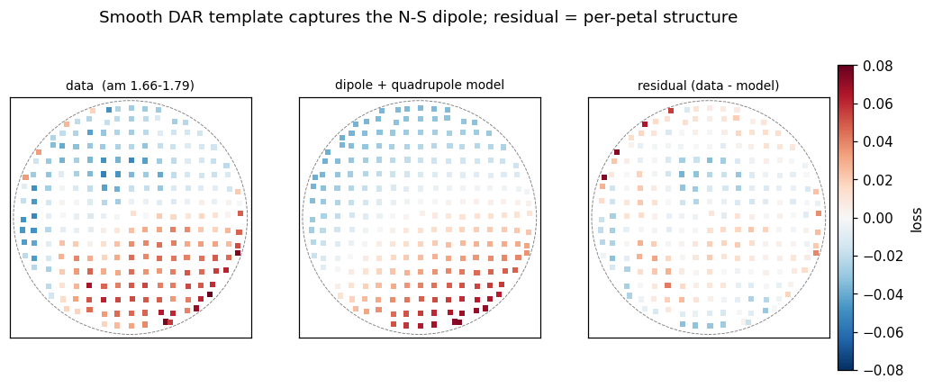
Data / DAR template / residual for one airmass bin
(b) The dipole rotates with the parallactic angle — the decisive test, enabled by the new pointing data. The loss is a tilt across the focal plane, a gradient vector g = (g_x, g_y) (with the per-exposure mean removed, a tilt reads as one side red, the opposite blue — the two-lobe look). If it is DAR its direction must track the parallactic angle q; an instrumental tilt would stay fixed. Binning exposures by q, the dipole’s focal-plane direction rotates with q:
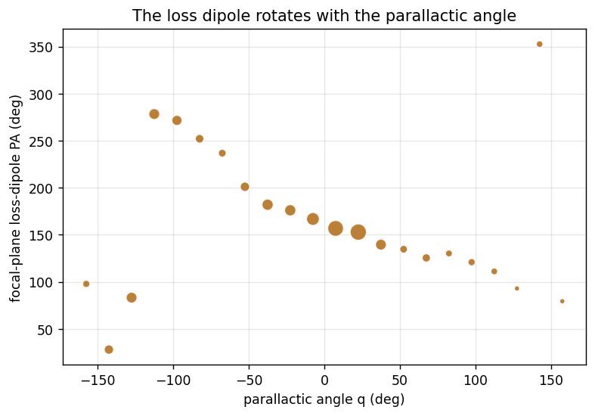
Loss-dipole direction rotates with the parallactic angle
Fitting the tilt as a fixed part plus a part that rotates with q (loss ≈ a·x+b·y + c·Re(w)+d·Im(w), w = e^{−i·s·q}(x+iy)): a rotating tilt explains more than a fixed one at equal parameter count (R² ≈ 0.130 for s=+1 vs 0.111 fixed; chirality resolved), and in the combined fit the rotating (DAR) amplitude exceeds the fixed (instrumental) one at ~4.7σ (|G| ≈ 36 vs |g_fix| ≈ 29 ×10⁻³, bootstrap over exposures), carrying ~60% of the dipole variance. So the dipole is a mix: a dominant DAR tilt that rotates with the sky, plus a smaller fixed instrumental tilt. This confirms the DAR origin geometrically, independent of the amplitude-scaling argument.

5. The physics: near the meridian it is the rotation, not the airmass change
Assume the fiber is positioned perfectly at any instant; the residual loss then comes from how the DAR offset changes while the telescope tracks. Definitions: position angle = direction from North toward East; parallactic angle q = the position angle of the zenith at the star (refraction pushes light toward the zenith, so the offset points at PA = q); ω = Earth’s sidereal rate; φ = latitude; z = zenith distance; H = hour angle.
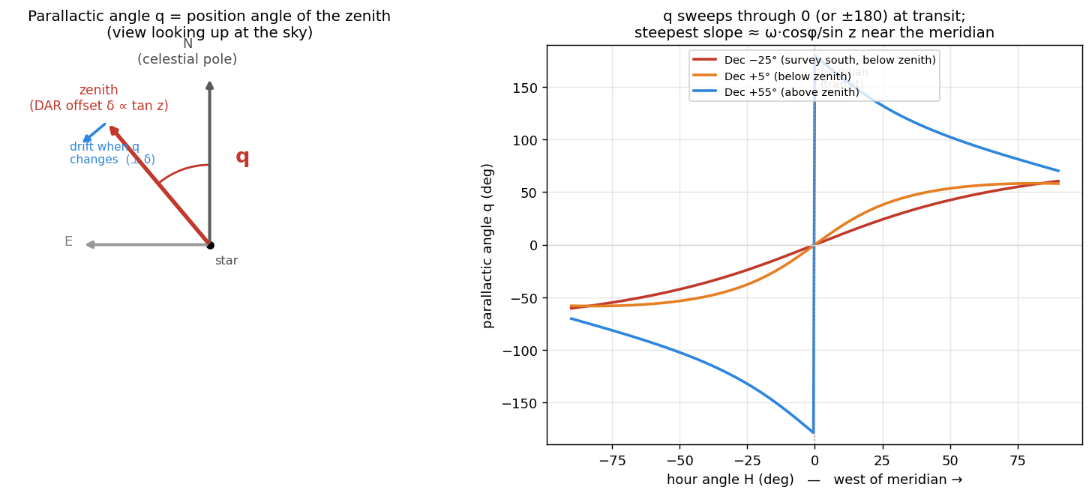
Parallactic angle: definition and evolution with hour angle
The offset has magnitude ∝ tan z, points at PA = q, and changes two ways as the Earth turns:
- magnitude (offset lengthens): rate ∝ sec²z·(dz/dt), and dz/dt ∝ sin H → zero at the meridian (airmass at a parabolic minimum);
- direction (offset rotates): rate ∝ tan z·(dq/dt), and dq/dt = ω·cosφ/sin z at transit → first-order and near-maximal at the meridian. Rotating a vector of length L by dθ moves its tip by L·dθ perpendicular to itself, so tan z is the lever arm and the drift is sideways.
So near the meridian — where DESI observes — the magnitude is frozen and the change is dominated by the parallactic-angle rotation, with drift rate
tan z·dq/dt = ω·cosφ·sec z,
present right at transit and growing with sec z — and sec z = airmass, so the effect scales with airmass. Distinctive prediction: the residual loss should be present at the meridian and grow with airmass — the opposite of an off-meridian magnitude-drift effect.
Two channels, one cause. The same parallactic rotation appears as (i) the DAR-dispersion drift — the dispersed image translating within the fiber, which nothing corrects — and (ii) a small field rotation the hexapod actively compensates (rot_rate tracks −dq/dt near the meridian), leaving only the residual quantified in FIELD_ROTATION_REPORT.md. Testing whether the hexapod term adds to the loss beyond tan z·Δq returns nothing independent, consistent with (ii) being compensated and subdominant. Channel (i) is the driver.

6. Reconciling the two spatial views: isotropic monopole vs. rotating dipole
An earlier pass at this data (before the pointing join) decomposed the loss by distance from field center and found something that looked, at first, like the opposite of DAR — worth stating plainly because the two views must be reconciled.
- The radial (monopole) gradient is large and isotropic, and it flattens with airmass. A per-star regression RCALIBFRAC ~ radius × airmass gives a huge, unambiguous interaction (R² = 0.132, interaction p = 2.2e-168, n = 1.61 M, cluster-robust by exposure), but the edge-vs-center flux ratio span shrinks with airmass (≈ +0.060 at low airmass → +0.036 at high), the opposite of naive “DAR worsens at the edge.” A validated zenith-direction decomposition (using desimeter’s own tested radec2tan/tan2fp transforms, checked against the DB parallactic column to std 0.003°) shows this radial pattern is isotropic: the signed along-zenith term explains almost nothing on its own (R² = 0.0007 vs 0.132), and splitting the outer radius into zenith-facing vs anti-zenith halves at matched radius/airmass shows only a tiny, non-monotonic difference.
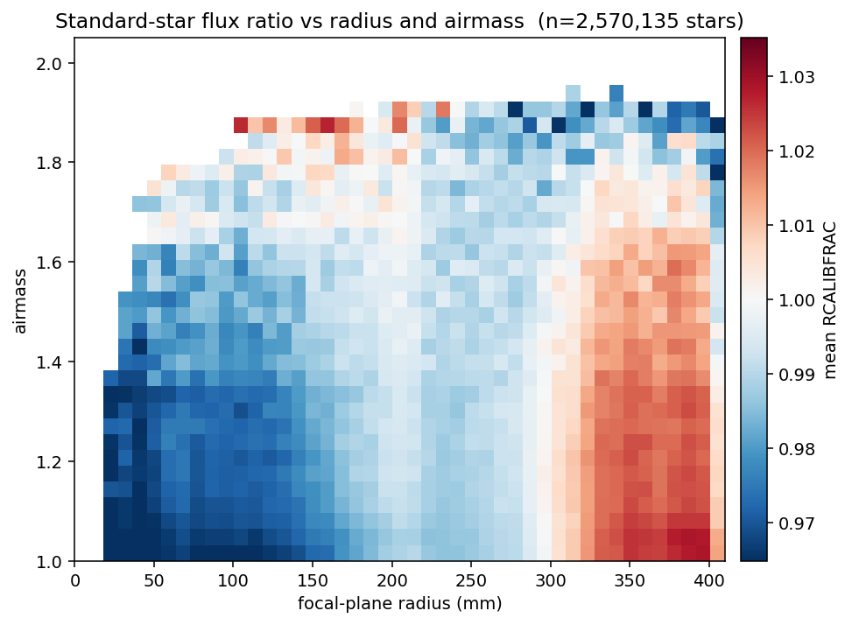
Standard-star flux ratio (RCALIBFRAC) vs focal-plane radius and airmass (n≈2.6M stars). The radial gradient is strong at low airmass — center (blue, ~0.97) to edge (red, ~1.03) — and flattens toward high airmass, the isotropic “flattens, not steepens” signature (not a directional DAR shift). Airmass>2.05 trimmed; color limits are robust (2–98%).
- The dipole, once isolated, is directional DAR — and it turns on at high airmass. The along- zenith (dipole) signal is sharply threshold-like: slope ≈ 0 (p = 0.89) for airmass < 1.4, rising to clearly positive (p = 0.005, raw corr 0.116) for airmass ≥ 1.8, right at the ADC’s ZD = 60° limit; the two most extreme individual exposures (airmass 2.28–2.33) show along-zenith correlations of 0.22 and 0.50 on their own.
These are different multipoles of the same maps, and they agree. The isotropic radial monopole (mean flux vs distance from center) is dominated by a static field pattern plus seeing (§8), with the ADC having already removed the bulk directional DAR — so there is little directional signal left in the population average. The dipole (mean-removed tilt) is the residual directional DAR, small at typical airmass and growing to clearly detectable near the ADC’s limit. The new pointing data (§4) is exactly this dipole seen with the parallactic angle attached: the fiber-loss decomposition inferred “directional DAR turns on at airmass ≥ 1.8,” and Test A confirms it directly — the dipole rotates with q. No contradiction; the pointing join sharpened a threshold the radial view had already found.

7. The residual accumulates over the exposure — two faces
That the effect is intra-exposure (accumulating with time, not a fixed high-airmass throughput offset) is the key discriminator for real DAR drift, and it shows up in two complementary observables.
(a) Mean loss — the rotation-drift channel, strongest near transit. With pointing/timing we test the drift tan z·dq/dt·T factor by factor:
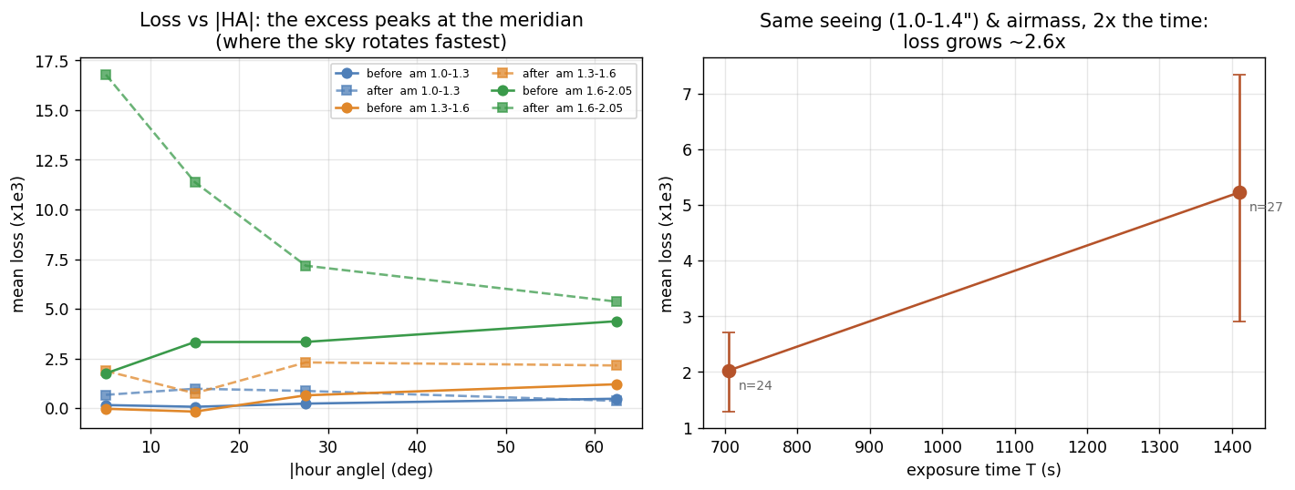
Loss vs |HA| (meridian-peaked) and the exposure-time split
- dq/dt — loss peaks at the meridian (left). At high airmass the loss is largest at low |HA| and falls toward high |HA|, exactly where dq/dt is largest then declines. A magnitude/ZD drift would do the opposite (grow off-meridian), ruling that alternative out.
- T — loss grows with exposure time (right). Holding seeing (1.0–1.4″) and airmass (~1.48, near the meridian) fixed, doubling the exposure time raises the loss ~2.6× (2.0 → 5.2 ×10⁻³). The exposure-time spread is driven mainly by transparency (normalized out of RCALIBFRAC, and not affecting seeing), so at fixed seeing and airmass this is near-controlled — the effect is genuinely time-integrated.
(b) Within-exposure scatter — the magnitude-change / ADC-mismatch channel, strongest off transit. Regressing the star-to-star scatter within each exposure, std_rcalibfrac ~ airmass + exptime, the airmass×exptime interaction is real and much stronger than for the mean (F = 169, p = 2.2e-38). But the right metric is not snapshot airmass — it is how much airmass actually changes during the exposure, |Δairmass|: substituting it nearly doubles the explanatory power (R² 0.096 → 0.144; → 0.204 on the complete population) and the coefficient is +0.149 (more airmass change → more disagreement between stars in the same exposure). This is the fixed-ADC mismatch: its one-shot correction increasingly misses as airmass evolves, smearing the flux distribution without necessarily shifting its mean.
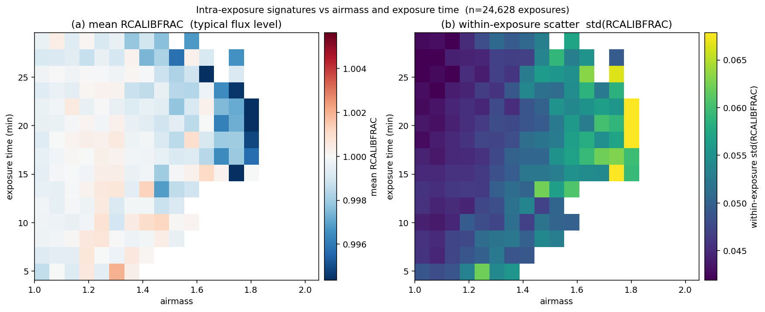
Intra-exposure signatures vs airmass and exposure time (n≈24.6k exposures). (a) Mean RCALIBFRAC — the typical flux level — dips slightly toward high airmass and long exposures. (b) Within-exposure star-to-star scatter, std(RCALIBFRAC), grows toward both high airmass and long exposure: the airmass×exposure-time interaction, and the fixed-ADC-mismatch signature. Low-count bins are masked and color limits are robust.
The two faces are one residual, split by hour angle. Near transit the airmass magnitude is frozen (|Δairmass| → 0) but dq/dt is maximal, so the rotation channel dominates and shows up as the mean-loss dipole (a). Off transit dq/dt falls but |Δairmass| grows (a field at fixed current airmass accumulates |Δairmass| ~30× faster 32° off transit than at transit — §10), so the magnitude-change / ADC-mismatch channel takes over and shows up as within-exposure scatter (b). Both are residual DAR left after a fixed ADC, both accumulate with exposure time, both grow with airmass — seen in different observables because they act in different parts of the track.
One caveat on the spatial side: the radial×airmass gradient itself does not robustly depend on exposure time (3-way radius:airmass:exptime interaction p = 0.105 after cluster-robust correction). The time dependence is firmly established in the aggregate (mean and scatter) channels; the static radial monopole is governed by absolute airmass level (fiber positions assigned once near the start), while airmass change governs the scatter — two distinct symptoms.

8. Seeing drives the isotropic radial pattern
The zenith-direction decomposition ruled out a coherent DAR shift as the cause of the isotropic radial×airmass pattern (§6), leaving the mechanism open. The most physically plausible alternative — airmass-driven seeing/PSF-size degradation interacting with a radially-varying fiber-coupling pattern — is directly testable, since seeing is a complete per-exposure DB scalar only weakly correlated with airmass (ρ = 0.098, so genuinely separable).
radius × seeing alone reproduces the same isotropic “flattening” signature and explains slightly more than radius × airmass (R² = 0.140 vs 0.132, identical negative-interaction sign). Combining both, each retains an independent, highly significant contribution (airmass coefficient shrinks only modestly, −0.0226 → −0.0195, still p = 3e-136; seeing’s is comparable, −0.0190), combined R² = 0.145; survives region/season controls. So the isotropic pattern is driven largely by seeing/PSF broadening — a general (non-directional) atmospheric effect, which is exactly why it does not align with the zenith direction the way DAR would — interacting with some radially-varying sensitivity in fiber coupling or throughput not yet localized (untested candidates: fiber positioner accuracy vs radius, spectrograph vignetting vs radius).
Operational note: unlike airmass and |Δairmass| (deterministic from Dec/HA/exptime), seeing has a stochastic weather-driven component not fixed by pointing — so a smarter exposure-time decision could in principle use live seeing alongside the geometry of Part III.

Part III — Observing-strategy implications

9. The rotation drift is largely irreducible, and invisible to dither validation
Irreducible by positioning. Worked example — Dec −25°, a 20-min exposure starting at HA = 5° (airmass ~1.85), fiber 300 mm from center:
quantity | value
target drift over the exposure (parallactic rotation ~5°) | ~28 μm
residual RMS offset even with perfect midpoint positioning | ~8 μm
midpoint position − integrated-loss-optimal position | ~0.1 μm
The exposure midpoint already coincides with the integrated-loss optimum to ~0.1 μm, so “optimize the fiber for integrated loss instead of the midpoint” gains essentially nothing. Positioning accuracy is not the lever.
Invisible to dither validation. Positioning is validated with fiber dithering (Schlafly et al. 2024, arXiv:2403.05688): short (3-min) exposures repositioned between each — an instantaneous metric. Over 3 minutes with repositioning, essentially no rotation drift accumulates, so the dithers cannot see this effect by construction. (The March-2026 second-order refraction term improves that instantaneous metric — a real, correct improvement — but does not bound the intra-exposure drift; the two should be tracked separately.)

10. Proximity to transit is the dominant lever — off-meridian does not help
Since the mean-loss (rotation) channel peaks at the meridian, one might hope to observe a given low-Dec field off the meridian, trading higher airmass for lower dq/dt. It does the opposite. For a fixed field the drift is minimized at transit and grows off-meridian: as the field leaves the meridian dq/dt falls but tan z rises (their product stays roughly flat) and the previously-zero magnitude drift switches on, so the total only increases. A 20-min exposure at Dec −25° drifts ~26 μm at transit, ~35 μm at HA = 1 h, ~75 μm at 2 h (Dec −40° runs ~70 μm to several hundred). Transit is already the optimal hour angle for any field — the drift cannot be scheduled away, only shortened.
The scatter (magnitude-change) channel says the same thing from the other side: at matched current airmass, an off-transit field accumulates |Δairmass| far faster:
Dec | HA to reach airmass ≈ 1.62 | airmass 10 min later
−5° | 38.3° off transit | 1.62 → 1.68 (Δ = +0.064)
−20° | 0° (at transit) | 1.62 → 1.62 (Δ = +0.002)
— a ~30× difference. So a deep-south field observed near transit can be genuinely safer than a moderate-Dec field observed well off transit, despite higher raw airmass. The answer to “does it depend only on airmass?” is no — proximity to transit matters as much as or more than Dec, and this piece follows from exact spherical geometry, not a fitted model.
Symmetric-window crossing table. DESI plans exposures straddling HA = 0 symmetrically; the relevant metric is then the airmass excursion max − min over the window, not a signed difference (which is ≈0 by symmetry). Empirical scatter increase vs window half-width (baseline scatter 0.0422):
Dec | transit airmass | ±2° (≈16 min) | ±4° (≈32 min) | ±6° (≈48 min) | ±8° (≈64 min)
−5° | 1.25 | +1% | +1% | +1% | +3%
−10° | 1.35 | +1% | +1% | +1% | +3%
−15° | 1.47 | +7% | +7% | +7% | +7%
−20° | 1.62 | +12% | +12% | +7% | +13%
−22° | 1.70 | +12% | +12% | — | —
−24° | 1.79 | +12% | +12% | too little data | too little data
−25° and south | 1.83+ | no data at any window width
Two findings: within the well-sampled range (Dec ≥ −22°) the excursion channel alone stays modest (+1–13% even for a generous ±8° window), so window width by itself isn’t a strong constraint there; but there is a hard data wall at Dec ≈ −24°/−25° — the southern DARK/BRIGHT program is only just beginning (Appendix A).

11. The ADC ZD = 60° wall constrains the southern program
The ADC has a hard operating limit at ZD = 60° (airmass 2.0), confirmed in the data: only 3/12,043 exposures (0.02%) exceed it, and those show a saturated, flat prism-separation angle (178.70° ± 0.0007°) rather than continued growth — a real mechanical/design stop. At KPNO’s latitude (31.9633°N) the best-case airmass for a field is sec(|lat − Dec|) at transit:
Dec | ZD at transit | airmass at transit (best case)
−10° | 41.96° | 1.35
−15° | 46.96° | 1.47
−20° | 51.96° | 1.62
−25° | 56.96° | 1.83
−28° | 59.96° | 2.00 — the ADC’s limit, at transit
−30° | 61.96° | 2.13
−35° | 66.96° | 2.56
Dec ≈ −28° is the critical threshold. Fields at Dec ≥ −25° stay within the ADC’s corrected range for the best part of their track. Fields at Dec ≤ −28° never drop below ZD = 60°, even at transit — their entire observation runs where the ADC cannot fully correct, so the loss there should be treated as substantially uncorrected DAR (a qualitatively larger effect than the mostly-corrected residual this sample, 99.98% within the ADC’s range, characterizes), and this is exactly the regime where the directional dipole (§6) turns on. Quantifying it directly needs a targeted Dec ≤ −28° sample, which does not exist yet (Appendix A).
Operational lookup (empirical, non-extrapolated). Rather than trust a linear extrapolation into the sparsely-sampled high-airmass corner (which produced physically backwards predictions and was discarded), the binned lookup reports only what was observed:
airmass_start | |Δairmass| | mean std_rcalibfrac | n
1.0–1.2 | 0–0.01 | 0.044 | 4,194
1.4–1.6 | 0–0.01 | 0.047 | 90
1.4–1.6 | 0.1–0.5 | 0.061 | 48
1.6–1.8 | 0.1–0.5 | 0.065 | 86
1.8–2.0 | 0.1–0.5 | 0.081 | 45
2.0–2.4 | 0.1–0.5 | 0.288 | 2 (too few to trust)
At fixed airmass, scatter rises monotonically with |Δairmass|; at fixed |Δairmass|, with airmass. The best-populated near-limit cell (airmass 1.8–2.0, large |Δairmass|, n = 45) shows ~2× the low-airmass baseline on real data.

12. What to do with this
- Schedule long/southern exposures to straddle transit as tightly as feasible — the single most effective lever, more so than Dec itself, and grounded in exact geometry (§10).
- Cap exposure duration at high airmass — the drift accumulates ∝ T, so shorter or split exposures reduce it; the ~1–2% flux loss is the quantity to weigh against the ~2-min-per-restart overhead. This report characterizes the effect; the cost/benefit needs the science-value of a given scatter increase, which is out of scope here.
- Treat Dec ≤ −28° as an under-corrected regime, not a residual one, and revisit with a targeted sample once the southern survey accumulates.
- Track instantaneous-positioning metrics and intra-exposure loss separately — dither validation does not bound the latter.
- Do not rely on positioning to fix the rotation drift — the midpoint is already the integrated-loss optimum to ~0.1 μm.

Conclusion
Two independent things are going on in the standard-star loss. First, the increase everyone would have noticed is a calibration-level shift that turned on around mid-2025 — present even at low airmass where DAR is negligible, and not caused by the March-2026 PlateMaker change (loss is unchanged across it at every airmass). Its origin is a calibration/measurement question we hand to Data Systems. Second, the airmass dependence of the loss, in every epoch, is residual DAR acting during the exposure — what remains after DESI’s fixed, airmass-driven ADC removes the bulk. It appears as a focal-plane dipole that rotates with the parallactic angle (a direct DAR confirmation), driven near the meridian by the rotation of the refraction offset and off the meridian by the magnitude change the fixed ADC cannot track; it scales with tan z·dq/dt·T, is largely irreducible by positioning, and is invisible to short dither sequences. Operationally, proximity to transit is the dominant lever, and the ADC’s ZD = 60° limit makes Dec ≤ −28° a qualitatively harder regime. It is a distinct, physical limit on high-airmass fiber throughput — separate from the mid-2025 calibration shift, and separate from instantaneous positioning accuracy.

Appendix A — Investigation history and corrections
This consolidates the corrections and confound checks made during the investigation; every core conclusion survives them.
- Snapshot airmass was the wrong metric for the scatter channel. Stage 1 originally used the single tcs.airmass snapshot; replacing it with a time-resolved |Δairmass| (computed from HA(t) = mount_ha + sidereal_rate·t, Dec fixed, KPNO latitude) nearly doubled the scatter R² (0.096 → 0.144) and sharpened significance (p 2.2e-38 → 3.2e-180). The recorded airmass was confirmed to be a start-of-exposure snapshot (matches computed start to 0.0006, vs 0.02–0.14 for end/mid-average), validating mount_ha as the t = 0 reference. The spatial “flattens, not steepens” direction is unchanged by this correction (it is governed by absolute airmass level, not airmass change).
- Population undercount — 22%, caught by the user. The program filter used exact-match LIKE ('DARK'/'BRIGHT'), silently excluding DARK1B (n = 1,859) and BRIGHT1B (n = 1,537) — together 22% of the true population. Re-ran every core test on the complete population (n = 15,206 exposures, 1.61 M stars): every finding survives, the Stage 1 scatter result is if anything stronger (R² 0.144 → 0.204), the Stage 2 interaction remains p = 2.2e-168 with the same sign, and the ADC correlation is unchanged (ρ = 0.9958). Numbers elsewhere reflect the original 12,043-exposure population unless marked complete/corrected; the qualitative story is unchanged.
- Region/season confound — checked, survives. Adding an empirical NGC/SGC region split and a cyclical season term (sin/cos of day-of-year) to both the aggregate and per-star models: both are detectable (huge n) but the key coefficients barely move (|Δairmass|:exptime +0.0112 → +0.0101, still p < 1e-33; radius:airmass −0.0226 → −0.0226, still p ~ 2e-168). Not a confound in either test — unlike the region effect in FIELD_ROTATION_REPORT.md.
- Extrapolation discarded twice. Coefficient-based linear predictions into the high-airmass corner (only ~2.8% of the sample has airmass > 1.7) produced physically backwards results (scatter decreasing with exposure time). Discarded in favor of empirical binned lookups both times — the same discipline applied throughout.
- Dec ≤ −28° follow-up — confirmed not yet possible. At science quality there are currently zero qualifying exposures at Dec ≤ −28° and only 6 at Dec ≤ −25° (all from the last two weeks of the archive). The southern DARK/BRIGHT program is only just beginning; the targeted low-Dec follow-up flagged throughout should be revisited as the survey accumulates.
- Still genuinely open. What radially-varying sensitivity seeing/PSF-size interacts with (fiber positioner accuracy vs radius? spectrograph vignetting vs radius?); the separate chromatic DAR smearing/elongation possibility (as opposed to translation) that the linear along-zenith test would not detect; and, of course, the origin of the Finding 1 calibration shift (→ Data Systems).

Appendix B — Status of each finding
Status | Finding
✅ | Finding 1: a flux-loss calibration shift (visible even at DAR-free low airmass) turned on ~mid-2025; three-epoch split shows it is not the 2026-03-07 PlateMaker change (B ≈ C at all airmass). Origin handed to Data Systems, not diagnosed here.
✅ | Mean-flux airmass×exptime interaction real (F = 23.8, p = 1.1e-6) but small (~1% at the extreme observed range).
✅ | Within-exposure scatter airmass×exptime interaction real and much stronger (F = 169, p = 2.2e-38); |Δairmass| is the right metric (R² 0.096 → 0.144 → 0.204 complete population).
✅ | Radial × airmass interaction huge and unambiguous (R² → 0.132 complete population, n = 1.61 M, cluster-robust) but flattens, not steepens — an isotropic monopole, not a directional shift.
✅ | DESI has a working, airmass-driven two-element ADC (prism separation vs airmass ρ = 0.996), STOPPED/fixed for the exposure with no rate field — so this study measures residual DAR; the fixed correction increasingly mismatches as airmass changes (the |Δairmass| mechanism). ADC angle timing not independently validated.
✅ | ADC hard limit ZD = 60°/airmass 2.0 real in the data (3/12,043 exceed it, saturated angle). Dec ≤ −28° never drops below it even at transit → under-corrected regime for the far-southern program.
✅ | Zenith-direction decomposition (using desimeter’s own validated transforms) shows the radial×airmass effect is isotropic on population average (directional R² 0.0007 vs 0.132) — but a real, threshold-like directional signal turns on at airmass ≥ 1.8 (p = 0.005), near the ADC limit.
✅ | New pointing data confirms the directional residual directly: the mean-removed loss dipole rotates with the parallactic angle (Test A), rotating (DAR) amplitude > fixed (instrumental) at ~4.7σ, ~60% of dipole variance. The same threshold-onset DAR the radial view inferred, now geometric.
✅ | Loss scales with the rotation drift tan z·dq/dt·T (Test B): peaks at the meridian (dq/dt), grows ~2.6× for 2× exposure time at fixed seeing/airmass.
✅ | Proximity to transit — not Dec or airmass alone — is the dominant lever (exact geometry: |Δairmass| grows ~30× faster 32° off transit). Off-meridian scheduling does not help; transit is optimal. Symmetric-window excursion table modest within Dec ≥ −22°, hard data wall at Dec ≈ −24°/−25°.
✅ | DAR rotation drift is largely irreducible by positioning (~28 μm drift, ~8 μm residual at perfect midpoint, midpoint = integrated-loss optimum to ~0.1 μm) and invisible to short dither sequences.
✅ | Seeing (ρ = 0.098 with airmass, separable) substantially explains the isotropic radial pattern (radius×seeing R² 0.140 > radius×airmass 0.132; both independent when combined).
✅ | Region/season confound checked (Stage 1 and Stage 2) — key coefficients essentially unchanged.
⬜ | Targeted Dec ≤ −28° sample — confirmed not yet possible (0 qualifying science exposures); revisit as the survey accumulates.
⬜ | Origin of the mid-2025 calibration shift → Data Systems (not investigated here).

Appendix C — Methods
- Notebooks. Reproduction / DAR template: notebooks/dar_fiber_loss_reproduction.ipynb. Pointing tests, time-series & three-epoch split: notebooks/dar_pointing_tests.ipynb. Both self-contained from the local parquet + the pointing CSV; execute clean.
- Epoch split (Finding 1). A night < 20250301; B 20250301 ≤ night ≤ 20260307; C 20260307 < night < 20260701 (July 2026 excluded, weather-limited). Per-airmass-bin means, bootstrap over exposures for the 16–84% intervals.
- Dipole fit. Weighted least squares of loss ≈ g_x·x + g_y·y (+ quadratic) on cell-mean maps; the fixed-vs-rotating separation fits loss ≈ a·x+b·y + c·Re(w)+d·Im(w), w = e^{−i·s·q}(x+iy).
- Geometry. sec z = airmass; parallactic angle q = atan2(sinH, tanφ cosDec − sinDec cosH), φ = 31.9634°; drift = tan z · Δq with Δq the parallactic sweep over the exposure; airmass trajectory HA(t) = mount_ha + sidereal_rate·t, Dec fixed.
- Zenith decomposition. desimeter.transform.radec2tan / tan2fp with each exposure’s actual rot_offset and ADC angles; validated against the DB parallactic column (std 0.003°).
- Errors. Bootstrap over exposures (stars within an exposure are correlated); per-star regressions use cluster-robust standard errors clustered by EXPID.
- Data access. Exposure list data/dar_exposure_list.csv; pointing/timing fetched via scripts/fetch_exposure_pointing.py → data/dar_exposure_pointing.csv (exposure.exposure, DOS_DB_*).

