Field Rotation Correction: Current Model, Measured Reality, and a Proposed Fix
Status: v3 — finalized for release (core rot_rate question concluded) Last updated: 2026-07-23 (added forward-in-time validation split + deployable-function envelope; reconciled with the now-completed DAR follow-on study) Sample: 9,320 exposures, 2023-01-18 to 2026-07-01 Source notebooks: notebooks/fieldrotation.ipynb, notebooks/fieldrotationcorrection.ipynb, notebooks/fieldrotation_correlation.ipynb Figures: notebooks/figures/*.png (generated directly from notebooks/merged_rot.csv)

Executive summary
The rotator-rate model that corrects for parallactic field rotation during DESI exposures is a cubic polynomial in mount pointing, last calibrated in September 2022. Comparing its predictions against what the guider actually measures, across 9,320 exposures spanning three and a half years, shows a real, statistically robust bias that grows with declination and is not explained by season, survey field, weather, insufficient update frequency, or (checked last) airmass beyond a marginal amount. Refitting the same functional form directly against current guider data — validated on data the fit never saw — cuts the bias to essentially zero and reduces scatter by about 10%. That ~10–12% improvement holds on both a random held-out split and a stricter forward-in-time (temporal) split, though the absolute go-forward scatter is higher than the headline (see Part 4).
Recommendation: deploy the recalibrated static model; do not build a dynamic guider-based correction at this time. Every candidate explanation tested for why a real-time correction would help — weather, TCS-correction magnitude, airmass — either came back weak, failed to replicate at full scale, or turned out to be better captured by a (marginal) static term. See the Conclusion section below for the full reasoning. A related but distinct question — whether differential atmospheric refraction at high airmass (relevant to upcoming southern-field observing) causes measurable fiber flux loss — was spun off as a separate study, now completed (DAR_FIBER_LOSS_REPORT.md); it does not involve rot_rate and should not be conflated with this conclusion, though it independently confirms the rotator correction is working (see the Conclusion’s handoff note).
Held-out metric (arcsec/min) | Current (2022) | Recalibrated (2026)
Bias — random split | -0.042 | -0.001
RMS — random split | 0.140 | 0.126
RMS — temporal split (forward in time) | 0.171 | 0.150
Exposures analyzed |  | 9,320

Part 1 — What the current model predicts — Established
DESI’s alt-az mount introduces a field rotation that changes continuously with hour angle and declination. The online system corrects for this using rot_rate, computed by desimeter.fieldmodel.dfieldrotdt() and stored per-exposure in hexapod['rot_rate']. Reading the actual source (not assuming): this function deliberately ignores time (mjd) and calls only dfieldrotdt_empirical_model — a 9-term cubic polynomial in normalized hour angle and declination, fit once in September 2022 (credited to S. Kent) against archival guide-star data. A separate, exact-geometry dfieldrotdt_physical_model exists in the same codebase but is not the one actually used.
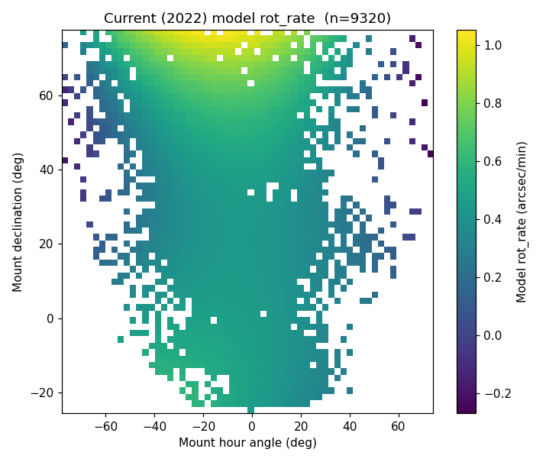
Current model heatmap
Fig. 1 — Current (2022) model’s predicted rot_rate across the sky actually observed, n=9,320. Rate ranges from near zero to just over 1 arcsec/min, strongly structured by declination.
Two real gotchas surfaced while working with this: exposure.exposure’s flat rotrate column looks like the obvious source but is dead (one non-null value across 361,939 rows) — the live value lives in the hexapod jsonb blob instead. The model also has a hard ±1.5 arcsec/min saturation clip outside its fitted range; none of the exposures analyzed here hit it.

Part 2 — What the guider actually sees — Established
If the model were perfect, the guider should measure a field rotation of zero, on average, once the correction is applied. To test this, we fit a straight line to each exposure’s per-frame rotation estimate (telemetry.guider_centroids, roughly 100-200 frames per exposure at ~8s cadence) against the frame’s own obstime. The fitted slope is the residual rotation rate left over after the model’s correction — what we call the measured rate throughout. Sign convention: measured = true_rate − model_rate, so a positive value means the model under-corrected (the true rotation exceeded the applied rate); the true underlying rate is therefore recoverable as model + measured (used in Part 4).
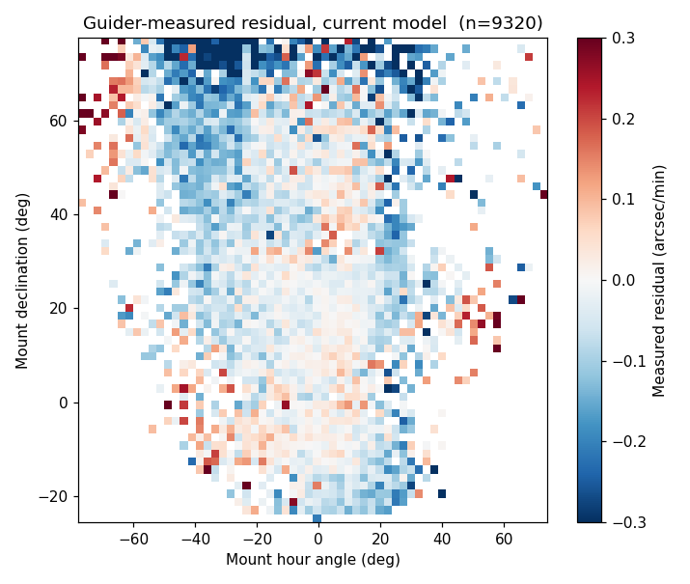
Measured residual heatmap
Fig. 2 — Guider-measured residual under the current model, same pointing grid as Fig. 1. Not flat, not centered on zero — real structure remains, most negative at high declination.
Noise floor: a minimum of 40 guider frames is required per exposure before its slope is used — short of that, the fit is noise-dominated. Frame-level noise itself was checked directly: within-exposure fit residuals show real short-timescale autocorrelation (median lag-1 ρ=0.27), so naive fit-uncertainty estimates understate the truth by roughly 1.3x — but even corrected, per-exposure precision (~0.02-0.05 arcsec/min) stays well below the actual effect sizes reported below.

Part 3 — Characterizing the discrepancy — Established

The raw correlation is misleading on its own
A naive rank correlation between model rate and measured rate is weak at full scale (Spearman ρ=-0.033, n=9,320) — but the linear (Pearson) correlation is substantial (r=-0.228, p=9e-110). The relationship is real but non-monotonic enough to fool a rank-based statistic; this is exactly why this report leans on the regression/recalibration results below rather than a single correlation number.
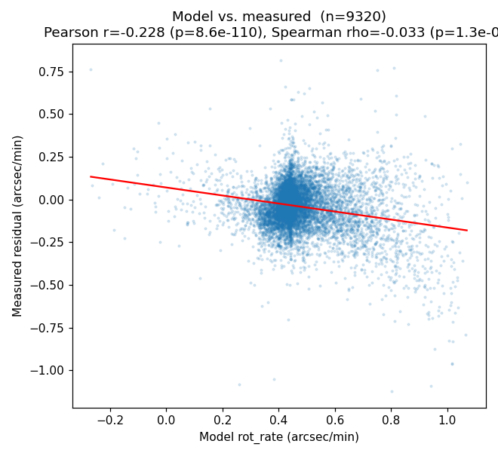
Model vs measured scatter
Fig. 3 — Model vs. measured, n=9,320. The fitted trend line is real (Pearson r=-0.228) even though the simple rank correlation undersells it.

It’s (mostly) declination, modeled correctly
Nested regression tests were run properly — and corrected once when they weren’t run properly enough. Against a naive linear HA+Dec model, both survey region (2 NGC patches + 1 SGC, confirmed empirically against a real DESI footprint scatter plot below) and a cyclical season term looked like independent, significant effects (region: F=95.0, p=1.4e-41). Once the baseline was upgraded to the correct, cubic HA/Dec basis — matching the real polynomial’s functional richness — region’s contribution nearly vanished (R² 0.4181→0.4187; one of its two levels dropped to p=0.80, no effect at all).
Lesson that generalizes beyond this analysis: testing whether a new predictor “adds explanatory power” is only as good as how well the baseline itself is modeled. A categorical variable can look like it’s capturing a real independent effect when it’s really just absorbing curvature a too-simple baseline missed.
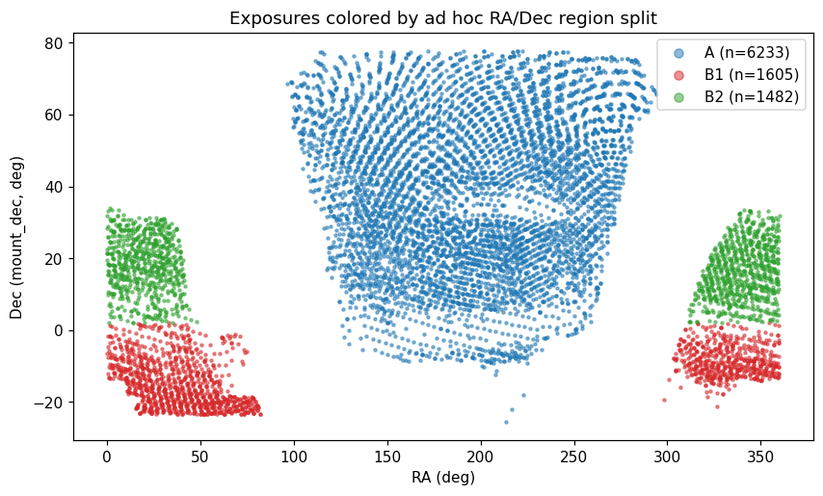
Region scatter plot
Fig. 4 — Exposures colored by an empirically-derived RA/Dec region split (gaps in the raw RA histogram, further split by Dec). Confirmed by direct comparison to match the real DESI footprint (2 NGC patches + 1 SGC) — a useful validation of the method, even though region was ultimately not needed in the final model.

Ruled out: not enough time resolution
Since the mount’s hour angle drifts roughly 5° over a 20-minute exposure while declination stays fixed, one candidate explanation was that a single rate snapshot per exposure can’t track the true, continuously-varying rate. Using the real desimeter formula, we computed the exact size of this effect: integrating the polynomial across each exposure’s actual guider-frame timestamps and comparing to the single logged snapshot gives a mean discrepancy (the “compromise” — how much a one-value-per-exposure rate differs from the properly time-integrated one) of just 0.0195 arcsec/min if the rate is applied once per exposure, or 0.0008 arcsec/min if re-evaluated every minute — one to two orders of magnitude below the actual discrepancy. More frequent re-evaluation of the same formula is not the fix.

Ruled out (as tested): weather
Condition | vs. signed residual | vs. |residual|
Seeing (FWHM) | ρ=+0.082, p=0.021 | ρ=-0.014, p=0.70
Transparency | ρ=+0.052, p=0.14 | ρ=-0.039, p=0.28
Wind speed | ρ=-0.016, p=0.65 | ρ=+0.016, p=0.65
Gust | ρ=-0.029, p=0.41 | ρ=+0.018, p=0.60
None of these (n=794, one nearest-in-time snapshot per exposure) show a relationship strong enough to explain the discrepancy — though a single snapshot may simply be too coarse to catch a gust partway through an exposure. See Part 5 for a proxy that worked better.

Part 4 — The recalibrated model — Validated
Since rotation_measured is the residual left over after rot_rate was already applied as the correction, the true underlying rate is recoverable as rot_rate_model + rotation_measured. Refitting the exact same cubic-in-(HA,Dec) functional form directly against this recovered rate — using all 9,320 exposures, no region or season term (tested and found unnecessary once the nonlinear form is used correctly) — and validating honestly on a held-out 30% split never seen during fitting (a random split across the full sample; a stricter forward-in-time split is checked below):
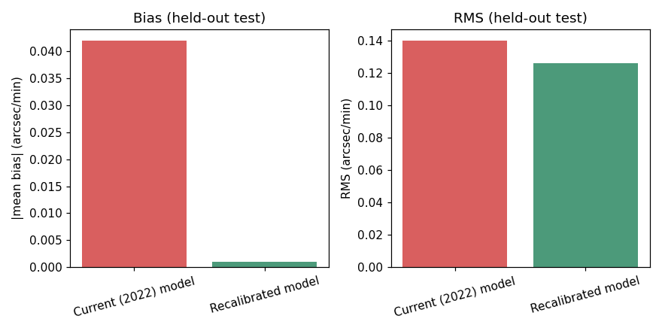
Validation bar charts
Fig. 5 — Held-out test performance, current vs. recalibrated model. Bias is essentially eliminated; RMS scatter drops by ~10%.
Term | Original (2022) | Recalibrated (2026)
const | +0.447 | +0.446
x (HA/60) | -0.065 | +0.036
y ((Dec-30)/30) | +0.067 | +0.056
x² | -0.382 | -0.432
xy | -0.021 | +0.056
y² | +0.121 | +0.073
x³ | +0.031 | -0.114
x²y | -0.196 | -0.123
xy² | -0.096 | -0.155
y³ | +0.043 | +0.021
Both largest-magnitude terms (const, x²) land close to the original; three smaller, more fitting-sensitive terms flip sign — consistent with a genuine, modest recalibration rather than anything broken in either fit.
import numpy as np
def new_rot_rate(ha_deg, dec_deg):
"""Recalibrated (2026) hexapod field-rotation rate.
Inputs : ha_deg — hour angle in DEGREES (not hours)
dec_deg — declination in DEGREES
Returns: rot_rate in arcsec/min.
Fitted domain (sky actually observed, n=9,320): HA ~ [-78, +74] deg,
Dec ~ [-26, +78] deg. Outside it the cubic extrapolates; the online model
applies a hard +/-1.5 arcsec/min saturation clip, reproduced here to match
original_rot_rate.py. Accepts scalars or numpy arrays.
"""
x = ha_deg / 60.0
y = (dec_deg - 30.0) / 30.0
rate = (0.44555 + 0.03625*x + 0.05556*y - 0.43236*x**2 + 0.05576*x*y
+ 0.07328*y**2 - 0.11390*x**3 - 0.12254*x**2*y - 0.15458*x*y**2 + 0.02106*y**3)
return np.clip(rate, -1.5, 1.5)
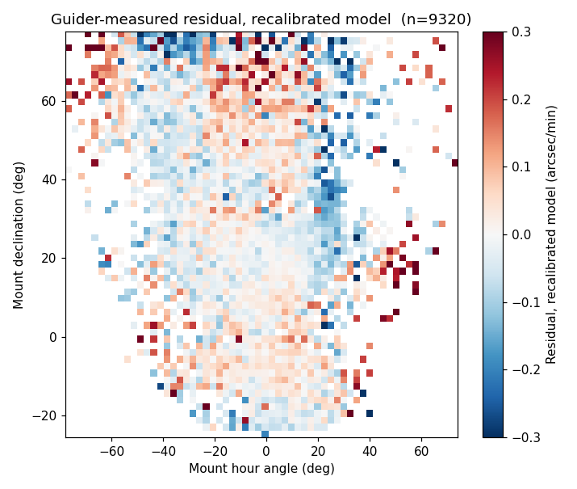
New model residual heatmap
Fig. 6 — Guider-measured residual under the recalibrated* model, same grid as Fig. 2. Visibly flatter and closer to zero across the sky.*

Validation split: random vs. forward-in-time
The 30% held out above is a random split — it measures generalization to similar data. Because the deployed model runs on future exposures, we also ran a stricter temporal split: fit on the earliest ~70% of exposures (by EXPID, which is time-ordered) and test on the most recent ~30%. The reproducible fit lives in notebooks/fieldrotationcorrection.ipynb and recovers the coefficients above to 5 decimals.
Split | Current (2022) RMS | Recalibrated RMS | Recal. bias
Random (the headline method) | 0.140 | 0.126 | -0.001
Temporal (train early / test late) | 0.171 | 0.150 | -0.004
Two things to read from this. (i) The recommendation is robust. On the forward-in-time test the recalibrated model still eliminates the bias (-0.063 → -0.004) and still reduces RMS by ~12% (0.171 → 0.150) — the value of recalibrating is essentially the same on both splits, and it is the stale 2022 model that degrades most on recent data (RMS 0.140 → 0.171). (ii) The go-forward scatter is higher than the headline. The honest forward-looking RMS is ~0.150, not 0.126: a random split lets the fit see points from the same nights/regime it is then tested on. The gap is real drift — and because the recent test window is exactly the more-southern, higher-airmass regime this report is written for, part of it is distribution-shift into that regime. Implication: deploy the recalibrated model (it wins on both splits), but treat the fit as needing periodic recalibration rather than permanent — the sky the model sees keeps moving, the same “nothing is static” lesson the companion DAR study independently hit with its mid-2025 calibration shift.

Airmass: real, but not worth adding to the deployed model
A late finding (raised while scoping a separate differential-atmospheric-refraction question, see below): adding airmass + airmass² as extra terms is highly statistically significant — testing against the same cubic HA/Dec baseline used throughout, R² rises from 0.1275 to 0.1370 (F=51.6, p=5.3e-23, n=9,320), and the effect is roughly twice as strong in the southern, high-airmass subset (Dec -30° to -10°) that upcoming DESI observing will lean on more heavily.
But translated into held-out RMS — the metric that actually matters for the deployed model — the gain is marginal:
Model | Held-out mean | Held-out RMS
Current (2022) | -0.042 | 0.1404
Recalibrated (no airmass) | -0.0009 | 0.1260
Recalibrated + airmass/airmass² | -0.0008 | 0.1254
A ~0.5% further RMS reduction — the same “statistically significant only because n is huge, practically marginal” pattern already seen with region and season. Applying the same bar used to exclude region from the final model, airmass is not included in the deployed static model either. It’s kept here as a documented, real finding because it’s directly relevant to the separate atmospheric-refraction investigation below, not because it changes the recommended model.

Part 5 — Toward a dynamic component — Concluded — not recommended (no confirmed driver)
Even the recalibrated model leaves real, unexplained exposure-to-exposure scatter — plausibly driven by conditions that vary exposure to exposure rather than anything predictable from pointing alone. The question is whether a real-time, guider-informed correction can recover some of it without injecting more noise than it removes.

Ruled out: a short rolling window
At the guider’s native cadence (~1 frame/10s), a naive scheme — fit a slope from just the last 5-6 frames and use it to update the correction every minute — is unusable: window-level slope uncertainty runs 1-8 arcsec/min, 15-100x larger than the actual signal. Fitting a rate from ~1 minute of data is dominated by noise, not signal.

A slower, cumulative window is more promising
Frames | ~elapsed | Typical stderr (arcsec/min)
30 | ~4 min | 0.36-0.58
40 | ~5.5 min | 0.22-0.34
60 | ~8 min | 0.11-0.17
80 | ~11 min | 0.07-0.10
100 | ~14 min | 0.05-0.07
An accumulated-since-start-of-exposure window only becomes trustworthy (comparable to the 0.126 arcsec/min residual scale) around frame 80-100, not frame 30-40 as first proposed — a real, measured correction to the initial design. A weighting scheme that ramps in a guider-based correction should target that later window, or better, weight by the estimate’s own reported uncertainty rather than a fixed frame count.

TCS correction size: a real, robust signal for measurement reliability — but not (as far as tested) for the true residual
The guider’s own tcs_correction_ra/tcs_correction_dec — how large a real-time pointing correction the telescope is making — was tested against two different things, and only one held up at full scale:
Relationship | ρ | p | n
TCS correction size ↔ slope-fit uncertainty | 0.283 | 1.1e-21 | 1,097 (full year)
TCS correction size ↔ |model residual| | 0.010 | 0.73 | 1,097 (full year)
The uncertainty relationship is solid and reproduces closely across every sample tested today (0.268 → 0.272 → 0.283 across three independent checks). The residual-magnitude relationship does not. An earlier small sample (n=122, one month) showed ρ=0.180 (p=0.047) and a near-doubling of median |residual| between calm and disturbed halves (0.108→0.188) — at full-year scale (n=1,097) that signal is gone: ρ=0.010 (p=0.73), and the low/high TCS-correction halves show essentially identical median |residual| (0.0828 vs. 0.0833). The March result was very likely a feature of that specific small, one-month sample, not a general effect — exactly the “small-sample inflation” pattern already seen twice elsewhere in this investigation (the raw correlation, the region/season nested-model check). Caught here by deliberately re-testing at scale rather than trusting the first positive result.
What this means in practice: TCS correction magnitude is a genuinely useful, well-confirmed signal for when a guider-based rate estimate can be trusted (noisier fits during high-correction periods argue for down-weighting the guider estimate then, not up-weighting it) — but it is not, as tested here, evidence that the true rotation error is bigger during those periods. That specific rationale for a dynamic correction (bigger disturbance → bigger true error → more value in a real-time fix) is now unconfirmed, not supported. The weather-snapshot tests in Part 3 also came back weak. As of this writing, nothing tested today robustly explains what drives the recalibrated model’s remaining ~0.126 arcsec/min RMS — that’s an honestly open question, not a solved one, and the case for a dynamic component now rests on the residual’s existence and size alone, not on a confirmed physical driver for it.

Conclusion & recommendation
Adopt the recalibrated static model (Part 4, cubic-in-HA/Dec, no region, no airmass) as the deployed fix. Do not build the dynamic guider-based correction at this time.
Static model — recommended for deployment. The recalibrated model is validated on held-out data the fit never saw: bias essentially eliminated (-0.042 → -0.001 arcsec/min) and RMS reduced ~10% (0.140 → 0.126 on a random split; the same ~12% improvement and near-zero bias hold on a stricter forward-in-time split, where the honest go-forward RMS is ~0.150 — see Part 4). Because the model drifts over the multi-year span, plan a periodic recalibration cadence rather than treating the 2026 fit as permanent. Region and airmass were both tested properly against this same model and both add real, statistically significant structure (huge n makes even small effects detectable) — but neither clears a practical bar once measured in held-out RMS terms (region: 0.126→0.1259; airmass: 0.126→0.1254, both roughly half a percent). Keeping the simpler model is the consistent call in both cases.
Dynamic component — not recommended right now, for a specific reason: no confirmed driver, not an engineering limitation. The mechanics of a guider-informed dynamic correction are sound and were characterized in detail (a cumulative window becomes trustworthy around frame 80-100 of a typical exposure) — the reason not to build it is that every candidate explanation for why it would help failed to survive scrutiny at full scale: - Weather (seeing, transparency, wind, gust): weak or null (Part 3). - TCS-correction magnitude, initially promising (n=122): did not replicate at full year scale (Part 5) — only its relationship to measurement uncertainty held up, not to the true residual size. - Airmass: real, but its explanatory power is already captured (to the small, marginal extent it’s worth capturing) by a static term, not something that needs real-time tracking.
Building real-time infrastructure (weighting scheme, hexapod-loop integration, its own validation burden) to chase a signal with no confirmed physical driver is not a good trade. If a future analysis identifies a real, reliable real-time predictor of when the static model falls short, that’s the trigger to revisit this — not before.
The follow-on DAR study (now completed) — and what it says back about this correction. The airmass finding, and the geometric argument that field rotation and differential atmospheric refraction (DAR) are orthogonal (a pure rotation cannot correct a shear/scale-type distortion), motivated a distinct follow-on study of whether DAR at high airmass causes measurable fiber flux loss on the southern Dec -10° to -30° fields much of upcoming DESI observing will use. That study is complete — see DAR_FIBER_LOSS_REPORT.md. Its two headline findings are separate from rot_rate (a mid-2025 flux-loss calibration shift, and a residual-DAR limit at high airmass), but two of its results speak directly back to this report:
- Independent confirmation that the rotator correction is working. Using calibstars flux — a completely different diagnostic from guider rotation fits — the DAR study found that adding the hexapod rot_rate term to a fiber-loss model contributes nothing beyond the DAR-dispersion drift (tan z·Δq). In its decomposition the field rotation is the compensated channel and the DAR dispersion the uncompensated one — so the compensated field rotation leaves no measurable residual in the science flux. That is empirical support for the orthogonality argument above, and for the correction doing its job.
- A physical home for the airmass term. The marginal airmass/airmass² structure in the residual (Part 4) sits in the same regime where the DAR study shows the parallactic-rotation family carries a sec z-type (airmass) dependence — so airmass-dependence here is physically expected, not mysterious (details in that report; no claim that the residual term is numerically identical to that factor).

A bonus, practical deliverable: removing the desimeter dependency
A related question came up while wrapping this up: how hard would it be to drop the desimeter package dependency from the online code entirely? Reading the actual function settles it: dfieldrotdt/dfieldrotdt_empirical_model only use numpy at runtime — no astropy, no coordinate transforms, nothing else from the package. The reason this has previously seemed like “a lot of work” is that the file it lives in (fieldmodel.py) imports astropy.table, astropy.time, and three desimeter.transform submodules at the top of the file — Python loads all of that the moment you import anything from it, even though dfieldrotdt itself never touches any of it.
Extracted the calculation into a standalone module (original_rot_rate.py — numpy-only, no desimeter/astropy dependency, original 2022 coefficients unchanged) and validated it directly against the real desimeter function (compare_rot_rate_models.py):
Check | Result
672-point scalar grid (full RA/Dec/LST domain) | max abs difference = 0.0
2,000 random points, vectorized array call | exactly equal (np.array_equal = True)
Edge cases: Dec=±90°, HA wrap at 180°, ±1.5 saturation clip | all exact matches
Bit-for-bit identical, not just numerically close. recalibrated_rot_rate.py (Part 4’s model) is built the same dependency-free way, so both the current and recalibrated models are now available without needing desimeter installed at all for this calculation. Production is being switched over to use the standalone function (starting with the original coefficients).

Status of each finding
Status | Finding
✅ Validated | Current model is a stale 2022 empirical fit, not physics-based — confirmed by reading the actual desimeter source.
✅ Validated | Real, guider-confirmed discrepancy exists, largest at high declination, not explained by noise.
✅ Validated | Not a temporal-resolution problem — re-evaluating the formula more often gains <0.02 arcsec/min.
✅ Validated | Region/season are not independently needed once pointing is modeled correctly (cubic, not linear).
✅ Validated | Recalibrated static model — held-out bias -0.042→-0.001, RMS 0.140→0.126 (random split).
✅ Validated | Forward-in-time (temporal) split confirms it: recalibrated still zeroes the bias (-0.063→-0.004) and cuts RMS ~12% (0.171→0.150). Go-forward RMS ~0.150 > the random-split 0.126 (real drift) → plan periodic recalibration. Reproducible in fieldrotationcorrection.ipynb.
✅ Validated | TCS-correction magnitude ↔ measurement uncertainty — confirmed at full-year scale (ρ=0.283, p=1.1e-21). Useful for weighting a guider estimate’s reliability.
⬜ Open (revised down) | TCS-correction magnitude ↔ true residual size — did not hold up at full-year scale (ρ=0.010, p=0.73); the earlier n=122 signal was likely a small-sample artifact.
✅ Validated | Airmass adds real, significant structure to the residual (F=51.6, p=5.3e-23) — but only a marginal ~0.5% held-out RMS gain; excluded from the deployed model on the same basis as region.
✅ Decided | Static model recommended for deployment; dynamic component not recommended at this time — no confirmed driver survived full-scale testing. See Conclusion above.
✅ Validated | desimeter-free standalone reimplementation (original_rot_rate.py) — verified bit-for-bit identical to the real function across a 672-point grid, 2,000 random points, and all tested edge cases. In progress: production is being switched to use it.
⬜ Open | Deployment path — the recalibrated model is a validated candidate, not yet proposed to the desimeter maintainers.
✅ Completed (handoff) | DAR-driven fiber flux loss at high airmass — separate study completed (DAR_FIBER_LOSS_REPORT.md): a mid-2025 flux-loss calibration shift + a residual-DAR limit. It also independently confirms this correction works — adding rot_rate to a flux-loss model adds nothing beyond DAR dispersion tan z·Δq (compensated vs. uncompensated channels).

