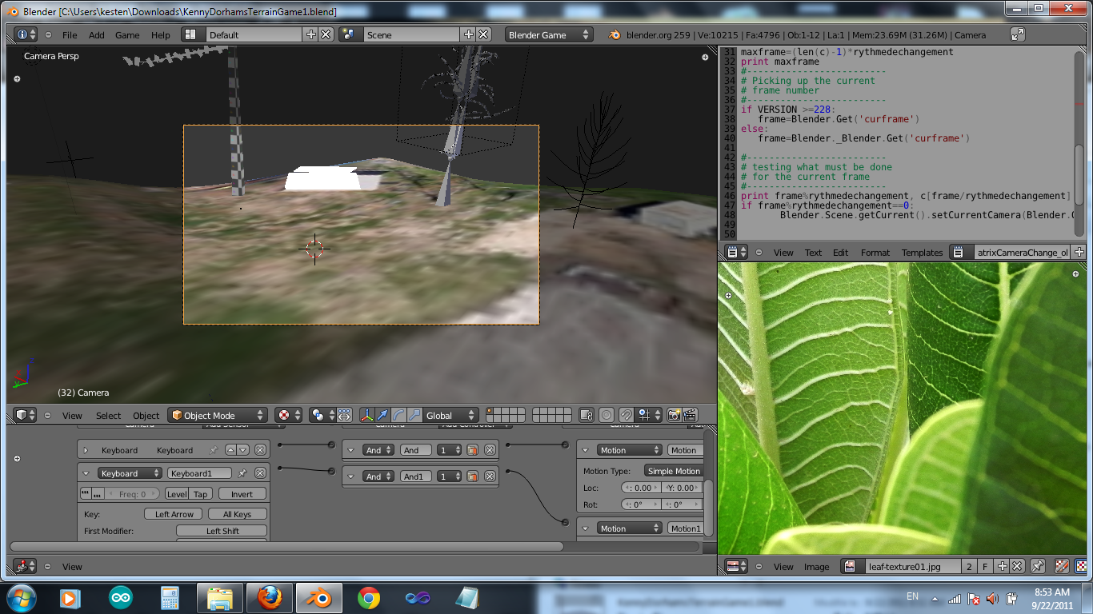
Download entire game folder from Media Fire.
Please report any bugs or problems with download to solarmobiletrailers@gmail.com or report them at https://github.com/darKoram

Playing the game requires that you install Blender from blender.org – it's free!
(will try to keep this up to date for those who don't use git)

This is the thread on blenderartists.org dsecribing the project

Introduction
The plan is a pretty simple game that I am using to teach myself more aspects of blender game programming. It would be a good opportunity if your main goal is to learn certain aspects of blender in a collaborative way, sharing your strengths while getting help from others where you get stuck. Game elements will be added depending on what you want to learn.
I was a physics engine coder for two years and shipped three titles, and am fairly comfortable with modifying blender c++ code and writing python scripts. My weakness is in the modeling and "making things look pretty" field. This game project will likely last about 2 months, at the end of which we will "ship" the game to all our friends. (Note that having shipped game experience is the most important part of getting hired at a game company).

Platform
Sept 2011. PC game. I have blender 2.59 installed on windows7. We will likely want to keep our versions in synch.
Game Concept
Kenny Dorham's Backyard is a real place in Austin Texas, live music capital of the USA. We need to make a concept sketch of the community garden/ sustainable technology park for presentation to the city. Our main challenge is all the permits required to do a pretty simple, positive thing. So the superVillan of the game is an old lady permit officer who comes around and gives you tickets for not having permits for all the fun things you want to do at Kenny Dorham's Backyard.
Select to play the game as one of three characters.
-Hippie with a flower cannon. Can shoot seeds or saplings of flowers, edibles or trees
Permit Lady gets you for not having a permit for flower cannon. We will use the new sapling addon and scripting to grow flowers and trees when the cannon is aimed at the right terrain. Our lot is not allowed to have any “permanent structures” added to it. So planting some peach trees and fig trees for shade may be in voilation of our lease.
-Conceptual artist installing sculptures (sample installations - bird feeder, fountain)
Bylaw violation will be specific to art piece (eg failure to apply for a scupture-of-a -horse permit). We want to have some speed modeling contests using Blender to create game elements.
Stage 1: Static Objects
Stage 2: Animated Objects
Stage 3: Objects with Logic Nodes
Stage 4: Objects controlled by scripts (AI)
Stage 5: Physics Objects

Stage 1 would be good for artistis looking to expand their modeling abilities and provide the game with some rich visuals.

Progressive states will provide some structure for those who want to learn more about scripting, game logic and artificial intelligence.
-Dragon. Can fly and breathe fire. What other magical dragon abilities should we have? Busted by permit lady for not having a fire permit. My plan is to borrow a nice dragon model and add the flying and special camera controllers.
Gameplay
Exploration: You can explore the elements of blender depending on the character.
Hippie will have exploration play related to environment modeling using generative tools like Sapling and BRIK.
Conceptual artist will have exploration play related to gameplay, scripting, logic
Dragon will have exporation play related to camera techniques and control of particle systems (fire) and developing flying and fire breathing skills.
Combat: The permit lady will write tickets on sticky-notes and throw them at the characters ninja-star style. If too many tickets sticks to you, the park is closed.
Hippie girl can defend with flower cannon flack and matrix-like slow motion dodging of permits. She can win by finding the correct giant stack of paperwork needed to get a permit application for her gardening and landscaping projects. Permit lady dissolves into dust like the wicked witch of the west if permit application is filed correctly.
Conceptual artist can buy time by distracting permit lady with his conceptual art. The more interesting the piece, the more time he gets to find a way to alter the gameplay, scripting, logic elements to eliminate the master villan.
Dragon can defend with expert flying and strong wind breath. Dragon can win by learning breath control techniques that allow it to aim its firebreath in a fine stream so as to scorch the permit pad in Permit Lady's hands without igniting Kenny Dorham's Backyard or singing Permit Ladys hair. Permit lady turns into giant Balrog and kills dragon like a flea if her hair gets singed.
Current Status
I used google earth to get a satellite view of the yard. I then deformed a mesh to emulate the apmitheatre bowl shape and added a live music stage. The texture of the ground is blurry and will be replaced by photos bit by bit, but the satellite view does give a good "grid" to work with. I've had a few professional photographers take pictures of the yard, the trees, the fences etc. Textures and materials is my particular weak point in blender though.

