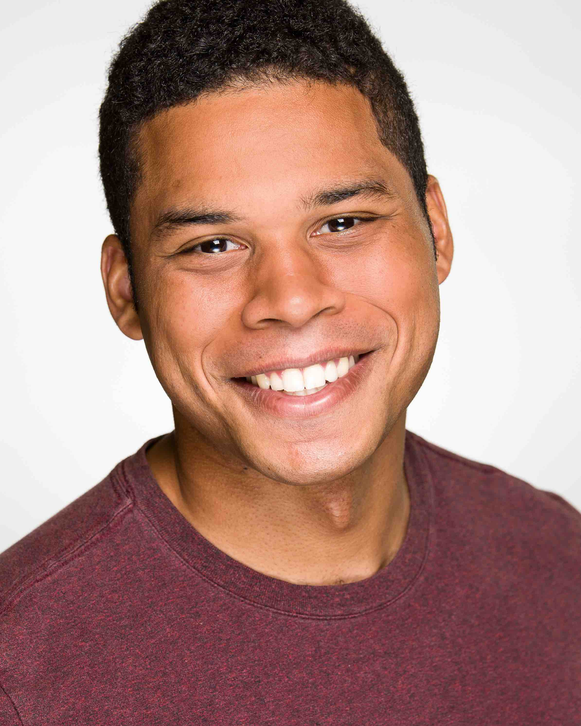DARA ANYA

**Full-Stack Web Developer**

Independent Web Developer with experience in back-end and front-end for

applications/websites using HTML/CSS, JavaScript, jQuery, Node.js, MySQL, React.js,

Material-UI, MongoDB, Mongoose, Sequelize and other programming languages.



[daraanya@gmail.com](mailto:daraanya@gmail.com) 713.367.4871 Texas, USA <https://www.linkedin.com/in/dara-anya/>



<https://github.com/dara-anya> <https://dara-anya.github.io/Professional-Portfolio/>

**Education**

University of Texas at Austin Austin, TX

*Bachelor of Science in Neuroscience* | *Elements of Computing Certificate* Graduated May 2016

University of Texas at Austin – Houston Coding Boot Camp Houston, TX

*Full-Stack Web Development Certificate* Achieved May 2019

**Projects**

**Who’s Calling Me?**

* A web application that calls APIs using Ajax and stores information in Firebase before displaying
* Enter a US phone number to determine its location and level of fraudulency
* Repository: <https://github.com/mjgardner/project1> | App: <https://mjgardner.github.io/project1/>

**Lebellum**

* An e-commerce web application framework to organize the selling of merchandise. Powered by Node.js, Express, MySQL, Sequelized and Stripe Checkout. Deployed to Heroku using JawsDB
* Piece of Cake is a small business that follows the Lebellum framework. Select from a variety of cupcakes available for purchase
* Repository: <https://github.com/dara-anya/Gangster_Squad> | App: <https://project2-lebellum.herokuapp.com/>

**Work Experience**

Resicom, Inc. Houston, TX

**Office Assistant** May 2018 – present

* Organize and update project documentation (insurance, quotes, contracts, etc.) for over five projects
* Schedule, coordinate and attend project and bid meetings with subcontractors and the clients
* Managed a $300,00 City of Houston Clearing and Grubbing project

Aspyr Media, Inc. Austin, TX

**Quality Assurance/ Compatibility Tester** July 2016 – Feb. 2018

* Successfully shipped, created, managed and supervised test cases and certification sweeps to

debug and evaluate the quality of two Triple-A game titles and four Triple-I game titles

* Ensured game functionality on different configurations of hardware and software
* Brainstormed and pitched ideas to Marketing and Production Teams to ensure games’ success