Immunological Memory & Tolerance to Self Antigens
Immunology — Lecture 13 (Dr Samira Abdul Wajid, WUSOM) · Tutor study guide built from your slides

How to read this guide
Label | What it means | Your responsibility
▌ FROM THE SLIDES | Content taken directly from the lecture (all 21 slides are covered) | Must know
▌ ADDITIONAL CONTEXT | Background added so the slide facts make sense | Know it well enough to reason
▌ HIGH-YIELD ADDITIONAL KNOWLEDGE | Not on the slides, but repeatedly tested on USMLE/NBME-style exams | Learn it

Your handwritten notes on these slides are accurate; where they point at something deeper ('why? somatic mutation', 'protein antigens are T-dependent'), the explanation is expanded in context.

Learning objectives (from the slides)
▌ FROM THE SLIDES
- Differentiate between primary and secondary immune responses.
- Understand how tolerance of self is established in the primary lymphoid organs and in the periphery.

Step 0 — The architecture before the facts
The title joins two topics that look unrelated — memory and tolerance — but they answer the two questions every adaptive immune system must solve:
Question | Answer in this lecture | What goes wrong if it fails
What must I NEVER attack? (self) | Tolerance: delete, edit, silence or suppress self-reactive lymphocytes | Autoimmunity (APS-1, IPEX, and the HLA-linked diseases from Lecture 10)
What have I fought BEFORE? (memory) | Memory cells → faster, bigger, better secondary response | Repeated infections; vaccines wouldn't work

Both topics are easiest to learn as the biography of one lymphocyte — where it is born, how it is tested at school, how it is controlled as an adult, and what happens when it meets its enemy once and then again:
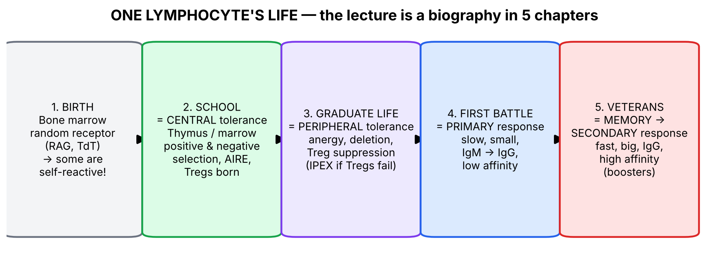
Figure 1. The lecture as a lymphocyte's life story. Every slide fits into one chapter.
💡 THE ORGANIZING PRINCIPLE
The root problem: T and B cells build their antigen receptors by randomly cutting and pasting gene segments (RAG enzymes) and adding random nucleotides (TdT). Randomness gives enormous diversity — enough to recognise almost any microbe — but it guarantees that some receptors will recognise self. Tolerance is the quality-control system that cleans up the dangerous products of this random process.
• Central tolerance = quality control at the factory (thymus, bone marrow) while the cell is immature.
• Peripheral tolerance = a security system in the field for the self-reactive cells that slipped past the factory.
• Memory = what remains after a successful response, so the next one is faster and better.

🧠 ANALOGY
Think of the thymus as a driving school. First test (positive selection): can you read the road signs (self-MHC)? If not, you fail and are discarded. Second test (negative selection): do you try to run over pedestrians (self-peptides)? If so, you are removed (or, for a few CD4 cells, retrained as traffic police = Tregs). Fewer than 5% of students graduate. Once on the road (periphery), rule-breakers are still caught: licence suspended (anergy), arrested (deletion), or kept in check by police (Treg suppression).

Section 1 — T-cell development in the thymus (slides 8, 9, 14, 15)

1.1 Big picture
T-cell precursors are born in the bone marrow but cannot mature there. They migrate to the thymus, where they build their TCR and are tested. The stages of development are defined mainly by the successive steps in the assembly and expression of functional antigen-receptor genes (slide 14) — in other words, each stage is named by which receptor pieces and co-receptors the cell has switched on.
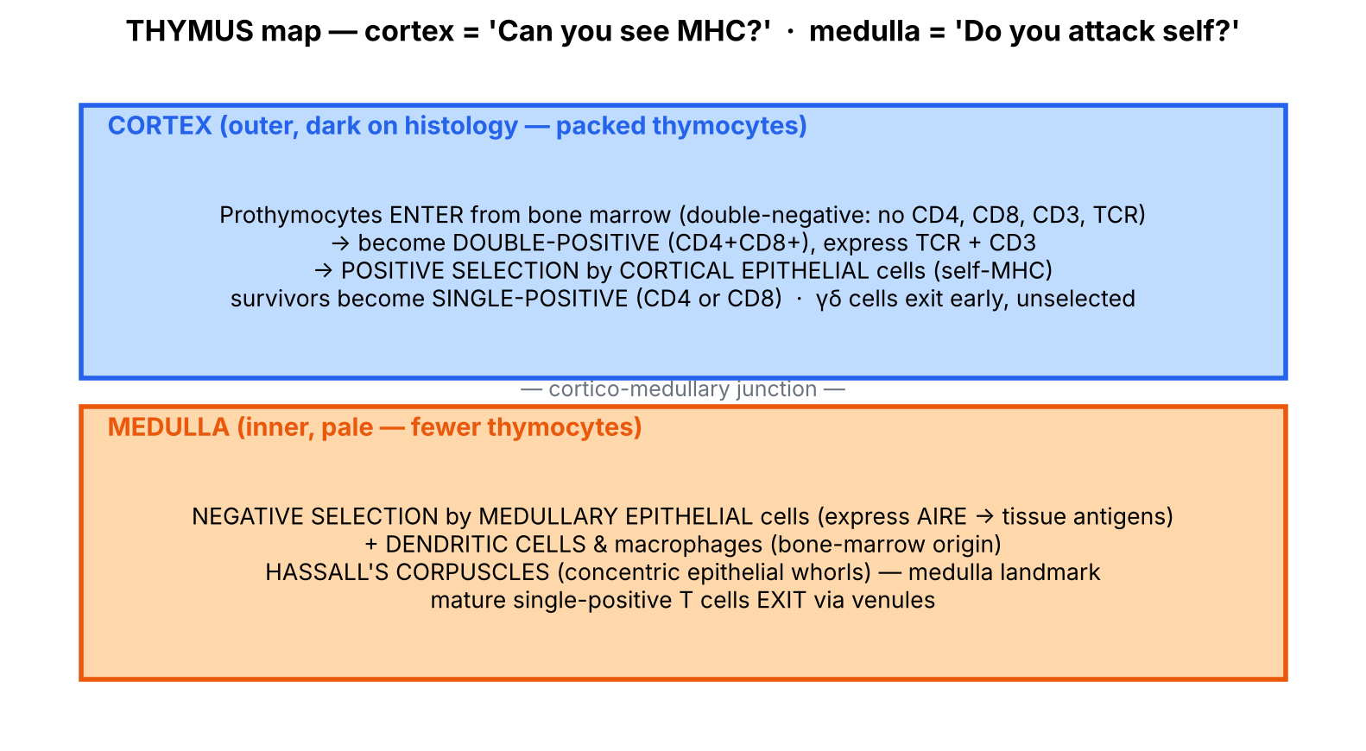
Figure 2. Thymus layout (simplified from slide 8): cortex = positive selection, medulla = negative selection.

1.2 What the slides say
▌ FROM THE SLIDES
Slide 8 — Thymus structure (diagram labels): capsule, trabeculae, cortex (subcapsular epithelium, cortical epithelial cells, thymocytes of bone-marrow origin), cortico-medullary junction, medulla (medullary epithelial cells, dendritic cells and macrophages of bone-marrow origin, Hassall's corpuscle).
Slide 9 — Stages of thymocyte development:
- Precursor cells (prothymocytes) arrive from the bone marrow as double-negative (DN) cells that do not express CD4, CD8, CD3 or TCR, and enter the cortical region.
- DN cells proliferate and differentiate into double-positive (DP) thymocytes expressing both CD4 and CD8 plus CD3 and TCR (as they migrate from cortex toward medulla they express TCR and accessory molecules).
- DP cells die within 3–4 days unless they recognize pMHC I (engaging CD8) or pMHC II (engaging CD4) on cortical epithelial cells — positive selection (within the cortex, for αβ thymocytes).
- Thymocytes surviving positive selection express only CD4 or only CD8 (plus CD3 and TCR) = single-positive.
- Medullary thymocytes that interact strongly with self-peptides on MHC I or MHC II of APCs undergo apoptotic death — negative selection — to remove potentially autoreactive cells.
- Mature single-positive thymocytes cross the endothelium of a venule and exit the thymus as T cells.
- γδ thymocytes exit quickly from the thymus: they express TCR and CD3, may or may not express CD4 or CD8, and exit without undergoing positive or negative selection.
Slide 15 — Markers across development:
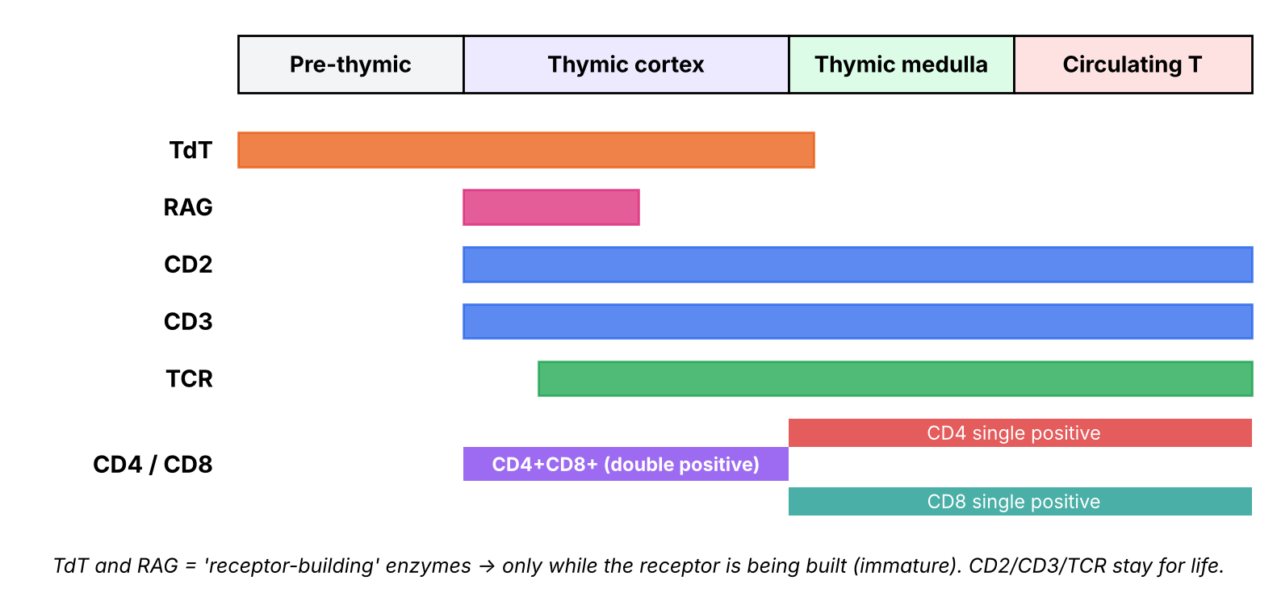
Figure 3. Marker timeline (redrawn from slide 15).
Marker | Pre-thymic | Thymic cortex | Thymic medulla | Circulating T cell
TdT | ✔ | ✔ | fades at junction | —
RAG | — | ✔ (early cortex only) | — | —
CD2 | — | ✔ | ✔ | ✔
CD3 | — | ✔ | ✔ | ✔
TCR | — | ✔ (slightly after CD3) | ✔ | ✔
CD4 / CD8 | — | CD4+CD8+ (double positive) | CD4 or CD8 (single positive) | CD4 or CD8

- T-cell markers are useful for identifying differentiation stages and for characterizing T-cell leukemias and lymphomas.
▌ ADDITIONAL CONTEXT
- Why do TdT and RAG switch off? They are the receptor-building tools. RAG1/RAG2 cut DNA to join V, D, J segments; TdT (terminal deoxynucleotidyl transferase) adds random nucleotides at the joints for extra diversity. Once a cell has a working, tested receptor, continuing to cut DNA would be dangerous, so the tools are put away. That is why TdT marks immature lymphocytes only.
- Why is the cortex dark and the medulla pale on histology? The cortex is crammed with small, dark-nucleus thymocytes (most of which die there); the medulla has fewer, more mature thymocytes plus pale epithelial cells and Hassall's corpuscles.
- Who does the testing? Cortical epithelial cells test positive selection; medullary epithelial cells (with AIRE) and bone-marrow-derived dendritic cells test negative selection.
▌ HIGH-YIELD ADDITIONAL KNOWLEDGE
- TdT+ blasts = acute lymphoblastic leukemia (ALL). T-ALL classically presents in an adolescent male with a mediastinal (thymic) mass — the leukemia cells are 'stuck' at a thymic stage (TdT+, CD2/CD3/CD7+, often CD4+CD8+).
- DiGeorge syndrome (22q11.2 deletion): the thymus and parathyroids come from the 3rd (and 4th) pharyngeal pouches → thymic aplasia → ↓T cells (no school), plus hypocalcemia (no parathyroids), conotruncal heart defects, abnormal facies. Absent thymic shadow on chest X-ray.
- RAG1/RAG2 deficiency → no TCR or BCR can be built → SCID with absent T and B cells (T−B−NK+).
- Thymoma is associated with myasthenia gravis (thymic negative selection goes wrong → anti-AChR).
🩺 CLINICAL CORRELATION
• Adolescent boy with dyspnea, superior vena cava syndrome, mediastinal mass and lymphoblasts that are TdT+, CD3+ → T-ALL (thymic stage).
• Infant with tetany, a cardiac outflow-tract defect and recurrent viral/fungal infections → DiGeorge (no thymus → no T-cell 'school').
• Flow cytometry uses exactly the markers on slide 15 (CD2, CD3, CD4, CD8, TdT) to classify leukemias and lymphomas.

🎯 EXAM FOCUS
• Prothymocytes = double negative (no CD4, CD8, CD3, TCR) → enter cortex.
• DP (CD4+CD8+) in cortex → positive selection on cortical epithelial cells → SP (CD4 or CD8).
• Negative selection in medulla (strong binding → apoptosis).
• γδ T cells leave early without positive or negative selection.
• TdT and RAG = immature markers; CD2, CD3, TCR persist.

⚠️ COMMON MISTAKES
• Swapping locations: positive = cortex, negative = medulla. (Mnemonic built on order: you meet the cortex first and the first test is the positive one.)
• Thinking DN means 'CD4−CD8− but TCR+' — slide-9 DN cells lack CD3 and TCR too.
• Thinking γδ T cells undergo the same selection — they don't (slide 9).
• Calling TdT a T-cell-specific marker — it marks immature T and B lymphoblasts.

Section 1 — Practice questions
Q1. [MCQ] A thymocyte in the outer cortex expresses CD4, CD8, CD3 and an αβ TCR. What is its developmental stage and next test?
A. Double negative; TCR gene rearrangement
B. Double positive; positive selection on cortical epithelial cells
C. Single positive; exit to periphery
D. Double positive; negative selection by B cells
E. Single positive; positive selection in the medulla

✅ ANSWER & EXPLANATION
B. DP thymocytes in the cortex undergo positive selection on cortical epithelial cells; survivors become single positive and move to the medulla for negative selection.

Q2. [MCQ] Which marker is present in pre-thymic and cortical thymocytes but lost in mature circulating T cells?
A. CD2
B. CD3
C. TCR
D. TdT
E. CD4

✅ ANSWER & EXPLANATION
D — TdT (slide 15). CD2, CD3 and TCR persist into circulating T cells.

Q3. [Clinical vignette] A 16-year-old boy has facial swelling and dyspnea. CT shows an anterior mediastinal mass; blood smear shows lymphoblasts that are TdT+, CD3+, CD4+ and CD8+. Interpret the markers.

✅ ANSWER & EXPLANATION
T-cell acute lymphoblastic leukemia (T-ALL). TdT = immature lymphoid cell (receptor still being built); CD3 = T lineage; CD4+CD8+ = double-positive cortical thymocyte stage (slide 15). The mediastinal mass is the thymus. This is exactly why the slide says markers characterize T-cell leukemias/lymphomas.

Q4. [Short answer] List the six steps of αβ thymocyte development from slide 9.

✅ ANSWER & EXPLANATION
(1) DN prothymocytes arrive from marrow; (2) DN → DP (CD4+CD8+, CD3, TCR); (3) DP die in 3–4 days unless they recognize pMHC on cortical epithelium (positive selection); (4) survivors become SP (CD4 or CD8); (5) medullary thymocytes binding self-peptide–MHC strongly die (negative selection); (6) mature SP cells exit via venules.

Q5. [Mechanism] Why would a RAG1 deficiency abolish both T and B cells but spare NK cells?

✅ ANSWER & EXPLANATION
RAG1/2 perform V(D)J recombination needed to build both TCRs and BCRs; without a receptor, T and B cells cannot pass developmental checkpoints and die. NK cells use germline-encoded receptors that need no recombination, so they develop normally (T−B−NK+ SCID).

Section 2 — Central tolerance: selection, MHC restriction, AIRE and B cells (slides 3, 4, 6, 7, 10, 11, 16)

2.1 The two arenas of tolerance (slides 3–4)
▌ FROM THE SLIDES
Immunologic tolerance to different self antigens may be induced when developing lymphocytes encounter these antigens in:
- Generative (central) lymphoid organs — a process called central tolerance; or
- When mature lymphocytes encounter self antigens in peripheral (secondary) lymphoid organs or peripheral tissues — peripheral tolerance.
Slide 4: Central tolerance — immature lymphocytes specific for self antigens may encounter them in the generative organs (thymus, bone marrow) and are deleted; B lymphocytes may change their specificity (receptor editing); and some T lymphocytes develop into regulatory T cells. Some self-reactive lymphocytes may complete maturation and enter peripheral tissues. Peripheral tolerance — mature self-reactive lymphocytes may be inactivated (anergy) or deleted by encounter with self antigens in peripheral tissues, or suppressed by regulatory T cells.
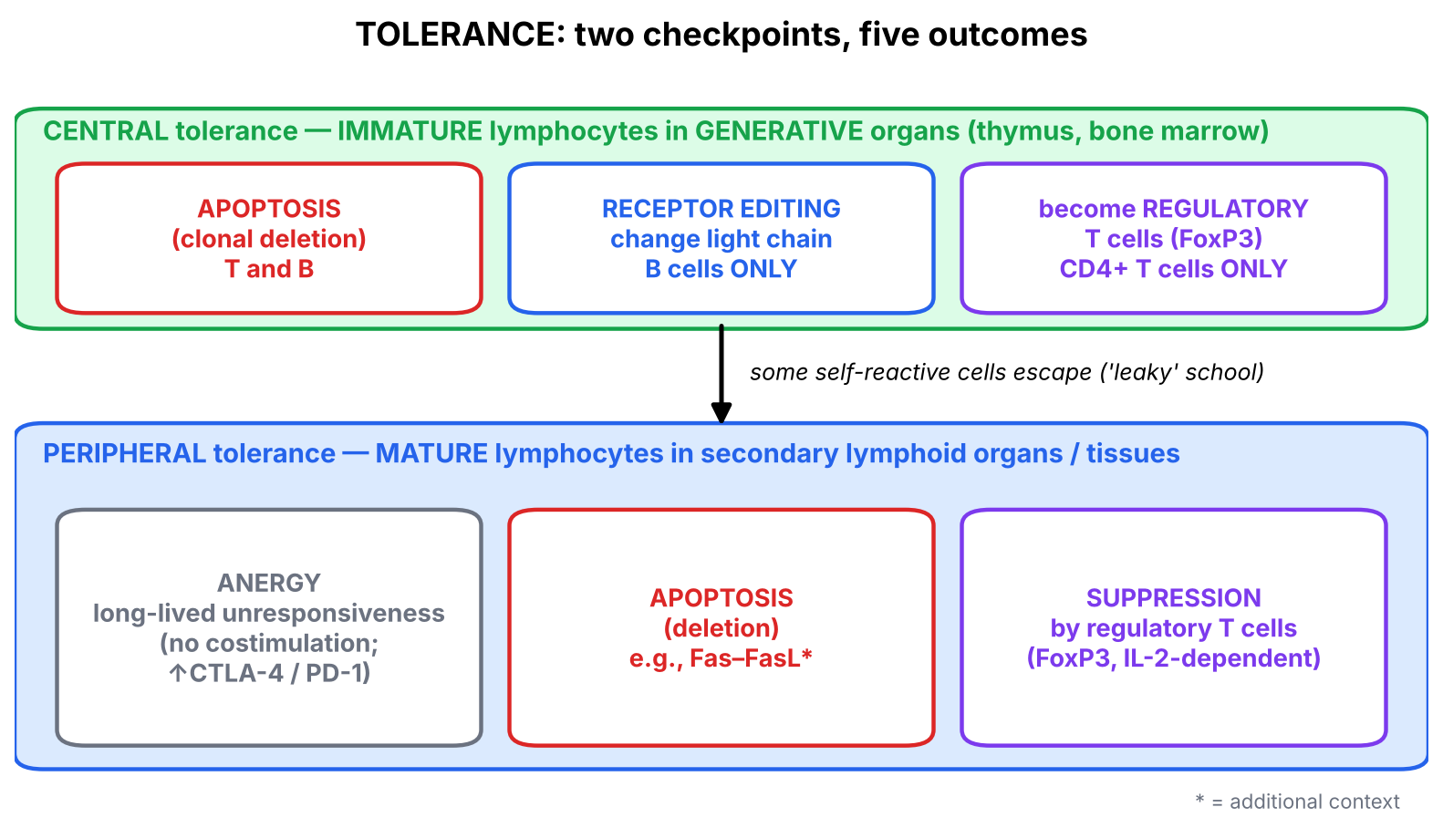
Figure 4. Central vs peripheral tolerance — six boxes to remember (redrawn from slide 4).
 | Central tolerance | Peripheral tolerance
Where | Generative organs: thymus (T), bone marrow (B) | Secondary lymphoid organs and peripheral tissues
Which cells | Immature lymphocytes | Mature lymphocytes
Outcomes | Deletion (apoptosis); receptor editing (B only); Treg development (CD4 T only) | Anergy; deletion (apoptosis); suppression by Tregs
Why both exist | Not every self-antigen is present in the thymus/marrow → some self-reactive cells escape | Catches the escapees in the tissues where their antigen actually lives

2.2 Positive and negative selection (slides 6–7, 10)
▌ FROM THE SLIDES
- Positive and negative selection ensure that mature T cells will be MHC-restricted and self-tolerant, respectively.
- Less than 5% of thymocytes survive these selection processes.
- If anything goes wrong with negative selection → autoimmune diseases. (Your note: another reason for autoimmunity is HLA inheritance — links straight to the HLA-disease table in Lecture 10.)
Positive selection: T cells able to recognize (bind) MHC molecules are selected to survive; others undergo apoptosis/clonal deletion in the thymus.
Negative selection: deletion of self-reactive T cells. T cells that avidly bind self-peptide in association with MHC (may include proteins abundant throughout the body, e.g., plasma proteins and common cellular proteins) are not selected — most undergo apoptosis/clonal deletion; a few survive as regulatory T cells. Those that do not bind to self-peptide survive.
Slide 10 — MHC restriction: antigen recognition in association with a 'self' MHC protein is called MHC restriction and is a result of positive thymic selection. The self MHC molecule presents foreign peptide to a T cell that was selected to recognize self-MHC weakly, but which may recognize self MHC–foreign peptide complexes well.
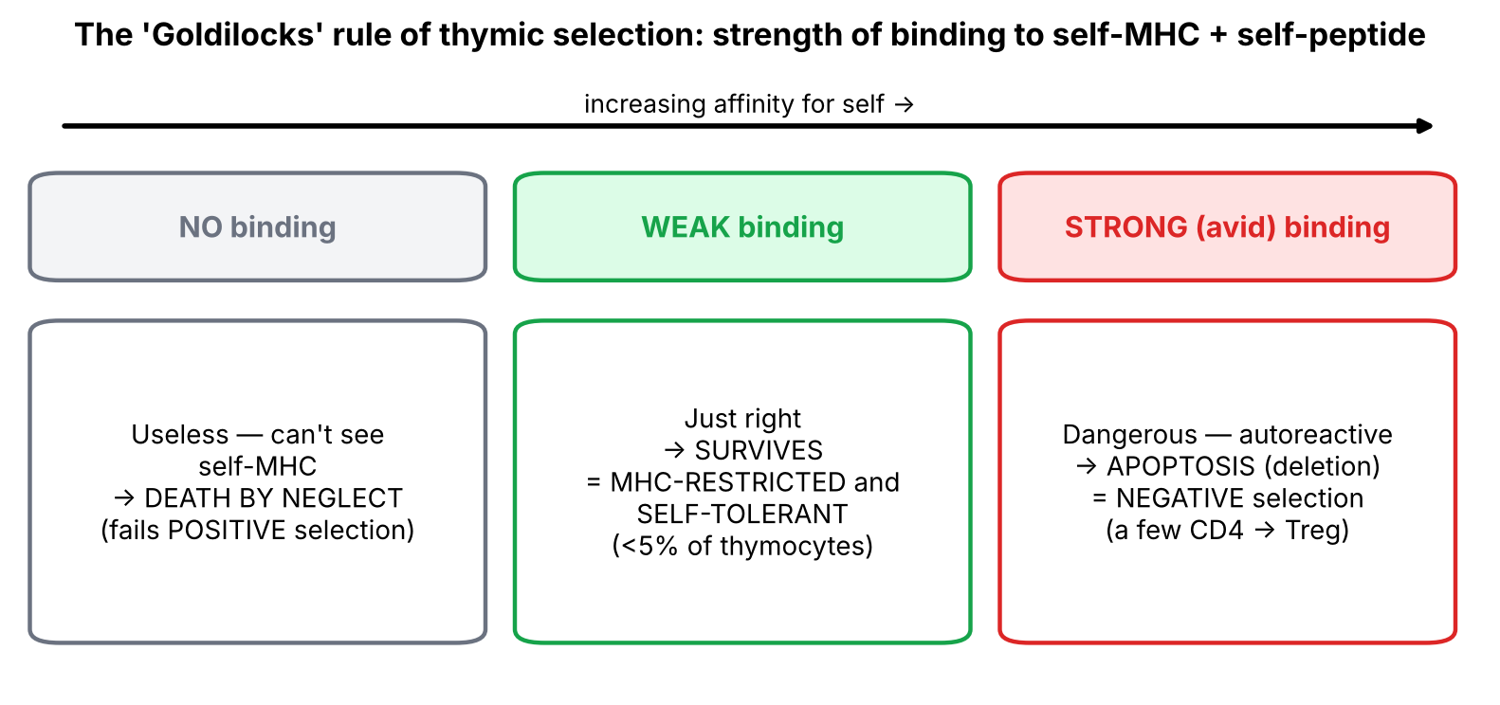
Figure 5. The 'Goldilocks' rule: too weak → death by neglect, too strong → deletion, just right → survive.
▌ ADDITIONAL CONTEXT
Your slide-6 notes, condensed: positive selection ensures MHC restriction (T cells can only recognise antigen presented by MHC molecules they were selected on — 'self-MHC'); negative selection eliminates thymocytes with high affinity for self-antigen–self-MHC, preventing autoimmunity; failure → autoreactive T cells escape.
Why must T cells be MHC-restricted? A T cell is useless if it can't 'see' the MHC display windows on your own cells (Lecture 10). Positive selection keeps only the T cells whose TCR fits your MHC shapes. Because your thymus uses your HLA alleles, every surviving T cell is tuned to your HLA — and this is also why foreign HLA (transplant) looks so provocative.
Where does CD4 vs CD8 come from? During positive selection, a DP cell whose TCR binds MHC II keeps CD4; one whose TCR binds MHC I keeps CD8 (the rule of 8 from Lecture 10). That is why MHC II deficiency (BLS type 2) produces no CD4 cells.

2.3 AIRE — showing the thymus every organ (slide 11)
▌ FROM THE SLIDES
- Tissue-restricted antigens — self proteins normally present only in certain peripheral tissues — are also expressed in some epithelial cells of the thymus. A protein called AIRE (autoimmune regulator) is responsible.
- Mutations in the AIRE gene → autoimmune polyendocrine syndrome.
- In this rare disorder, several tissue antigens are not expressed in the thymus, so immature T cells specific for them are not eliminated and do not develop into regulatory cells.
- These cells mature into functionally competent T cells that enter peripheral tissues and react harmfully against the tissue-restricted antigens, which are expressed normally in the appropriate peripheral tissues.
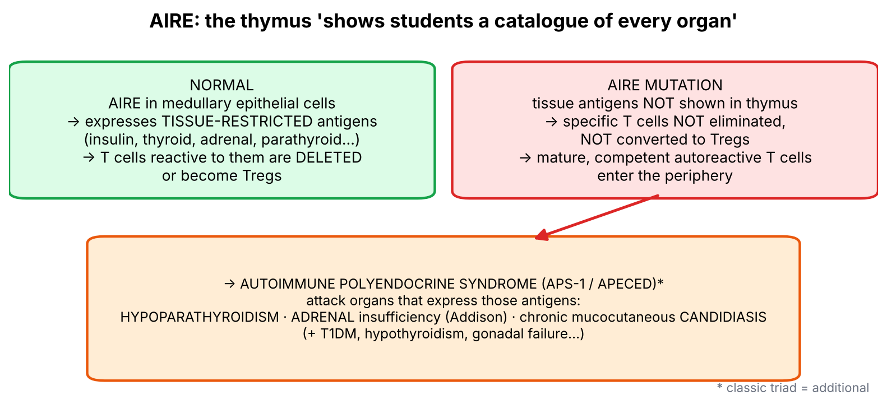
Figure 6. AIRE normal function and failure.
▌ ADDITIONAL CONTEXT
The problem AIRE solves: negative selection can only delete T cells against antigens that are present in the thymus. Insulin lives in the pancreas, thyroglobulin in the thyroid — so how would the thymus ever test against them? AIRE is a transcription regulator in medullary thymic epithelial cells that switches on a 'catalogue' of organ-specific genes, so developing T cells meet these antigens at school.
▌ HIGH-YIELD ADDITIONAL KNOWLEDGE
- APS-1 / APECED (autoimmune polyendocrinopathy–candidiasis–ectodermal dystrophy), autosomal recessive AIRE mutation. Classic triad: chronic mucocutaneous candidiasis, hypoparathyroidism, adrenal insufficiency (Addison disease). The candidiasis is explained by autoantibodies against IL-17 and IL-22 — the Th17 cytokines needed against Candida (Lecture 11–12).
- Compare with IPEX (Section 3): AIRE = failure of central tolerance (deletion of tissue-specific T cells); IPEX = failure of peripheral suppression (no Tregs). Both cause polyendocrinopathy.

2.4 B-cell central tolerance (slide 16)
▌ FROM THE SLIDES
- Stem cells in the bone marrow generate a host of B lymphocytes.
- Each newly formed B cell randomly generates a BCR.
- When B cells bind too strongly to stromal cells (autoantigens), they are induced to undergo apoptosis/clonal deletion.
- Only cells with low affinity to self molecules in the bone marrow progress to the mature, naive B-cell stage (→ blood → spleen).
From slide 4: B lymphocytes may also change their specificity by receptor editing (B cells only).
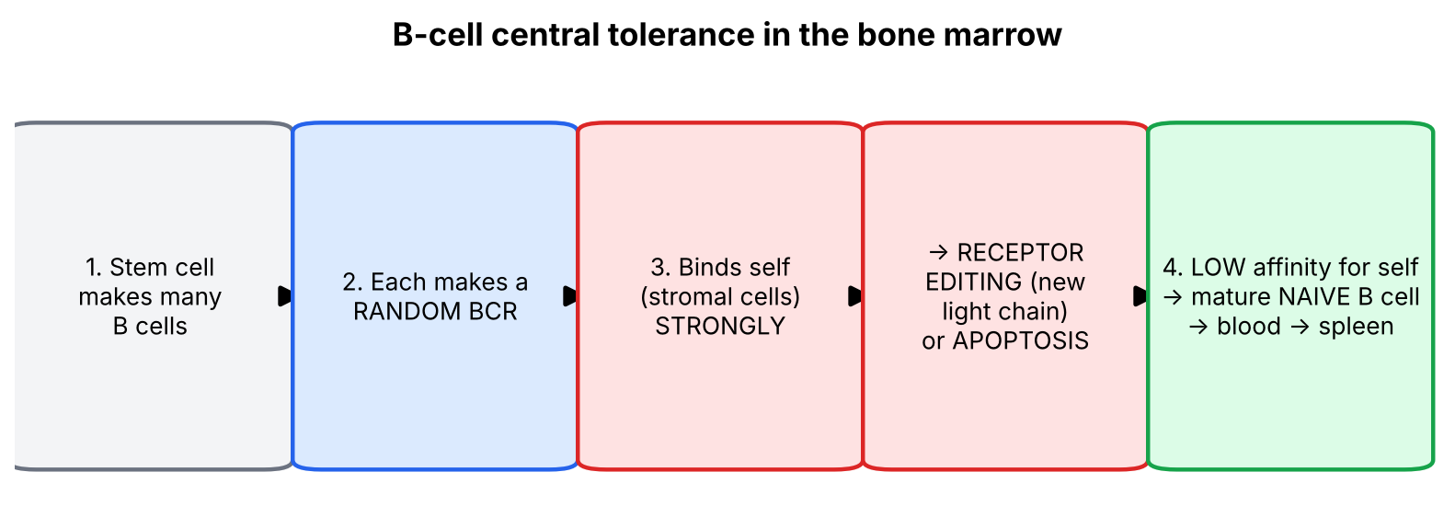
Figure 7. B-cell central tolerance (slide 16 + receptor editing from slide 4).
▌ ADDITIONAL CONTEXT
Receptor editing: a self-reactive immature B cell reactivates RAG and rearranges a new light chain — 'a second chance' to make a non-self-reactive BCR before being deleted. T cells can't do this (no receptor editing in T-cell central tolerance per slide 4).
Feature | T cells (thymus) | B cells (bone marrow)
Positive selection on self-MHC | Yes (cortex) | Not described in this lecture
Deletion of strongly self-reactive cells | Yes (medulla) | Yes
Receptor editing | No | Yes
Become regulatory cells | Yes (CD4 → Treg) | No
Survival requirement | Weak binding to self-MHC; not strong binding to self-peptide | Low affinity to self

🩺 CLINICAL CORRELATION
• APS-1 (AIRE): child with chronic oral thrush, then tetany (hypocalcemia from hypoparathyroidism), then fatigue/hypotension/hyperpigmentation (Addison).
• Myasthenia gravis with thymoma/thymic hyperplasia: abnormal thymus → faulty negative selection → anti-AChR antibodies; thymectomy can help.
• HLA + failed tolerance = autoimmunity: your note links this to HLA inheritance — HLA alleles (e.g., DR3/DR4 in T1DM) shape which self-peptides are presented during selection and in the periphery.

🎯 EXAM FOCUS
• Central tolerance outcomes: deletion, receptor editing (B only), Tregs (CD4 T only).
• Positive selection → MHC restriction; negative selection → self-tolerance; failure of negative selection → autoimmunity.
• < 5% of thymocytes survive.
• AIRE → tissue-restricted antigens in thymic epithelium; mutation → autoimmune polyendocrine syndrome.
• B cells: strong binding to self → apoptosis/clonal deletion (or editing); low affinity → naive B cell.

⚠️ COMMON MISTAKES
• Saying positive selection makes T cells 'self-tolerant' — it makes them MHC-restricted; negative selection makes them self-tolerant.
• Thinking cells that fail positive selection are 'autoreactive' — they simply can't see MHC (death by neglect).
• Forgetting that a few strongly self-reactive CD4 cells become Tregs rather than dying.
• Thinking AIRE works in the bone marrow or periphery — it acts in thymic medullary epithelium.
• Attributing receptor editing to T cells — B cells only.

Section 2 — Practice questions
Q1. [MCQ] A thymocyte's TCR binds strongly to a self-peptide presented on MHC II by a medullary dendritic cell. What is the most likely fate?
A. Positive selection into CD8+
B. Apoptosis, or differentiation into a regulatory T cell
C. Receptor editing of its light chain
D. Exit to periphery as a naive CD4+ T cell
E. Differentiation into a γδ T cell

✅ ANSWER & EXPLANATION
B. Strong (avid) binding in the medulla → negative selection; most die, a few become Tregs. Receptor editing (C) is a B-cell mechanism.

Q2. [MCQ] MHC restriction of T cells is the direct result of:
A. Negative selection in the medulla
B. Positive selection in the cortex
C. AIRE expression
D. Receptor editing
E. Anergy

✅ ANSWER & EXPLANATION
B (slide 10).

Q3. [Clinical vignette] A 9-year-old girl has had oral thrush since infancy. She now presents with carpopedal spasm (low calcium, low PTH) and later develops hyperpigmentation and hypotension. Which gene is most likely mutated and what tolerance mechanism failed?

✅ ANSWER & EXPLANATION
AIRE. Without AIRE, medullary thymic epithelial cells don't express tissue-restricted antigens (parathyroid, adrenal…), so T cells specific for them are neither deleted nor converted to Tregs → autoimmune polyendocrine syndrome (APS-1: candidiasis, hypoparathyroidism, Addison). This is a failure of central tolerance.

Q4. [Short answer] Name the three outcomes of central tolerance and which lymphocyte type each applies to.

✅ ANSWER & EXPLANATION
Deletion/apoptosis (T and B); receptor editing (B cells only); development into regulatory T cells (CD4+ T cells only).

Q5. [Mechanism] Why would a person's T cells respond poorly to foreign peptides presented on another person's MHC in one sense, yet strongly attack a transplanted organ in another?

✅ ANSWER & EXPLANATION
Positive selection tunes T cells to recognize foreign peptides on self-MHC (MHC restriction), so they don't efficiently 'read' peptides in foreign MHC grooves the normal way. However, foreign MHC molecules themselves were never present during negative selection, so many T cells cross-react with them strongly (alloreactivity) → rejection.

Section 3 — Peripheral tolerance: anergy, regulatory T cells and IPEX (slides 4, 5, 12, 13)

3.1 Big picture
Central tolerance is 'leaky': some self-reactive cells always escape (slide 4). Peripheral tolerance provides three safeguards for mature lymphocytes: switch them off (anergy), kill them (deletion), or have another cell hold them back (Treg suppression).

3.2 What is anergy? (slide 5)
▌ FROM THE SLIDES
- Anergy in T cells = long-lived functional unresponsiveness induced when these cells recognize self antigen.
- Self antigens are normally displayed with low levels of costimulators.
- Anergic cells survive but are incapable of responding to the antigen.
The two best-defined mechanisms of anergy:
- When T cells recognize antigens without costimulation, the TCR complex may lose its ability to transmit activating signals.
- On recognition of self antigens, T cells may express higher levels of inhibitory receptors, CTLA-4 or PD-1, which inhibit responses to subsequent antigen recognition.
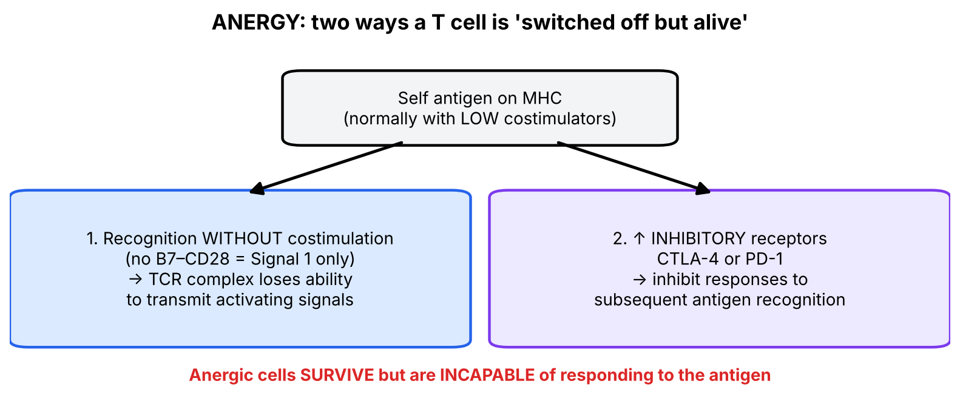
Figure 8. Two routes to anergy (slide 5).
▌ ADDITIONAL CONTEXT
Connect to Lecture 11–12: Signal 1 (TCR–MHC/peptide) + Signal 2 (CD28–B7) = activation. Healthy tissues and resting APCs show self-peptides without B7, so a self-reactive T cell that meets them receives Signal 1 alone → anergy. B7 appears only when APCs sense microbes. This is how the immune system 'knows' to respond to infection but ignore self.
Peripheral deletion (slide 4) — not detailed on the slides — occurs mainly through apoptosis, e.g., repeated stimulation induces Fas and FasL, and Fas–FasL engagement kills the chronically activated cell (activation-induced cell death).
▌ HIGH-YIELD ADDITIONAL KNOWLEDGE
- Checkpoint-inhibitor autoimmunity: anti-CTLA-4 (ipilimumab) and anti-PD-1 (nivolumab, pembrolizumab) remove anergy-maintaining brakes → colitis, hepatitis, thyroiditis, hypophysitis, T1DM.
- CTLA-4 haploinsufficiency → lymphoproliferation and multi-organ autoimmunity; abatacept (CTLA-4-Ig) is used to treat it and RA.
- Fas mutation → ALPS (autoimmune lymphoproliferative syndrome): failure of peripheral deletion → lymphadenopathy, splenomegaly, autoimmune cytopenias, ↑ CD4−CD8− (double-negative) αβ T cells in blood.

3.3 Regulatory T cells (slide 12)
▌ FROM THE SLIDES
- CD4+ T cells that recognize self antigens may differentiate into regulatory cells in the thymus or peripheral tissues and suppress the activation of potentially harmful lymphocytes specific for these self antigens, in a process dependent on the transcription factor FoxP3.
- These regulatory cells inhibit the activation of naive T cells and their differentiation into effector T cells by contact-dependent mechanisms or by secreting cytokines that inhibit T-cell responses.
- Figure: Tregs also cause inhibition of other cells (B cells, NK cells).
- The generation and maintenance of regulatory T cells also require IL-2.
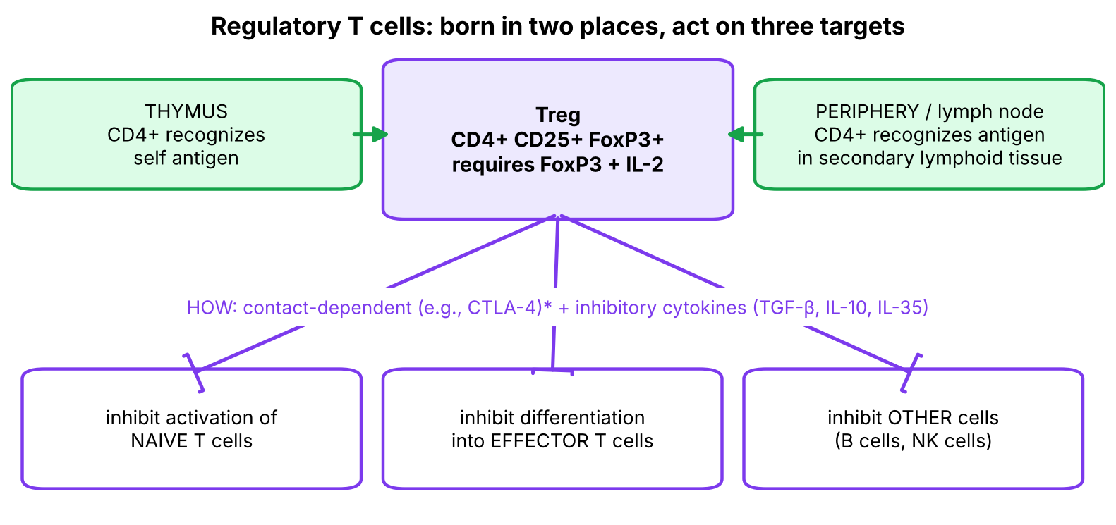
Figure 9. Treg origin and targets (redrawn from slide 12).
▌ ADDITIONAL CONTEXT
- Treg identity (from Lecture 11–12, slide 17): CD3+ CD4+ CD25+ FoxP3+; induced by TGF-β + IL-2; secrete TGF-β, IL-10, IL-35; inhibited by IL-6.
- How do Tregs suppress? (a) Cytokines: IL-10 and TGF-β calm APCs and T cells; (b) CTLA-4 on Tregs strips B7 from APCs → neighbouring T cells can't get Signal 2; (c) high-affinity CD25 (IL-2Rα) soaks up IL-2, starving effector T cells of their growth factor.
- Why does a Treg need IL-2 even though IL-2 is a T-cell growth factor? IL-2 is made by activated effector T cells — so the more the immune system is activated, the more IL-2 is available to maintain Tregs. It is a built-in negative feedback loop. (Paradox to remember: IL-2 deficiency causes autoimmunity, not just immunodeficiency.)

3.4 IPEX syndrome (slide 13)
▌ FROM THE SLIDES
- IPEX = Immune dysregulation, Polyendocrinopathy, Enteropathy, X-linked.
- Mutations of the gene encoding FoxP3 cause this systemic, multiorgan autoimmune disease, demonstrating the importance of FoxP3+ regulatory T cells for the maintenance of self-tolerance.
Characterized by: autoimmune endocrine conditions (e.g., type 1 DM); chronic diarrhea; eczema; Treg cells absent.
FOXP3 mutation (X-linked → boys)
↓
No functional regulatory T cells (Treg absent)
↓
Self-reactive T cells that escaped central tolerance are no longer suppressed
↓
Immune DYSREGULATION — attacks on many organs:
Endocrine (Polyendocrinopathy): β-cells → T1DM in infancy; thyroid
Gut (Enteropathy): intractable chronic diarrhea, failure to thrive
Skin: eczema
↓
Diagnosis: absent CD4+CD25+FOXP3+ cells by flow cytometry; FOXP3 sequencing
Treatment: immunosuppression; hematopoietic stem cell transplant (curative)

AIRE vs IPEX — the most likely comparison question
Feature | APS-1 (AIRE mutation) | IPEX (FOXP3 mutation)
Tolerance arm that fails | Central (thymic deletion of tissue-specific T cells + Treg generation) | Peripheral suppression (no Tregs)
Inheritance | Autosomal recessive (added) | X-linked (boys)
Onset | Childhood (added) | Infancy (added)
Hallmarks | Candidiasis, hypoparathyroidism, Addison (added) | T1DM, chronic diarrhea, eczema, Treg absent
Shared theme | Polyendocrine autoimmunity | Polyendocrine autoimmunity

🩺 CLINICAL CORRELATION
• IPEX: male infant with watery diarrhea, eczema and insulin-dependent diabetes in the first months of life → check FOXP3 Tregs.
• Checkpoint-inhibitor colitis/thyroiditis = iatrogenic loss of peripheral tolerance.
• Low-dose IL-2 therapy is being studied to expand Tregs in autoimmune disease — logical consequence of slide 12 ('Tregs require IL-2').
• Calcineurin inhibitors (tacrolimus) reduce IL-2 → can impair Tregs as well as effectors.

🎯 EXAM FOCUS
• Anergy = long-lived functional unresponsiveness after recognizing self antigen; cells survive; mechanisms: no costimulation and ↑ CTLA-4 / PD-1.
• Tregs: CD4+, FoxP3-dependent, made in thymus or periphery, inhibit naive T activation and effector differentiation (contact-dependent + cytokines), also inhibit B and NK cells; require IL-2.
• IPEX = FOXP3 mutation: endocrine autoimmunity (T1DM), chronic diarrhea, eczema, Tregs absent.

⚠️ COMMON MISTAKES
• Confusing anergy (cell alive but unresponsive) with deletion (cell dies).
• Thinking self-antigens are presented with high costimulation — they are displayed with low costimulators.
• Thinking Tregs are CD8+ — they are CD4+ (CD25+, FoxP3+).
• Mixing up IPEX (FOXP3, peripheral) with APS-1 (AIRE, central).
• Forgetting IL-2's dual role: drives effector expansion and maintains Tregs.

Section 3 — Practice questions
Q1. [MCQ] A self-reactive T cell recognizes its antigen on a pancreatic β cell that expresses MHC I but no B7. What is the expected outcome?
A. Clonal expansion
B. Anergy
C. Receptor editing
D. Differentiation into Th17
E. Memory formation

✅ ANSWER & EXPLANATION
B. Recognition without costimulation → TCR complex loses ability to transmit activating signals → anergy (slide 5).

Q2. [MCQ] Which transcription factor is essential for regulatory T-cell function, and which cytokine do Tregs require for generation and maintenance?
A. T-bet; IL-12
B. GATA3; IL-4
C. FoxP3; IL-2
D. RORγt; IL-6
E. AIRE; IL-10

✅ ANSWER & EXPLANATION
C (slide 12).

Q3. [Clinical vignette] A 4-month-old boy has severe watery diarrhea, a scaly eczematous rash and hyperglycemia requiring insulin. His maternal uncle died in infancy with similar features. Flow cytometry shows no CD4+CD25+FOXP3+ cells. Diagnosis and mechanism?

✅ ANSWER & EXPLANATION
IPEX syndrome — X-linked FOXP3 mutation (maternal uncle affected) → absent Tregs → self-reactive T cells escape peripheral suppression → polyendocrinopathy (T1DM), enteropathy (diarrhea), eczema (slide 13).

Q4. [Short answer] Give the two best-defined mechanisms of T-cell anergy.

✅ ANSWER & EXPLANATION
(1) Antigen recognition without costimulation → TCR complex loses its ability to transmit activating signals. (2) Recognition of self antigen → ↑ inhibitory receptors CTLA-4 or PD-1 → inhibit responses to subsequent antigen recognition.

Q5. [Mechanism] Explain why a patient treated with pembrolizumab (anti-PD-1) for lung cancer might develop new hypothyroidism.

✅ ANSWER & EXPLANATION
PD-1 upregulation on self-reactive T cells is one mechanism maintaining anergy (slide 5). Blocking PD-1 releases this brake → previously anergic thyroid-reactive T cells become active → autoimmune thyroiditis → hypothyroidism (immune-related adverse event).

Section 4 — Immunological memory: primary vs secondary responses (slides 17–21)

4.1 Big picture
Immunological memory is the ability of the immune system to respond more rapidly and effectively to a pathogen that has been encountered previously (slide 20). Your note marks this section 'high yield'. Every difference between the primary and secondary response follows from one fact: after the first encounter, the body keeps an expanded, already-trained population of memory cells.
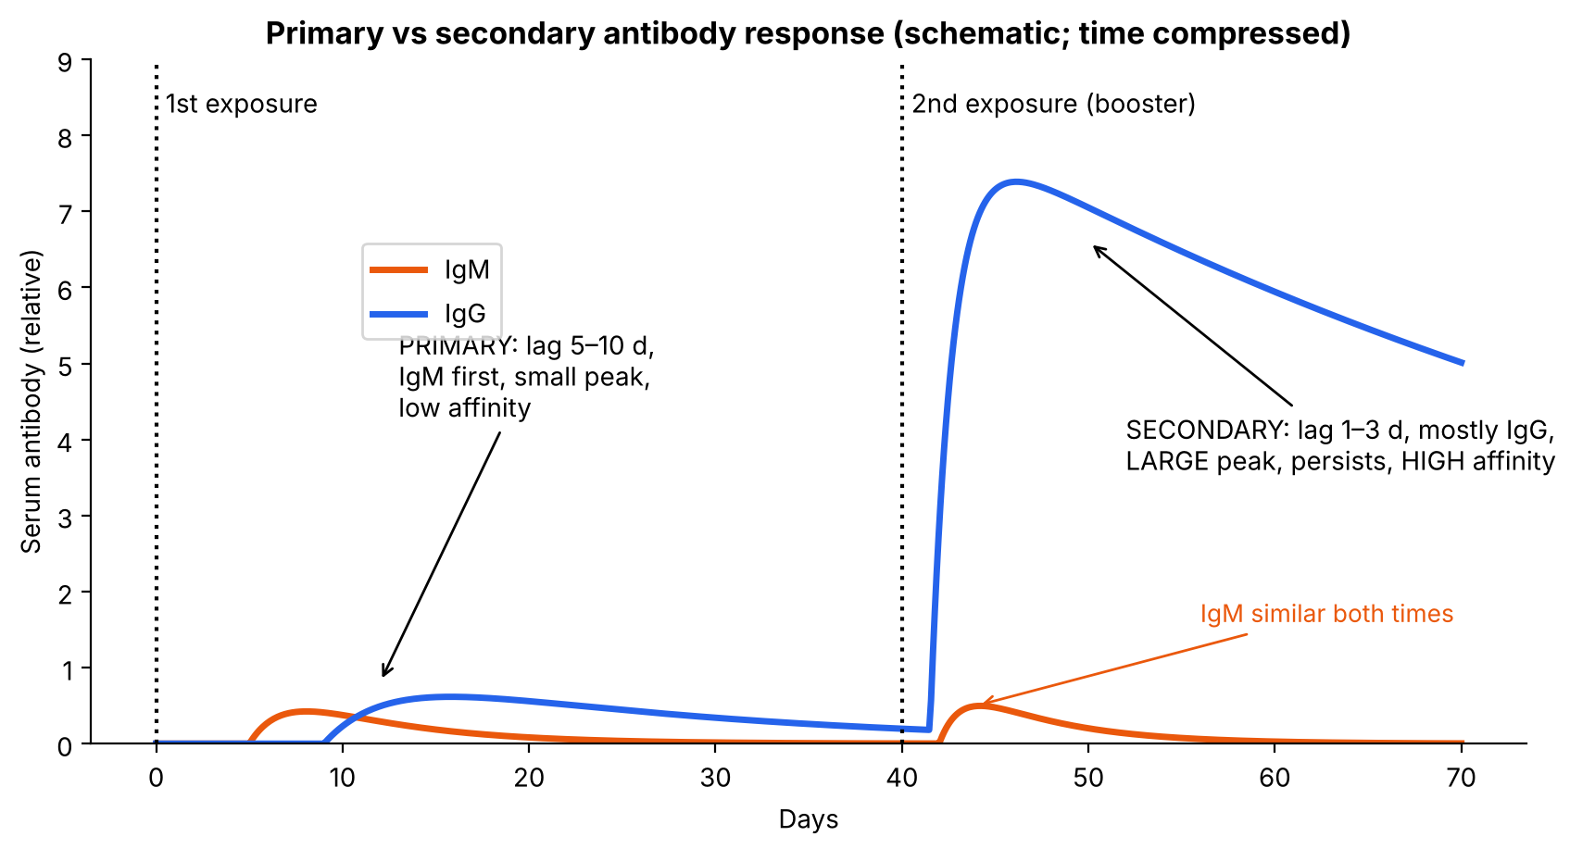
Figure 10. Primary vs secondary antibody response (schematic; inspired by slides 19–20).

4.2 What the slides say
▌ FROM THE SLIDES
The primary response (slide 17):
- When an individual encounters an antigen for the first time, the antibody produced is detectable in the serum within days or weeks.
- This time varies with the nature and dose of the antigen and the route of administration.
- Serum antibody concentration continues to rise for several weeks and then declines; the level may drop to very low levels.
- The first antibodies produced are IgM. Then IgG, IgA, or both are made.
- IgM levels tend to decline sooner than IgG levels.
The secondary response (slide 18):
- On subsequent exposure to the same antigen months or years later, the antibody response is more rapid and generates higher levels than the primary response.
- This is attributed to the persistence of memory cells generated during the primary response.
- This memory effect is the fundamental basis for vaccine boosters.
- The amount of IgM produced is qualitatively similar to that after the first contact; however more IgG is produced, and IgG persists much longer than in the primary response.
- Such antibody tends to bind antigen with higher affinity.
Slide 19 (graph): injection of antigen A → primary response to A (small, peaks ~1–2 months, declines). Second injection of A plus a first injection of a new antigen B at ~3.5 months → secondary response to A (steep, high, sustained) while the response to B is only a primary response. In the primary response, IgM is the first antibody to appear. In the secondary response, IgG appears earlier and shows a more rapid rise and a higher final concentration.
Slide 20: first exposure: a B cell → memory B cells + fewer plasma cells → fewer antibodies, longer response time. Second exposure: memory B cells → more memory B cells + more plasma cells → more antibodies, shorter response time. Memory B cells: ~10-year lifespan; memory T cells: last many decades.

4.3 The comparison table (slide 21)
▌ FROM THE SLIDES
Feature | Primary response | Secondary response
Time lag after immunization | 5–10 days | 1–3 days
Peak response | Small | Large
Antibody isotype | IgM then IgG | Increasing IgG, IgA or IgE
Antibody affinity | Variable to low | High (affinity maturation)
Inducing agent | All immunogens | Protein antigens
Immunization protocol | High dose of antigen (often with adjuvant) | Low dose of antigen (often without adjuvant)

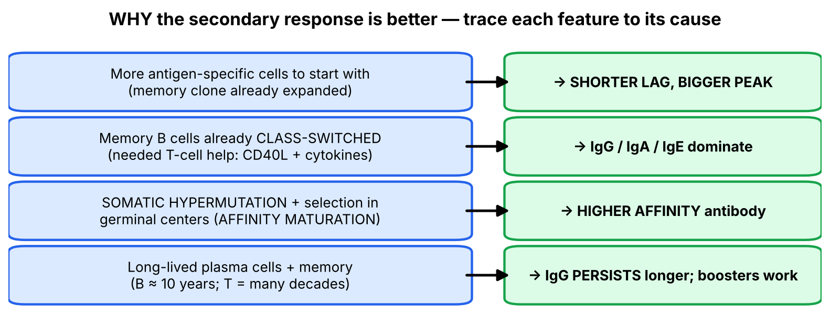
Figure 11. Each feature of the secondary response traced back to its cause.

4.4 Reasoning through each row (your notes answered)
▌ ADDITIONAL CONTEXT
Row | Why it is so
Shorter lag | A naive clone may be 1 in 100,000 cells and must first be found by a DC, activated and expanded. Memory clones are already expanded and have a lower activation threshold (less dependent on costimulation) → respond within days
Bigger peak | More starting cells → more plasma cells (slide 20)
IgG/IgA/IgE instead of IgM | Memory B cells have already class-switched during the primary response. Class switching requires CD40L–CD40 + cytokines from helper T cells (Lecture 11–12; hyper-IgM if CD40L is missing)
Higher affinity — your note: 'why? somatic mutation' | Correct: in germinal centers, the enzyme AID introduces point mutations into antibody variable-region genes (somatic hypermutation). B cells whose mutated BCR binds antigen more tightly win the competition for antigen and Tfh help and survive → affinity maturation. Each new exposure repeats this selection
Only protein antigens give a secondary response — your note: 'protein antigens are T-dependent so class switching is only possible with T cells' | Correct: proteins can be processed and shown on MHC II to helper T cells → T help → class switching, affinity maturation and memory. Polysaccharides/lipids can't be presented on MHC → T-independent → mainly IgM, little memory
Lower antigen dose, no adjuvant needed for the secondary response | Memory cells are easier to trigger; the primary response needs more antigen and an adjuvant to mature DCs (↑B7) and recruit naive cells
IgM similar both times | IgM is made by newly recruited, not-yet-switched B cells; memory doesn't greatly change this component

▌ HIGH-YIELD ADDITIONAL KNOWLEDGE
- Serology reasoning: IgM = recent/acute infection (primary response); IgG = past infection or immunity (or chronic infection). Examples: anti-HAV IgM = acute hepatitis A; anti-HBc IgM = acute hepatitis B; IgM in a newborn = congenital infection (IgM does not cross the placenta; IgG does).
- Conjugate vaccines (Hib, pneumococcal PCV, meningococcal): polysaccharide capsule (T-independent; poor in children < 2 years) is linked to a protein carrier → helper T cells are recruited → class switching, affinity maturation and memory — exactly the 'protein antigens' row of slide 21.
- Booster logic: tetanus/diphtheria booster every 10 years fits the ~10-year memory B-cell lifespan quoted on slide 20.
- Anamnestic response is the formal name for the secondary (memory) response.
🩺 CLINICAL CORRELATION
• Hepatitis B serology: anti-HBc IgM → acute infection; anti-HBc IgG with anti-HBs → resolved infection; anti-HBs alone → vaccinated (vaccine = HBsAg protein only).
• TORCH infections: IgM in cord blood indicates the fetus itself was infected; IgG may simply be maternal antibody.
• Tetanus prophylaxis: a wound in someone with an up-to-date series gets a booster (secondary response within days) rather than passive immunoglobulin.
• Infants < 2 years respond poorly to pure polysaccharide vaccines → use conjugate vaccines.

🎯 EXAM FOCUS
• Primary: lag 5–10 days, IgM first then IgG/IgA, small peak, low affinity, IgM declines before IgG.
• Secondary: lag 1–3 days, IgG (IgA, IgE) dominates, large and persistent, high affinity (affinity maturation), requires protein (T-dependent) antigen, low dose without adjuvant.
• Basis of vaccine boosters = persistence of memory cells.
• Memory B ≈ 10 years; memory T = many decades.
• Graph questions: a new antigen (B) given with the booster still produces only a primary response — memory is antigen-specific.

⚠️ COMMON MISTAKES
• Saying the secondary response produces more IgM — IgM is similar; it is IgG that increases.
• Thinking memory is general — a booster of A gives no head start against unrelated antigen B (slide 19).
• Assuming polysaccharide antigens generate strong memory — memory and class switching need T-cell help (protein antigens).
• Confusing affinity maturation (better binding through somatic hypermutation) with class switching (change of constant region/isotype).
• Mixing the lag times: 5–10 days primary vs 1–3 days secondary.

Section 4 — Practice questions
Q1. [MCQ] A child receives a first dose of tetanus toxoid. Which antibody class appears first in serum?
A. IgG
B. IgA
C. IgM
D. IgE
E. IgD

✅ ANSWER & EXPLANATION
C — IgM is the first antibody in a primary response (slide 17).

Q2. [MCQ] Which feature is characteristic of the secondary but NOT the primary response?
A. Lag of 5–10 days
B. IgM predominance
C. High-affinity antibody due to affinity maturation
D. Requires high antigen dose with adjuvant
E. Can be induced by all immunogens

✅ ANSWER & EXPLANATION
C (slide 21). A, B, D, E describe the primary response.

Q3. [Clinical vignette] A 25-year-old nurse sustains a needlestick. She completed the hepatitis B vaccine series 8 years ago and has low anti-HBs titers. She is given a booster dose; one week later anti-HBs titers are very high. Explain.

✅ ANSWER & EXPLANATION
The vaccine (HBsAg, a protein antigen) generated memory B and T cells during the primary series. The booster triggers a secondary (anamnestic) response: short lag (1–3 days), large rise in high-affinity IgG — the 'memory effect, the fundamental basis for vaccine boosters' (slide 18).

Q4. [Short answer] Using slide 19, what happens when antigen B is injected for the first time at the same moment as the second injection of antigen A?

✅ ANSWER & EXPLANATION
A shows a rapid, large, sustained secondary response; B shows only a small, slower primary response. Memory is specific to the antigen previously encountered.

Q5. [Mechanism] Why does a Haemophilus influenzae type b polysaccharide vaccine work poorly in infants and fail to produce a booster effect, while the conjugate vaccine works?

✅ ANSWER & EXPLANATION
Pure polysaccharide is a T-independent antigen: it can't be presented on MHC II → no helper T cells → mainly IgM, no class switching, little affinity maturation or memory (infants' T-independent responses are especially weak). Conjugating it to a protein carrier lets B cells present carrier peptides to helper T cells → T-dependent response → IgG, affinity maturation, memory and booster effects (slide 21: secondary response needs protein antigens).

Whole-lecture review

A. Complete high-yield summary
WHY TOLERANCE? Random receptor generation (RAG, TdT) → some lymphocytes are self-reactive

T-CELL DEVELOPMENT (thymus)
DN (no CD4/CD8/CD3/TCR) → cortex → DP (CD4+CD8+, CD3, TCR)
POSITIVE selection (cortex, cortical epithelium): binds self-MHC → survive
→ MHC RESTRICTION; no binding → die in 3–4 days
→ SP (CD4 or CD8) → medulla
NEGATIVE selection (medulla, mTEC + DCs): avid self-peptide–MHC binding
→ apoptosis (a few → Tregs) → SELF-TOLERANCE
< 5% survive · γδ T cells leave without selection
Markers: TdT (pre-thymic→cortex), RAG (cortex), CD2/CD3/TCR (for life)

CENTRAL TOLERANCE: deletion · receptor editing (B only) · Treg (CD4 T only)
AIRE → tissue-restricted antigens in thymus; mutation → autoimmune
polyendocrine syndrome
B cells (marrow): strong self binding → apoptosis; low affinity → naive B

PERIPHERAL TOLERANCE: anergy · deletion · Treg suppression
Anergy: alive but unresponsive; (1) no costimulation (2) ↑CTLA-4 / PD-1
Treg: CD4+, FoxP3-dependent, need IL-2; inhibit naive T, effectors, B, NK
IPEX = FOXP3 mutation: T1DM, chronic diarrhea, eczema, Tregs absent

MEMORY
Primary: lag 5–10 d, IgM → IgG/IgA, small peak, low affinity
Secondary: lag 1–3 d, ↑IgG (IgA, IgE), large & persistent, high affinity
(affinity maturation), protein antigens, low dose, no adjuvant
Memory B ≈ 10 years; memory T = decades; basis of vaccine boosters

B. Genuinely arbitrary facts — memorize directly
# | Fact | Memory hook
1 | Positive selection = cortex; negative = medulla | Alphabet and order: Cortex before Medulla; Positive before Negative
2 | < 5% of thymocytes survive | 'Fewer than 1 in 20 graduate'
3 | DP cells die in 3–4 days without positive selection | —
4 | Marker timeline: TdT, RAG early; CD2, CD3, TCR persist | 'Tools put away, ID card kept'
5 | AIRE → autoimmune polyendocrine syndrome | AIRE = AutoImmune REgulator
6 | IPEX = FOXP3; T1DM, diarrhea, eczema | Spell it out: Immune dysregulation, Polyendocrinopathy, Enteropathy, X-linked
7 | Lag: primary 5–10 d, secondary 1–3 d | 'A week vs a weekend'
8 | Memory B ≈ 10 years; memory T = decades | Tetanus booster every 10 years

C. Common exam traps
⚠️ COMMON MISTAKES
• Positive selection → MHC restriction; negative selection → self-tolerance (not the other way around).
• Positive selection in cortex; negative selection in medulla.
• Receptor editing = B cells only; Treg generation = CD4 T cells only.
• γδ T cells skip positive and negative selection.
• TdT marks immature lymphocytes (ALL), not mature T cells.
• Anergic cells survive; deleted cells die.
• Self antigens are shown with low costimulation.
• AIRE = central (thymus); FOXP3 = peripheral (Treg) — both cause polyendocrinopathy.
• Tregs need IL-2 — IL-2 loss can cause autoimmunity.
• Secondary response: IgM similar, IgG much higher and longer-lasting.
• Secondary responses require protein (T-dependent) antigens.
• Memory is antigen-specific (antigen B gets only a primary response).

D. Your slide notes — checked
Slide | Your note | Verdict
6 | Positive selection → MHC restriction; negative selection removes high-affinity autoreactive cells; failure → autoimmunity | Correct
7 | 'If anything goes wrong → autoimmune conditions; another reason is HLA inheritance' | Correct — HLA alleles determine which self-peptides are presented (Lecture 10)
17 | 'High yield' | Agreed — primary vs secondary is a classic exam topic
21 | 'Affinity is low in primary but high in secondary … why? somatic mutation' | Correct — somatic hypermutation (AID) + selection in germinal centers = affinity maturation
21 | 'Protein antigens are T-dependent so class switching only possible with T cells' | Correct — CD40L–CD40 + cytokines from helper T cells

E. Visuals worth looking up
Image | Where | What to look for
Thymus histology (H&E) | Histology atlas | Dark cortex packed with thymocytes, pale medulla, Hassall's corpuscles (pink concentric whorls) in the medulla
Germinal center | Lymph node histology | Pale center with tingible-body macrophages — site of somatic hypermutation and affinity maturation
Chest X-ray in DiGeorge vs T-ALL | Radiology atlas | Absent thymic shadow (DiGeorge) vs anterior mediastinal mass (T-ALL)
Antibody response curves | Your slides 19–20 | Lag, peak height, IgM vs IgG curves for first and second exposure

F. 20 medical-school-level practice questions
Q1. [MCQ] Where are tolerance mechanisms for IMMATURE lymphocytes applied?
A. Lymph nodes
B. Spleen
C. Thymus and bone marrow
D. Peripheral tissues
E. Mucosa-associated lymphoid tissue

✅ ANSWER & EXPLANATION
C — generative (central) lymphoid organs (slide 3).

Q2. [MCQ] Which central tolerance mechanism applies ONLY to B cells?
A. Clonal deletion
B. Receptor editing
C. Treg generation
D. Anergy
E. Positive selection

✅ ANSWER & EXPLANATION
B (slide 4).

Q3. [MCQ] Approximately what fraction of thymocytes survive positive and negative selection?
A. < 5%
B. 25%
C. 50%
D. 75%
E. > 95%

✅ ANSWER & EXPLANATION
A (slide 6).

Q4. [Mechanism] A double-positive thymocyte's TCR does not bind any self-MHC molecule on cortical epithelial cells. What happens?
A. It becomes a Treg
B. It undergoes receptor editing
C. It dies within 3–4 days (death by neglect)
D. It exits as a γδ T cell
E. It becomes a CD8 single-positive cell

✅ ANSWER & EXPLANATION
C. Failing positive selection → apoptosis (slide 9: DP cells die within 3–4 days unless they recognize pMHC).

Q5. [MCQ] Which T-cell population leaves the thymus without undergoing positive or negative selection?
A. CD4+ αβ T cells
B. CD8+ αβ T cells
C. γδ T cells
D. Tregs
E. NKT cells

✅ ANSWER & EXPLANATION
C (slide 9).

Q6. [Vignette] Flow cytometry of a lymphoblastic leukemia shows TdT+, CD2+, CD3+, CD4+CD8+ cells. At which developmental stage are these cells arrested?
A. Pre-thymic progenitor
B. Cortical double-positive thymocyte
C. Medullary single-positive thymocyte
D. Circulating naive T cell
E. Memory T cell

✅ ANSWER & EXPLANATION
B. TdT + CD4+CD8+ = cortical thymocyte (slide 15). Pre-thymic cells lack CD2/CD3/CD4/CD8; medullary/circulating cells are single positive and TdT−.

Q7. [MCQ] MHC restriction means that T cells:
A. Can recognize free antigen
B. Recognize antigen only when presented by self-MHC
C. Express both CD4 and CD8
D. Are deleted if they bind self-MHC
E. Only recognize MHC II

✅ ANSWER & EXPLANATION
B (slide 10). It results from positive selection.

Q8. [Vignette] A 12-year-old with chronic mucocutaneous candidiasis develops hypocalcemic seizures and, two years later, Addison disease. Thymic expression of which category of antigens is defective?
A. MHC class I molecules
B. Ubiquitous plasma proteins
C. Tissue-restricted antigens
D. Microbial PAMPs
E. Costimulatory molecules

✅ ANSWER & EXPLANATION
C. AIRE drives thymic epithelial expression of tissue-restricted antigens; AIRE mutation → autoimmune polyendocrine syndrome (slide 11).

Q9. [Mechanism] Why can negative selection in the thymus delete T cells reactive to albumin but would fail to delete T cells reactive to insulin without AIRE?

✅ ANSWER & EXPLANATION
Albumin is an abundant plasma protein present everywhere, including the thymus (slide 7 mentions plasma proteins and common cellular proteins). Insulin is tissue-restricted to β cells; it is only displayed in the thymus because AIRE switches on its gene in medullary epithelial cells.

Q10. [MCQ] An immature B cell in the bone marrow binds strongly to a self-antigen on stromal cells. Which outcome is possible?
A. Class switching to IgG
B. Receptor editing or apoptosis
C. Positive selection to the spleen
D. Somatic hypermutation
E. Differentiation into a plasma cell

✅ ANSWER & EXPLANATION
B (slides 4, 16).

Q11. [MCQ] Which statement about anergic T cells is correct?
A. They undergo apoptosis immediately
B. They survive but cannot respond to antigen
C. They require high costimulation to form
D. They are generated only in the thymus
E. They express FoxP3

✅ ANSWER & EXPLANATION
B (slide 5).

Q12. [Vignette] A patient on anti-CTLA-4 therapy for melanoma develops severe colitis. Which tolerance mechanism has been disrupted?
A. AIRE-dependent negative selection
B. Receptor editing
C. Peripheral anergy/inhibitory receptor signaling
D. Positive selection
E. Allelic exclusion

✅ ANSWER & EXPLANATION
C. CTLA-4 upregulation is one of the two anergy mechanisms (slide 5); blocking it breaks peripheral tolerance.

Q13. [MCQ] Regulatory T cells inhibit all of the following EXCEPT:
A. Activation of naive T cells
B. Differentiation into effector T cells
C. B cells
D. NK cells
E. Thymic positive selection of cortical thymocytes

✅ ANSWER & EXPLANATION
E. Slide 12 lists naive T activation, effector differentiation, B cells and NK cells as targets.

Q14. [Vignette] A male infant has intractable diarrhea, eczema and type 1 diabetes. Which mutation and which missing cell?

✅ ANSWER & EXPLANATION
FOXP3 mutation → IPEX; regulatory T cells are absent (slide 13).

Q15. [Mechanism] A mouse lacking IL-2 develops severe multi-organ autoimmunity rather than just immunodeficiency. Why?

✅ ANSWER & EXPLANATION
Slide 12: generation and maintenance of Tregs require IL-2. Without IL-2, Tregs disappear → self-reactive T cells are no longer suppressed → autoimmunity, outweighing the loss of IL-2-driven effector expansion.

Q16. [MCQ] In the primary antibody response, which is true?
A. IgG appears first
B. Lag time is 1–3 days
C. IgM levels decline sooner than IgG levels
D. Antibody affinity is high
E. Only protein antigens can induce it

✅ ANSWER & EXPLANATION
C (slide 17). A, B, D are false; E — the primary response can be induced by all immunogens (slide 21).

Q17. [Vignette] A newborn has microcephaly and periventricular calcifications. Cord blood shows CMV-specific IgM. Why is IgM, rather than IgG, diagnostic of congenital infection?

✅ ANSWER & EXPLANATION
IgM is the first antibody of a primary response made by the infected fetus itself, and IgM (pentamer) does not cross the placenta; IgG can be maternal (transplacental). So fetal IgM proves fetal infection (high-yield additional, built on slide 17).

Q18. [MCQ] The higher affinity of antibody in the secondary response is due to:
A. Class switching
B. Somatic hypermutation and selection (affinity maturation)
C. More IgM production
D. Receptor editing in the marrow
E. Treg suppression

✅ ANSWER & EXPLANATION
B (slide 21; your note 'somatic mutation').

Q19. [Mechanism] On slide 19, why is the response to antigen B at month 4 small and slow even though the animal is mounting a large response to A at the same time?

✅ ANSWER & EXPLANATION
Memory is antigen-specific. Only A-specific clones were expanded and converted to memory during the first exposure; B-specific clones are still rare naive cells that must go through a full primary response.

Q20. [MCQ] Which statement about the lifespan of memory cells is from the lecture?
A. Memory B cells last ~1 year; memory T ~10 years
B. Memory B cells ~10 years; memory T cells many decades
C. Both last only months
D. Memory T cells last ~10 years; memory B decades
E. NK cells form the longest-lived memory

✅ ANSWER & EXPLANATION
B (slide 20).

G. 10 rapid-recall questions
# | Question | Answer
1 | Central vs peripheral tolerance — which cells, where? | Central: immature, thymus/marrow; peripheral: mature, secondary organs/tissues
2 | Where does positive selection happen and what does it produce? | Thymic cortex; MHC restriction
3 | Where does negative selection happen and what does it produce? | Thymic medulla; self-tolerance
4 | Phenotype of prothymocytes? | Double negative: no CD4, CD8, CD3, TCR
5 | Marker of immature lymphoblasts on slide 15? | TdT (and RAG)
6 | AIRE mutation causes? | Autoimmune polyendocrine syndrome
7 | Two mechanisms of anergy? | No costimulation; ↑CTLA-4/PD-1
8 | Treg requirements? | FoxP3 + IL-2
9 | IPEX features? | T1DM (endocrine), chronic diarrhea, eczema, Tregs absent
10 | Lag times primary vs secondary? | 5–10 days vs 1–3 days

H. Key takeaways
- Random receptor generation makes self-reactivity inevitable; tolerance cleans it up at two checkpoints — central (immature cells, thymus/marrow) and peripheral (mature cells, tissues).
- In the thymus: positive selection (cortex) → MHC restriction; negative selection (medulla) → self-tolerance; AIRE brings organ antigens into the thymus; <5% survive.
- In the periphery: anergy (no costimulation, ↑CTLA-4/PD-1), deletion, and FoxP3+ Tregs (need IL-2). Failures: APS-1 (AIRE), IPEX (FOXP3), checkpoint-inhibitor autoimmunity.
- Memory makes the second response faster, bigger, IgG-dominated and higher-affinity — only for protein (T-dependent) antigens — which is why boosters and conjugate vaccines work.

I. Two questions to test your understanding
🔁 CHECK YOURSELF
1. A patient has a thymoma that lacks AIRE expression. Which type of autoimmunity would you predict, and why? → Autoimmunity against tissue-restricted antigens (e.g., anti-AChR myasthenia gravis, endocrine autoimmunity), because T cells specific for those antigens are not deleted in the thymus.
2. Why does a person vaccinated against tetanus 5 years ago, who steps on a nail, need only a booster and not tetanus immune globulin? → Memory B cells (≈10-year lifespan) mount a secondary response in 1–3 days with high-affinity IgG that neutralizes the toxin in time.

