Toxicology & Heavy Metal Poisoning
Pharmacology — Toxicology (Dr. Shanti Gurung, 35 slides) + Week 7 Heavy Metal Poisoning & Toxicology (Kaplan & First Aid tables, 13 slides) · Tutor study guide

How to read this guide
Label | What it means | Your responsibility
▌ FROM THE SLIDES | Content from either deck (both fully covered). [Tox] = Dr. Gurung's deck; [Kaplan] = the Week 7 heavy-metal/First Aid deck | Must know
▌ ADDITIONAL CONTEXT | Background added so the slide facts make sense | Know it well enough to reason
▌ HIGH-YIELD ADDITIONAL KNOWLEDGE | Not on the slides, but repeatedly tested on USMLE/NBME-style exams | Learn it

The blue ticks on the Kaplan deck (AChE inhibitors, atropine/muscarinic blockers, salicylates, β-blockers, heavy-metal table, antidote summary, physostigmine, activated charcoal, P-450) are flagged ✔ professor emphasis.

Step 0 — The architecture before the facts
Toxicology looks like an endless list of 'poison → antidote' pairs. It becomes manageable when you ask the same pharmacology chain for every poison: what molecule does it hit → what does that do downstream → which signs result → where can an antidote interrupt the chain?
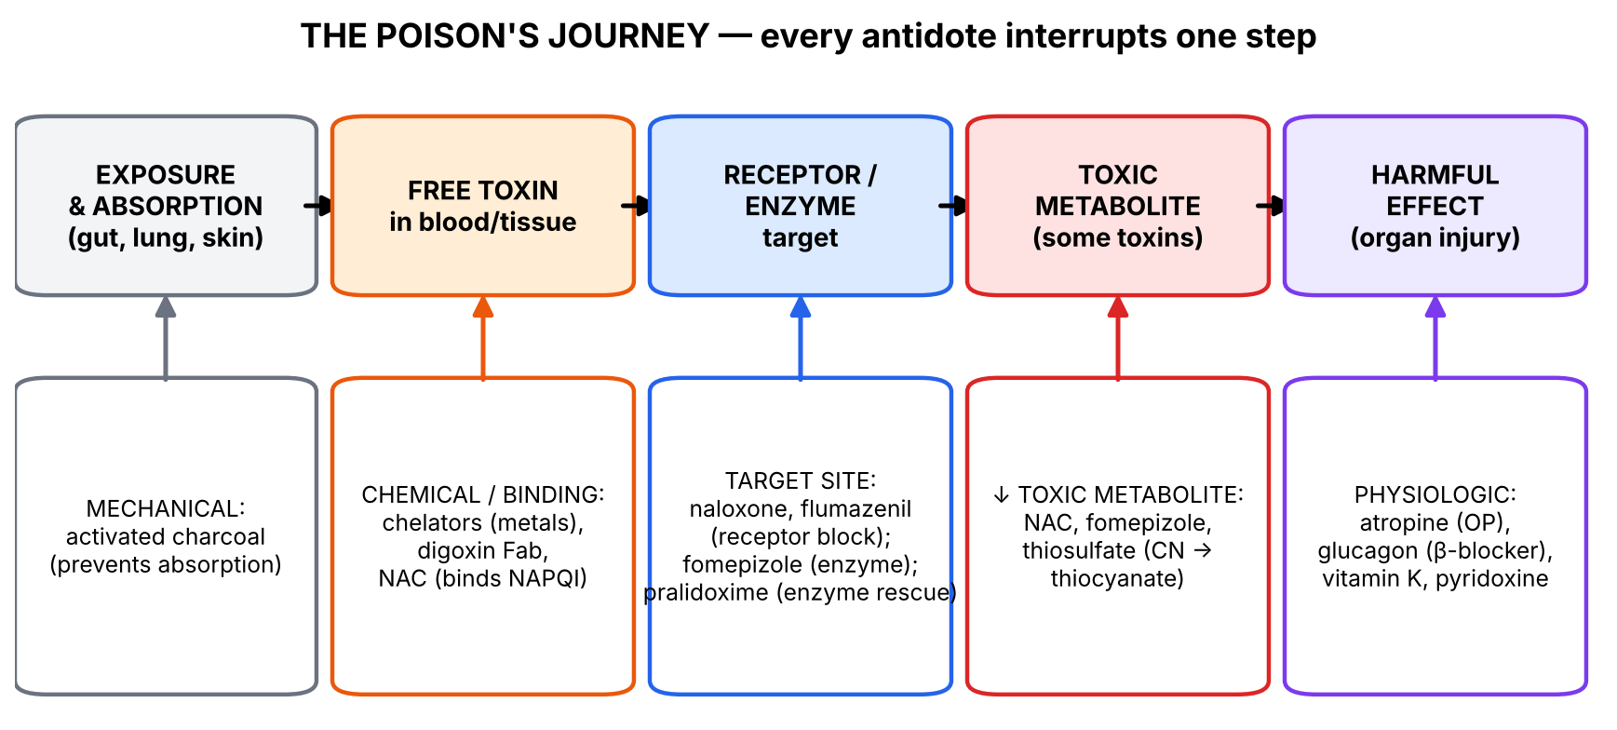
Figure 1. A poison's journey and the five places an antidote can intervene.
💡 THE ORGANIZING PRINCIPLE
Three organizing families cover almost everything in both decks:
• Metals that grab –SH groups (arsenic, lead, mercury; iron and copper by overload) → treated by chelators (a molecule with its own –SH/ligand 'claws' that pulls the metal off and lets the kidney excrete it).
• Drugs/chemicals that act on a receptor or enzyme (opioids, benzodiazepines, anticholinergics, organophosphates) → produce a recognizable toxidrome and are treated by a receptor antagonist or a physiological opposite.
• Toxins that work through a toxic metabolite or by blocking oxygen use (acetaminophen, methanol, cyanide, CO) → treated by blocking the metabolite's formation, mopping it up, or restoring oxygen use.
Every antidote fits one of the slide's types — chemical, mechanical, physiologic — or one of the four action points in the 'Antidotes Mechanisms of Action' diagram.

🧠 ANALOGY
Think of a poison as a burglar. You can (1) lock the door (charcoal stops absorption), (2) handcuff the burglar (chelators, digoxin Fab, NAC binding NAPQI), (3) change the lock he is picking (naloxone, flumazenil take the receptor), (4) stop him from making more burglars (fomepizole stops toxic metabolites), or (5) repair the damage he is doing (atropine, glucagon act downstream).

Section 1 — Basic principles: poison, toxicokinetics and antidote types [Tox slides 1–5]

1.1 What the slides say
▌ FROM THE SLIDES
- Paracelsus (1493–1541): 'All substances are poisons; there is none that is not a poison. The right dose differentiates a poison and a remedy.'
- Toxicology: scientific discipline overlapping biology, chemistry, pharmacology and medicine; studies the adverse effects of chemical substances on living organisms and the practice of diagnosing and treating exposures to toxins and toxicants.
- Toxin: a harmful substance produced within living cells or organisms.
- Toxicant: any toxic substance, man-made or naturally occurring.
- Toxicokinetics: how a toxicant gets into the body and what happens to it — absorption, distribution, metabolism, excretion.
- Antidote: a therapeutic agent that counteracts the toxic actions of a drug/toxin. Types: Chemical — reacts with the poison to form a harmless compound (e.g., chelators and heavy metals); Mechanical — prevents absorption (e.g., activated charcoal); Physiologic — counteracts by opposite physiologic effects (e.g., atropine in organophosphate poisoning).
- Universal antidote: 2 parts activated charcoal (adsorbs the toxicant) + 1 part magnesium oxide (catalyzes inactivation) + 1 part tannic acid (inactivates the toxicant).
- Antidote mechanisms of action (slide 4 diagram):
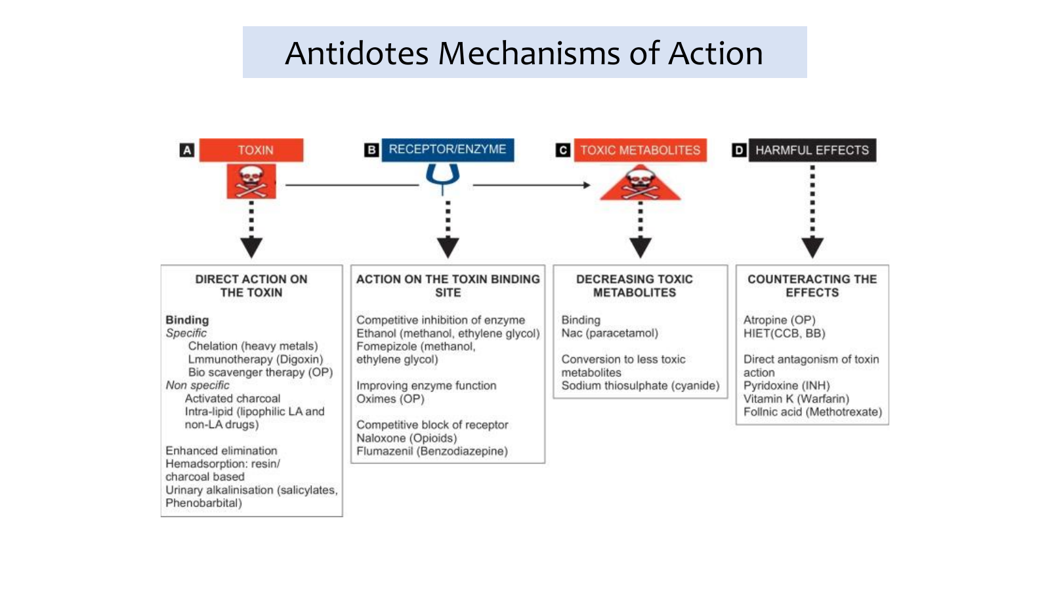
Tox slide 4: antidote mechanisms of action — at the toxin, the receptor/enzyme, the toxic metabolite, or the harmful effect.
Action point (slide 4) | Approach | Examples on the slide
A. Direct action on the toxin | Specific binding | Chelation (heavy metals), immunotherapy (digoxin Fab), bioscavenger therapy (OP)
 | Non-specific binding | Activated charcoal; intralipid (lipophilic local anesthetics and other lipophilic drugs)
 | Enhanced elimination | Hemadsorption (resin/charcoal); urinary alkalinization (salicylates, phenobarbital)
B. Action on the toxin binding site | Competitive enzyme inhibition | Ethanol, fomepizole (methanol, ethylene glycol)
 | Improving enzyme function | Oximes (organophosphates)
 | Competitive receptor block | Naloxone (opioids), flumazenil (benzodiazepines)
C. Decreasing toxic metabolites | Binding | NAC (paracetamol)
 | Conversion to less toxic metabolite | Sodium thiosulfate (cyanide)
D. Counteracting the effects | Physiologic opposite | Atropine (OP), HIET — high-dose insulin euglycemia (CCB, β-blocker)
 | Direct antagonism of toxin action | Pyridoxine (INH), vitamin K (warfarin), folinic acid (methotrexate)

1.2 Making sense of it
▌ ADDITIONAL CONTEXT
- Toxin vs toxicant: every toxin is a toxicant, but not every toxicant is a toxin. Botulinum toxin and snake venom are toxins (biologically produced); lead and methanol are toxicants (not made by a living organism).
- Toxicokinetics vs toxicodynamics: kinetics = what the body does to the poison (ADME); dynamics = what the poison does to the body (mechanism at receptor/enzyme). The decks' metal slides are headed 'Toxicokinetic & Toxicodynamic' for this reason.
- Why activated charcoal works: a huge porous surface area adsorbs many organic molecules in the gut, preventing absorption (and for some drugs, interrupting enterohepatic recirculation). It fails for small, ionized or inorganic substances — see the Kaplan rule 'all oral poisonings except Fe, CN, Li, solvents, mineral acids, corrosives' and the slide statement that it does not adsorb arsenic well. HY mnemonic for charcoal non-binders: 'PHAILS' — Pesticides*, Hydrocarbons, Acids/alkalis, Iron/Inorganics, Lithium, Solvents.
- Urinary alkalinization (HY): weak acids (salicylates, phenobarbital) become ionized in alkaline urine → ion trapping → cannot be reabsorbed → excreted. Same logic as pharmacokinetics of weak acids/bases.
🎯 EXAM FOCUS
• Definitions: toxin (biologically produced) vs toxicant (any); toxicokinetics = ADME of the toxicant.
• Antidote types: chemical (chelators), mechanical (charcoal), physiologic (atropine for OP).
• Universal antidote = 2 charcoal : 1 MgO : 1 tannic acid.
• Expect 'which antidote acts by X?' questions using slide 4 categories.

⚠️ COMMON MISTAKES
• Calling naloxone a 'physiologic' antidote — it is a competitive receptor antagonist (acts at the binding site). Atropine for OP is the classic physiologic antidote (it blocks the downstream muscarinic receptor, not the poison).
• Assuming charcoal works for everything — not for metals (Fe, As, Li), CN, alcohols, acids/alkalis.
• Swapping toxin and toxicant.

Section 1 — Practice questions
Q1. [MCQ] Atropine in organophosphate poisoning is an example of which antidote type?
A. Chemical
B. Mechanical
C. Physiologic
D. Immunologic
E. Enhanced elimination

✅ ANSWER & EXPLANATION
C (Tox slide 3). Atropine blocks muscarinic receptors to oppose excess ACh; it does not touch the organophosphate.

Q2. [MCQ] The universal antidote contains activated charcoal, magnesium oxide and tannic acid in which ratio?
A. 1:1:1
B. 2:1:1
C. 1:2:1
D. 3:1:1
E. 2:2:1

✅ ANSWER & EXPLANATION
B — 2 parts charcoal, 1 part MgO, 1 part tannic acid.

Q3. [Clinical vignette] A child ingests a bottle of her mother's iron tablets. A student suggests activated charcoal. Why is this inappropriate, and what is the specific antidote?

✅ ANSWER & EXPLANATION
Iron is a small, inorganic, ionized metal that charcoal does not adsorb (Kaplan: charcoal for all oral poisonings except Fe, CN, Li, solvents, mineral acids, corrosives). Specific antidote: deferoxamine IV (chelator); Kaplan also lists gastric aspiration + carbonate lavage.

Q4. [Short answer] Using the slide-4 framework, classify these antidotes: fomepizole, NAC, vitamin K, digoxin Fab.

✅ ANSWER & EXPLANATION
Fomepizole — action on binding site (competitive enzyme inhibition of alcohol dehydrogenase). NAC — decreasing toxic metabolites (binding NAPQI). Vitamin K — counteracting effects (direct antagonism of warfarin's action). Digoxin Fab — direct action on toxin (specific immunologic binding).

Q5. [Mechanism] Explain why alkalinizing the urine speeds salicylate excretion.

✅ ANSWER & EXPLANATION
Salicylate is a weak acid. In alkaline urine it exists mainly in the ionized (charged) form, which cannot diffuse back across tubular membranes (ion trapping) → more is excreted.

Section 2 — Heavy metals and chelators [Tox slides 5–24; Kaplan slides 4–5, 6–7]

2.1 The organizing principle
The Tox deck's 'Clinical Toxicology' map (slide 5) groups the course into drug/medication overdose (acetaminophen, amphetamine, anticholinergics, alcohol, barbiturates, benzodiazepines, cocaine, digoxin, opioids, anticholinesterases, phencyclidine, phenothiazines, phenytoin, salicylate, theophylline, TCAs), heavy-metal poisoning (arsenic, lead, mercury, cadmium, iron) and miscellaneous (CO, caustics/corrosives, cyanide, H₂S, LSD, marijuana, methanol). The heavy metals share one mechanism:
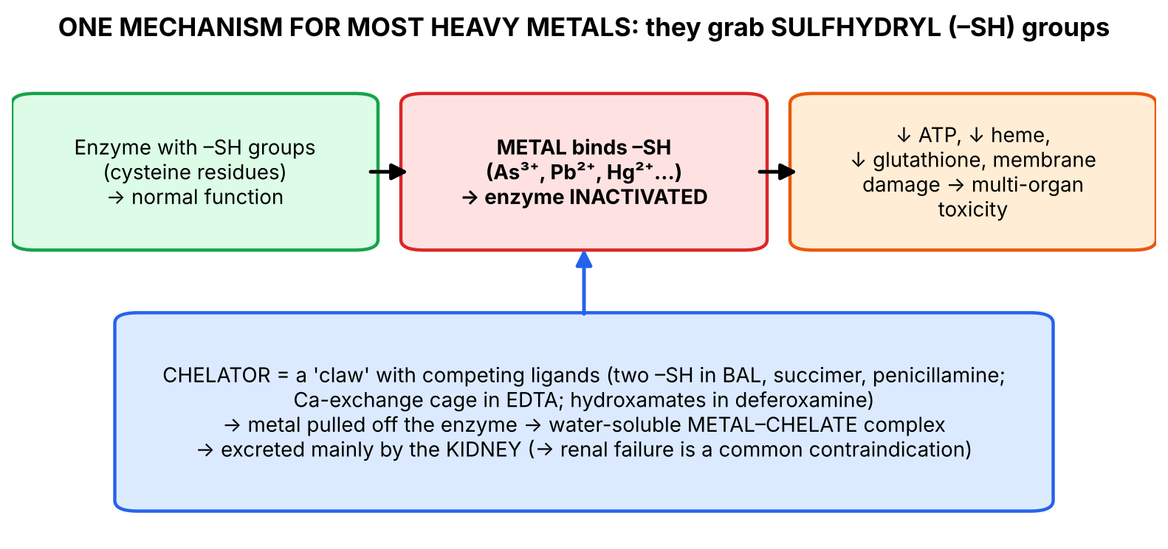
Figure 2. Metals poison –SH enzymes; chelators pull them off and the kidney excretes the complex.
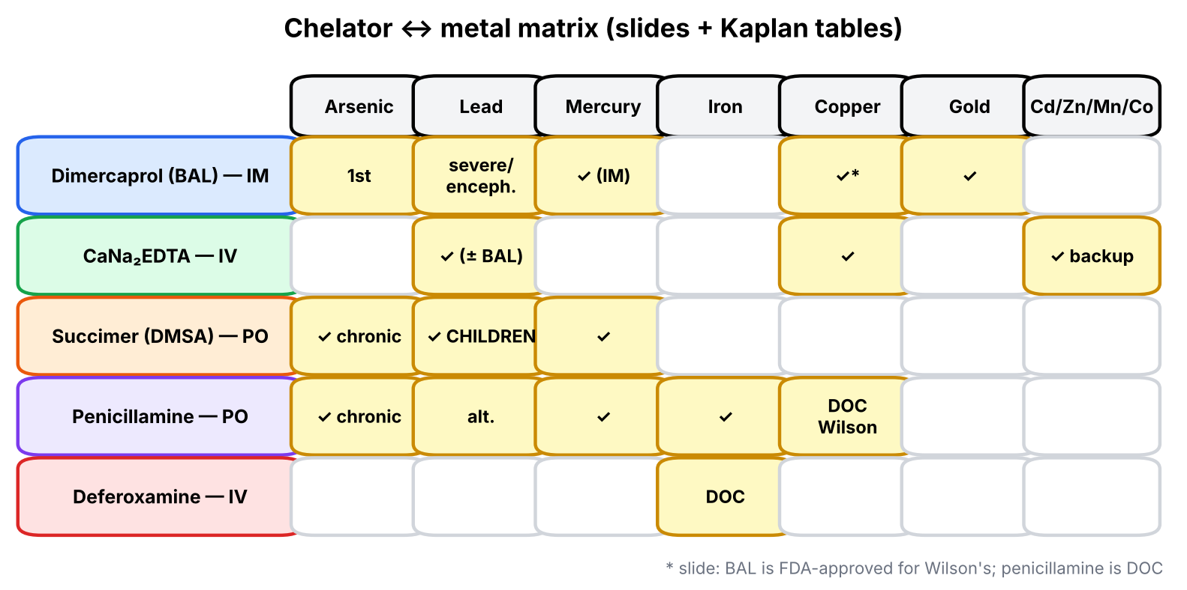
Figure 3. Which chelator for which metal (both decks combined).

2.2 Arsenic
▌ FROM THE SLIDES
- Sources [Tox]: industrial exposure (smelting/refining of metals and ores, glass production, semiconductor industry), rodenticide, contaminated wine, seafood and fish, groundwater, soil pica in children. [Kaplan]: wood preservatives, pesticides, ant poisons.
- Inorganic arsenic is more toxic than organic; very few organ systems escape.
- Trivalent arsenic inhibits numerous enzymes by binding sulfhydryl groups → ↓ cellular ATP, ↓ glucose uptake, ↓ gluconeogenesis, ↓ fatty-acid oxidation, ↓ acetyl-CoA production, ↓ glutathione (which normally prevents oxidative damage).
- 2–4 weeks after exposure ceases, remaining arsenic is in keratin-rich tissues (nails, hair, skin).
- Chronic skin lesions: 'rain-drop' skin pigmentation, hyperkeratosis of palms, and Mees lines (transverse white lines on nails).
- [Kaplan] Acute: GI distress, garlic breath, 'rice-water' stools, torsades, seizures. Chronic: pallor, skin pigmentation, alopecia, stocking-glove neuropathy, myelosuppression.
- Management [Tox]: hemodynamic stabilization (crystalloids to replace losses from vomiting/diarrhea); dimercaprol (BAL in oil) = first-line; don't delay definitive chelation and hemodialysis; activated charcoal does not adsorb arsenic well; GI decontamination is controversial. [Kaplan]: activated charcoal, dimercaprol; penicillamine or succimer (chronic).
▌ ADDITIONAL CONTEXT
Mechanism → signs: arsenic as arsenite (As³⁺) binds the paired –SH groups of lipoic acid, the cofactor of pyruvate dehydrogenase and α-ketoglutarate dehydrogenase (HY — same cofactor list as 'tender loving care for nancy'). Glycolysis cannot feed the TCA cycle → ↓ ATP, lactic acidosis. Arsenate (As⁵⁺) substitutes for phosphate and uncouples ATP synthesis. Energy-hungry gut epithelium and capillaries fail first → massive 'rice-water' diarrhea and capillary leak → hypovolemic shock; myocardium → QT prolongation/torsades; long axons → stocking-glove sensorimotor neuropathy; keratin binds As (–SH-rich) → Mees lines, hyperpigmentation; chronic exposure → skin, lung and bladder cancer, angiosarcoma of liver (HY).

2.3 Dimercaprol (BAL) [Tox]
▌ FROM THE SLIDES
- Also called British anti-Lewisite (BAL). Long the mainstay of chelation for lead or arsenic poisoning.
- A copper-chelating agent FDA-approved for Wilson disease (as stated on the slide).
- Arsenic and other heavy metals react with adjacent sulfhydryl groups on metabolic enzymes → inhibit them. The two SH groups of dimercaprol bind these metals.
- [Kaplan antidote table] Dimercaprol → arsenic, gold, mercury, lead; oral succimer for milder lead and mercury toxicity.
▌ HIGH-YIELD ADDITIONAL KNOWLEDGE
- Given IM in peanut oil; contraindicated in peanut allergy; can cause hypertension/tachycardia; avoid in iron poisoning (BAL–Fe complex is toxic). Lewisite was an arsenic war gas — hence the name.
- Clarification: most references list penicillamine (or trientine) + zinc as standard Wilson therapy; BAL is historical/rarely used. For your exam, reproduce the slide statement and remember penicillamine = DOC (Tox slide 'Penicillamine').

2.4 Lead
▌ FROM THE SLIDES
- Sources [Tox]: soil and dust, paints (old buildings), dyes, contaminated water, folk remedies, soil pica in children. [Kaplan]: tap water, leaded paint chips, herbal remedies, gas-sniffing, glazed kitchenware.
- Nearly all organ systems involved; most affected: nervous system, GI, hematopoietic, renal, cardiovascular.
- Carried bound to RBCs; crosses the BBB and placenta.
- Accumulates in bone and teeth, replacing calcium → ~30-year half-life once deposited.
- Affinity for SH groups; toxic to zinc-dependent enzymes → heme synthesis (hemoglobin, cytochromes); steroid metabolism and membrane integrity; ↓ vitamin D activation in renal tubular cells (1-hydroxy → 1,25-dihydroxyvitamin D).
- Clinical image: lead blue lines (Burton lines) on the gums.
- [Kaplan] Acute: nausea, vomiting, GI pain, malaise, tremor, tinnitus, paresthesias, encephalopathy (red or black feces). Chronic: anemia (↓ heme), neuropathy (wrist drop), nephropathy (proteinuria, failure), hepatitis, intellectual disability (from pica), ↓ fertility, ↑ stillbirths.
- Management [Tox]: ABCs; diazepam (seizures); EDTA, or BAL plus EDTA; aggressive hydration; nutritional supplementation — iron, calcium (calcium-rich foods), phosphorus. [Kaplan]: gastric lavage + dimercaprol (severe) or EDTA or succimer (penicillamine if dimercaprol/succimer unusable); children: succimer PO.
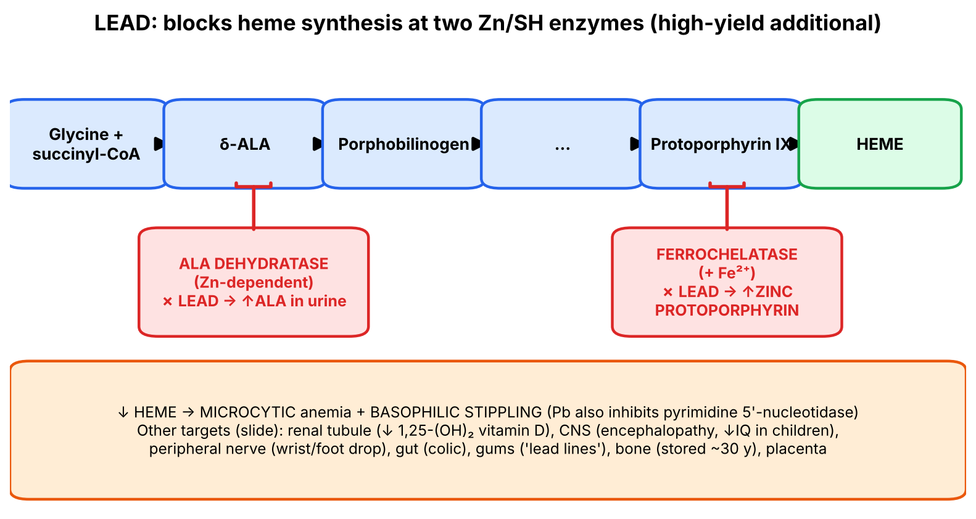
Figure 4. How lead causes anemia — and the lab findings that follow.
▌ ADDITIONAL CONTEXT
Why iron and calcium supplements? Lead competes with calcium (bone, absorption) and with iron/zinc (absorption via the same divalent metal transporter, heme enzymes). Deficient children absorb more lead, so repleting Ca and Fe reduces absorption. Why BAL first in encephalopathy? EDTA alone can mobilize lead from bone into blood and transiently worsen brain levels; BAL (lipid-soluble, enters cells) is started first, then EDTA (HY).
▌ HIGH-YIELD ADDITIONAL KNOWLEDGE
- Lab hallmarks: microcytic anemia, basophilic stippling, ↑ free erythrocyte/zinc protoporphyrin, ↑ δ-ALA in urine; X-ray 'lead lines' at metaphyses in children; blood lead level is the diagnostic test.
- Sideroblastic anemia (ringed sideroblasts) is a lead complication — iron enters the mitochondrion but can't be inserted into protoporphyrin.

2.5 Calcium disodium edetate (CaNa₂EDTA) [Tox]
▌ FROM THE SLIDES
- Higher affinity for Pb, Zn, Cd, Mn, Cu; removes them from the body by exchanging with the calcium it holds.
- In the lead–edetate chelate, lead is incorporated into five heterocyclic rings.
- [Kaplan] EDTA: backup in lead poisoning, then rarer toxicities (Cd, Cr, Co, Mn, Zn).
▌ HIGH-YIELD ADDITIONAL KNOWLEDGE
- Must be the calcium disodium salt: plain disodium EDTA chelates the body's calcium → fatal hypocalcemia. EDTA is nephrotoxic (metal complexes excreted renally) → hydrate and monitor renal function.

2.6 Mercury
▌ FROM THE SLIDES
- Sources [Tox]: industrial (smelting, mining); thermometers, dental amalgams, fluorescent light bulbs, disc batteries, electrical switches; bacteria convert mercury in water to organic mercury (more toxic) in fish. [Kaplan]: elemental in instruments; salts in amalgams, batteries, dyes, electroplating, fireworks, photography.
- Binds sulfhydryl groups in proteins → altered enzyme activity.
- Vapor inhalation → acute necrotizing bronchitis, pneumonitis.
- Long-term exposure → CNS (psychiatric disturbances).
- Ingestion → GI ulceration/perforation and hemorrhage, rapidly followed by circulatory collapse; breakdown of mucosal barriers → ↑ absorption → kidneys: proximal tubular necrosis and anuria.
- [Kaplan] Acute vapor: chest pain, dyspnea, pneumonitis. Acute inorganic salt ingestion: GI distress and bleeding, shock, renal failure. Chronic organic Hg: CNS effects, ataxia, paresthesias, auditory and visual loss.
- Management [Tox]: remove the source; ABCs; activated charcoal for GI decontamination; control diarrhea; BAL chelation. [Kaplan]: succimer PO or dimercaprol (IM); charcoal for oral ingestion, then succimer PO or dimercaprol — NOT IV (dimercaprol) → redistribution of Hg to the CNS → ↑ neurotoxicity.
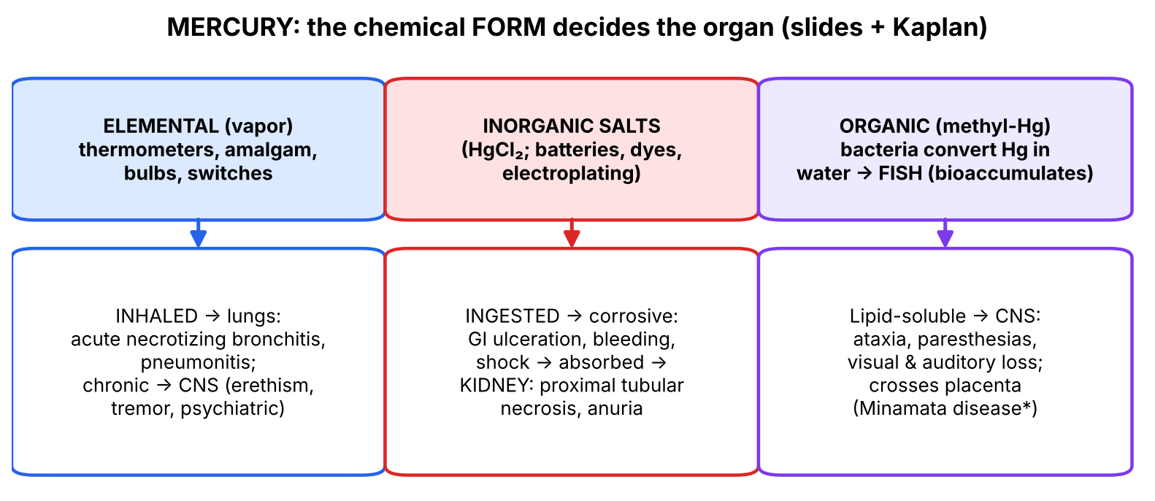
Figure 5. The form of mercury determines the target organ.
▌ ADDITIONAL CONTEXT
Why does form matter? Elemental Hg is poorly absorbed from the gut but volatile → absorbed in the lung. Inorganic salts are corrosive and water-soluble → GI injury, then concentrated in the proximal tubule. Methylmercury is lipid-soluble → crosses the BBB and placenta → CNS and fetal brain. This is also why lipid-soluble chelators can carry Hg into the brain (Kaplan's warning).
▌ HIGH-YIELD ADDITIONAL KNOWLEDGE
- Chronic mercury ('mad hatter') = erethism: shyness, irritability, tremor, gingivitis; acrodynia ('pink disease') in children. Minamata disease = methylmercury from contaminated fish → congenital cerebral palsy-like illness.

2.7 Iron [Kaplan] and deferoxamine [Tox]
▌ FROM THE SLIDES
- [Kaplan] Iron (medicinal for anemia, prenatal supplements): acute, mainly children — severe GI distress → necrotizing gastroenteritis with hematemesis and bloody diarrhea, dyspnea, shock, coma. Treatment: gastric aspiration + carbonate lavage, deferoxamine IV.
- Deferoxamine [Tox] — indications: acute iron intoxication and secondary iron overload from multiple transfusions. Mechanism: binds iron avidly; competes for loosely bound iron in microsomal/mitochondrial cytochromes and hemoproteins. Contraindications: severe renal disease or anuria — drug and iron chelate are excreted mainly by the kidney.
▌ HIGH-YIELD ADDITIONAL KNOWLEDGE
- Stages of iron toxicity: GI corrosion (0–6 h) → latent 'quiet' phase → shock + metabolic acidosis (mitochondrial injury, 12–24 h) → hepatic necrosis → late gastric outlet scarring. Radiopaque tablets on abdominal X-ray. Deferoxamine–iron complex (ferrioxamine) turns urine 'vin rosé' color. Oral chelators for chronic overload: deferasirox, deferiprone.

2.8 Penicillamine and succimer [Tox]
▌ FROM THE SLIDES
Chelator | Indications | Mechanism | Contraindications
Penicillamine | Wilson disease (copper accumulation): DOC. [Kaplan antidote table: copper, iron, lead, mercury; arsenic chronic] | Binds copper avidly (chelation) | Severe renal disease, pregnancy
Succimer (DMSA) | Secondary drug to BAL & EDTA for acute lead poisoning, especially small children. [Kaplan: children — succimer PO; mercury; arsenic chronic] | Metal chelator | Severe renal disease
Deferoxamine | Acute iron poisoning; transfusion iron overload | Binds iron avidly | Severe renal disease/anuria
Dimercaprol (BAL) | Arsenic (1st line), lead (severe), mercury, gold; [slide: Wilson approved] | Two –SH groups bind metals | (HY: peanut allergy, iron)
CaNa₂EDTA | Lead (with BAL); Cd, Cr, Co, Mn, Zn | Exchanges its Ca for the metal | (HY: renal impairment)

▌ HIGH-YIELD ADDITIONAL KNOWLEDGE
- Penicillamine adverse effects: myopathy (listed on Kaplan slide 10), drug-induced lupus, proteinuria/membranous nephropathy, myasthenia-like syndrome, rash, bone marrow suppression, and pyridoxine (B6) deficiency — give B6. It is also used in cystinuria and RA (historically).
- Succimer is oral and water-soluble → the go-to chelator for children with moderate lead levels.
🩺 CLINICAL CORRELATION
• Toddler in an old house with abdominal pain, constipation, irritability, developmental regression; microcytic anemia with basophilic stippling → lead → oral succimer; if encephalopathy → BAL + CaNa₂EDTA; remove the source.
• Worker with garlic breath, rice-water diarrhea and long QT after rodenticide ingestion → arsenic → fluids + dimercaprol.
• Woman with chronic hyperpigmented 'raindrop' skin, palmar keratoses, Mees lines and stocking-glove neuropathy from well water → chronic arsenic (Bangladesh/West Bengal groundwater).
• Broken mercury thermometer heated on a stove → chest pain, dyspnea → elemental Hg pneumonitis.
• Child with hematemesis after prenatal-vitamin ingestion, then shock 12 h later → iron → deferoxamine IV.

🎯 EXAM FOCUS
• All metals here bind –SH groups; chelators provide competing ligands; complexes are cleared renally (→ renal disease = contraindication).
• Arsenic: inorganic > organic; keratin tissues (hair, nails, skin) at 2–4 weeks; raindrop skin, Mees lines; acute garlic breath, rice-water stools, torsades; BAL first-line; charcoal binds As poorly.
• Lead: RBC-bound, crosses BBB & placenta, bone half-life ~30 y, Zn/SH enzymes (heme, steroid, vitamin D); lead lines; EDTA ± BAL, succimer in children, supplement Fe, Ca, P; diazepam for seizures.
• Mercury: vapor → necrotizing bronchitis/pneumonitis; salts → GI ulceration, proximal tubular necrosis, anuria; organic → CNS; BAL/succimer, dimercaprol NOT IV.
• Deferoxamine (iron; CI renal failure) · Penicillamine (Wilson DOC; CI renal disease, pregnancy) · Succimer (children's lead; CI renal disease) · EDTA exchanges Ca, five rings.

⚠️ COMMON MISTAKES
• Giving activated charcoal for arsenic, iron or lithium — it doesn't bind them.
• Using plain disodium EDTA instead of calcium disodium EDTA (hypocalcemia).
• Forgetting succimer is the oral chelator preferred in children with lead poisoning.
• Assuming organic forms are always less toxic: for arsenic, inorganic is worse; for mercury, organic (methyl-Hg) is worse (slide: 'organic mercury — more toxic').
• Giving dimercaprol IV — it is IM (Kaplan: IV redistributes Hg to CNS).

Section 2 — Practice questions
Q1. [MCQ] Arsenic's major toxic mechanism is:
A. Inhibition of cytochrome oxidase
B. Binding to sulfhydryl groups of enzymes
C. Opioid receptor agonism
D. Inhibition of acetylcholinesterase
E. Formation of methemoglobin

✅ ANSWER & EXPLANATION
B (Tox slide 'Toxicokinetic & Toxicodynamic').

Q2. [MCQ] Four weeks after an arsenic exposure ended, which sample would best demonstrate arsenic?
A. Serum
B. Urine
C. Hair or nails
D. Cerebrospinal fluid
E. Saliva

✅ ANSWER & EXPLANATION
C — keratin-rich tissues hold arsenic 2–4 weeks after exposure ceases.

Q3. [Clinical vignette] A 3-year-old living in a 1940s house has abdominal pain, constipation, irritability and language regression. Hb 9.1 g/dL, MCV 68 fL, smear shows basophilic stippling. Blood lead is markedly elevated without encephalopathy. Which chelator, which route, and which supplements?

✅ ANSWER & EXPLANATION
Succimer (DMSA) PO — preferred for children (Tox slide 'Succimer'; Kaplan 'children: succimer PO'). Supplement iron, calcium and phosphorus (Tox management slide) — deficiency increases lead absorption. Remove the lead source (paint).

Q4. [MCQ] Deferoxamine is contraindicated in:
A. Hepatic disease
B. Severe renal disease/anuria
C. Pregnancy only
D. Children
E. Hypertension

✅ ANSWER & EXPLANATION
B — drug and iron chelate are excreted mainly by the kidney.

Q5. [MCQ] Which form of mercury primarily causes proximal tubular necrosis after ingestion?
A. Elemental vapor
B. Inorganic mercuric salts
C. Methylmercury
D. Mercury in dental amalgam
E. Mercury in fluorescent bulbs (intact)

✅ ANSWER & EXPLANATION
B (both decks): salts corrode the GI tract, get absorbed and concentrate in the proximal tubule → necrosis and anuria.

Q6. [Short answer] List the three heme/zinc-dependent processes lead disrupts according to the Tox slide.

✅ ANSWER & EXPLANATION
Heme synthesis (hemoglobin, cytochromes); steroid metabolism and membrane integrity; vitamin D activation in renal tubular cells (1-hydroxy → 1,25-dihydroxyvitamin D).

Q7. [Mechanism] Explain why lead has a half-life of about 30 years once in the body.

✅ ANSWER & EXPLANATION
Lead substitutes for calcium in bone hydroxyapatite (and teeth). Bone turns over slowly, so lead is released gradually over decades — a slow-release reservoir (Tox slide). Pregnancy, fractures and osteoporosis can remobilize it.

Section 3 — Receptor-level poisons: the toxidromes [Tox slides 25–29; Kaplan slides 2–3]

3.1 The organizing principle — read the patient like a dashboard
Most drug overdoses act on a receptor or enzyme in the autonomic or central nervous system. Because the autonomic nervous system controls pupils, sweat, heart, gut and secretions, each class produces a reproducible toxidrome (toxic syndrome). Learn the physiology once, and the signs derive themselves:
Autonomic target | Normal effect of stimulation | So excess → / block →
Muscarinic (parasympathetic) | Miosis, salivation, sweating, bronchospasm/secretions, bradycardia, GI motility, urination | Excess (OP): all of these ↑ · Block (atropine): dry, hot, mydriatic, tachycardic, ileus, retention
Nicotinic (NMJ, ganglia) | Skeletal-muscle contraction | Excess (OP): fasciculations → weakness → paralysis (respiratory failure)
Adrenergic (sympathetic) | Mydriasis, tachycardia, hypertension, sweating, hyperthermia | Excess (cocaine, amphetamine): sympathomimetic toxidrome — note SWEATY (unlike anticholinergic)
μ-opioid | Analgesia, sedation, respiratory drive ↓, miosis | Excess: triad CNS depression, respiratory depression, miosis
GABA-A | Neuronal inhibition | Excess (BZD, barbiturate, ethanol): sedation, ataxia, coma, respiratory depression

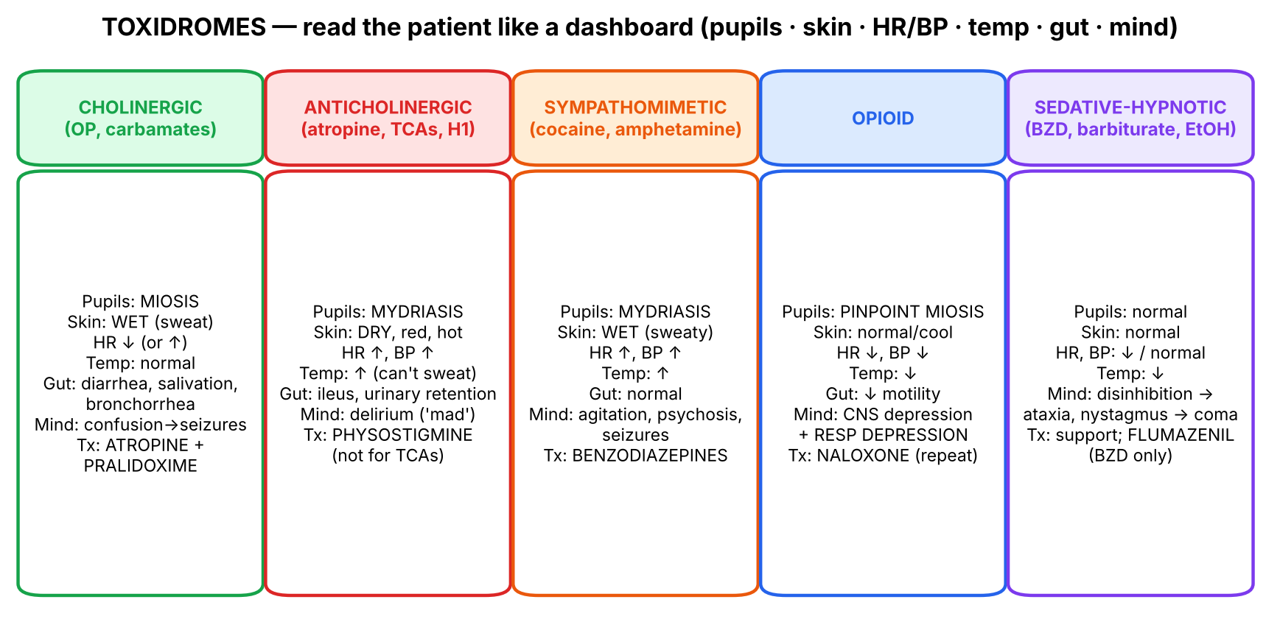
Figure 6. Five toxidromes compared (built from both decks; Tx = treatment).

3.2 Anticholinergics ✔ [Tox slide 25; Kaplan]
▌ FROM THE SLIDES
- Mechanism: block muscarinic receptors in the CNS and peripheral nervous system.
- Presentation: 'Red as a beet, dry as a bone, blind as a bat, mad as a hatter, hot as a hare' = flushing, dry skin and mucous membranes, mydriasis with loss of accommodation, altered mental status, fever. [Kaplan]: ↑ HR, ↑ BP, hyperthermia (hot, dry skin), delirium, hallucinations.
- Antidote: physostigmine — the only reversible AChE inhibitor able to directly antagonize CNS manifestations; it is an uncharged tertiary amine that efficiently crosses the BBB. [Kaplan]: control CV symptoms and hyperthermia + physostigmine; physostigmine for atropine, antihistamines, antiparkinsonian drugs — NOT tricyclics.
▌ ADDITIONAL CONTEXT
Why each sign: blocked M3 on sweat glands (sympathetic cholinergic) → can't sweat → hyperthermia and flushing (cutaneous vasodilation to dump heat); blocked M3 on iris sphincter and ciliary muscle → mydriasis + cycloplegia ('blind'); blocked M2 in SA node → tachycardia; blocked central muscarinic receptors → delirium ('mad'); also urinary retention and ileus. Why tertiary vs quaternary? Physostigmine (tertiary, uncharged) enters the CNS; neostigmine/pyridostigmine (quaternary, charged) cannot — they won't reverse delirium.
Why NOT for tricyclics? TCAs also block fast Na⁺ channels in the heart (wide QRS). Physostigmine can precipitate bradycardia, asystole and seizures in TCA overdose. TCA treatment = sodium bicarbonate (Tox antidote table).

3.3 Organophosphate & carbamate anticholinesterases ✔ [Tox slides 28–29; Kaplan]
▌ FROM THE SLIDES
- Organophosphates (OPs) irreversibly bind cholinesterase → phosphorylation and inactivation.
- Carbamates give a similar picture but bind cholinesterase temporarily (~6 hours) with no permanent damage; they have poor CNS penetration → minimal CNS symptoms.
- Presentation: miosis, bronchospasm, excessive secretions, diarrhea. [Kaplan]: miosis, salivation, sweats, GI cramps, diarrhea, muscle twitches → seizures, coma, respiratory failure.
- Antidote: atropine; pralidoxime (PAM) for organophosphates (not carbamates). [Kaplan]: respiratory support; atropine + pralidoxime (for irreversible AChE inhibitors).
- Anti-ChEs are esters of carbamic acid or derivatives of phosphoric acid (slide 29):
Group | Chemical class | Members (slide 29)
Reversible | Carbamates | Physostigmine (eserine), neostigmine, pyridostigmine, edrophonium, rivastigmine, donepezil, galantamine
Reversible | Acridine | Tacrine
Irreversible | Organophosphates | Dyflos (DFP), echothiophate, malathion*, diazinon* (TIK-20); tabun, sarin, soman (nerve gases for chemical warfare)
Irreversible (as listed) | Carbamates | Carbaryl* (SEVIN), propoxur* (BAYGON) — *insecticides

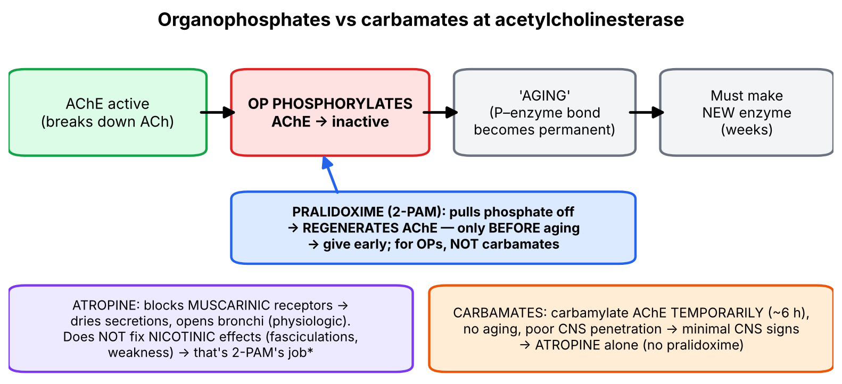
Figure 7. Why pralidoxime must be given early, and why carbamates don't need it.
▌ ADDITIONAL CONTEXT
- Aging: after OP binding, the phosphorylated enzyme loses an alkyl group and becomes permanently resistant → pralidoxime only works before aging (minutes for soman, hours for most insecticides). After aging, recovery requires synthesis of new AChE (weeks).
- Slide 29 nuance: carbaryl and propoxur are carbamate insecticides; the Tox text says carbamates bind temporarily (~6 h) with no permanent damage — that is the more important clinical fact. The table places them under 'irreversible' to separate them from the clinical (drug) carbamates.
▌ HIGH-YIELD ADDITIONAL KNOWLEDGE
- Mnemonic for muscarinic excess: DUMBBELSS — Diarrhea, Urination, Miosis, Bronchospasm, Bradycardia, Emesis, Lacrimation, Sweating, Salivation (also SLUDGE). Nicotinic: fasciculations, weakness, paralysis.
- Endpoint for atropine dosing = drying of bronchial secretions (not pupil size or heart rate). Very large doses may be required.
- Decontaminate the patient (remove clothing, wash skin) — staff protection.

3.4 Benzodiazepines & sedative-hypnotics [Tox slide 26; Kaplan]
▌ FROM THE SLIDES
- Mechanism: potentiates GABA activity.
- Presentation: drowsiness, confusion, respiratory depression. [Kaplan sedative-hypnotics and ethanol]: disinhibition (initial), lethargy, ataxia, nystagmus, stupor, coma, hypothermia, respiratory failure.
- Antidote: flumazenil — drug of choice to reverse BZDs; antagonist at the benzodiazepine binding site. [Kaplan]: ventilatory support; flumazenil if BZDs implicated; also for zolpidem, zaleplon.
▌ ADDITIONAL CONTEXT
Why BZDs alone are rarely lethal but combinations are: BZDs increase the frequency of GABA-A chloride channel opening only when GABA is present (ceiling effect). Barbiturates and alcohol increase duration and at high doses open the channel directly → no ceiling → respiratory arrest. Flumazenil does not reverse barbiturates or alcohol.
▌ HIGH-YIELD ADDITIONAL KNOWLEDGE
- Flumazenil caution: can precipitate seizures in chronic BZD users (withdrawal) and in mixed overdoses with TCAs (BZD was suppressing TCA seizures). Usually reserved for iatrogenic BZD oversedation.

3.5 Opioid narcotics [Tox slide 27; Kaplan]
▌ FROM THE SLIDES
- Mechanism: opioid receptor agonist.
- Clinical triad: CNS depression, respiratory depression, miosis. [Kaplan]: lethargy, sedation, ↓ HR, ↓ BP, hypoventilation, miosis, coma, respiratory failure.
- Antidote: naloxone, IV or IM. [Kaplan]: ventilatory support; naloxone at frequent intervals.
▌ ADDITIONAL CONTEXT
Why 'at frequent intervals'? Naloxone's half-life (~60–90 min) is shorter than that of many opioids (methadone, extended-release oxycodone, fentanyl patches), so the patient can re-sedate after naloxone wears off → repeated doses or infusion and prolonged observation.
▌ HIGH-YIELD ADDITIONAL KNOWLEDGE
- Pinpoint pupils + respiratory depression = opioid until proven otherwise. Exceptions: meperidine (mydriasis/normal pupils, serotonin syndrome risk), and pontine hemorrhage also gives pinpoint pupils. Naloxone precipitates withdrawal in dependent patients.

3.6 Other overdoses in the Kaplan table
▌ FROM THE SLIDES
Compound | Signs and symptoms [Kaplan] | Interventions and antidotes
CNS stimulants (cocaine, amphetamine) | Anxiety/agitation, hyperthermia (warm, sweaty skin), mydriasis, ↑ HR, ↑ BP, psychosis, seizures | Control CV symptoms, hyperthermia and seizures — ± BZDs or antipsychotics
Salicylates (ASA) ✔ | Confusion, lethargy, hyperventilation, hyperthermia, dehydration, hypokalemia, acidosis, seizures, coma | Correct acidosis and electrolytes — urinary alkalinization, possible hemodialysis
SSRIs | Agitation, confusion, hallucination, muscle rigidity, hyperthermia, ↑ HR, ↑ BP, seizures | Control hyperthermia and seizures — possible cyproheptadine, antipsychotics, BZDs
Tricyclic antidepressants | Mydriasis, hyperthermia (hot, dry skin), 3 Cs: convulsions, coma, cardiotoxicity → arrhythmias | Control seizures and hyperthermia, correct acidosis + possible antiarrhythmics (Tox table: sodium bicarbonate)
β-blockers ✔ | (bradycardia, hypotension, hypoglycemia — HY) | Glucagon

▌ ADDITIONAL CONTEXT
- Salicylates — why both alkalosis and acidosis? Salicylate directly stimulates the medullary respiratory center → respiratory alkalosis first (hyperventilation); it also uncouples oxidative phosphorylation (→ hyperthermia, lactic acid) and adds organic acids → high anion-gap metabolic acidosis. Classic adult picture = mixed respiratory alkalosis + metabolic acidosis, with tinnitus (HY). Bicarbonate both corrects acidosis and ion-traps salicylate in urine and keeps it out of the brain.
- SSRIs → serotonin syndrome (HY): neuromuscular hyperactivity (clonus, hyperreflexia), autonomic instability, altered mental status; cyproheptadine = 5-HT2A antagonist.
- TCAs (HY): block fast Na⁺ channels → wide QRS (> 100 ms) → ventricular arrhythmias; also anticholinergic and α1-blocking (hypotension). Sodium bicarbonate raises serum Na⁺ and pH → reduces Na⁺-channel blockade. Remember the 3 Cs.
- β-blocker → glucagon: glucagon activates its own Gs-coupled receptor on cardiomyocytes → ↑ cAMP bypassing the blocked β-receptor → ↑ heart rate and contractility (a physiologic antidote). HIET (high-dose insulin euglycemia) is another option (Tox slide 4).
- Cocaine (HY): avoid pure β-blockers (unopposed α → coronary vasospasm/hypertension); use benzodiazepines first.
🩺 CLINICAL CORRELATION
• Farmer with pinpoint pupils, drooling, wheezing, diarrhea and muscle twitching after spraying crops → OP → decontaminate + atropine (to dry secretions) + pralidoxime early.
• Child after eating jimsonweed seeds: hot, flushed, dry, dilated pupils, delirious, urinary retention → anticholinergic → physostigmine (if no TCA).
• Unresponsive man, RR 6, pinpoint pupils, needle marks → naloxone; observe for re-sedation.
• Teenager after aspirin overdose: tinnitus, hyperventilation, fever, mixed acid-base disorder → bicarbonate (urinary alkalinization) ± hemodialysis.
• Depressed patient after amitriptyline overdose: wide QRS, seizures, dilated pupils → sodium bicarbonate; NOT physostigmine.

🎯 EXAM FOCUS
• Anticholinergic: 'red, dry, blind, mad, hot' → physostigmine (tertiary amine crosses BBB) — not for TCAs.
• OP: irreversible phosphorylation; carbamates temporary (~6 h), poor CNS entry; Tx atropine + pralidoxime (PAM for OP only).
• BZD: potentiates GABA → flumazenil (BZD-site antagonist; also zolpidem, zaleplon).
• Opioid triad: CNS depression, respiratory depression, miosis → naloxone IV/IM, repeat.
• Salicylate → urinary alkalinization ± dialysis; TCA → bicarbonate; β-blocker → glucagon; SSRI → cyproheptadine; stimulants → BZDs.

⚠️ COMMON MISTAKES
• Using neostigmine for anticholinergic delirium — it can't cross the BBB.
• Giving physostigmine for TCA overdose — risk of asystole/seizures.
• Giving pralidoxime for carbamate poisoning — not indicated per slide.
• Thinking atropine reverses muscle weakness in OP — atropine is muscarinic only.
• Confusing anticholinergic (DRY skin) with sympathomimetic (SWEATY skin) — both have mydriasis, tachycardia, hyperthermia.
• Expecting flumazenil to reverse alcohol or barbiturates.

Section 3 — Practice questions
Q1. [MCQ] Why is physostigmine, rather than neostigmine, used for anticholinergic delirium?
A. It is irreversible
B. It is a quaternary amine
C. It is an uncharged tertiary amine that crosses the BBB
D. It blocks muscarinic receptors
E. It has a longer half-life

✅ ANSWER & EXPLANATION
C (Tox slide 25).

Q2. [MCQ] Pralidoxime is indicated for poisoning with:
A. Carbaryl
B. Propoxur
C. Malathion
D. Atropine
E. Physostigmine

✅ ANSWER & EXPLANATION
C — malathion is an organophosphate. Carbaryl and propoxur are carbamates (no PAM).

Q3. [Clinical vignette] A 45-year-old farmer collapses after spraying diazinon. He has pinpoint pupils, profuse sweating and salivation, wheeze with copious bronchial secretions, HR 48, and muscle fasciculations with weakness. Give treatment and explain each drug's target.

✅ ANSWER & EXPLANATION
Atropine — blocks muscarinic receptors → dries secretions, relieves bronchospasm and bradycardia (titrate to dry chest). Pralidoxime — reactivates phosphorylated AChE before aging, fixing nicotinic effects (fasciculations, weakness) as well. Plus airway/respiratory support and decontamination.

Q4. [Clinical vignette] A man found unconscious has RR 6/min, pinpoint pupils and BP 90/60. He wakes after naloxone, but 90 minutes later is again unresponsive. Why?

✅ ANSWER & EXPLANATION
Opioid overdose (CNS depression, respiratory depression, miosis). Naloxone's duration is shorter than many opioids (e.g., methadone), so its effect wore off — give repeat doses ('at frequent intervals') or an infusion.

Q5. [Short answer] Translate each part of 'red as a beet, dry as a bone, blind as a bat, mad as a hatter, hot as a hare'.

✅ ANSWER & EXPLANATION
Flushing; dry skin and mucous membranes; mydriasis with loss of accommodation; altered mental status (delirium); fever (hyperthermia).

Q6. [Mechanism] Why is glucagon effective for β-blocker overdose?

✅ ANSWER & EXPLANATION
Glucagon binds its own Gs-coupled receptors on cardiac cells → ↑ adenylyl cyclase → ↑ cAMP, bypassing the blocked β-adrenergic receptor → increases heart rate and contractility.

Section 4 — Poisons that work through metabolites or oxygen: acetaminophen, methanol, cyanide, CO [Tox slides 22–24, 30–33; Kaplan slide 2]

4.1 Acetaminophen
▌ FROM THE SLIDES
- Normally metabolized by conjugation in the liver to non-toxic products.
- In acute overdose, or when the maximum daily dose is exceeded over a prolonged period, normal pathways saturate.
- Excess is metabolized via the mixed-function oxidase P450 system to a toxic metabolite.
- With excessive toxic metabolite formation or reduced glutathione stores, the reactive metabolite covalently binds vital proteins and the lipid bilayer of hepatocytes → hepatic injury and centrilobular liver necrosis.
- Case-study clues: history of OTC drug for pain and fever; RUQ pain; jaundice; rising AST & ALT.
- Management: supportive (IV fluids, oxygen); antidote N-acetylcysteine (NAC) — ↑ glutathione stores, combines directly with the reactive metabolite as a glutathione substitute, and enhances sulfate conjugation. Begin early, before the metabolite causes irreversible damage.
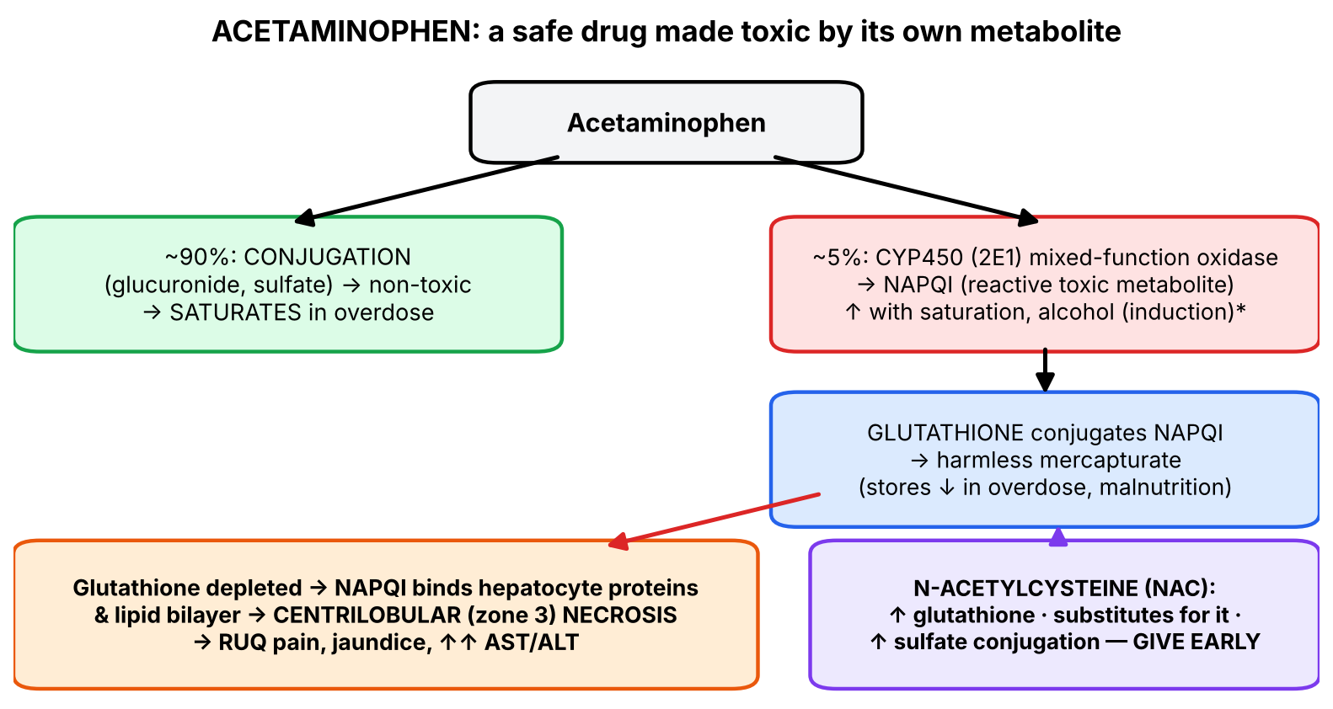
Figure 8. Acetaminophen metabolism and where NAC acts.
▌ ADDITIONAL CONTEXT
- The toxic metabolite is NAPQI (N-acetyl-p-benzoquinone imine), made mainly by CYP2E1.
- Why centrilobular (zone 3)? Zone 3 hepatocytes (around the central vein) have the highest CYP450 content and the lowest oxygen → most NAPQI formed there.
- Who is at higher risk: chronic alcohol use (CYP2E1 induction + low glutathione), malnutrition/fasting (low glutathione), enzyme inducers (connects to the P450 inducer list in Section 5).
▌ HIGH-YIELD ADDITIONAL KNOWLEDGE
- Timeline: day 1 — nausea/vomiting or nothing; day 2–3 — RUQ pain, AST/ALT rising (often > 1,000); day 3–4 — peak hepatotoxicity, coagulopathy (↑ INR), encephalopathy; survivors recover by ~2 weeks. Early NAC (within 8–10 h) is nearly 100% protective.
- Rumack–Matthew nomogram (serum level at ≥ 4 h after single acute ingestion) decides NAC.
- Kaplan liver list: acetaminophen is one of the causes of focal-to-massive hepatic necrosis (HAVAc — halothane, acetaminophen, valproate, *Amanita phalloides*).

4.2 Methanol (and ethylene glycol)
▌ FROM THE SLIDES
- Toxicity is mediated by its metabolites: methanol → (alcohol dehydrogenase) → formaldehyde → formic acid, the likely cause of major organ toxicity.
- Formic acid inhibits cytochrome oxidase → tissue hypoxia and lactic acid production.
- Most characteristic symptom: visual disturbance — blurred vision and a sense of 'being in a snowstorm'.
- Treatment: fomepizole (inhibits alcohol dehydrogenase); IV ethanol (competes for ADH); sodium bicarbonate (corrects metabolic acidosis).
- [Kaplan antidote table] Ethanol → methanol or ethylene glycol; fomepizole (ADH inhibitor) now approved for both.
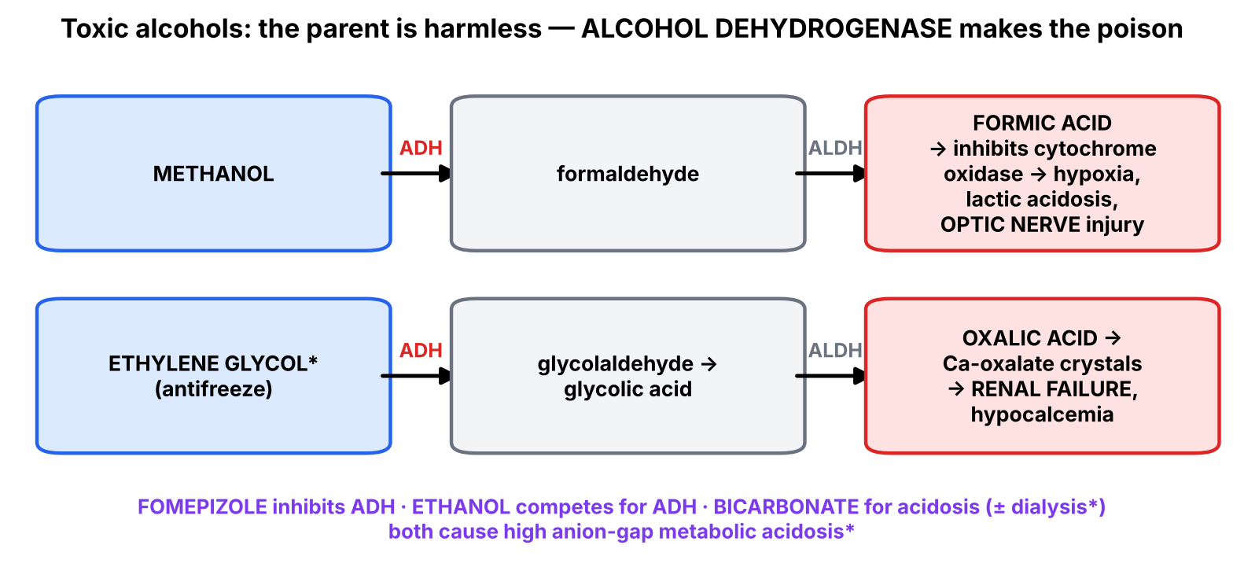
Figure 9. Toxic alcohols — the antidote blocks the enzyme that makes the poison.
▌ ADDITIONAL CONTEXT
- Why the eye? The retina and optic nerve have very high oxidative metabolism; formate blocks cytochrome oxidase there → optic disc edema → permanent blindness. Putamen necrosis can also occur.
- Why do fomepizole and ethanol work? They prevent the parent (relatively harmless) alcohol from being converted to its toxic acids; the unmetabolized methanol is then excreted or removed by hemodialysis. Fomepizole is preferred (no intoxication, easier dosing).
▌ HIGH-YIELD ADDITIONAL KNOWLEDGE
- Both methanol and ethylene glycol → high anion-gap metabolic acidosis and an elevated osmolal gap. Ethylene glycol (antifreeze, sweet taste) → calcium oxalate crystals (envelope-shaped) in urine → acute kidney injury and hypocalcemia. HY anion-gap mnemonic MUDPILES (Methanol, Uremia, DKA, Propylene glycol, Iron/INH, Lactic acidosis, Ethylene glycol, Salicylates).

4.3 Cyanide
▌ FROM THE SLIDES
- Affects virtually all tissues by binding metalloenzymes; principal toxicity = inactivation of cytochrome oxidase (cytochrome a₃) → inhibition of cellular respiration.
- Tissues with the highest O₂ need (brain) are most affected; death in seconds to minutes to several hours.
- Presentation: bitter almond odor on breath; elevated measured venous O₂ saturation (blocked cellular O₂ consumption); CV collapse, respiratory failure, seizures.
- Treatment: amyl nitrite (inhaled), sodium nitrite (IV) → induce methemoglobin (Fe³⁺), which binds cyanide (non-toxic cyanmethemoglobin); sodium thiosulfate — second-line because of its slower mechanism.
- Slide 33 diagram: cyanide + cytochrome oxidase → cyan-cytochrome oxidase; sodium nitrite + Hb → methemoglobin, which pulls CN off → reactivated cytochrome oxidase + cyanmethemoglobin; sodium thiosulfate + rhodanese → sodium thiocyanate (excreted renally) + sulfide; hemoglobin regenerated.
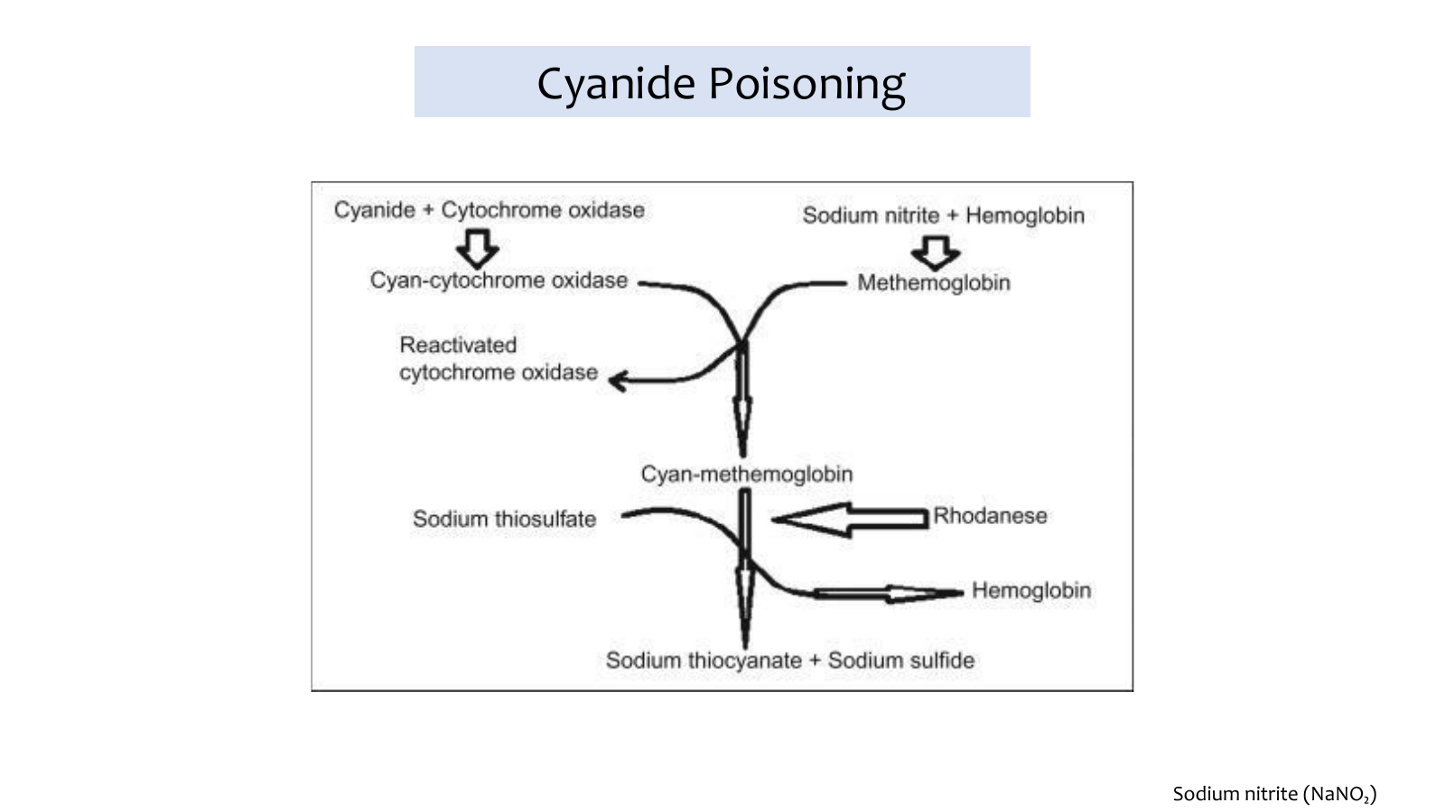
Tox slide 33: cyanide antidote pathway (nitrite → methemoglobin; thiosulfate + rhodanese → thiocyanate).
▌ ADDITIONAL CONTEXT
Why is venous blood bright red? Cells cannot use oxygen, so O₂ stays on hemoglobin as blood passes through tissues → venous O₂ saturation approaches arterial ('arterialized' venous blood). Cells switch to anaerobic glycolysis → severe lactic acidosis. Why induce methemoglobinemia on purpose? Cyanide binds Fe³⁺. Cytochrome a₃ contains Fe³⁺, but so does methemoglobin — and there is far more hemoglobin than cytochrome oxidase, so the nitrite creates a large 'decoy' Fe³⁺ pool that steals cyanide back.
▌ HIGH-YIELD ADDITIONAL KNOWLEDGE
- Hydroxocobalamin (vitamin B12a) is now first-line in many guidelines: its cobalt binds CN → cyanocobalamin, excreted in urine; turns skin and urine red. Preferred in smoke inhalation, where CO already reduces O₂ delivery and nitrites would make it worse (methemoglobin can't carry O₂).
- Sources: smoke inhalation (burning plastics), nitroprusside infusion, amygdalin (apricot pits), industrial (electroplating). H₂S (sewer gas; 'rotten eggs') also inhibits cytochrome oxidase.

4.4 Carbon monoxide [Kaplan slide 2]
▌ FROM THE SLIDES
- Toxic at > 10% carboxyhemoglobin: nausea and vomiting, dyspnea with hyperventilation, mydriasis, vertigo; CV signs prominent — ↓ BP, syncope, ↑ HR, arrhythmias.
- Treatment: hyperbaric O₂ and decontamination (humidified 100% O₂ OK in mild OD); antidote table: oxygen; Tox management list: O₂, HBO.
- Speaker notes — sources: household appliances (gas fires, boilers, central heating, water heaters, cookers, open fires using gas, oil, coal and wood) when fuel does not burn fully; running a car engine in an enclosed space.
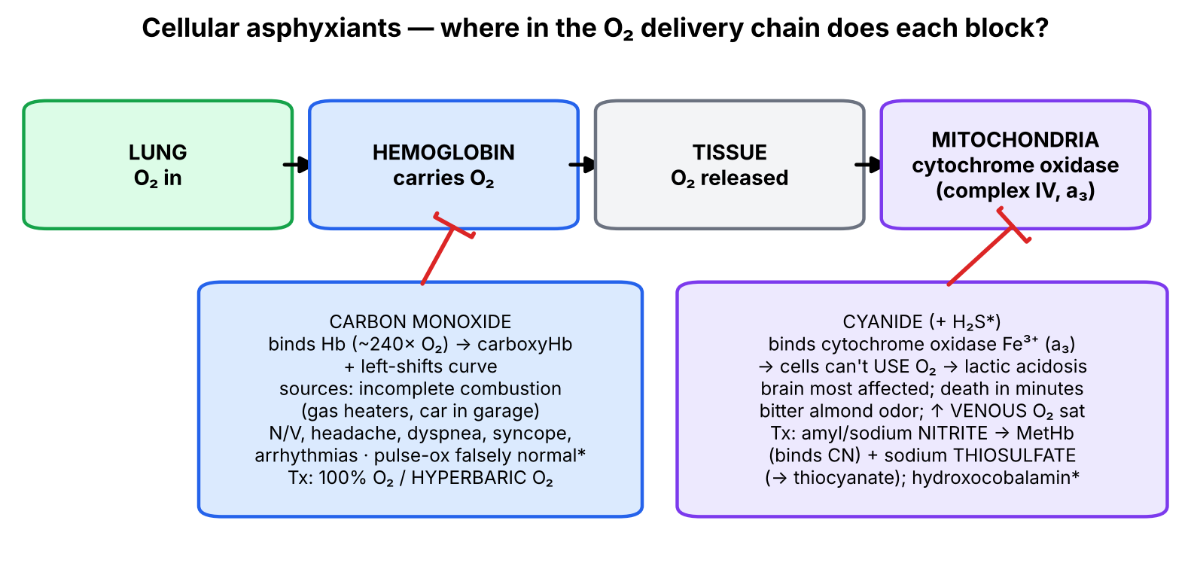
Figure 10. CO blocks O₂ carriage; cyanide blocks O₂ use.
▌ ADDITIONAL CONTEXT
Mechanism: CO binds hemoglobin ~240 times more avidly than O₂ → carboxyhemoglobin can't carry O₂, and the remaining O₂ is held more tightly (left shift of the dissociation curve) → tissue hypoxia, worst in brain and heart. CO also binds cytochrome oxidase and myoglobin. Why 100% / hyperbaric O₂? High O₂ partial pressure competes CO off hemoglobin: COHb half-life ~4–5 h on room air, ~1 h on 100% O₂, ~20–30 min with hyperbaric O₂.
▌ HIGH-YIELD ADDITIONAL KNOWLEDGE
- Pulse oximetry is falsely normal (can't distinguish COHb from O₂Hb) → measure COHb by co-oximetry. Classic: headache in a whole family/household in winter; 'cherry-red' skin (late, unreliable). Delayed neuropsychiatric sequelae; bilateral globus pallidus lesions.
🩺 CLINICAL CORRELATION
• Woman 2 days after a suicide attempt with paracetamol: RUQ pain, jaundice, ALT 4,500 → acetaminophen hepatotoxicity → NAC even if late; consider transplant criteria.
• Patrons of a party serving 'home-made' spirits present with blurred, 'snowstorm' vision and severe metabolic acidosis → methanol → fomepizole + bicarbonate + hemodialysis.
• Fire victim, confused, severe lactic acidosis, bright red venous blood → CO and cyanide → 100% O₂ + hydroxocobalamin (HY).
• Family with headaches and nausea every morning in winter, better when away from home → CO from a faulty boiler → COHb level, 100% O₂/HBO.

🎯 EXAM FOCUS
• Acetaminophen: saturation of conjugation → P450 toxic metabolite → glutathione depletion → centrilobular necrosis; clues OTC use, RUQ pain, jaundice, ↑ AST/ALT; NAC early (↑ glutathione, substitutes for it, ↑ sulfation).
• Methanol: ADH → formaldehyde → formic acid → inhibits cytochrome oxidase → hypoxia, lactic acidosis; 'snowstorm' vision; fomepizole, IV ethanol, bicarbonate.
• Cyanide: cytochrome oxidase a₃; bitter almonds, ↑ venous O₂ sat; amyl/sodium nitrite (methemoglobin binds CN), sodium thiosulfate second-line (rhodanese → thiocyanate).
• CO: > 10% COHb; N/V, dyspnea, mydriasis, vertigo, CV signs; hyperbaric O₂ (100% O₂ in mild).

⚠️ COMMON MISTAKES
• Thinking the parent drug (acetaminophen, methanol) is the direct toxin — it's the metabolite.
• Waiting for liver enzymes to rise before giving NAC — start early.
• Giving nitrites to a smoke-inhalation victim with high COHb (worsens O₂ delivery) — HY.
• Trusting a normal pulse oximeter reading in CO poisoning.
• Calling sodium thiosulfate first-line — the slide says second-line (slower).

Section 4 — Practice questions
Q1. [MCQ] Which pattern of liver necrosis is characteristic of acetaminophen toxicity?
A. Periportal (zone 1)
B. Centrilobular (zone 3)
C. Bridging fibrosis
D. Piecemeal necrosis
E. Cholestasis only

✅ ANSWER & EXPLANATION
B (Tox slide 22).

Q2. [MCQ] N-acetylcysteine protects the liver by all of the following EXCEPT:
A. Increasing glutathione stores
B. Directly combining with the reactive metabolite
C. Enhancing sulfate conjugation
D. Inhibiting alcohol dehydrogenase
E. Acting as a glutathione substitute

✅ ANSWER & EXPLANATION
D — that's fomepizole.

Q3. [Clinical vignette] A 40-year-old drank 'moonshine'. Twelve hours later he complains that it looks as if he is 'in a snowstorm'; pH 7.08 with a high anion gap. Explain the mechanism and treatment.

✅ ANSWER & EXPLANATION
Methanol → ADH → formaldehyde → formic acid, which inhibits cytochrome oxidase → tissue hypoxia, lactic acidosis, optic nerve damage. Treat with fomepizole (or IV ethanol) to block ADH, sodium bicarbonate for acidosis (and hemodialysis, HY).

Q4. [MCQ] In cyanide poisoning, sodium nitrite works by:
A. Binding cyanide directly
B. Forming methemoglobin, which binds cyanide
C. Activating rhodanese
D. Competing with O₂ for hemoglobin
E. Inhibiting cytochrome oxidase

✅ ANSWER & EXPLANATION
B (Tox slides 32–33).

Q5. [Short answer] Why is the measured venous O₂ saturation elevated in cyanide poisoning?

✅ ANSWER & EXPLANATION
Cyanide blocks cytochrome oxidase, so cells cannot consume O₂; oxygen remains bound to hemoglobin in venous blood → venous saturation approaches arterial.

Q6. [Mechanism] A family develops headache, nausea and dizziness after a gas heater is used in a closed room. Explain why tissue hypoxia occurs despite a normal pulse-oximetry reading, and the rationale for hyperbaric O₂.

✅ ANSWER & EXPLANATION
CO from incomplete combustion binds Hb with far higher affinity than O₂ (carboxyhemoglobin) and left-shifts the curve → less O₂ delivered. Pulse oximeters read COHb as oxyhemoglobin → falsely normal. Hyperbaric O₂ raises O₂ partial pressure, displacing CO and shortening COHb half-life dramatically (Kaplan: hyperbaric O₂; 100% O₂ in mild cases).

Section 5 — Antidote master tables [Kaplan slides 6–7; Tox slide 34]
▌ FROM THE SLIDES
Both decks end with an antidote list. They are merged below, then re-sorted by mechanism so each pairing has a reason.
Toxin | Antidote | Source | WHY it works (mechanism family)
Acetaminophen | N-acetylcysteine | Both | ↓ toxic metabolite (glutathione donor)
Anticholinergics (atropine, antihistamines, antiparkinsonian — NOT TCAs) | Physostigmine ✔ | Both | ↑ ACh at muscarinic sites (reversible AChE inhibitor, crosses BBB)
AChE inhibitors (physostigmine, neostigmine, pyridostigmine, OPs: malathion, parathion) | Atropine + pralidoxime (PAM for irreversible) | Both | Physiologic block of muscarinic receptors + enzyme reactivation
Arsenic / lead / mercury / gold | Dimercaprol (BAL); oral succimer (milder Pb/Hg) | Both | Chelation (–SH groups)
Lead / mercury | Succimer (DMSA) | Tox 34 | Chelation
Lead (backup), Cd, Cr, Co, Mn, Zn | EDTA | Kaplan | Chelation (Ca exchange)
Iron and iron salts | Deferoxamine | Both | Chelation
Copper (Wilson), iron, lead, mercury | Penicillamine | Kaplan | Chelation
β-blockers ✔ | Glucagon | Both | Bypasses β-receptor (Gs → cAMP)
Benzodiazepines, zolpidem, zaleplon | Flumazenil | Both | Competitive antagonist at BZD site
Carbon monoxide | Oxygen / hyperbaric O₂ | Both | Displaces CO from Hb
Cyanide | Nitrites (then thiosulfate) | Tox | MetHb decoy; conversion to thiocyanate
Digoxin | Digoxin immune Fab (Digibind) | Both | Antibody binds the drug
Methanol / ethylene glycol | Fomepizole / ethanol | Both | Block alcohol dehydrogenase
Isoniazid (INH) | Pyridoxine (B6) | Tox | Replaces B6 depleted by INH (→ GABA synthesis; seizures)
Methemoglobinemia | Methylene blue | Tox | Reduces Fe³⁺ back to Fe²⁺ (via NADPH-MetHb reductase)
Opioids | Naloxone | Both | Competitive μ antagonist
Organophosphates | Atropine | Tox | Physiologic (muscarinic block)
TCAs | Sodium bicarbonate | Tox | Overcomes Na⁺-channel block; alkalinizes
Theophylline, β-agonists | Esmolol | Kaplan | β1 block of tachycardia (physiologic)
Heparins | Protamine | Kaplan | Positively charged; binds negatively charged heparin
Warfarin, coumarins | Vitamin K | Kaplan | Restores synthesis of factors II, VII, IX, X
Most oral poisonings (NOT Fe, CN, Li, solvents, mineral acids, corrosives) ✔ | Activated charcoal | Kaplan | Adsorbs toxin (mechanical)

💡 THE ORGANIZING PRINCIPLE
Sort the antidotes into 5 boxes and almost none is arbitrary:
• Chelators (metals): BAL, EDTA, succimer, penicillamine, deferoxamine.
• Receptor antagonists (same receptor as poison): naloxone, flumazenil.
• Physiologic opposites (different receptor/pathway): atropine (for ACh excess), physostigmine (for ACh block), glucagon, esmolol.
• Binders / neutralizers: digoxin Fab, protamine, NAC, nitrites (via MetHb), hydroxocobalamin*.
• Replace or rescue what the toxin depleted/blocked: vitamin K, pyridoxine, methylene blue, oxygen, folinic acid, fomepizole/ethanol (block enzyme), pralidoxime (rescue enzyme).

🎯 EXAM FOCUS
• These two tables are the highest-yield single resource in the lecture — expect direct 'antidote for X' questions.
• Professor ticks: AChE inhibitors, anticholinergics, salicylates, β-blockers (glucagon), heavy metals, physostigmine, activated charcoal.

Section 6 — Adverse drug reactions, drug-induced lupus, P-450 and sulfa drugs [Kaplan slides 8–13]

6.1 How to tame the First Aid drug-reaction list
The Kaplan deck reproduces the First Aid 'drug reactions by system' list — 60+ pairings. Instead of memorizing it as text, ask why the drug harms that organ. Most entries fall into five mechanisms:
Mechanism | Logic | Entries from the slides
Extension of the drug's own pharmacology | The intended action, overdone or in the wrong tissue | Coronary vasospasm (cocaine, sumatriptan — vasoconstrictors); flushing (vancomycin, adenosine, niacin, Ca²⁺-channel blockers — vasodilation/histamine); torsades (class IA quinidine, class III sotalol — prolong repolarization); antimuscarinic effects (atropine, TCAs, H1 blockers, neuroleptics); Parkinsonism & tardive dyskinesia (antipsychotics, metoclopramide, reserpine — dopamine block/depletion); hot flashes (tamoxifen, clomiphene — anti-estrogen); adrenal insufficiency (glucocorticoid withdrawal — HPA suppression); fat redistribution (glucocorticoids, protease inhibitors); osteoporosis (corticosteroids, heparin); gout (furosemide, thiazides — ↓ uric acid excretion; niacin, cyclosporine, pyrazinamide); hyperglycemia (niacin, tacrolimus, protease inhibitors); cough (ACE inhibitors — ↑ bradykinin; ARBs no cough); gynecomastia (spironolactone, digitalis, cimetidine, chronic alcohol, estrogens, ketoconazole — anti-androgen/estrogen); diabetes insipidus (lithium, demeclocycline — block ADH action); SIADH (carbamazepine, cyclophosphamide)
Toxic to rapidly dividing / high-turnover cells | Kill or stop DNA synthesis | Agranulocytosis (clozapine, carbamazepine, colchicine, PTU, methimazole, dapsone); aplastic anemia (chloramphenicol, benzene, NSAIDs, PTU, methimazole); megaloblastic anemia (phenytoin, methotrexate, sulfa — folate antagonism); pulmonary fibrosis (bleomycin, amiodarone, busulfan); dilated cardiomyopathy (doxorubicin, daunorubicin — free radicals)
Toxic metabolite / direct organ toxicity | Organ that metabolizes or excretes the drug is damaged | Hepatic necrosis (halothane, acetaminophen, valproate, Amanita phalloides — HAVAc); hepatitis (INH); hemorrhagic cystitis (cyclophosphamide, ifosfamide → acrolein; prevent with mesna); nephro/ototoxicity (aminoglycosides, vancomycin, loop diuretics, cisplatin); Fanconi syndrome (expired tetracycline); gray baby syndrome (chloramphenicol — neonates can't glucuronidate); tendon rupture/cartilage damage (fluoroquinolones)
Immune / hypersensitivity | Drug acts as hapten or triggers autoimmunity | Coombs+ hemolytic anemia (methyldopa); Stevens-Johnson (penicillin, ethosuximide, carbamazepine, sulfa, lamotrigine, allopurinol, phenytoin, phenobarbital); SLE-like syndrome (hydralazine, INH, procainamide, phenytoin); interstitial nephritis (methicillin, NSAIDs, furosemide); photosensitivity (sulfonamides, amiodarone, tetracycline); acute cholestatic hepatitis (macrolides)
Enzyme / biochemical vulnerability of host | Host defect unmasked by the drug | Hemolysis in G6PD deficiency (INH, sulfonamides, primaquine, aspirin, ibuprofen, nitrofurantoin — oxidant stress); disulfiram-like reaction (metronidazole, certain cephalosporins, procarbazine, 1st-gen sulfonylureas — inhibit aldehyde dehydrogenase); thrombosis (OCPs — ↑ clotting factors); pseudomembranous colitis (clindamycin, ampicillin — kill normal flora → C. difficile)
Other on the list |  | Cinchonism (quinidine, quinine); seizures (bupropion, imipenem/cilastatin, isoniazid); gingival hyperplasia (phenytoin, verapamil); myopathies (fibrates, niacin, colchicine, hydroxychloroquine, interferon-α, penicillamine, statins, glucocorticoids); hypothyroidism (lithium, amiodarone, sulfonamides)

The full slide lists with their mnemonics (for direct recall)
▌ FROM THE SLIDES
System / reaction | Causal agents [Kaplan slides 8–11] | Mnemonic
CV: coronary vasospasm | Cocaine, sumatriptan
Cutaneous flushing | Vancomycin, adenosine, niacin, Ca²⁺ channel blockers | VANC
Dilated cardiomyopathy | Doxorubicin (Adriamycin), daunorubicin
Torsades de pointes | Class III (sotalol), class IA (quinidine)
Heme: agranulocytosis | Clozapine, carbamazepine, colchicine, PTU, methimazole, dapsone | Agranulocytosis Could Certainly Cause Pretty Major Damage
Aplastic anemia | Chloramphenicol, benzene, NSAIDs, PTU, methimazole
Direct Coombs+ hemolytic anemia | Methyldopa
Gray baby syndrome | Chloramphenicol
Hemolysis in G6PD deficiency | INH, sulfonamides, primaquine, aspirin, ibuprofen, nitrofurantoin | hemolysis IS PAIN
Megaloblastic anemia | Phenytoin, methotrexate, sulfa drugs | having a blast with PMS
Thrombotic complications | OCPs (estrogens, progestins)
Resp: cough | ACE inhibitors (ARBs — no cough)
Pulmonary fibrosis | Bleomycin, amiodarone, busulfan | it's hard to BLAB
GI: acute cholestatic hepatitis | Macrolides
Focal–massive hepatic necrosis | Halothane, acetaminophen, valproic acid, Amanita phalloides | liver HAVAc
Hepatitis | INH
Pseudomembranous colitis | Clindamycin, ampicillin
Endo: adrenocortical insufficiency | Glucocorticoid withdrawal (HPA suppression)
Gynecomastia | Spironolactone, digitalis, cimetidine, chronic alcohol, estrogens, ketoconazole | Some Drugs Create Awesome Knockers
Hot flashes | Tamoxifen, clomiphene
Hypothyroidism | Lithium, amiodarone, sulfonamides
Hyperglycemia | Niacin, tacrolimus, protease inhibitors
MSK: fat redistribution | Glucocorticoids, protease inhibitors
Gingival hyperplasia | Phenytoin, verapamil
Gout | Furosemide, thiazides, niacin, cyclosporine, pyrazinamide
Myopathies | Fibrates, niacin, colchicine, hydroxychloroquine, IFN-α, penicillamine, statins, glucocorticoids | Fish N CHIPS Give you myopathies
Osteoporosis | Corticosteroids, heparin
Photosensitivity | Sulfonamides, amiodarone, tetracycline | SAT for a photo
Stevens-Johnson rash | Penicillin, ethosuximide, carbamazepine, sulfa, lamotrigine, allopurinol, phenytoin, phenobarbital | bad rash after a PEC SLAPP
SLE-like syndrome | Hydralazine, INH, procainamide, phenytoin | it's not HIPP to have lupus
Tendonitis/rupture, cartilage damage (kids) | Fluoroquinolones
Renal: diabetes insipidus | Lithium, demeclocycline
Fanconi syndrome | Expired tetracycline
Interstitial nephritis | Methicillin, NSAIDs, furosemide
Hemorrhagic cystitis | Cyclophosphamide, ifosfamide (prevent with mesna)
SIADH | Carbamazepine, cyclophosphamide
Neuro: cinchonism | Quinidine, quinine
Parkinson-like syndrome | Antipsychotics, reserpine, metoclopramide
Seizures | Bupropion, imipenem/cilastatin, isoniazid
Tardive dyskinesia | Antipsychotics
Multiorgan: antimuscarinic | Atropine, TCAs, H1 blockers, neuroleptics, digoxin
Disulfiram-like reaction | Metronidazole, certain cephalosporins, procarbazine, 1st-gen sulfonylureas
Nephrotoxicity/ototoxicity | Aminoglycosides, vancomycin, loop diuretics, cisplatin

6.2 Drug-induced SLE (Kaplan slide 12)
▌ FROM THE SLIDES
Diagram of symptoms: CNS — seizures; skin — butterfly rash, discoid lupus; serositis — pleuritis, pericarditis; heart — endocarditis, myocarditis; glomerulonephritis; hematologic — hemolytic anemia, leukopenia, thrombocytopenia; arthritis; lymphadenopathy. Drugs (slide 10): hydralazine, INH, procainamide, phenytoin ('not HIPP to have lupus').
▌ HIGH-YIELD ADDITIONAL KNOWLEDGE
- Drug-induced lupus is characterized by anti-histone antibodies (> 95%); anti-dsDNA usually negative; renal and CNS involvement are rare (unlike idiopathic SLE); it resolves when the drug is stopped. Risk is higher in slow acetylators (hydralazine, procainamide, INH are acetylated by NAT2).

6.3 Cytochrome P-450 interactions ✔ (Kaplan slide 13)
▌ FROM THE SLIDES
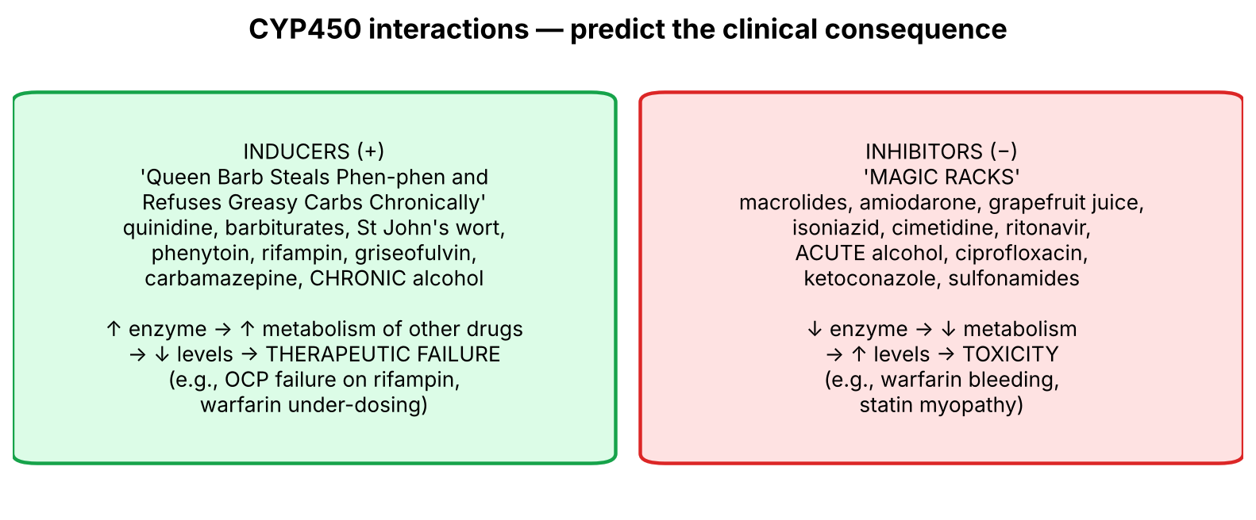
Figure 11. P-450 inducers and inhibitors — predict the effect on a co-administered drug.
- Inducers (+): quinidine*, barbiturates, St John's wort, phenytoin, rifampin, griseofulvin, carbamazepine, chronic alcohol use — 'Queen Barb Steals Phen-phen and Refuses Greasy Carbs Chronically'. (*Quinidine can induce and inhibit different isoforms; induction is the more important effect.)
- Inhibitors (−): macrolides, amiodarone, grapefruit juice, isoniazid, cimetidine, ritonavir, acute alcohol abuse, ciprofloxacin, ketoconazole, sulfonamides — 'MAGIC RACKS'.
▌ ADDITIONAL CONTEXT
How to use it: inducer + drug cleared by CYP → lower levels → loss of effect (e.g., rifampin → oral contraceptive failure; carbamazepine → warfarin needs ↑). Inhibitor → higher levels → toxicity (e.g., erythromycin + statin → myopathy; ketoconazole + warfarin → bleeding). Connect to toxicology: chronic alcohol (inducer of CYP2E1) increases NAPQI formation from acetaminophen, while acute alcohol (inhibitor) competes for the enzyme.

6.4 Sulfa drugs (Kaplan slide 13)
▌ FROM THE SLIDES
- Probenecid, furosemide, acetazolamide, celecoxib, thiazides, sulfonamide antibiotics, sulfasalazine, sulfonylureas — 'Popular FACTSSS'.
- Patients with sulfa allergy may develop fever, urinary tract infection, pruritic rash, Stevens-Johnson syndrome, hemolytic anemia, thrombocytopenia, agranulocytosis and urticaria (hives) — mild to life-threatening.
🩺 CLINICAL CORRELATION
• Woman on rifampin for TB becomes pregnant despite taking her OCP → P-450 induction.
• Patient on simvastatin starts clarithromycin → muscle pain, dark urine → CYP3A4 inhibition → myopathy/rhabdomyolysis.
• Man on hydralazine for hypertension develops arthritis, pleuritic chest pain and positive anti-histone antibodies → drug-induced lupus → stop the drug.
• Patient with G6PD deficiency develops dark urine after primaquine for malaria → oxidant hemolysis (Heinz bodies, bite cells).
• Patient on metronidazole vomits, flushes and becomes tachycardic after drinking beer → disulfiram-like reaction.

🎯 EXAM FOCUS
• Know each mnemonic: VANC, CCCPMD, IS PAIN, PMS, BLAB, HAVAc, SDCAK, Fish N CHIPS G, SAT, PEC SLAPP, HIPP, MAGIC RACKS, Queen Barb…, Popular FACTSSS.
• Drug-induced lupus: HIPP; clinical features on slide 12 (+ anti-histone, HY).
• P-450 questions test the direction of the interaction (inducer → less effect; inhibitor → toxicity).

⚠️ COMMON MISTAKES
• Mixing chronic alcohol (inducer) with acute alcohol (inhibitor).
• Thinking ARBs cause cough like ACE inhibitors — they don't (no bradykinin accumulation).
• Forgetting that mesna prevents cyclophosphamide hemorrhagic cystitis (binds acrolein).
• Calling procainamide lupus 'anti-dsDNA positive' — it's anti-histone.

Sections 5–6 — Practice questions
Q1. [MCQ] The antidote for heparin overdose is:
A. Vitamin K
B. Protamine
C. Flumazenil
D. Fomepizole
E. Methylene blue

✅ ANSWER & EXPLANATION
B (Kaplan antidote table). Vitamin K reverses warfarin.

Q2. [MCQ] A patient overdoses on isoniazid and develops refractory seizures. The antidote is:
A. Naloxone
B. Pyridoxine (vitamin B6)
C. Physostigmine
D. Deferoxamine
E. Sodium bicarbonate

✅ ANSWER & EXPLANATION
B (Tox antidote list). INH depletes B6 → ↓ GABA synthesis → seizures.

Q3. [Clinical vignette] A 58-year-old on procainamide develops fever, polyarthritis and pleuritic chest pain. Kidney function and CNS are normal. What is the likely diagnosis, which antibody would you expect, and what is the treatment?

✅ ANSWER & EXPLANATION
Drug-induced lupus (HIPP: hydralazine, INH, procainamide, phenytoin); anti-histone antibodies (HY); renal/CNS involvement is uncommon. Treatment: stop procainamide — symptoms resolve.

Q4. [MCQ] Which drug would most likely DECREASE the effectiveness of warfarin?
A. Ciprofloxacin
B. Ketoconazole
C. Rifampin
D. Cimetidine
E. Amiodarone

✅ ANSWER & EXPLANATION
C — rifampin induces P-450 → faster warfarin metabolism. The others are inhibitors (↑ warfarin effect, bleeding).

Q5. [Short answer] List the sulfa-containing drugs from the slide using 'Popular FACTSSS'.

✅ ANSWER & EXPLANATION
Probenecid, furosemide, acetazolamide, celecoxib, thiazides, sulfonamide antibiotics, sulfasalazine, sulfonylureas.

Q6. [Mechanism] Why does metronidazole cause a disulfiram-like reaction with alcohol?

✅ ANSWER & EXPLANATION
It inhibits aldehyde dehydrogenase → acetaldehyde accumulates after ethanol intake → flushing, nausea, vomiting, tachycardia, hypotension (same mechanism as disulfiram).

Whole-lecture review

A. Complete high-yield summary
BASICS: 'the dose makes the poison' (Paracelsus) · toxin = biological, toxicant = any
Antidote types: chemical (chelators) · mechanical (charcoal) · physiologic (atropine)
Universal antidote: 2 charcoal : 1 MgO : 1 tannic acid

METALS (bind –SH) → CHELATORS (renal excretion; CI severe renal disease)
Arsenic: inorganic > organic; keratin (hair/nails) at 2–4 wk; raindrop skin,
Mees lines; garlic breath, rice-water stools, torsades; BAL 1st; charcoal poor
Lead: RBC-bound, crosses BBB/placenta, bone t½ ~30 y; Zn enzymes (heme,
steroid, vit D); lead lines; EDTA ± BAL; succimer (children); Fe/Ca/P supps
Mercury: vapor→lung; salts→GI ulcer, proximal tubular necrosis; organic→CNS;
BAL (IM, not IV)/succimer; charcoal for oral
Iron → deferoxamine · Copper (Wilson) → penicillamine (DOC)

TOXIDROMES
Anticholinergic: red, dry, blind, mad, hot → physostigmine (not TCAs)
Cholinergic (OP/carbamate): miosis, secretions, bronchospasm, diarrhea
→ atropine + pralidoxime (OP only); carbamates ~6 h, little CNS
Opioid: CNS + resp depression + miosis → naloxone (repeat)
BZD: GABA potentiation → flumazenil · β-blocker → glucagon
Salicylate → alkalinize urine ± dialysis · TCA → bicarbonate · SSRI → cyproheptadine

METABOLITE / O₂ POISONS
Acetaminophen → P450 → toxic metabolite; ↓ glutathione → centrilobular
necrosis → NAC early
Methanol → formic acid (cyt oxidase) → 'snowstorm' vision → fomepizole/EtOH, HCO₃
Cyanide → cyt oxidase a₃; bitter almond; ↑ venous O₂ sat → nitrites, thiosulfate
CO → COHb >10%: N/V, dyspnea, mydriasis, vertigo, CV signs → 100% / HBO

ADRs by system (First Aid mnemonics) · drug-induced SLE (HIPP)
P-450: inducers 'Queen Barb…' · inhibitors MAGIC RACKS · sulfa: Popular FACTSSS

B. Genuinely arbitrary facts — memorize directly
# | Fact | Memory hook
1 | Universal antidote 2 : 1 : 1 (charcoal : MgO : tannic acid) | 'Two charcoal, one each of the rest'
2 | Arsenic → keratin tissues at 2–4 weeks | Arsenic hides in hair
3 | Lead bone half-life ~30 years | 'Lead lasts a generation'
4 | Carbamates bind AChE ~6 h | —
5 | CO toxicity threshold > 10% COHb | —
6 | Charcoal doesn't bind Fe, CN, Li, solvents, mineral acids, corrosives | 'PHAILS' (HY)
7 | BAL = British anti-Lewisite; given IM | War-gas antidote
8 | EDTA: lead in five heterocyclic rings; exchanges its Ca | —
9 | Mnemonics for ADRs, P-450 and sulfa | See Section 6
10 | Esmolol for theophylline/β-agonist; protamine for heparin; vitamin K for warfarin | —

C. Common exam traps
⚠️ COMMON MISTAKES
• Physostigmine reverses anticholinergic delirium — but not TCA toxicity (use bicarbonate).
• Pralidoxime only for organophosphates and only early (before aging); not carbamates.
• Atropine fixes muscarinic effects only.
• Activated charcoal doesn't bind iron, arsenic, lithium, cyanide, alcohols, corrosives.
• Organic mercury is MORE toxic; inorganic arsenic is MORE toxic.
• Dimercaprol is IM — never IV.
• Succimer = oral chelator for children with lead.
• Deferoxamine, penicillamine, succimer are contraindicated in severe renal disease (penicillamine also pregnancy).
• NAC must start early; centrilobular (zone 3) necrosis.
• Cyanide: venous O₂ saturation is high; thiosulfate is second-line (slower).
• CO: pulse oximetry falsely normal (HY).
• Chronic alcohol induces P-450; acute alcohol inhibits.

D. Visuals worth reviewing
Image | Where | What to look for
Raindrop pigmentation, palmar keratoses, Mees lines | Tox slide 'Dermatological lesions in chronic arsenic exposure' | Speckled hyper/hypopigmentation; transverse white nail bands
Lead (Burton) lines | Tox lead slide | Blue-black line along the gingival margin
Basophilic stippling | Hematology atlas | Fine blue dots in RBCs (aggregated rRNA)
Methylmercury in the food chain | Tox mercury slide | Bacteria → plankton → fish → humans (bioaccumulation)
Antidote mechanisms diagram | Tox slide 4 | Four action points: toxin, receptor/enzyme, metabolite, effect
Cyanide antidote flowchart | Tox slide 33 | Nitrite → MetHb → CN-MetHb; thiosulfate + rhodanese → thiocyanate

E. 20 medical-school-level practice questions
Q1. [MCQ] Which statement reflects Paracelsus's principle?
A. Only synthetic chemicals are toxic
B. Natural substances are safe
C. The dose differentiates a poison from a remedy
D. Antidotes always reverse toxicity
E. Toxins are always made by living organisms

✅ ANSWER & EXPLANATION
C.

Q2. [MCQ] Snake venom is best described as a:
A. Toxicant only
B. Toxin
C. Chelator
D. Antidote
E. Mechanical poison

✅ ANSWER & EXPLANATION
B — produced within a living organism (a toxin is also a toxicant).

Q3. [Vignette] A 35-year-old man is admitted with profuse 'rice-water' diarrhea, garlic odor on breath, hypotension and QT prolongation after his business partner 'seasoned' his food. What is the first-line chelator and the most important initial supportive measure?

✅ ANSWER & EXPLANATION
Arsenic poisoning. Dimercaprol (BAL) first-line; IV crystalloids for hemodynamic stabilization (losses from vomiting/diarrhea). Charcoal binds arsenic poorly; consider hemodialysis.

Q4. [MCQ] Mees lines and 'raindrop' pigmentation suggest chronic exposure to:
A. Lead
B. Mercury
C. Arsenic
D. Iron
E. Copper

✅ ANSWER & EXPLANATION
C.

Q5. [MCQ] Lead toxicity causes anemia because lead inhibits:
A. Vitamin B12 absorption
B. Zinc/SH-dependent enzymes of heme synthesis
C. Erythropoietin production only
D. Cytochrome oxidase
E. G6PD

✅ ANSWER & EXPLANATION
B (Tox slide; ALA dehydratase and ferrochelatase, HY).

Q6. [Vignette] A child with lead encephalopathy (seizures, altered consciousness) is admitted. Which regimen does the lecture recommend, and what is given for seizures?

✅ ANSWER & EXPLANATION
BAL plus EDTA for chelation (Tox; Kaplan: dimercaprol for severe), diazepam for seizures, aggressive hydration, nutritional supplementation (Fe, Ca, P).

Q7. [MCQ] Kaplan warns that dimercaprol should NOT be given IV in mercury poisoning because:
A. It is ineffective
B. It causes hypocalcemia
C. It redistributes mercury to the CNS, increasing neurotoxicity
D. It causes methemoglobinemia
E. It binds iron

✅ ANSWER & EXPLANATION
C.

Q8. [MCQ] The drug of choice for Wilson disease is:
A. Deferoxamine
B. Penicillamine
C. EDTA
D. Succimer
E. Flumazenil

✅ ANSWER & EXPLANATION
B (Tox penicillamine slide).

Q9. [Vignette] A 19-year-old took 40 tablets of an OTC pain reliever 6 hours ago. She feels well. Why must treatment begin now, and with what?

✅ ANSWER & EXPLANATION
Acetaminophen: early asymptomatic phase hides ongoing NAPQI formation; once glutathione is depleted, centrilobular necrosis begins and becomes irreversible. Start N-acetylcysteine early (ideally within 8–10 h, HY) — it restores glutathione, binds the metabolite and enhances sulfation.

Q10. [MCQ] Which finding is NOT part of the anticholinergic toxidrome?
A. Mydriasis
B. Dry skin
C. Hyperthermia
D. Diaphoresis
E. Delirium

✅ ANSWER & EXPLANATION
D — anticholinergics block sweating; diaphoresis points to cholinergic or sympathomimetic toxicity.

Q11. [Vignette] A toddler ingested an unknown insecticide. He has miosis, wheeze, drooling and diarrhea but no CNS depression; symptoms resolve within 8 hours with atropine alone. Which class of insecticide was it most likely, and why was pralidoxime unnecessary?

✅ ANSWER & EXPLANATION
Carbamate (e.g., carbaryl/propoxur): binds AChE temporarily (~6 h), no permanent damage, poor CNS penetration (minimal CNS signs). Pralidoxime is for organophosphates, not carbamates (Tox slide 28).

Q12. [MCQ] Flumazenil reverses toxicity from all of the following EXCEPT:
A. Diazepam
B. Lorazepam
C. Zolpidem
D. Zaleplon
E. Phenobarbital

✅ ANSWER & EXPLANATION
E — barbiturates do not act at the BZD site.

Q13. [MCQ] The opioid toxic triad consists of:
A. Mydriasis, hyperthermia, delirium
B. CNS depression, respiratory depression, miosis
C. Seizures, coma, cardiotoxicity
D. Tachycardia, hypertension, sweating
E. Ataxia, nystagmus, hypothermia

✅ ANSWER & EXPLANATION
B (Tox slide 27). C = TCA 3 Cs.

Q14. [Vignette] A patient with an amitriptyline overdose has QRS 140 ms, seizures and dilated pupils. A resident proposes physostigmine. Why not, and what should be given?

✅ ANSWER & EXPLANATION
Kaplan: physostigmine NOT for tricyclics — risk of bradyarrhythmia/asystole and seizures. Give sodium bicarbonate (Tox list; Kaplan: correct acidosis, control seizures, antiarrhythmics) to overcome fast Na⁺-channel blockade.

Q15. [MCQ] Salicylate overdose is managed with:
A. Urinary acidification
B. Urinary alkalinization and possibly hemodialysis
C. Flumazenil
D. Physostigmine
E. Deferoxamine

✅ ANSWER & EXPLANATION
B (Kaplan).

Q16. [MCQ] In methanol poisoning, fomepizole works by:
A. Binding formic acid
B. Inhibiting alcohol dehydrogenase
C. Inducing P-450
D. Chelating methanol
E. Reactivating cytochrome oxidase

✅ ANSWER & EXPLANATION
B.

Q17. [Vignette] A goldsmith's assistant collapses with seizures and severe lactic acidosis; breath smells of bitter almonds and venous blood is bright red. Give the slide's antidote sequence and the mechanism of each.

✅ ANSWER & EXPLANATION
Cyanide. (1) Amyl nitrite inhaled / sodium nitrite IV → convert Hb to methemoglobin (Fe³⁺), which binds CN (cyanmethemoglobin) and frees cytochrome oxidase; (2) sodium thiosulfate (second-line, slower) → donates sulfur so rhodanese converts CN to thiocyanate, excreted in urine.

Q18. [MCQ] Hyperbaric oxygen is the treatment of choice for significant poisoning with:
A. Cyanide only
B. Carbon monoxide
C. Methanol
D. Lead
E. Opioids

✅ ANSWER & EXPLANATION
B (Kaplan).

Q19. [MCQ] Which drug is a P-450 inhibitor according to MAGIC RACKS?
A. Rifampin
B. Phenytoin
C. Ketoconazole
D. Carbamazepine
E. St John's wort

✅ ANSWER & EXPLANATION
C. The others are inducers.

Q20. [MCQ] Pulmonary fibrosis is a known adverse effect of which group?
A. Bleomycin, amiodarone, busulfan
B. Clindamycin, ampicillin
C. Hydralazine, INH, procainamide
D. Lithium, demeclocycline
E. Vancomycin, adenosine, niacin

✅ ANSWER & EXPLANATION
A — 'BLAB' (Kaplan slide 9).

F. 10 rapid-recall questions
# | Question | Answer
1 | Three antidote types? | Chemical, mechanical, physiologic
2 | First-line chelator for arsenic? | Dimercaprol (BAL)
3 | Oral chelator for lead in children? | Succimer (DMSA)
4 | Antidote for iron? | Deferoxamine (IV)
5 | Antidote for acetaminophen? | N-acetylcysteine
6 | Antidote for anticholinergic toxicity? | Physostigmine
7 | Antidote for organophosphates? | Atropine + pralidoxime
8 | Antidote for β-blocker overdose? | Glucagon
9 | Antidote for methanol? | Fomepizole (or ethanol) + bicarbonate
10 | Antidote for cyanide (slide first-line)? | Amyl/sodium nitrite (then thiosulfate)

G. Key takeaways
- Every poison has a target, a downstream effect and a point where an antidote can intervene — learn the chain, not the pair.
- Heavy metals bind –SH groups; chelators pull them off and the kidney excretes the complex.
- Toxidromes are autonomic/CNS physiology exaggerated — read pupils, skin, vitals, gut and mental status.
- Metabolite poisons (acetaminophen, methanol) are stopped by blocking or mopping up the metabolite; oxygen poisons (CO, cyanide) by restoring O₂ carriage or use.
- The ADR, P-450 and sulfa lists become manageable when grouped by mechanism; the mnemonics then hold the details.

H. Two questions to test your understanding
🔁 CHECK YOURSELF
1. A patient with chronic alcohol use takes a moderate overdose of acetaminophen. Why is the risk of liver failure higher than in a non-drinker? → Chronic alcohol induces CYP2E1 (↑ NAPQI) and depletes glutathione (malnutrition) — both sides of the toxic balance worsen.
2. A firefighter has both CO and cyanide toxicity. Why might sodium nitrite be dangerous here? → Nitrite creates methemoglobin, which cannot carry O₂; with COHb already reducing O₂ delivery, this can be fatal → hydroxocobalamin (HY) + 100% O₂ is preferred.

