MHC & Processing and Presentation of Antigens
Immunology — Lecture 10 (Dr Samira Abdul Wajid, WUSOM) · Tutor study guide built from your slides

How to read this guide
Every block of teaching is labeled so you always know what you are responsible for:
Label | What it means | Your responsibility
▌ FROM THE SLIDES | Content taken directly from the lecture (all 16 slides are covered) | Must know — this is what your exam is written from
▌ ADDITIONAL CONTEXT | Background I added so the slide facts make sense (the 'why') | Know it well enough to reason; not directly examinable unless it appears elsewhere
▌ HIGH-YIELD ADDITIONAL KNOWLEDGE | Not on the slides, but repeatedly tested on USMLE/NBME-style exams | Learn it — it will show up on boards and often in-house exams

Your own handwritten notes on the slides (e.g., 'rule of 8', 'know this diagram', 'remember the ones highlighted in blue and red', 'invariant chain function?') are answered directly in the relevant sections.

Learning objectives (from the slides)
▌ FROM THE SLIDES
- Identify cells that express MHC I and MHC II molecules and describe their structures.
- Describe the process of antigen processing and presentation with class I MHC and class II MHC.

Step 0 — The architecture before the facts
Your professor presents this lecture as: genes → structure → table → pathways → diseases → inheritance → disease associations. That order is fine for a slide deck, but it leaves facts without anchors. Instead, hang every fact on four questions:
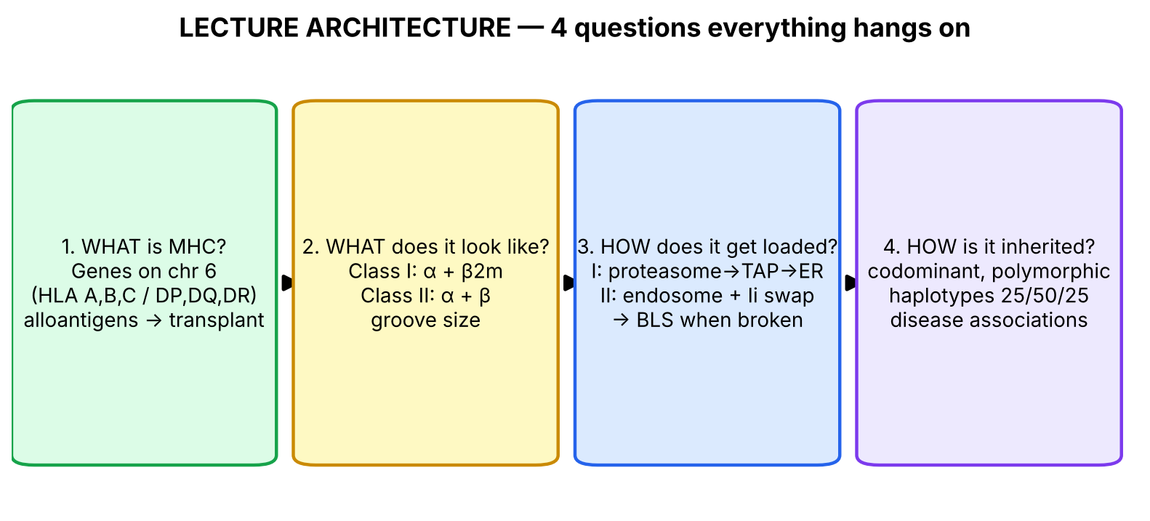
Figure 1. The whole lecture answers four questions. Every fact below belongs to one of these boxes.
And underneath all four questions is a single organizing idea — the immune system has two different security problems and built two different display systems to solve them:
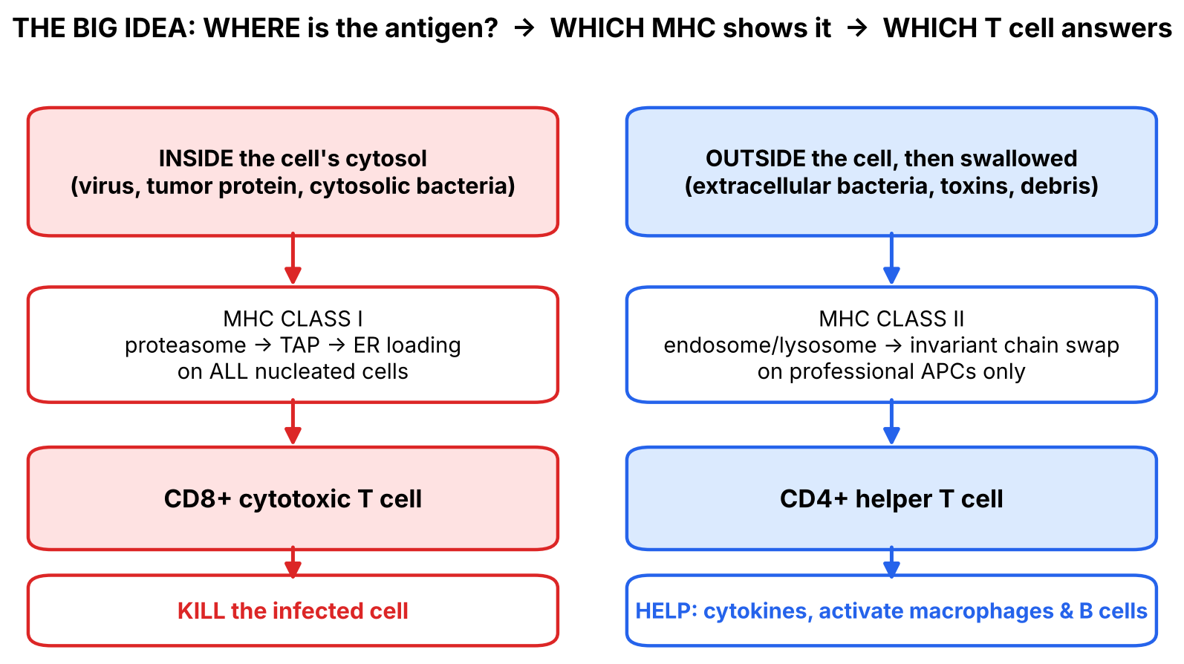
Figure 2. The one picture that makes the whole lecture predictable.
💡 THE ORGANIZING PRINCIPLE
T cells are 'blind' to whole proteins floating around. They can only see a short peptide sitting in an MHC groove on a cell surface. MHC is the cell's display window (or 'show-and-tell tray').
• Problem 1: 'Is THIS cell infected/abnormal on the inside?' Any nucleated cell can be infected by a virus, so every nucleated cell needs a display window for its internal proteins → MHC class I → read by CD8+ killer T cells → the answer to a hijacked cell is to kill it.
• Problem 2: 'What is floating around OUTSIDE in the tissues?' Only specialised scavenger cells eat outside material, so only professional APCs (dendritic cells, macrophages, B cells) need this window → MHC class II → read by CD4+ helper T cells → the answer is to coordinate/help (activate macrophages, help B cells make antibody).
If you can reconstruct this picture, you can DERIVE most of the comparison table instead of memorizing it.

🧠 ANALOGY
Think of each cell as a house. MHC I is a window every house has: it continuously shows small samples of what is being cooked inside. A police officer (CD8+) walking by sees 'virus stew' in the window and demolishes the house.
MHC II is a museum display case that only museums (APCs) have: the museum collects things found outside, cuts them into exhibits, and shows them to a detective (CD4+), who then calls in the right specialists.

Section 1 — What is the MHC? (Genes, chromosome 6, transplantation)

1.1 Big picture
Before a T cell can respond, something has to show it the antigen. The proteins that do the showing are the Major Histocompatibility Complex (MHC) proteins. The name sounds strange because they were discovered by transplant researchers: they are the 'major' molecules that decide whether tissue is 'compatible' (histo = tissue). Their true day job, however, is antigen presentation; transplant rejection is a side-effect of how variable they are.

1.2 What the slides say
▌ FROM THE SLIDES
- MHC proteins are alloantigens — they differ among members of the same species.
- In humans, MHC proteins are encoded by the Human Leukocyte Antigen (HLA) genes, clustered on chromosome 6 (short arm, 6p).
- The HLA region has three regions: Class II (closest to the centromere), Class III (middle), Class I (farthest from the centromere).
- Class II region genes: HLA-DP, HLA-DQ, HLA-DR (each built from A and B chain genes, e.g., DPA1/DPB1, DQA1/DQB1, DRA/DRB1–9). Also in this region: DO, DM, TAP, PSMB (antigen-processing machinery).
- Class III region genes: complement components C2 and C4, and the cytokines TNF-α and TNF-β (lymphotoxin). This locus does NOT encode any histocompatibility antigens.
- Class I region genes: HLA-B, HLA-C, HLA-A (also MICA).
- The success of tissue and organ transplants depends on the donor's and recipient's MHC proteins, which present antigens to T cells.
- If the MHC proteins on the donor's cells differ from those on the recipient's cells, an immune response occurs in the recipient.
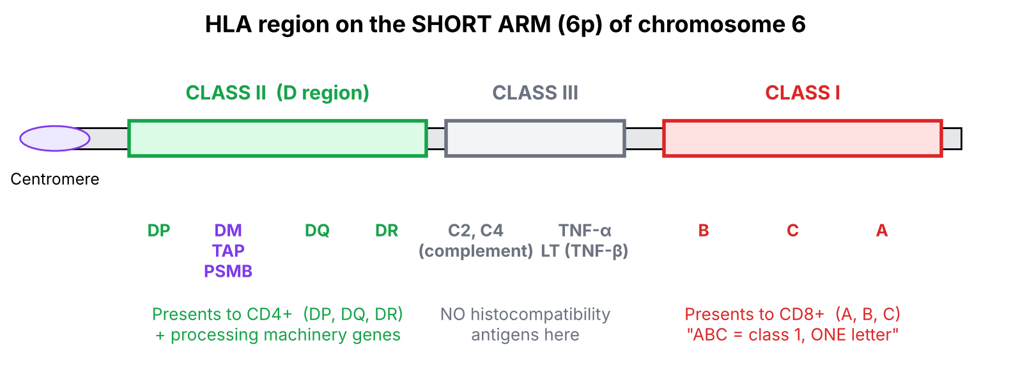
Figure 3. Map of the HLA region (redrawn from slide 3). Read it left-to-right: II → III → I.

1.3 Making sense of it — definitions and the 'why'
Term | Plain-language meaning | Why it matters
MHC | The gene complex (and its protein products) that puts peptides on display for T cells | No MHC display = T cells cannot respond
HLA | The human name for MHC ('human leukocyte antigen' — first found on white blood cells) | On exams 'MHC' and 'HLA' are used interchangeably in humans
Alloantigen | An antigen that differs between individuals of the SAME species (allo = other) | Explains transplant rejection: your T cells see a stranger's MHC as foreign
Locus / loci | The location of a gene on a chromosome | Class I loci = A, B, C; Class II loci = DP, DQ, DR
Haplotype | The set of HLA alleles on ONE chromosome 6, inherited together as a block | Basis of the 25/50/25 sibling rule (Section 5)

▌ ADDITIONAL CONTEXT
Why does the class II region also contain TAP, PSMB, DM, DO? These are the genes for the machinery that loads peptides onto MHC: TAP (pumps peptides into the ER for class I), PSMB (subunits of the proteasome that chops proteins for class I), HLA-DM (swaps peptides into class II), HLA-DO (regulates DM). Evolution clustered the 'display window' genes and the 'tools to stock the window' genes in one neighbourhood. Notice the irony: TAP serves class I but sits physically in the class II region — a favourite trick question.
Why is class III here if it has no histocompatibility antigens? It is simply other immune genes that happen to live in the same neighbourhood: complement (C2, C4, factor B) and TNF/lymphotoxin. Because these genes are physically close, they are inherited together with HLA genes (linkage) — which is why some diseases (e.g., C4 deficiency, a lupus risk) track with particular HLA haplotypes.
Why are MHC molecules so variable (alloantigens)? Each MHC allele has a slightly differently shaped groove and therefore binds a different set of peptides. A population with many variants is unlikely to be wiped out by a single microbe, because some individuals will always be able to present it. The downside: your neighbour's MHC looks foreign to your T cells → transplant rejection.
▌ HIGH-YIELD ADDITIONAL KNOWLEDGE
Mnemonic built on the logic: class I genes are single letters (A, B, C) and class II genes are double letters (DP, DQ, DR) — 'one letter for class one, two letters for class two'.
Transplant matching: the most important loci matched for kidney transplant are HLA-A, HLA-B, HLA-DR (DR matters most). Rejection is mediated mainly by recipient T cells recognizing donor MHC (allorecognition); preformed anti-HLA antibodies cause hyperacute rejection — detected before transplant by a crossmatch.

1.4 Cause-and-effect chain: why mismatched transplants are rejected
Donor organ expresses donor HLA (different alleles)
↓
Recipient T cells encounter donor MHC (alloantigen)
↓
Donor MHC + peptide 'looks like' self-MHC carrying a foreign peptide
↓ (a large fraction of T cells cross-react with foreign MHC)
CD8+ T cells attack donor cells (class I)
+ CD4+ T cells drive inflammation & antibodies (class II)
↓
Graft rejection → prevented by HLA matching + immunosuppression

🩺 CLINICAL CORRELATION
• Organ transplantation: HLA typing of donor and recipient and a pre-transplant crossmatch (recipient serum + donor cells) are done to avoid rejection. A sibling who is HLA-identical is the ideal living related donor.
• Bone marrow (hematopoietic stem cell) transplant: HLA matching is even more critical, because the donor's T cells can attack the recipient — graft-versus-host disease (GVHD).
• Class III link: inherited C2/C4 deficiency (genes in the class III region) is a strong risk factor for SLE.

🎯 EXAM FOCUS
• Chromosome 6 (short arm) — HLA genes.
• Class I loci A, B, C; class II loci DP, DQ, DR.
• Class III = C2, C4, TNF-α, TNF-β (lymphotoxin) and no histocompatibility antigens.
• MHC = alloantigens → basis of transplant rejection.
• Typical question: 'Which of the following genes is located in the MHC but does NOT encode an antigen-presenting molecule?' → C4 / TNF / TAP.

⚠️ COMMON MISTAKES
• Saying class III encodes 'class III MHC molecules that present antigen' — false; class III genes encode NO histocompatibility antigens.
• Thinking β2-microglobulin is in the HLA region — it is NOT (it is encoded on chromosome 15 — see Section 2).
• Confusing 'alloantigen' (differs between individuals of the same species) with 'autoantigen' (self-antigen targeted in autoimmunity) or 'xenoantigen' (from a different species).
• Assuming TAP is in the class I region because it serves class I — it sits in the class II region.

Section 1 — Practice questions
Q1. [MCQ] Which of the following gene products is encoded within the class III region of the human MHC?
A. HLA-C
B. HLA-DQ
C. β2-microglobulin
D. Complement component C4
E. CD8

✅ ANSWER & EXPLANATION
D — C4. Class III contains C2, C4, TNF-α and lymphotoxin (TNF-β).
A is class I. B is class II. C (β2m) is NOT encoded in the MHC at all. E (CD8) is a T-cell co-receptor, not an MHC gene.

Q2. [MCQ] MHC proteins are described as alloantigens. This means they:
A. Are identical in all humans
B. Differ among members of the same species
C. Are only found in other species
D. Are self-antigens targeted in autoimmune disease
E. Are encoded on the X chromosome

✅ ANSWER & EXPLANATION
B. 'Allo' = other individual of the same species. This is precisely why transplants between non-identical people provoke an immune response. C describes xenoantigens; D describes autoantigens.

Q3. [Clinical vignette] A 40-year-old man with end-stage renal disease receives a kidney from an unrelated deceased donor who is mismatched at HLA-A, -B and -DR. Despite immunosuppression, he develops rising creatinine at 3 weeks; biopsy shows T-cell infiltration of tubules. What is the fundamental reason his immune system attacked the graft?

✅ ANSWER & EXPLANATION
His T cells recognized donor MHC (HLA) molecules as foreign alloantigens. MHC proteins differ between individuals, and the success of transplants depends on donor and recipient MHC matching. When they differ, an immune response occurs in the recipient (this is acute cellular rejection). Matching HLA-A, -B and especially -DR reduces this risk.

Q4. [Short answer] List the genes found in each of the three HLA regions in their order from the centromere.

✅ ANSWER & EXPLANATION
Centromere → Class II (DP, DM/DO/TAP/PSMB, DQ, DR) → Class III (C2, C4, TNF-α, lymphotoxin) → Class I (B, C, A).

Q5. [Mechanism] Why would a population with highly polymorphic MHC genes survive an epidemic better than a population with only one MHC allele?

✅ ANSWER & EXPLANATION
Each allele binds a different set of peptides. With many alleles, some individuals will almost always be able to present peptides from any new microbe and mount a T-cell response. With one allele, a microbe whose peptides do not fit that groove could escape T-cell recognition in everyone.

Section 2 — Structure of MHC I and MHC II, and which cells express them

2.1 Big picture
Both classes are built to do the same job — hold a peptide in a groove on top and show it to a T-cell receptor — but they are assembled differently. The structural differences explain (1) why they hold different-sized peptides and (2) why each is recognised by a different co-receptor (CD8 vs CD4).
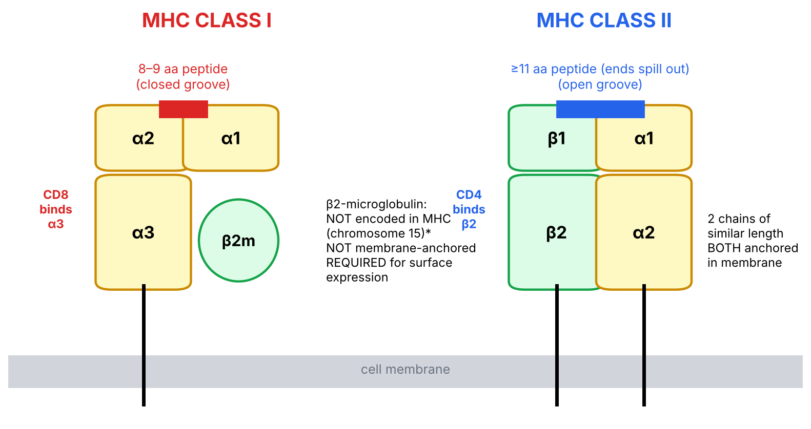
Figure 4. Structure of MHC class I vs class II (redrawn from slide 5). Yellow = α chain(s); green = β chain / β2-microglobulin.

2.2 MHC class I — what the slides say
▌ FROM THE SLIDES
- Class I MHC consists of an α heavy chain and a light chain, β2-microglobulin (β2m).
- The heavy chain folds into domains α1, α2, α3; α1 + α2 form the peptide-binding groove; α3 sits near the membrane next to β2m.
- β2-microglobulin is NOT encoded within the MHC.
- β2-microglobulin is required for the expression of MHC I.
- Any mutation of β2-microglobulin → NO class I MHC expression.
- β2m functions in peptide-loading and transport of the class I antigen to the cell surface.
- The binding pocket can only hold peptides of 8 to 9 amino acids.

2.3 MHC class II — what the slides say
▌ FROM THE SLIDES
- Class II MHC consists of 2 chains of similar length, α and β (domains α1, α2 and β1, β2).
- The groove is formed by α1 + β1.
- The binding groove can hold peptides of 11 or more amino acids.

2.4 The 'why' behind the structure
▌ ADDITIONAL CONTEXT
Why does class I need β2m? Think of β2m as the scaffold/support beam that lets the heavy chain fold correctly. Without it, the heavy chain is misfolded, cannot load peptide, and is retained in the ER and destroyed. So no β2m → no surface class I — even though the heavy-chain gene is perfectly normal.
Why 8–9 aa vs ≥11 aa? In class I, the two ends of the groove are closed (like a hot-dog bun pinched at both ends) — the peptide must fit exactly, so it is short (8–10 aa). In class II, the ends are open (like a sub roll open at both ends) — longer peptides lie in the groove with their ends hanging out (typically 13–25 aa).
Why does CD8 bind class I and CD4 bind class II? The co-receptors grab the non-variable 'stalk' of the MHC: CD8 binds the α3 domain of class I, CD4 binds the β2 domain of class II. This physical fit is what enforces the pairing. Your note on the slide — the 'rule of 8' — captures it: MHC I × CD8 = 8; MHC II × CD4 = 8.
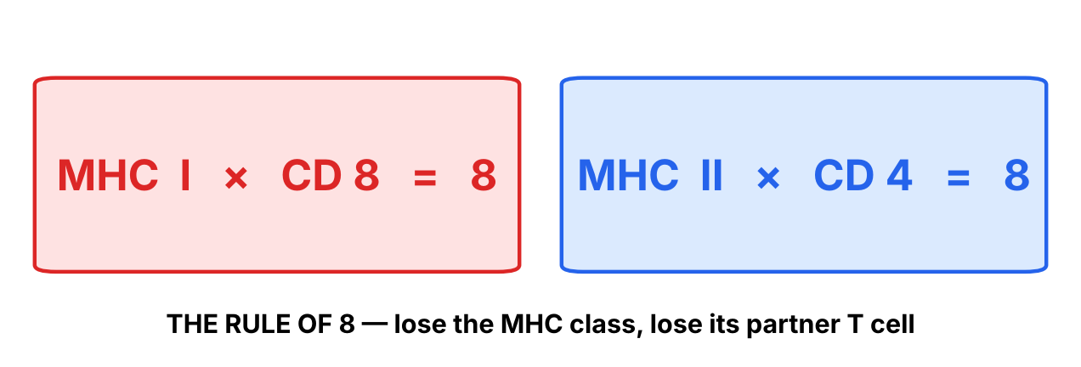
Figure 5. The rule of 8 (from your slide notes).
▌ HIGH-YIELD ADDITIONAL KNOWLEDGE
- β2-microglobulin is encoded on chromosome 15. It is shed into the blood: serum β2m is a tumor-burden/prognostic marker in multiple myeloma and some lymphomas, and it accumulates in long-term dialysis patients (dialysis-related amyloidosis, Aβ2M → carpal tunnel syndrome).
- IFN-γ upregulates both MHC I and MHC II (and can induce MHC II on non-APCs such as thyroid epithelium or endothelium) — this links to autoimmunity.

2.5 MHC Class I vs Class II — the full comparison (slide 6, expanded)
▌ FROM THE SLIDES
Feature | MHC Class I | MHC Class II
Loci | HLA-A, HLA-B, HLA-C | HLA-DP, HLA-DQ, HLA-DR
Binds to | CD8+ T cells | CD4+ T cells
Associated protein | β2-microglobulin | Invariant chain
Expressed on | All nucleated cells (NOT RBCs)  Antigen-presenting cells (APCs)  Platelets | APCs only: macrophages, dendritic cells, B cells
Function | Present endogenous antigens (viral or cytosolic proteins) to CD8+ T cells | Present extracellular (exogenous) antigens to CD4+ T cells
Antigen loading | Processed peptides loaded onto class I in the ER after delivery via TAP (transporter associated with antigen processing) | Processed peptides loaded onto class II following release of the invariant chain in endocytic (acidic) vesicles
Structure | α heavy chain (α1-α3) + β2m | α chain + β chain of similar length
Peptide length | 8–9 amino acids | ≥ 11 amino acids

▌ ADDITIONAL CONTEXT
Extra feature (added) | MHC Class I | MHC Class II
Groove ends | Closed | Open
Groove formed by | α1 + α2 | α1 + β1
Co-receptor binding site | α3 (CD8) | β2 (CD4)
Result of recognition | Killing of the presenting cell (perforin, granzymes, Fas-L) | Cytokine help (Th1, Th2, Th17, Tfh)
Peptide-protecting partner | Chaperones/peptide-loading complex in ER | Invariant chain → CLIP, removed by HLA-DM

Why each cell type has what it has
Cell | MHC I? | MHC II? | Reason (derive it!)
Mature RBC | NO | NO | No nucleus → no protein synthesis → nothing to display and cannot be virus-infected in the usual way (no machinery to make viral proteins)
Platelet | YES (slide) | No | Anucleate, but carries class I acquired from megakaryocyte/plasma → relevant to platelet refractoriness after transfusion (anti-HLA antibodies)
Hepatocyte, neuron*, muscle, epithelium | YES | No (unless IFN-γ) | Any nucleated cell can be virus-infected → must be able to signal to CD8+ T cells
Dendritic cell | YES | YES | Most potent APC; activates naive T cells
Macrophage | YES | YES | Eats microbes, shows them to CD4+ T cells to get 'activation help' (IFN-γ)
B cell | YES | YES | Shows the antigen it captured via its BCR to CD4+ Tfh cells to obtain help for class switching

*Neurons express very low levels of class I — a detail you do not need for this lecture.
🩺 CLINICAL CORRELATION
• β2-microglobulin mutation → no surface class I → CD8+ T cells cannot develop/function normally → susceptibility to viral infections (rare; mirrors TAP deficiency).
• Tumors frequently mutate β2m (e.g., some melanomas, colorectal cancers) to hide from CD8+ T cells — this is a mechanism of resistance to immune-checkpoint inhibitors.
• Platelet transfusion refractoriness: multiply transfused patients make anti-HLA class I antibodies that destroy transfused platelets → give HLA-matched platelets.
• RBC transfusions are matched for ABO/Rh, not HLA, because RBCs lack MHC.

🎯 EXAM FOCUS
• Class I = all nucleated cells + platelets, NOT RBCs. Class II = APCs only (DCs, macrophages, B cells).
• β2m: not MHC-encoded, required for class I surface expression; β2m mutation → no class I.
• Peptide size: class I 8–9 aa, class II ≥11 aa.
• Associated proteins: class I ↔ β2m, class II ↔ invariant chain.
• Likely question formats: 'Which cell lacks MHC I?' (RBC); 'Which protein is required for class I expression but not encoded in the MHC?' (β2m).

⚠️ COMMON MISTAKES
• Writing that class I has 'two chains of similar length' — that is class II. Class I is one long α chain + small β2m.
• Saying class II is on 'all cells' — only professional APCs (constitutively).
• Forgetting platelets do carry class I even though they are anucleate (RBCs don't).
• Thinking class I is ONLY on non-APCs — APCs express both classes.
• Mixing up peptide sizes: remember the closed-ended class I groove holds the shorter peptide.

Section 2 — Practice questions
Q1. [MCQ] Which of the following cells does NOT express MHC class I molecules?
A. Platelet
B. Hepatocyte
C. Neutrophil
D. Mature erythrocyte
E. B lymphocyte

✅ ANSWER & EXPLANATION
D — mature RBC. Class I is on all nucleated cells and on platelets; mature RBCs have no nucleus and lack MHC I. B cells (E) have both class I and II.

Q2. [MCQ] A protein is required for surface expression of MHC class I, functions in peptide loading and transport, and is encoded outside the HLA complex. Which protein is it?
A. Invariant chain
B. TAP
C. β2-microglobulin
D. HLA-DM
E. CD8

✅ ANSWER & EXPLANATION
C — β2-microglobulin. A: invariant chain pairs with class II. B: TAP transports peptides and IS encoded in the MHC (class II region). D: HLA-DM is class II-region, class II-pathway. E: CD8 is the T-cell co-receptor.

Q3. [Clinical vignette] A melanoma initially shrinks on anti-PD-1 therapy, then progresses. Sequencing shows a biallelic loss-of-function mutation in B2M. Why did the tumor escape?

✅ ANSWER & EXPLANATION
Without β2-microglobulin, MHC class I cannot be expressed on the tumor surface. Tumor peptides are no longer displayed to CD8+ cytotoxic T cells, so even 'un-braked' (anti-PD-1-activated) CTLs cannot recognise and kill the tumor. (Additional context: the tumor would now be a target for NK cells, which kill cells lacking MHC I.)

Q4. [Short answer] Explain, using groove structure, why class I binds 8–9 aa peptides while class II binds ≥11 aa peptides.

✅ ANSWER & EXPLANATION
Class I groove (α1+α2) has closed ends; the peptide must fit entirely within it → short, fixed length. Class II groove (α1+β1) has open ends; longer peptides lie across it with their ends overhanging → ≥11 aa, variable length.

Q5. [Mechanism] A mouse lacks CD8α. Which MHC molecule's function is primarily lost, and why?

✅ ANSWER & EXPLANATION
Class I. CD8 stabilises the TCR–MHC I interaction by binding the α3 domain of class I; without CD8, class I-restricted cytotoxic T cells do not develop or signal properly (rule of 8: MHC I ↔ CD8).

Section 3 — Pathways for loading MHC molecules with peptides

3.1 The ground rule (slide 7)
▌ FROM THE SLIDES
- MHC class I and class II molecules are unstable without the addition of peptide.
- They will not be expressed at the cell surface without the addition of peptide.
▌ ADDITIONAL CONTEXT
Why would evolution build this rule? An empty MHC on the surface would be dangerous: it could pick up random peptides from the extracellular fluid and make a healthy cell look infected. By making MHC structurally dependent on its peptide (the peptide is literally part of the folded molecule), the cell guarantees that every surface MHC is displaying something that was deliberately processed inside the cell. This single rule explains BOTH bare lymphocyte syndrome type 1 (no TAP → no peptide → no surface class I) and the effect of β2m loss.
💡 THE ORGANIZING PRINCIPLE
The two pathways are best learned as one question: where does the protein live, and where does the MHC meet it?
• Class I meets its peptide in the ER — so the peptide must be pumped into the ER from the cytosol (TAP). That is why class I shows cytosolic (endogenous) proteins.
• Class II meets its peptide in an acidic endosome — the compartment where swallowed material ends up. That is why class II shows extracellular (exogenous) proteins.
• Each pathway needs a 'guard' so the wrong peptides do not get in: class II uses the invariant chain to block its groove while it passes through the ER (where class I peptides are).

3.2 Endogenous pathway → MHC class I (slide 8)
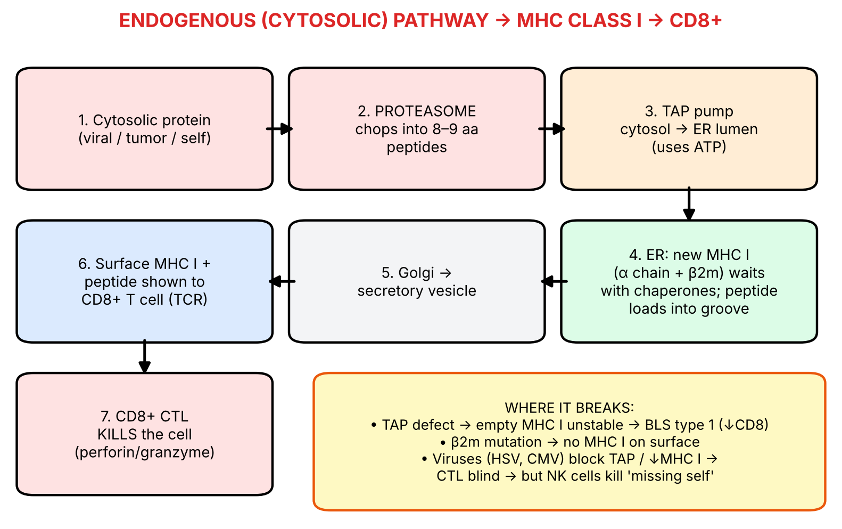
Figure 6. Endogenous (cytosolic) pathway. Follow the numbers in a 'U'.
▌ FROM THE SLIDES
- In normal, nucleated cells, MHC class I molecules are synthesized in the ER.
- Endogenous antigens (e.g., viral proteins) are degraded in proteasomes in the cytosol.
- The peptides are transported through TAP (transporter associated with antigen processing) into the endoplasmic reticulum. (Your note: if TAP is deficient → no loading.)
- In the ER they become bound in the grooves of newly formed class I molecules.
- The MHC I–peptide complex is transported to the cell surface (via Golgi) and expressed on the membrane.
- Cytotoxic (CD8+) T cells recognize the combination of MHC class I + altered-self peptide …
- … and destroy the target cell ('killing' arrow on the slide).
▌ ADDITIONAL CONTEXT
- Proteasome: a barrel-shaped protease complex in the cytosol that degrades ubiquitin-tagged proteins. Normal cells constantly show self-peptides on class I — T cells ignore these (tolerance). When a virus infects, viral peptides join the display → 'altered self'. IFN-γ induces the immunoproteasome (subunits encoded by PSMB genes in the MHC), which makes peptides that fit class I grooves even better.
- TAP (TAP1/TAP2): an ATP-dependent pump in the ER membrane — a 'door' from cytosol into ER. In the ER, a peptide-loading complex (tapasin, calreticulin, ERp57) holds empty class I right next to TAP so peptides load efficiently.
- A correction to a note on your slide: the annotation says 'proteasome is where bacterial protein will be broken down'. Be careful: the proteasome handles cytosolic proteins — viral, tumor, self, and bacteria that live in the cytosol (e.g., Listeria). Most bacteria are extracellular or sit in phagosomes, so their proteins go down the class II (endosomal) route. Exam questions often hinge on this.
▌ HIGH-YIELD ADDITIONAL KNOWLEDGE
- Viral immune evasion: HSV and CMV block TAP or retain/degrade class I; HIV Nef and adenovirus downregulate class I. The 'cost' to the virus: cells without class I are killed by NK cells ('missing-self' recognition).
- Cross-presentation: dendritic cells can take up extracellular material (e.g., from a virus-infected dead cell) and route it into the class I pathway — this is how naive CD8+ T cells get activated against viruses that do not infect DCs.

3.3 Exogenous / endosomal pathway → MHC class II (slide 9) — 'know this diagram'
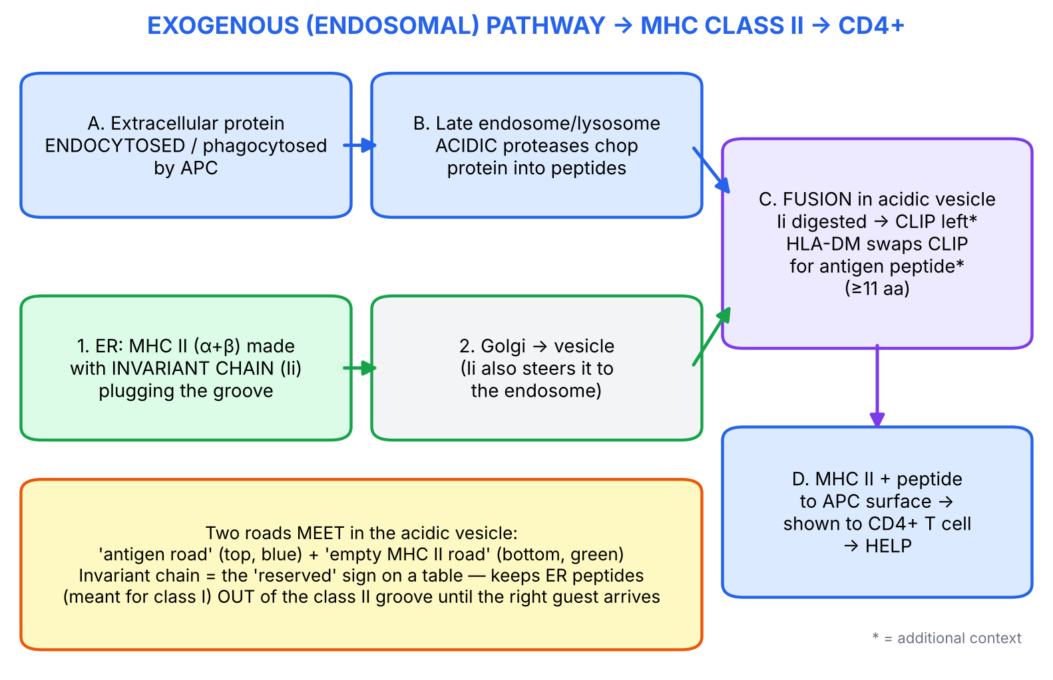
Figure 7. Exogenous (endosomal) pathway — two roads that meet in the acidic vesicle.
▌ FROM THE SLIDES
- Class II MHC molecules are synthesized in the ER with a protein, the invariant chain (Ii), that blocks the peptide-binding groove (prevents normal cellular peptides from binding there) — this happens in APCs (dendritic cells, macrophages, B cells).
- Extracellular proteins that are internalized by APCs are processed in late endosomes and lysosomes.
- The MHC–invariant chain complex is transported to the site of the acidic vesicles.
- The invariant chain is dissolved away and the site becomes occupied with processed peptide.
- The class II antigen–peptide complex is then transported to the surface of the APC, where it is available for interaction with CD4+ T cells.

Your question on the slide: 'invariant chain function?'
Job of the invariant chain | What would happen without it
1. Plugs the class II groove in the ER (slide) — so ER peptides destined for class I can't bind class II | Class II would display self/cytosolic peptides from the ER instead of extracellular antigen
2. Helps α and β chains fold/assemble (added) | Poor class II assembly
3. Targets class II to the endosomal/acidic compartment (added) | Class II would not reach the place where exogenous peptides are

Your other note — 'when in your cell is immunity taken off? acidic vesicles; if something goes wrong, loading is faulty' — is exactly right: the acidic pH activates proteases (cathepsins) that both chop the antigen and digest the invariant chain. If acidification fails, both steps fail → poor class II presentation.
▌ ADDITIONAL CONTEXT
The detail behind 'dissolved away': proteases trim Ii down to a small fragment, CLIP (class II-associated invariant chain peptide), which still sits in the groove. HLA-DM (encoded in the class II region) acts like a 'bouncer' — it pries CLIP out and lets an antigenic peptide take its place. HLA-DO regulates DM.
▌ HIGH-YIELD ADDITIONAL KNOWLEDGE
- Superantigens (e.g., *S. aureus* TSST-1, staph enterotoxins, *S. pyogenes* exotoxin A) skip processing entirely — they cross-link the outside of MHC II (not the groove) to the TCR Vβ region → massive polyclonal T-cell activation → cytokine storm → toxic shock syndrome.
- Chloroquine/hydroxychloroquine raise endosomal pH → reduce class II antigen processing/TLR signalling — one reason they help in SLE and RA.

3.4 Side-by-side: the two pathways
Step | Class I (endogenous) | Class II (exogenous)
Source of antigen | Cytosolic protein (virus, tumor, self, cytosolic bacteria) | Extracellular protein taken up by endocytosis/phagocytosis
Cells that do it | All nucleated cells | APCs: DCs, macrophages, B cells
Where protein is cut | Proteasome (cytosol) | Late endosome/lysosome (acidic proteases)
Transport step | TAP pumps peptides into ER | Endocytic vesicle fuses with MHC II vesicle
Where peptide meets MHC | ER | Acidic endocytic vesicle
Groove guard / helper | β2m + chaperones (peptide-loading complex) | Invariant chain → CLIP → HLA-DM
Who reads it | CD8+ cytotoxic T cell | CD4+ helper T cell
Outcome | Kill the cell | Help (cytokines, macrophage activation, B-cell help)
Breaks in | BLS type 1 (TAP), β2m loss, viral evasion | BLS type 2 (transcription factors)

3.5 Full immune story — from trigger to treatment (viral infection example)
TRIGGER Influenza virus infects a respiratory epithelial cell
↓
RECOGNITION Viral proteins made in cytosol → proteasome → TAP → ER → MHC I
↓ (a DC also cross-presents viral antigen in the lymph node)
IMMUNE RESPONSE Naive CD8+ T cell activated (with CD4+ help via MHC II on the DC)
↓
MECHANISM CTL's TCR + CD8 bind MHC I–viral peptide on infected cells
↓
OUTCOME Perforin/granzyme → apoptosis → virus can't replicate
↓
CLINICAL Fever/malaise (cytokines); damage from killing infected cells
↓
DIAGNOSIS Viral testing; defective T-cell immunity → recurrent infections
↓
PREVENTION Vaccines; live vaccines engage class I (strong CD8+ response)

🩺 CLINICAL CORRELATION
• Viral hepatitis: liver damage in hepatitis B is largely caused by CD8+ T cells killing hepatocytes that display HBV peptides on MHC I — the 'killing' arrow on slide 8 explains the rise in ALT.
• Toxic shock syndrome: superantigens bypass the class II pathway (bind outside the groove) → huge cytokine release → fever, hypotension, rash.
• Live vs killed vaccines: live attenuated vaccines produce proteins inside cells → class I → CD8+ response (plus antibodies). Killed/subunit vaccines are taken up from outside → mainly class II → CD4+ help and antibodies.

🎯 EXAM FOCUS
• Order of class I pathway: proteasome (cytosol) → TAP → ER loading → Golgi → surface → CD8+ → killing.
• Order of class II pathway: MHC II + invariant chain made in ER → endocytosed antigen processed in late endosome/lysosome → fusion in acidic vesicle → Ii removed → peptide loaded → surface → CD4+.
• Peptide-free MHC is unstable and NOT expressed on the surface.
• Questions love asking: 'Which molecule prevents ER peptides from binding class II?' (invariant chain); 'Where do class I molecules acquire peptide?' (ER); 'A drug that raises lysosomal pH would impair which response?' (CD4+ responses to extracellular antigen).

⚠️ COMMON MISTAKES
• 'Class I peptides are loaded in the endosome' — NO, class I loads in the ER.
• 'TAP transports peptides out of the ER' — NO, TAP moves peptides from cytosol INTO the ER.
• 'Invariant chain binds class I' — NO, it binds class II. (Class I's partner is β2m.)
• Assuming all bacterial proteins go through the proteasome — most bacteria are extracellular/phagosomal → class II.
• Forgetting that healthy cells continuously display self peptides on MHC I — presence of MHC I is normal; the peptide changes in infection.

Section 3 — Practice questions
Q1. [MCQ] In a virus-infected hepatocyte, where do viral peptides first become associated with MHC class I?
A. Cytosol
B. Endoplasmic reticulum
C. Golgi apparatus
D. Late endosome
E. Cell surface

✅ ANSWER & EXPLANATION
B — ER. Peptides made by the proteasome in the cytosol are pumped by TAP into the ER, where they bind newly synthesized class I. Late endosome (D) is the class II loading site.

Q2. [MCQ] Which molecule prevents peptides in the endoplasmic reticulum from occupying the groove of newly synthesized MHC class II?
A. β2-microglobulin
B. TAP
C. Invariant chain
D. Proteasome
E. CD4

✅ ANSWER & EXPLANATION
C — invariant chain. It blocks the class II groove until it is digested away in the acidic vesicle and replaced by processed exogenous peptide.

Q3. [Clinical vignette] A patient with rheumatoid arthritis is started on hydroxychloroquine, a weak base that accumulates in and raises the pH of lysosomes. Which immune process would this drug most directly impair?
A. Proteasomal degradation of viral proteins
B. TAP transport of peptides
C. Processing of extracellular antigen for presentation to CD4+ T cells
D. β2m association with class I
E. NK-cell killing of class I-deficient cells

✅ ANSWER & EXPLANATION
C. Class II processing and invariant-chain removal require acidic proteases in late endosomes/lysosomes. Raising the pH impairs class II loading → less CD4+ T-cell activation. The class I pathway (A, B, D) does not depend on acidic vesicles.

Q4. [Short answer] Why are MHC molecules not found on the cell surface without bound peptide, and what is the protective advantage?

✅ ANSWER & EXPLANATION
Peptide-free MHC is structurally unstable and is degraded instead of exported (slide 7). This ensures that only deliberately processed internal (class I) or endocytosed (class II) peptides are displayed, preventing random surface loading that could cause healthy cells to be mistakenly attacked.

Q5. [Mechanism] HSV produces a protein (ICP47) that blocks TAP. Trace the consequences step by step.

✅ ANSWER & EXPLANATION
TAP blocked → viral peptides cannot enter the ER → class I cannot be loaded → empty class I is unstable → less class I on the surface → CD8+ CTLs cannot recognise the infected cell (immune evasion). However, low class I removes the inhibitory signal for NK cells → NK cells kill the cell ('missing self').

Section 4 — When the display system breaks: MHC deficiencies (Bare lymphocyte syndromes)

4.1 Big picture
If you understand the two pathways, these diseases need almost no memorization: break a step in a pathway → that MHC class is not expressed → the T cell that depends on it does not develop. The name 'bare lymphocyte' comes from lymphocytes that are 'bare' — they lack MHC on their surface.

4.2 What the slides say
▌ FROM THE SLIDES
Disease | Deficiency | Signs and symptoms
MHC class I deficiency  (Bare lymphocyte syndrome type 1) | Failure of TAP molecules to transport peptides to the ER | CD8+ T cells deficient  CD4+ T cells normal
MHC class II deficiency  (Bare lymphocyte syndrome type 2) | Failure of class II MHC expression  Defects in transcription factors | Deficient in CD4+ T cells  CD8+ T cells normal

Your slide note: 'rule of 8 — 2 × 4 = 8, 1 × 8 = 8 → if class II is deficient, CD4 is deficient; if class I is deficient, CD8 is deficient.'
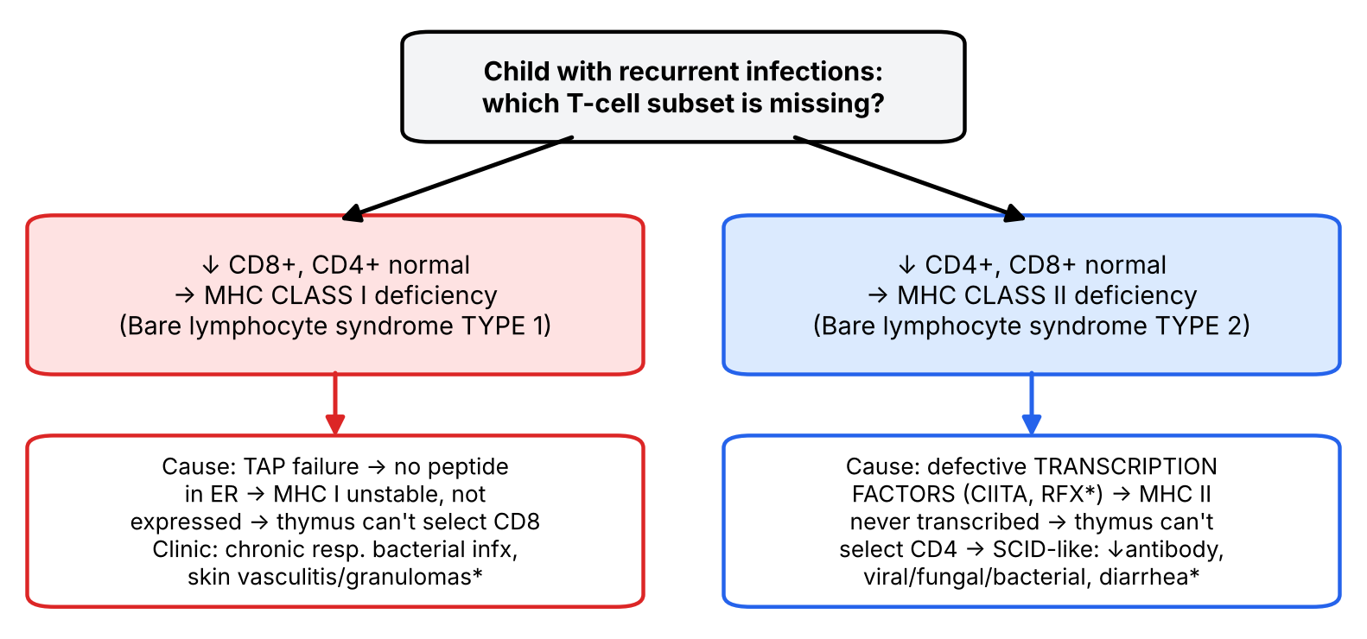
Figure 8. Decision tree for the bare lymphocyte syndromes (* = additional context).

4.3 Why does losing MHC remove a whole T-cell population?
▌ ADDITIONAL CONTEXT
Developing T cell in the THYMUS (double-positive CD4+CD8+)
↓
POSITIVE SELECTION: T cell must recognise self-MHC in thymus to survive
↓
binds MHC I → keeps CD8, becomes CD8+ T cell
binds MHC II → keeps CD4, becomes CD4+ T cell
↓
No MHC I (TAP defect) → no positive selection signal for CD8 lineage → ↓CD8+
No MHC II (TF defect) → no positive selection signal for CD4 lineage → ↓CD4+

So the MHC defect causes a T-cell numbers problem, even though no T-cell gene is mutated. That is the reasoning examiners want.

Mechanism of every finding
Finding | BLS type 1 (class I / TAP) | BLS type 2 (class II / transcription factor)
Underlying defect | TAP1/TAP2 (or tapasin) → no peptide in ER → class I unstable | CIITA, RFX5, RFXAP, RFXANK (added) → class II genes never transcribed
Surface MHC I | Very low | Normal
Surface MHC II | Normal | Absent
CD8+ count | ↓ | Normal
CD4+ count | Normal | ↓
Antibodies (added) | Usually near normal | ↓ (no T-cell help → poor class switching)
Typical clinical picture (added) | Milder; chronic bacterial sinopulmonary infections, bronchiectasis; necrotizing granulomatous skin lesions | Severe, SCID-like in infancy: recurrent bacterial, viral, fungal (incl. opportunistic) infections, chronic diarrhea, failure to thrive
Treatment (added) | Supportive (antibiotics, airway care) | Hematopoietic stem cell transplantation; IVIG and prophylaxis meanwhile

▌ ADDITIONAL CONTEXT
Why is type 1 surprisingly mild? NK cells and CD4+ T cells still work, and some peptides reach class I through TAP-independent routes. Why is type 2 severe? CD4+ T cells are the 'conductors' of nearly the entire adaptive response — without them, B cells cannot class-switch, macrophages are not activated, and CD8+ cells get little help.
🩺 CLINICAL CORRELATION
• Infant with failure to thrive, chronic diarrhea, Pneumocystis pneumonia, low CD4+, normal CD8+, low immunoglobulins, and no HLA-DR on B cells/monocytes by flow cytometry → MHC class II deficiency (BLS type 2). Cure = HSCT.
• Older child/young adult with chronic sinusitis, bronchiectasis and ulcerating skin granulomas, low CD8+, reduced HLA-A/B/C on flow cytometry → TAP deficiency (BLS type 1).
• Diagnosis: flow cytometry for CD4/CD8 counts and surface HLA class I / HLA-DR, then genetic testing.

🎯 EXAM FOCUS
• Class I deficiency = TAP failure → ↓CD8+, normal CD4+.
• Class II deficiency = transcription-factor defects → ↓CD4+, normal CD8+.
• Rule of 8 is the fastest way to answer lab-value questions.
• Possible questions: 'Which cell population is decreased in a TAP defect?' / 'What is the molecular basis of BLS type 2?' (transcription factors, NOT mutations of the HLA genes themselves).

⚠️ COMMON MISTAKES
• Swapping the types: type 1 = class I, type 2 = class II (the numbers match).
• Thinking BLS type 2 is caused by mutations in HLA-DR genes themselves — it is caused by defective transcription factors (the genes are normal but never switched on).
• Thinking TAP deficiency reduces CD4+ cells because TAP is encoded in the class II region — location ≠ function. TAP serves class I.
• Confusing BLS with DiGeorge (no thymus → ↓ all T cells) or SCID (↓ T ± B/NK cells): in BLS only ONE subset is low.

Section 4 — Practice questions
Q1. [MCQ] A patient has a homozygous nonsense mutation in TAP1. Which laboratory result is expected?
A. ↓CD4+, normal CD8+
B. ↓CD8+, normal CD4+
C. ↓CD4+ and ↓CD8+
D. Absent B cells
E. Absent NK cells

✅ ANSWER & EXPLANATION
B. No TAP → no peptides enter ER → class I unstable/not expressed → CD8+ T cells are not positively selected. CD4+ (class II) is normal. A describes BLS type 2; C suggests SCID/DiGeorge.

Q2. [Clinical vignette] A 7-month-old boy has persistent diarrhea, oral thrush, failure to thrive and Pneumocystis pneumonia. CD4+ count is very low, CD8+ normal, IgG and IgA low. Flow cytometry shows no HLA-DR on B cells. Genetic analysis of HLA-DR genes is normal. What is the most likely molecular defect?
A. TAP1 mutation
B. β2-microglobulin mutation
C. Mutation in a transcription factor controlling class II genes (e.g., CIITA)
D. Adenosine deaminase deficiency
E. CD40 ligand deficiency

✅ ANSWER & EXPLANATION
C. MHC class II deficiency (BLS type 2) results from defective transcription factors; the HLA genes themselves are normal. Low CD4 → poor B-cell help → low IgG/IgA. A/B cause class I deficiency (↓CD8). D (ADA-SCID) lowers T, B and NK cells. E (hyper-IgM) has normal CD4 counts and HIGH IgM.

Q3. [Short answer] Explain why a defect in an MHC molecule (not in a T-cell gene) leads to reduced numbers of a T-cell subset.

✅ ANSWER & EXPLANATION
In the thymus, developing T cells survive only if their TCR recognises self-MHC (positive selection). Recognition of class I commits cells to CD8; class II to CD4. Without class I or class II, the corresponding lineage receives no survival signal and is not produced.

Q4. [Mechanism] Predict NK-cell activity toward the cells of a patient with BLS type 1 and explain.

✅ ANSWER & EXPLANATION
NK cells are inhibited by self-MHC class I (via inhibitory receptors). Low class I removes that 'brake' → NK cells could be more activated against the patient's own cells, which may contribute to the necrotizing skin lesions seen in TAP deficiency (additional context).

Section 5 — HLA inheritance

5.1 Big picture
Two words control all the inheritance rules: codominant and haplotype. Once you see that the whole HLA block on one chromosome 6 travels as one unit, the 25/50/25 sibling rule is just a Punnett square.

5.2 What the slides say
▌ FROM THE SLIDES
- Expression of MHC alleles is codominant: the protein products of both alleles at a locus are expressed equally in the cell.
- Polymorphic genes — many different alleles are present in the population → different individuals are able to present and respond to different microbial peptides.
- Co-dominant expression — both parental alleles of each MHC gene are expressed → increases the number of different MHC molecules that can present peptides to T cells.
- The particular combination of MHC alleles found on a single chromosome is called an MHC haplotype.
- Each person has two haplotypes — one on the paternal and one on the maternal chromosome 6.
- These genes are very diverse (polymorphic): at least 3900 HLA-A, 4800 HLA-B, 3500 HLA-C and > 4600 HLA-D alleles.

Basic rule in HLA inheritance (slide 13)
- 25% chance of inheriting all of the same HLA genes (the same two haplotypes) as any one sibling.
- 25% chance of not inheriting any of the same HLA genes (none of the same haplotypes).
- 50% chance of sharing one haplotype with a sibling.
- Therefore, a 1 in 4 chance (25%) of being an identical match with one of their siblings.
- Using a parent as a transplant donor is considered a 1-haplotype match.
- An identical 2-haplotype match is rarely achieved owing to crossing over between individual loci during meiosis when homologous chromosomes align (slide 14, Goljan).
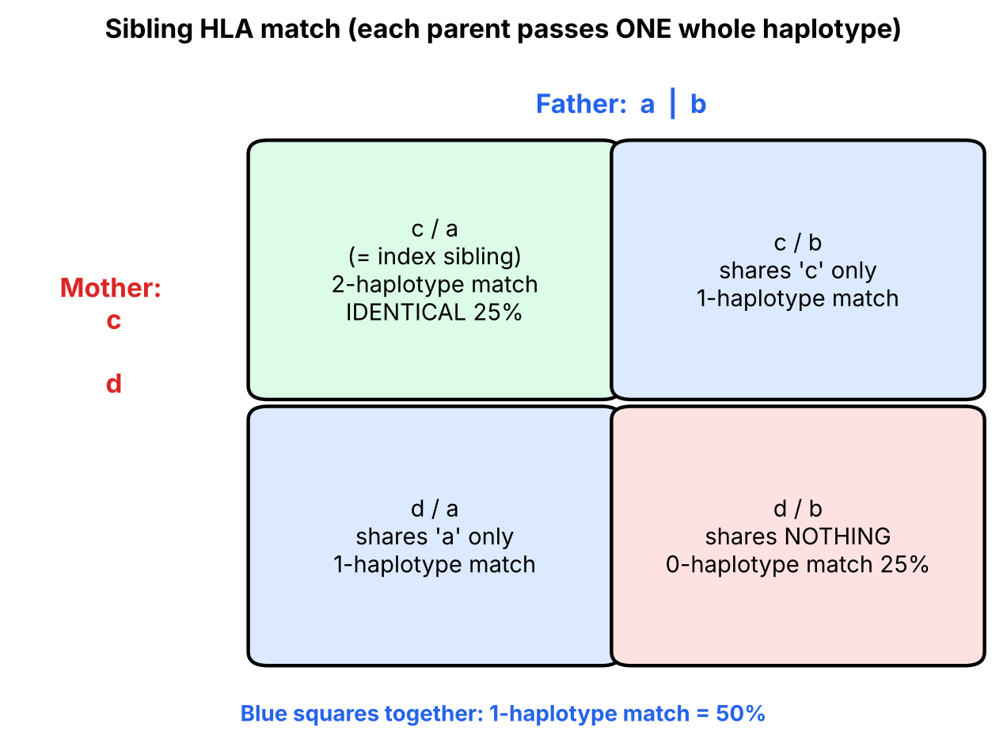
Figure 9. Why the numbers are 25 / 50 / 25 (simplified from slide 14).

5.3 Understanding the numbers
▌ ADDITIONAL CONTEXT
Label the father's haplotypes a and b, the mother's c and d. Each child receives one from each parent, so there are only four possible children: ac, ad, bc, bd — each with probability ¼. Pick any sibling, say ac. Another sibling is:
- ac → shares both haplotypes (2-haplotype, identical) — 1 of 4 = 25%
- ad or bc → shares exactly one — 2 of 4 = 50%
- bd → shares none — 1 of 4 = 25%
Why is a parent ALWAYS a 1-haplotype match? Because you received exactly one of your two haplotypes from that parent — no more, no less (barring recombination). Likewise, your child always shares exactly one haplotype with you.
Note on 'crossing over': the slide (quoting Goljan) states a perfect 2-haplotype match is rarely achieved because of crossing over. For your exam, reproduce this statement. For context, the HLA region is usually inherited as an intact block; recombination within it occurs in roughly 1–2% of meioses, so occasionally a sibling who 'should' be identical differs at one locus — which is why full HLA typing is still done rather than assuming.
▌ HIGH-YIELD ADDITIONAL KNOWLEDGE
- Probability that at least one of n siblings is HLA-identical = 1 − (¾)ⁿ. With 1 sibling: 25%; 2 siblings: 44%; 3 siblings: 58%.
- Number of class I molecules on a cell: a person heterozygous at A, B and C expresses 6 different class I molecules (2 each) — this is codominance in action. (Class II can be even more because α and β chains can mix.)
- HLA identical twins (monozygotic) = identical at all loci (an isograft/syngeneic graft); no rejection.

5.4 Worked example — slide 15 family
▌ FROM THE SLIDES
Father: A1, B7, DR3 / A8, B5, DR2 Mother: A2, B8, DR4 / A9, B27, DR5
 | Father: A1, B7, DR3 | Father: A8, B5, DR2
Mother: A2, B8, DR4 | A2, B8, DR4 / A1, B7, DR3 | A2, B8, DR4 / A8, B5, DR2
Mother: A9, B27, DR5 | A9, B27, DR5 / A1, B7, DR3 | A9, B27, DR5 / A8, B5, DR2

▌ ADDITIONAL CONTEXT
Combine this with Section 6 — this is exactly how an examiner will connect the two halves of the lecture:
Child | Disease associations predicted by slide 16
A2, B8, DR4 / A1, B7, DR3 | B8 → myasthenia gravis, Graves; DR4 → RA, T1DM; DR3 → SLE, Graves, Hashimoto, T1DM. DR3/DR4 heterozygote = highest T1DM genetic risk
A2, B8, DR4 / A8, B5, DR2 | B8 → MG, Graves; DR4 → RA, T1DM; DR2 → MS, hay fever, SLE, Goodpasture
A9, B27, DR5 / A1, B7, DR3 | B27 → PAIR spondyloarthropathies; DR5 + DR3 → Hashimoto; DR3 → SLE, Graves, T1DM
A9, B27, DR5 / A8, B5, DR2 | B27 → PAIR; DR5 → Hashimoto; DR2 → MS, hay fever, SLE, Goodpasture

🩺 CLINICAL CORRELATION
• Bone-marrow transplant for leukemia: the first search is among siblings (25% chance each is identical). If none matches, an unrelated registry donor or a haploidentical (1-haplotype) donor — often a parent or child — is used.
• Codominance in disease: because both alleles are expressed, inheriting one risk allele (e.g., one copy of HLA-B27) is enough to confer the association.
• Paternity/forensic testing historically used HLA haplotypes because they are inherited as blocks.

🎯 EXAM FOCUS
• Codominant: both alleles expressed equally.
• Haplotype = set of alleles on one chromosome 6; each person has two.
• Sibling: 25% identical, 50% one-haplotype, 25% none. Parent (or child) = always 1-haplotype.
• Polymorphism numbers (A ≈ 3900, B ≈ 4800, C ≈ 3500, D > 4600) — know that HLA-B is the most polymorphic class I locus.
• Expect a Punnett-square question with named alleles (like slide 15) asking for a child's haplotypes, match probability or disease risk.

⚠️ COMMON MISTAKES
• Calculating HLA inheritance gene-by-gene like independent Mendelian traits — the haplotype is inherited as a block.
• Saying a parent can be a perfect match 25% of the time — a parent is a 1-haplotype match.
• Confusing 'codominant' (both expressed) with 'dominant' (one masks the other) or 'incomplete dominance' (blended).
• Answering '50%' for 'chance of being identical with a sibling' — 50% is for sharing one haplotype; identical is 25%.

Section 5 — Practice questions
Q1. [MCQ] A patient needs a kidney and has one brother. What is the probability the brother is a 2-haplotype (identical) HLA match?
A. 0%
B. 25%
C. 50%
D. 75%
E. 100%

✅ ANSWER & EXPLANATION
B — 25%. There are 4 equally likely haplotype combinations; only one matches the patient. 50% (C) is the chance of a one-haplotype match.

Q2. [MCQ] A patient's mother volunteers as a donor. Which degree of HLA match is she?
A. 0-haplotype
B. 1-haplotype
C. 2-haplotype
D. Depends on chance, 25% identical
E. Cannot be determined

✅ ANSWER & EXPLANATION
B. A child inherits exactly one haplotype from each parent, so a parent always shares one haplotype (slide 14).

Q3. [Clinical vignette] Using the slide-15 family (Father A1,B7,DR3 / A8,B5,DR2; Mother A2,B8,DR4 / A9,B27,DR5): their son, haplotype A9,B27,DR5 / A8,B5,DR2, develops low-back pain and morning stiffness that improves with exercise. From which parent did he inherit the most relevant HLA allele, and what is the diagnosis?

✅ ANSWER & EXPLANATION
Mother (her haplotype A9, B27, DR5). HLA-B27 → ankylosing spondylitis (inflammatory back pain: morning stiffness improving with activity). Because HLA alleles are codominant, a single copy is sufficient for the association.

Q4. [Short answer] A person is heterozygous at HLA-A, -B and -C. How many different class I molecules can their cells display, and which principle explains this?

✅ ANSWER & EXPLANATION
Six (two A, two B, two C) — because MHC alleles are codominantly expressed (both parental alleles expressed equally).

Q5. [Mechanism] Explain how polymorphism and codominance together benefit both the individual and the population.

✅ ANSWER & EXPLANATION
Codominance doubles the number of distinct MHC molecules in each person → a wider range of peptides can be presented (individual benefit). Polymorphism means different people present different peptides → no single microbe can evade T cells in the entire population (population benefit). Cost: high chance of mismatch in transplantation.

Section 6 — HLA subtypes associated with diseases

6.1 Big picture — why would an MHC allele predispose to disease?
▌ ADDITIONAL CONTEXT
Each HLA allele has a uniquely shaped groove. Some grooves happen to be very good at presenting a particular self-peptide (or a microbial peptide that resembles self) to T cells. If tolerance to that peptide is imperfect, the person is at higher risk of an autoimmune attack on the tissue that makes it.
Inherited HLA allele with a particular groove shape
↓
Presents a specific self-peptide (or modified/look-alike peptide) very efficiently
↓ + environmental trigger (infection/mimicry; gluten; smoking)
Autoreactive CD4+ (class II alleles) or CD8+ (class I alleles) T cells activated
↓
Tissue-specific autoimmune disease

Association ≠ destiny: most people carrying HLA-B27 never develop ankylosing spondylitis, but most patients with AS carry B27 (~90%). The allele raises risk; it does not cause disease by itself.

6.2 What the slides say (slide 16 — 'remember the ones highlighted in blue and red')
▌ FROM THE SLIDES
HLA subtype | Disease(s)
HLA-B8 | Myasthenia gravis; Graves disease
HLA-DR2 | Multiple sclerosis; Hay fever; SLE; Goodpasture syndrome
HLA-DR3 | SLE; Graves disease; Hashimoto thyroiditis; DM type I
HLA-DR4 | Rheumatoid arthritis; DM type I
HLA-DR5 | Hashimoto thyroiditis
HLA-DQ2 / DQ8 | Celiac disease
HLA-B27 | Psoriatic arthritis; Ankylosing spondylitis; IBD-associated arthritis; Reactive arthritis (PAIR)

6.3 Reorganizing the list so it has anchors
💡 THE ORGANIZING PRINCIPLE
This slide is a classic 'words without anchors' list. Ask: what makes these items a group?
• Class I alleles (B27, B8) → a CD8/antibody story; the diseases are 'systemic structural' (spine) or 'antibody against a receptor'.
• Class II alleles (DR, DQ) → CD4 help → organ-specific autoimmunity, autoantibodies and endocrine glands.
• Then notice the overlaps — they make the list shorter: Graves (B8 + DR3), SLE (DR2 + DR3), Hashimoto (DR3 + DR5), T1DM (DR3 + DR4).

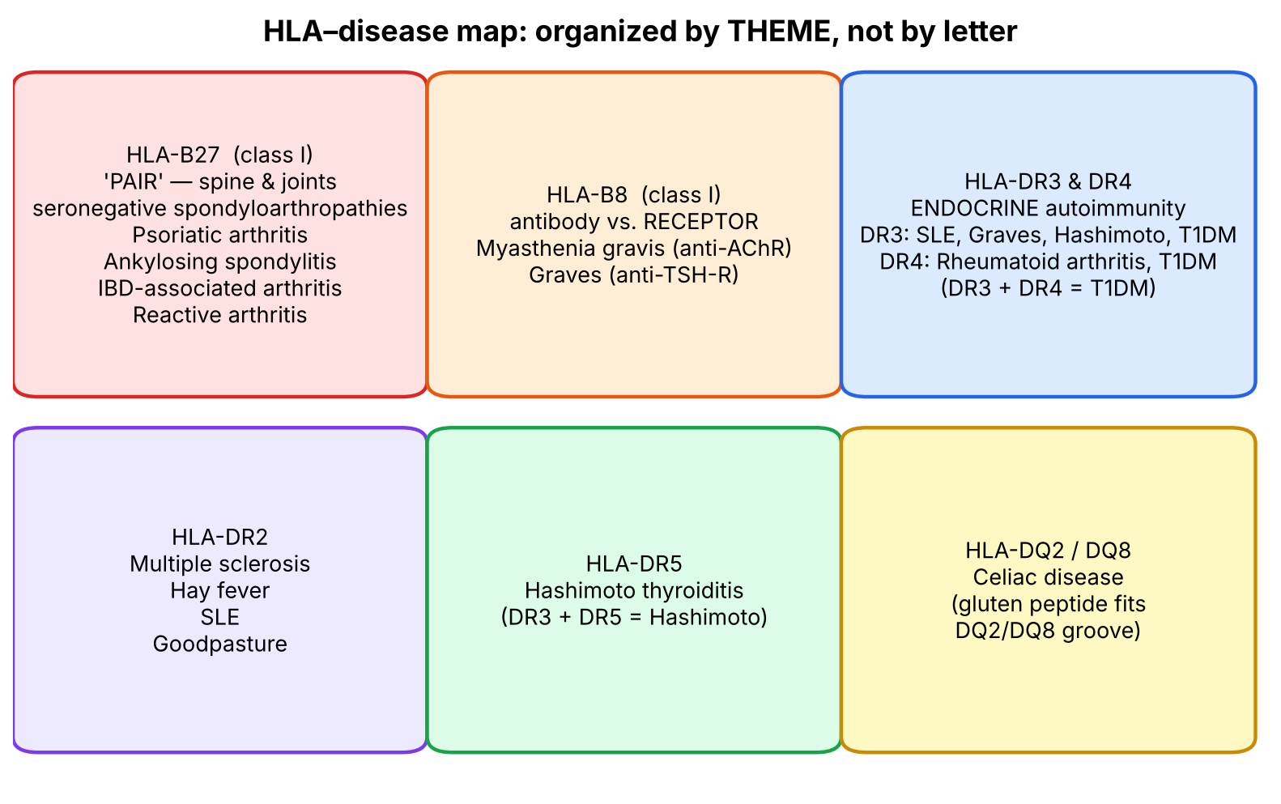
Figure 10. HLA–disease map grouped by theme.
Allele | Anchor (logic first, then hook) | Diseases
HLA-B27 | Spine & joints; 'seronegative' (RF-negative) spondyloarthropathies. Hook: PAIR | Psoriatic arthritis, Ankylosing spondylitis, IBD-associated arthritis, Reactive arthritis
HLA-B8 | Both are antibodies against a receptor (anti-AChR; anti-TSH-receptor). Hook: 'B-8 ate the receptors' | Myasthenia gravis, Graves disease
HLA-DR2 | Hook: Goodpasture attacks 2 organs (lung + kidney); MS; plus SLE, hay fever | MS, hay fever, SLE, Goodpasture
HLA-DR3 | Endocrine + SLE: '3 glands' — thyroid (Graves, Hashimoto) and pancreas (T1DM) — plus SLE | SLE, Graves, Hashimoto, T1DM
HLA-DR4 | Hook: a joint has 4 walls → RA; DR3 + DR4 together → T1DM | Rheumatoid arthritis, T1DM
HLA-DR5 | Hook: 'Hashi-FIVE' (DR5 + DR3 both → Hashimoto) | Hashimoto thyroiditis
HLA-DQ2/DQ8 | Gluten (gliadin) peptides fit the DQ2/DQ8 groove after deamidation by tissue transglutaminase | Celiac disease

Genuinely arbitrary — just memorize
- Which DR number goes with which disease (DR2 vs DR3 vs DR4 vs DR5) has no physiological logic — use the hooks above and spaced repetition.
▌ HIGH-YIELD ADDITIONAL KNOWLEDGE
HLA allele (not on slides) | Association | Why it is tested
HLA-B*57:01 | Abacavir hypersensitivity (HIV drug) | Must screen before prescribing
HLA-B*15:02 | Carbamazepine → SJS/TEN (esp. Southeast Asian ancestry) | Screen before starting
HLA-B*58:01 | Allopurinol → SJS/TEN | Pharmacogenomic screening
HLA-A3 | Hereditary hemochromatosis (linked to HFE on 6p) | Classic association
HLA-DR4 'shared epitope' | RA — presents citrullinated peptides (anti-CCP antibodies) | Mechanism of RA
HLA-DQ2/DQ8 negative | Essentially excludes celiac disease (high negative predictive value) | Diagnostic reasoning

🩺 CLINICAL CORRELATION
• Reactive arthritis: young adult with arthritis, urethritis and conjunctivitis weeks after Chlamydia or a GI infection (Salmonella, Shigella, Campylobacter, Yersinia) → HLA-B27 (molecular mimicry).
• Ankylosing spondylitis: young man, inflammatory low-back pain better with exercise, sacroiliitis, 'bamboo spine' on X-ray → HLA-B27.
• Celiac disease: diarrhea, iron-deficiency anemia, dermatitis herpetiformis; anti-tTG IgA; villous atrophy → HLA-DQ2/DQ8.
• T1DM: child with polyuria, polydipsia, DKA; strongest HLA risk in DR3/DR4 heterozygotes.
• Goodpasture: hemoptysis + hematuria; anti-GBM (type IV collagen) antibodies → HLA-DR2.

🎯 EXAM FOCUS
• HLA-B27 = PAIR — the single most tested HLA association.
• DR3 & DR4 → T1DM; DR4 → RA; DQ2/DQ8 → celiac; DR2 → MS & Goodpasture; B8 → MG & Graves; DR3/DR5 → Hashimoto.
• Vignettes give the disease and ask for the HLA allele, or give a pedigree with HLA haplotypes and ask which child is at risk (combine with slide 15).

⚠️ COMMON MISTAKES
• Linking B27 to rheumatoid arthritis — RA is DR4; B27 is the seronegative spondyloarthropathies.
• Mixing DR2 (MS) with DR3 — anchor MS + Goodpasture together on DR2.
• Thinking DQ2/DQ8 'cause' celiac — they are necessary but not sufficient (~30% of the population carries DQ2, few develop celiac).
• Forgetting that some diseases have two alleles (Graves: B8 & DR3; SLE: DR2 & DR3; Hashimoto: DR3 & DR5; T1DM: DR3 & DR4).

Section 6 — Practice questions
Q1. [MCQ] A 24-year-old man has 6 months of low-back pain and stiffness that is worst in the morning and improves with exercise. X-ray shows bilateral sacroiliitis. Which HLA type is most strongly associated?
A. HLA-DR4
B. HLA-B27
C. HLA-DR3
D. HLA-B8
E. HLA-DQ2

✅ ANSWER & EXPLANATION
B — HLA-B27 (ankylosing spondylitis; PAIR). DR4 (A) is RA, which is seropositive and affects small joints of the hands symmetrically, not the sacroiliac joints.

Q2. [MCQ] A woman has fatigable ptosis and diplopia worse at the end of the day, and antibodies against the acetylcholine receptor. Which HLA association is listed for this disease and shares the same 'antibody vs receptor' logic with Graves disease?
A. HLA-B8
B. HLA-DR5
C. HLA-B27
D. HLA-DQ8
E. HLA-DR2

✅ ANSWER & EXPLANATION
A — HLA-B8 (myasthenia gravis and Graves disease, both antibodies directed at receptors).

Q3. [Clinical vignette] A 30-year-old man presents with hemoptysis and hematuria. Kidney biopsy shows linear IgG along the glomerular basement membrane. Which HLA type is associated?

✅ ANSWER & EXPLANATION
HLA-DR2 — Goodpasture syndrome (anti-type IV collagen antibodies attacking lung and kidney: 'DR2 → 2 organs'). DR2 is also associated with MS, hay fever and SLE.

Q4. [Short answer] Name the four diseases on the slide that are associated with TWO different HLA types, and the types.

✅ ANSWER & EXPLANATION
Graves (B8, DR3); SLE (DR2, DR3); Hashimoto (DR3, DR5); Type 1 DM (DR3, DR4).

Q5. [Mechanism] Why are HLA-DQ2/DQ8 (class II) rather than a class I allele linked to celiac disease?

✅ ANSWER & EXPLANATION
Gluten is an exogenous (dietary) protein taken up by APCs in the gut mucosa → processed via the endosomal pathway → presented on class II to CD4+ T cells. Tissue transglutaminase deamidates gliadin, making it fit the DQ2/DQ8 groove tightly. Exogenous antigen → class II → CD4 — the same rule as the whole lecture.

Whole-lecture review

A. Complete high-yield summary (one page)
MHC = HLA genes on chr 6p; ALLOANTIGENS → transplant matching
├─ Class II region: DP, DQ, DR (+TAP, PSMB, DM, DO) → CD4+
├─ Class III: C2, C4, TNF-α, lymphotoxin (NO HLA antigens)
└─ Class I region: B, C, A → CD8+

STRUCTURE
Class I : α heavy chain + β2m (not MHC-encoded; required) | 8–9 aa
Class II: α + β chains of similar length | ≥11 aa

EXPRESSION
Class I : all nucleated cells + platelets (NOT RBCs) + APCs
Class II: APCs only — dendritic cells, macrophages, B cells

LOADING (MHC unstable & not expressed without peptide)
Class I : cytosol → proteasome → TAP → ER → Golgi → surface → CD8+ → KILL
Class II: ER (MHC II + invariant chain) ───────┐
endocytosed protein → late endosome ─┴→ acidic vesicle:
Ii removed, peptide loaded → surface → CD4+ → HELP

DEFICIENCIES (rule of 8: I×8, II×4)
BLS type 1 = class I def. = TAP failure → ↓CD8+, CD4+ normal
BLS type 2 = class II def. = transcription factors → ↓CD4+, CD8+ normal

INHERITANCE
Codominant; polymorphic; 2 haplotypes (1 maternal, 1 paternal)
Sibling: 25% identical · 50% one · 25% none | Parent = 1-haplotype

DISEASE: B27 PAIR · B8 MG/Graves · DR2 MS/hay fever/SLE/Goodpasture
DR3 SLE/Graves/Hashimoto/T1DM · DR4 RA/T1DM
DR5 Hashimoto · DQ2/DQ8 celiac

B. Facts that are genuinely arbitrary — memorize these directly
Everything else in this lecture can be derived from the 'two problems, two windows' logic. These cannot:
# | Arbitrary fact | Memory hook
1 | HLA genes are on chromosome 6 (short arm) | 6 classical loci: A, B, C + DP, DQ, DR
2 | Order on chromosome: II – III – I from centromere | Read it as a phone number: 2-3-1, with class II hugging the centromere
3 | Class III = C2, C4, TNF-α, lymphotoxin | 'Complement and cachectin (TNF) live in the middle'
4 | β2m is NOT in the MHC (chromosome 15) | 'β2m is the outsider that everyone needs'
5 | Peptide lengths 8–9 vs ≥11 | Class I = rule of 8 → 8–9 aa
6 | Platelets have class I; RBCs do not | Platelets: 'little bits of a nucleated megakaryocyte'
7 | BLS type 2 = transcription-factor defect | 'Type 2: genes fine, switch broken'
8 | Allele counts: A ≥3900, B ≥4800, C ≥3500, D >4600 | B is the biggest
9 | Individual HLA–disease pairs (DR2/3/4/5, B8, B27, DQ2/8) | See Section 6 hooks

C. Common exam traps
⚠️ COMMON MISTAKES
• TAP location vs function: encoded in the class II region but serves class I.
• β2m: required for class I but not encoded in the MHC; β2m mutation = no class I.
• Class III encodes no histocompatibility antigens.
• RBCs lack MHC I; platelets have it.
• Class I loads in the ER, class II in acidic endocytic vesicles.
• Invariant chain goes with class II (blocks groove), not class I.
• Most bacterial proteins are presented on class II; only cytosolic pathogens (viruses, Listeria) use class I (outside cross-presentation).
• BLS type 1 ↔ class I ↔ ↓CD8; type 2 ↔ class II ↔ ↓CD4 — don't swap.
• Sibling identical = 25%, one-haplotype = 50%; parent = always 1-haplotype.
• B27 = spondyloarthropathies, NOT rheumatoid arthritis (DR4).
• Codominant ≠ dominant: both alleles are expressed equally.

D. Visuals worth looking up (and what to look for)
Image | Where to find it | What to look for
Crystal structure of MHC I and MHC II (top view of groove) | Janeway's Immunobiology / Abbas Cellular & Molecular Immunology, MHC chapter | Class I groove closed at both ends (peptide fully buried); class II open at the ends (peptide hangs out)
Class I and class II processing pathways | Abbas ch. 6 'Antigen presentation' or your slides 8–9 | Trace the physical compartments: cytosol → ER (class I) vs endosome meeting ER-derived vesicle (class II); find TAP, Ii and CLIP
Ankylosing spondylitis X-ray | Radiopaedia: 'bamboo spine' | Fused vertebrae with syndesmophytes; bilateral sacroiliitis
Celiac biopsy | Pathology atlas (e.g., Robbins): celiac disease | Villous atrophy, crypt hyperplasia, intraepithelial lymphocytes

E. 20 medical-school-level practice questions
Q1. [Vignette] A 9-year-old girl has had recurrent sinusitis and pneumonia since age 4 and now has bronchiectasis and ulcerating granulomatous skin lesions on her legs. CD4+ count is normal; CD8+ count is markedly reduced. Flow cytometry shows very low HLA-A, -B and -C on her lymphocytes, though class I heavy-chain mRNA is normal. Which molecule is most likely defective?
A. CIITA
B. TAP
C. Invariant chain
D. HLA-DM
E. CD40 ligand

✅ ANSWER & EXPLANATION
B — TAP. Normal heavy-chain mRNA but low surface class I = loading problem; no peptide in ER → unstable class I → ↓CD8. This is BLS type 1. A → class II deficiency (↓CD4). C, D → class II loading. E → hyper-IgM syndrome (class switching defect, normal T counts).

Q2. [MCQ] Which statement about the class III region of the MHC is correct?
A. It encodes HLA-DR
B. It encodes β2-microglobulin
C. It encodes complement components and TNF but no histocompatibility antigens
D. It encodes the invariant chain
E. It is located on chromosome 15

✅ ANSWER & EXPLANATION
C. Straight from slide 3. β2m (B) is on chr 15; class III is on chr 6.

Q3. [MCQ] An intracellular protein from a cytosolic virus is processed for presentation. Arrange the correct sequence.
A. Endosome → TAP → ER → surface
B. Proteasome → TAP → ER → Golgi → surface
C. Lysosome → invariant chain removal → surface
D. Proteasome → endosome → Golgi → surface
E. TAP → proteasome → ER → surface

✅ ANSWER & EXPLANATION
B. Cytosolic (endogenous) protein → proteasome → TAP → ER loading on class I → Golgi → surface → CD8+. C is the class II route.

Q4. [Mechanism] A knockout mouse lacks the invariant chain. Which outcome is most likely?
A. Absent class I expression
B. Class II molecules bind ER-derived peptides and are poorly delivered to endosomes, impairing presentation of extracellular antigen
C. Enhanced CD4+ responses to extracellular bacteria
D. Loss of proteasome function
E. Absent CD8+ T cells

✅ ANSWER & EXPLANATION
B. The invariant chain blocks the class II groove in the ER and directs class II to acidic vesicles. Without it, ER peptides occupy class II and exogenous presentation to CD4+ cells is impaired.

Q5. [MCQ] Which cell type constitutively expresses BOTH MHC class I and class II?
A. Hepatocyte
B. Erythrocyte
C. B lymphocyte
D. Platelet
E. Skeletal muscle fiber

✅ ANSWER & EXPLANATION
C. B cells are professional APCs (class II) and nucleated (class I). A, E: class I only. B: neither. D: class I only.

Q6. [Vignette] Three siblings are tested as potential stem-cell donors for their brother with leukemia. Assuming no recombination, what is the probability that at least one sibling is HLA-identical?
A. 25%
B. 42%
C. 58%
D. 75%
E. 100%

✅ ANSWER & EXPLANATION
C — ≈58%. P(one sibling not identical) = ¾. P(none of 3) = (¾)³ = 27/64 ≈ 42%. So P(at least one) = 1 − 27/64 = 37/64 ≈ 58%. (B is the trap — that's the probability of none.)

Q7. [MCQ] The binding groove of MHC class I can accommodate peptides of approximately:
A. 3–4 amino acids
B. 8–9 amino acids
C. 11 or more amino acids
D. 50–100 amino acids
E. Whole proteins

✅ ANSWER & EXPLANATION
B. Class I = 8–9 aa (closed groove). C = class II.

Q8. [Vignette] A 26-year-old man develops painful knee swelling, dysuria and bilateral conjunctivitis 3 weeks after an episode of Shigella dysentery. Which HLA type is he most likely to carry?
A. HLA-DR4
B. HLA-DR3
C. HLA-B27
D. HLA-B8
E. HLA-DQ8

✅ ANSWER & EXPLANATION
C — HLA-B27 (reactive arthritis; the 'R' in PAIR). Mechanism (additional): molecular mimicry between bacterial and self-peptides presented by B27.

Q9. [Mechanism] Why do CD8+ T cells, but not CD4+ T cells, recognise virus-infected hepatocytes?
A. Hepatocytes express only MHC class I
B. CD4 binds class I
C. Hepatocytes express only class II
D. Viral peptides cannot bind class I
E. CD8+ cells recognise free viral protein

✅ ANSWER & EXPLANATION
A. Hepatocytes are non-APC nucleated cells: class I only. Viral proteins made in their cytosol go down the class I pathway → CD8+. T cells never recognise free antigen (E).

Q10. [MCQ] In a family, the father is A3B3C3D3/A4B4C4D4 and the mother is A1B1C1D1/A2B2C2D2. A child is A2B2C2D2/A4B4C4D4. What is the probability that a second child shares exactly one haplotype with this child?
A. 0%
B. 25%
C. 50%
D. 75%
E. 100%

✅ ANSWER & EXPLANATION
C — 50% (A2B2C2D2/A3B3C3D3 or A1B1C1D1/A4B4C4D4) — exactly the slide-14 example. Identical = 25%, none (A1B1C1D1/A3B3C3D3) = 25%.

Q11. [Vignette] A 6-month-old girl has chronic watery diarrhea, failure to thrive, oral candidiasis and Pneumocystis pneumonia. Labs: CD4+ 150/µL (low), CD8+ normal, low IgG and IgA. B cells and monocytes lack HLA-DR. What is the best definitive treatment?
A. IVIG alone
B. Thymus transplant
C. Hematopoietic stem cell transplant
D. Enzyme replacement (PEG-ADA)
E. Splenectomy

✅ ANSWER & EXPLANATION
C. This is MHC class II deficiency (BLS type 2; transcription-factor defect). HSCT supplies donor-derived APCs that express class II (additional context). B treats complete DiGeorge; D treats ADA-SCID.

Q12. [MCQ] β2-microglobulin is best described as:
A. Encoded within the HLA class I region
B. The light chain of MHC class II
C. Required for surface expression of MHC class I but encoded outside the MHC
D. The protein that blocks the class II groove
E. The transporter that moves peptides into the ER

✅ ANSWER & EXPLANATION
C. A is false (chr 15). B — class II has α and β chains, not β2m. D = invariant chain. E = TAP.

Q13. [Vignette] An 8-year-old with type 1 diabetes is HLA typed. Which genotype confers the highest genetic risk listed in your lecture's associations?
A. DR2/DR5
B. DR3/DR4
C. B27/B8
D. DQ2 only
E. DR5/DR5

✅ ANSWER & EXPLANATION
B — DR3/DR4. Both DR3 and DR4 are associated with T1DM; heterozygotes carrying both have the greatest risk (high-yield additional). DR2 is actually protective for T1DM (additional).

Q14. [Mechanism] Staphylococcal toxic shock syndrome toxin (TSST-1) activates up to 20% of all T cells. How does this differ from normal antigen presentation?
A. It is processed by the proteasome and presented on class I
B. It binds the outside of MHC class II and the TCR Vβ chain without processing
C. It binds the class II groove after invariant-chain removal
D. It requires TAP
E. It is presented by RBCs

✅ ANSWER & EXPLANATION
B. Superantigens bypass processing and groove loading, cross-linking MHC II and TCR Vβ → polyclonal activation → cytokine storm (high-yield additional).

Q15. [MCQ] Codominant expression of MHC alleles means:
A. Only the maternal allele is expressed
B. One allele masks the other
C. Both parental alleles at a locus are expressed equally
D. The alleles blend into a single intermediate protein
E. Only one allele per haplotype is expressed

✅ ANSWER & EXPLANATION
C (slide 11). This increases the number of different MHC molecules that can present peptides.

Q16. [Vignette] A 35-year-old woman has heat intolerance, weight loss, exophthalmos and a diffuse goitre; TSH is suppressed and TSH-receptor antibodies are positive. Which pair of HLA types is associated with her disease according to your lecture?
A. B27 and DR4
B. B8 and DR3
C. DR2 and DR5
D. DQ2 and DQ8
E. DR4 and DR5

✅ ANSWER & EXPLANATION
B — B8 and DR3 (Graves disease appears in both rows).

Q17. [Mechanism] An APC is treated with a proteasome inhibitor (e.g., bortezomib). Which presentation is most impaired?
A. Presentation of phagocytosed bacterial protein to CD4+ cells
B. Presentation of cytosolic viral peptides to CD8+ cells
C. Superantigen activation of T cells
D. B-cell presentation of BCR-captured antigen
E. Invariant-chain removal

✅ ANSWER & EXPLANATION
B. The proteasome generates class I peptides from cytosolic proteins. Class II processing (A, D, E) uses endosomal/lysosomal proteases; superantigens (C) need no processing.

Q18. [MCQ] Why do transfused RBCs not require HLA matching, while transfused platelets sometimes do?
A. RBCs carry class II only
B. RBCs lack MHC class I; platelets carry class I and can be destroyed by anti-HLA antibodies
C. Platelets carry class II
D. RBCs have more HLA polymorphism
E. Platelets lack MHC

✅ ANSWER & EXPLANATION
B. Slide 6: class I on all nucleated cells and platelets, not RBCs. Multiply transfused patients may develop anti-HLA class I antibodies → platelet refractoriness.

Q19. [Vignette] A 28-year-old woman has episodes of optic neuritis and later leg weakness separated in time; MRI shows periventricular white-matter plaques. Which HLA type is associated?
A. HLA-DR2
B. HLA-DR4
C. HLA-B27
D. HLA-DQ8
E. HLA-B8

✅ ANSWER & EXPLANATION
A — HLA-DR2 (multiple sclerosis; demyelinating lesions disseminated in time and space).

Q20. [Mechanism] A patient needs a kidney. His father, mother, a brother and an unrelated volunteer are offered. Assuming no recombination, which statement is correct?
A. The father has a 25% chance of being an identical match
B. The mother is always a 1-haplotype match
C. The brother is always a 1-haplotype match
D. The unrelated volunteer is a 1-haplotype match
E. Parents are always 2-haplotype matches

✅ ANSWER & EXPLANATION
B. Each parent always shares exactly one haplotype. The brother could be 0, 1 or 2 (25/50/25). An unrelated volunteer shares haplotypes only by chance.

F. 10 rapid-recall questions
# | Question | Answer
1 | Which chromosome carries the HLA genes? | Chromosome 6 (short arm)
2 | Class I loci? Class II loci? | A, B, C / DP, DQ, DR
3 | Which MHC class binds CD8? CD4? | Class I → CD8; Class II → CD4 (rule of 8)
4 | Protein associated with class I? Class II? | β2-microglobulin / invariant chain
5 | Peptide length: class I vs class II? | 8–9 aa vs ≥11 aa
6 | Which cells lack MHC I? | Mature RBCs (platelets DO have it)
7 | Where are class I peptides loaded? Via what? | ER, via TAP
8 | BLS type 1 defect and lab finding? | TAP failure → ↓CD8+, CD4+ normal
9 | Chance a sibling is HLA-identical? | 25% (1 in 4)
10 | HLA-B27 diseases? | PAIR: Psoriatic arthritis, Ankylosing spondylitis, IBD-associated arthritis, Reactive arthritis

G. Key takeaways
- MHC is the display window that lets T cells 'see'. Where the antigen lives decides which window (I vs II) and which T cell (CD8 vs CD4) responds.
- Both MHC classes are unstable without peptide — every pathway step exists to deliver the right peptide to the right MHC in the right compartment.
- Break a step → lose that MHC → lose its T-cell partner (rule of 8).
- HLA genes are polymorphic, codominant and inherited as haplotypes → 25/50/25 sibling rule and transplant matching.
- Particular alleles shape which peptides are shown → disease associations (B27 PAIR, DR3/DR4 T1DM, DQ2/DQ8 celiac…).

H. Two questions to test your understanding (try before you check)
🔁 CHECK YOURSELF
1. Listeria monocytogenes escapes the phagosome into the cytosol. Which MHC class presents its proteins, and which T cell clears it? → Class I, CD8+ (cytosolic = endogenous — even though it is a bacterium!).
2. Why can't a virus that infects only RBCs be cleared by CD8+ T cells? → RBCs have no nucleus to make viral protein and no MHC I to display it. (Malaria parasites hide inside RBCs partly for this reason — additional context.)

