Neoplasia: Grading, Staging & Laboratory Diagnosis
Pathology — Neoplasia lecture 7 (Dr. Samith Ahmed) · Tutor study guide built from your slides and speaker notes

How to read this guide
Label | What it means | Your responsibility
▌ FROM THE SLIDES | Content from the slides and speaker notes (all 33 slides covered) | Must know
▌ ADDITIONAL CONTEXT | Background added so the slide facts make sense | Know it well enough to reason
▌ HIGH-YIELD ADDITIONAL KNOWLEDGE | Not on the slides, but repeatedly tested on USMLE/NBME-style exams | Learn it

Items the professor marked with * on the slides (frozen section, IHC, tumor markers, AFP, Bence Jones, CEA, PSA, cytokeratin) are flagged ★ professor emphasis.

Learning objectives (from the slides)
▌ FROM THE SLIDES
- Calculate grading of tumors; illustrate the criteria used for grade; delineate microscopic features of low- and high-grade tumors.
- Calculate staging; compute TNM staging for clinical cases.
- Identify, choose, analyze and interpret laboratory tests for diagnosis, prognosis and follow-up of cancers.
- Recall serum tumor markers and their associated tumors.
- Outline comparative indications, interpretations and limitations of biopsy, frozen section, FNAC and IHC.

Step 0 — The architecture before the facts
This lecture is a toolkit. The tools stop feeling like a random list once you see that every one of them answers one of three questions a clinician asks about any tumor:
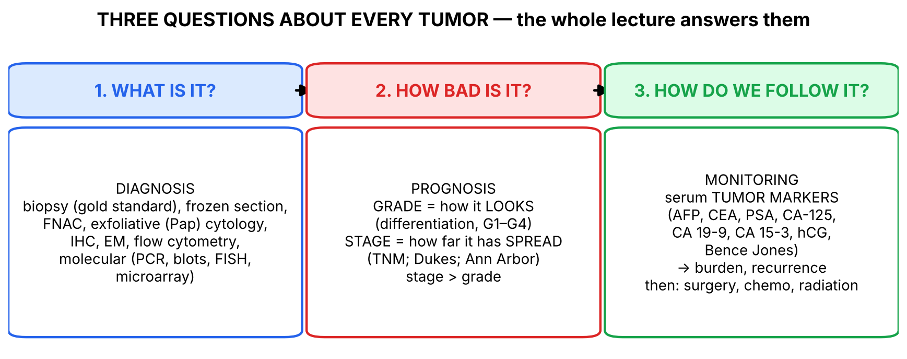
Figure 1. Three questions — every slide answers one of them.
Within question 1, the diagnostic methods make most sense arranged by level of zoom — from the tissue down to the gene — because each level answers a different sub-question:
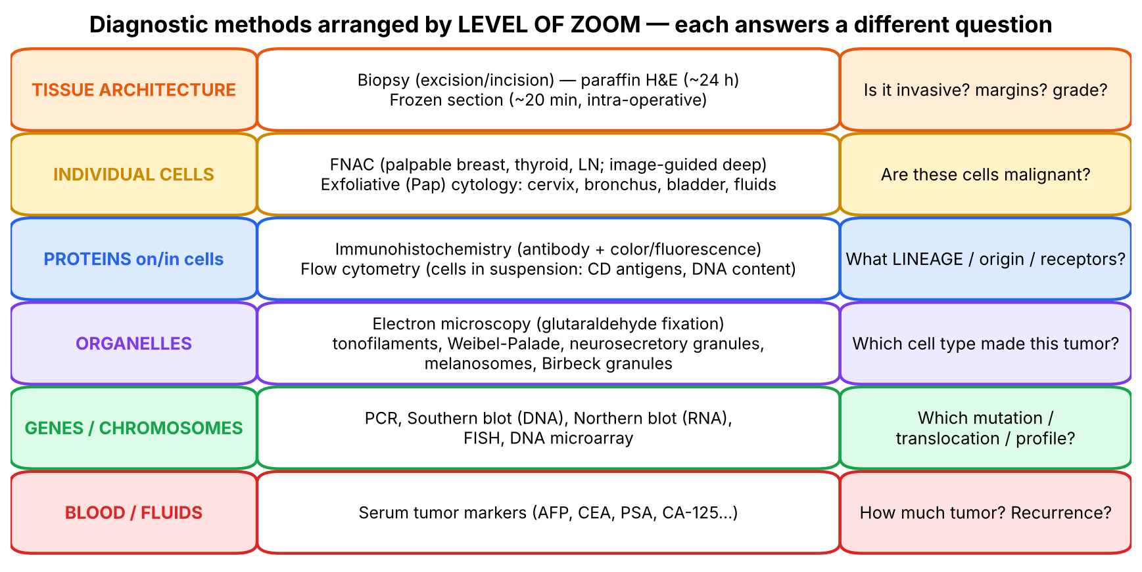
Figure 2. The diagnostic toolkit as a zoom ladder.
💡 THE ORGANIZING PRINCIPLE
Why so many methods? No single test answers everything:
• Architecture (is it invading? what grade?) needs tissue → biopsy, frozen section.
• Cell appearance (are these cells malignant?) can be judged from loose cells → FNAC, Pap smear — quicker and cheaper, but blind to architecture.
• Lineage (carcinoma vs sarcoma vs lymphoma vs melanoma) when the cells look primitive → proteins (IHC, flow) or organelles (EM).
• Genetic identity (translocation, amplification) for diagnosis, prognosis and targeted therapy → molecular methods.
• Monitoring after treatment without repeated biopsies → serum markers.
Every comparison question ('why FNAC rather than biopsy?', 'why IHC?') is answered by asking which level of zoom the question needs.

Section 1 — Grading (slides 3–5)

1.1 What the slides say
▌ FROM THE SLIDES
- The grade and stage of a cancer have a significant impact on management and prognosis; the stage is usually the more important parameter (slide 3).
- Grading is based on the histologic appearance of the tumor and involves estimating its degree of differentiation. Four grades, I to IV.
- Poorly differentiated / undifferentiated malignancies are usually more aggressive with a poorer prognosis.
Grade | Grade category | Definition
I | Low grade | Well differentiated
II | Intermediate grade | Moderately differentiated
III | High grade | Poorly differentiated
IV | High grade | Anaplastic (notes: 'nearly anaplastic')

- Notes: criteria are established for different tumor types to assist grading — e.g., mucin secretion by an adenocarcinoma of the colon suggests differentiation.
- Slide 5 diagram (adenocarcinoma): G1 — cells form orderly glands resembling normal; G2 — glands still recognizable but irregular; G3 — gland formation largely lost, more atypia; G4 — single, pleomorphic, disorganized cells with no glands.
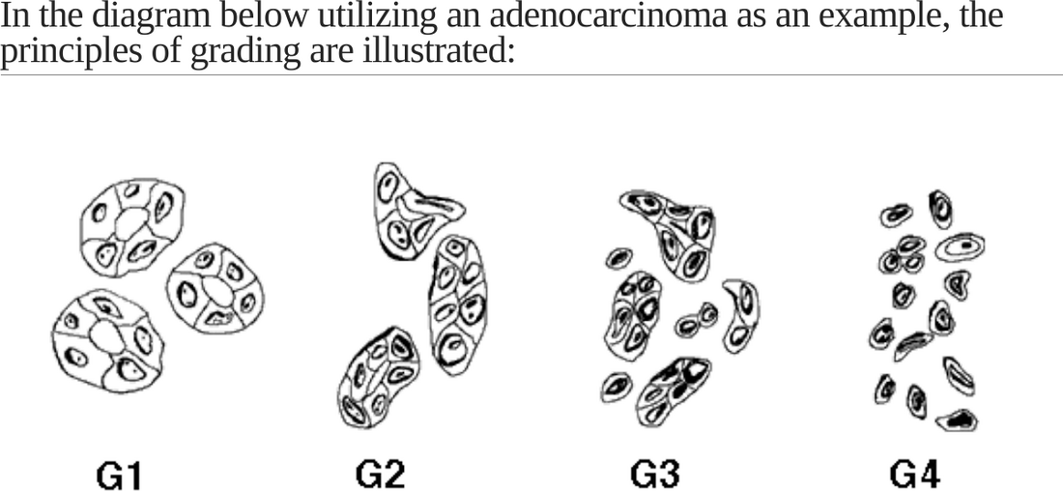
Slide 5: grading principles in an adenocarcinoma (G1 → G4).

1.2 What 'differentiation' means — and why it predicts behavior
▌ ADDITIONAL CONTEXT
Differentiation = how closely tumor cells resemble the normal cells they came from, in structure and function. A well-differentiated colon adenocarcinoma still builds glands and secretes mucin — it 'remembers' its job. An anaplastic tumor has lost almost all specialized features. Cells that have lost their specialized program usually also lost growth controls → divide faster, invade more, metastasize earlier.
Microscopic feature | Low grade (G1) | High grade (G3–G4)
Architecture | Organized; glands/keratin pearls preserved | Sheets of cells; no recognizable pattern
Pleomorphism (variation in size/shape) | Minimal | Marked; tumor giant cells
Nucleus | Near normal N:C ratio, fine chromatin | ↑ N:C ratio (up to 1:1), hyperchromatic, coarse chromatin, prominent nucleoli
Mitoses | Few, normal | Many, atypical (tripolar, bizarre)
Function | Retained (mucin, keratin, hormones) | Lost
Behavior | Slower growth, better prognosis | Aggressive, poorer prognosis

Why is stage more important than grade? Grade predicts how the tumor will probably behave; stage tells you what it has already done. A low-grade tumor that has already metastasized (stage IV) is incurable by surgery; a high-grade tumor caught while still small and node-negative may be cured. Grading is also subjective (pathologist-dependent) and tumors are often heterogeneous (graded by the worst area).
▌ HIGH-YIELD ADDITIONAL KNOWLEDGE
- Tumor-specific grading systems: Gleason score (prostate — architectural pattern; sum of two most common patterns), Nottingham/Bloom–Richardson (breast — tubule formation, nuclear pleomorphism, mitoses), Fuhrman/ISUP (renal — nucleolar prominence). The principle on slide 4 applies to all.
- Anaplasia = complete lack of differentiation; hallmark of malignancy (benign tumors are well differentiated).
🩺 CLINICAL CORRELATION
• A pathology report reading 'moderately differentiated adenocarcinoma of the colon' = grade II.
• Prostate cancer management depends heavily on the Gleason grade group (watchful waiting for low grade vs radical treatment for high grade).

🎯 EXAM FOCUS
• Grade = histology/differentiation; four grades I–IV: well, moderately, poorly differentiated, anaplastic.
• Low grade = G1; high grade = G3–IV; poorly differentiated → more aggressive, poorer prognosis.
• Stage is usually more important than grade.
• Mucin secretion in colon adenocarcinoma = sign of differentiation.

⚠️ COMMON MISTAKES
• Confusing grade (microscopic look) with stage (anatomic spread).
• Thinking a 'grade IV' tumor must be 'stage IV' — they are independent.
• Saying grade is the most important prognostic factor — it is stage.

Section 1 — Practice questions
Q1. [MCQ] A colon adenocarcinoma forms well-formed glands with abundant mucin and few mitoses. Its grade is:
A. Grade I (low)
B. Grade II
C. Grade III
D. Grade IV
E. Cannot be graded without lymph nodes

✅ ANSWER & EXPLANATION
A. Well differentiated (glands + mucin = differentiation) → grade I. Lymph nodes are used for stage, not grade (E).

Q2. [MCQ] Which statement is correct?
A. Grade is based on tumor size
B. Stage is based on degree of differentiation
C. Stage is usually more important than grade for prognosis
D. Grade IV means distant metastases
E. Well-differentiated tumors are high grade

✅ ANSWER & EXPLANATION
C (slides 3, 6).

Q3. [Clinical vignette] Two patients have colon adenocarcinoma. Patient A: grade III, 2 cm, confined to the bowel wall, nodes negative. Patient B: grade I, 3 cm, with liver metastases. Who has the worse prognosis and why?

✅ ANSWER & EXPLANATION
Patient B. Stage (extent of spread) is the most important prognostic factor; distant metastasis (M1) outweighs favorable grade. Patient A's high grade predicts aggressive biology, but the tumor has not yet spread and can be resected.

Q4. [Short answer] List four microscopic features that distinguish a high-grade from a low-grade tumor.

✅ ANSWER & EXPLANATION
Loss of architecture; marked pleomorphism; high N:C ratio with hyperchromatic nuclei and prominent nucleoli; numerous/atypical mitoses; loss of specialized function (e.g., mucin).

Q5. [Mechanism] Why do poorly differentiated tumors tend to behave more aggressively?

✅ ANSWER & EXPLANATION
Loss of differentiation reflects accumulation of genetic changes that disable both the specialized program and growth/adhesion controls; such cells proliferate faster, have reduced cohesion (E-cadherin loss), invade and metastasize more readily.

Section 2 — Staging and the TNM system (slides 6–7)

2.1 What the slides say
▌ FROM THE SLIDES
- Staging is the most important prognostic factor.
- Based on the size of the primary tumor and extent of spread, both to regional nodes and to more widespread sites.
- TNM is the most commonly used system: T = tumor size (> 2 cm correlates with metastatic ability); N = lymph node involvement; M = extranodal metastasis (e.g., liver, lung).
- TNM progresses from least important to most important prognostic factor: T — T0 in situ, then T1–T4 by size; N — N0 no nodes, N1–N3 by extent; M — M0 none, M1–M2 by extent.
- Other systems (notes): Dukes — colorectal cancers; Ann Arbor — Hodgkin and non-Hodgkin lymphomas.
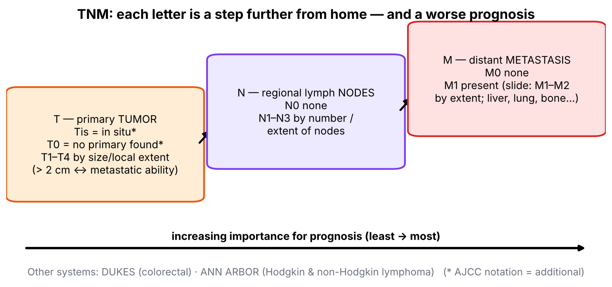
Figure 3. TNM as a journey away from home.
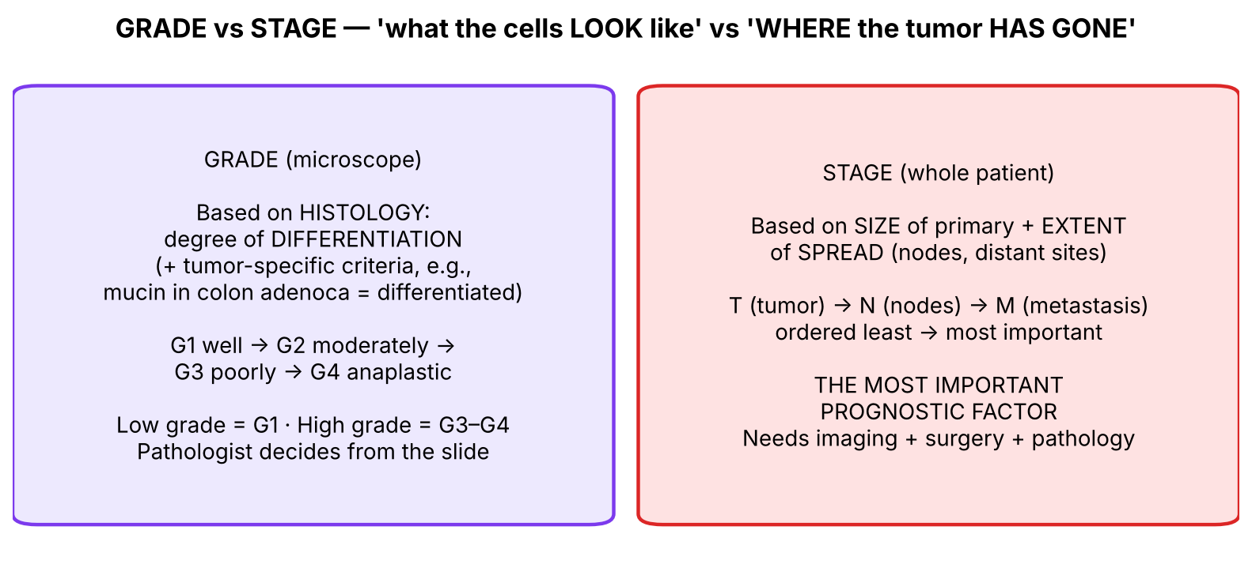
Figure 4. Grade vs stage side by side.

2.2 Making sense of it
▌ ADDITIONAL CONTEXT
- Why is M worse than N and N worse than T? A bigger primary (T) can still be cut out. Nodal spread (N) shows the tumor has learned to enter lymphatics → micrometastases elsewhere are likely. Distant metastasis (M) means systemic disease — surgery alone can no longer cure it.
- Notation update (AJCC): in current TNM, Tis = carcinoma in situ and T0 = no evidence of primary tumor (e.g., cancer found only in a node); M is usually M0/M1 (with subcategories such as M1a/b/c). The slide's 'T0 in situ' and 'M1–M2' are older/simplified wording — know the slide version for this exam, and the AJCC version for boards.
- TNM → stage group: T, N, M are combined into stage I–IV. General pattern: stage I–II = localized; III = regional nodes; IV = distant metastasis (any T, any N, M1).
- Clinical vs pathologic staging: cTNM from exam/imaging before treatment; pTNM from the resected specimen.
▌ HIGH-YIELD ADDITIONAL KNOWLEDGE
- Most common sites of metastasis: liver (GI tumors via portal vein), lung (sarcomas via systemic veins), bone, brain. Sarcomas spread hematogenously; carcinomas usually go to lymph nodes first (exceptions: RCC, HCC, follicular thyroid, choriocarcinoma → blood).
- Sentinel lymph node biopsy (breast, melanoma) samples the first draining node to determine N without full node dissection.
🩺 CLINICAL CORRELATION
• Worked example: breast carcinoma 3 cm (T2), 2 ipsilateral axillary nodes positive (N1), no distant metastasis on imaging (M0) → T2 N1 M0 → regional disease (stage II/III by group) → surgery + systemic therapy.
• Same tumor with a liver metastasis → T2 N1 M1 = stage IV, regardless of T and N.
• Hodgkin lymphoma is staged by Ann Arbor (number/side of diaphragm of node regions, B symptoms), not TNM.

🎯 EXAM FOCUS
• Stage = most important prognostic factor; size of primary + spread to nodes + distant sites.
• T size (> 2 cm ↔ metastatic ability); N nodes; M extranodal metastasis (liver, lung).
• Order of importance: T < N < M.
• Dukes = colorectal; Ann Arbor = lymphomas.
• Learning objective: 'compute TNM' — expect a vignette asking you to assign T, N, M.

⚠️ COMMON MISTAKES
• Putting distant lymph nodes under M only when they are beyond regional drainage — regional nodes are N; non-regional nodes count as M.
• Thinking a large T automatically means stage IV — only M1 makes stage IV.
• Using Ann Arbor for carcinomas or TNM for lymphomas.

Section 2 — Practice questions
Q1. [MCQ] In the TNM system, which component carries the greatest prognostic weight?
A. T
B. N
C. M
D. Grade
E. Tumor marker level

✅ ANSWER & EXPLANATION
C — M (TNM progresses from least to most important).

Q2. [MCQ] Which staging system is used for Hodgkin lymphoma?
A. Dukes
B. Ann Arbor
C. Gleason
D. Bloom–Richardson
E. Breslow

✅ ANSWER & EXPLANATION
B (slide 7 notes). Dukes = colorectal.

Q3. [Clinical vignette] A 54-year-old woman has a 1.8-cm breast carcinoma. Sentinel node biopsy shows no tumor; CT shows no distant lesions. Assign TNM using the slide's framework.

✅ ANSWER & EXPLANATION
T1 (small primary, < 2 cm), N0 (no nodal involvement), M0 (no distant metastasis) → early-stage, best prognosis. Size < 2 cm correlates with lower metastatic ability (slide 6).

Q4. [Short answer] Define T, N and M and give the range of values for each according to the slide.

✅ ANSWER & EXPLANATION
T = size of primary (T0 in situ, T1–T4 by size); N = nodal involvement (N0 none, N1–N3 by extent); M = distant metastasis (M0 none, M1–M2 by extent).

Q5. [Mechanism] Why does the slide state that T > 2 cm correlates with metastatic ability?

✅ ANSWER & EXPLANATION
Larger tumors have had more cell divisions → more genetic heterogeneity and a higher chance of subclones able to invade and metastasize; they also have more contact with lymphatics and vessels and greater total cell number shedding into circulation.

Section 3 — Morphologic diagnosis: biopsy, frozen section, FNAC and cytology (slides 8–14)

3.1 Overview of diagnostic modalities (slide 8)
▌ FROM THE SLIDES
Category | Methods (slide 8)
Morphologic | Biopsy (gold standard); frozen section ★; fine-needle aspiration cytology; exfoliative cytology; immunohistochemistry ★
Molecular | Flow cytometry; DNA probe analysis
Biochemical | Tumor markers ★

Speaker notes: a biopsy may be examined by paraffin section (~24 hours) or frozen section (~20 minutes, while the patient is on the operating table). FNAC = aspiration of cells, smeared, stained and examined. Cytologic (Papanicolaou) smear = examination of exfoliated cells; used for dysplasia and carcinoma of the cervix and tumors of bronchus, stomach and urinary bladder. Flow cytometry quantitates cell-surface antigens and DNA content — especially useful for leukemias and lymphomas. DNA probe analysis = PCR or FISH, useful for N-MYC, RET, BRCA1/2, BCR-ABL; chromosomal analysis, e.g., Philadelphia chromosome in CML.

3.2 Handling the specimen (slide 9)
▌ FROM THE SLIDES
- Sampling approaches: excision or biopsy.
- Tissue is fixed in 10% formalin for light microscopy and in glutaraldehyde for electron microscopy.
- Quick-frozen section and hormonal analysis are carried out on fresh, unfixed tissue.
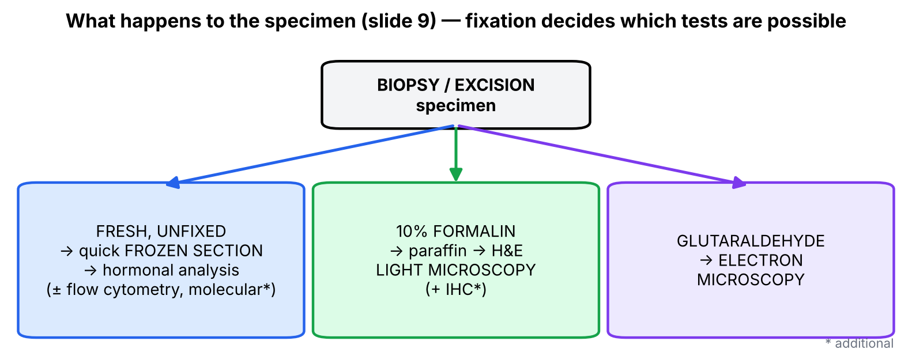
Figure 5. Fixation determines which test is possible.
▌ ADDITIONAL CONTEXT
Why different fixatives? Formalin cross-links proteins → preserves tissue architecture for H&E (and most IHC), but damages fine membranes and destroys enzyme/receptor activity. Glutaraldehyde cross-links more tightly → preserves ultrastructure for EM. Freezing is instant (no processing) but leaves ice-crystal artifact; it preserves native proteins for hormone/receptor assays.

3.3 Biopsy (slide 10)
▌ FROM THE SLIDES
- Excisional biopsy — the whole lesion is removed (slide image: pigmented lesion excised with surrounding skin).
- Stained with H&E — slide image shows malignant melanoma (pleomorphic cells with brown melanin pigment).
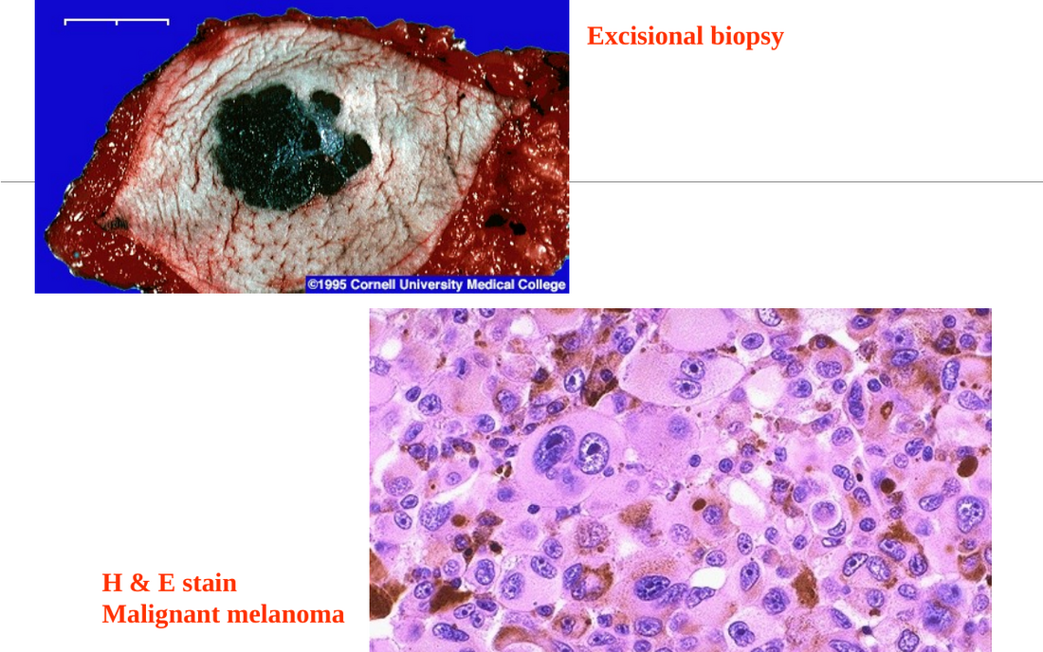
Slide 10: excisional biopsy of a pigmented lesion and H&E of malignant melanoma.
▌ ADDITIONAL CONTEXT
- Incisional/core biopsy removes only part of a large lesion; excisional removes all of it (also therapeutic for small lesions — e.g., suspected melanoma should be excised with a margin, not shaved, so that depth (Breslow thickness) can be measured — HY).
- Biopsy = gold standard because it preserves architecture → shows invasion (through basement membrane), margins, and allows grading.

3.4 Frozen section ★
▌ ADDITIONAL CONTEXT
The slides list frozen section among the starred methods and the notes give the key fact: ~20 minutes while the patient is on the operating table (vs ~24 h for paraffin). Uses (indications): decide benign vs malignant during surgery, check resection margins, assess sentinel lymph nodes, confirm that diagnostic tissue was obtained. Limitations: freezing artifacts, poorer morphology, difficult with fatty tissue and bone; final diagnosis always confirmed on paraffin sections.

3.5 Fine-needle aspiration cytology (slides 11–12)
▌ FROM THE SLIDES
- Aspirating cells and attendant fluid with a small-bore needle.
- Used for readily palpable lesions in breast, thyroid and lymph nodes.
- Less invasive and more rapidly performed.
- Notes: usually for superficial masses, but with ultrasound/CT guidance also deeper masses (liver, lungs). Advantages: quick; no anesthesia (local for deep masses); cheaper; no admission; report in < 2 hours.
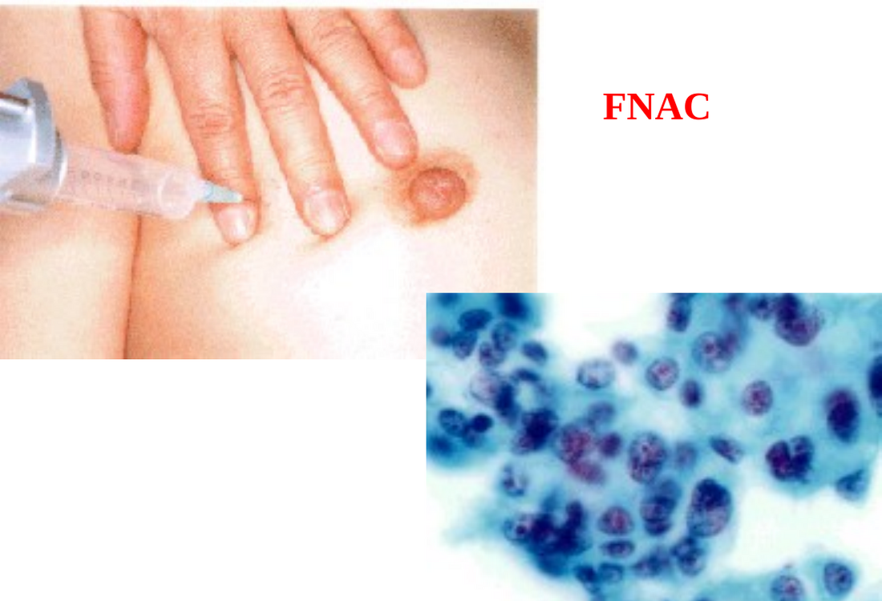
Slide 12: FNAC of a breast lump and the resulting cytology smear.
▌ HIGH-YIELD ADDITIONAL KNOWLEDGE
- Main limitation of FNAC: no tissue architecture → cannot assess invasion. Classic example: follicular thyroid adenoma vs carcinoma cannot be distinguished by FNAC because carcinoma is defined by capsular or vascular invasion — needs excision. Also: false negatives from sampling error (needle misses the tumor).

3.6 Exfoliative (Papanicolaou) cytology (slides 13–14)
▌ FROM THE SLIDES
- Pap smears screen for cervical carcinoma, and also endometrial, bronchogenic, bladder, prostatic and gastric carcinoma.
- Also used to identify tumor cells in abdominal, pleural, joint and CSF fluids.
- Slide 14: normal Pap smears vs Pap smear showing cervical dysplasia (enlarged, hyperchromatic nuclei with high N:C ratio).
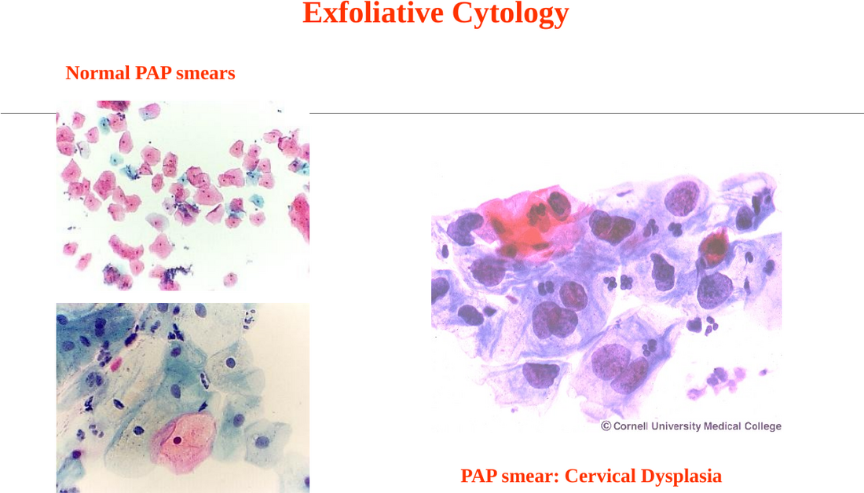
Slide 14: exfoliative cytology — normal Pap smears vs cervical dysplasia.
▌ ADDITIONAL CONTEXT
Why it works: cancer and dysplastic cells are less cohesive than normal cells (reduced adhesion molecules) and shed (exfoliate) easily into secretions, which can be collected painlessly — cervical scrape, sputum, urine, effusions. Ideal for screening: cheap, repeatable, detects precursor (dysplasia) stages before invasion.

3.7 Comparing the morphologic methods (learning objective 5)
Method | Indication | Speed / invasiveness | What you can interpret | Main limitation
Biopsy (paraffin) | Definitive diagnosis of any mass | ~24 h; surgical/needle procedure | Architecture, invasion, grade, margins; IHC, molecular | Slower, more invasive, more costly
Frozen section ★ | Intra-operative decisions (malignant? margins? node?) | ~20 min, patient on table | Benign vs malignant, margin status | Freezing artifact; must be confirmed on paraffin
FNAC | Palpable breast, thyroid, LN; image-guided deep masses | < 2 h report; no admission, no/local anesthesia; cheap | Whether cells are malignant; cell type | No architecture → can't show invasion; sampling error
Exfoliative (Pap) cytology | Screening (cervix); bronchus, stomach, bladder, fluids | Painless, cheap, repeatable | Dysplasia/malignant cells | Screening only; abnormal result needs biopsy
IHC ★ | Undifferentiated tumors, lymphomas, metastasis of unknown origin, receptors | Added to biopsy (hours) | Lineage, origin, prognostic/therapeutic markers | Needs tissue; no single marker is 100% specific

🩺 CLINICAL CORRELATION
• Thyroid nodule → ultrasound-guided FNAC first; 'follicular neoplasm' result → lobectomy for histology.
• Breast lump → triple assessment: exam, imaging, FNAC/core biopsy.
• During a lumpectomy the surgeon sends margins for frozen section to decide whether to excise more tissue.
• Malignant pleural effusion → cytology of the fluid can show adenocarcinoma cells without a lung biopsy.

🎯 EXAM FOCUS
• Biopsy = gold standard; paraffin ~24 h; frozen ~20 min intra-operatively.
• 10% formalin → LM; glutaraldehyde → EM; fresh unfixed → frozen section and hormonal analysis.
• FNAC: small-bore needle; palpable breast, thyroid, LN; quick, cheap, no anesthesia, report < 2 h; image-guided for liver/lung.
• Pap smear: cervix (also endometrium, bronchus, bladder, prostate, stomach); body fluids (peritoneal, pleural, joint, CSF).

⚠️ COMMON MISTAKES
• Saying FNAC can diagnose invasion — it lacks architecture.
• Fixing tissue in formalin when a frozen section or hormone assay is needed — those require fresh tissue.
• Using glutaraldehyde for routine H&E (it's for EM).
• Confusing exfoliative cytology (cells shed spontaneously/scraped) with FNAC (cells aspirated with a needle).

Section 3 — Practice questions
Q1. [MCQ] A surgeon wants to know, during an operation, whether the margins of a resected tumor are free. Which method?
A. Paraffin section
B. Frozen section
C. FNAC
D. Pap smear
E. Electron microscopy

✅ ANSWER & EXPLANATION
B — ~20 minutes while the patient is on the table.

Q2. [MCQ] Tissue for electron microscopy should be fixed in:
A. 10% formalin
B. Glutaraldehyde
C. Alcohol
D. Nothing — fresh
E. Bouin solution

✅ ANSWER & EXPLANATION
B (slide 9).

Q3. [Clinical vignette] A 38-year-old woman has a 2-cm thyroid nodule. FNAC shows a cellular follicular lesion without papillary nuclear features. Why can't FNAC tell whether this is adenoma or carcinoma, and what is the next step?

✅ ANSWER & EXPLANATION
Follicular carcinoma is defined by capsular and/or vascular invasion — an architectural feature. FNAC aspirates loose cells and cannot show architecture. Next step: surgical excision (lobectomy) for histological examination of the capsule and vessels.

Q4. [Short answer] List five advantages of FNAC from the speaker notes.

✅ ANSWER & EXPLANATION
Quick; no anesthesia (local only for deep masses); cheaper; no admission required; report in < 2 hours. (Also less invasive.)

Q5. [Mechanism] Why are exfoliated cells from a malignant lesion more abundant in a Pap smear than from normal epithelium?

✅ ANSWER & EXPLANATION
Malignant and dysplastic cells have reduced cell–cell adhesion (e.g., loss of E-cadherin), so they detach (exfoliate) more easily into secretions, where they can be sampled.

Section 4 — Immunohistochemistry and electron microscopy: 'what lineage is this?' (slides 15–19, 23–24)

4.1 What the slides say — IHC
▌ FROM THE SLIDES
- IHC uses antibodies to antigens typical of particular tumor types; binding is revealed by fluorescent labels or chemical reactions producing colored products.
- Uses: (1) diagnosis of undifferentiated tumors by detecting tissue-specific intermediate filaments; (2) categorization of leukemias and lymphomas; (3) determining the site of origin of metastasis; (4) detection of molecules with prognostic or therapeutic significance.
- Notes — intermediate filaments: epithelial → cytokeratin; mesenchymal → vimentin; muscle → desmin; neural → neurofilaments.
- Slide 16: cytokeratin+ → carcinoma; desmin+ → muscle origin; CD19, CD20 → B-cell tumors; CD2 → T cells. Site of origin of metastasis: tissue/organ-specific antigens in the metastatic deposit, e.g., PSA. Prognostic/therapeutic: breast cancer ER/PR+ → good prognosis; ERBB2 (HER2) over-expression → poor prognosis.
Slide 17 — important IHC stains | Marker(s)
Leukocyte malignancies | CD45 (CLA/LCA — common leukocyte antigen)
Neuroendocrine tumors | S-100, NSE (neuron-specific enolase)
Carcinomas | Cytokeratin intermediate filaments, EMA (epithelial membrane antigen)
Mesenchymal tumors | Vimentin
Muscle-derived sarcomas | Desmin
Tumors of endothelium | Factor VIII-related antigen

Slide 18 — monoclonal antibodies by antigen group | Antigens
Epithelial | EMA, CEA, cytokeratin ★★★★
Mesenchymal | Desmin, actin, vimentin, factor VIII-related antigen
Neural | GFAP (glial fibrillary acidic protein), NSE, neurofilaments, chromogranin, S-100
Miscellaneous | PSA, hCG, thyroglobulin, calcitonin

Slide 19 (notes): (A) gastric adenocarcinoma positive for cytokeratin by immunoperoxidase — typical of carcinomas, distinguishes them from sarcomas and lymphomas; helpful when differentiation/morphology alone cannot classify. (B) sarcoma positive for vimentin; tumor cells invading normal muscle fibers (which don't stain). (C) high-grade prostatic adenocarcinoma — ill-defined glands, single infiltrating cells. (D) PSA immunostain — prostatic adenocarcinoma cells positive.
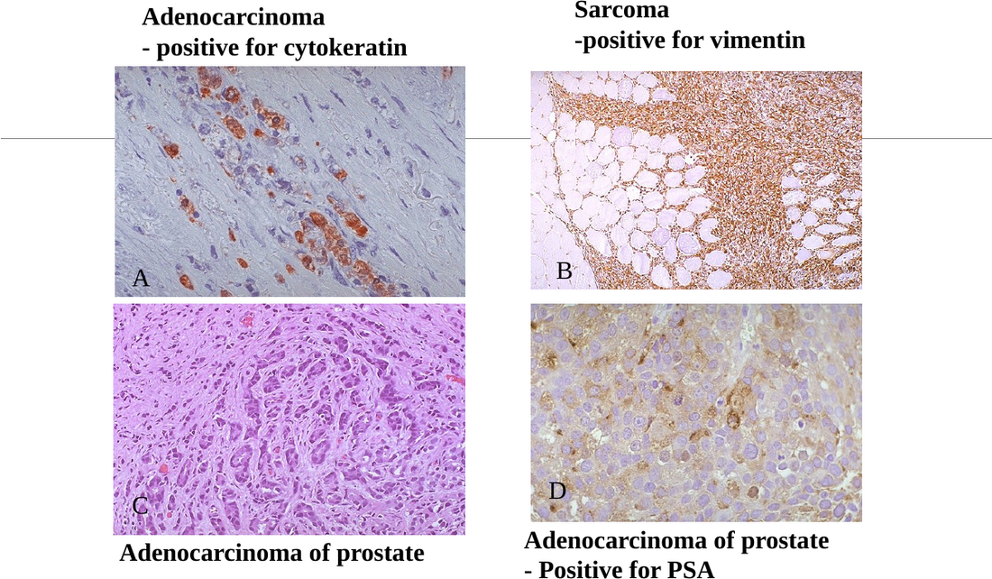
Slide 19: cytokeratin (A), vimentin (B), prostatic adenocarcinoma H&E (C) and PSA immunostain (D).

4.2 The organizing principle — lineage logic
💡 THE ORGANIZING PRINCIPLE
IHC markers are not random: each one is a protein the normal parent cell needs for its job. Tumor cells keep many of these proteins even when they look primitive, so the protein betrays the family.
• Cytoskeleton (intermediate filaments) → broad family: cytokeratin (epithelium), vimentin (mesenchyme), desmin (muscle), neurofilament (neurons), GFAP (glia).
• Leukocyte surface proteins (CD antigens) → blood cells: CD45 = any leukocyte; CD19/CD20 = B; CD2 (CD3) = T.
• Products the cell makes for export → exact organ: PSA (prostate), thyroglobulin (thyroid follicular cells), calcitonin (thyroid C cells), hCG (trophoblast), factor VIII-related antigen/vWF (endothelium).
• Receptors the cell uses → treatment: ER/PR, HER2.
So the workflow is: broad family first (filament / CD45) → organ-specific product → therapeutic receptor.

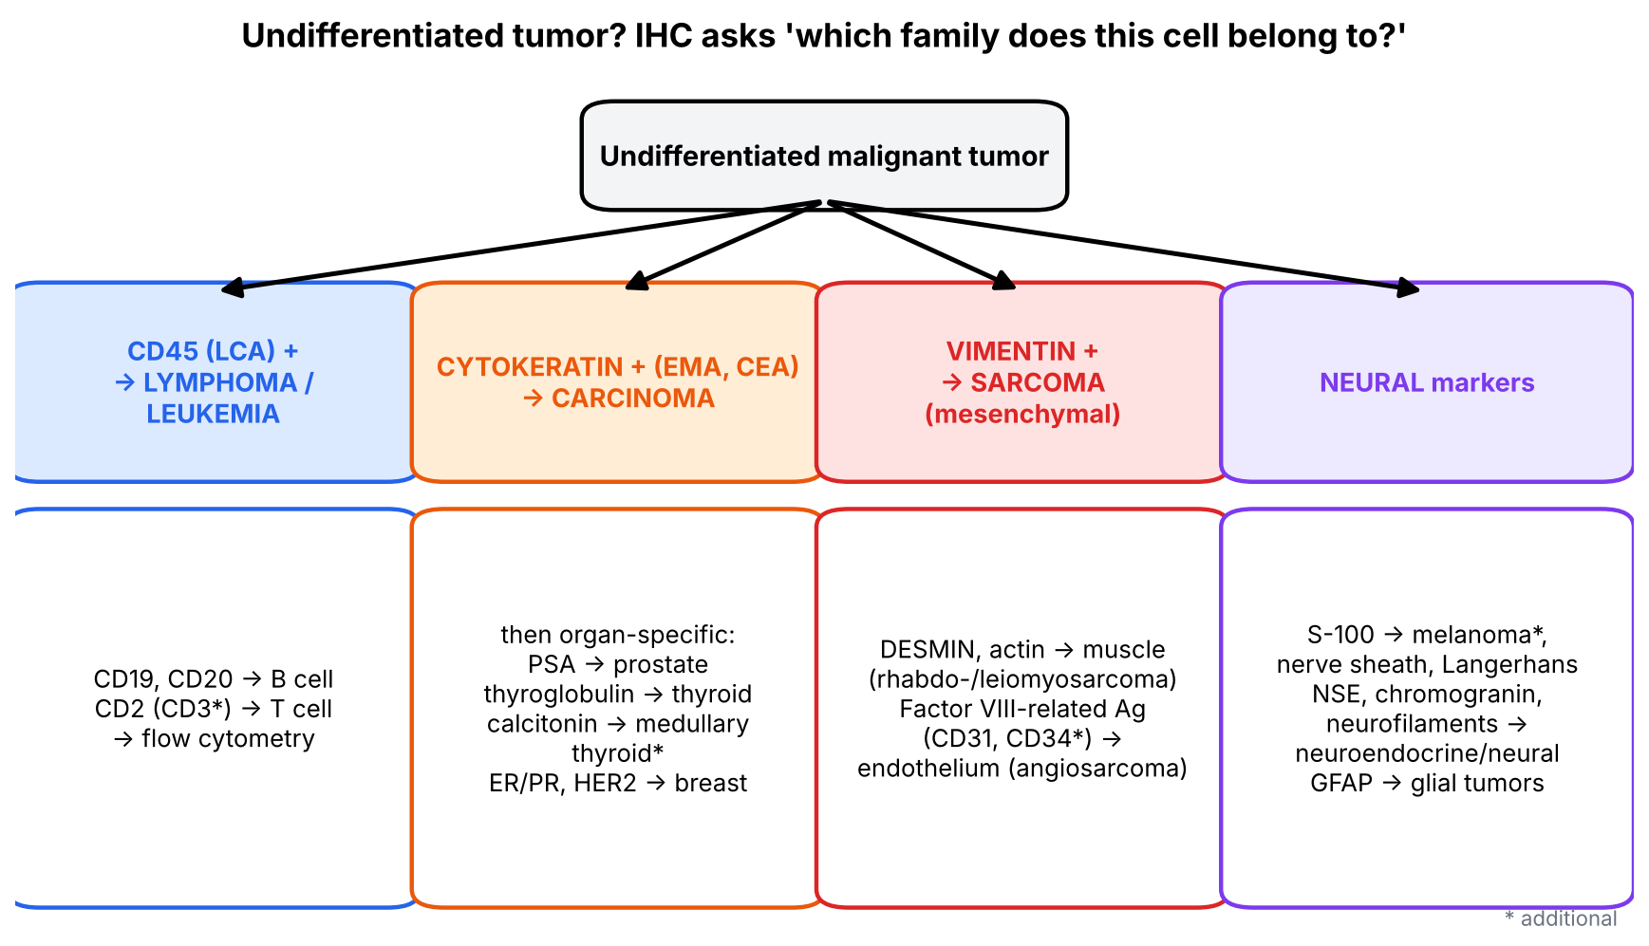
Figure 6. IHC decision tree for an undifferentiated tumor.
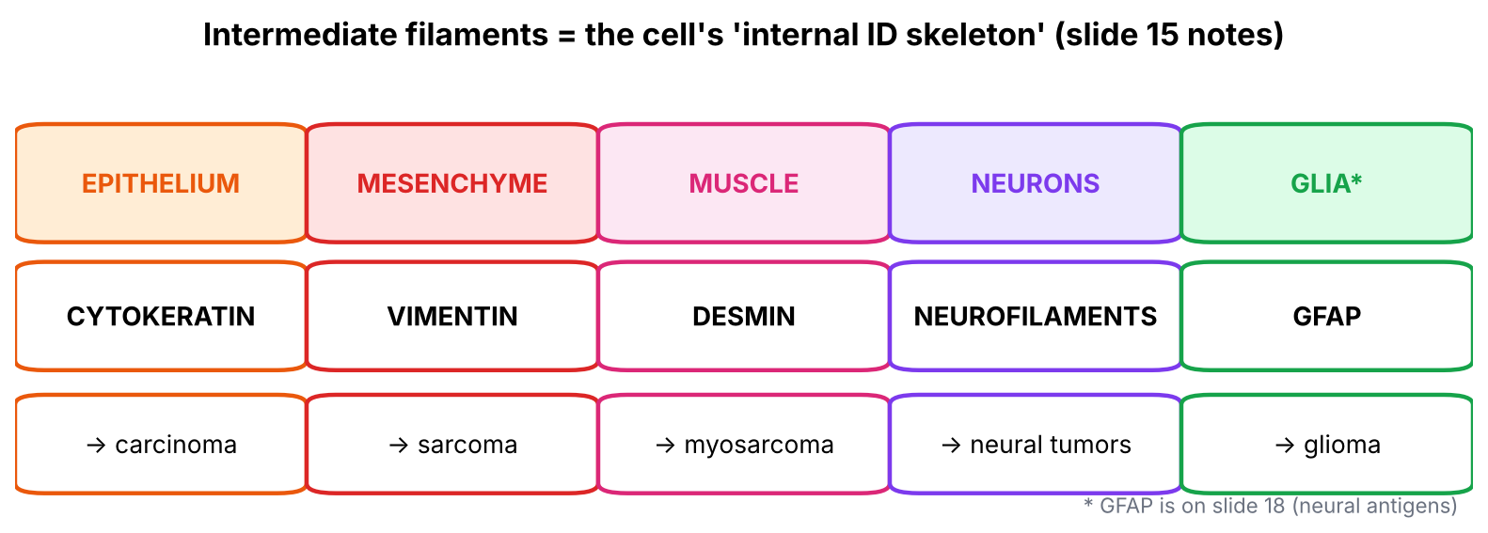
Figure 7. Intermediate filaments = tissue identity cards.
▌ ADDITIONAL CONTEXT
- S-100 — a clarification: slide 17 lists S-100 under neuroendocrine tumors. In practice, S-100 is the classic marker of neural-crest-derived cells — melanoma, Schwann cells (schwannoma, neurofibroma) and Langerhans cells — and is less specific for neuroendocrine tumors, which are better marked by chromogranin, synaptophysin and NSE. For your exam, reproduce the slide; for boards, link S-100 → melanoma, nerve sheath tumors, Langerhans cell histiocytosis.
- Factor VIII-related antigen = von Willebrand factor, stored in endothelial Weibel–Palade bodies — the same organelle seen on EM in angiosarcoma (slide 23). CD31 and CD34 are modern endothelial markers (HY).
▌ HIGH-YIELD ADDITIONAL KNOWLEDGE
- HER2 (ERBB2) amplification → poor prognosis but targetable by trastuzumab; ER/PR+ → better prognosis and responds to tamoxifen/aromatase inhibitors. Triple-negative (ER−, PR−, HER2−) = worst prognosis, no targeted hormone therapy.
- HMB-45 and Melan-A = more specific melanoma markers; TTF-1 = lung adenocarcinoma and thyroid; CK7/CK20 pattern helps locate the primary of a metastatic adenocarcinoma.

4.3 Electron microscopy findings (slides 23–24)
▌ FROM THE SLIDES
EM finding | Tumor
Tonofilaments | Epithelial tumors
Weibel–Palade bodies | Angiosarcomas
Neurosecretory granules | Neuroendocrine tumors
Melanosomes | Malignant melanoma
Birbeck granules — look like a tennis racket | Histiocytic tumor, e.g., histiocytosis X; CD1-positive

Notes: tonofilament bundles in the cytoplasm of adjacent tumor cells; a tumor vessel with many small dense Weibel–Palade bodies in endothelial cells on either side of the lumen; Birbeck granules — tennis-racket-shaped structures in Langerhans cells in histiocytosis X (Langerhans cell histiocytosis), which includes eosinophilic granuloma, Letterer–Siwe disease and Hand–Schüller–Christian disease.
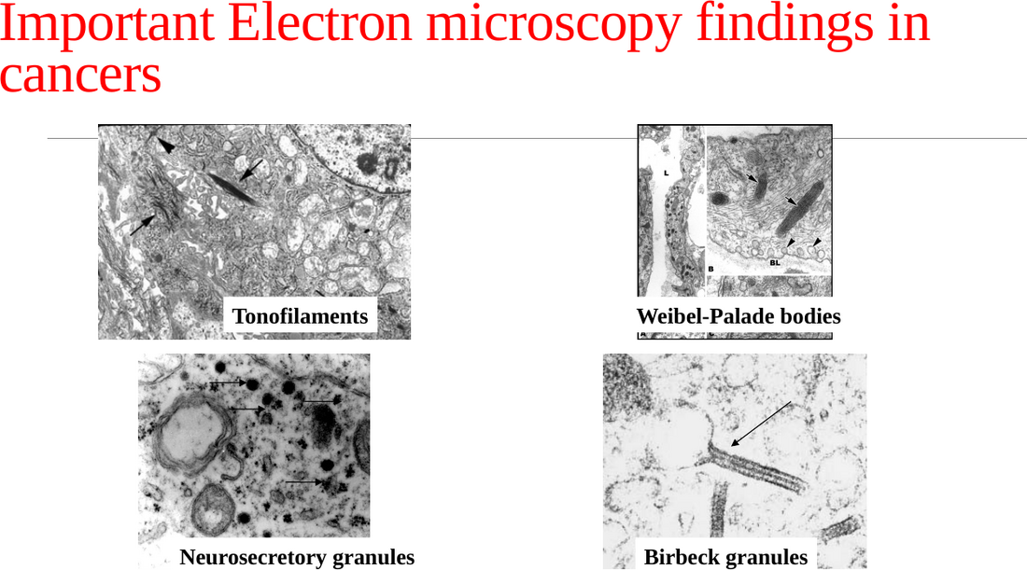
Slide 24: EM — tonofilaments, Weibel–Palade bodies, neurosecretory granules, Birbeck granules.
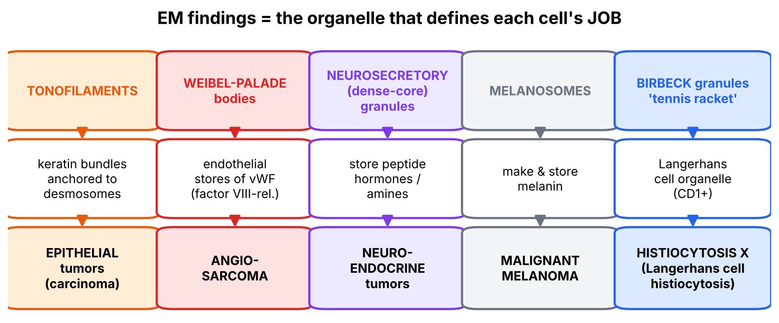
Figure 8. Each EM finding is the organelle that performs the parent cell's job.
▌ HIGH-YIELD ADDITIONAL KNOWLEDGE
- Langerhans cell histiocytosis: Birbeck granules on EM; IHC CD1a+, S-100+, langerin (CD207)+; lytic skull lesions in a child; Letterer–Siwe (infant, multisystem, rapidly fatal), Hand–Schüller–Christian (triad: lytic skull lesions, diabetes insipidus, exophthalmos), eosinophilic granuloma (solitary bone lesion, best prognosis).
- Today EM is largely replaced by IHC for lineage, but the slide pairings remain classic exam facts.
🩺 CLINICAL CORRELATION
• Metastatic adenocarcinoma in a man's spine, primary unknown → IHC for PSA proves a prostatic origin → treat with androgen deprivation.
• Small round blue cell tumor in a child → CD45 (lymphoma), desmin/myogenin (rhabdomyosarcoma), neural markers (neuroblastoma) and molecular tests sort it out.
• Breast cancer pathology report always includes ER, PR and HER2 — they decide therapy.
• Child with lytic skull lesion and polyuria → biopsy shows Langerhans cells with Birbeck granules (CD1a+).

🎯 EXAM FOCUS
• Cytokeratin ★ → carcinoma; vimentin → sarcoma; desmin → muscle; CD45 → leukocytes; CD19/CD20 → B; CD2 → T; factor VIII → endothelium; GFAP → glia; PSA → prostate.
• IHC uses: undifferentiated tumors, lymphoma categorization, site of origin of metastasis, prognostic/therapeutic markers (ER/PR good, HER2 poor).
• EM: tonofilaments → epithelial; Weibel–Palade → angiosarcoma; neurosecretory granules → neuroendocrine; melanosomes → melanoma; Birbeck (tennis racket, CD1+) → histiocytosis X.

⚠️ COMMON MISTAKES
• Thinking vimentin means 'muscle' — vimentin = mesenchymal (broad); desmin = muscle.
• Forgetting that ER/PR positivity is GOOD while HER2 over-expression is POOR prognosis.
• Linking Birbeck granules to Langerhans cells of the pancreas (islets) — it's the Langerhans dendritic cell of the skin/bone (different 'Langerhans').
• Linking Weibel–Palade bodies to epithelium — they are endothelial (vWF).

Section 4 — Practice questions
Q1. [MCQ] An undifferentiated tumor stains strongly for cytokeratin and EMA but not for CD45 or vimentin. It is most likely a:
A. Lymphoma
B. Sarcoma
C. Carcinoma
D. Glioma
E. Melanoma

✅ ANSWER & EXPLANATION
C — cytokeratin and EMA are epithelial markers.

Q2. [MCQ] Which breast cancer IHC result indicates a POOR prognosis according to the slide?
A. ER positive
B. PR positive
C. HER2 (ERBB2) over-expression
D. Cytokeratin positive
E. Vimentin negative

✅ ANSWER & EXPLANATION
C (slide 16).

Q3. [Clinical vignette] A 70-year-old man has multiple sclerotic vertebral lesions. Biopsy shows adenocarcinoma of unknown primary. Which single IHC stain would best establish the site of origin?

✅ ANSWER & EXPLANATION
PSA — a tissue/organ-specific antigen (slide 16, 19D). A positive stain in the metastatic deposit proves prostatic origin.

Q4. [MCQ] Tennis-racket-shaped cytoplasmic granules on EM in a CD1-positive tumor indicate:
A. Melanoma
B. Angiosarcoma
C. Langerhans cell histiocytosis (histiocytosis X)
D. Carcinoid tumor
E. Squamous cell carcinoma

✅ ANSWER & EXPLANATION
C — Birbeck granules (slides 23–24).

Q5. [Short answer] List the four intermediate filaments from slide 15's notes and their tissues.

✅ ANSWER & EXPLANATION
Cytokeratin — epithelial; vimentin — mesenchymal; desmin — muscle; neurofilaments — neural.

Q6. [Mechanism] Why does an anaplastic carcinoma still stain for cytokeratin even though it no longer looks epithelial?

✅ ANSWER & EXPLANATION
Morphological differentiation (glands, keratin pearls) is lost earlier than the basic cytoskeletal program; tumor cells retain the intermediate filament of their parent lineage, so IHC reveals the lineage even when H&E cannot (slide 19 notes).

Section 5 — Serum tumor markers (slides 20–22)

5.1 What the slides say
▌ FROM THE SLIDES
- Tumor markers are tumor-derived or tumor-associated molecules — hormones, enzymes, oncofetal antigens, etc. — detectable in blood or body fluids.
- Uses: screen for cancers; adjunct to diagnosis; estimate tumor burden; detect recurrence.
Tumor marker | Associated cancer (slide 21)
AFP (α-fetoprotein) ★ | Hepatocellular carcinoma; yolk sac tumor of ovary or testis
Bence Jones protein ★ | Multiple myeloma; Waldenström macroglobulinemia
CA 15-3 | Breast carcinoma
CA 19-9 | Pancreatic adenocarcinoma
CA-125 | Surface-derived (epithelial) ovarian cancer
CEA ★ | Colorectal and pancreatic adenocarcinomas
PSA ★ | Prostatic carcinoma

Speaker notes (slide 22):
- AFP — normally produced by fetal yolk sac and liver. Markedly elevated → malignant tumors of testis or liver; mild–moderate elevation → non-neoplastic liver disease (cirrhosis, hepatitis).
- CEA — normally produced by fetal gut, liver and pancreas. Markedly elevated in cancers of colon, pancreas, breast and stomach; less marked in cirrhosis, hepatitis and ulcerative colitis. Mainly useful to estimate tumor burden in colorectal cancer and to monitor recurrence after surgery.
- Testicular tumor markers: AFP → yolk sac tumor; β-hCG → choriocarcinoma of testis.
- Oncofetal proteins — expressed normally only during fetal/embryonic life; their expression by tumor cells reflects dedifferentiation (undifferentiated cells resemble embryonic counterparts). Examples: CEA, AFP.
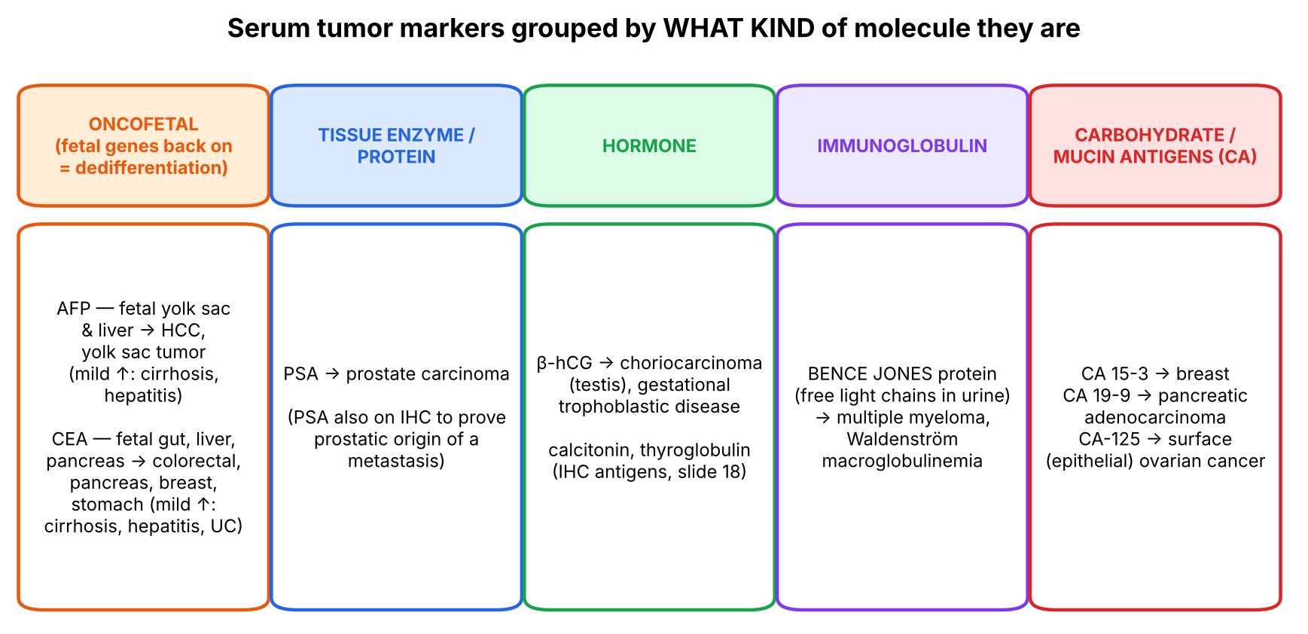
Figure 9. Tumor markers sorted by the kind of molecule.

5.2 Making sense of it
💡 THE ORGANIZING PRINCIPLE
Organizing principle: a serum marker is something the tumor cell makes and leaks into blood. Ask 'what kind of cell would make this?':
• Oncofetal (AFP, CEA): fetal genes re-awakened by dedifferentiation → AFP from liver/yolk sac lineages (HCC, yolk sac tumor); CEA from endodermal gut lineages (colon, pancreas, stomach).
• Tissue products (PSA): the normal prostate makes PSA to liquefy semen → prostate tumors leak more.
• Hormones (hCG): trophoblast makes hCG → choriocarcinoma.
• Immunoglobulin fragments (Bence Jones = free light chains): plasma cells make antibodies → plasma-cell/lymphoplasmacytic tumors (myeloma, Waldenström).
• CA numbers (mucin-type glycoproteins named by the antibody clone) — the genuinely arbitrary group: 15-3 breast, 19-9 pancreas, 125 ovary.

▌ ADDITIONAL CONTEXT
Why are markers poor for screening despite slide 20 listing 'screen'? Most markers lack specificity (CEA ↑ in smokers, UC, cirrhosis; AFP ↑ in hepatitis, pregnancy; PSA ↑ in BPH, prostatitis) and sensitivity (small, early tumors may not raise them). Their best use is monitoring a known cancer: a level that falls after surgery and then rises again signals recurrence. Screening use is limited to specific high-risk settings (e.g., AFP + ultrasound in cirrhotics; PSA with shared decision-making).
▌ HIGH-YIELD ADDITIONAL KNOWLEDGE
Marker | Extra high-yield facts
AFP | ↑ in HCC, yolk sac (endodermal sinus) tumor, mixed germ cell tumors; also ↑ in maternal serum with neural tube defects; ↓ in Down syndrome screening
β-hCG | Choriocarcinoma, hydatidiform mole, some seminomas (mild); pure seminoma does NOT raise AFP
CEA | Not a screening test; baseline before colon surgery, then serial monitoring
PSA | Organ-specific, not cancer-specific: ↑ in BPH, prostatitis, after instrumentation
CA-125 | Monitoring epithelial ovarian cancer; also ↑ in endometriosis, PID, pregnancy
CA 19-9 | Pancreatic adenocarcinoma, cholangiocarcinoma; not useful in Lewis-antigen-negative people
Bence Jones | Free light chains in urine; not detected by urine dipstick (dipstick detects albumin)
Others | Calcitonin → medullary thyroid carcinoma; LDH → seminoma/lymphoma burden; alkaline phosphatase → bone metastases

🩺 CLINICAL CORRELATION
• Young man with a testicular mass: AFP ↑ → yolk sac component; β-hCG ↑ → choriocarcinoma; normal AFP with mild hCG → seminoma.
• Cirrhotic patient with rising AFP and a new liver nodule → HCC.
• Colon cancer resected; CEA normalizes, then rises a year later → recurrence → imaging.
• Older patient with back pain, anemia, hypercalcemia, renal failure; urine light chains → multiple myeloma (Bence Jones).

🎯 EXAM FOCUS
• AFP ★ → HCC, yolk sac tumor (ovary/testis); mild ↑ in cirrhosis, hepatitis.
• CEA ★ → colorectal, pancreatic (also breast, stomach); mild ↑ in cirrhosis, hepatitis, UC; monitor tumor burden/recurrence in colorectal cancer.
• PSA ★ → prostate; Bence Jones ★ → myeloma, Waldenström.
• CA 15-3 breast · CA 19-9 pancreas · CA-125 surface ovarian.
• Testis: AFP → yolk sac; β-hCG → choriocarcinoma.
• Oncofetal = fetal proteins re-expressed through dedifferentiation (CEA, AFP).

⚠️ COMMON MISTAKES
• Using tumor markers to make a definitive diagnosis — they are adjuncts; histology confirms.
• Assuming a mildly raised AFP or CEA means cancer — think cirrhosis, hepatitis, UC.
• Swapping CA 19-9 (pancreas) and CA-125 (ovary).
• Linking AFP to choriocarcinoma — it's β-hCG; AFP = yolk sac.

Section 5 — Practice questions
Q1. [MCQ] A 24-year-old man has a testicular mass and markedly elevated serum AFP. Which tumor component is most likely?
A. Seminoma
B. Choriocarcinoma
C. Yolk sac tumor
D. Leydig cell tumor
E. Lymphoma

✅ ANSWER & EXPLANATION
C (slide 22). β-hCG would point to choriocarcinoma (B).

Q2. [MCQ] CEA is MOST useful for:
A. Population screening for colon cancer
B. Monitoring tumor burden and recurrence after colorectal cancer surgery
C. Diagnosing ulcerative colitis
D. Diagnosing prostate cancer
E. Distinguishing benign from malignant liver nodules

✅ ANSWER & EXPLANATION
B (slide 22 notes).

Q3. [Clinical vignette] A 55-year-old man with hepatitis C cirrhosis has AFP of 18 ng/mL (mildly raised) one year and 2,400 ng/mL the next, with a new 4-cm liver mass. Interpret.

✅ ANSWER & EXPLANATION
Mild AFP elevation fits non-neoplastic liver disease (cirrhosis/hepatitis); a marked rise with a new mass indicates hepatocellular carcinoma (slide 22).

Q4. [Short answer] Define oncofetal antigens and explain why tumors express them.

✅ ANSWER & EXPLANATION
Proteins normally expressed only during fetal/embryonic life (CEA, AFP). Tumor cells dedifferentiate and resemble their embryonic counterparts, re-expressing these fetal genes.

Q5. [Mechanism] Why does PSA, though elevated in prostate cancer, have limited specificity?

✅ ANSWER & EXPLANATION
PSA is organ-specific, not cancer-specific: any increase in prostatic epithelial mass or disruption of the gland (BPH, prostatitis, biopsy, catheterization) releases more PSA into blood.

Section 6 — Flow cytometry, molecular techniques and treatment (slides 25–33)

6.1 Flow cytometry (slides 25–26)
▌ FROM THE SLIDES
- Rapidly and quantitatively measures individual cell characteristics — e.g., membrane antigens and DNA content of tumor cells.
- Useful in identification and classification of tumors arising from T and B cells and from mononuclear-phagocytic cells.
- Slide 26 diagram: stained cells in suspension are hydrodynamically focused (sheath fluid) into single file; a laser hits each cell; forward and side scatter (size, granularity) and fluorescence from antibody-labelled cells are detected.
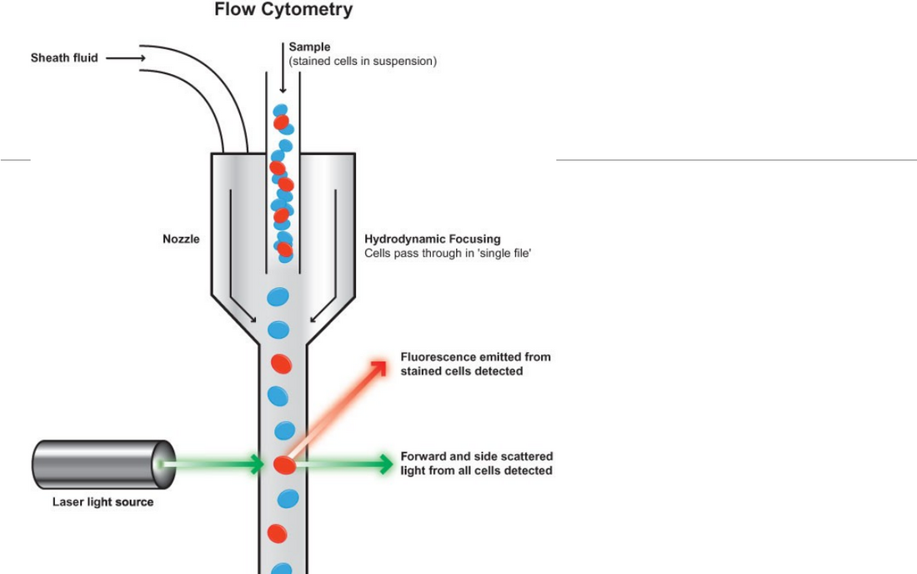
Slide 26: principle of flow cytometry.
▌ ADDITIONAL CONTEXT
Why flow suits leukemias/lymphomas: blood and marrow cells are already in suspension, and their lineage is defined by CD surface antigens (CD19/20 B, CD3/CD2 T, CD34 blasts…). Flow counts thousands of cells per second and shows whether a population is clonal (e.g., all B cells express only κ or only λ light chain — HY). DNA content measures ploidy and S-phase fraction (proliferation → prognosis).

6.2 Molecular techniques (slides 27–32)
▌ FROM THE SLIDES
- DNA analysis by Southern blot; RNA analysis by Northern blot; polymerase chain reaction (PCR).
- Uses: diagnosis of malignant neoplasms; prognosis; detection of minimal residual disease; diagnosis of hereditary predisposition to cancer.
- In-situ hybridization — FISH: fluorescent dyes applied; detects microdeletions, subtelomere deletions and alterations in chromosome number; useful for N-MYC, RET, BRCA1/2, BCR-ABL.
- Slide 30: Philadelphia chromosome — a metaphase cell positive for the BCR/ABL rearrangement using FISH.
- DNA microarray analysis: molecular profiling of a tumor by gene-chip technology; measures expression of several thousand genes; fluorescent labels code the cDNA synthesized from mRNA.
- Slide 32 notes: RNA extracted from tumor and normal tissue → cDNA labeled (normal green, tumor red) → combined and hybridized to the array → confocal laser scanner → red = higher in tumor, green = higher in normal, black = no difference; rows = genes, columns = samples.
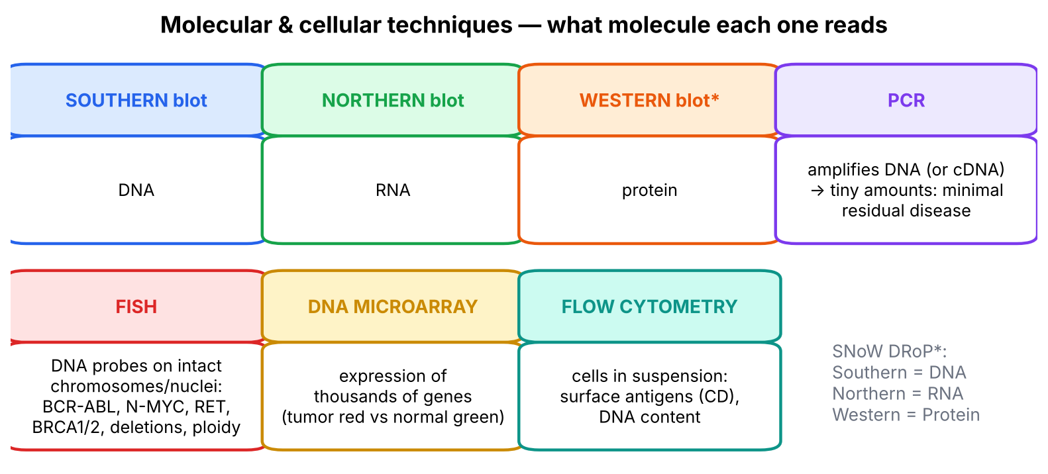
Figure 10. What each technique reads.
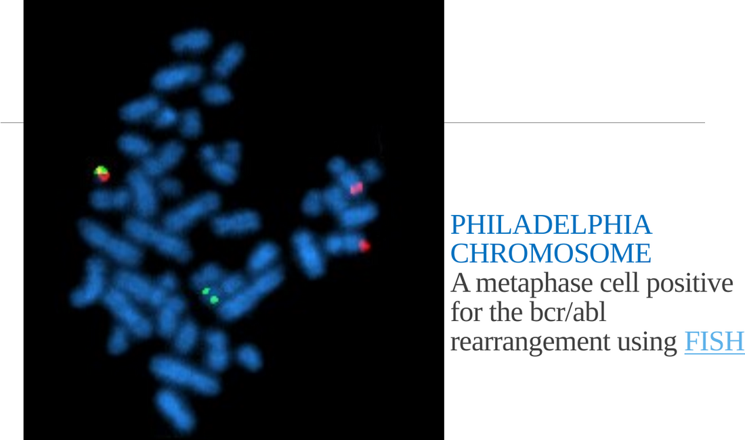
Slide 30: FISH showing BCR/ABL fusion (Philadelphia chromosome).
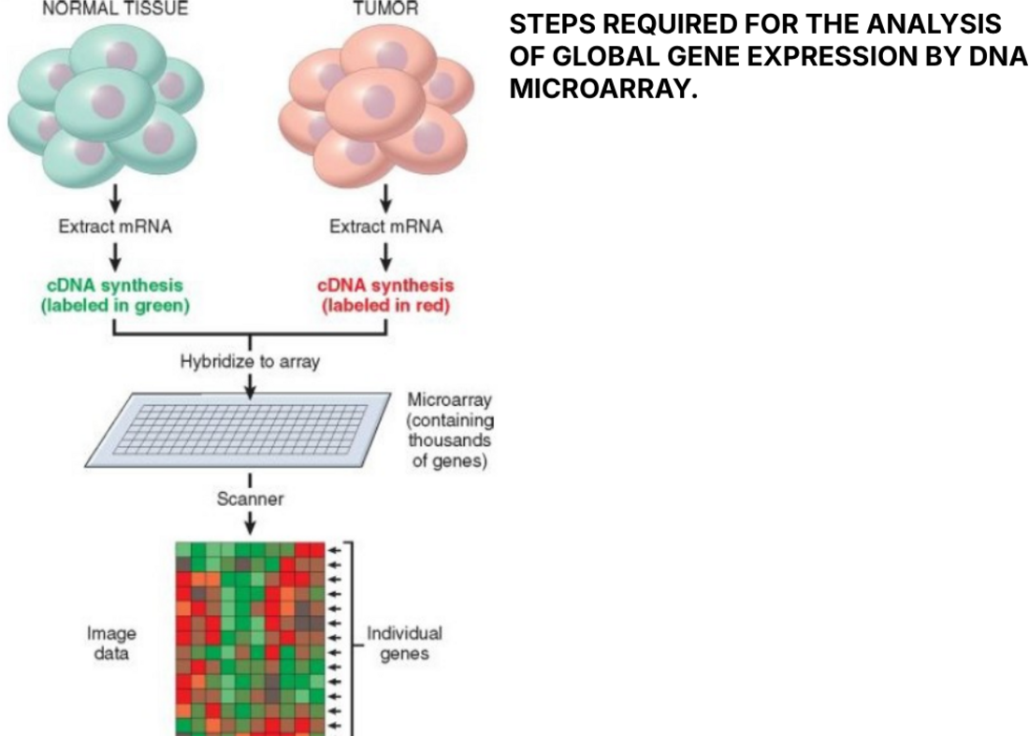
Slide 32: steps of DNA microarray analysis.
▌ ADDITIONAL CONTEXT
Gene (slide) | Alteration | Tumor / meaning (HY)
BCR-ABL | t(9;22) fusion → constitutively active tyrosine kinase (Philadelphia chromosome) | CML (also some ALL); treated with imatinib; PCR monitors minimal residual disease
N-MYC | Amplification | Neuroblastoma — amplification = poor prognosis
RET | Activating point mutation (germline) | MEN 2A/2B, medullary thyroid carcinoma → prophylactic thyroidectomy
BRCA1/BRCA2 | Germline loss-of-function (DNA repair) | Hereditary breast/ovarian (BRCA2 also male breast, pancreas, prostate) → hereditary predisposition testing
HER2 (ERBB2) | Amplification (by FISH or IHC) | Breast cancer → trastuzumab

Why PCR detects minimal residual disease: it amplifies a tumor-specific sequence (e.g., BCR-ABL transcript or a clonal immunoglobulin/TCR rearrangement) millions of times, finding 1 tumor cell among 10⁵–10⁶ normal cells — far below what a microscope can see.

6.3 Treatment modalities (slide 33)
▌ FROM THE SLIDES
- Surgery, chemotherapy, radiation therapy.
▌ ADDITIONAL CONTEXT
Connecting back to the lecture: grade and stage choose the modality (localized low stage → surgery ± radiation; nodal/metastatic → systemic chemotherapy); IHC/molecular markers add targeted therapy (tamoxifen for ER+, trastuzumab for HER2+, imatinib for BCR-ABL); tumor markers and PCR monitor response and recurrence.
🩺 CLINICAL CORRELATION
• CML: FISH/karyotype for Philadelphia chromosome at diagnosis; quantitative PCR for BCR-ABL to monitor response to imatinib.
• Neuroblastoma: N-MYC amplification by FISH changes risk group and treatment intensity.
• Family with early breast and ovarian cancer: germline BRCA1/2 testing → risk-reducing surgery/surveillance.
• Lymphocytosis in an older adult: flow cytometry shows clonal CD5+ CD19+ CD20(dim)+ B cells → CLL (HY).

🎯 EXAM FOCUS
• Flow cytometry: membrane antigens + DNA content; T/B-cell and monocyte/macrophage tumors.
• Southern = DNA; Northern = RNA; PCR = amplification; uses: diagnosis, prognosis, minimal residual disease, hereditary predisposition.
• FISH: microdeletions, subtelomere deletions, chromosome number; N-MYC, RET, BRCA1/2, BCR-ABL; Philadelphia chromosome.
• Microarray: thousands of genes; cDNA from mRNA, tumor red / normal green.
• Treatment: surgery, chemotherapy, radiation.

⚠️ COMMON MISTAKES
• Mixing up blots: Southern = DNA, Northern = RNA (SNoW DRoP; Western = protein).
• Thinking FISH needs dividing cells only — interphase FISH works on non-dividing nuclei too (HY).
• Reading microarray colors backwards: red = up in tumor, green = up in normal, black = no difference.
• Using flow cytometry for solid carcinomas — it needs cells in suspension, so it is mainly for hematologic neoplasms.

Section 6 — Practice questions
Q1. [MCQ] Which technique detects the BCR-ABL rearrangement directly on metaphase or interphase chromosomes with fluorescent probes?
A. Northern blot
B. FISH
C. Flow cytometry
D. IHC for cytokeratin
E. Serum CEA

✅ ANSWER & EXPLANATION
B (slides 28, 30).

Q2. [MCQ] RNA expression of a gene in tumor tissue is best analyzed by:
A. Southern blot
B. Northern blot
C. Western blot
D. Karyotype
E. Frozen section

✅ ANSWER & EXPLANATION
B (slide 27).

Q3. [Clinical vignette] A patient with CML is in complete hematologic remission on imatinib. Which test detects the few leukemic cells that remain, and what is this concept called?

✅ ANSWER & EXPLANATION
Quantitative PCR for BCR-ABL transcripts — detects minimal residual disease (slide 27), far below the threshold of morphology or FISH.

Q4. [Short answer] On a DNA microarray comparing tumor (red) and normal (green), what does a red spot, a green spot and a black spot mean?

✅ ANSWER & EXPLANATION
Red: gene expression higher in tumor; green: higher in normal tissue; black: no difference (slide 32 notes).

Q5. [Mechanism] Why is flow cytometry especially suited for classifying leukemias and lymphomas?

✅ ANSWER & EXPLANATION
These cells naturally exist in suspension (blood, marrow, disaggregated nodes), and their lineage/maturation stage is defined by surface CD antigens. Flow measures many antigens on thousands of individual cells rapidly, and can show clonality and DNA content.

Whole-lecture review

A. Complete high-yield summary
GRADE = histology/differentiation (subjective, tumor-specific criteria)
I well (low) · II moderate (intermediate) · III poor (high) · IV anaplastic
poorly differentiated → aggressive, poorer prognosis
STAGE = size + spread → MOST IMPORTANT prognostic factor (stage > grade)
TNM least → most important: T (T0/in situ, T1–T4; >2 cm ↔ mets)
N (N0, N1–N3) · M (M0, M1–M2; liver, lung)
Dukes = colorectal · Ann Arbor = Hodgkin & NHL

DIAGNOSIS
Morphologic: biopsy (gold std; paraffin ~24 h) · frozen section (~20 min)
FNAC (breast, thyroid, LN; quick, cheap, no anesthesia, <2 h)
exfoliative/Pap (cervix, endometrium, bronchus, bladder, prostate,
stomach; fluids)
Fixation: 10% formalin → LM · glutaraldehyde → EM · fresh → frozen, hormones
IHC: cytokeratin/EMA carcinoma · vimentin sarcoma · desmin muscle
CD45 leukocyte · CD19/20 B · CD2 T · FVIII endothelium · GFAP glia
S-100, NSE neuroendocrine · PSA prostate · ER/PR good, HER2 poor
EM: tonofilaments epithelial · Weibel-Palade angiosarcoma
neurosecretory granules NE · melanosomes melanoma
Birbeck (tennis racket, CD1+) histiocytosis X
Flow: antigens + DNA content (T/B/monocytic tumors)
Molecular: Southern DNA · Northern RNA · PCR (MRD, heredity)
FISH: N-MYC, RET, BRCA1/2, BCR-ABL (Philadelphia) · microarray
MARKERS: AFP HCC/yolk sac · CEA colorectal/pancreas · PSA prostate
Bence Jones myeloma/Waldenström · CA 15-3 breast · CA 19-9 pancreas
CA-125 ovary · β-hCG choriocarcinoma · uses: screen, adjunct, burden,
recurrence
TREATMENT: surgery, chemotherapy, radiation

B. Genuinely arbitrary facts — memorize directly
# | Fact | Memory hook
1 | Paraffin ~24 h; frozen ~20 min; FNAC report < 2 h | 'Day, minutes, hours'
2 | T > 2 cm correlates with metastatic ability | —
3 | Dukes → colorectal; Ann Arbor → lymphomas | 'Ann Arbor's lymph nodes'
4 | CA 15-3 breast; CA 19-9 pancreas; CA-125 ovary | Ascending numbers: breast (15) → pancreas (19) → ovary (125) going down the body
5 | Bence Jones → myeloma and Waldenström | Both make immunoglobulin
6 | Weibel–Palade → angiosarcoma; Birbeck → histiocytosis X (CD1+) | WP = vWF Packages; Birbeck = Bat (tennis racket)
7 | FISH genes: N-MYC, RET, BRCA1/2, BCR-ABL | 'My RETired BRother BCR'
8 | Microarray colors: tumor red, normal green | 'Red alert = tumor'
9 | Factor VIII-related antigen → endothelium | vWF lives in endothelium

C. Common exam traps
⚠️ COMMON MISTAKES
• Stage, not grade, is the most important prognostic factor.
• Grade IV ≠ stage IV.
• M is the most important letter of TNM; only M1 makes stage IV.
• FNAC cannot assess invasion (no architecture).
• Frozen section/hormone assays need FRESH tissue; EM needs glutaraldehyde.
• Vimentin = mesenchymal, desmin = muscle, cytokeratin = epithelial.
• ER/PR+ = good prognosis; HER2+ = poor (but treatable).
• AFP = yolk sac, β-hCG = choriocarcinoma.
• CEA is for monitoring, not screening; mildly ↑ in cirrhosis, hepatitis, UC.
• Southern DNA, Northern RNA (Western protein).
• Birbeck granules → Langerhans *dendritic* cells (histiocytosis X), not pancreatic islets.

D. Images worth reviewing
Image | Where | What to look for
Grades G1–G4 adenocarcinoma | Slide 5 | Gland formation fading as grade increases
Pap smear dysplasia | Slide 14 | Enlarged hyperchromatic nuclei, ↑ N:C ratio vs normal squames
Cytokeratin vs vimentin IHC | Slide 19 | Brown cytoplasmic staining identifying lineage
EM panel | Slide 24 | Tonofilament bundles, dense Weibel–Palade rods, round dense-core granules, tennis-racket Birbeck granules
Philadelphia FISH | Slide 30 | Fused red-green (yellow) signal = BCR-ABL fusion

E. 20 medical-school-level practice questions
Q1. [MCQ] Grading of a tumor is based primarily on:
A. Tumor size
B. Lymph node involvement
C. Degree of differentiation on histology
D. Distant metastases
E. Serum tumor marker levels

✅ ANSWER & EXPLANATION
C (slide 4).

Q2. [MCQ] A tumor described as 'anaplastic' is grade:
A. I
B. II
C. III
D. IV
E. 0

✅ ANSWER & EXPLANATION
D (slide 4).

Q3. [Vignette] A 62-year-old man has a 4-cm lung carcinoma with ipsilateral hilar nodal metastases and a single adrenal metastasis. Which component of his TNM status most determines his prognosis?
A. T
B. N
C. M
D. Histologic grade
E. Smoking history

✅ ANSWER & EXPLANATION
C — distant metastasis (M1) is the most important prognostic factor (TNM progresses least → most important).

Q4. [MCQ] Which staging system is used for colorectal carcinoma according to the slides (besides TNM)?
A. Ann Arbor
B. Dukes
C. Gleason
D. Clark
E. FIGO

✅ ANSWER & EXPLANATION
B (slide 7 notes).

Q5. [MCQ] The gold standard for diagnosing a neoplasm is:
A. FNAC
B. Pap smear
C. Biopsy
D. Tumor markers
E. Flow cytometry

✅ ANSWER & EXPLANATION
C (slide 8).

Q6. [Vignette] During a mastectomy, the surgeon needs to know within 20 minutes whether a sentinel node contains metastatic carcinoma. Which method and why?

✅ ANSWER & EXPLANATION
Frozen section on fresh, unfixed tissue — gives an answer in ~20 minutes while the patient is still on the table (slides 8–9), guiding whether axillary dissection is needed.

Q7. [MCQ] Which is NOT an advantage of FNAC?
A. Can be done without general anesthesia
B. Cheap
C. No admission needed
D. Report in < 2 hours
E. Shows capsular and vascular invasion

✅ ANSWER & EXPLANATION
E — FNAC lacks architecture.

Q8. [MCQ] Exfoliative cytology is used to screen for which cancer most commonly?
A. Thyroid
B. Cervical
C. Testicular
D. Bone
E. Brain

✅ ANSWER & EXPLANATION
B (slide 13).

Q9. [Vignette] A poorly differentiated malignant tumor is CD45-negative, cytokeratin-negative, vimentin-positive and desmin-positive. Classify it.

✅ ANSWER & EXPLANATION
Sarcoma of muscle origin (e.g., rhabdomyosarcoma/leiomyosarcoma): vimentin = mesenchymal; desmin = muscle; negative CD45 excludes lymphoma; negative cytokeratin excludes carcinoma (slides 15–17).

Q10. [MCQ] Which IHC marker identifies B-cell tumors?
A. CD2
B. CD45 alone
C. CD19/CD20
D. Cytokeratin
E. GFAP

✅ ANSWER & EXPLANATION
C (slide 16). CD2 = T cells; CD45 = any leukocyte.

Q11. [MCQ] Factor VIII-related antigen positivity suggests a tumor of:
A. Epithelium
B. Endothelium
C. Muscle
D. Glia
E. Melanocytes

✅ ANSWER & EXPLANATION
B (slide 17).

Q12. [Vignette] A breast carcinoma is ER+, PR+, HER2-negative. What does this imply about prognosis and therapy?

✅ ANSWER & EXPLANATION
Good prognostic profile (hormone receptor positive, slide 16) and responsive to hormonal therapy (tamoxifen/aromatase inhibitors, HY); no HER2 over-expression (which would indicate poorer prognosis and trastuzumab use).

Q13. [MCQ] Weibel–Palade bodies seen on EM indicate:
A. Carcinoma
B. Angiosarcoma
C. Melanoma
D. Neuroendocrine tumor
E. Histiocytosis X

✅ ANSWER & EXPLANATION
B (slide 23).

Q14. [Vignette] A 3-year-old has lytic skull lesions. Biopsy shows histiocytes that are CD1-positive with tennis-racket-shaped granules on EM. Diagnosis?

✅ ANSWER & EXPLANATION
Langerhans cell histiocytosis (histiocytosis X) — Birbeck granules (slides 23–24).

Q15. [MCQ] A markedly elevated AFP in a woman with an ovarian mass suggests:
A. Serous cystadenocarcinoma
B. Yolk sac tumor
C. Granulosa cell tumor
D. Teratoma (mature)
E. Choriocarcinoma

✅ ANSWER & EXPLANATION
B (slide 21). CA-125 would point to surface epithelial cancer (A); β-hCG to choriocarcinoma (E).

Q16. [MCQ] A patient without cancer has a mildly elevated CEA. Which condition from the lecture best explains it?
A. Ulcerative colitis
B. Hypothyroidism
C. Migraine
D. Osteoarthritis
E. Asthma

✅ ANSWER & EXPLANATION
A. Slide 22: CEA is mildly raised in non-neoplastic cirrhosis, hepatitis and ulcerative colitis — a reason it is a poor screening test.

Q17. [Vignette] An elderly man has anemia, bone pain and renal impairment. Urine contains free light chains. Which marker is this and which diseases does the lecture associate with it?

✅ ANSWER & EXPLANATION
Bence Jones protein → multiple myeloma and Waldenström macroglobulinemia (slide 21).

Q18. [MCQ] Which technique is best for detecting minimal residual disease in CML?
A. H&E histology
B. Frozen section
C. PCR
D. Southern blot
E. Serum CEA

✅ ANSWER & EXPLANATION
C (slide 27).

Q19. [MCQ] FISH is useful for detecting all of the following EXCEPT:
A. N-MYC amplification
B. RET alterations
C. BRCA1/2 alterations
D. BCR-ABL fusion
E. Serum CA-125

✅ ANSWER & EXPLANATION
E — a serum protein, not a chromosomal alteration.

Q20. [Mechanism] A pathologist receives a tumor in formalin and is asked for EM, frozen section and hormone receptor analysis on fresh tissue. Explain what is still possible and what should have been done.

✅ ANSWER & EXPLANATION
Formalin-fixed tissue supports light microscopy (and IHC, additional). Frozen section and hormonal analysis need fresh, unfixed tissue; EM needs glutaraldehyde fixation (slide 9). Tissue should have been divided at collection: part fresh, part formalin, part glutaraldehyde.

F. 10 rapid-recall questions
# | Question | Answer
1 | More important prognostic factor: grade or stage? | Stage
2 | Grade II means? | Moderately differentiated (intermediate grade)
3 | TNM order of importance? | T < N < M
4 | Frozen section turnaround? | ~20 minutes
5 | Fixative for EM? | Glutaraldehyde
6 | Carcinoma vs sarcoma IHC markers? | Cytokeratin vs vimentin
7 | Leukocyte common antigen? | CD45
8 | Tennis-racket granules? | Birbeck — histiocytosis X (CD1+)
9 | AFP vs β-hCG in testis? | Yolk sac tumor vs choriocarcinoma
10 | Southern vs Northern blot? | DNA vs RNA

G. Key takeaways
- Every test answers one of three questions — what is it, how bad is it, how do we follow it.
- Grade = differentiation (I–IV); stage = TNM spread — stage matters more; in TNM, M matters most.
- Choose the diagnostic method by the level of zoom needed: architecture (biopsy/frozen), cells (FNAC/Pap), proteins (IHC/flow), organelles (EM), genes (PCR/FISH/microarray), blood (markers).
- IHC and EM reveal lineage through the proteins and organelles a cell needs for its job; markers in serum help monitor rather than diagnose.

H. Two questions to test your understanding
🔁 CHECK YOURSELF
1. A pathologist sees a sheet of undifferentiated cells and can't decide between carcinoma, lymphoma and melanoma. Which three stains settle it in one step? → Cytokeratin (carcinoma), CD45 (lymphoma), S-100 (melanoma; HMB-45 additional).
2. Why might a well-differentiated (grade I) thyroid follicular tumor still need surgery after a 'benign-looking' FNAC? → Because malignancy is defined by invasion (capsule/vessels) — an architectural feature FNAC cannot assess; grade/appearance alone doesn't exclude carcinoma.

