The Cell-Mediated Immune Response
Immunology — Lectures 11–12 (Dr Samira Abdul Wajid, WUSOM) · Tutor study guide built from your slides

How to read this guide
Label | What it means | Your responsibility
▌ FROM THE SLIDES | Content taken directly from the lecture (all 31 slides are covered) | Must know
▌ ADDITIONAL CONTEXT | Background added so the slide facts make sense | Know it well enough to reason
▌ HIGH-YIELD ADDITIONAL KNOWLEDGE | Not on the slides, but repeatedly tested on USMLE/NBME-style exams | Learn it

Your handwritten notes on the slides are answered in context. A few of them contain errors that would cost you marks; these are flagged in 'Your slide notes — checked' boxes and collected in one table at the end.

Learning objectives (from the slides)
▌ FROM THE SLIDES
- Examine the biological purpose and means of activation of T cells.
- Discuss the functions of Th cell subpopulations.
- Explain the mechanisms of effector cell killing and the disease settings in which they would be used.
- Identify the mechanisms of immune evasion by viruses.

Step 0 — The architecture before the facts
This lecture contains a lot of names (CD28, B7, CTLA-4, PD-1, LFA-1, ICAM-1, IL-12, T-bet, RORγt, FoxP3, perforin, Fas…) and two long lists of organisms. They stop being 'words without anchors' once you see that the whole lecture tells one story in five acts. Each new name is just a character playing a role in one of the acts.
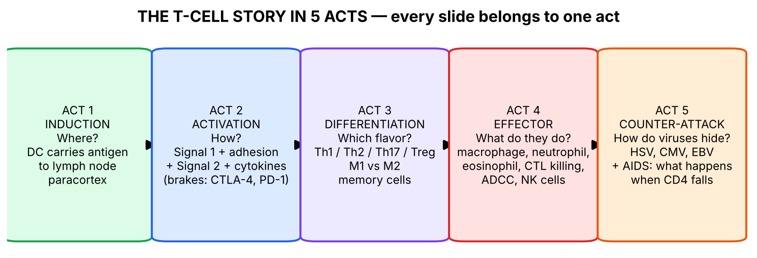
Figure 1. The five acts of a T-cell response. Every slide in this lecture belongs to one of these boxes.
💡 THE ORGANIZING PRINCIPLE
Why does cell-mediated immunity (CMI) exist at all? Antibodies float in blood and tissue fluid. They are excellent against things that are outside cells, but they cannot get inside a cell. Some microbes deliberately hide inside our cells — inside a macrophage's vesicles (TB, Listeria) or in the cytosol of any cell (viruses). To fight them, the body needs cells that inspect other cells: T cells.
• CD4+ helper T cells work like generals: they don't kill; they release cytokines that tell other cells (macrophages, neutrophils, eosinophils, B cells) what to do.
• CD8+ cytotoxic T cells work like snipers: they find an infected cell and kill it directly.
• NK cells are the innate backup snipers: they kill cells that have tried to hide from CD8 cells.
Connect to Lecture 10: CD4 reads MHC II (exogenous antigen, APCs); CD8 reads MHC I (endogenous antigen, all nucleated cells). This lecture is what happens after that recognition.

🧠 ANALOGY
Think of an army. Dendritic cells are scouts who capture enemy uniforms in the field and run back to headquarters (the lymph node). At HQ, they show the uniform to recruits (naive T cells). A recruit whose receptor matches the uniform gets a 'go' order (costimulation), clones itself thousands of times (clonal expansion), is trained into a specialist (Th1/Th2/Th17/CTL), and is sent back to the battlefield. A few veterans stay behind as memory cells. Meanwhile, the enemy tries to steal or forge uniforms (viral immune evasion).

Act 1 — Induction: getting antigen to the T cells (slides 3–7)

1.1 Big picture
A naive T cell has never met its antigen and circulates only through secondary lymphoid organs (lymph nodes, spleen, mucosal lymphoid tissue). The microbe is usually in a peripheral tissue (skin, lung, gut). So the first problem is logistics: bring the antigen to where the naive T cells are. Dendritic cells solve this.
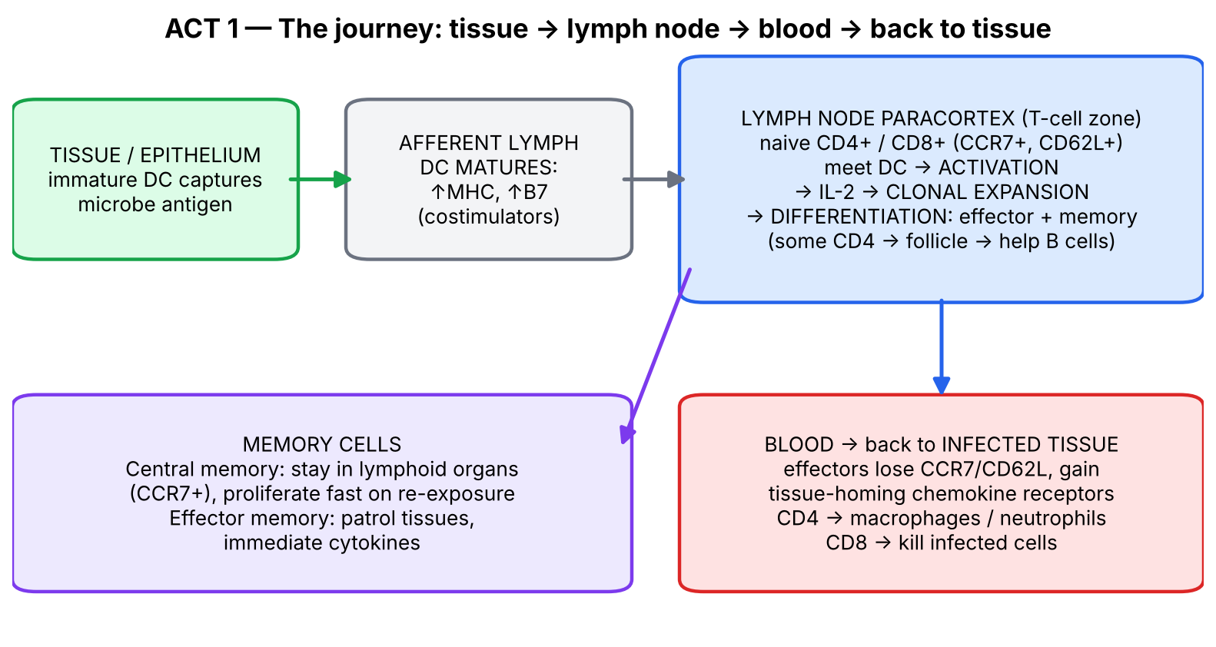
Figure 2. The geography of a T-cell response (redrawn from the Robbins figure on slide 4).

1.2 What the slides say
▌ FROM THE SLIDES
Slide 4 (Robbins figure) — the full sequence: dendritic cell with antigen → antigen recognition in lymphoid organs (CD4+ and CD8+ T cells) → T-cell proliferation and differentiation (naive T cell + APC → IL-2 and IL-2R → effector T cells and memory T cells) → differentiated effector and memory T cells enter the circulation → migration of effector T cells to the site of antigen → CD4+ effector T cells: cytokine secretion → macrophage activation (killing of ingested microbes) and inflammation (recruitment of neutrophils); CD8+ T cells (CTLs): killing of infected cells with microbes in the cytoplasm.
Slide 5 — Induction and effector phases of CMI:
- DCs capture microbial antigens from epithelia and tissues and transport them to lymph nodes.
- During this process the DCs mature, and express high levels of MHC molecules and costimulators.
- Naive T cells recognize MHC-associated peptide antigens displayed on DCs.
- The T cells are activated to proliferate and differentiate into effector and memory cells, many of which enter the circulation and serve various functions in CMI.
- Some activated CD4+ T cells remain in the lymph node, migrate into follicles, and help B cells to produce antibodies.
- CD4+ effector T cells of the Th1 subset recruit and activate phagocytes to destroy microbes.
- CD8+ cytotoxic T lymphocytes (CTLs) kill infected cells harboring microbes in the cytoplasm.
Slide 7 — Antigen-presenting cells: the critical first step in eliciting the adaptive response to a primary antigenic challenge is the processing of antigen for presentation to naive T lymphocytes. Professional APCs:
Professional APC | Slide statement | What it is best at (added)
Dendritic cells | Do not have to be activated in order to present antigen to T cells | The ONLY APC that can efficiently activate naive T cells; constitutively high MHC II; migrates to nodes
Macrophages | Digest microbes and present them to T cells to elicit a Th1 response or CMI | Present to already-activated (effector) Th1 cells and in return receive IFN-γ → become better killers
B cells | Present specific protein antigens to T cells to help elicit a humoral or Th2 response; the only APC that specifically recognizes antigen via the B-cell receptor | Use the BCR to grab one specific antigen, present it on MHC II to a Tfh/Th2 cell and receive help (CD40L, IL-4) to class switch

▌ ADDITIONAL CONTEXT
- Paracortex = the T-cell zone of the lymph node (your slide note: 'naive CD4, CD8 in the paracortex'). Follicles in the cortex = B-cell zones; that is why CD4 cells that help B cells must 'migrate into follicles'.
- Why must DCs mature? In tissues, immature DCs are built to eat (high phagocytosis, low B7). Once they sense microbes through Toll-like receptors, they switch to show-and-tell mode: more MHC, more B7 (costimulator), and CCR7, the chemokine receptor that guides them along lymphatics into the paracortex. Only mature DCs can deliver Signal 2 (Act 2). This is how the innate system 'licenses' the adaptive system: no microbe → no B7 → no T-cell activation.
- Naive T cells home to lymph nodes using CCR7 and L-selectin (CD62L). After differentiating, effector cells lose CCR7 and CD62L (slide 16) so they can leave and go to inflamed tissues.
▌ HIGH-YIELD ADDITIONAL KNOWLEDGE
- Granuloma formation in TB is the visible result of this chain: macrophage presents → Th1 makes IFN-γ → macrophages become epithelioid cells and fuse into giant cells; TNF-α holds the granuloma together. Anti-TNF drugs (infliximab, adalimumab) can reactivate latent TB → screen with PPD or IGRA first.
- Interferon-γ release assay (IGRA) for TB literally measures IFN-γ released by the patient's memory Th1 cells when exposed to TB antigens.
📝 YOUR SLIDE NOTES — CHECKED
Slide-4 note said infected macrophages 'release IL-2 and TNF and 12'. Correction: macrophages release IL-12 (and TNF, IL-1, IL-6). IL-2 is made by T cells, not macrophages. Chain: macrophage → IL-12 → Th1 → IFN-γ → activates macrophage.
Slide-4 note says 'there are no plasma cells here' (in the paracortex). Correct — plasma cells develop from B cells in follicles/medulla, not in the T-cell paracortex.

🩺 CLINICAL CORRELATION
• Tuberculosis: latent TB is held in check by Th1 cells activating macrophages in granulomas; anything that removes Th1/IFN-γ/TNF (HIV, anti-TNF therapy, steroids) → reactivation.
• Vaccination: the DC → lymph node → memory sequence is what vaccines exploit; adjuvants work largely by maturing DCs (↑B7).
• Lymphadenopathy (swollen lymph nodes) during infection = clonal expansion of lymphocytes in the node.

🎯 EXAM FOCUS
• DCs capture antigen, mature (↑MHC, ↑costimulators), migrate to the lymph node, activate naive T cells.
• Three professional APCs: DCs (no activation needed), macrophages (Th1/CMI), B cells (humoral/Th2; only APC with antigen-specific receptor = BCR).
• Th1 → activates phagocytes; CTLs → kill cells with microbes in the cytoplasm; some CD4 → follicles → B-cell help.
• Typical question: 'Which APC is most important in initiating a primary T-cell response?' → dendritic cell.

⚠️ COMMON MISTAKES
• Thinking naive T cells are activated in the infected tissue — activation happens in secondary lymphoid organs; effectors then travel to the tissue.
• Thinking macrophages are the main APC for naive T cells — that is the DC.
• Forgetting that B cells are APCs — and the only one that recognizes antigen specifically (via BCR).

Act 1 — Practice questions
Q1. [MCQ] Which cell is primarily responsible for transporting microbial antigen from the skin to the lymph node and activating naive T cells?
A. Macrophage
B. Neutrophil
C. Dendritic cell
D. Mast cell
E. Plasma cell

✅ ANSWER & EXPLANATION
C. DCs capture antigen in epithelia, mature (↑MHC, ↑costimulators) and present to naive T cells in the lymph node. Macrophages (A) mainly present to effector Th1 cells in tissues.

Q2. [MCQ] Which professional APC is unique in recognizing antigen specifically through its own antigen receptor?
A. Dendritic cell
B. Macrophage
C. B cell
D. Langerhans cell
E. Monocyte

✅ ANSWER & EXPLANATION
C — B cell (slide 7). Its BCR binds a specific antigen, which is internalized, processed, and presented on MHC II to helper T cells.

Q3. [Clinical vignette] A 55-year-old with rheumatoid arthritis starts infliximab (anti-TNF-α). Four months later he develops fever, night sweats and an upper-lobe cavity. Explain the immunological basis.

✅ ANSWER & EXPLANATION
Reactivation of latent tuberculosis. TB is a facultative intracellular pathogen controlled by Th1 cells → IFN-γ → macrophage activation within granulomas, and TNF-α is required to maintain granulomas. Blocking TNF breaks down the granuloma and lets bacilli escape. Patients are screened (PPD/IGRA) before anti-TNF therapy.

Q4. [Short answer] List, in order, the steps from antigen capture in tissue to killing of an infected cell by a CTL.

✅ ANSWER & EXPLANATION
DC captures antigen in tissue → DC matures (↑MHC, ↑B7) and migrates to lymph node → naive CD8+ T cell recognizes MHC I–peptide (+ costimulation, IL-2) → proliferation and differentiation into effector CTLs and memory cells → effectors enter circulation → migrate to infected tissue → recognize MHC I–peptide on infected cell → kill it (perforin/granzymes, Fas/FasL).

Q5. [Mechanism] Why would a protein antigen injected without any adjuvant (no microbial components) tend to induce tolerance rather than immunity?

✅ ANSWER & EXPLANATION
Without microbial PAMPs, DCs don't mature and don't express high levels of B7 costimulators. T cells then receive Signal 1 (TCR–MHC/peptide) without Signal 2 (CD28–B7) → anergy rather than activation (see Act 2).

Act 2 — Activation: recognition, costimulation, cytokines and brakes (slides 8–12)

2.1 Big picture
A T cell that can kill or trigger inflammation is dangerous. If it reacted every time its TCR touched a matching peptide, it might react to self. So activation is built like a bank vault that needs several keys at once: the right antigen (Signal 1), a firm grip (adhesion), proof of danger (Signal 2, costimulation), growth signals (cytokines, Signal 3) — and, afterwards, brakes to switch it off.
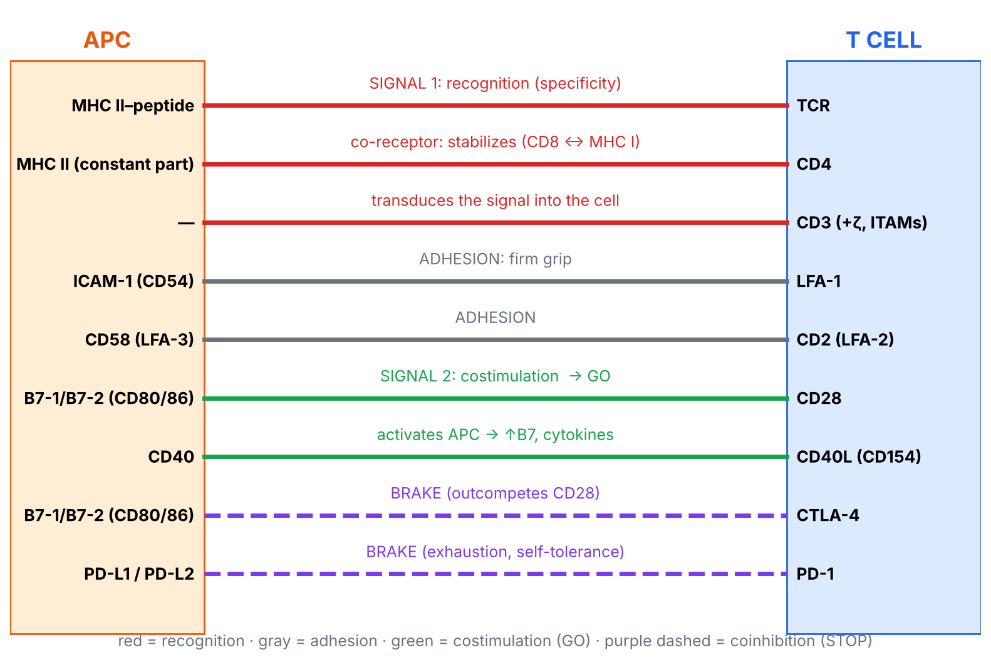
Figure 3. The 'immunological synapse' — every receptor-ligand pair on slides 9–11, colour-coded by job.

2.2 What the slides say — the five requirements (slide 9)
▌ FROM THE SLIDES
The initiation of T-cell responses (in secondary lymphoid organs) requires multiple receptors on the T cell recognizing their specific ligands on APCs:
- T-cell receptor (TCR) recognizes MHC-associated peptide antigens.
- CD4 or CD8 co-receptors on the T cells bind to MHC molecules on the APC and work with the TCR complex to deliver activating signals. CD3 transduces the signal that specific binding has occurred.
- Adhesion molecules strengthen the binding of T cells to APCs.
- Costimulators, expressed on APCs after encounter with microbes, bind costimulatory receptors on naive T cells, promoting responses to infectious pathogens: CD28 on T cell recognizes B7 on APC; CD40L (CD154) on activated T cells binds CD40 on APCs — this activates the APC to express more B7 and to secrete cytokines that enhance T-cell differentiation.
- Cytokines amplify the T-cell response and direct it along differentiation pathways: naive (Th0) cell produces IFN-γ and IL-2; macrophages secrete IL-1, IL-6, IL-12 and TNF-α to activate helper T cells; binding of IL-2 to the IL-2 receptor on the naive (Th0) cell causes proliferation, producing a clone of T cells specific for the antigen.

Activation of naive helper T cells (slide 10)
▌ FROM THE SLIDES
- The binding between the MHC–peptide complex and the TCR acts as the first signal toward Th-cell activation.
- Recognition is enhanced by CD4, which attaches to non-polymorphic regions on the MHC II molecule.
- Adhesion molecules: (1) LFA-1 (leukocyte function-associated antigen 1) : ICAM-1 (CD54) — promote firm adhesion between T cell and APC; (2) CD2 : CD58.
- T cells require further costimulation through binding of CD28 with either of its ligands, CD80 or CD86 (B7.1 or B7.2).
- If all events transpire → full activation → production of T-cell cytokines (IL-2, IL-4, IFN-γ…) and a proliferative response.

Activation of T cells — helper and cytotoxic (slide 12)
▌ FROM THE SLIDES
- Left (helper): APC presents processed antigen on class II MHC; TCR recognizes it; the helper T cell is activated to produce IL-2, which binds its own receptor and further activates it (autocrine). CD4 binds MHC II, stabilizing the interaction. B7 on the APC must interact with CD28 on the helper cell for full activation. To activate cytotoxic T cells, B7 and CD28 must also interact when the APC presents viral antigen with class I MHC.
- Right (cytotoxic): a virus-infected cell presents viral antigen with class I MHC; the TCR recognizes it, and in conjunction with IL-2 produced by the helper T cell, the cytotoxic T cell is activated to kill the virus-infected cell. CD8 binds class I MHC, stabilizing the interaction.
- Class II = two polypeptides, both encoded in the HLA locus; class I = one HLA-encoded polypeptide + β2-microglobulin, encoded elsewhere (links straight back to Lecture 10).
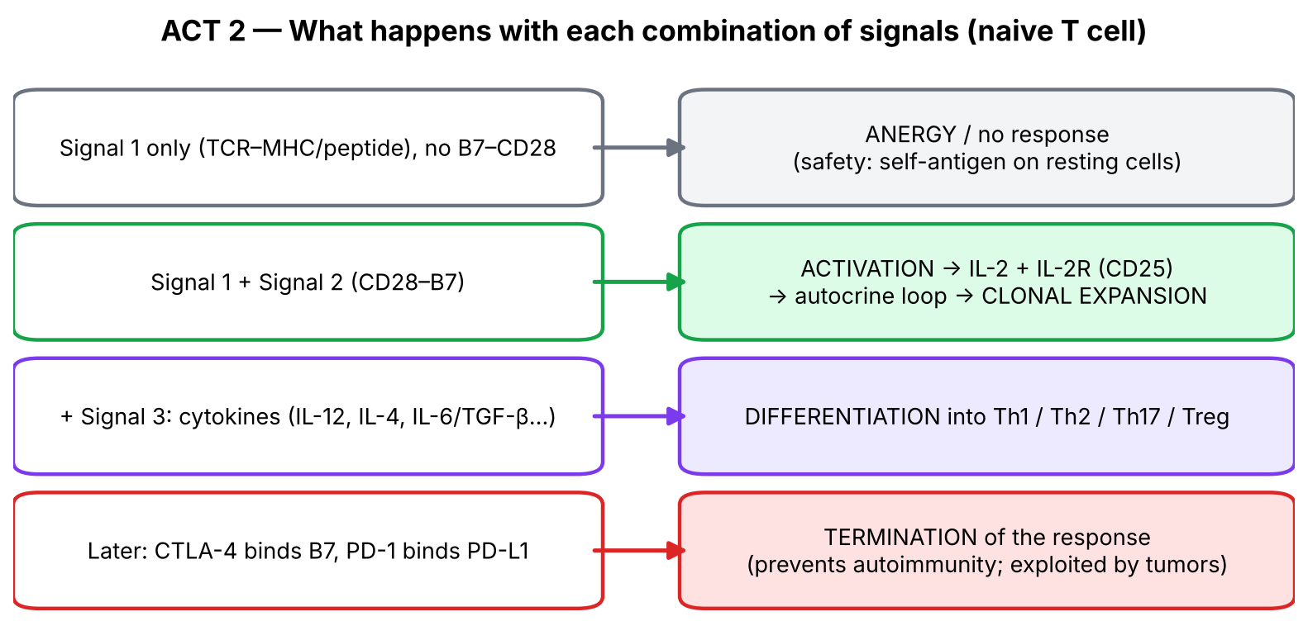
Figure 4. What each combination of signals produces.

2.3 The brakes — inhibitory receptors (slide 11)
▌ FROM THE SLIDES
- Two important inhibitory receptors (coinhibitors): CTLA-4 and PD-1, which are structurally related to CD28.
- CTLA-4, like CD28, recognizes B7-1 and B7-2 on APCs.
- PD-1 recognizes two different but structurally related ligands, PD-L1 and PD-L2, on many cell types.
- Both are induced in activated T cells and function to terminate the responses of these cells.
- CTLA-4 and PD-1 prevent responses to self antigens and are also involved in inhibiting T-cell responses to some tumors and chronic viral infections.
- Slide-11 figure also labels the T-cell side: CD4 = signal transduction; TCR = antigen recognition; CD3 (with ITAMs) and ζ chains, CD28, CTLA-4, PD-1 (inhibitory motif) = signal transduction; LFA-1 = adhesion.

2.4 Making sense of it — the logic of each molecule
Molecule pair (T cell : APC) | Category | Why it exists
TCR : MHC–peptide | Signal 1 — recognition | Gives specificity: only the clone whose TCR fits responds
CD4 : MHC II / CD8 : MHC I | Co-receptor | Binds the constant part of MHC → ensures CD4 talks to MHC II and CD8 to MHC I; boosts signal
CD3 (+ ζ chains) | Signal transducer | TCR itself has no signalling tail; CD3 carries ITAMs that start the kinase cascade (B-cell analogue: Igα/Igβ — your note)
LFA-1 : ICAM-1 (CD54) | Adhesion | Velcro: holds cells together long enough for signalling
CD2 (LFA-2) : CD58 (LFA-3) | Adhesion | Second Velcro strip
CD28 : B7-1/B7-2 (CD80/CD86) | Signal 2 — costimulation (GO) | Proof of danger: B7 appears on APCs only after they sense microbes
CD40L (CD154) : CD40 | Two-way costimulation | T cell 'talks back' to the APC → APC makes more B7 and IL-12 → positive feedback loop
IL-2 : IL-2R (CD25) | Signal 3 — growth | Autocrine fuel for clonal expansion; also feeds CD8 cells (paracrine)
CTLA-4 : B7 | Coinhibitor (STOP) | Binds B7 with higher affinity than CD28 → steals B7 → switches response off
PD-1 : PD-L1/PD-L2 | Coinhibitor (STOP) | Ligands on many tissues → stops T cells attacking peripheral tissues; causes 'exhaustion' in chronic infection

▌ ADDITIONAL CONTEXT
Anergy: a T cell that receives Signal 1 without Signal 2 doesn't just ignore the antigen — it becomes functionally unresponsive for a long time. This is a major mechanism of peripheral tolerance, because healthy tissues present self-peptides on MHC but lack B7.
CD28 vs CTLA-4 timing: resting T cells express CD28; CTLA-4 appears after activation (2–3 days). So the same B7 molecule says 'go' early and 'stop' later — a built-in timer.
▌ HIGH-YIELD ADDITIONAL KNOWLEDGE
Drug / disease | Target | Effect (connect to the mechanism)
Ipilimumab | Anti-CTLA-4 | Removes the brake → stronger anti-tumor T cells (melanoma); side-effect = autoimmunity (colitis, hepatitis, hypophysitis)
Nivolumab, pembrolizumab | Anti-PD-1 | Reverses exhaustion of tumor-specific T cells; immune-related adverse events
Atezolizumab, durvalumab | Anti-PD-L1 | Same idea from the ligand side
Abatacept / belatacept | CTLA-4–Ig fusion protein | Soaks up B7 → no CD28 costimulation → treats RA / prevents transplant rejection
Cyclosporine, tacrolimus | Calcineurin inhibitors | Block NFAT → no IL-2 transcription → no clonal expansion (transplant)
Sirolimus (rapamycin) | mTOR | Blocks the response to IL-2 signaling
Basiliximab | Anti-IL-2R (CD25) | Blocks IL-2 binding (transplant induction)
Hyper-IgM syndrome | CD40L deficiency (X-linked) | T cells can't give B cells the CD40 signal → no class switching → ↑IgM, ↓IgG/IgA/IgE; Pneumocystis infections

📝 YOUR SLIDE NOTES — CHECKED
Several notes on slides 9–11 say 'when B7 interacts with CD8 it is costimulation, so instead of CD28, CTLA-4 is expressed' (also written 'cd250', 'cd38'). Correction: B7 + CD28 = costimulation (GO); B7 + CTLA-4 = inhibition (STOP). B7 does not bind CD8; CD8 binds MHC class I.
Slide-12 note: 'if T is normal but not able to be activated we call it allergic'. The term is ANERGIC (anergy = Signal 1 without Signal 2). Allergy is a Th2/IgE hypersensitivity — a different concept.
Slide-12 note: 'patient born without CD4 → hyper-IgM; no costimulation → hyper-IgM'. Correction: hyper-IgM syndrome is caused by CD40L (CD154) deficiency on activated CD4 T cells (most often X-linked), not by absence of CD4 or of B7/CD28. CD4 counts are normal; what fails is the CD40L–CD40 handshake that tells B cells to switch from IgM to IgG/IgA/IgE.
Slide-9 note 'if IL-2 is not released there won't be clonal expansion' — correct, and this is exactly how cyclosporine/tacrolimus work.

🩺 CLINICAL CORRELATION
• Cancer immunotherapy: tumors exploit PD-L1 to switch off T cells; checkpoint inhibitors release those brakes. Expect immune-related adverse events (colitis, thyroiditis, pneumonitis) — autoimmunity is the price of removing tolerance.
• Transplant immunosuppression targets each signal: Signal 2 (belatacept), Signal 3 (tacrolimus/cyclosporine → ↓IL-2; basiliximab; sirolimus).
• Hyper-IgM syndrome: a boy with recurrent sinopulmonary infections and Pneumocystis pneumonia; very high IgM, absent IgG/IgA; CD40L is not expressed on activated T cells.

🎯 EXAM FOCUS
• Signal 1 = TCR–MHC/peptide (+ CD4/CD8, CD3 transduces). Signal 2 = CD28–B7 (CD80/86). CD40L (CD154)–CD40 activates APC.
• Adhesion: LFA-1–ICAM-1 (CD54), CD2–CD58.
• IL-2 → IL-2R → clonal expansion (autocrine); helper-derived IL-2 also activates CTLs.
• Coinhibitors CTLA-4 (binds B7) and PD-1 (binds PD-L1/PD-L2) — induced on activated T cells; terminate responses; prevent self-reactivity; exploited by tumors and chronic viruses.
• Macrophages secrete IL-1, IL-6, IL-12, TNF-α; naive Th0 secretes IFN-γ, IL-2 (slide statement).

⚠️ COMMON MISTAKES
• Saying CD28 binds CD40, or that CTLA-4 binds PD-L1 — learn the pairs: CD28/CTLA-4 ↔ B7; PD-1 ↔ PD-L1/L2; CD40L ↔ CD40.
• Thinking CTLA-4 and PD-1 are on resting T cells — they are induced after activation.
• Mixing up which side each molecule is on: B7, CD40, ICAM-1, CD58, PD-L1 = APC/target side; CD28, CTLA-4, CD40L, LFA-1, CD2, PD-1 = T-cell side.
• Forgetting that CTLs also need costimulation and IL-2 from helper cells (slide 12).

Act 2 — Practice questions
Q1. [MCQ] A naive CD4+ T cell binds MHC II–peptide on a resting APC that does not express B7. What is the most likely outcome?
A. Full activation and IL-2 production
B. Differentiation into Th1 cells
C. Anergy
D. Apoptosis of the APC
E. Differentiation into memory cells

✅ ANSWER & EXPLANATION
C — anergy. Signal 1 without Signal 2 (CD28–B7) leaves the T cell unresponsive — a mechanism of peripheral tolerance.

Q2. [MCQ] Which pairing is correctly matched?
A. CD28 — PD-L1
B. CTLA-4 — B7-1/B7-2
C. LFA-1 — CD58
D. CD2 — ICAM-1
E. CD40L — CD28

✅ ANSWER & EXPLANATION
B. CTLA-4, like CD28, binds B7-1/B7-2. Correct others: PD-1–PD-L1; LFA-1–ICAM-1; CD2–CD58; CD40L–CD40.

Q3. [Clinical vignette] A 62-year-old man with metastatic melanoma responds dramatically to ipilimumab, but develops bloody diarrhea; colonoscopy shows colitis with lymphocytic infiltrate. Explain both effects.

✅ ANSWER & EXPLANATION
Ipilimumab blocks CTLA-4, an inhibitory receptor induced on activated T cells that binds B7 and terminates responses. Removing it lets tumor-specific T cells keep proliferating (anti-tumor effect), but it also removes a key safeguard against self-reactive T cells → autoimmune colitis (immune-related adverse event).

Q4. [Clinical vignette] A 2-year-old boy has recurrent otitis media and Pneumocystis pneumonia. IgM is markedly elevated; IgG, IgA and IgE are very low. CD4 and CD8 counts are normal. Which molecule is most likely defective?
A. CD28
B. CD40 ligand
C. B7-1
D. IL-2 receptor
E. CTLA-4

✅ ANSWER & EXPLANATION
B — CD40L (CD154). Activated T cells use CD40L to signal B cells (CD40) for class switching; without it B cells make only IgM. CD40L–CD40 also activates macrophages/DCs (IL-12) → susceptibility to Pneumocystis. This corrects the slide note linking hyper-IgM to absent CD4.

Q5. [Short answer] Explain how IL-2 acts in an autocrine manner during T-cell activation and why blocking its production prevents transplant rejection.

✅ ANSWER & EXPLANATION
After Signals 1+2, the T cell makes IL-2 and up-regulates IL-2R (CD25); IL-2 binds the T cell's own receptor → proliferation → clonal expansion (and it helps CTLs). Calcineurin inhibitors (cyclosporine, tacrolimus) block IL-2 transcription → no expansion of donor-reactive T cells → less rejection.

Q6. [Mechanism] Why is the CD40L–CD40 interaction described as a 'positive feedback loop'?

✅ ANSWER & EXPLANATION
An activated T cell's CD40L binds CD40 on the APC → APC expresses more B7 and secretes cytokines (e.g., IL-12) → stronger CD28 costimulation and differentiation signals for the T cell → T cell more activated → more CD40L. Each partner amplifies the other.

Act 3 — Differentiation: Th subsets, macrophage types and memory (slides 6, 13–17)

3.1 Big picture — why have different kinds of helper cell?
Different enemies need different weapons. A bacterium hiding inside a macrophage, a bacterium multiplying in pus, and a 30-cm worm in the gut cannot all be killed the same way. So a naive CD4 cell (Th0) 'listens' to the cytokines in its environment — which reflect what kind of microbe the innate system detected — and becomes the specialist that recruits the right weapon.
💡 THE ORGANIZING PRINCIPLE
The organizing rule for every Th subset is one chain: inducing cytokine → master transcription factor → signature cytokine → effector cell recruited → type of microbe killed.
• Th1: IL-12 (+IFN-γ) → T-bet → IFN-γ → macrophage → intracellular (vesicular) microbes
• Th2: IL-4 → GATA3 → IL-4, IL-5, IL-13 → eosinophils + IgE → helminths
• Th17: IL-6 + TGF-β + IL-23 → RORγt → IL-17 → neutrophils → extracellular bacteria & fungi
• Treg: TGF-β + IL-2 → FOXP3 → TGF-β, IL-10, IL-35 → suppress other T cells → self-tolerance
If you can write these four chains, you can reconstruct the whole slide-17 table.

3.2 What drives the choice? (slide 13)
▌ FROM THE SLIDES
- Differentiation of Th subsets is dictated by the type of pathogen and the type of macrophage differentiation in the inflammatory focus.
- Microbes that stimulate a strong initial innate response with production of IL-12 from M1 cells or IFN-γ by NK cells predispose to Th1 production. (Your note: Th1 environment = pro-inflammatory cytokines IL-1, IL-6, IL-12.)
- In the absence of such stimuli, the constitutive production of IL-4 by Th0 cells and stimulation of M2 cells result in Th2 production. (Your note: Th2 is the default differentiation.)

3.3 Macrophage populations: M1 vs M2 (slides 14–15)
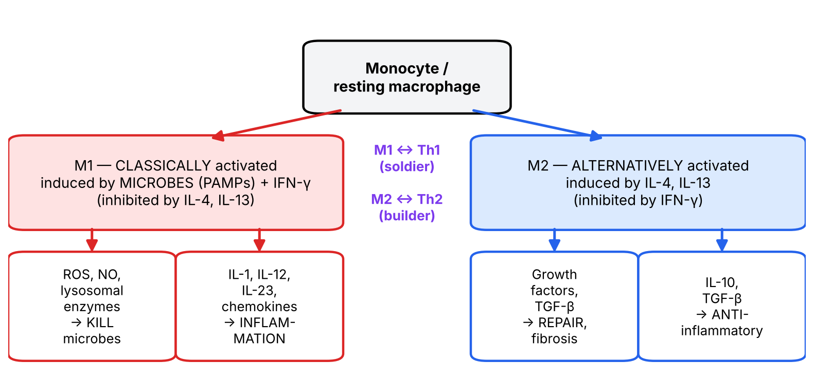
Figure 5. Classical (M1) vs alternative (M2) macrophage activation (redrawn from the Robbins figure, slide 15).
▌ FROM THE SLIDES
- Different stimuli activate monocytes/macrophages into functionally distinct populations.
- M1 (classically activated) — induced by PAMPs (microbes) and cytokines, particularly IFN-γ. Produce ROS, NO, lysosomal enzymes → microbicidal actions (phagocytosis and killing of many bacteria and fungi), and IL-1, IL-12, IL-23, chemokines → inflammation. They phagocytose and destroy microbes and dead tissue and can potentiate inflammatory reactions. M1 polarization is inhibited by IL-13 and IL-4.
- M2 (alternatively activated) — induced by IL-13 and IL-4. Produce growth factors, TGF-β → tissue repair, fibrosis, and IL-10, TGF-β → anti-inflammatory effects. Important in tissue repair and resolution of inflammation. M2 polarization is inhibited by IFN-γ.
Feature | M1 (classical) | M2 (alternative)
Induced by | Microbes (PAMPs), IFN-γ | IL-4, IL-13
Inhibited by | IL-4, IL-13 | IFN-γ
Products | ROS, NO, lysosomal enzymes; IL-1, IL-12, IL-23, chemokines | Growth factors, TGF-β; IL-10
Job | Kill microbes; drive inflammation | Repair tissue, fibrosis; switch off inflammation
Partner Th subset | Th1 (M1 makes IL-12 → Th1; Th1 makes IFN-γ → M1) | Th2 (Th2 makes IL-4/IL-13 → M2)
Analogy | Soldier | Builder / cleaner

📝 YOUR SLIDE NOTES — CHECKED
Slide-15 note: 'IFN-γ is not coming from T, it is coming from NK cells'. Partly right: early in infection (innate phase), NK cells are the main IFN-γ source that tips macrophages to M1 and naive T cells to Th1. Later, once Th1 cells exist, they become a major IFN-γ source too. Both are true at different times.
Slide-15 note: 'what drives M2? IL-4 from Th0, and IL-13' — correct.

3.4 The four Th subsets (slides 16–17)
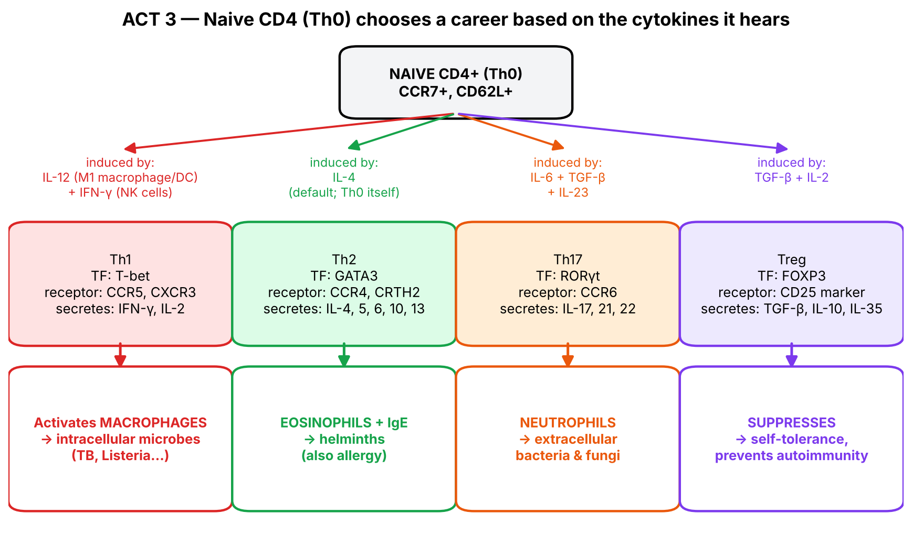
Figure 6. The Th0 career tree (slides 16–17 combined).
▌ FROM THE SLIDES
Slide 16: During a primary immune response, specific cytokines derived from the innate immune system and unique master transcription factors (T-bet, GATA3, RORγt) direct naive CD4 T cells to differentiate into Th1, Th2 or Th17 effector cells. Each subset loses expression of L-selectin (CD62L) and CCR7 and expresses characteristic chemokine receptors (Th1: CCR5, CXCR3; Th2: CCR4, CRTH2; Th17: CCR6). The expression of adhesion and chemokine receptors is altered during effector differentiation.
Slide 17 — Subsets of helper (CD4+) T cells (your note: all of these cells are CD3+ CD4+):
 | Th1 (induces CMI) | Th2 (induces humoral) | Th17 | Treg
Identification | CD3+, CD4+ | CD3+, CD4+ | CD3+, CD4+, RORγt | CD3+, CD4+, FoxP3, CD25
Induced by | IFN-γ, IL-12 | IL-4 | IL-6, IL-23, TGF-β | TGF-β, IL-2
Secretes | IFN-γ, IL-2 | IL-4, IL-5, IL-6, IL-10, IL-13 | IL-17, IL-21, IL-22 | TGF-β, IL-10, IL-35
Function | Activates macrophages to kill phagocytosed microbes | Activates eosinophils and promotes IgE for parasite defense | Immunity against extracellular microbes (bacteria, fungi) via recruiting neutrophils | Prevents autoimmunity by maintaining tolerance to self antigens
Inhibited by | IL-4, IL-10 (from Th2) | IFN-γ (from Th1) | IFN-γ, IL-4 | IL-6

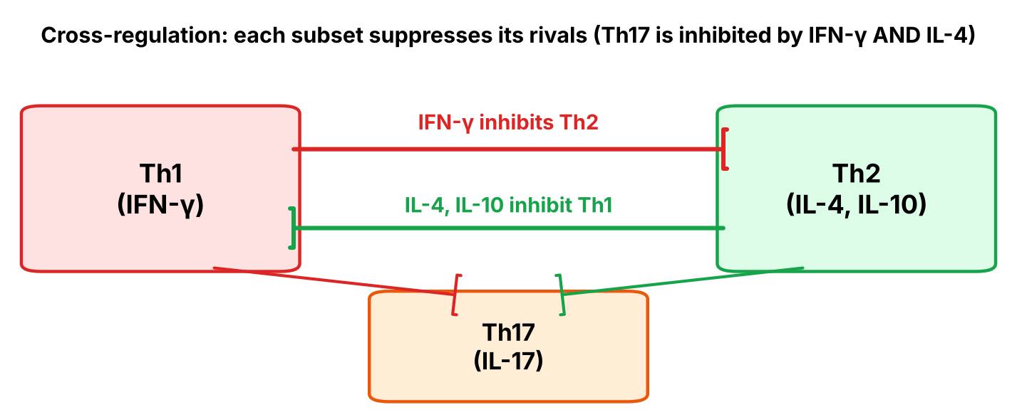
Figure 7. Cross-regulation — subsets keep each other in check (the 'Inhibited by' row as a picture).

Reading the table with logic instead of memory
Pattern | Why it makes sense
Th1 makes IFN-γ, which is also what induces Th1 and M1 macrophages | Positive feedback: once a Th1 response starts, it reinforces itself and its weapon (M1 macrophage)
Th2 makes IL-4, which is what induces Th2 and M2 | Same self-reinforcing logic for Th2
Th2 cytokines: IL-4 (IgE class switch, Th2 growth), IL-5 (eosinophil growth & activation), IL-13 (mucus, M2, IgE), IL-10 (anti-inflammatory) | Everything needed to expel a worm: IgE coats it, eosinophils attack it, mucus flushes it
Th1 is inhibited by Th2 (IL-4, IL-10); Th2 is inhibited by Th1 (IFN-γ) | Prevents wasting resources on two strategies at once; commits the response
Th17 is induced by IL-6 + TGF-β; Treg by TGF-β + IL-2; Treg is inhibited by IL-6 | TGF-β is the shared starting point. Add IL-6 (inflammation = danger) → Th17; without IL-6 → Treg. Inflammation literally switches tolerance OFF and attack ON
Treg markers CD25 (= IL-2Rα) and FoxP3 | Tregs soak up IL-2 with their high-affinity CD25 → starve effector T cells of IL-2

▌ HIGH-YIELD ADDITIONAL KNOWLEDGE
Defect | Subset affected | Clinical picture
IL-12 receptor / IFN-γ receptor deficiency | Th1–macrophage axis | Disseminated mycobacterial (incl. BCG, atypical) and Salmonella infections; treat with IFN-γ
STAT3 mutation (Job / hyper-IgE syndrome) | Th17 deficiency | Cold staphylococcal abscesses, retained primary teeth, ↑IgE, eczema, coarse facies (FATED)
AIRE / IL-17 defects | Th17 | Chronic mucocutaneous candidiasis
FOXP3 mutation (IPEX) | Treg absence | Immune dysregulation, Polyendocrinopathy (T1DM in infancy), Enteropathy (diarrhea), X-linked; eczema
Th2 excess | Th2 | Allergic asthma, atopic dermatitis; anti-IL-5 (mepolizumab) for eosinophilic asthma; anti-IL-4Rα (dupilumab) for atopic dermatitis
Th1 / Th17 excess | Th1, Th17 | Type IV hypersensitivity (PPD test, contact dermatitis); psoriasis → anti-IL-17 (secukinumab), anti-IL-12/23 (ustekinumab)

📝 YOUR SLIDE NOTES — CHECKED
Slide-17 note: 'which cytokine can shut down Th1 and Th17? Th2 … like IL-4 and IL-3'. Correction: the slide says Th1 is inhibited by IL-4 and IL-10 (from Th2), and Th17 by IFN-γ and IL-4. IL-3 is not involved.
Slide-16 notes ('Th17 = IL-6, TGF-β, IL-23'; 'Th2 chemokine receptor = CCR4'; 'T-bet ↔ Th1, GATA3 ↔ Th2, RORγt ↔ Th17') — all correct.
Slide-17 take-home note: 'all 3 will be in action at the same time' — reasonable: real infections contain a mix of subsets; cross-regulation determines which one dominates.

3.5 Memory T cells (slide 6)
▌ FROM THE SLIDES
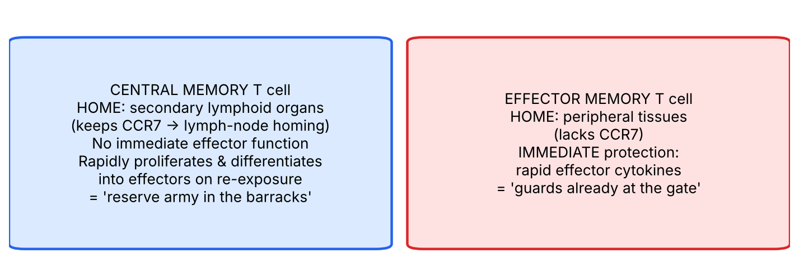
Figure 8. Two kinds of memory T cells (slide 6). Your note: 'don't bother about the structure, only the function'.
- Central memory T cells — preferentially reside in secondary lymphoid organs, mounting recall responses to antigens. Even though they lack immediate effector functions, they rapidly proliferate and differentiate into effector T cells after antigen stimulation.
- Effector memory T cells — preferentially found in peripheral tissues. They provide immediate protection upon antigen challenge, e.g., through rapid production of effector cytokines.
- Slide figure markers on memory cells: CD44, CD3, TCR, IL-7R, CCR7 (structure not examinable per your note).
▌ ADDITIONAL CONTEXT
Why two kinds? Effector memory cells give a fast first line in the tissues where the microbe got in last time; central memory cells provide a large, long-lasting reserve that can expand into a fresh army. The CCR7 label tells you where each lives: CCR7 = lymph-node homing receptor → central memory keeps it. IL-7R is the survival receptor that keeps memory cells alive for years without antigen.
🩺 CLINICAL CORRELATION
• PPD / tuberculin skin test: memory Th1 cells recognise TB antigen injected into skin → IFN-γ → macrophage recruitment → induration at 48–72 h (type IV hypersensitivity).
• Allergic asthma & helminth infection share the Th2 program: ↑IgE, eosinophilia. A patient with eosinophilia and ↑IgE → think helminth or atopy.
• Psoriasis is Th17-driven (neutrophil microabscesses) → anti-IL-17 biologics work.
• Booster vaccinations work because memory cells respond faster and stronger the second time.

🎯 EXAM FOCUS
• Th1: IL-12/IFN-γ → T-bet → IFN-γ, IL-2 → macrophages; inhibited by IL-4, IL-10.
• Th2: IL-4 → GATA3 → IL-4, 5, 6, 10, 13 → eosinophils, IgE; inhibited by IFN-γ; default pathway.
• Th17: IL-6, IL-23, TGF-β → RORγt → IL-17, 21, 22 → neutrophils; inhibited by IFN-γ, IL-4.
• Treg: TGF-β, IL-2 → FoxP3, CD25 → TGF-β, IL-10, IL-35 → tolerance; inhibited by IL-6.
• M1: PAMPs + IFN-γ → kill/inflame; M2: IL-4, IL-13 → repair/anti-inflammatory.
• Effector cells lose CD62L and CCR7; chemokine receptors: Th1 CCR5/CXCR3, Th2 CCR4/CRTH2, Th17 CCR6.
• Central memory = lymphoid organs, no immediate function, rapid proliferation; effector memory = tissues, immediate cytokines.

⚠️ COMMON MISTAKES
• Thinking Th1 directly kills — Th1 activates macrophages; only CTLs/NK kill directly.
• Confusing Th17 (neutrophils, extracellular bacteria/fungi) with Th2 (eosinophils, worms).
• Forgetting IL-5 = eosinophils and IL-4 = IgE class switch.
• Mixing up the transcription factors (T-bet/Th1, GATA3/Th2, RORγt/Th17, FoxP3/Treg).
• Saying IL-6 induces Tregs — IL-6 inhibits Tregs and pushes toward Th17.

Act 3 — Practice questions
Q1. [MCQ] A naive CD4+ T cell is exposed to IL-6 and TGF-β. Which transcription factor will it express, and which effector cell will it recruit?
A. T-bet; macrophages
B. GATA3; eosinophils
C. RORγt; neutrophils
D. FoxP3; none (suppression)
E. Bcl-6; B cells

✅ ANSWER & EXPLANATION
C. IL-6 + TGF-β (+IL-23) → Th17 (RORγt) → IL-17 → neutrophil recruitment against extracellular bacteria and fungi. TGF-β without IL-6 (+IL-2) → Treg (D).

Q2. [MCQ] Which cytokine both promotes M1 macrophage polarization and inhibits Th2 differentiation?
A. IL-4
B. IL-10
C. IFN-γ
D. IL-13
E. TGF-β

✅ ANSWER & EXPLANATION
C — IFN-γ. It induces M1 and Th1 and inhibits Th2 and M2. IL-4/IL-13 do the opposite. IL-10/TGF-β are anti-inflammatory.

Q3. [Clinical vignette] A 4-year-old boy has had disseminated infection with the BCG vaccine strain and later recurrent non-typhoidal Salmonella bacteremia. Neutrophil function and antibody levels are normal. Which pathway is most likely defective?
A. CD40L–CD40
B. IL-12 / IFN-γ axis
C. IL-4 / GATA3 axis
D. IL-17 / RORγt axis
E. Complement C5–C9

✅ ANSWER & EXPLANATION
B. Mycobacteria and Salmonella are facultative intracellular organisms living in macrophages; control requires IL-12 → Th1 → IFN-γ → macrophage activation. IL-12R or IFN-γR deficiency → disseminated mycobacterial/Salmonella infections (high-yield additional).

Q4. [Clinical vignette] An infant boy has intractable watery diarrhea, insulin-dependent diabetes at 3 months and eczema. Which cell population is most likely absent and what is its marker?

✅ ANSWER & EXPLANATION
Regulatory T cells, identified by FoxP3 (and CD25) — this is IPEX syndrome (FOXP3 mutation). Without Tregs, tolerance to self antigens fails → multi-organ autoimmunity (slide 17: Tregs prevent autoimmunity).

Q5. [Short answer] Compare central memory and effector memory T cells by location, immediate function and response to re-exposure.

✅ ANSWER & EXPLANATION
Central memory: secondary lymphoid organs; no immediate effector function; rapidly proliferate/differentiate into effectors on re-exposure. Effector memory: peripheral tissues; immediate protection via rapid effector cytokine production.

Q6. [Mechanism] Explain why Th2 is called the 'default' pathway in the slide, and what must happen for Th1 to dominate instead.

✅ ANSWER & EXPLANATION
Th0 cells constitutively make some IL-4, which drives GATA3 and Th2 differentiation (and M2 macrophages) unless something overrides it. For Th1 to dominate, microbes must trigger a strong innate response: M1 macrophages/DCs make IL-12 and NK cells make IFN-γ → T-bet → Th1; IFN-γ then suppresses the Th2 program.

Act 4A — Effector phase: matching the weapon to the hiding place (slides 19–21)

4A.1 Big picture
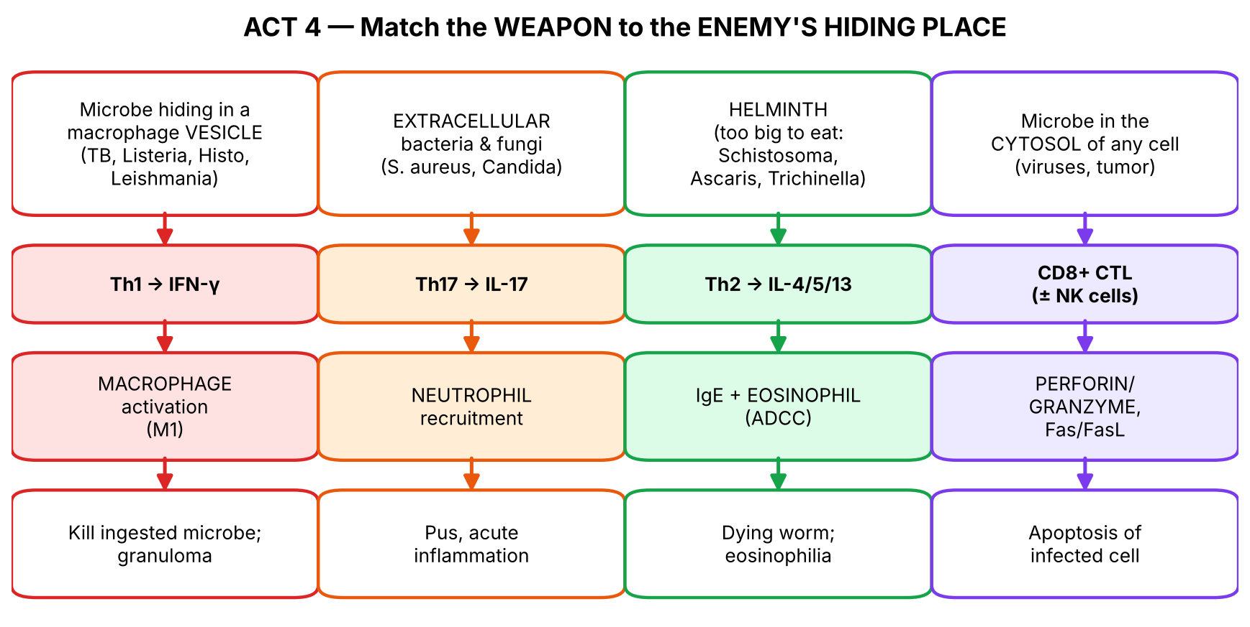
Figure 9. The single map that organizes all effector mechanisms: WHERE the microbe hides decides WHICH T cell and WHICH weapon.

4A.2 Role of CMI in host defense (slides 19–20)
▌ FROM THE SLIDES
Cell-mediated immunity has evolved to battle 2 different types of pathogens:
- Facultative intracellular pathogens — have adapted to living inside phagocytes, e.g., *Listeria*, *Mycobacterium tuberculosis*, *Legionella*.
- Obligate intracellular pathogens — can't replicate outside of host cells (your note: like viruses).
Facultative intracellular (slide 20) | Obligate intracellular (slide 20)
Francisella | Viruses
Brucella | Toxoplasma
Bartonella | Leishmania
Salmonella | Trypanosoma cruzi
Legionella | Chlamydia
Listeria | Rickettsia
Yersinia pestis | Coxiella
Mycobacterium tuberculosis | Anaplasma
Cryptococcus | Mycobacterium leprae
 | Ehrlichia

Giving the two lists anchors
💡 THE ORGANIZING PRINCIPLE
Ask two questions of every organism: (1) Can it survive outside a cell? (facultative = yes, obligate = no) and (2) What kind of organism is it? Then the 19 names collapse into 6 small groups.
Facultative organisms are mostly bacteria acquired from animals or food/water that hide in macrophages: zoonoses (Francisella–rabbits/ticks, Brucella–unpasteurized dairy, Bartonella–cats, Yersinia pestis–rodent fleas), food/water (Salmonella, Listeria, Legionella), and the granuloma-formers (M. tuberculosis, Cryptococcus).
Obligate organisms are viruses, bacteria that lack metabolic independence (Chlamydia and the Rickettsia-like group: Rickettsia, Coxiella, Anaplasma, Ehrlichia), M. leprae, and the intracellular protozoa (Toxoplasma, Leishmania, T. cruzi).
The point for the exam: because these microbes are inside cells, antibodies can't reach them → defense depends on Th1 → macrophage activation (vesicular microbes) and CD8 CTL/NK killing (cytosolic microbes). Defects in CMI (HIV, steroids, anti-TNF, IL-12/IFN-γ defects) → infections with exactly these organisms.

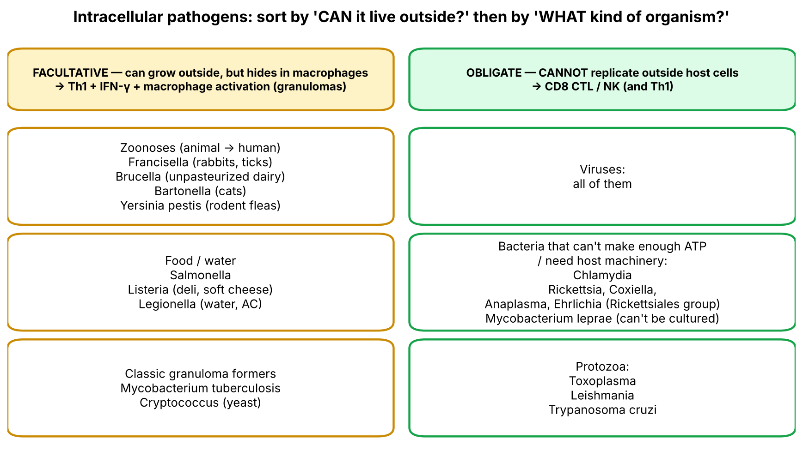
Figure 10. Slide 20 reorganized by 'can it live outside?' and 'what kind of organism?'.
▌ ADDITIONAL CONTEXT
- Your note 'note the difference between the 2 mycobacteria': *M. tuberculosis* is facultative (it can be grown in culture, slowly, on Löwenstein–Jensen medium); *M. leprae* is obligate — it cannot be cultured in vitro (grown in armadillos or mouse footpads) and prefers cool body areas (skin, peripheral nerves).
- Cryptococcus is a yeast: the only fungus on the slide lists. It is encapsulated and survives within macrophages — another reason it appears in AIDS (CD4 < 100).
- Several protozoa on the obligate list live inside macrophages (Leishmania) — so they too depend on Th1/IFN-γ for control.

4A.3 Effector mechanisms of T-cell-mediated immunity (slide 21)
▌ FROM THE SLIDES
- Effector cells of the CD4+ lineage (Th1, Th2, Th17): these three subsets produce distinct sets of cytokines that defend against different types of microbial infection in tissues.
- Effector cells of the CD8+ lineage: naive CD8+ T cells differentiate into functional CTLs that acquire the ability to kill infected cells and tumor cells.
- (A) Phagocyte with ingested microbes in vesicles: effector Th1 and Th17 cells recognize microbial antigens and secrete cytokines that recruit leukocytes (inflammation) and activate phagocytes to kill the microbes. Th2 effector cells (not shown) recruit eosinophils, which destroy helminthic parasites.
- (B) Infected cell with microbial antigens in the cytoplasm: CD8+ CTLs kill infected cells with microbial antigens in the cytosol. CD8+ T cells also produce cytokines that induce inflammation and activate macrophages.
▌ ADDITIONAL CONTEXT
Your slide-4 note on Th17 & neutrophils: 'what is the connection between CD4 and neutrophils? Th17 attracts neutrophils → inflammatory response, pus formation' — correct. IL-17 makes local cells release neutrophil chemokines (e.g., IL-8/CXCL8) and G-CSF.
🩺 CLINICAL CORRELATION
• Listeria in pregnancy/neonates/elderly/immunosuppressed: CMI is naturally reduced in pregnancy → listeriosis → meningitis, sepsis.
• Legionella pneumonia in smokers/elderly; Brucella after unpasteurized goat cheese; Francisella (tularemia) after rabbit skinning; Bartonella (cat-scratch disease, bacillary angiomatosis in AIDS).
• Coccidioidomycosis, histoplasmosis, TB disseminate when Th1/macrophage activation fails (HIV, steroids, anti-TNF).

🎯 EXAM FOCUS
• CMI targets facultative (Listeria, M. tuberculosis, Legionella…) and obligate (viruses, Chlamydia, Rickettsia…) intracellular pathogens.
• M. tuberculosis = facultative; M. leprae = obligate.
• Th1 → macrophages; Th17 → neutrophils; Th2 → eosinophils; CD8 → kills infected cells/tumor cells (and makes cytokines).
• Typical question: 'Which organism is an obligate intracellular pathogen?' or 'A patient with defective IFN-γ signaling is most susceptible to…?'

⚠️ COMMON MISTAKES
• Placing M. leprae with M. tuberculosis — they are on opposite lists.
• Calling Chlamydia/Rickettsia 'facultative' because they are bacteria — they are obligate.
• Thinking antibody is the main defense against intracellular microbes — it is CMI.

Act 4A — Practice questions
Q1. [MCQ] Which of the following is an OBLIGATE intracellular pathogen according to the lecture?
A. Mycobacterium tuberculosis
B. Listeria monocytogenes
C. Mycobacterium leprae
D. Salmonella
E. Legionella

✅ ANSWER & EXPLANATION
C. M. leprae cannot replicate outside host cells (cannot be cultured). The others are facultative intracellular.

Q2. [Clinical vignette] A 30-year-old pregnant woman who eats unpasteurized soft cheese develops fever and myalgia; blood cultures grow Gram-positive rods with tumbling motility. Which arm of immunity is principally responsible for clearing this organism?
A. Complement-mediated lysis
B. Neutralizing IgG
C. Cell-mediated immunity (Th1/IFN-γ macrophage activation and CD8 CTLs)
D. IgE-mediated eosinophil activation
E. Mast-cell degranulation

✅ ANSWER & EXPLANATION
C. Listeria is a facultative intracellular bacterium that escapes into the cytosol; it is controlled by Th1-activated macrophages and CD8 CTLs. Pregnancy reduces CMI, explaining susceptibility.

Q3. [Short answer] Group the obligate intracellular organisms from slide 20 into three categories.

✅ ANSWER & EXPLANATION
Viruses; bacteria — Chlamydia, Rickettsia, Coxiella, Anaplasma, Ehrlichia, M. leprae; protozoa — Toxoplasma, Leishmania, Trypanosoma cruzi.

Q4. [Mechanism] Why can't antibodies efficiently clear M. tuberculosis, and what does the immune system do instead?

✅ ANSWER & EXPLANATION
TB lives inside macrophage phagosomes, out of reach of antibody. The macrophage presents TB peptides on MHC II and secretes IL-12 → Th1 differentiation → Th1 makes IFN-γ → macrophage becomes M1 (ROS, NO, phagolysosome fusion) → kills TB; persistent antigen → granuloma (walls off infection; maintained by TNF).

Act 4B — Killing mechanisms: CTLs, ADCC and NK cells (slides 22–29)

4B.1 Cytotoxic T lymphocytes (slides 22–23)
▌ FROM THE SLIDES
- CTLs kill altered host cells (virus-infected cells and tumor cells) that express abnormal peptides in the groove of their MHC class I on the cell surface.
1. Destruction via perforin and granzymes:
- Attachment to the target cell (mediated by TCR, CD8, LFA-1).
- Production of cytotoxic granules.
- Exocytosis of granule contents (perforin and granzymes).
- Detachment from the target cell, and apoptosis via activation of caspases.
2. Destruction via Fas/FasL interactions: activated CD8+ T cells express FasL, which binds Fas on the target cell → activation of the caspase cascade → apoptosis.
Slide 23 figure: CD8+ T cell receives IL-2 (via IL-2 receptor) → binds virus-infected cell via TCR + CD8 ↔ MHC I + β2M and paired costimulatory/adhesion molecules LFA-1:ICAM-1 and LFA-2:LFA-3 → activation, proliferation, differentiation → granules → release of perforin (forms polyperforin channels) and granzymes (proteases to trigger apoptosis) + FasL–Fas → activation of apoptosis → death of virus-infected cell.
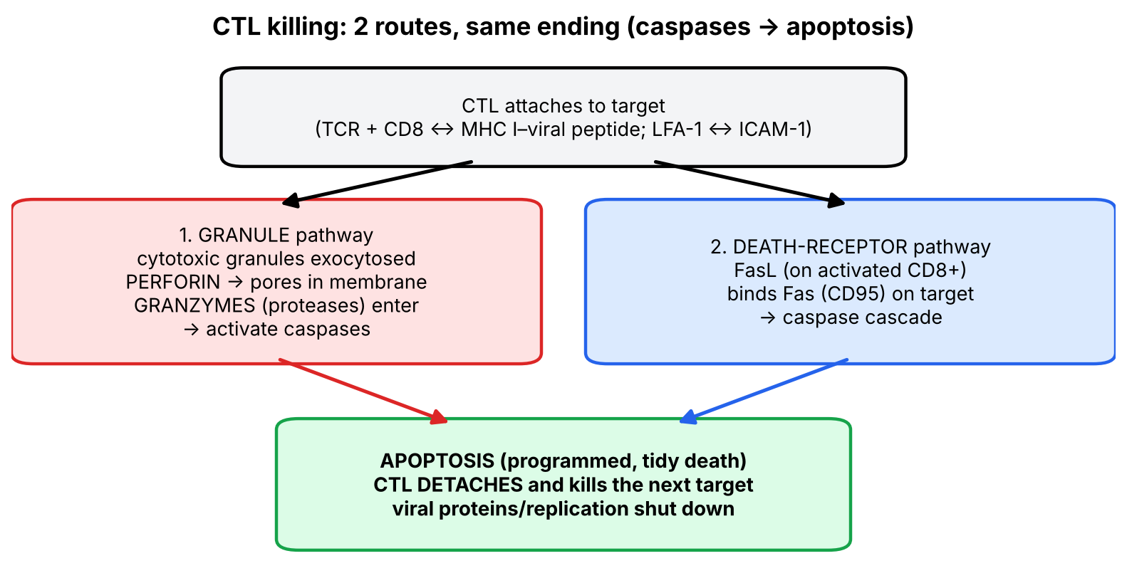
Figure 11. The two CTL killing routes converge on caspases.
▌ ADDITIONAL CONTEXT
- Why apoptosis rather than lysis? Apoptosis packages the cell neatly — including the viruses inside — so the virus isn't spilled out, and inflammation is minimal. Granzymes also degrade viral and host proteins, stopping viral production.
- Your note '2 general markers for CTL: CD8 (and CD3); CD4 is helper' — correct: CTLs are CD3+ CD8+; helpers are CD3+ CD4+.
▌ HIGH-YIELD ADDITIONAL KNOWLEDGE
- Perforin deficiency → familial hemophagocytic lymphohistiocytosis (HLH): CTLs/NK can't kill infected cells, keep secreting IFN-γ → macrophages eat blood cells → fever, splenomegaly, cytopenias, very high ferritin.
- Fas (or FasL) mutation → autoimmune lymphoproliferative syndrome (ALPS): lymphocytes that should be deleted by Fas-mediated apoptosis accumulate → lymphadenopathy, splenomegaly, autoimmune cytopenias, ↑ double-negative (CD4−CD8−) T cells.
- Hepatitis B/C: most liver injury is caused by CTLs killing infected hepatocytes, not by the virus itself.

4B.2 Antibody-dependent cell-mediated cytotoxicity — ADCC (slides 24–26)
▌ FROM THE SLIDES
ADCC is a cytotoxic reaction mediated by effector cells that involves:
- Binding of antibodies (IgG or IgE) to epitopes on the target cell — IgG for the majority of responses, IgE for helminths.
- Recognition of the Fc fragment by effector cells.
- Release of cytotoxic substances by effector cells.
- Destruction/lysis of the target cell.
Cells capable of ADCC — they express Fc receptors: macrophages, NK cells, neutrophils, eosinophils. Killing is accomplished through release of (your note: 'remember the cytotoxic components released'):
Weapon | NK cell | Eosinophil | Macrophage | Neutrophil
Perforin, granzymes | ✔ | ✔
TNF | ✔ |  | ✔
Lytic enzymes |  | ✔ | ✔ | ✔

Pattern to remember the table: the two 'killer-style' cells (NK, eosinophil) use perforin/granzymes; the two 'cytokine-makers' (NK, macrophage) use TNF; the three 'phagocyte/granulocyte' cells (macrophage, neutrophil, eosinophil) use lytic enzymes. NK is the only one using both perforin/granzymes and TNF; eosinophil is the only one with both perforin/granzymes and lytic enzymes.
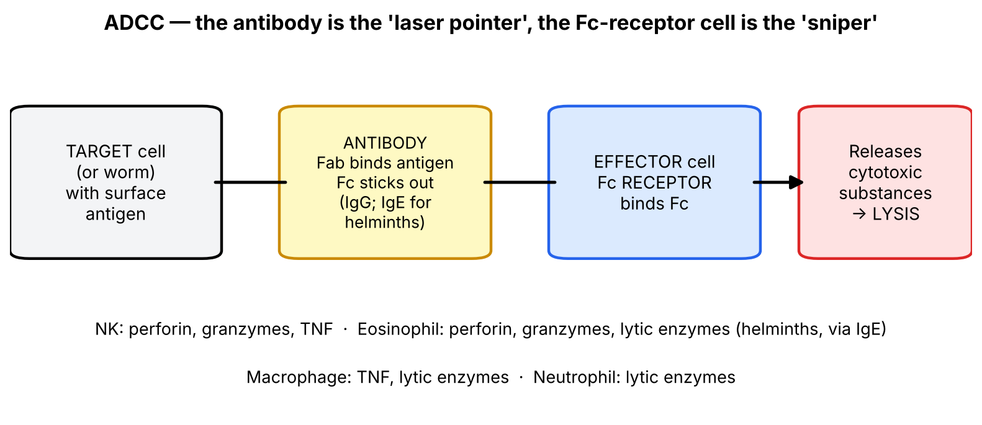
Figure 12. ADCC: antibody tags the target, the Fc-receptor cell pulls the trigger.

IgE production in helminth infection (slide 26 — 'important for the exam')
▌ FROM THE SLIDES
Helminth (Trichinella, Schistosoma, Ascaris…)
↓
Th2 cells → IL-4, IL-5, IL-6, IL-9, IL-10, IL-13
↓ ↓
IgE ↑↑ (only a small fraction Eosinophils ++
is directed against the helminth) ↓
↓ ↓
IgE specific for worm proteins binds Fc receptors on eosinophils
↓
ADCC → dying worm

▌ ADDITIONAL CONTEXT
- Why a worm needs ADCC: a helminth is far too large to be phagocytosed and isn't inside a cell, so neither macrophages nor CTLs can handle it. Instead, IgE coats the worm and eosinophils attach via Fc receptors and release toxic granule proteins (major basic protein, eosinophil cationic protein, peroxidase) onto its surface.
- Why is total IgE so high but mostly non-specific? IL-4 drives class switching to IgE in many B cells polyclonally, so most of the IgE is not specific to the worm (slide: 'only a small fraction is directed against the helminth').
📝 YOUR SLIDE NOTES — CHECKED
Slide-31 note: '3 cells with Fc receptor for IgE: mast cells, basophils, eosinophils (type I hypersensitivity); Fc receptor for IgG: NK, neutrophil, monocyte, eosinophil; eosinophil has 2 receptors' — correct and high-yield. NK cells use CD16 (FcγRIII) for IgG-mediated ADCC.

▌ HIGH-YIELD ADDITIONAL KNOWLEDGE
- Therapeutic ADCC: monoclonal antibodies such as rituximab (anti-CD20), trastuzumab (anti-HER2) and cetuximab (anti-EGFR) kill tumor cells partly by ADCC via NK-cell CD16.

4B.3 NK cells (slides 27–29)
▌ FROM THE SLIDES
- NK cells (CD16 and CD56) — your note: 'important'.
- Their stimulation does not generate memory (they are part of innate immunity, not adaptive).
- They DO NOT require exposure to antigen for activation.
- Activity is enhanced by IL-2, IL-12, IFN-α and IFN-β.
How do NK cells recognize the target? (slide 28) NK cells use two categories of receptors in the Killer Immunoglobulin-like Receptor (KIR) family:
- Activating receptor binds to lectins (conserved among many pathogens).
- Inhibitory receptor binds to MHC class I.
Slide-28 figure: (a) Tolerance — healthy cell with MHC I: inhibitory signal dominates → NK-cell inhibition. (b) Missing self — tumour cell with loss of MHC molecule expression → NK-cell activation → cytokines and cytotoxic mediators → killing of tumour cell.
How do NK cells kill virus-infected / tumor cells? (slide 29): Perforins → produce holes in target-cell membranes; Granzymes → proteases that shut down the production of viral proteins and ultimately cause apoptosis.
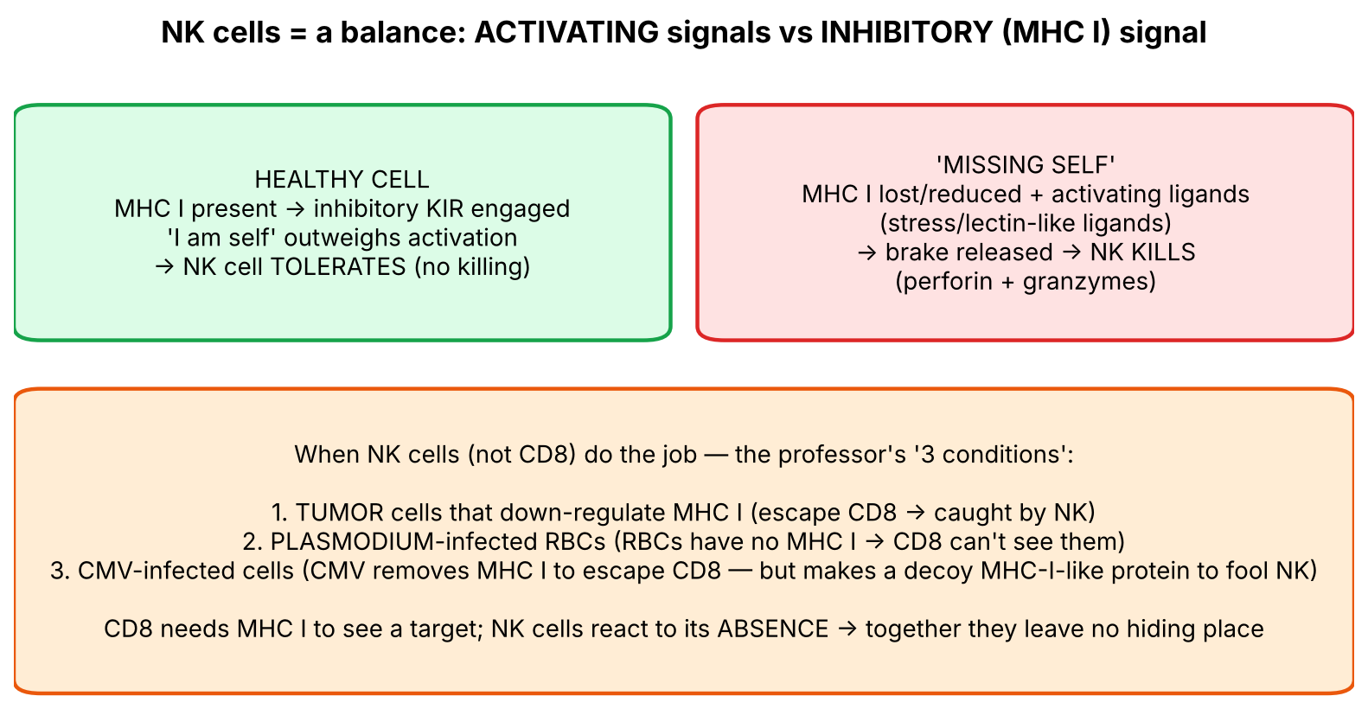
Figure 13. NK cells weigh 'go' against 'stop' — and the professor's three NK conditions.

CD8 CTL vs NK cell — the most commonly confused pair
Feature | CD8+ CTL | NK cell
Immune system | Adaptive | Innate
Markers | CD3+, CD8+ | CD16, CD56 (CD3−)
Needs prior antigen exposure / priming? | Yes (lymph node activation) | No
Specificity | One peptide–MHC I via TCR | Balance of activating (lectin-like ligands) vs inhibitory (MHC I) receptors
Target MHC I | Required (sees peptide in MHC I) | Absence triggers killing ('missing self')
Memory | Yes | No (slide)
Killing tools | Perforin, granzymes, FasL | Perforin, granzymes (+ TNF; ADCC via CD16)
Enhanced by | IL-2 from helper T cells | IL-2, IL-12, IFN-α, IFN-β
Speed | Days (needs clonal expansion) | Hours (already armed)

Your note: 'NK cells are part of innate, CD8 are part of adaptive; they do similar work but CD8 more specific, powerful, so in any condition where CD8 are deficient NK comes in' — a good summary.
▌ ADDITIONAL CONTEXT
- Terminology: NK-cell receptors include the KIR family and lectin-like (C-type lectin) receptors such as NKG2D, which recognises stress-induced ligands (MICA/MICB — MICA is the gene you saw in the HLA class I region in Lecture 10). The slide's 'activating receptor binds to lectins' is a simplified way of saying this.
- Why don't NK cells kill normal RBCs (which also lack MHC I)? Healthy RBCs don't display activating ligands. Killing needs activation > inhibition, not merely absent inhibition.
📝 YOUR SLIDE NOTES — CHECKED
Slide-27 note: 'HSV for example is an RNA virus'. Correction: HSV is a DNA virus (double-stranded DNA, herpesvirus family — like CMV, EBV and VZV). The herpesviruses are the classic examples of viruses that evade CD8 and are controlled by NK cells.
Slide-28 note: the '3 conditions' where NK (not CD8) is the key killer — tumour cells with ↓MHC I, Plasmodium-infected RBCs (mature RBCs have no MHC I, so CD8 can't see them), and CMV-infected cells (CMV removes MHC I). Correct as the lecture frames it, and 'important for the exam'.

▌ HIGH-YIELD ADDITIONAL KNOWLEDGE
- NK-cell deficiency → severe, recurrent herpesvirus infections (HSV, VZV, CMV, EBV) and HPV.
- Chédiak–Higashi syndrome (LYST defect) → defective granule trafficking → impaired NK/CTL and neutrophil killing, partial albinism, neuropathy.
🩺 CLINICAL CORRELATION
• Tumour immunity: tumours that lose MHC I escape CTLs but become NK targets — the two systems cover each other's blind spots.
• Malaria: Plasmodium hides in RBCs (no MHC I) → no CD8 recognition → NK cells and antibodies are important.
• Schistosomiasis / ascariasis / trichinosis: eosinophilia + ↑IgE = Th2 → IgE → eosinophil ADCC.
• Hemophagocytic lymphohistiocytosis: loss of perforin-mediated killing → uncontrolled immune activation.

🎯 EXAM FOCUS
• CTL killing: attachment (TCR, CD8, LFA-1) → granules → perforin + granzymes → caspases → apoptosis; and FasL–Fas → caspases → apoptosis.
• ADCC = antibody (IgG, or IgE for helminths) + Fc receptor cells (macrophages, NK, neutrophils, eosinophils). Weapons: perforin/granzymes (NK, eos), TNF (macrophage, NK), lytic enzymes (macrophage, neutrophil, eos).
• Helminths: Th2 → IL-4, 5, 6, 9, 10, 13 → ↑IgE + eosinophils → ADCC.
• NK = CD16, CD56; no memory; no antigen exposure needed; enhanced by IL-2, IL-12, IFN-α/β; activating receptor ↔ lectins, inhibitory ↔ MHC I; kill by perforin + granzymes.

⚠️ COMMON MISTAKES
• Saying perforin directly kills by lysis as the main mechanism — perforin makes pores; granzymes enter and trigger apoptosis.
• Thinking NK cells need MHC I to recognize targets — they are inhibited by MHC I.
• Saying NK cells form memory — the slide says they do not.
• Forgetting that eosinophil ADCC uses IgE (helminths) while most ADCC uses IgG.
• Mixing CD16/CD56 (NK) with CD3/CD8 (CTL).

Act 4B — Practice questions
Q1. [MCQ] A tumour cell has lost all surface MHC class I. Which cell is most likely to kill it, and through which receptor balance?
A. CD8+ CTL; TCR binding MHC I
B. NK cell; loss of inhibitory signal from MHC I
C. CD4+ Th1 cell; TCR binding MHC II
D. Neutrophil; complement receptors
E. B cell; BCR

✅ ANSWER & EXPLANATION
B. No MHC I → CTLs can't see the cell, but NK inhibitory receptors are no longer engaged → 'missing self' → NK activation → perforin/granzymes.

Q2. [MCQ] Which statement about NK cells is correct?
A. They require prior antigen exposure
B. They generate long-lived memory
C. They express CD16 and CD56
D. Their activity is suppressed by IL-12
E. They kill only via Fas–FasL

✅ ANSWER & EXPLANATION
C. NK cells are CD16+ CD56+, need no prior exposure, form no memory (per slide), are enhanced by IL-2, IL-12, IFN-α/β and kill with perforin + granzymes.

Q3. [Clinical vignette] A 28-year-old man from rural Egypt has hematuria, eosinophilia (25%) and markedly elevated IgE. Urine microscopy shows eggs with a terminal spine. Describe the immune mechanism that kills the parasite.

✅ ANSWER & EXPLANATION
Schistosoma haematobium → Th2 activation → IL-4 (IgE class switching), IL-5 (eosinophil production/activation), IL-13 etc. → IgE binds worm antigens → eosinophils bind IgE via Fc receptors → release perforin, granzymes, lytic enzymes (major basic protein) → ADCC → dying worm. Most of the IgE is not worm-specific.

Q4. [Clinical vignette] A 3-year-old has persistent fever, massive splenomegaly, pancytopenia and ferritin > 10,000 ng/mL. Bone marrow shows macrophages engulfing red cells. Genetic testing reveals a PRF1 mutation. Which killing step is defective?

✅ ANSWER & EXPLANATION
Perforin-mediated pore formation by CTLs and NK cells → granzymes can't enter targets → infected cells survive → continuous antigen stimulation and IFN-γ → macrophage hyperactivation (familial HLH, high-yield additional).

Q5. [Short answer] List the four steps of CTL killing via perforin/granzyme, and the second (non-granule) killing pathway.

✅ ANSWER & EXPLANATION
(1) Attachment via TCR, CD8, LFA-1; (2) production of cytotoxic granules; (3) exocytosis of perforin and granzymes; (4) detachment and apoptosis via caspases. Second pathway: FasL on the CTL binds Fas on the target → caspase cascade → apoptosis.

Q6. [Mechanism] Why would a monoclonal anti-CD20 antibody kill lymphoma cells even though the antibody itself has no toxic activity?

✅ ANSWER & EXPLANATION
The antibody's Fab binds CD20 on the lymphoma cell; its Fc tail is recognized by Fc receptors (e.g., CD16 on NK cells, and macrophages) → these effector cells release perforin/granzymes, TNF, lytic enzymes → target lysis (ADCC). Complement activation also contributes.

Act 5 — When the system is attacked: viral immune evasion and AIDS (slides 18, 30–31)

5.1 Big picture
Every defense creates pressure on microbes to evolve around it. Since CD8 killing depends on the MHC class I assembly line (Lecture 10: proteasome → TAP → ER → surface), viruses that persist for life — especially the herpesviruses (HSV, CMV, EBV) — have evolved proteins that sabotage each step. HIV, by contrast, attacks the generals themselves (CD4 cells), so the whole cell-mediated system collapses.

5.2 Immune evasion by viruses (slide 30)
▌ FROM THE SLIDES
- After bypassing host tissue barriers, microbes must also evade host innate and adaptive immunity to successfully proliferate and be transmitted to the next host.
Virus | Evasion mechanism (slide) | Step of the class I pathway it hits
Herpes simplex virus (HSV) | Inhibition of antigen presentation: HSV peptide interferes with the TAP transporter | TAP (peptides can't enter ER)
Cytomegalovirus (CMV) | Inhibition of antigen presentation: inhibition of proteasomal activity; removal of class I MHC molecules from the ER | Proteasome + ER (two steps)
Epstein–Barr virus (EBV) | Inhibition of antigen presentation: inhibition of proteasomal activity | Proteasome

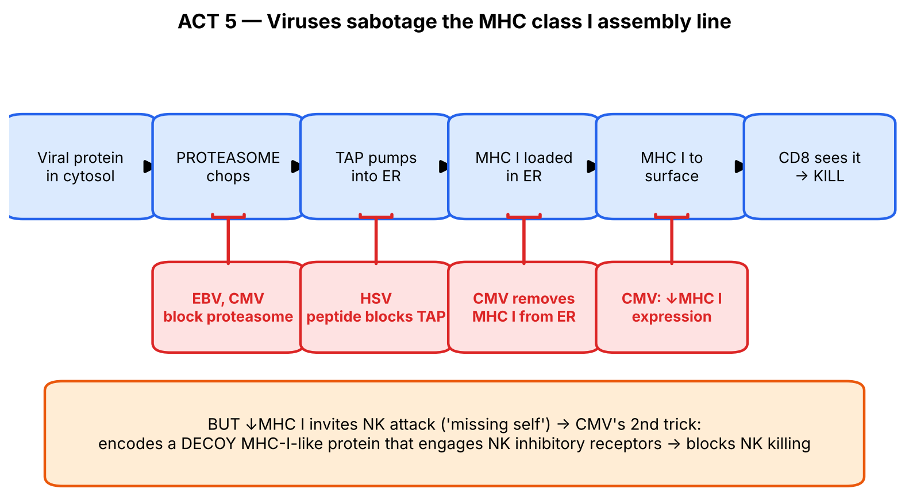
Figure 14. Each virus attacks a station on the class I assembly line (redrawn from slide 30).

5.3 Immune evasion by cytomegalovirus (slide 31 — 'important for NBME')
▌ FROM THE SLIDES
Strategies to inhibit killing by CD8+ T cells AND NK cells:
- Reduces MHC class I expression → inhibits killing by CD8+ T cells. (Your note: why? So they can escape CD8 attack.)
- Encodes a 'decoy' molecule (viral protein) that resembles MHC class I → blocks NK-cell attack.
💡 THE ORGANIZING PRINCIPLE
CMV faces a trap: if it keeps MHC I, CD8 cells see it; if it removes MHC I, NK cells see it ('missing self'). CMV's solution is to do both at once — remove real MHC I (to blind CD8) and display a fake MHC-I-like protein that engages NK inhibitory receptors (to calm NK). This is why the slide pairs the two strategies — each solves the problem the other creates.
Logical chain: ↓MHC I → CD8 blind → but NK should activate → decoy MHC-I-like molecule → NK inhibited → virus persists for life (latency).

▌ ADDITIONAL CONTEXT
- Other evasion tricks worth knowing (beyond the slide): HIV Nef down-regulates MHC I (but spares HLA-C/E to avoid NK); adenovirus E3 retains MHC I in the ER; poxviruses make decoy cytokine receptors; EBV makes a viral IL-10 homologue; many viruses (influenza, HIV) change their surface antigens (antigenic variation).
- Why herpesviruses? They establish lifelong latency (HSV in sensory ganglia, CMV in monocytes, EBV in B cells). Lifelong survival in a host with an intact immune system demands sophisticated evasion — hence their dominance on this slide.

5.4 CD4 count and opportunistic infections in AIDS (slide 18)
▌ FROM THE SLIDES
- As CD4+ cell count ↓ →
  - ↑ risk of reactivation of past infections (TB, HSV, shingles)
  - ↑ risk of dissemination of bacterial and fungal infections (coccidioidomycosis) and non-Hodgkin lymphomas
▌ ADDITIONAL CONTEXT
Why CD4 loss is so devastating — connect to every act of this lecture:
HIV infects CD4+ T cells (via CD4 + CCR5/CXCR4) → CD4 count falls
↓
↓ Th1 → ↓ IFN-γ → macrophages not activated → TB, Histoplasma, Cocci, MAC disseminate
↓ Help for CTLs (↓ IL-2) → latent viruses reactivate: HSV, VZV (shingles), CMV
↓ Help for B cells (CD40L, IL-4/21) → poor antibody responses
↓ Th17 → mucosal Candida (thrush, esophagitis)
↓ Immune surveillance of EBV/HHV-8 → non-Hodgkin lymphoma, Kaposi sarcoma

▌ HIGH-YIELD ADDITIONAL KNOWLEDGE
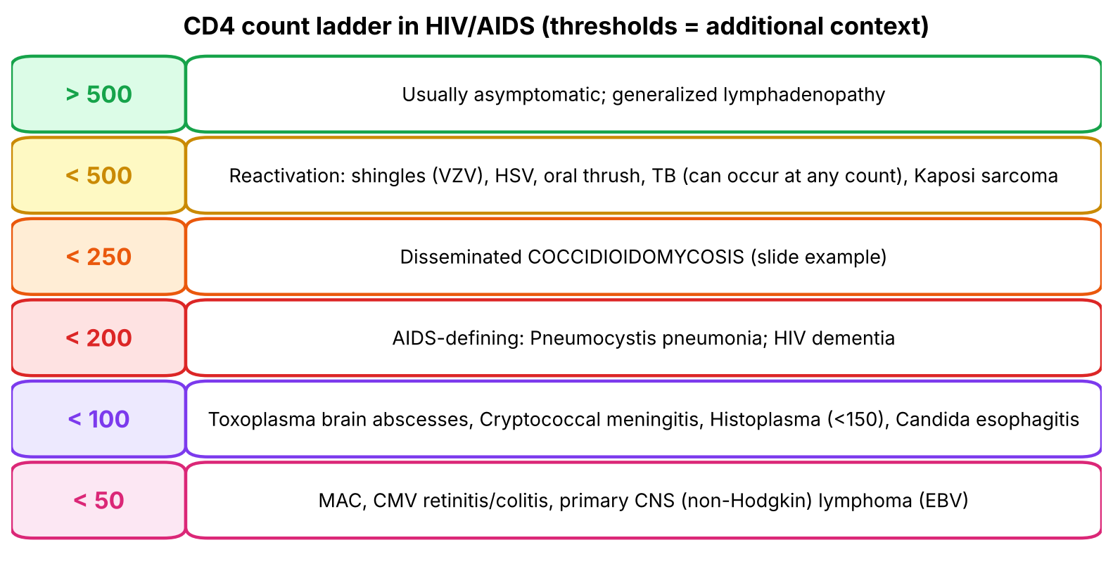
Figure 15. Opportunistic infections appear at predictable CD4 thresholds (thresholds are high-yield additional knowledge; slide examples highlighted).
- Prophylaxis thresholds (high-yield): CD4 < 200 → TMP-SMX (Pneumocystis); < 100 + Toxoplasma IgG+ → TMP-SMX covers Toxoplasma; < 50 → azithromycin for MAC is no longer routine if ART is started promptly, but the association with MAC remains highly tested.
- Coccidioidomycosis (Southwestern US desert: Arizona, California's San Joaquin Valley): inhaled arthroconidia → in tissue forms spherules filled with endospores; disseminates (skin, bone, meninges) when CD4 is low (≈ < 250), in pregnancy, and in people of Filipino/African descent.
📝 YOUR SLIDE NOTES — CHECKED
Slide-18 note: 'coccidioidomycosis produces what types of spores? atropolineum, aspergillus'. Correction: *Coccidioides* produces arthroconidia (barrel-shaped 'arthrospores') in the soil, which are inhaled; in tissue it forms spherules containing endospores. *Aspergillus* is a different mold (septate hyphae branching at 45°, conidia on conidiophores) and is not a spore type of Coccidioides.
Slide-31 note 'why does CMV reduce class I expression? so that they can escape CD8 attack' — correct.

🩺 CLINICAL CORRELATION
• CMV in transplant and AIDS patients: CMV retinitis (CD4 < 50), colitis, pneumonitis; in transplant recipients, CMV reactivation when T-cell immunity is suppressed. Treated with ganciclovir/valganciclovir.
• EBV-driven lymphomas in AIDS and post-transplant (PTLD): loss of CTL surveillance of EBV-infected B cells.
• Shingles in a young adult with no other risk factors → consider HIV testing (CD4 decline unmasks latent VZV).
• TB can reactivate at any CD4 count but becomes more disseminated (miliary, extrapulmonary) as CD4 falls.

🎯 EXAM FOCUS
• HSV → blocks TAP; CMV → inhibits proteasome + removes MHC I from ER; EBV → inhibits proteasome.
• CMV: ↓MHC I (escape CD8) + decoy MHC-I-like protein (escape NK).
• Falling CD4 → reactivation (TB, HSV, shingles) and dissemination (bacterial, fungal — coccidioidomycosis) and non-Hodgkin lymphoma.
• Typical question: 'A virus that reduces MHC I would be expected to be susceptible to which cell?' → NK cell; 'Which virus produces a protein that mimics MHC I?' → CMV.

⚠️ COMMON MISTAKES
• Mixing which virus blocks TAP (HSV) vs proteasome (EBV, CMV).
• Forgetting CMV's second strategy (NK decoy) — it is the commonly tested half.
• Thinking ↓MHC I lets a virus escape all killing — it exposes the cell to NK cells unless there is a decoy.

Act 5 — Practice questions
Q1. [MCQ] A virus produces a peptide that binds the TAP transporter and prevents peptide translocation into the ER. Which virus is this?
A. EBV
B. CMV
C. HSV
D. HIV
E. Influenza

✅ ANSWER & EXPLANATION
C — HSV (slide 30). EBV and CMV inhibit proteasomal activity; CMV also removes MHC I from the ER.

Q2. [MCQ] CMV-infected fibroblasts show markedly reduced surface MHC I, yet are NOT killed efficiently by NK cells. What explains this?
A. NK cells require MHC II
B. CMV encodes a decoy MHC-I-like molecule that engages NK inhibitory receptors
C. CMV blocks perforin
D. NK cells require antibody to kill
E. CMV increases Fas expression

✅ ANSWER & EXPLANATION
B (slide 31). The decoy protein delivers the 'self' (inhibitory) signal, so the missing-self response is blocked.

Q3. [Clinical vignette] A 38-year-old man with untreated HIV (CD4 = 180/µL) who recently moved from Arizona develops fever, skin nodules and lytic bone lesions. Biopsy shows large spherules filled with endospores. Why did this infection disseminate?

✅ ANSWER & EXPLANATION
Coccidioidomycosis. Control of Coccidioides needs Th1 cells → IFN-γ → activated macrophages and granulomas. With falling CD4 counts, Th1-mediated macrophage activation fails → the fungus escapes the lungs and disseminates (slide 18). Spherules with endospores = tissue form (inhaled form = arthroconidia).

Q4. [Short answer] Name three consequences of falling CD4 counts listed on slide 18.

✅ ANSWER & EXPLANATION
↑ reactivation of past infections (TB, HSV, shingles); ↑ dissemination of bacterial and fungal infections (e.g., coccidioidomycosis); ↑ non-Hodgkin lymphomas.

Q5. [Mechanism] Using the class I pathway, explain why a proteasome-inhibiting viral protein reduces CTL recognition.

✅ ANSWER & EXPLANATION
Viral cytosolic proteins must be cut by the proteasome into 8–9 aa peptides → TAP → ER → loaded onto MHC I. If the proteasome is inhibited, no viral peptides are generated → MHC I carries no viral peptide (and empty MHC I is unstable) → CTLs' TCRs find nothing to recognize → infected cell survives (EBV, CMV).

Whole-lecture review

A. Complete high-yield summary
ACT 1 INDUCTION
DC captures Ag in tissue → MATURES (↑MHC, ↑costimulators) → lymph node paracortex
APCs: DC (no activation needed) · Macrophage (Th1/CMI) · B cell (Th2; BCR-specific)

ACT 2 ACTIVATION (in secondary lymphoid organs)
Sig 1: TCR–MHC/peptide; CD4–MHC II / CD8–MHC I; CD3 transduces
Adhesion: LFA-1–ICAM-1 (CD54); CD2–CD58
Sig 2: CD28–B7 (CD80/86); CD40L (CD154)–CD40 → APC makes more B7
Sig 3: IL-2 → IL-2R → clonal expansion; Mφ: IL-1, IL-6, IL-12, TNF-α
Brakes: CTLA-4 (binds B7) · PD-1 (binds PD-L1/L2) → terminate, self-tolerance

ACT 3 DIFFERENTIATION (pathogen + macrophage type)
Th1: IL-12, IFN-γ → T-bet → IFN-γ, IL-2 → macrophages (⊣ IL-4, IL-10)
Th2: IL-4 → GATA3 → IL-4,5,6,10,13 → eosinophils, IgE (⊣ IFN-γ)
Th17: IL-6, IL-23, TGF-β → RORγt → IL-17,21,22 → neutrophils (⊣ IFN-γ, IL-4)
Treg: TGF-β, IL-2 → FoxP3, CD25 → TGF-β, IL-10, IL-35 → tolerance (⊣ IL-6)
M1: PAMPs + IFN-γ → kill/inflame · M2: IL-4, IL-13 → repair/anti-inflammatory
Memory: central (lymphoid organs) · effector (tissues, immediate)

ACT 4 EFFECTOR
Facultative intracellular (TB, Listeria, Legionella…) · Obligate (viruses, Chlamydia…)
CTL: TCR/CD8/LFA-1 attach → perforin + granzymes; FasL–Fas → caspases → apoptosis
ADCC: IgG (IgE for worms) + FcR cells (Mφ, NK, neutrophil, eosinophil)
Helminth: Th2 → IgE ↑↑ + eosinophils → ADCC
NK (CD16, CD56): no memory, no Ag needed, ↑ by IL-2, IL-12, IFN-α/β;
activating R ↔ lectins, inhibitory R ↔ MHC I; perforin + granzymes

ACT 5 EVASION / FAILURE
HSV → TAP · EBV → proteasome · CMV → proteasome + MHC I removal + NK decoy
↓CD4 → reactivation (TB, HSV, zoster), dissemination (cocci), NHL

B. Genuinely arbitrary facts — memorize directly
Everything else can be reasoned from the five-act story. These cannot:
# | Fact | Memory hook
1 | CD numbers: B7 = CD80/CD86; CD40L = CD154; ICAM-1 = CD54; CD2 ↔ CD58 | 'B7 = 80/86' — 'seven gives eighty-six'
2 | NK markers CD16 and CD56 | '16 and 56 — NK cells have a 6 in both'
3 | Transcription factors: T-bet, GATA3, RORγt, FoxP3 | T-bet on Th1 (one bet); GATA3/Th2 (G-A-T-A = 2 pairs); RORγt/Th17 ('ROaR' of neutrophils); FoxP3/Treg ('the fox regulates the hen-house')
4 | Th chemokine receptors: Th1 CCR5/CXCR3, Th2 CCR4/CRTH2, Th17 CCR6 | Th2 = 'CCR4 — four-letter allergy'
5 | Th2 cytokines: IL-4, 5, 6, 10, 13 (+ IL-9 in helminth slide) | 'Th2 is a 4-5-6 team of 10 and 13'
6 | Th17 cytokines IL-17, 21, 22 | 17, 21, 22 — 'teen to twenties'
7 | Treg cytokines TGF-β, IL-10, IL-35 | 'Tregs calm: TGF, 10, 35'
8 | Facultative vs obligate organism lists | Use the grouping tree (Figure 10)
9 | HSV–TAP; EBV–proteasome; CMV–proteasome + ER MHC I removal + NK decoy | 'HSV = Halts Shuttle (TAP)'; CMV 'Cleverest' (does everything)
10 | ADCC weapon table (perforin/granzymes: NK, eos; TNF: Mφ, NK; lytic enzymes: Mφ, neutrophil, eos) | See pattern in Act 4B

C. Common exam traps
⚠️ COMMON MISTAKES
• CD28 = GO; CTLA-4 = STOP; both bind B7. PD-1 binds PD-L1/L2.
• Hyper-IgM = CD40L deficiency, not CD4 or B7 deficiency.
• Signal 1 without Signal 2 → anergy (not 'allergy').
• IL-12 comes from macrophages/DCs; IL-2 comes from T cells.
• IL-6 pushes toward Th17 and inhibits Treg; TGF-β is shared by both.
• Th2 is the default; Th1 needs IL-12/IFN-γ from a strong innate response.
• M. tuberculosis = facultative; M. leprae = obligate.
• NK cells are inhibited by MHC I; CTLs need MHC I.
• NK: no memory, no prior antigen needed.
• Perforin makes pores; granzymes cause apoptosis.
• ADCC uses IgG usually, IgE for helminths (eosinophils).
• HSV is a DNA virus; it blocks TAP.
• CMV's decoy fools NK cells, not CD8 cells.

D. Your slide notes — consolidated corrections
Slide | Your note | Correct version
4 | Infected macrophage releases 'IL-2, TNF and 12' | Macrophage releases IL-12 (+ TNF, IL-1, IL-6); IL-2 is made by T cells
9–11 | 'When B7 interacts with CD8/cd250/cd38 it is costimulation, so CTLA-4 is expressed' | B7–CD28 = costimulation; B7–CTLA-4 = inhibition. B7 doesn't bind CD8
12 | T cell not activated = 'allergic' | Anergic (anergy)
12 | Patient born without CD4 / no costimulation → hyper-IgM | Hyper-IgM = CD40L (CD154) deficiency; CD4 counts normal
15 | IFN-γ comes from NK, not T | Early: NK cells; later: Th1 cells as well
17 | Th2 shuts down Th1/Th17 with 'IL-4 and IL-3' | IL-4 and IL-10 (Th1); Th17 inhibited by IFN-γ and IL-4
18 | Coccidioides spores = 'atropolineum, aspergillus' | Arthroconidia (environment); spherules with endospores (tissue)
27 | HSV is an RNA virus | HSV is a dsDNA virus (herpesvirus)

E. Visuals worth looking up
Image | Where | What to look for
Immunological synapse | Abbas, Cellular & Molecular Immunology — T-cell activation chapter | Central TCR–MHC cluster surrounded by a ring of LFA-1–ICAM-1 (the 'bull's-eye')
Caseating granuloma | Robbins — tuberculosis | Central caseous necrosis, epithelioid macrophages, Langhans giant cells (horseshoe nuclei), lymphocyte rim — the visible product of Th1 → IFN-γ → macrophages
Coccidioides spherule | Microbiology atlas (GMS or H&E stain) | Large thick-walled spherule packed with endospores
Eosinophils around a helminth | Parasitology atlas (Schistosoma granuloma) | Egg surrounded by eosinophils = IgE/eosinophil ADCC
CMV inclusion ('owl's eye') | Robbins — CMV | Enlarged cell with large intranuclear inclusion and halo

F. 20 medical-school-level practice questions
Q1. [Vignette] A researcher blocks CD80 and CD86 on dendritic cells, then adds peptide-loaded DCs to naive CD4+ T cells with a matching TCR. What happens?
A. Full activation and IL-2 production
B. Anergy
C. Th1 differentiation
D. Apoptosis of the DCs
E. Treg differentiation only

✅ ANSWER & EXPLANATION
B. CD80/86 = B7, the ligands for CD28 (Signal 2). Signal 1 alone → anergy.

Q2. [MCQ] Which molecule, induced on activated T cells, binds B7 with high affinity and terminates the response?
A. CD28
B. CTLA-4
C. PD-L1
D. CD40L
E. LFA-1

✅ ANSWER & EXPLANATION
B — CTLA-4. PD-L1 (C) is a ligand on APC/tissues, not a T-cell receptor.

Q3. [Vignette] A tumour biopsy shows strong PD-L1 expression and infiltrating CD8+ T cells that produce little IFN-γ. Which drug is most likely to restore their function?
A. Abatacept
B. Pembrolizumab
C. Tacrolimus
D. Basiliximab
E. Rituximab

✅ ANSWER & EXPLANATION
B — anti-PD-1. PD-L1 on the tumour engages PD-1 on T cells → exhaustion. Abatacept (A) blocks costimulation (immunosuppressive); tacrolimus (C) blocks IL-2; basiliximab (D) blocks IL-2R; rituximab (E) targets CD20 on B cells.

Q4. [MCQ] Which cytokine is secreted by macrophages and is the key driver of Th1 differentiation?
A. IL-2
B. IL-4
C. IL-10
D. IL-12
E. IL-17

✅ ANSWER & EXPLANATION
D — IL-12 (slide 13: IL-12 from M1 cells predisposes to Th1).

Q5. [Mechanism] A Th cell population expresses GATA3 and CCR4. Which effect would its cytokines most directly cause?
A. Neutrophil recruitment
B. Macrophage M1 activation
C. Eosinophil activation and IgE class switching
D. Suppression of all T cells
E. CTL killing

✅ ANSWER & EXPLANATION
C. GATA3 + CCR4 = Th2 → IL-4 (IgE), IL-5 (eosinophils), IL-13.

Q6. [Vignette] A 6-year-old with eczema has recurrent 'cold' staphylococcal skin abscesses, two pneumatoceles, retained primary teeth and IgE of 5,000 IU/mL. Which T-cell subset is primarily defective?
A. Th1
B. Th2
C. Th17
D. Treg
E. CD8 CTL

✅ ANSWER & EXPLANATION
C — Th17 (STAT3 mutation; hyper-IgE/Job syndrome). Without IL-17, neutrophils are not recruited → 'cold' abscesses (high-yield additional; links to slide 17 Th17 function).

Q7. [MCQ] Which cytokine combination drives regulatory T-cell development, and which cytokine inhibits it?
A. IL-12 + IFN-γ; IL-4
B. IL-4; IFN-γ
C. TGF-β + IL-2; IL-6
D. IL-6 + IL-23; IFN-γ
E. IL-10; IL-2

✅ ANSWER & EXPLANATION
C (slide 17).

Q8. [Vignette] A wound biopsy 3 weeks after injury shows macrophages producing TGF-β and IL-10, with new collagen deposition. Which cytokines most likely induced these macrophages?
A. IFN-γ and LPS
B. IL-4 and IL-13
C. IL-12 and IL-23
D. TNF-α and IL-1
E. IL-17 and IL-22

✅ ANSWER & EXPLANATION
B. M2 (alternatively activated) macrophages are induced by IL-4 and IL-13 → tissue repair, fibrosis, anti-inflammatory effects.

Q9. [MCQ] Which memory T-cell population resides mainly in secondary lymphoid organs and lacks immediate effector function?
A. Effector memory
B. Central memory
C. Tissue-resident Th17
D. NK memory
E. Treg

✅ ANSWER & EXPLANATION
B — central memory (slide 6).

Q10. [MCQ] Which organism is a FACULTATIVE intracellular pathogen?
A. Chlamydia trachomatis
B. Rickettsia rickettsii
C. Brucella abortus
D. Coxiella burnetii
E. Toxoplasma gondii

✅ ANSWER & EXPLANATION
C — Brucella. The others are obligate intracellular (slide 20).

Q11. [Vignette] A veterinarian develops undulant fever and arthralgia after drinking unpasteurized goat milk. Which effector mechanism is most important to clear the organism?
A. IgE-mediated eosinophil ADCC
B. Th1 → IFN-γ → macrophage activation
C. Th17 → neutrophil recruitment
D. Complement MAC
E. Treg suppression

✅ ANSWER & EXPLANATION
B. Brucella is a facultative intracellular bacterium living in macrophages → controlled by Th1/IFN-γ macrophage activation.

Q12. [Mechanism] A CTL attaches to an influenza-infected epithelial cell. Which molecules mediate attachment according to the lecture?
A. TCR, CD4, LFA-1
B. TCR, CD8, LFA-1
C. BCR, CD19, CD21
D. CD16, CD56
E. Fc receptor, IgG

✅ ANSWER & EXPLANATION
B (slide 22). CD8 binds MHC I; LFA-1 binds ICAM-1.

Q13. [MCQ] Granzymes kill target cells mainly by:
A. Forming pores in the membrane
B. Activating caspases → apoptosis
C. Fixing complement
D. Opsonizing the target
E. Binding Fas

✅ ANSWER & EXPLANATION
B. Perforin forms the pores (A); granzymes are proteases that enter and activate caspases → apoptosis (and shut down viral protein production).

Q14. [Vignette] A 9-year-old boy has massive lymphadenopathy, splenomegaly, autoimmune hemolytic anemia and increased CD4−CD8− (double-negative) T cells. Which CTL killing pathway component is likely mutated?
A. Perforin
B. Granzyme B
C. Fas
D. CD28
E. IL-2

✅ ANSWER & EXPLANATION
C — Fas (ALPS, high-yield additional). Fas–FasL apoptosis is used both by CTLs and to delete chronically activated/self-reactive lymphocytes.

Q15. [MCQ] Which pair of cells both release perforin and granzymes during ADCC?
A. Macrophage and neutrophil
B. NK cell and eosinophil
C. Neutrophil and eosinophil
D. Macrophage and NK cell
E. Mast cell and basophil

✅ ANSWER & EXPLANATION
B (slide 24). Macrophage+NK share TNF; macrophage+neutrophil+eosinophil share lytic enzymes.

Q16. [Vignette] A traveller returns from Southeast Asia with eosinophilia and periorbital edema after eating undercooked pork; muscle biopsy shows encysted larvae. Which antibody class mediates the ADCC that helps kill this parasite, and which cell carries it out?

✅ ANSWER & EXPLANATION
IgE and eosinophils (Trichinella spiralis, a helminth; slide 26). Th2 → IL-4 (IgE) + IL-5 (eosinophils) → IgE binds worm → eosinophil Fc receptor → ADCC.

Q17. [MCQ] NK-cell activity is enhanced by all of the following EXCEPT:
A. IL-2
B. IL-12
C. IFN-α
D. IFN-β
E. IL-10

✅ ANSWER & EXPLANATION
E — IL-10 is anti-inflammatory. Slide 27: NK cells are enhanced by IL-2, IL-12, IFN-α and IFN-β.

Q18. [Mechanism] Plasmodium-infected red cells are not recognized by CD8+ T cells. Why, and which cell type partly compensates?
A. RBCs lack MHC II; macrophages
B. RBCs lack MHC I; NK cells
C. RBCs lack Fas; neutrophils
D. RBCs lack B7; B cells
E. RBCs lack CD58; eosinophils

✅ ANSWER & EXPLANATION
B. Mature RBCs have no MHC I (Lecture 10), so CTLs can't see Plasmodium peptides; NK cells are one of the 'three conditions' where NK, not CD8, does the job.

Q19. [Vignette] A kidney-transplant recipient on tacrolimus develops fever, leukopenia and colitis; biopsy shows enlarged cells with 'owl's-eye' intranuclear inclusions. Which two evasion strategies does this virus use against cytotoxic cells?

✅ ANSWER & EXPLANATION
CMV: (1) reduces MHC I expression (inhibits proteasome activity and removes MHC I from the ER) → escapes CD8+ CTLs; (2) encodes a decoy MHC-I-like protein → blocks NK-cell attack. Tacrolimus (↓IL-2 → ↓T-cell expansion) allowed reactivation.

Q20. [MCQ] As CD4 counts fall in HIV, which pattern is described in the lecture?
A. ↓ risk of TB reactivation
B. ↑ risk of reactivation (TB, HSV, shingles) and dissemination of bacterial/fungal infections and non-Hodgkin lymphoma
C. ↑ IgE and eosinophilia only
D. Selective loss of NK cells
E. Increased Treg function only

✅ ANSWER & EXPLANATION
B (slide 18).

G. 10 rapid-recall questions
# | Question | Answer
1 | Where are naive T cells activated? | Secondary lymphoid organs (lymph node paracortex)
2 | Signal 2 for naive T cells? | CD28 (T cell) ↔ B7 = CD80/CD86 (APC)
3 | CD154 is? | CD40 ligand (on activated T cells; binds CD40 on APC)
4 | Two coinhibitors and their ligands? | CTLA-4 ↔ B7-1/B7-2; PD-1 ↔ PD-L1/PD-L2
5 | Th1: inducer, TF, cytokine, target? | IL-12/IFN-γ; T-bet; IFN-γ (IL-2); macrophages
6 | Th17: inducers and recruited cell? | IL-6, IL-23, TGF-β; neutrophils
7 | Treg markers? | CD3, CD4, CD25, FoxP3
8 | NK markers and enhancers? | CD16, CD56; IL-2, IL-12, IFN-α/β
9 | Which virus blocks TAP? | HSV
10 | Which antibody mediates ADCC against helminths and which cell? | IgE; eosinophils

H. Key takeaways
- CMI exists because antibodies can't reach microbes inside cells; CD4 cells coordinate, CD8 cells and NK cells kill.
- Naive T cells need antigen + adhesion + costimulation + cytokines, in a lymph node, delivered by a mature DC; brakes (CTLA-4, PD-1) end the response.
- The pathogen type sets the cytokine environment → Th1 / Th2 / Th17 / Treg → each recruits its own effector (macrophage / eosinophil / neutrophil / suppression).
- Killing happens through perforin/granzymes, Fas/FasL, and ADCC; NK cells cover CD8's blind spot (missing self).
- Persistent viruses sabotage the MHC I pathway (HSV–TAP; EBV/CMV–proteasome; CMV–ER removal + NK decoy); HIV destroys CD4 cells → opportunistic infections at predictable thresholds.

I. Two questions to test your understanding
🔁 CHECK YOURSELF
1. A drug blocks IL-6 signalling (tocilizumab). Predict its effect on the Th17/Treg balance. → Less Th17, relatively more Treg (TGF-β without IL-6 favours Treg; IL-6 normally inhibits Treg).
2. A patient lacks IFN-γ receptors. Which macrophage type and Th subset fail, and which of the organisms on slide 20 would you expect? → M1 macrophages and the Th1 effector arm fail → facultative intracellular bacteria such as M. tuberculosis/atypical mycobacteria, Salmonella, Listeria.

