Clinical Aspects of Neoplasia & Paraneoplastic Syndromes
Pathology — Neoplasia lecture 6 (Dr. Samith Ahmed) · Tutor study guide built from your slides and speaker notes

How to read this guide
Label | What it means | Your responsibility
▌ FROM THE SLIDES | Content from the slides and their speaker notes (all 26 slides covered) | Must know
▌ ADDITIONAL CONTEXT | Background added so the slide facts make sense | Know it well enough to reason
▌ HIGH-YIELD ADDITIONAL KNOWLEDGE | Not on the slides, but repeatedly tested on USMLE/NBME-style exams | Learn it

The professor marked emphasis with asterisks (* to *). Those items are flagged here as ★ professor emphasis — treat them as the most likely exam questions.

Step 0 — The architecture before the facts
This lecture looks like a long list of tumors and syndromes. It is really an answer to one question: how does a tumor make a patient sick? Every slide fits into one of four answers, ordered by how far the effect is from the tumor itself:
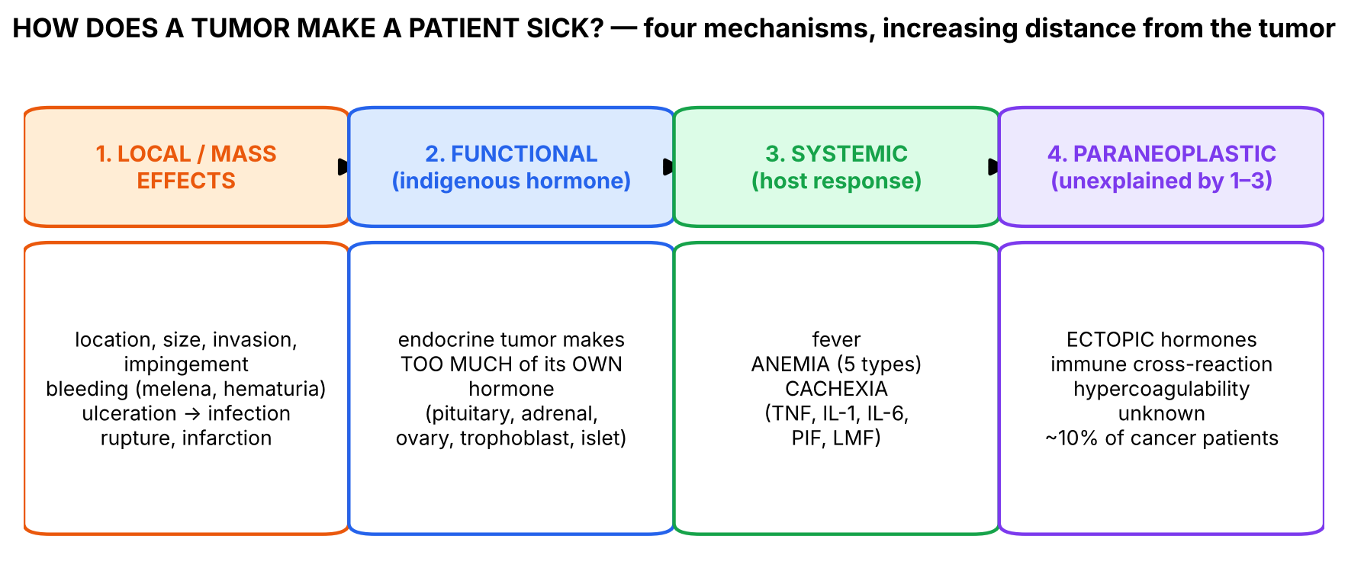
Figure 1. The four mechanisms. Every fact in the lecture belongs in one column.
💡 THE ORGANIZING PRINCIPLE
Pathology chain for this lecture: tumor (etiology) → what the tumor cell can do (grow, invade, bleed, secrete) → mechanism (mass effect, hormone, cytokines, antibodies, procoagulants) → clinical manifestation → complication → diagnosis.
• If a symptom is explained by where the tumor is → local effect.
• If explained by a hormone the tissue normally makes → functional (indigenous) effect.
• If explained by the body's response to the tumor (cytokines, iron trapping) → systemic effect (fever, anemia, cachexia).
• If none of these explains it → paraneoplastic syndrome.
This is the single most important idea: paraneoplastic is a diagnosis of exclusion, defined by what it is NOT (slide 11).

🧠 ANALOGY
Think of a tumor as a badly behaved tenant in an apartment block. It can (1) damage the walls around it (local effects); (2) if it lives in a factory flat (endocrine gland), run the factory's own machines too hard (functional hormones); (3) make the whole building run a fever and burn its furniture for fuel (cachexia, anemia); or (4) start making products it was never licensed to make — or make the building's security guards attack the residents (paraneoplastic: ectopic hormones, autoantibodies).

Section 1 — Local effects and general clinical features (slides 2–4)

1.1 What the slides say
▌ FROM THE SLIDES
- Both benign and malignant tumors cause morbidity and mortality; all masses require anatomic evaluation (slide 2).
- Clinical aspects of neoplasia (slide 3): location and impingement on adjacent structures; functional effects — hormone synthesis / paraneoplastic syndromes; fever; symptoms from bleeding, rupture, infarction and infections when the tumor ulcerates; cachexia (TNF, proteolysis-inducing factor, lipid-mobilizing factor).
- Local and hormonal effects (slide 4): location, size, local invasion, functional activity (hormone); bleeding → melena, hematuria, anemia; secondary infection from ulceration; non-endocrine tumors → paraneoplastic syndromes.
Speaker notes:
- A tiny pituitary adenoma (benign, possibly non-functional) can compress and destroy the surrounding normal gland → serious hypopituitarism.
- Hormone production is seen with benign and malignant neoplasms arising in endocrine glands.
- Non-endocrine tumors may elaborate hormones or hormone-like products → paraneoplastic syndromes.
- Melena (blood in stool) and hematuria are characteristic of neoplasms of the gut and urinary tract.
- TNF mobilizes fats from tissue stores and suppresses appetite; PIF and LMF increase catabolism of muscle and adipose tissue.
- Slide 4: a benign β-cell adenoma of the pancreatic islets (< 1 cm) may produce enough insulin to cause fatal hypoglycemia.

1.2 Making sense of it
▌ ADDITIONAL CONTEXT
Why can a benign tumor kill? 'Benign' describes behavior (no invasion, no metastasis), not consequences. Location and function matter as much as biology:
Benign tumor | Why dangerous | Mechanism category
Pituitary adenoma (non-functional) | Compresses normal gland → hypopituitarism; compresses optic chiasm → bitemporal hemianopia (HY) | Local (location/impingement)
Insulinoma (< 1 cm) | Insulin → fatal hypoglycemia | Functional (indigenous hormone)
Meningioma | Raises intracranial pressure in a closed skull | Local (size in a confined space)
Leiomyoma of the uterus / GI tract | Ulceration → bleeding → anemia | Local (bleeding)

Why do ulcerating tumors bleed and get infected? Tumors outgrow their blood supply → central ischemic necrosis (infarction) → the overlying mucosa breaks down → exposed vessels bleed (melena from colon/stomach, hematuria from bladder/kidney) and bacteria colonize necrotic tissue (secondary infection, e.g., post-obstructive pneumonia behind a bronchial tumor).
Fever in cancer: tumor or host macrophages release pyrogenic cytokines (IL-1, IL-6, TNF) that reset the hypothalamic set point. Classic febrile tumors (HY): renal cell carcinoma, Hodgkin lymphoma (Pel-Ebstein fever), hepatocellular carcinoma, leukemias. Infection (from neutropenia or obstruction) is the other major cause.
🩺 CLINICAL CORRELATION
• Painless hematuria in an older smoker → bladder (urothelial) carcinoma or renal cell carcinoma until proven otherwise.
• Melena / iron-deficiency anemia in an older adult → colorectal or gastric cancer work-up (colonoscopy, endoscopy).
• Episodic sweating, confusion, hypoglycemia relieved by glucose (Whipple triad) → insulinoma, even if tiny on imaging.
• Headache + bitemporal hemianopia + hypopituitarism → pituitary macroadenoma (mass effect).

🎯 EXAM FOCUS
• Benign tumors can cause serious morbidity/mortality through location (pituitary) or function (insulinoma < 1 cm).
• Melena and hematuria = neoplasms of gut and urinary tract.
• Cachexia mediators: TNF, PIF, LMF (slide 3).
• Typical question: 'A small, non-functioning, benign pituitary tumor causes which complication?' → hypopituitarism by compression.

⚠️ COMMON MISTAKES
• Assuming 'benign' means harmless.
• Calling hormone excess from an endocrine-gland tumor 'paraneoplastic' — that is a functional effect of an indigenous hormone.
• Forgetting that size is not destiny: a 1-cm insulinoma can kill; a 10-cm lipoma may be harmless.

Section 1 — Practice questions
Q1. [MCQ] A 45-year-old has recurrent fasting confusion relieved by glucose. CT shows a 0.8-cm well-circumscribed pancreatic islet tumor without invasion. Which statement is correct?
A. It cannot be clinically significant because it is < 1 cm
B. Its symptoms are a paraneoplastic syndrome
C. It is a functional tumor producing an indigenous hormone that can cause fatal hypoglycemia
D. It must be malignant because it causes symptoms
E. Its symptoms are due to cachexia

✅ ANSWER & EXPLANATION
C (slide 4). Insulin is native to β cells → functional, not paraneoplastic (B). Benign tumors can be lethal (A, D).

Q2. [MCQ] A non-functioning pituitary adenoma most commonly harms the patient by:
A. Ectopic ACTH
B. Compression of the normal gland causing hypopituitarism
C. Distant metastasis
D. Cachexia
E. PTHrP secretion

✅ ANSWER & EXPLANATION
B (slide 3 speaker notes).

Q3. [Clinical vignette] A 70-year-old man has fatigue and black, tarry stools. Hb is 8.9 g/dL with low MCV. Which tumor category and which clinical aspect of neoplasia does this illustrate?

✅ ANSWER & EXPLANATION
A gastrointestinal neoplasm (gastric or colorectal) that ulcerates and bleeds → melena → anemia (slides 3–4). This is a local effect, not paraneoplastic. Low MCV suggests iron deficiency from chronic blood loss.

Q4. [Short answer] List the clinical aspects of neoplasia given on slide 3.

✅ ANSWER & EXPLANATION
Location/impingement on adjacent structures; functional effects (hormone synthesis/paraneoplastic syndromes); fever; bleeding, rupture, infarction and infection when the tumor ulcerates; cachexia (TNF, PIF, LMF).

Q5. [Mechanism] Explain how a bronchial carcinoma can cause recurrent pneumonia even before metastasizing.

✅ ANSWER & EXPLANATION
Local effect: the tumor obstructs a bronchus → secretions accumulate distal to the obstruction → bacterial colonization → post-obstructive pneumonia; ulceration/necrosis of the tumor surface also invites infection (slide 3: infection when tumor ulcerates).

Section 2 — Functional tumors: indigenous hormone production (slide 5)

2.1 Big picture
Endocrine glands are hormone factories. A tumor of an endocrine cell often keeps the factory's machinery and makes the same hormone in excess, without the normal feedback brakes. The resulting syndrome is simply the physiology of that hormone, exaggerated. Because the hormone is native to the tissue, this is NOT paraneoplastic (slide 11).
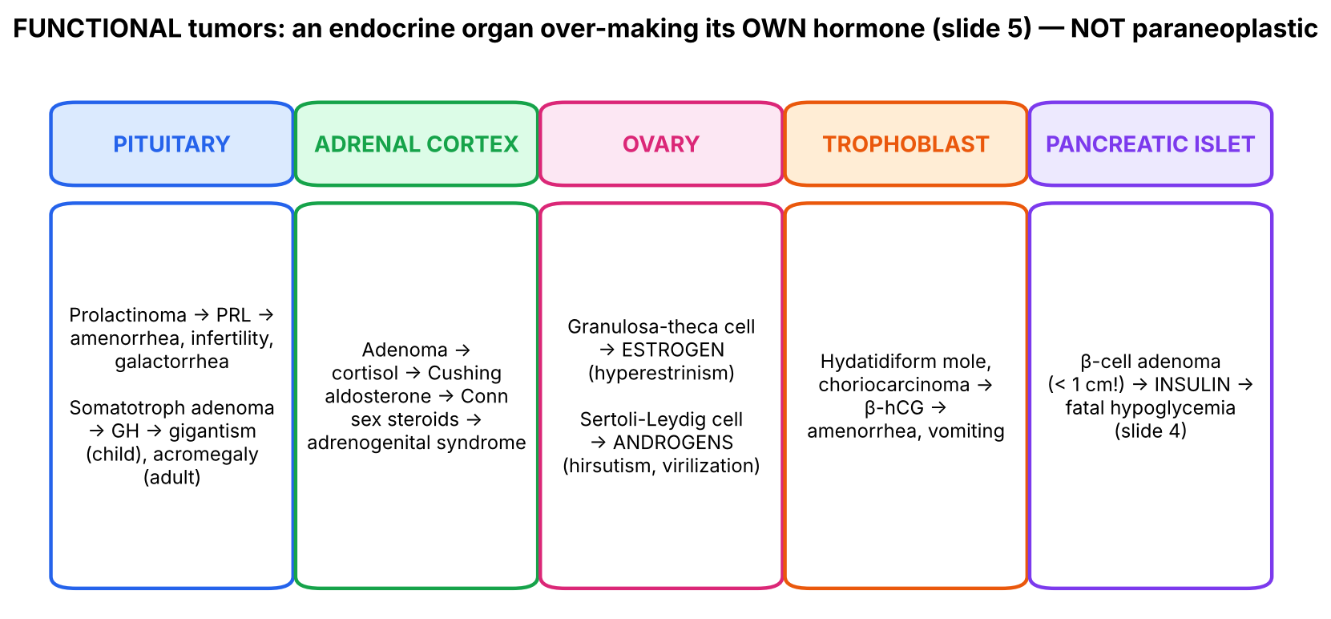
Figure 2. Functional (indigenous-hormone) tumors from slides 4–5.

2.2 What the slides say
▌ FROM THE SLIDES
Organ | Tumor | Hormone | Syndrome
Pituitary | Prolactinoma | Prolactin | Amenorrhea, infertility, galactorrhea
Pituitary | Somatotroph adenoma | Growth hormone | Gigantism (children) / acromegaly (adults)
Adrenal | Adrenal adenoma | Cortisol | Cushing syndrome
Adrenal | Adrenal adenoma | Mineralocorticoids | Conn syndrome
Adrenal | Adrenal adenoma | Sex hormones | Adrenogenital syndrome
Ovary | Granulosa-theca cell tumor | Estrogen | Hyperestrinism
Ovary | Sertoli-Leydig cell tumor | Androgens | Excess androgen — hirsutism
Trophoblast | Hydatidiform mole, choriocarcinoma | β-hCG | Amenorrhea & vomiting
Pancreatic islet (slide 4) | β-cell adenoma (< 1 cm) | Insulin | Fatal hypoglycemia

Speaker notes: hyperestrinism can cause precocious sexual development, endometrial hyperplasia and increased risk of endometrial carcinoma; excess androgens in females → masculinization and defeminization.

2.3 Derive each syndrome from physiology
▌ ADDITIONAL CONTEXT
Hormone | Normal job | Excess → each finding
Prolactin | Milk production; suppresses GnRH (lactational amenorrhea) | Galactorrhea (milk); ↓GnRH → ↓LH/FSH → amenorrhea, infertility (men: ↓libido, ED)
GH (via IGF-1) | Growth of bone, soft tissue; anti-insulin | Before epiphyseal closure → long bones lengthen (gigantism); after → bones thicken, hands/feet/jaw enlarge (acromegaly); insulin resistance, cardiomegaly (HY)
Cortisol | Stress hormone: gluconeogenesis, catabolism, anti-inflammatory | Central obesity, moon face, striae, proximal myopathy, hyperglycemia, osteoporosis, hypertension
Aldosterone | Na⁺ retention, K⁺/H⁺ excretion | Hypertension, hypokalemia, metabolic alkalosis (Conn)
Adrenal androgens | Weak sex steroids | Virilization of females, precocious puberty in boys (adrenogenital)
Estrogen | Proliferates endometrium, breast; puberty | Precocious puberty, endometrial hyperplasia → carcinoma, abnormal uterine bleeding
Androgen | Male characteristics | Hirsutism, deep voice, clitoromegaly (masculinization); breast atrophy, amenorrhea (defeminization)
β-hCG | Maintains corpus luteum in pregnancy | Pregnancy-like state: amenorrhea, hyperemesis (vomiting); very high hCG can stimulate the TSH receptor → hyperthyroidism (HY); theca-lutein cysts (HY)

▌ HIGH-YIELD ADDITIONAL KNOWLEDGE
- Granulosa cell tumor: Call-Exner bodies on histology; estrogen → postmenopausal bleeding / precocious puberty; inhibin is a tumor marker.
- Prolactinoma is the most common functioning pituitary adenoma; treated first with dopamine agonists (cabergoline, bromocriptine) because dopamine is the physiological inhibitor of prolactin.
- Acromegaly screening: IGF-1; confirm with failure of GH suppression after oral glucose.
- Choriocarcinoma metastasizes early, hematogenously, to the lungs ('cannonball' lesions); hCG is the tumor marker to follow.
🩺 CLINICAL CORRELATION
• Young woman with amenorrhea + galactorrhea + negative pregnancy test → check prolactin → MRI pituitary.
• Woman with enlarged uterus 'too big for dates', vaginal bleeding, hyperemesis, very high β-hCG → hydatidiform mole.
• Postmenopausal bleeding + ovarian mass → estrogen-secreting granulosa cell tumor causing endometrial hyperplasia.
• Hypertension + hypokalemia → Conn syndrome (aldosterone-producing adrenal adenoma).

🎯 EXAM FOCUS
• Prolactinoma → amenorrhea, infertility, galactorrhea; somatotroph adenoma → gigantism (child) / acromegaly (adult).
• Adrenal adenoma: cortisol → Cushing; mineralocorticoid → Conn; sex hormone → adrenogenital.
• Granulosa-theca → hyperestrinism (endometrial hyperplasia/carcinoma); Sertoli-Leydig → androgens (hirsutism).
• Mole / choriocarcinoma → β-hCG → amenorrhea & vomiting.

⚠️ COMMON MISTAKES
• Calling these 'paraneoplastic' — the hormones are indigenous to the tissue of origin.
• Swapping the ovarian tumors: Granulosa = estroGen (female); Sertoli-Leydig = teStosterone (male-type).
• Mixing gigantism and acromegaly — the difference is timing relative to epiphyseal closure.

Section 2 — Practice questions
Q1. [MCQ] A 58-year-old woman has postmenopausal bleeding. Endometrial biopsy shows hyperplasia. Ultrasound shows a solid ovarian mass. Which tumor is most likely?
A. Sertoli-Leydig cell tumor
B. Granulosa-theca cell tumor
C. Choriocarcinoma
D. Serous cystadenoma
E. Teratoma

✅ ANSWER & EXPLANATION
B. Estrogen excess (hyperestrinism) → endometrial hyperplasia and increased risk of endometrial carcinoma (slide 5 notes).

Q2. [MCQ] Which pairing is a FUNCTIONAL (indigenous) effect rather than a paraneoplastic syndrome?
A. Small cell lung carcinoma → ACTH
B. Squamous cell lung carcinoma → PTHrP
C. Adrenal adenoma → aldosterone
D. Pancreatic carcinoma → Trousseau syndrome
E. Gastric carcinoma → acanthosis nigricans

✅ ANSWER & EXPLANATION
C. Aldosterone is native to the adrenal cortex → Conn syndrome (functional). The others are paraneoplastic.

Q3. [Clinical vignette] A 26-year-old woman, 12 weeks pregnant, has severe vomiting, vaginal bleeding, a uterus larger than expected for dates, and β-hCG far above normal. Ultrasound shows a 'snowstorm' pattern. Explain the vomiting and amenorrhea.

✅ ANSWER & EXPLANATION
Hydatidiform mole: abnormal trophoblast secretes very high β-hCG (slide 5). hCG maintains a pregnancy-like hormonal state (amenorrhea), and very high levels are linked to hyperemesis. (HY: hCG can also stimulate TSH receptors → hyperthyroidism.)

Q4. [Short answer] List the three syndromes an adrenal adenoma can cause and their hormones.

✅ ANSWER & EXPLANATION
Cortisol → Cushing syndrome; mineralocorticoids (aldosterone) → Conn syndrome; sex hormones → adrenogenital syndrome.

Q5. [Mechanism] Explain why a prolactinoma causes amenorrhea and infertility, not just galactorrhea.

✅ ANSWER & EXPLANATION
Prolactin inhibits hypothalamic GnRH release → ↓LH and FSH → no follicle development or ovulation → amenorrhea and infertility. (This is the same mechanism as lactational amenorrhea.)

Section 3 — Systemic effects I: anemia and the bone marrow (slides 6–7)

3.1 Big picture
Anemia is extremely common in cancer, but it is not one disease. The lecture lists five types; each corresponds to a different way of failing to keep enough red cells: iron trapped, iron lost, folate consumed, RBCs destroyed, or marrow crowded out.
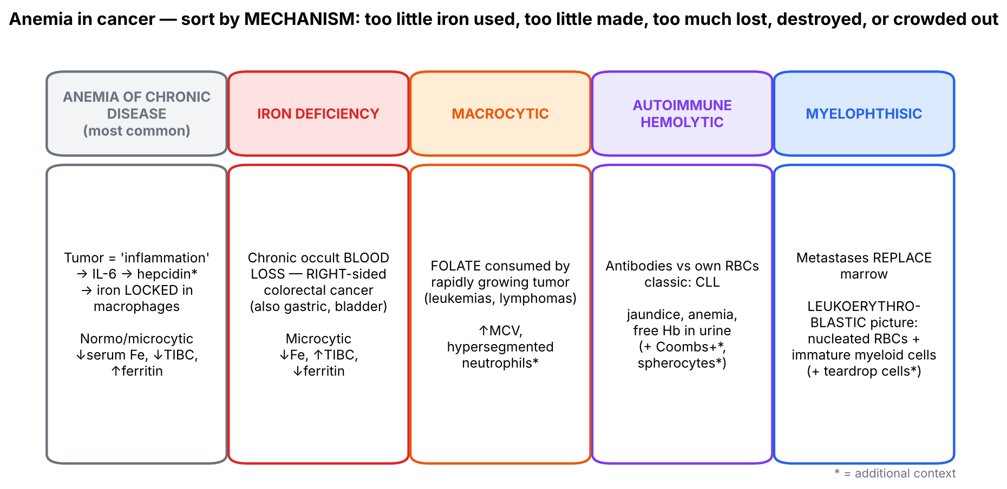
Figure 3. Five anemias of cancer arranged by mechanism (slides 6–7 and notes).

3.2 What the slides say
▌ FROM THE SLIDES
- Anemia of chronic disease — most common type. (Notes: the body treats tumors as inflammatory lesions 'due to bacteria' and stores iron in macrophages; although total iron stores are adequate, iron is not made available for Hb synthesis → anemia.)
- Iron-deficiency anemia (notes) — right-sided colorectal cancer causes bleeding and loss of blood in stool. ★ Colorectal cancer is starred on the slide.
- Macrocytic anemia — folate deficiency from rapid tumor growth, as in leukemias and lymphomas.
- Autoimmune hemolytic anemia — the body makes antibodies to its own RBCs → jaundice, anemia, free Hb in urine; ★ chronic lymphocytic leukemia.
- Myelophthisic anemia ★★★★★ (slide 7) — anemia related to metastasis to bone marrow; metastases replace normal hematopoietic elements, so RBC precursors are scarce.
- Leukoerythroblastic blood picture — marrow metastasis pushes immature hematopoietic cells (nucleated RBCs, myeloblasts) into the peripheral blood. Notes: myelophthisic processes can be suspected from nucleated RBCs and/or immature myeloid cells (metamyelocytes, myelocytes) in the blood. Slide image: metastasis from a carcinoma to the vertebral bone marrow.
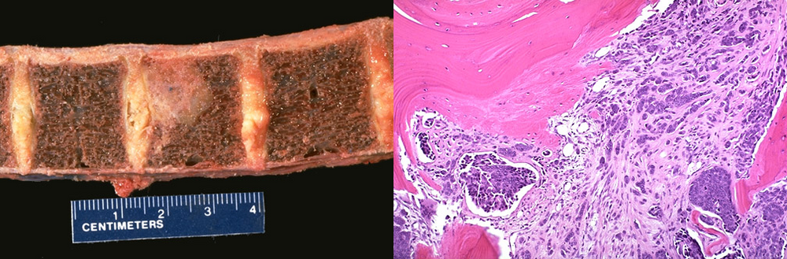
Slide 7 images: carcinoma metastatic to vertebral bodies (gross, left) and replacing marrow between bone trabeculae (histology, right).

3.3 The mechanisms in more depth
▌ ADDITIONAL CONTEXT
Type | Mechanism (why) | Lab picture | Typical cancer
Anemia of chronic disease | Cytokines (IL-6) ↑ hepcidin → blocks ferroportin → iron trapped in macrophages + ↓ gut absorption; evolutionary 'starve the bacteria' response | Normocytic (or mildly microcytic); ↓ serum iron, ↓ TIBC, ↑ ferritin | Any (most common)
Iron deficiency | Chronic occult GI bleeding from ulcerated tumor | Microcytic, hypochromic; ↓ iron, ↑ TIBC, ↓ ferritin | Right-sided colon (occult bleeding), gastric
Macrocytic | Rapidly dividing tumor cells consume folate needed for DNA synthesis → megaloblastic erythropoiesis | ↑ MCV, hypersegmented neutrophils | Leukemias, lymphomas
Autoimmune hemolytic | Neoplastic or dysregulated B cells make anti-RBC antibodies (usually warm IgG) → splenic destruction / intravascular lysis | ↑ indirect bilirubin, ↑ LDH, ↓ haptoglobin, Coombs+, spherocytes; hemoglobinuria | CLL, lymphomas
Myelophthisic | Space-occupying replacement of marrow (metastasis, fibrosis) → disrupted marrow architecture lets immature cells escape | Leukoerythroblastic: nucleated RBCs + immature granulocytes; teardrop RBCs (dacrocytes) | Breast, prostate, lung (common bone metastasizers); also myelofibrosis

▌ HIGH-YIELD ADDITIONAL KNOWLEDGE
- Right vs left colon cancer: right-sided (wide lumen, liquid stool) → occult bleeding, iron-deficiency anemia, fatigue; left-sided (narrow lumen, formed stool) → obstruction, change in bowel habits, 'apple-core' lesion, blood-streaked stool. Iron-deficiency anemia in an older man or postmenopausal woman = colon cancer until proven otherwise.
- Ferritin is the key discriminator: low in iron deficiency, high (acute-phase reactant) in anemia of chronic disease.
🩺 CLINICAL CORRELATION
• 65-year-old man with fatigue and microcytic anemia, no visible bleeding → colonoscopy (right-sided colon cancer).
• Woman with treated breast cancer, new back pain, pancytopenia and nucleated RBCs on smear → bone marrow metastasis (myelophthisic).
• Elderly patient with lymphocytosis and smudge cells who becomes jaundiced with dark urine → CLL with autoimmune hemolytic anemia.

🎯 EXAM FOCUS
• Anemia of chronic disease = most common cancer anemia (iron trapped in macrophages).
• Iron deficiency ← right-sided colorectal cancer bleeding ★.
• Macrocytic ← folate deficiency from rapid tumor growth (leukemias, lymphomas).
• AIHA ← CLL ★ (jaundice, anemia, free Hb in urine).
• Myelophthisic anemia ★★★★★ ← marrow metastasis → leukoerythroblastic blood (nucleated RBCs, myeloblasts).

⚠️ COMMON MISTAKES
• Calling all cancer anemia 'iron deficiency' — chronic disease is most common, and ferritin is high.
• Thinking anemia of chronic disease means the body is iron-deficient — stores are adequate, just unavailable.
• Confusing leukoerythroblastic (immature cells in blood from marrow infiltration) with leukemia (malignant clone of blasts).
• Associating AIHA with CML instead of CLL.

Section 3 — Practice questions
Q1. [MCQ] A patient with metastatic prostate cancer has anemia; the peripheral smear shows nucleated RBCs, myelocytes and teardrop cells. What is the mechanism?
A. Iron sequestration in macrophages
B. Folate consumption
C. Replacement of marrow by metastatic tumor
D. Autoantibodies against RBCs
E. Chronic GI blood loss

✅ ANSWER & EXPLANATION
C — myelophthisic anemia with a leukoerythroblastic picture (slide 7).

Q2. [MCQ] Which lab pattern indicates anemia of chronic disease rather than iron deficiency?
A. ↓ ferritin, ↑ TIBC
B. ↑ ferritin, ↓ TIBC
C. ↑ MCV, hypersegmented neutrophils
D. Positive Coombs test
E. Nucleated RBCs

✅ ANSWER & EXPLANATION
B. Iron is stored (ferritin high) but unavailable; TIBC falls. A = iron deficiency.

Q3. [Clinical vignette] A 72-year-old man with chronic lymphocytic leukemia develops jaundice, fatigue and dark red-brown urine. Hb 7.5 g/dL, ↑ indirect bilirubin, ↑ LDH, ↓ haptoglobin. What complication has occurred and why?

✅ ANSWER & EXPLANATION
Autoimmune hemolytic anemia (slide 6: CLL). Dysregulated/neoplastic B cells produce antibodies against the patient's own RBCs → hemolysis → jaundice (bilirubin), anemia and free hemoglobin in urine.

Q4. [Short answer] Explain why right-sided colon cancer presents with anemia while left-sided colon cancer more often presents with obstruction.

✅ ANSWER & EXPLANATION
The right colon has a wide lumen and liquid stool → tumors grow large without obstructing, but ulcerate and bleed slowly (occult) → iron-deficiency anemia. The left colon is narrower with formed stool → annular tumors obstruct and change bowel habits (HY additional).

Q5. [Mechanism] Why does a tumor cause the body to sequester iron, according to the speaker notes?

✅ ANSWER & EXPLANATION
The body treats the tumor as an inflammatory lesion 'due to bacteria'; inflammatory signaling (IL-6 → hepcidin, additional) locks iron in macrophages to deny it to microbes. Iron stores are adequate but unavailable for hemoglobin synthesis → anemia of chronic disease.

Section 4 — Systemic effects II: cancer cachexia (slides 8–9)

4.1 What the slides say
▌ FROM THE SLIDES
- Cancer cachexia ★★★★ is a hypercatabolic state, defined by loss of muscle mass (with or without loss of fat) that cannot be explained by diminished food intake.
- Occurs in about 50% of cancer patients, most commonly with advanced gastrointestinal, pancreatic and lung cancers.
- Highly debilitating: extreme weight loss, fatigue, muscle atrophy, anemia, anorexia and edema.
- Responsible for about 30% of cancer deaths, as a consequence of atrophy of the diaphragm and other respiratory muscles.
- Causes ★★★★★: inflammatory mediators/cytokines — TNF ★★★, IL-1 and IL-6. Cytokines increase degradation of skeletal-muscle myosin heavy chain through signaling pathways → ubiquitination of target proteins → proteolysis via the proteasome. Muscle wasting is the cardinal feature.
- Some patients lose fat stores — due to lipid-mobilizing factor, which sensitizes adipocytes to lipolytic stimuli.
- Speaker notes: the exact cause is not known; TNF mobilizes fats and suppresses appetite; PIF and LMF increase catabolism of muscle and adipose tissue.
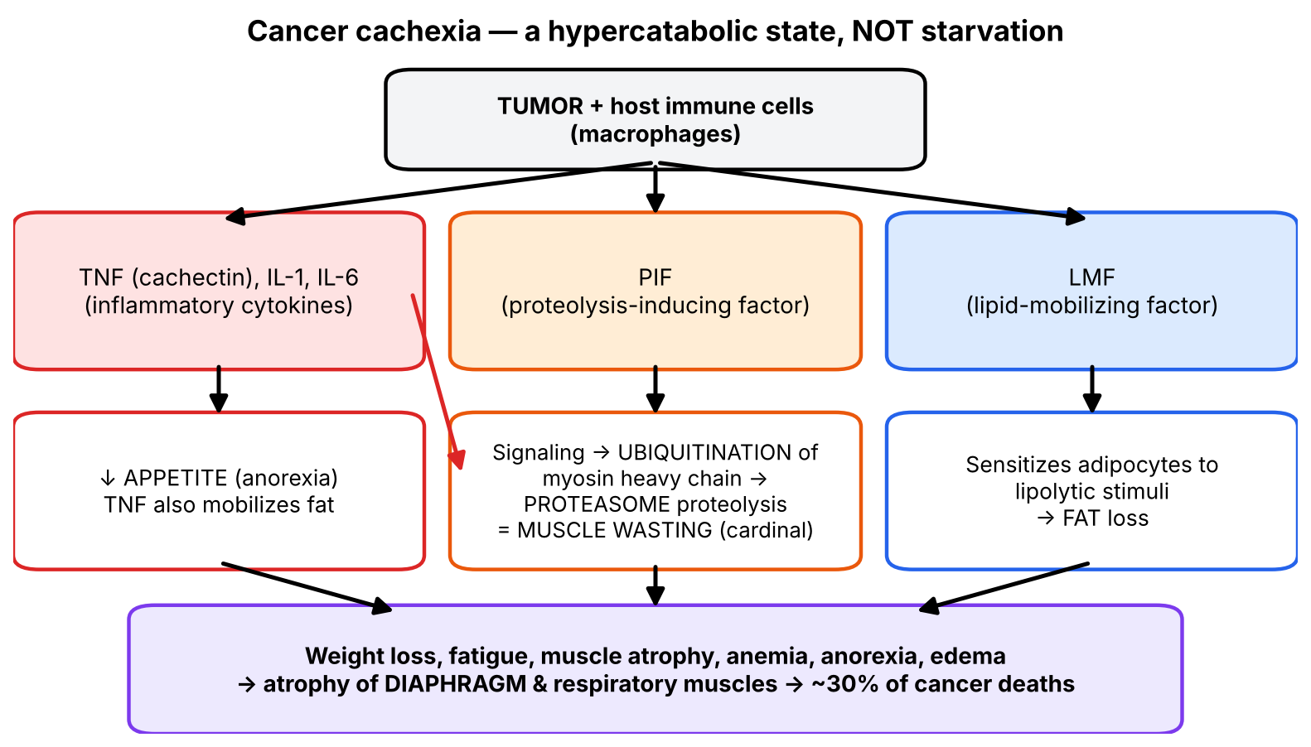
Figure 4. The cachexia cascade (slides 3, 8, 9 and notes).

4.2 Cachexia vs starvation — why the definition matters
▌ ADDITIONAL CONTEXT
Feature | Simple starvation | Cancer cachexia
Cause | Not enough food | Cytokine-driven hypercatabolism (TNF, IL-1, IL-6, PIF, LMF)
What is lost first | Fat (body spares muscle) | Muscle (cardinal feature) ± fat
Basal metabolic rate | Falls (adaptation) | Normal or rises
Reversed by feeding? | Yes | No — 'cannot be explained by diminished food intake'
Inflammation markers | Normal | ↑ CRP, ↑ IL-6

Connect to biochemistry: the ubiquitin–proteasome pathway is the same machinery used to make MHC class I peptides (Lecture 10). In cachexia, cytokine signaling (largely via NF-κB) up-regulates muscle-specific E3 ubiquitin ligases, tagging myosin heavy chain for destruction. TNF-α was historically called 'cachectin' for exactly this effect.
Why edema and anemia? Muscle and visceral protein catabolism + reduced hepatic albumin synthesis (inflammation diverts the liver to acute-phase proteins) → hypoalbuminemia → edema; anemia of chronic disease contributes to fatigue.
🩺 CLINICAL CORRELATION
• Pancreatic or gastric cancer patient who keeps losing weight despite adequate nutrition → cachexia, not just poor intake.
• Death from cachexia often comes through respiratory failure / pneumonia due to weak respiratory muscles (slide 8).
• Appetite stimulants (megestrol, corticosteroids) improve intake but don't reverse muscle loss — consistent with a catabolic, not intake-based, disease (HY).

🎯 EXAM FOCUS
• Definition: muscle loss not explained by diminished intake; hypercatabolic.
• ~50% of cancer patients (GI, pancreatic, lung); ~30% of cancer deaths (respiratory muscle atrophy).
• Mediators: TNF (key), IL-1, IL-6; PIF; LMF (fat).
• Mechanism: ubiquitination → proteasomal degradation of myosin heavy chain.

⚠️ COMMON MISTAKES
• Thinking cachexia is due to poor eating — by definition it is not.
• Saying fat loss is the cardinal feature — muscle wasting is.
• Confusing LMF (fat) with PIF (protein/muscle).
• Calling cachexia a paraneoplastic syndrome — slide 11 explicitly says paraneoplastic syndrome is not cancer cachexia.

Section 4 — Practice questions
Q1. [MCQ] Which cytokine is most emphasized as a cause of cancer cachexia?
A. IL-4
B. IL-10
C. TNF
D. TGF-β
E. IL-2

✅ ANSWER & EXPLANATION
C — TNF ★★★ (also IL-1, IL-6).

Q2. [MCQ] Which pathway mediates muscle protein breakdown in cancer cachexia?
A. Lysosomal autophagy only
B. Caspase-mediated apoptosis
C. Ubiquitination and proteasomal degradation of myosin heavy chain
D. Complement-mediated lysis
E. Calpain-induced necrosis only

✅ ANSWER & EXPLANATION
C (slide 9).

Q3. [Clinical vignette] A 63-year-old man with metastatic pancreatic cancer has lost 18% of his body weight in 4 months despite nasogastric feeding at full caloric requirements. Temporal muscle wasting and pedal edema are present. Explain why feeding hasn't helped and the most likely cause of eventual death from this process.

✅ ANSWER & EXPLANATION
Cancer cachexia is hypercatabolic: TNF, IL-1, IL-6 and PIF drive ubiquitin–proteasome degradation of muscle, and LMF drives fat loss, independent of intake (slides 8–9). About 30% of cancer deaths result from atrophy of the diaphragm and respiratory muscles → respiratory failure/pneumonia.

Q4. [Short answer] List the five features of cancer cachexia given on slide 8 plus the cardinal one.

✅ ANSWER & EXPLANATION
Extreme weight loss, fatigue, muscle atrophy, anemia, anorexia, edema; muscle wasting is the cardinal feature.

Q5. [Mechanism] How does TNF contribute to both sides of cachexia (intake and catabolism)?

✅ ANSWER & EXPLANATION
TNF suppresses appetite (anorexia, ↓ intake) and mobilizes fat from stores; together with IL-1/IL-6 it activates signaling that ubiquitinates myosin heavy chain for proteasomal degradation (↑ catabolism).

Section 5 — Paraneoplastic syndromes: definition and the master table (slides 10–15)

5.1 Definition — what it is and what it is NOT (slides 11–12)
▌ FROM THE SLIDES
Some cancer-bearing individuals develop signs and symptoms that cannot readily be explained by the anatomic distribution of the tumor or by the elaboration of hormones indigenous to the tissue from which the tumor arose. Paraneoplastic syndromes occur in about 10% of persons with cancer (slide 12).
Slide 11 defines it by exclusion. A paraneoplastic syndrome:
Is… | Is NOT…
A symptom complex occurring in cancer patients | Cancer cachexia
Due to production of ectopic hormones (slide 11) | Due to local spread
 | Due to distant spread (metastasis)
 | Due to hormones indigenous (native) to the tissue of origin

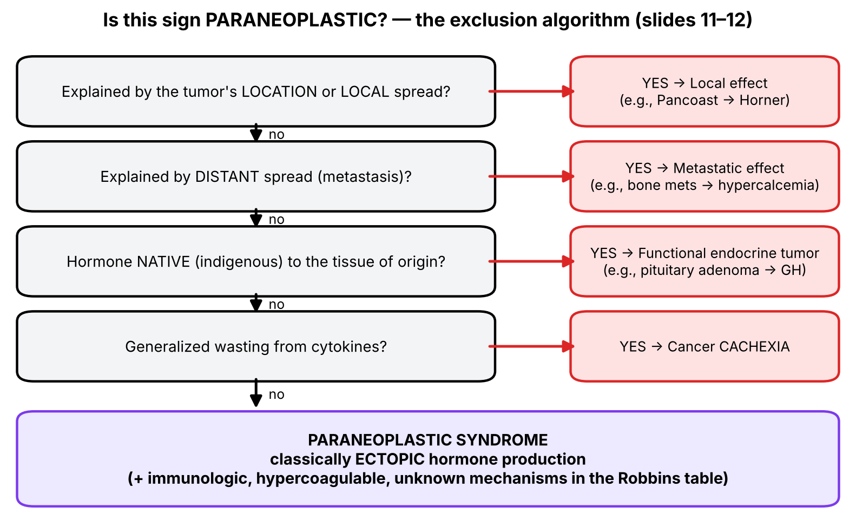
Figure 5. Turning slide 11 into a decision algorithm.
▌ ADDITIONAL CONTEXT
A nuance worth knowing: slide 11 says paraneoplastic syndromes are due to ectopic hormones — that is the classic, best-known mechanism. But the Robbins table on slides 14–15 also lists immunologic (autoantibodies), hypercoagulable (tumor procoagulants) and unknown mechanisms. On an exam, 'ectopic hormone' is the textbook answer for the endocrinopathies; for skin, nerve and clotting syndromes, use the mechanism listed in the table.

5.2 Why they matter (slide 13)
▌ FROM THE SLIDES
- May be the earliest manifestation of an occult neoplasm.
- Cause significant clinical problems and may even be lethal.
- Mimic metastatic disease and therefore confound treatment.
- Are the most difficult to manage.

5.3 The master table (slides 14–15, Robbins)
▌ FROM THE SLIDES
Clinical syndrome | Major forms of underlying cancer | Causal mechanism
ENDOCRINOPATHIES
Cushing syndrome | Small cell carcinoma of lung; pancreatic carcinoma; neural tumors | ACTH or ACTH-like substance
SIADH | Small cell carcinoma of lung; intracranial neoplasms | Antidiuretic hormone or atrial natriuretic hormones
Hypercalcemia | Squamous cell carcinoma of lung; breast carcinoma; renal carcinoma; adult T-cell leukemia/lymphoma | PTHrP, TGF-α, TNF, IL-1
Hypoglycemia | Ovarian carcinoma; fibrosarcoma; other mesenchymal sarcomas | Insulin or insulin-like substance
Polycythemia | Renal carcinoma; cerebellar hemangioma; hepatocellular carcinoma | Erythropoietin
Osteomalacia | Phosphaturic mesenchymal tumor | FGF-23
NERVE AND MUSCLE SYNDROMES
Myasthenia | Bronchogenic carcinoma; thymic neoplasms | Immunologic
Disorders of the central and peripheral nervous systems | Breast carcinoma | —
DERMATOLOGIC DISORDERS
Acanthosis nigricans | Gastric carcinoma; lung carcinoma; uterine carcinoma | Immunologic; secretion of epidermal growth factor
Dermatomyositis | Bronchogenic carcinoma; breast carcinoma | Immunologic
OSSEOUS, ARTICULAR, SOFT TISSUE
Hypertrophic osteoarthropathy and clubbing of the fingers | Bronchogenic carcinoma; thymic neoplasms | Unknown
VASCULAR AND HEMATOLOGIC
Venous thrombosis (Trousseau phenomenon) | Pancreatic carcinoma; bronchogenic carcinoma; other cancers | Tumor products (mucins that activate clotting)
Disseminated intravascular coagulation | Acute promyelocytic leukemia; prostatic carcinoma | Tumor products that activate clotting
Nonbacterial thrombotic endocarditis | Advanced cancers | Hypercoagulability
Red cell aplasia | Thymic neoplasms | Unknown
OTHERS
Nephrotic syndrome | Various cancers | Tumor antigens, immune complexes

5.4 Giving the table anchors — two ways to slice it
💡 THE ORGANIZING PRINCIPLE
A 20-row table is the definition of 'words without anchors'. Slice it two ways and most rows become predictable:
• By mechanism (Figure 6): what is the tumor doing — making a hormone, provoking antibodies, triggering clotting, or unknown?
• By tumor (Figure 7): what does the tumor's cell of origin already know how to make? Small cell lung carcinoma comes from neuroendocrine (Kulchitsky) cells, which carry the machinery for peptide hormones — so it makes ACTH and ADH. Mucin-secreting adenocarcinomas (pancreas, lung, GI) release mucins/tissue factor — so they cause clotting (Trousseau, NBTE). The thymus is an immune organ — so thymomas cause immune syndromes (myasthenia, red cell aplasia). The kidney normally senses oxygen and makes EPO — so renal carcinoma makes EPO (polycythemia).
The genuinely arbitrary pairings (e.g., squamous cell lung carcinoma → PTHrP; breast carcinoma → neurological syndromes; ovarian carcinoma/fibrosarcoma → hypoglycemia) need direct memorization — they are listed in the review section.

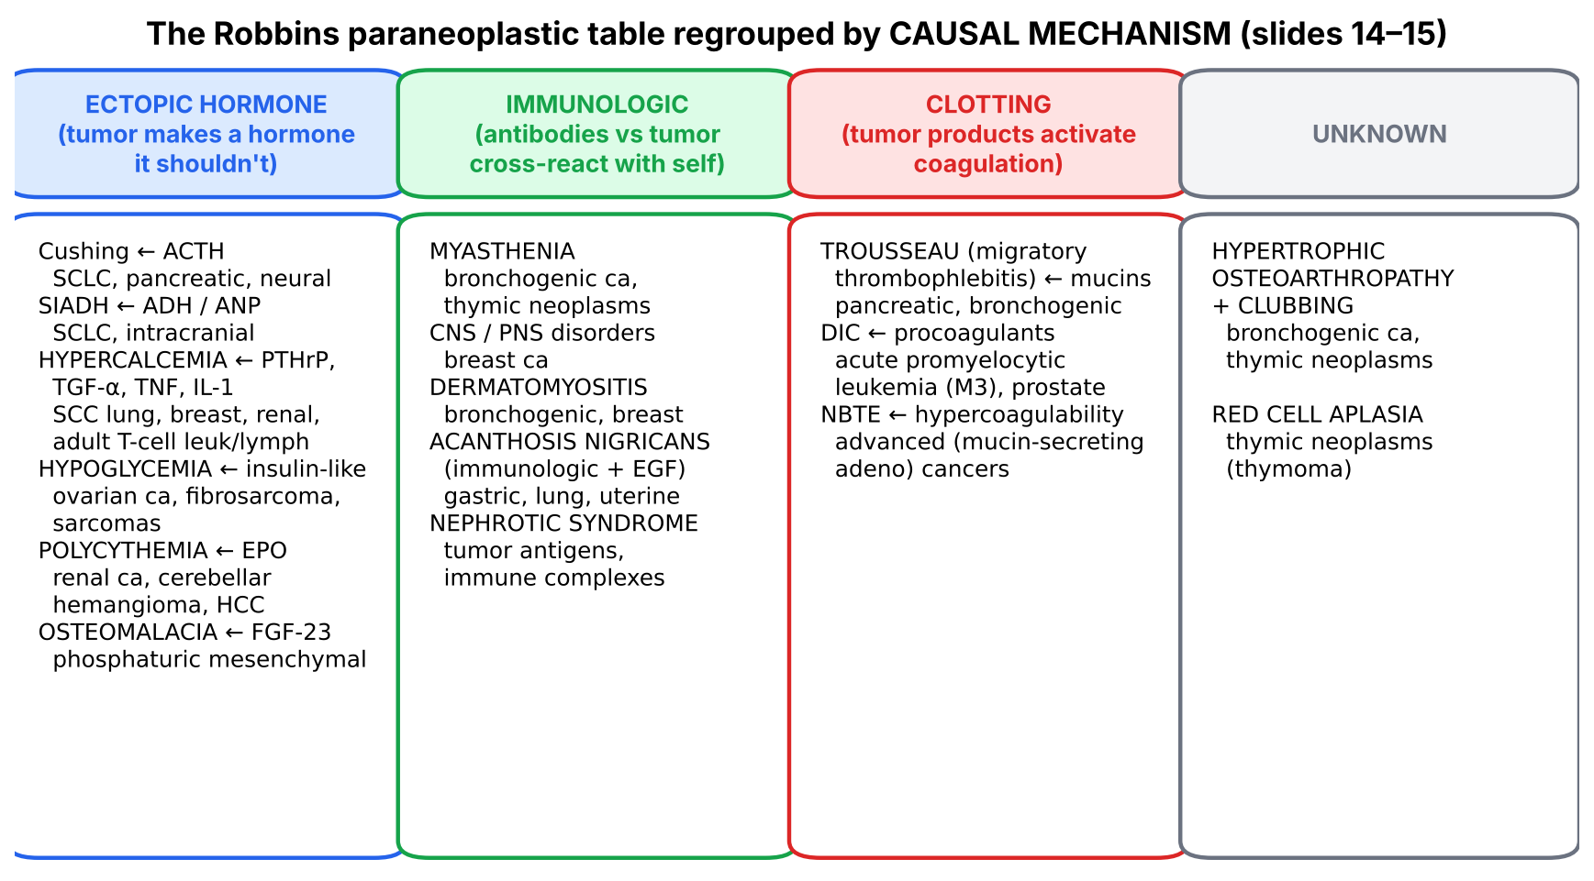
Figure 6. Robbins table regrouped by mechanism.
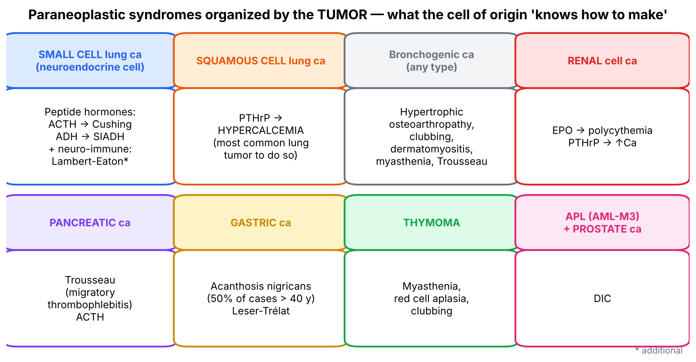
Figure 7. Robbins table regrouped by tumor.
▌ ADDITIONAL CONTEXT
Row | Physiology that explains the findings
SIADH | Excess ADH → water retention in collecting duct → dilutional hyponatremia, concentrated urine, euvolemia → confusion, seizures. (ANP also causes natriuresis → hyponatremia.)
Hypoglycemia (sarcomas) | Large mesenchymal tumors secrete big IGF-II ('insulin-like substance') → activates insulin receptors; insulin itself is suppressed (HY).
Polycythemia | EPO → ↑ RBC mass → ↑ hematocrit, hyperviscosity. The slide's 'cerebellar hemangioma' = cerebellar hemangioblastoma (von Hippel–Lindau). HY mnemonic list: pheochromocytoma, renal cell carcinoma, HCC, hemangioblastoma, leiomyoma.
Osteomalacia | FGF-23 → kidney wastes phosphate and ↓ 1α-hydroxylase (↓ calcitriol) → hypophosphatemia → poorly mineralized bone (osteomalacia), bone pain, fractures.
Myasthenia | Thymoma → myasthenia gravis (anti-AChR antibodies). With bronchogenic (small cell) carcinoma the classic syndrome is Lambert–Eaton myasthenic syndrome (anti-presynaptic voltage-gated Ca²⁺ channel antibodies; weakness improves with repeated use) — HY.
CNS/PNS disorders | Antibodies against tumor antigens cross-react with neurons: e.g., anti-Yo → cerebellar degeneration (breast, ovarian), anti-Hu → encephalomyelitis/sensory neuropathy (small cell lung) — HY.
Dermatomyositis | Immune attack on muscle and skin (heliotrope rash, Gottron papules, proximal weakness) → screen for lung, breast (and ovarian, HY) carcinoma.
Nephrotic syndrome | Tumor antigen–antibody immune complexes deposit in glomeruli → membranous nephropathy (solid tumors); minimal change disease with Hodgkin lymphoma (HY).

🩺 CLINICAL CORRELATION
• A paraneoplastic sign may be the first clue to cancer (slide 13): new acanthosis nigricans in a thin 60-year-old, sudden eruptive seborrheic keratoses, migratory thrombophlebitis, adult-onset dermatomyositis — all warrant a malignancy search.
• Paraneoplastic syndromes can mimic metastases (slide 13): e.g., hypercalcemia from PTHrP may be mistaken for bone metastases, leading to wrong staging and treatment.
• Treating the underlying tumor often resolves endocrine paraneoplastic syndromes; immune-mediated neurological syndromes often persist (HY).

🎯 EXAM FOCUS
• Definition by exclusion: not cachexia, not local or distant spread, not indigenous hormones; due to ectopic hormones (slide 11).
• ~10% of cancer patients.
• Significance: earliest sign of occult cancer, may be lethal, mimics metastasis, difficult to manage.
• Exams test table pairings in both directions: syndrome → tumor and tumor → syndrome (Figures 6–7).

⚠️ COMMON MISTAKES
• Calling hypercalcemia from bone metastases paraneoplastic — it is not (slide 19); only humoral (PTHrP) hypercalcemia is.
• Calling GH excess from a pituitary adenoma paraneoplastic — indigenous hormone.
• Assuming cachexia is paraneoplastic — slide 11 excludes it.
• Thinking paraneoplastic syndromes only happen with advanced cancer — they are often the earliest sign.

Section 5 — Practice questions
Q1. [MCQ] Which of the following is a paraneoplastic syndrome?
A. Hypopituitarism from a pituitary macroadenoma
B. Hypercalcemia from lytic bone metastases of breast cancer
C. Cushing syndrome from ACTH secreted by small cell lung carcinoma
D. Conn syndrome from an adrenal adenoma
E. Cachexia in pancreatic cancer

✅ ANSWER & EXPLANATION
C. A = local; B = metastatic (not paraneoplastic per slide 19); D = indigenous hormone; E = cachexia (excluded on slide 11).

Q2. [MCQ] Approximately what proportion of cancer patients develop paraneoplastic syndromes?
A. 1%
B. 10%
C. 30%
D. 50%
E. 90%

✅ ANSWER & EXPLANATION
B (slide 12). 50% = cachexia; 30% = cancer deaths from cachexia.

Q3. [Clinical vignette] A 66-year-old smoker has confusion and a serum sodium of 118 mEq/L with inappropriately concentrated urine and normal volume status. CXR shows a central hilar mass. Which tumor and mechanism?

✅ ANSWER & EXPLANATION
Small cell carcinoma of the lung secreting ADH (or ANP) → SIADH → dilutional hyponatremia → confusion (slide 14). SCLC derives from neuroendocrine cells that can make peptide hormones.

Q4. [Short answer] List the four reasons paraneoplastic syndromes are clinically significant (slide 13).

✅ ANSWER & EXPLANATION
(1) Earliest manifestation of an occult neoplasm; (2) cause significant clinical problems, may be lethal; (3) mimic metastatic disease and confound treatment; (4) most difficult to manage.

Q5. [Mechanism] A patient with a large retroperitoneal fibrosarcoma has recurrent fasting hypoglycemia. Insulin and C-peptide levels are LOW. Explain.

✅ ANSWER & EXPLANATION
The sarcoma secretes an insulin-like substance (big IGF-II, additional) that activates insulin receptors → hypoglycemia. Because it is not insulin, endogenous insulin and C-peptide are appropriately suppressed — distinguishing it from an insulinoma (high insulin and C-peptide).

Section 6 — The five starred paraneoplastic syndromes in depth (slides 16–26)
The professor numbered five syndromes for detailed discussion: 1. Cushing, 2. Hypercalcemia, 3. Acanthosis nigricans, 4. Hypertrophic osteoarthropathy, 5. Vascular & hematologic. Each is followed through the chain etiology → pathogenesis → morphology → mechanism → clinical → complications → diagnosis.

6.1 Ectopic Cushing syndrome (slide 16) ★★★★★★
▌ FROM THE SLIDES
- Endocrinopathy from ectopic hormone production.
- Excessive production of ACTH or ACTH-like substance.
- Small cell carcinoma of the lung accounts for ~50% of cases ★★★★★.
- Elevated serum levels of both pro-opiomelanocortin (POMC) and corticotropin (ACTH).
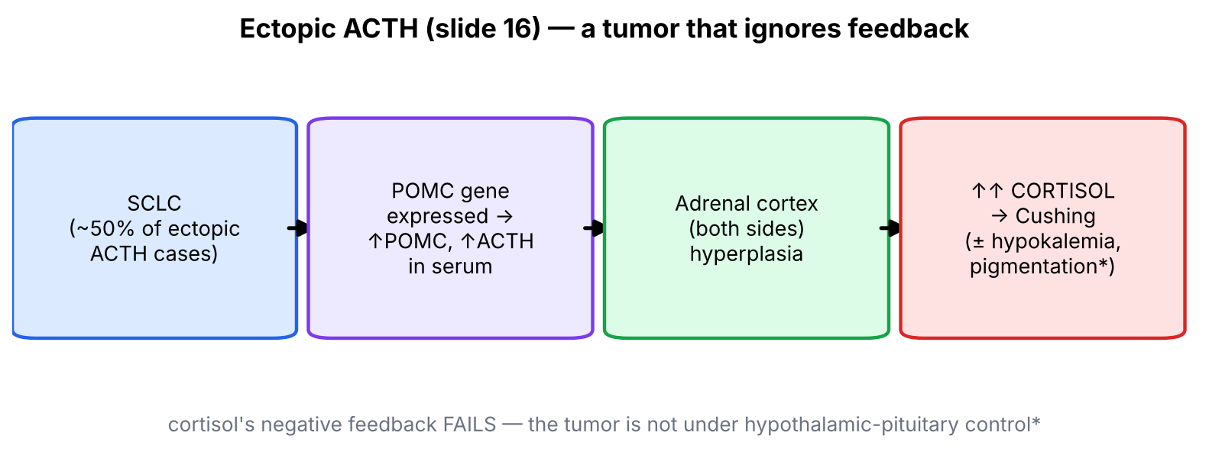
Figure 8. Ectopic ACTH pathway.
▌ ADDITIONAL CONTEXT
Step | Explanation
Etiology | SCLC (neuroendocrine origin), also pancreatic carcinoma and neural tumors / carcinoids (table)
Pathogenesis | Tumor expresses the POMC gene; POMC is cleaved to ACTH (and MSH). Tumor secretion is autonomous — no feedback from cortisol
Morphology | Bilateral adrenal cortical hyperplasia (both glands driven by ACTH)
Clinical | Cushing features; with very aggressive SCLC, patients may have rapid onset hypokalemia, hypertension, weakness, hyperglycemia before classic body-habitus changes; hyperpigmentation (MSH activity of POMC fragments)
Diagnosis (HY) | ↑ cortisol, ↑ ACTH, no suppression with high-dose dexamethasone (pituitary Cushing disease usually suppresses); CT chest

6.2 Hypercalcemia (slides 17–19) — most common paraneoplastic syndrome ★★★★★
▌ FROM THE SLIDES
- Hypercalcemia is the most common paraneoplastic syndrome.
- Two general processes cause cancer hypercalcemia: (1) osteolysis induced by cancer, whether primary in bone (multiple myeloma) or metastatic to bone from any primary — not paraneoplastic (slide 19); (2) production of calcemic humoral substances by extra-osseous neoplasms — paraneoplastic.
- Humoral substances: PTHrP, TGF-α, TNF, IL-1.
- They bind the same G-protein-coupled receptor as PTH, the PTH/PTHrP receptor.
- PTHrP increases bone resorption and renal calcium uptake, while inhibiting renal phosphate transport → raises serum calcium.
- Squamous cell carcinoma of the lung is the most common lung neoplasm associated with hypercalcemia; also breast, ovarian, renal carcinoma, T-cell leukemia/lymphoma.
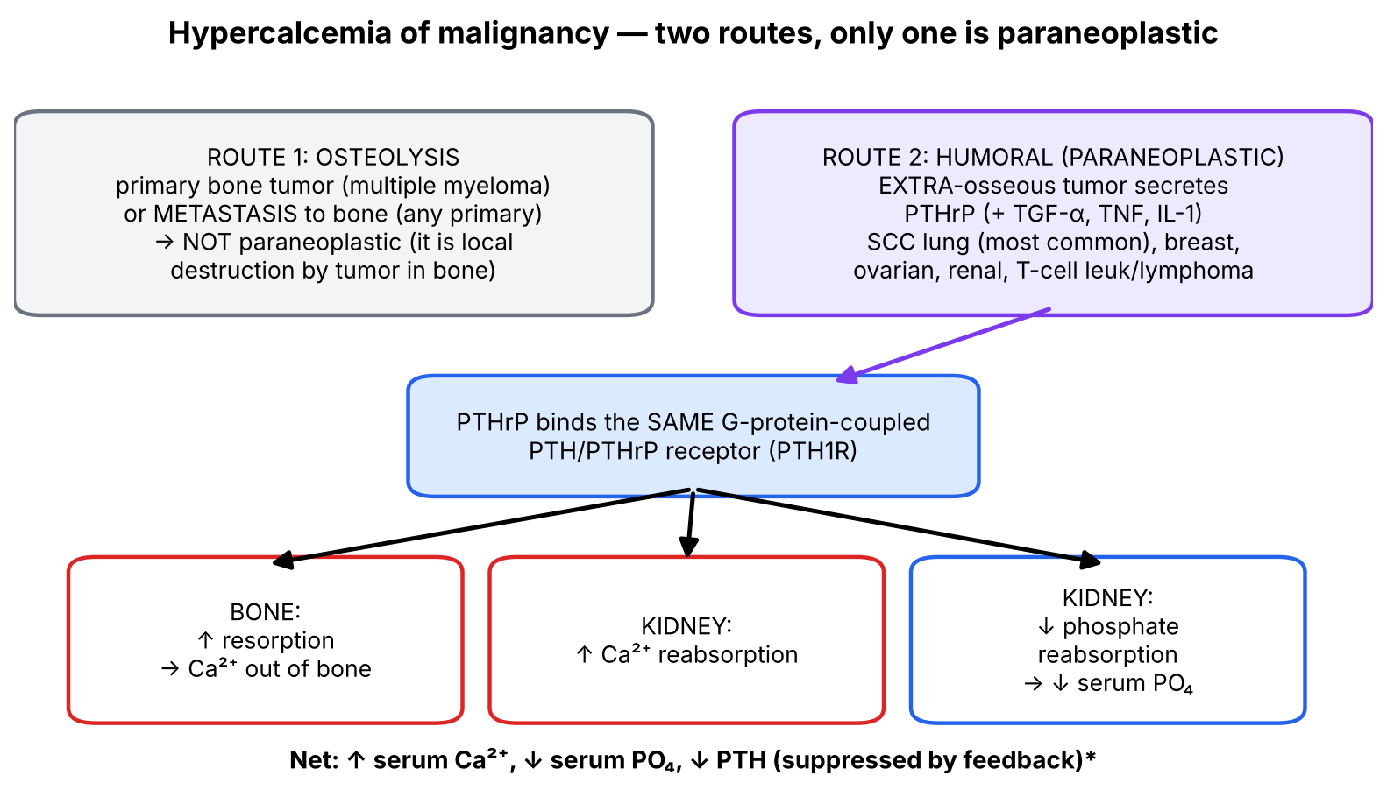
Figure 9. Two routes to hypercalcemia — only the humoral one is paraneoplastic.

Lab reasoning — distinguishing causes of hypercalcemia
▌ HIGH-YIELD ADDITIONAL KNOWLEDGE
Cause | Serum Ca | PTH | PTHrP | Phosphate | Calcitriol
Primary hyperparathyroidism | ↑ | ↑ | — | ↓ | ↑
Humoral (PTHrP) — SCC lung, breast, renal | ↑ | ↓ (feedback) | ↑ | ↓ | ↓/normal
Osteolytic metastases / myeloma | ↑ | ↓ | — | Normal/↑ | ↓
Lymphoma (Hodgkin, some NHL) | ↑ | ↓ | — | Normal/↑ | ↑ (tumor 1α-hydroxylase)

Clinical findings of hypercalcemia (HY, 'stones, bones, groans, thrones, psychiatric overtones'): kidney stones, polyuria (nephrogenic DI), bone pain, constipation, nausea, confusion, short QT. Severe hypercalcemia is an oncologic emergency → IV saline, then bisphosphonates/calcitonin.
HY memory hook: Squamous cell → Stones (calcium). Adult T-cell leukemia/lymphoma is caused by HTLV-1 and characteristically presents with hypercalcemia and lytic lesions.

6.3 Acanthosis nigricans and Leser–Trélat (slides 20–22) ★★★★
▌ FROM THE SLIDES
- Gray-black patches of thickened, hyperkeratotic skin with a velvety appearance ★★★★★.
- Occurs rarely as a genetically determined disease in juveniles or adults.
- In 50% of cases (patients older than 40), the lesion is associated with gastric carcinoma ★★★★★ (table also lists lung and uterine carcinoma; mechanism immunologic / epidermal growth factor secretion).
- Sometimes accompanied by seborrheic keratoses (Leser–Trélat sign).
- These skin changes may appear before the cancer is discovered.
- Slide 22: Leser–Trélat sign in a man in his 60s with > 500 brown verrucous seborrheic keratoses coalescing into plaques on chest and back, eruptive onset within 6 months.
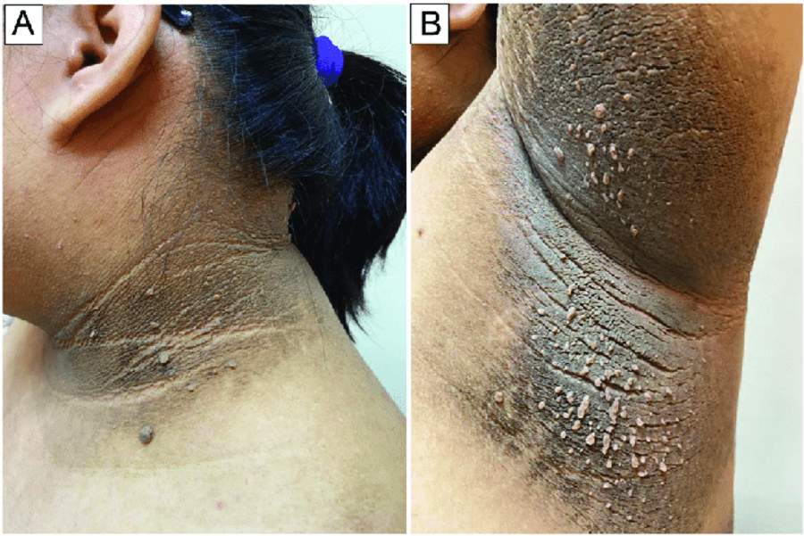
Slide 21: acanthosis nigricans of the neck (A) and axilla (B) — velvety, hyperpigmented, thickened skin in flexures.
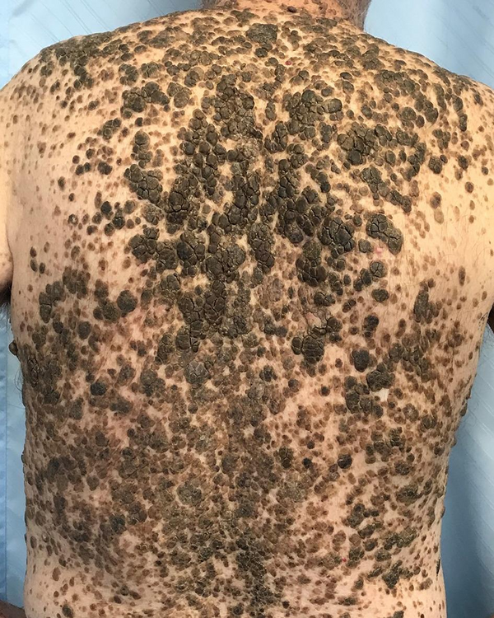
Slide 22: Leser–Trélat sign — sudden eruption of hundreds of seborrheic keratoses.
▌ ADDITIONAL CONTEXT
Mechanism: growth factors (EGF/TGF-α) secreted by the tumor act on epidermal keratinocytes and fibroblasts → proliferation → thick, pigmented, velvety skin. The benign (much more common) form of acanthosis nigricans is caused by insulin resistance (obesity, type 2 diabetes, PCOS): high insulin activates IGF-1 receptors on keratinocytes — the same growth-factor logic.
Feature | Benign (insulin-resistance) AN — HY | Malignant (paraneoplastic) AN — slides
Patient | Young, obese, diabetic, PCOS | Older than 40, often thin, weight loss
Onset | Gradual | Rapid, extensive; may involve mucosa, palms ('tripe palms')
Associated tumor | None | Gastric carcinoma (≈50%), lung, uterine
Mechanism | Insulin → IGF-1 receptors | Tumor growth factors (EGF), immunologic

6.4 Hypertrophic osteoarthropathy (slides 23–24) ★★★★
▌ FROM THE SLIDES
- Seen in 1–10% of patients with lung (bronchogenic) carcinoma ★★★★★ (table: also thymic neoplasms; mechanism unknown).
- Characterized by periosteal new bone formation, primarily at the distal ends of long bones, metatarsals, metacarpals and proximal phalanges; arthritis of adjacent joints; and clubbing of the digits.
- Clubbing is seldom seen in non-cancer patients but may occur with liver disease, diffuse lung disease, congenital cyanotic heart disease, ulcerative colitis and other disorders.
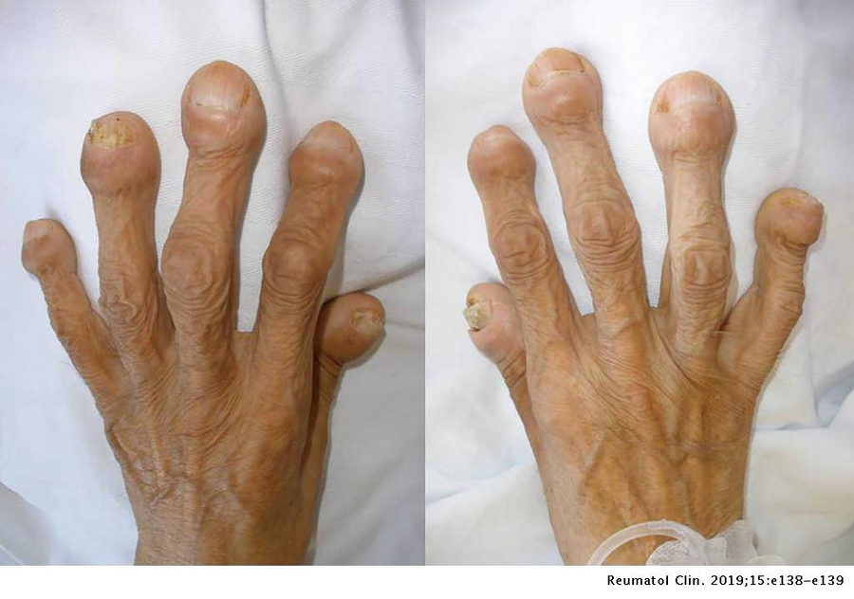
Slide 24: digital clubbing in hypertrophic osteoarthropathy — bulbous fingertips, loss of the normal nail-bed angle.
▌ ADDITIONAL CONTEXT
Leading hypothesis for the 'unknown' mechanism: megakaryocytes/platelet clumps bypass the lung capillary filter (tumor shunting) and lodge in fingertip capillaries, releasing PDGF and VEGF → vascular proliferation, edema and periosteal bone formation. This fits the non-cancer causes too: right-to-left shunts (cyanotic heart disease) and lung disease all let platelets bypass the pulmonary capillary bed.
Clinical: painful, swollen wrists/ankles in a smoker; X-ray shows periosteal new bone ('periostitis') along distal long bones; may regress after tumor resection. Most associated with adenocarcinoma of the lung (HY).

6.5 Vascular and hematologic manifestations (slides 25–26)
▌ FROM THE SLIDES
- Migratory thrombophlebitis (Trousseau syndrome) ★★★★ — with deep-seated cancers, e.g., carcinomas of the pancreas or lung ★★★★. (Table: tumor products — mucins that activate clotting.)
- DIC may complicate acute promyelocytic leukemia (AML-M3) ★★★★ and prostatic adenocarcinoma.
- Nonbacterial thrombotic endocarditis (NBTE) ★★★★ — bland, small, nonbacterial fibrinous vegetations on cardiac valve leaflets (more often left-sided), particularly with advanced mucin-secreting adenocarcinomas; potential sources of emboli.
- Red cell aplasia (mechanism unknown) — thymic neoplasms (thymoma) ★★★★.
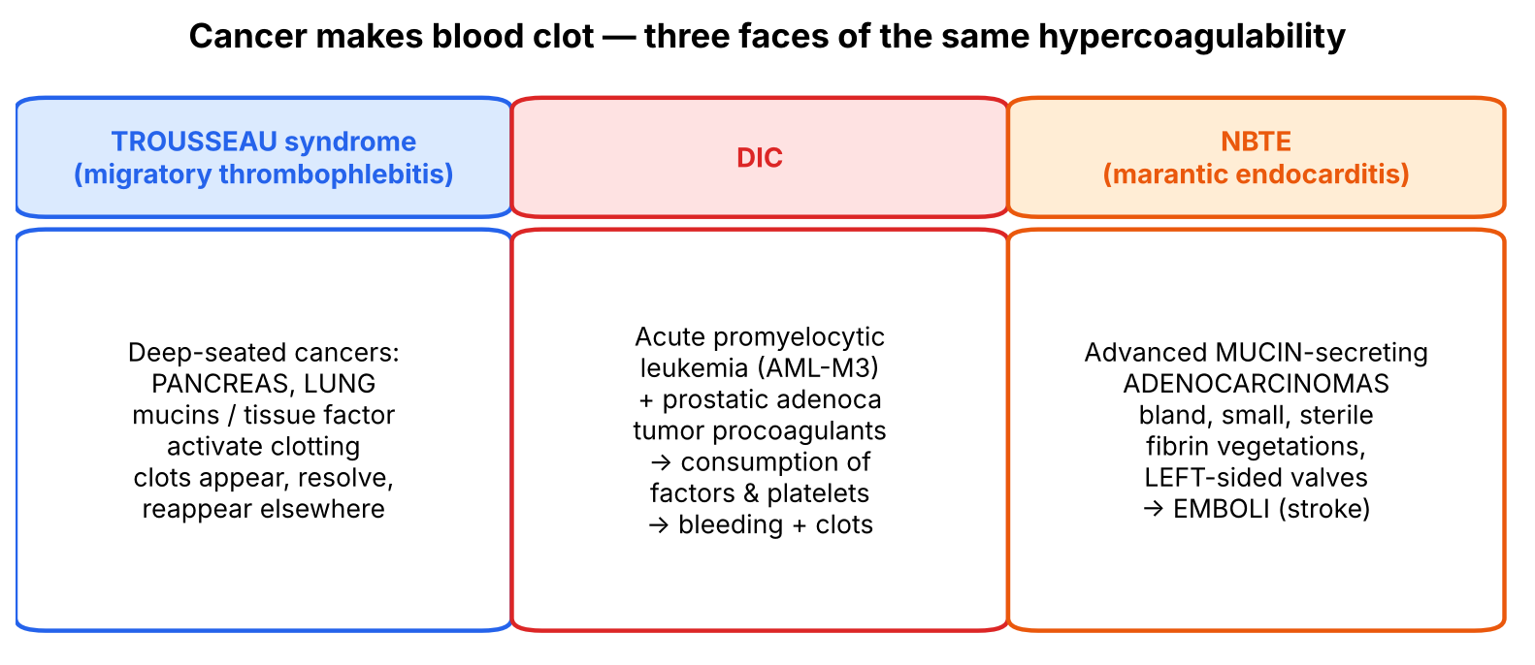
Figure 10. The three clotting syndromes of cancer.
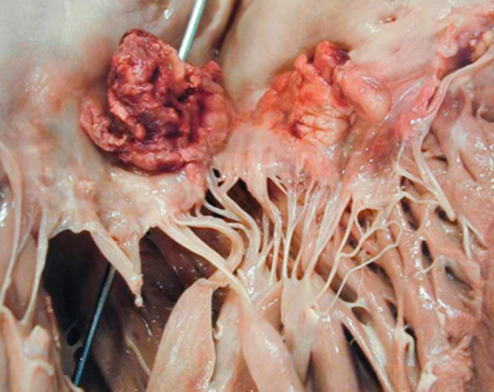
Slide 26: nonbacterial thrombotic endocarditis — small, bland fibrin vegetations along the valve closure line.
▌ ADDITIONAL CONTEXT
- Trousseau: mucins and tissue factor on tumor cells activate the extrinsic coagulation pathway (Virchow triad: hypercoagulability). Clots appear in unusual sites, resolve, and recur elsewhere ('migratory'). Unexplained or recurrent DVT, especially in unusual sites, should prompt a search for occult cancer (pancreas!).
- DIC in APL (HY): promyelocyte granules contain procoagulants (tissue factor) and annexin II (↑ fibrinolysis) → consumption of platelets and factors + hyperfibrinolysis → bleeding and thrombosis; t(15;17) PML-RARA; treat with all-trans retinoic acid (ATRA), which matures the promyelocytes.
- NBTE vs infective vs Libman–Sacks (HY):
Feature | NBTE (marantic) | Infective endocarditis | Libman–Sacks
Setting | Advanced cancer (mucin-secreting adenocarcinoma), hypercoagulable states | Bacteremia (S. aureus, viridans strep) | SLE
Vegetations | Small, bland, sterile, along line of closure, left-sided | Large, friable, infected, destructive | Small, sterile, on BOTH surfaces of valve
Main danger | Embolism (stroke) | Valve destruction, septic emboli | Usually mild; mitral regurgitation

- Red cell aplasia + thymoma: a T-cell-mediated or antibody-mediated attack on erythroid precursors; ~50% improve after thymectomy (HY). Thymoma also → myasthenia gravis (Lecture 13: thymic tolerance failure).
🩺 CLINICAL CORRELATION
• SCLC + rapid hypokalemic weakness + hyperglycemia + high ACTH not suppressed by dexamethasone → ectopic Cushing.
• Smoker with confusion, polyuria, constipation; Ca 14 mg/dL, low PTH, high PTHrP; central lung mass → SCC lung, humoral hypercalcemia.
• Thin 64-year-old with new velvety dark axillary skin + early satiety + weight loss → endoscopy for gastric carcinoma.
• Recurrent DVTs in the arm and leg over weeks + epigastric pain radiating to the back → pancreatic carcinoma (Trousseau).
• Bleeding from venipuncture sites + Auer rods in promyelocytes → APL with DIC — emergency.
• Embolic stroke in a patient with metastatic mucinous adenocarcinoma, negative blood cultures → NBTE.

🎯 EXAM FOCUS
• Cushing ← ACTH/POMC ← SCLC (~50%) ★.
• Hypercalcemia = most common paraneoplastic syndrome ★; humoral PTHrP (+ TGF-α, TNF, IL-1) via PTH/PTHrP receptor: ↑ bone resorption, ↑ renal Ca reabsorption, ↓ renal phosphate reabsorption; SCC lung most common lung tumor; bone metastases/myeloma = not paraneoplastic.
• Acanthosis nigricans = gray-black, velvety, hyperkeratotic; 50% > 40 y with gastric carcinoma ★; Leser–Trélat = eruptive seborrheic keratoses.
• Hypertrophic osteoarthropathy = periosteal new bone + arthritis + clubbing; 1–10% of bronchogenic carcinoma ★.
• Trousseau ← pancreas, lung ★; DIC ← APL (M3), prostate ★; NBTE ← mucin-secreting adenocarcinoma, left-sided, emboli ★; red cell aplasia ← thymoma ★.

⚠️ COMMON MISTAKES
• Linking hypercalcemia to small cell lung carcinoma — it is squamous cell. SCLC = ACTH, ADH.
• Expecting high PTH in PTHrP hypercalcemia — PTH is suppressed.
• Forgetting that PTHrP lowers phosphate (inhibits renal phosphate transport).
• Associating acanthosis nigricans only with diabetes — in an older patient think gastric carcinoma.
• Thinking NBTE vegetations are infected — they are sterile, bland fibrin.
• Mixing up DIC cancers: APL (M3) and prostate — not CML.

Section 6 — Practice questions
Q1. [MCQ] A smoker has Ca²⁺ 13.8 mg/dL, low phosphate and undetectable PTH. A central cavitating lung mass is found. Which substance is most likely responsible?
A. ACTH
B. ADH
C. PTHrP
D. Erythropoietin
E. FGF-23

✅ ANSWER & EXPLANATION
C — PTHrP from squamous cell carcinoma (slides 18–19). PTH is suppressed by the high calcium; phosphate is low because PTHrP inhibits renal phosphate transport.

Q2. [MCQ] Which cause of hypercalcemia in a cancer patient is NOT a paraneoplastic syndrome?
A. PTHrP from squamous cell lung carcinoma
B. PTHrP from renal cell carcinoma
C. Osteolytic bone metastases from breast carcinoma
D. PTHrP from adult T-cell leukemia/lymphoma
E. TGF-α from ovarian carcinoma

✅ ANSWER & EXPLANATION
C (slide 19): osteolysis by tumor in bone = local/metastatic effect.

Q3. [Clinical vignette] A 61-year-old thin man notices rapidly darkening, velvety skin in both axillae and on the back of his neck, followed two months later by hundreds of new 'stuck-on' brown warty lesions on his trunk. He reports early satiety. What is the most likely underlying tumor and what are these two signs called?

✅ ANSWER & EXPLANATION
Gastric carcinoma (≈50% of acanthosis nigricans in patients > 40). Signs: acanthosis nigricans + Leser–Trélat sign (eruptive seborrheic keratoses). Both may appear before the cancer is discovered (slide 20).

Q4. [Clinical vignette] A 58-year-old man has had three episodes of superficial thrombophlebitis in different limbs over 6 weeks, plus weight loss and back pain. Which cancer should be sought and what is the mechanism?

✅ ANSWER & EXPLANATION
Pancreatic carcinoma — Trousseau syndrome (migratory thrombophlebitis) with deep-seated cancers; tumor mucins (and tissue factor) activate clotting (slides 15, 25).

Q5. [MCQ] A patient with a thymoma develops severe anemia with reticulocytopenia but normal white cells and platelets. Bone marrow lacks erythroid precursors. Diagnosis?
A. Myelophthisic anemia
B. Pure red cell aplasia
C. Autoimmune hemolytic anemia
D. Anemia of chronic disease
E. DIC

✅ ANSWER & EXPLANATION
B — red cell aplasia associated with thymic neoplasms (slide 25; mechanism unknown, likely immune).

Q6. [Short answer] List the three components of hypertrophic osteoarthropathy and four non-cancer causes of clubbing.

✅ ANSWER & EXPLANATION
(1) Periosteal new bone formation at distal long bones, metatarsals, metacarpals, proximal phalanges; (2) arthritis of adjacent joints; (3) clubbing of digits. Non-cancer clubbing: liver disease, diffuse lung disease, congenital cyanotic heart disease, ulcerative colitis.

Q7. [Mechanism] Explain each of PTHrP's three actions and how they combine to raise serum calcium.

✅ ANSWER & EXPLANATION
Acting on the PTH/PTHrP receptor: (1) bone — stimulates osteoclast-mediated resorption (via osteoblast RANKL) → Ca²⁺ released; (2) kidney — ↑ distal tubular Ca²⁺ reabsorption → less Ca²⁺ lost; (3) kidney — inhibits proximal phosphate reabsorption → phosphaturia, ↓ serum phosphate (less Ca–phosphate complexing). Net: ↑ serum Ca²⁺.

Whole-lecture review

A. Complete high-yield summary
HOW A TUMOR MAKES YOU SICK
1 LOCAL: location, size, invasion, impingement (pituitary adenoma → hypopit.)
bleeding (melena, hematuria → anemia), ulceration → infection,
rupture, infarction
2 FUNCTIONAL (indigenous hormone, benign or malignant endocrine tumors)
Prolactinoma → amenorrhea, infertility, galactorrhea
Somatotroph → gigantism / acromegaly · Insulinoma <1 cm → fatal hypoglycemia
Adrenal: cortisol → Cushing · mineralocorticoid → Conn · sex → adrenogenital
Granulosa-theca → estrogen (endometrial hyperplasia/ca)
Sertoli-Leydig → androgens · Mole/choriocarcinoma → β-hCG
3 SYSTEMIC: fever; ANEMIA:
chronic disease (most common; Fe trapped) · iron deficiency (R colon ca)
macrocytic (folate; leukemia/lymphoma) · AIHA (CLL)
myelophthisic (marrow mets → leukoerythroblastic: nRBC, myeloblasts)
CACHEXIA: ~50% of patients, ~30% of deaths (respiratory muscle atrophy)
TNF, IL-1, IL-6 → ubiquitin-proteasome of myosin; LMF → fat; PIF
4 PARANEOPLASTIC (~10%): not cachexia, not local/distant spread,
not indigenous hormone → ectopic hormone (+ immune, clotting, unknown)
Cushing ← ACTH/POMC ← SCLC (50%) · SIADH ← SCLC
HYPERCALCEMIA (most common) ← PTHrP ← SCC lung, breast, renal, ATLL
Hypoglycemia ← ovarian ca, sarcomas · Polycythemia ← EPO ← RCC, HCC
Osteomalacia ← FGF-23 · Myasthenia ← lung ca, thymoma
Acanthosis nigricans ← gastric ca (50% >40 y) ± Leser–Trélat
Dermatomyositis ← lung, breast · HOA + clubbing ← lung ca (1–10%)
Trousseau ← pancreas, lung · DIC ← APL (M3), prostate
NBTE ← mucinous adenoca · Red cell aplasia ← thymoma
Nephrotic ← immune complexes

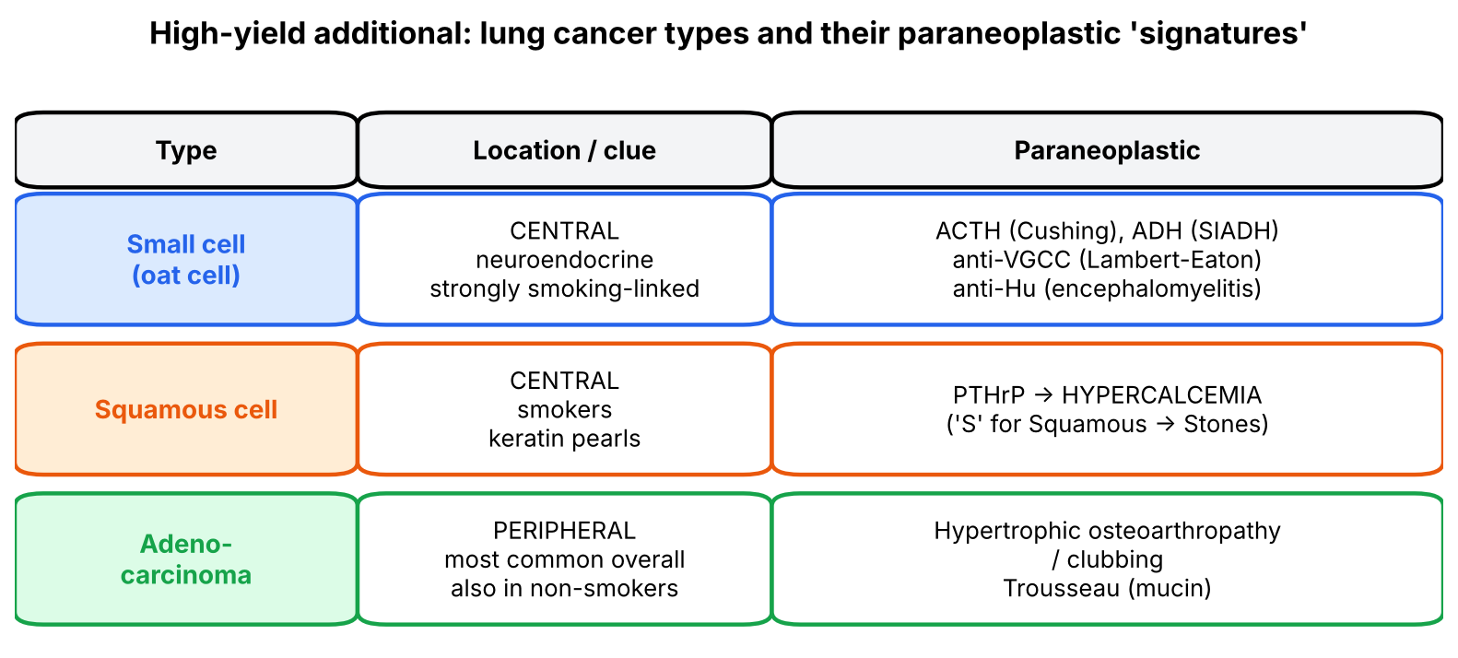
Figure 11. High-yield additional: lung cancer types and their paraneoplastic signatures.

B. Genuinely arbitrary facts — memorize directly
The reasoning tools (four mechanisms, cell-of-origin logic, physiology of each hormone) cover most of the lecture. These pairings and numbers have no derivable logic:
# | Fact | Memory hook
1 | Paraneoplastic ≈ 10%; cachexia ≈ 50% of patients and 30% of deaths; HOA in 1–10% of lung ca; SCLC ≈ 50% of ectopic ACTH | '10 para, 50 cachexia, 30 die'
2 | SCC lung → PTHrP → hypercalcemia | Squamous → Stones (calcium)
3 | Gastric ca → acanthosis nigricans (50% > 40 y) | 'Velvet stomach lining shows on the skin'
4 | Ovarian ca, fibrosarcoma, sarcomas → hypoglycemia | Big tumors eat glucose and secrete insulin-like factor
5 | Breast ca → CNS/PNS disorders; lung + breast → dermatomyositis | —
6 | Thymoma → myasthenia, red cell aplasia, HOA | Thymus = immune school (Lecture 13)
7 | APL (M3) and prostate → DIC | 'Promyelocytic & Prostate → Procoagulants'
8 | Phosphaturic mesenchymal tumor → FGF-23 → osteomalacia | FGF-23 = 'phosphate-flushing factor'
9 | CLL → AIHA | 'C' for Coombs-positive

C. Common exam traps
⚠️ COMMON MISTAKES
• Indigenous vs ectopic: GH from pituitary adenoma, cortisol from adrenal adenoma = functional, not paraneoplastic.
• Hypercalcemia from bone metastases or myeloma = NOT paraneoplastic; only humoral (PTHrP) is.
• Cachexia is not paraneoplastic and is not due to reduced intake.
• Squamous cell lung ca = hypercalcemia; small cell = ACTH, ADH.
• PTHrP hypercalcemia: PTH low, phosphate low.
• Anemia of chronic disease is the most common cancer anemia — ferritin high.
• Iron-deficiency anemia points to right-sided colon cancer.
• Leukoerythroblastic picture = marrow infiltration (myelophthisic), not leukemia per se.
• Acanthosis nigricans in an older, thin patient = gastric carcinoma, not diabetes.
• NBTE vegetations are sterile; mostly left-sided; danger = emboli.
• DIC = APL (M3) and prostate.
• Red cell aplasia = thymoma.

D. Visuals worth looking up
Image | Where | What to look for
Leukoerythroblastic smear | Hematology atlas | Nucleated RBCs, myelocytes/metamyelocytes, teardrop cells
Acanthosis nigricans / tripe palms | Dermatology atlas (and slide 21) | Velvety hyperpigmented flexural skin; ridged palms in malignant AN
Clubbing — Schamroth window test | Clinical exam videos | Loss of the diamond-shaped window between opposed nails; nail-bed angle > 180°
Hypertrophic osteoarthropathy X-ray | Radiopaedia | Periosteal new bone along distal radius/ulna, tibia/fibula
Squamous cell lung ca histology | Robbins | Keratin pearls, intercellular bridges (the PTHrP tumor)
Small cell lung ca histology | Robbins | Small blue cells, nuclear molding, scant cytoplasm, salt-and-pepper chromatin (the ACTH/ADH tumor)

E. 20 medical-school-level practice questions
Q1. [MCQ] Which statement best defines a paraneoplastic syndrome?
A. Symptoms caused by tumor compression of adjacent organs
B. Symptoms due to metastases
C. Symptoms not explained by the tumor's anatomic distribution or by hormones indigenous to its tissue of origin
D. Weight loss from anorexia
E. Hormone excess from an endocrine adenoma

✅ ANSWER & EXPLANATION
C (slide 12).

Q2. [MCQ] The most common paraneoplastic syndrome is:
A. Cushing syndrome
B. SIADH
C. Hypercalcemia
D. Acanthosis nigricans
E. Trousseau syndrome

✅ ANSWER & EXPLANATION
C (slides 17, 19).

Q3. [Vignette] A 59-year-old smoker develops proximal weakness, moon facies and hypokalemia over 6 weeks. Serum ACTH and POMC are high. CXR shows a central mass. Which tumor?
A. Squamous cell carcinoma
B. Adenocarcinoma
C. Small cell carcinoma
D. Bronchial carcinoid only
E. Mesothelioma

✅ ANSWER & EXPLANATION
C — SCLC causes ~50% of ectopic ACTH Cushing (slide 16).

Q4. [MCQ] PTHrP raises serum calcium by all of the following EXCEPT:
A. Increasing bone resorption
B. Increasing renal calcium reabsorption
C. Inhibiting renal phosphate transport
D. Binding the PTH/PTHrP receptor
E. Directly stimulating PTH release from the parathyroids

✅ ANSWER & EXPLANATION
E. PTH is suppressed by hypercalcemia; PTHrP acts directly on the shared receptor.

Q5. [Vignette] A 70-year-old with multiple myeloma has Ca²⁺ 13 mg/dL from extensive lytic lesions. Is this paraneoplastic?

✅ ANSWER & EXPLANATION
No. Slide 19: hypercalcemia from osteolysis by a tumor primary in bone (myeloma) or metastatic to bone is not paraneoplastic — it is local bone destruction. Paraneoplastic hypercalcemia requires humoral substances from an extra-osseous tumor.

Q6. [MCQ] A patient with renal cell carcinoma has hematocrit 58%. The mechanism is:
A. Hemoconcentration from vomiting
B. Ectopic erythropoietin production
C. PTHrP
D. Folate excess
E. Splenic sequestration

✅ ANSWER & EXPLANATION
B (slide 14).

Q7. [Vignette] A 40-year-old has bone pain, fractures, hypophosphatemia and low calcitriol. A small soft-tissue tumor in the thigh is found; removal cures the symptoms. Which hormone was involved?
A. PTHrP
B. FGF-23
C. Calcitriol
D. Calcitonin
E. IGF-II

✅ ANSWER & EXPLANATION
B — phosphaturic mesenchymal tumor → FGF-23 → osteomalacia (slide 14).

Q8. [MCQ] Which anemia is most common in cancer patients?
A. Iron deficiency
B. Myelophthisic
C. Anemia of chronic disease
D. Megaloblastic
E. Autoimmune hemolytic

✅ ANSWER & EXPLANATION
C (slide 6).

Q9. [Vignette] A 66-year-old man with fatigue has Hb 9 g/dL, MCV 72 fL, ferritin 8 ng/mL; no visible bleeding. Most appropriate next step and likely tumor?

✅ ANSWER & EXPLANATION
Colonoscopy — iron-deficiency anemia from occult bleeding of a right-sided colorectal carcinoma (slide 6 notes).

Q10. [MCQ] A leukoerythroblastic blood picture in a cancer patient indicates:
A. Acute leukemia
B. Marrow infiltration by metastases (myelophthisis)
C. Hemolysis
D. Iron deficiency
E. Folate deficiency

✅ ANSWER & EXPLANATION
B (slide 7).

Q11. [MCQ] Which statement about cancer cachexia is correct?
A. It is caused mainly by decreased food intake
B. Fat loss is its cardinal feature
C. It occurs in ~10% of cancer patients
D. It is mediated by TNF, IL-1, IL-6 leading to proteasomal degradation of myosin
E. It is a paraneoplastic syndrome

✅ ANSWER & EXPLANATION
D (slides 8–9, 11).

Q12. [Vignette] A 7-year-old girl has breast development and vaginal bleeding. A unilateral ovarian mass is found. Which tumor and why is this NOT paraneoplastic?

✅ ANSWER & EXPLANATION
Granulosa-theca cell tumor → estrogen (hyperestrinism) → precocious sexual development (slide 5 notes). Estrogen is indigenous to ovarian granulosa/theca cells → functional tumor, not paraneoplastic.

Q13. [MCQ] Acanthosis nigricans in a patient over 40 is most often associated with:
A. Colon carcinoma
B. Gastric carcinoma
C. Prostate carcinoma
D. Hodgkin lymphoma
E. Melanoma

✅ ANSWER & EXPLANATION
B (slide 20: ~50%).

Q14. [MCQ] The Leser–Trélat sign refers to:
A. Migratory thrombophlebitis
B. Sudden eruption of numerous seborrheic keratoses
C. Clubbing with periostitis
D. Velvety flexural hyperpigmentation
E. Heliotrope rash

✅ ANSWER & EXPLANATION
B (slides 20, 22).

Q15. [Vignette] A 62-year-old smoker has painful swollen wrists and ankles and clubbed fingers. X-rays show periosteal new bone along the distal radius and tibia. Diagnosis and associated tumor?

✅ ANSWER & EXPLANATION
Hypertrophic osteoarthropathy — periosteal new bone formation + arthritis + clubbing, in 1–10% of bronchogenic carcinoma (slide 23).

Q16. [MCQ] Which tumor is most classically associated with DIC as a presenting feature?
A. Chronic lymphocytic leukemia
B. Acute promyelocytic leukemia (AML-M3)
C. Hodgkin lymphoma
D. Squamous cell carcinoma of lung
E. Seminoma

✅ ANSWER & EXPLANATION
B (slide 25; also prostatic adenocarcinoma).

Q17. [Vignette] A 55-year-old woman with metastatic mucinous adenocarcinoma of the colon has a sudden left hemiparesis. Echo shows small mitral vegetations; blood cultures are repeatedly negative. Explain.

✅ ANSWER & EXPLANATION
Nonbacterial thrombotic endocarditis — bland, sterile fibrin vegetations on (left-sided) valves in advanced mucin-secreting adenocarcinomas due to hypercoagulability; they embolize → stroke (slide 25).

Q18. [MCQ] Red cell aplasia as a paraneoplastic syndrome is classically associated with:
A. Renal cell carcinoma
B. Thymoma
C. Gastric carcinoma
D. Pancreatic carcinoma
E. Small cell lung carcinoma

✅ ANSWER & EXPLANATION
B (slide 25).

Q19. [Mechanism] Why might a paraneoplastic syndrome lead a clinician to mis-stage a cancer as metastatic?

✅ ANSWER & EXPLANATION
Slide 13: paraneoplastic syndromes mimic metastatic disease. Example: hypercalcemia, bone pain from hypertrophic osteoarthropathy, or neurological deficits from antibodies may be attributed to bone or brain metastases, leading to inappropriate palliative rather than curative treatment.

Q20. [Vignette] A thin 68-year-old with weight loss is found to have hyponatremia (Na 121), and separately develops recurrent superficial thrombophlebitis. CT shows a small central lung mass and a pancreatic head mass. Assign each syndrome to its most likely tumor.

✅ ANSWER & EXPLANATION
Hyponatremia → SIADH → small cell lung carcinoma (ADH/ANP). Migratory thrombophlebitis → Trousseau → pancreatic carcinoma (mucins activating clotting); bronchogenic carcinoma can also cause Trousseau, but pancreas is classic (slides 14–15, 25).

F. 10 rapid-recall questions
# | Question | Answer
1 | % of cancer patients with paraneoplastic syndromes? | ~10%
2 | Most common paraneoplastic syndrome? | Hypercalcemia
3 | Most common lung tumor causing hypercalcemia, and the mediator? | Squamous cell carcinoma; PTHrP
4 | Tumor causing ~50% of ectopic ACTH? | Small cell lung carcinoma
5 | Three mediators of cancer cachexia? | TNF, IL-1, IL-6 (+ PIF, LMF)
6 | Most common anemia in cancer? | Anemia of chronic disease
7 | Blood picture of marrow metastasis? | Leukoerythroblastic (nucleated RBCs, myeloblasts)
8 | Acanthosis nigricans in > 40 y → which cancer? | Gastric carcinoma
9 | Trousseau syndrome cancers? | Pancreas, lung
10 | Paraneoplastic red cell aplasia tumor? | Thymoma

G. Key takeaways
- Tumors harm patients through local, functional (indigenous hormone), systemic (fever, anemia, cachexia) and paraneoplastic mechanisms — classify every sign before naming it.
- Paraneoplastic = exclusion: not local, not metastatic, not indigenous hormone, not cachexia; classically ectopic hormones; ~10% of patients; often the first clue to cancer.
- Cell-of-origin logic predicts many pairings: neuroendocrine SCLC → peptide hormones; mucinous adenocarcinoma → clotting; thymoma → immune syndromes; kidney → EPO.
- Hypercalcemia (PTHrP, SCC lung) is the most common; bone-metastatic hypercalcemia is not paraneoplastic.
- Cachexia is cytokine-driven muscle catabolism (TNF, IL-1, IL-6 → ubiquitin–proteasome), not starvation, and kills via respiratory muscle atrophy.

H. Two questions to test your understanding
🔁 CHECK YOURSELF
1. A patient with small cell lung cancer develops hypercalcemia. Is this more likely paraneoplastic (PTHrP) or metastatic? → SCLC rarely makes PTHrP; it metastasizes early and widely, so bone metastases (not paraneoplastic) are more likely. Check PTHrP and bone scan.
2. Why would removing the primary tumor cure ectopic Cushing but often NOT cure an antibody-mediated paraneoplastic neuropathy? → The hormone disappears with its source; autoantibodies and memory lymphocytes (Lecture 13) persist after the antigen source is gone, and neurons don't regenerate well.

